

**PRIYADARSHINI COLLEGE OF ENGINEERING, NAGPUR**

**DEPARTMENT OF COMPUTER TECHNOLOGY**

SESSION 2021-2022

**"**PREDICTION OF SONG MOOD THROUGH LYRICS**”**

Name of the Guide : Ms.Priyanka Padmane

Name of the Projectees: Krishi Agrahari, Rajsi Kesharwani, Kirti Mohitkar, Shazia Khan, Nikhil Kamale.

**PO’s** : PO1.Engineering knowledge: Apply the knowledge of mathematics, science, engineering fundamentals, and an engineering specialization to the solution of complex engineering problems.

PO2. Problem analysis: Identify, formulate, review research literature, and analyzecomplex engineering problems reaching substantiated conclusions using first principles of mathematics, natural sciences, and engineering sciences.

PO3. Design/development of solutions: Design solutions for complex engineering problems and design system components or processes that meet the specified needs with appropriate consideration for the public health and safety, and the cultural,societal, and environmental considerations.

PO4. Conduct investigations of complex problems: Use research-based knowledge and research methods including design of experiments, analysis and interpretation of data,and synthesis of the information to provide valid conclusions.

PO5. Modern tool usage: Create, select, and apply appropriate techniques, resources, and modern engineering and IT tools including prediction and modeling to complex engineering activities with an understanding of the limitations.

**PSO’s:** PSO1**.**An ability to analyze a problem and identify its solution by applying knowledge of computing and fundamental concepts appropriate to the discipline.

PSO2.An ability to design and develop a computerized systems using conventional and modern techniques, tools for solving real world engineering problems of varying complexity.

PSO 3.An ability to employ the knowledge of Programme specific domains for professional growth and pursuing higher education to meet the current industrial needs.

**CONCLUSION** : We handled the challenge of identifying musical mood in this study by evaluating lyrics and acoustic data using supervised learning methods and reasoning. Deep learning system implementations have been proposed in combination with several data representations based on the natural language processing and digitizer processing techniques. The procedure was finished with the training and assessment of the three suggested systems—lyrics only, audio only, and multi-modal. The experimental approach validates the basic hypothesis: multi-modal systems outperform uni-modal systems. In the case of recognising the mood created by music, that both lyrics and indeed the audio include relevant information for building deep learning models. The results demonstrate some emotion uniformity in playlists, implying that emotion identification generates useful information for developing Recommender Systems. The short dataset size limits the model's training. With more datasets, more complicated and successful categorization algorithms would be conceivable.

**FUTURE SCOPE** : Future work can indeed be accomplished in a variety of ways. The first, and most importantly, direction concerns the amount of the dataset required for the effective creation of a strong deep learning system. Because the data we utilised in this study was restricted, future work would entail designing a system that executes unsupervised learn from unlabeled data, which is abundant. A better alternative for improvements would be to combine vast volumes of unlabeled and modest amounts of labelled data to create systems that include semi-supervised and/or ego learning techniques. In terms of data, using data with lyrics and music aligned will bring significant value and robustness. r. Future study might also rely on a database containing labels reflecting the degree of ambiguity of a track's mood, since we know that listener variability can be large in some circumstances.

**PUBLICATION :**

Published Paper I –Titled “Prediction of song mood through lyrics” in International Research Journal of Modernization in Engineering Technology and Science ( Peer-Reviewed, Open Access, Fully Refereed International Journal ) Volume:04/Issue:04/April-2022.

Paper II – Titled “Preliminary work on: Prediction of Song Mood Through Lyrics” in International Journal of Scientific Research in Engineering and Management (IJSREM) Volume: 06 Issue: 05 | May – 2022.

musical emotions, owing to the subjectivity and difficulty of obtaining this information. Emotion recognition frequently requires the study of human emotions in multimodal formats such as text, audio, or video. We are interested in employing the textual modality in this study because the job is closer to Sentiment Analysis [8], which is the computer treatment of views, feelings, and subjectivity in a natural language text. It may also be used to improve how an RS obtains information about a playlist. Emotion identification is a difficult problem, and most extant efforts rely on data sources that make this process easier by containing particular phrases and sections of text, such as hash-tags in tweets.

**APPLICATION:**

1. To understand the emotion of song.

2. Song recommendation.

3.Improve user experience.

**CO’s :**

CO1.Acquire a sound technical knowledge for problem identification and formulation through the prior knowledge,literature,review and original ideas

CO2. Use software engineering tools to analyse, design, implement, validate and maintain a project

CO3.Develop solution to the identified problems by applying and integrating the knowledge acquired throughout his/her undergraduate study and modern techniques.

CO4.Prepare and present a well-organised progress of a project in written and verbal form periodically.

CO5.Work in a team and communicate with superiors, peers and the community.

CO6.To publish and share their project works with outside world at national and international level.

**DATA FLOW DIAGRAM :**

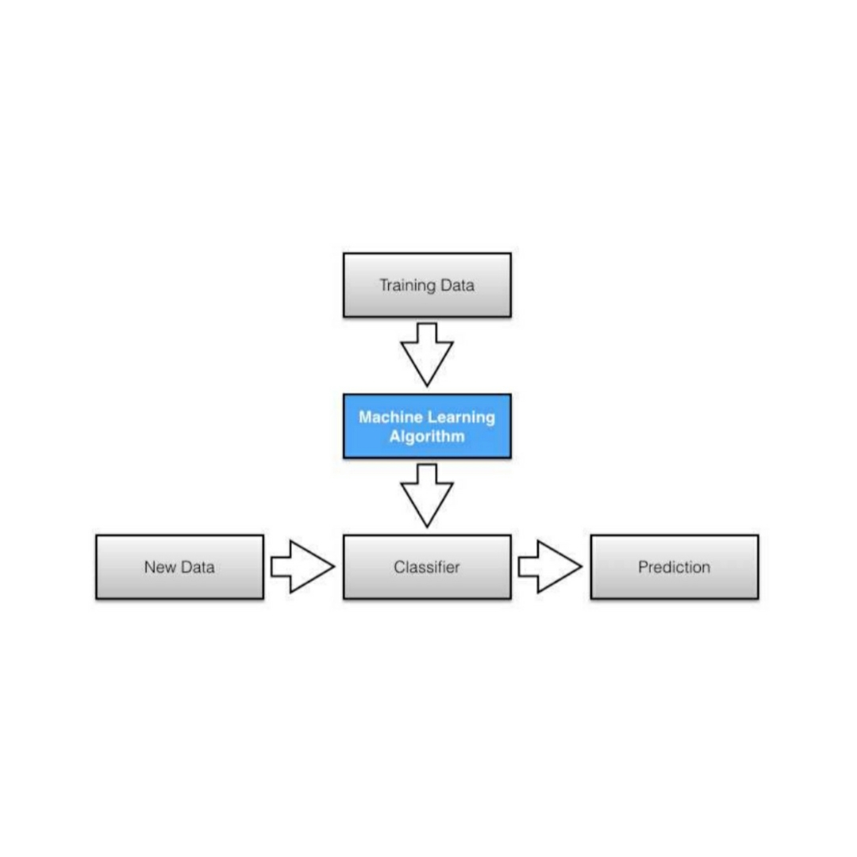

**INTRODUCTION**: The relevance of genre and emotion classification in music organisation has long been acknowledged by the industry, owing to the expansion of music recordings available online [1]. Some music player platforms, such as Spotify, are well-known for their music recommendation system, in which they propose songs based on their customers' historical or genre interests. It would be a nice idea if users could receive suggestions depending on the mood of the lyrics. Lyrics-based analysis might aid the music business by automatically classifying the genres and emotions of a song published by an artist to improve user experience when searching for songs. The goal of this research is to develop an automated classifier of genres and emotions based on song lyrics. However, we propose that the lyrical feeling of the title songs can be considered as a transient vision, but in keeping with the audience"s mood, or so they thought. Numerous studies clearly indicate the influence of mood on singing choice and the impact of music on mood or even purchasing behaviour (Areni and Kim, 1993; Bruner, 1990; Chen et al., 2007; R McCraty, 1998) While researchers have attempted to interpret basically public opinion and market inventories by assessing the sentiment of articles, microblogging, and definitely social networking sites, no studies have determined this correlation in a significant way by studying techniques using definitely famous lyrics. Online music streaming services have enabled users to create and share unique playlists in recent years, providing Recommender Systems (RS) a critical role in the playlists continuance duty. Modern RSs rarely rely on musical emotions, owing to the subjectivity and difficulty of obtaining this information. Emotion recognition

**ABSTRACT** : Because of the growth of track recordings online [1], the importance of style and emotion type in the music business has long been recognised, or so they believed. Some track player structures, such as Spotify, are known for their track recommendation system, in which they predominantly recommend tracks based on their client's historical or style choices personally in a large way. Customers receiving suggestions only based on the mood of the lyrics, which is actually quite crucial, might be a very nice idea. Lyrics-primarily based totally evaluation should provide benefits to the track enterprise by robotically tagging the genres and feelings of a song uploaded by essentially means of an artist to generally improve user's essentially enjoy while attempting to actually find songs in a fairly significant way. The main purpose of this particular experiment is to build an automatic classifier of genres and emotions based entirely on song lyrics, or so they believed. In the experiment, we fine-tuned the pre-trained version and performed switch learning for two types of tasks: style prediction and emotion prediction on a large scale. For all intents and purposes, the version's input is the song lyrics, and the outputs are largely genre and feeling designations, divided into four categories, or so they believed.

CO’s :

CO1. Use software engineering tools to analyze, design, implement, validate and maintain the project.

CO2. Able to work in a team and communicate with superior peers.

CO3. To publish and share their project work with outside world at national and international level.