OUTPUT

1. Ordering item

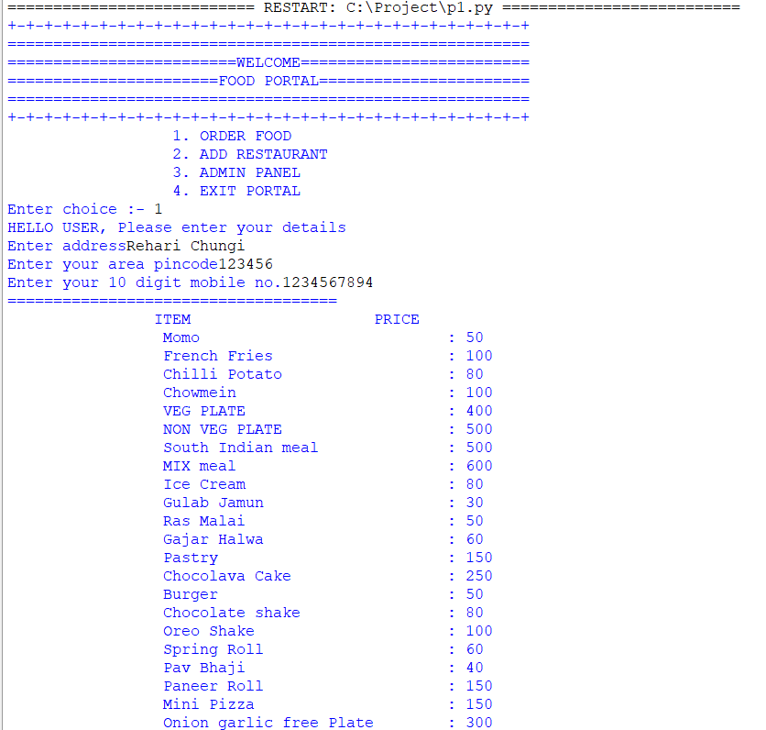

1. Adding Restaurant

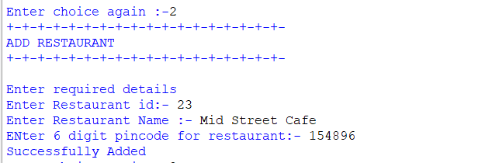

1. Getting Revenue

