DAYANANDA SAGAR COLLEGE OF ENGINEERING
(An Autonomous Institute affiliated to VTU, Belagavi, Approved by AICTE & ISO 9001:2008 Certified)
Accredited by National Assessment & Accreditation Council (NAAC) with ‘A’ grade,
Shavige Malleshwara Hills, Kumaraswamy Layout, Bengaluru-111

Report
On
“ SMART CAMPUS INFORMATION SYSTEM APPLICATION ”
Submitted by
KRISHIKA RATHOD
Second Semester B.E (CSE)
2025-2026
Under the guidance of
Alka Rani
Dept. of CSE
DSCE, Bangalore
Department of Computer Science and Engineering
Bangalore-780111

VISVESVARAYA TECHNOLOGICAL UNIVERSITY
DAYANANDA SAGAR COLLEGE OF ENGINEERING
Shavige Malleshwara Hills, Kumaraswamy Layout, Bangalore - 560111
Department of Computer Science & Engineering

CERTIFICATE
Faculty In-charge  Alka Rani  Department of CSE,  DSCE | Dr. Ramesh Babu  Vice principal & Head  Department of CSE,  DSCE
Signature.................... | Signature....................
Name of the Examiners:  1. ....................................  2. .................................... | Signature with date:  ………………………………  ……………………………….
This is to certify that the application entitled “SMART CAMPUS INFORMATION SYSTEM APPLICATION” is a bonafide work carried out by Abhijeet Singh[USN- 1DS25CS006] and Aashutosh Dubey[USN-1DS25CS003] during the Second Semester Python Programming Laboratory Sessions, Bachelor of Engineering in Computer Science and Engineering under Visvesvaraya Technological University, Belgaum in the academic year 2025–26.

Application – Smart Campus Information System
Dayananda Sagar College of Engineering plans to develop a simple Python-based Smart Campus Information System to manage student information, academic records, and performance analysis.
At present, several administrative tasks such as student registration, course enrollment, record maintenance, searching student data, fee calculation, and performance analysis are often handled manually.
These manual processes can be time-consuming, inefficient, and prone to errors.
To improve efficiency and accuracy, the institution intends to implement a basic software system that enables administrative staff to perform various academic management tasks digitally.
The system will allow administrators to register students, manage course enrollments, maintain academic records, search and sort student data, calculate fees, store and retrieve records from files, scan directories for project files, and analyze student performance using data analytics tools.
The Smart Campus Information System will be developed gradually through Python laboratory experiments.
Each experiment focuses on implementing a specific functional module, and together these modules form a complete integrated application.
The final system will consist of several modules such as Student Registration, Course Enrollment Management, Student Records Management, Search and Sorting, Fee Calculation, File Management, Directory Scanning, and Performance Analytics, all integrated through a Main System Application Dashboard.
Students will develop these modules week by week, and in the final weeks they will integrate all modules to demonstrate the complete working of the Smart Campus Information System.

Smart Campus Information System (Mini Project Integration)
Demonstrate a complete Python application for the Smart Campus Information System by integrating all the modules developed from Lab 1 to Lab 8.
The final program should demonstrate the working of all components including:
- Student registration and grade evaluation
- Course enrollment management
- Student record storage and management
- Searching and sorting student data
- Fee calculation using functions
- File-based academic record management
- Directory scanning with exception handling
- Student performance analytics using NumPy, Pandas, and Matplotlib

Project Architecture and Module Explanation

1. System Architecture and Modularity
The Smart Campus Information System is built upon the core principles of modular programming. Rather than writing a single monolithic script, the system is separated into highly cohesive, loosely coupled functions (modules). Each module is responsible for a distinct feature of the campus administration process. This architectural choice provides several distinct advantages:
- Maintainability: By isolating logic into functions like module5_fee_calculation() or module6_file_handling(), bugs can be traced and fixed within specific domains without affecting the entire application.
- Reusability: Modules are designed to rely on a shared global data structure (campus_data dictionary). This allows multiple modules to read and write to the same state fluidly.
- Scalability: New features (e.g., library management or alumni tracking) can be added simply by defining a new function and linking it to the main integration menu.

2. Detailed Explanation of Modules

Module 1: Student Registration & Grade Evaluation (1a & 1b)
Functionality:
The registration module (module1a_register) is the entry point for data collection. It prompts the administrator to input a student's name, age, and exam score. Based on the score out of 100, the system automatically assigns an alphabetical grade and a qualitative remark using an if-elif decision ladder. The student is assigned a unique, auto-generated ID (starting at 101) and stored as a dictionary inside the global campus_data list.
The evaluation module (module1b_evaluate_grade) acts as the view layer. It iterates through the global student list and formats the stored dictionaries into a readable report.

Module 2: Course Enrollment Management
Functionality:
This module manages course allocations using dynamic lists and tuples. It employs a while loop to continuously accept course names and corresponding credits from the user until a maximum limit (5 courses) is reached or the user types 'done'. Input validation is implemented to ensure that credits are positive integers. Once enrollment is complete, it iterates over the tuple pairs to display a comprehensive enrollment report.

Module 3: Student Records & Event Management (3a & 3b)
Functionality:
module3a_show_records provides a streamlined display of core student data. More interestingly, module3b_event_management implements mathematical Set Operations to manage student participation across multiple campus events. The user inputs comma-separated names of students participating in Event A and Event B.
Using Python's built-in set data structures, the module dynamically calculates:
- Intersection (A & B): Students participating in both events.
- Union (A | B): A unified roster of all unique participants.
- Difference (A - B / B - A): Students exclusively participating in one specific event, showcasing efficient data filtering.

Module 4: Sorting & Searching
Functionality:
This module demonstrates fundamental data structures and algorithmic processing using the generated student IDs. It implements two sorting algorithms from scratch without relying on Python's built-in .sort() method:
- Bubble Sort: Iteratively swaps adjacent elements if they are in the wrong order.
- Selection Sort: Finds the minimum element in the unsorted sub-array and swaps it with the first unsorted element.
Following the sort, the module asks the user for a target ID and locates it using both Linear Search (O(N) time complexity) and Binary Search (O(log N) time complexity), providing practical exposure to algorithm efficiency.

Module 5: Fee Calculation
Functionality:
This module demonstrates the concept of nested functions and keyword arguments. A nested helper function calculate_fee(tuition, hostel=0, transport=0) is defined with default parameters. The system dynamically updates the total fee based on the user's conditional input ('yes' or 'no' for hostel and transport accommodations). This demonstrates how functions can be made flexible to handle varying amounts of input arguments.

Module 6: File Handling
Functionality:
To ensure data persistence, this module handles file I/O operations. It first opens a text file named 'student_records.txt' in write mode ('w') and writes the registered student data in a Comma Separated Values (CSV) format. Subsequently, it opens the file in read mode ('r'), skips the header line, and processes the text data to calculate the total number of students, the average marks, and identifies the top-performing student. This ensures that the campus system can permanently log records to the hard drive.

Module 7: Directory Scanning with Exceptions
Functionality:
This module utilizes the 'os' library (specifically os.walk) to traverse file system directories. It introduces robust Error Handling by wrapping the execution in try-except blocks. It defines a custom exception class, MissingFileOrFolderError, which is explicitly raised if a scanned directory is entirely empty. It also catches standard FileNotFoundError exceptions if the user provides an invalid path, ensuring the application does not crash unexpectedly during administrative file audits.

Module 8: Performance Analytics
Functionality:
This module bridges the gap between basic administration and data science. It integrates third-party libraries (NumPy and Matplotlib). It converts the list of student scores into a NumPy array to efficiently calculate statistical metrics like the Mean, Median, and Standard Deviation. Finally, it leverages Matplotlib to generate an interactive bar chart visualizing student performance, allowing administrators to visually assess the grading curve of the campus.

3. System Integration via the Main() Function
The entire system is orchestrated by the main() function, which serves as the interactive dashboard.
The integration is achieved using an infinite while True loop that continuously displays the system menu. The user’s input is processed through a comprehensive if-elif-else control structure. Based on the alphanumeric choice (e.g., '1a', '5', '8'), the main function triggers the respective modular function.
This design ensures that the user remains within the application ecosystem until they explicitly choose option '9' to Exit, which triggers a break statement, safely terminating the program loop. This creates a cohesive, menu-driven user experience typical of enterprise command-line applications.

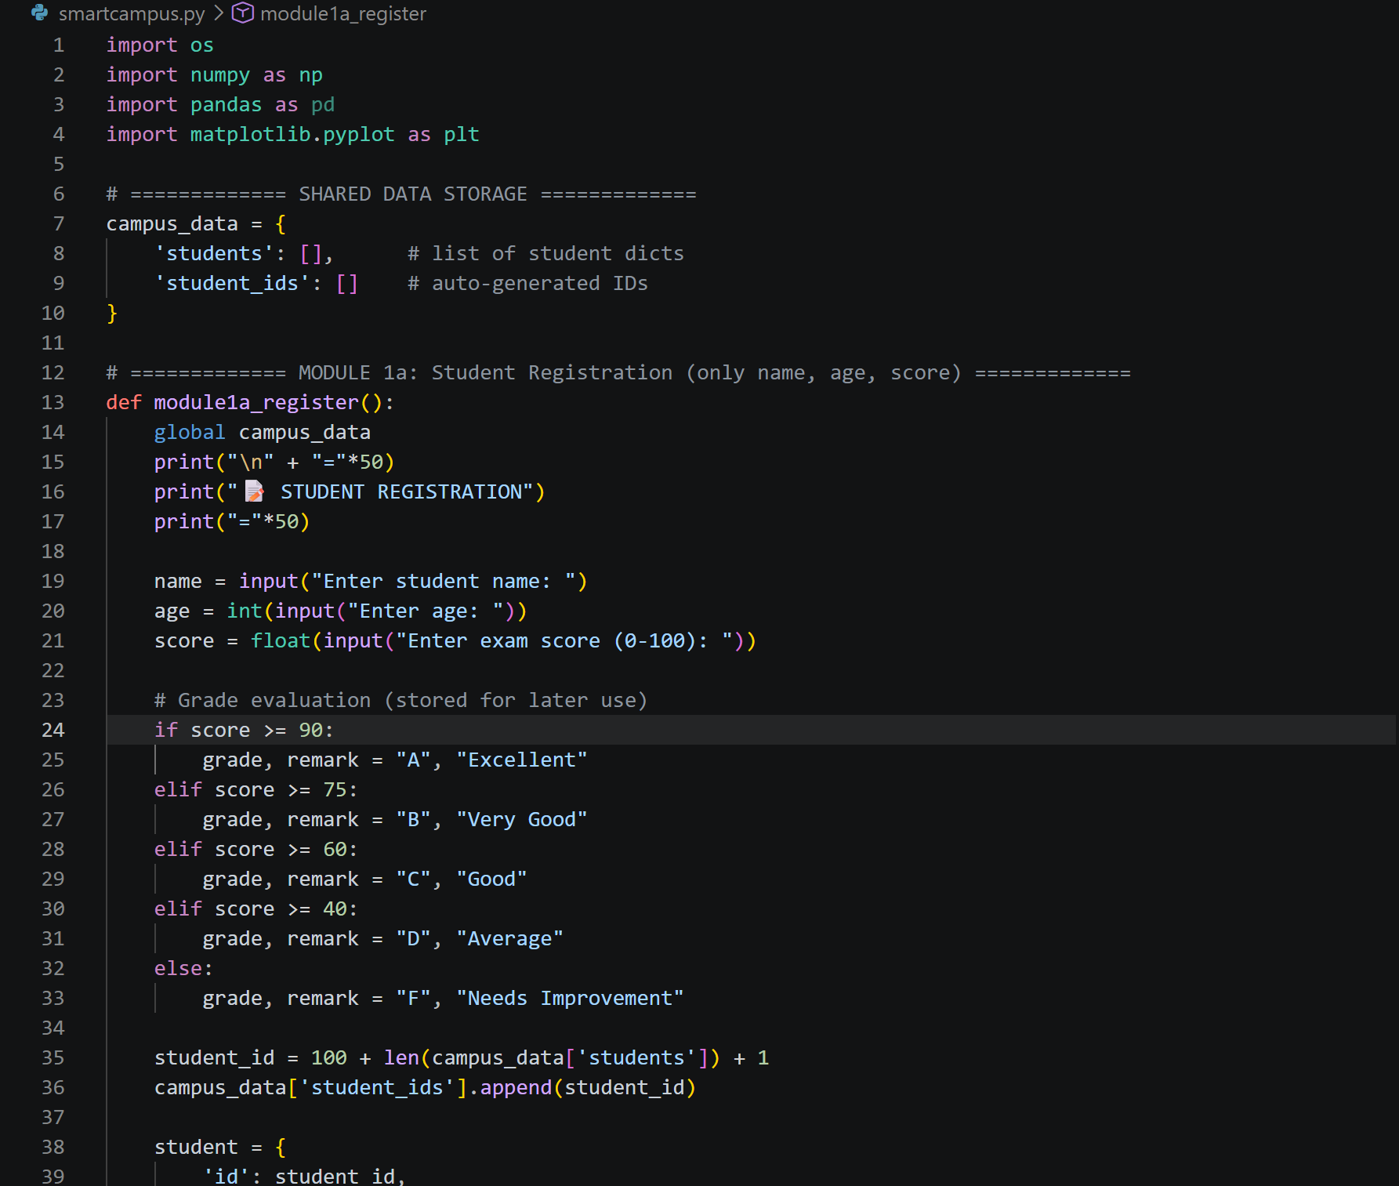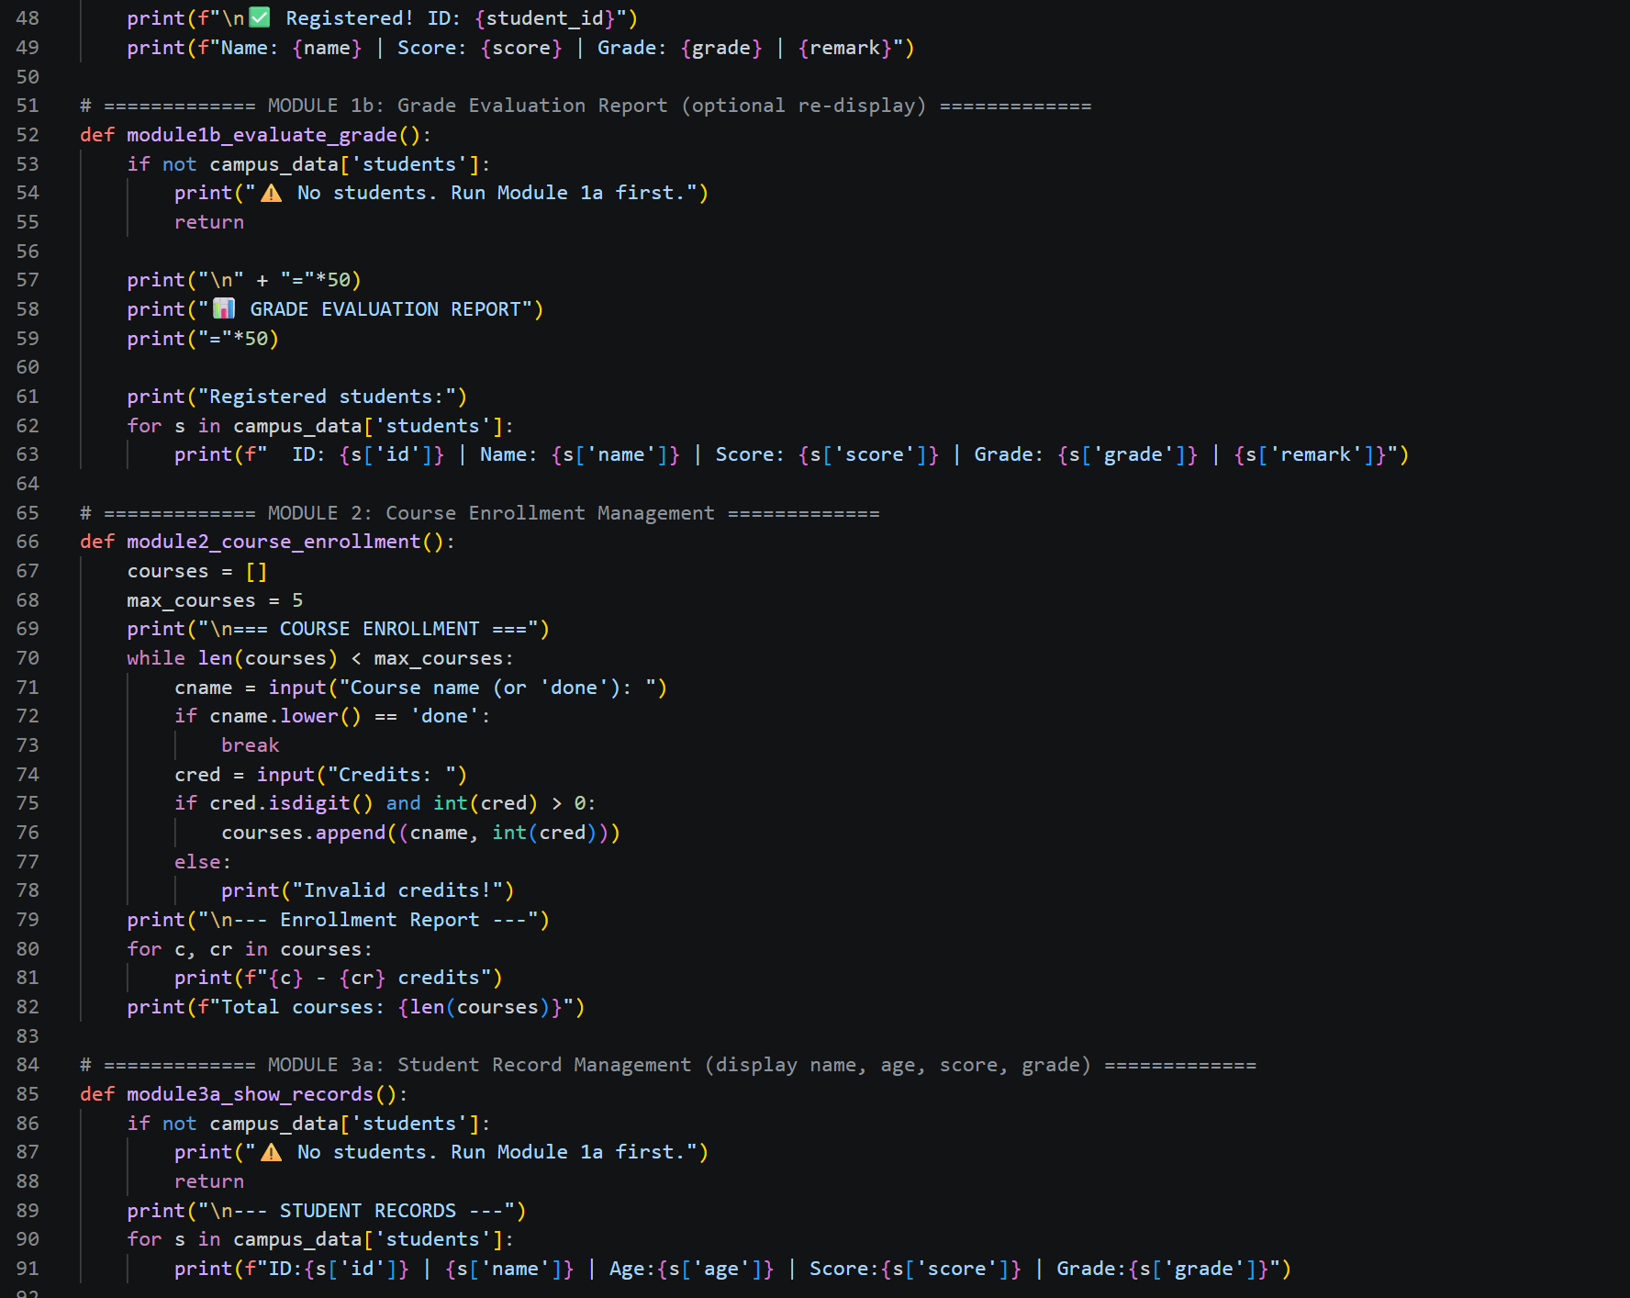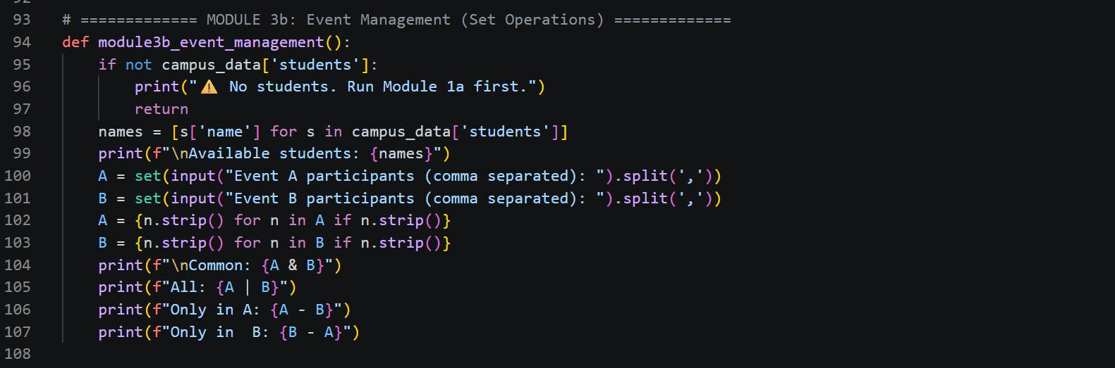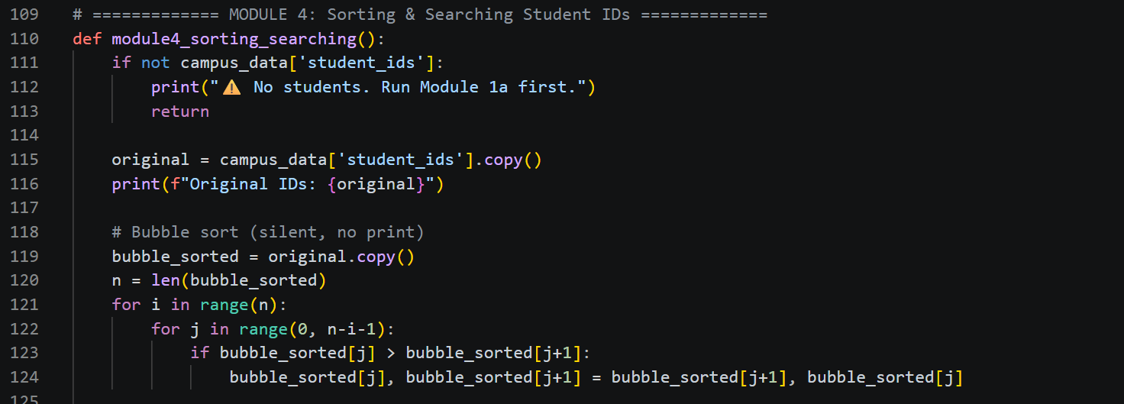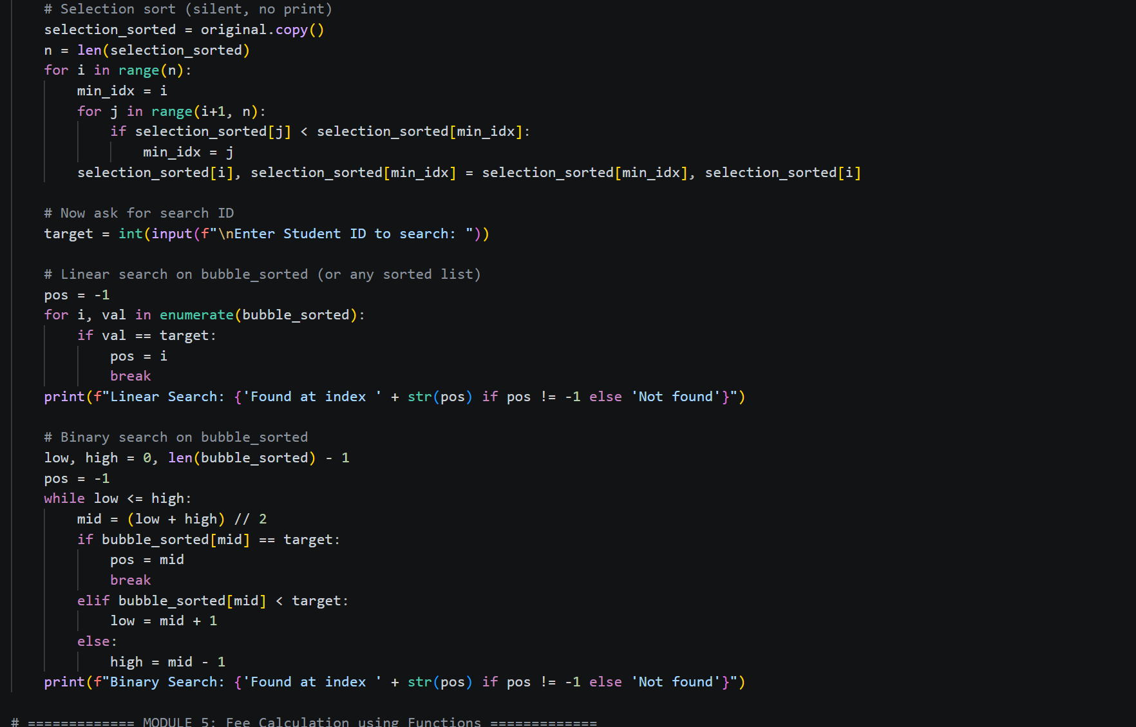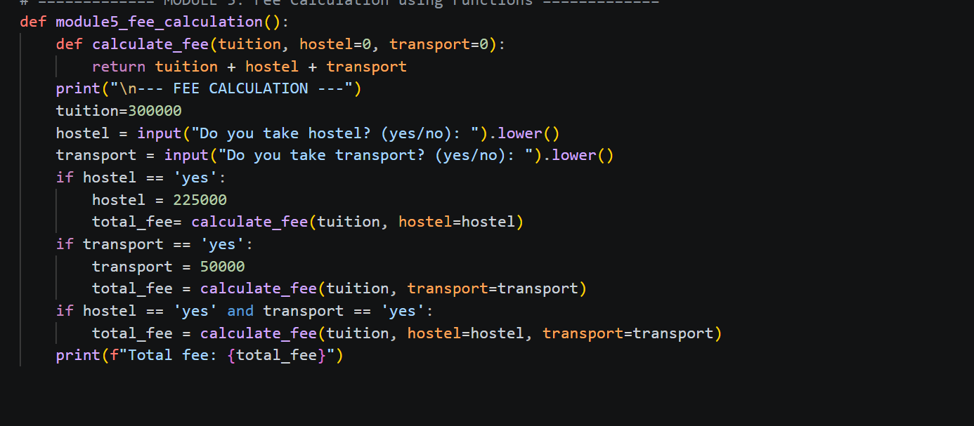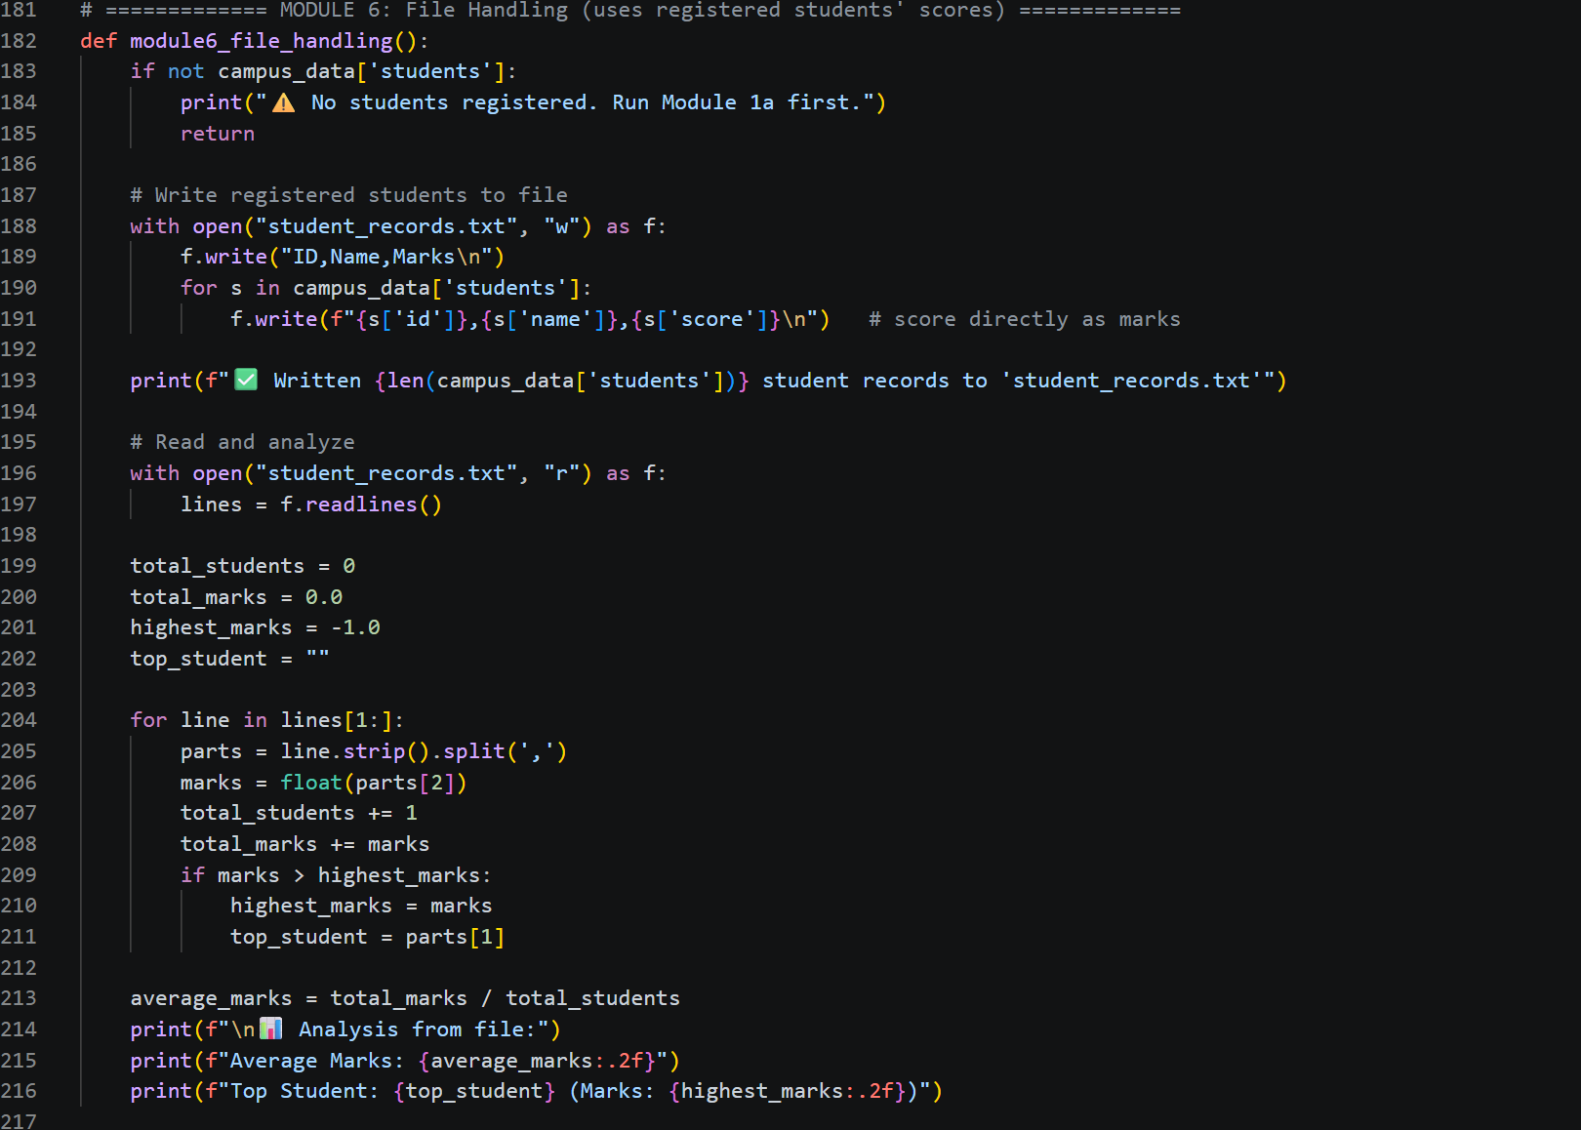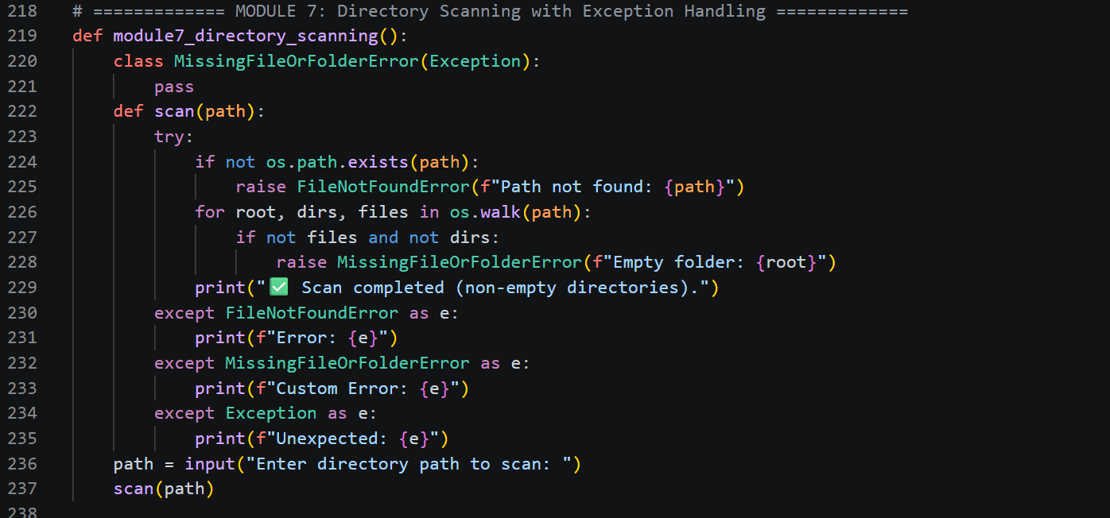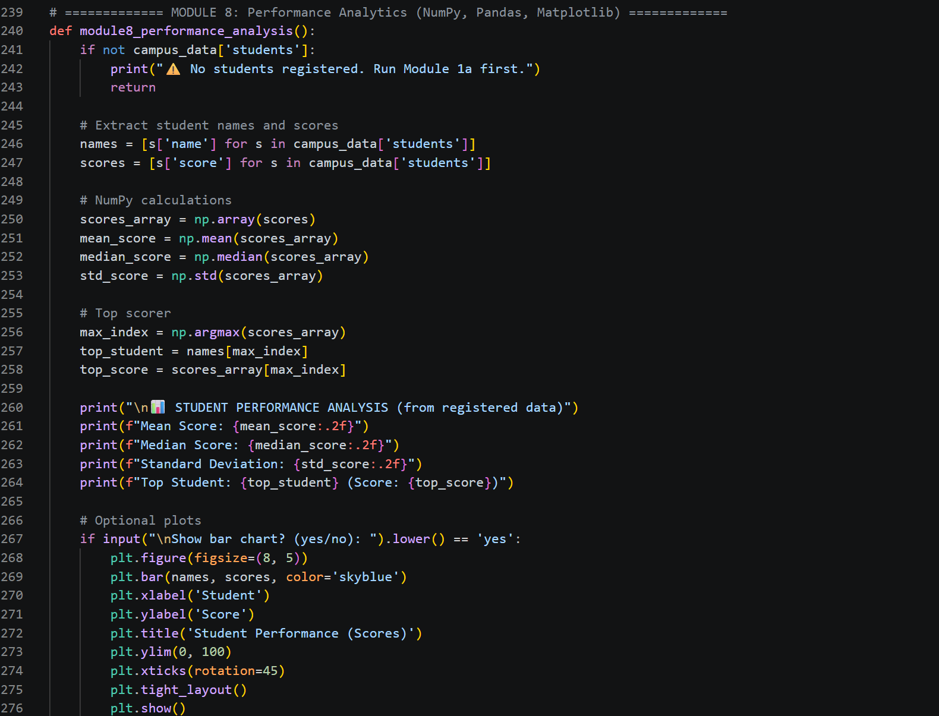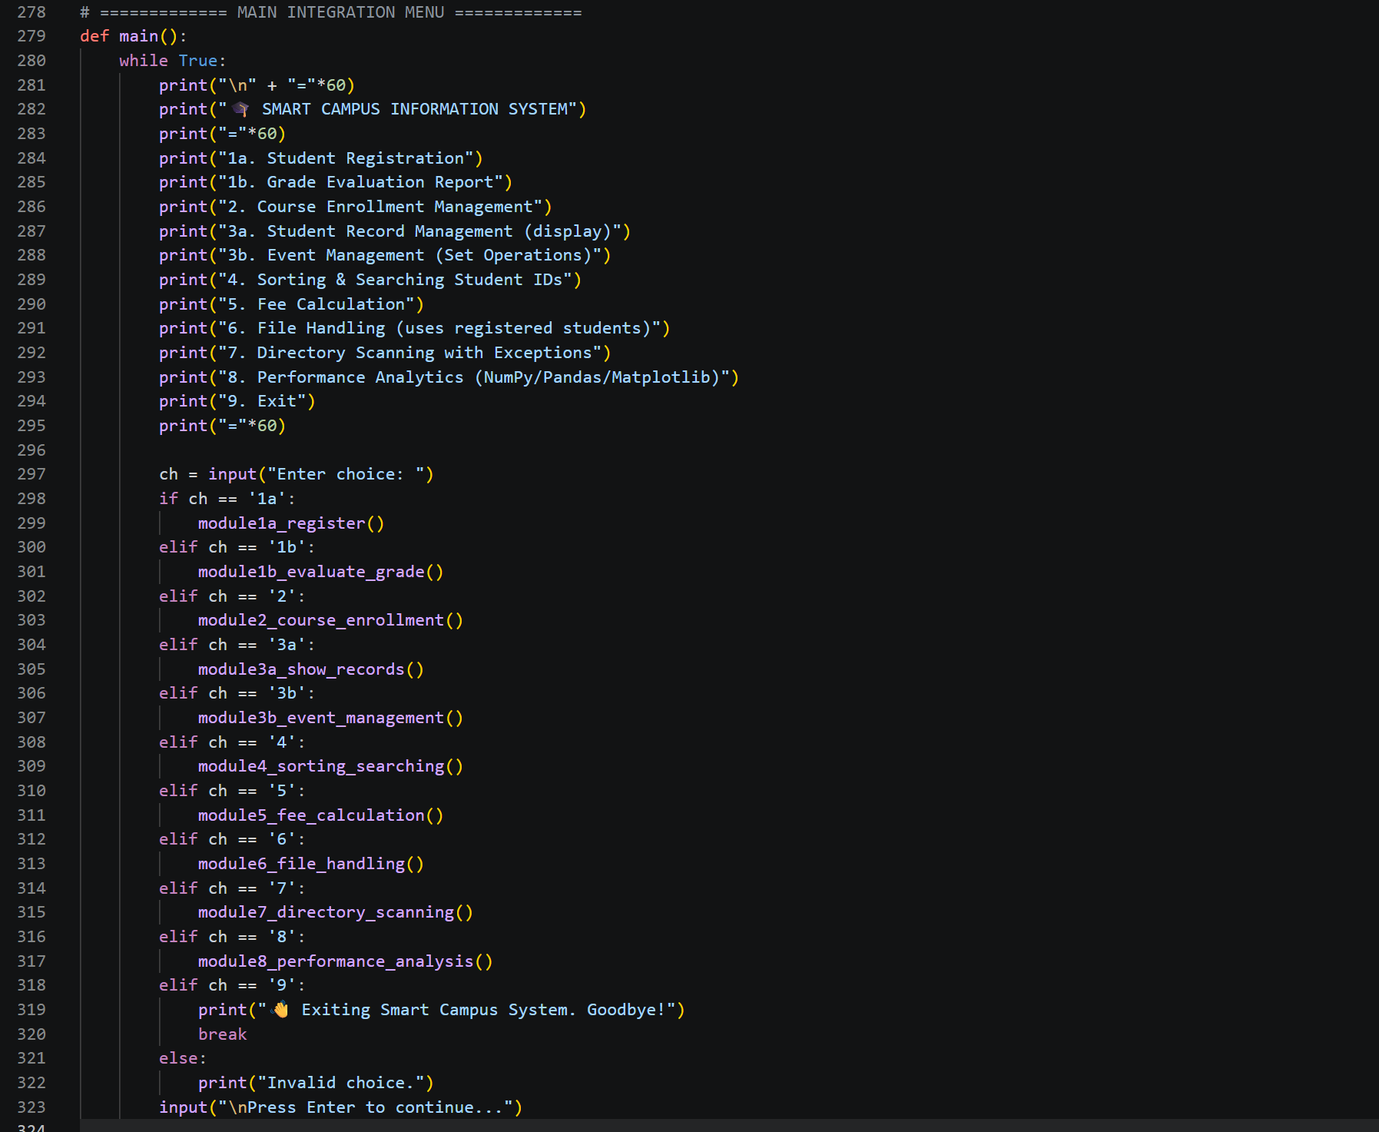
Program code :
, Evaluation,Course enrollment and record management :
Sorting and searching , Fee calculation :
File handling and directory scanning :
Performance analysis function:
Main Function:

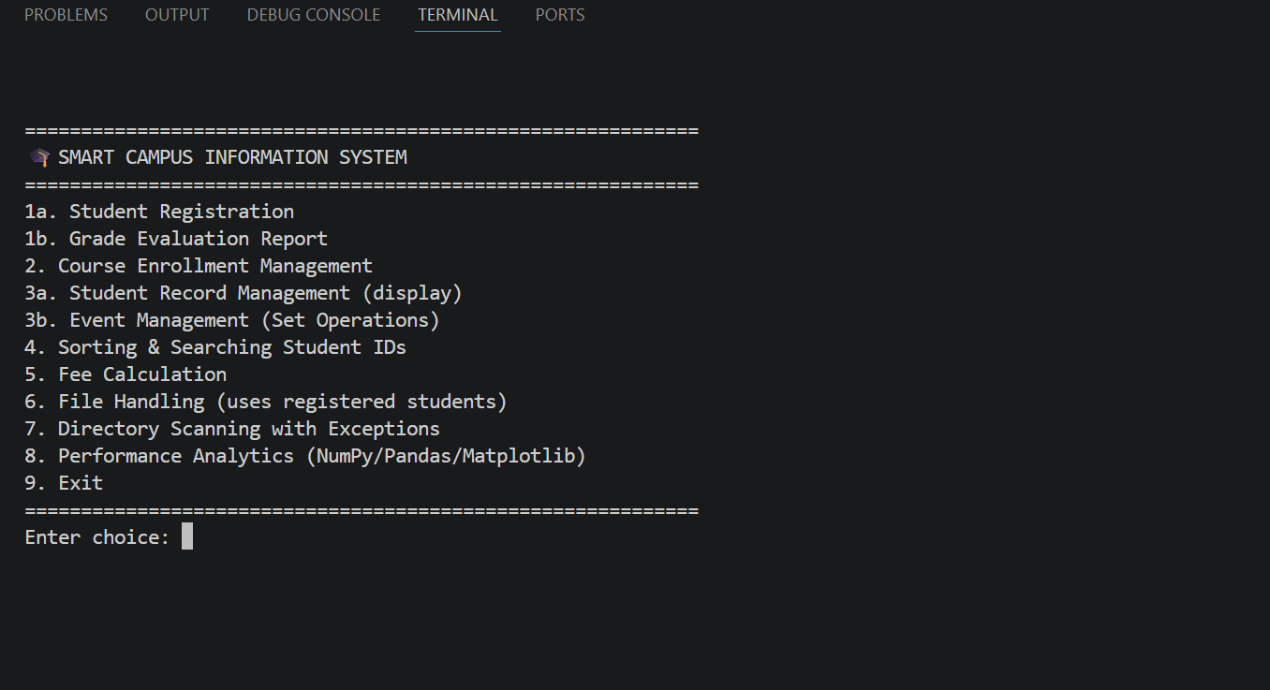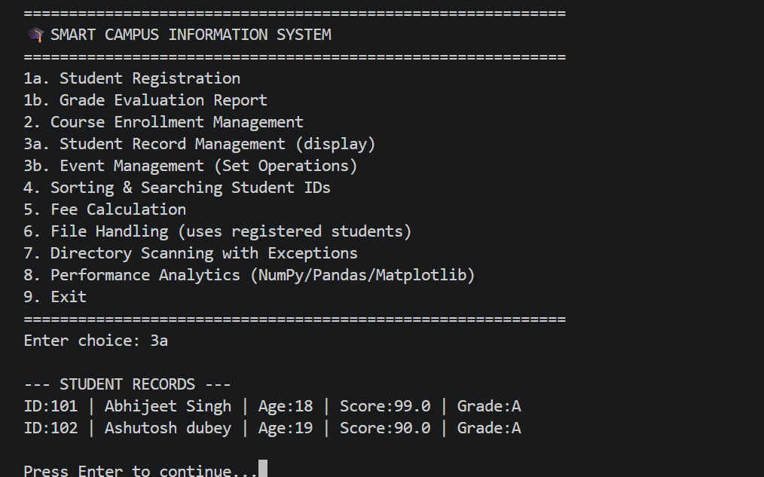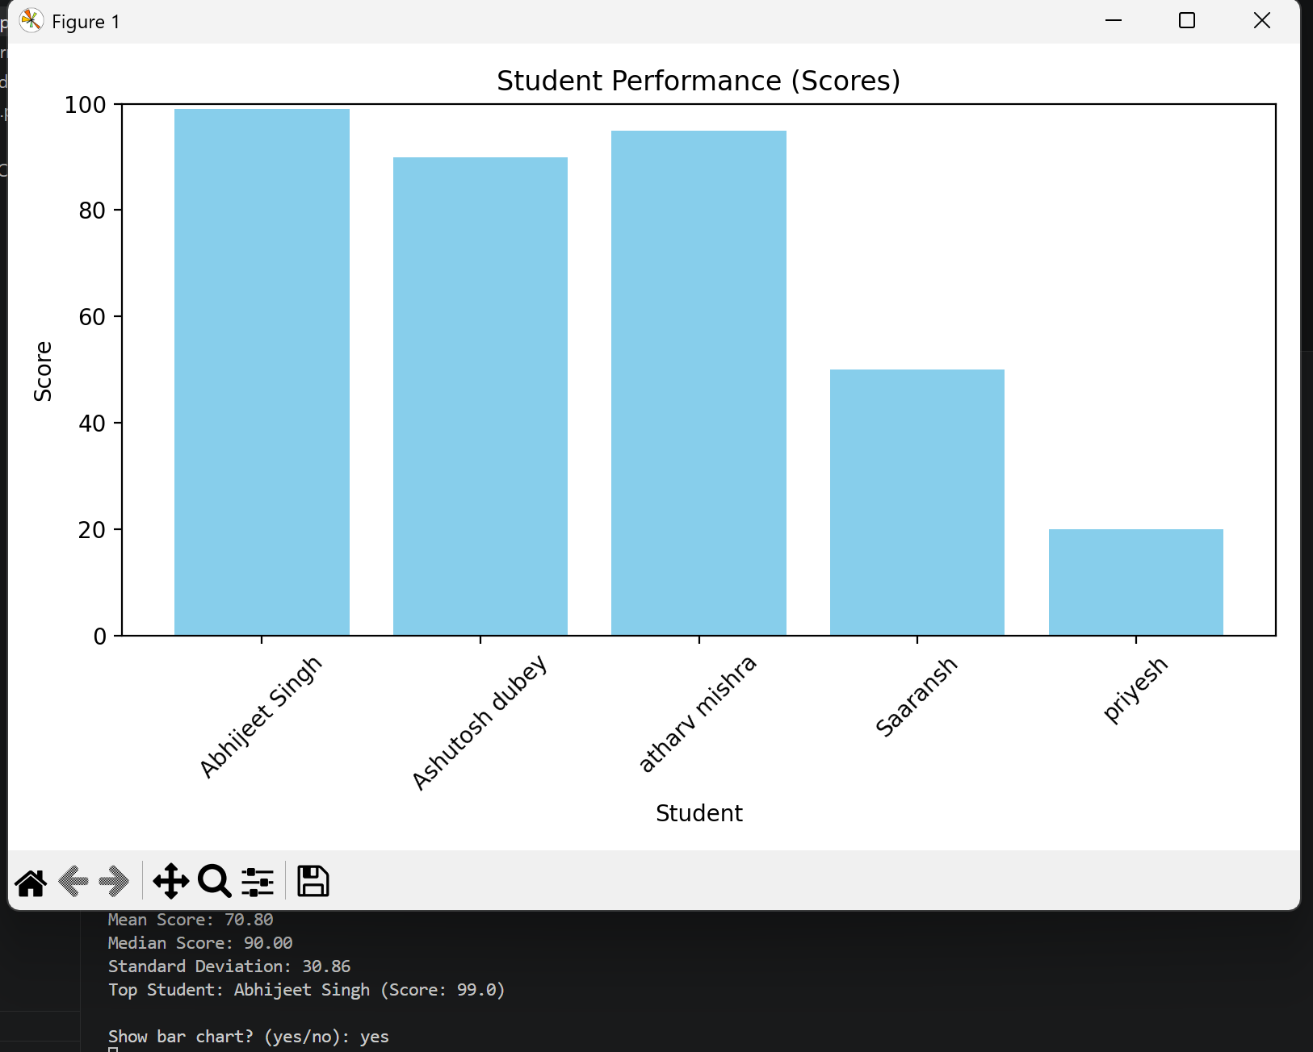
Output:

