* **static and non-static members:-**

1. We cannot declare the static variable in the function, it is compulsory to declare static variable at class-level only.

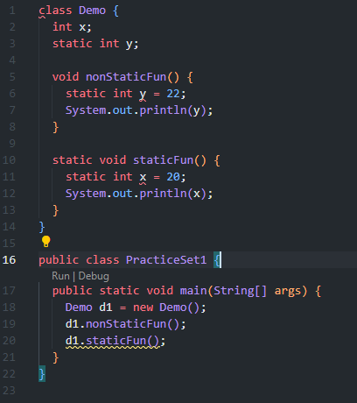

1. We van access static variable from both static and non-static function.
2. We can not access non-static members in static function.

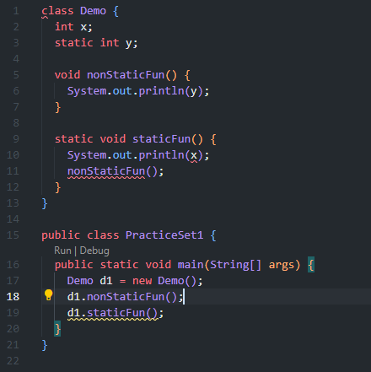

* **final keyword:-**

it is compulsory to initialize final variables, otherwise it gives compile-time error.

