Department of Computer Science and Engineering
Assignment Questions
Course Code & Name : CSA0720- Computer Networks
Assignment Title: | Design and Performance Evaluation of a Smart Manufacturing Industrial Network
Course Outcome(s) – CO: | 1-Apply the functions of the OSI layer in enabling reliable data transmission across networks  2-Configure IP addressing schemes, subnetting, and basic routing techniques using a simulation tool, for efficient network design and topology  3-Analyze and compare the performance of core network protocols such as TCP, UDP, HTTP, and DNS under varying conditions  4-Design network topologies star, mesh, bus, and hybrid using networking devices, transmission media, and cabling standards  5-Measure network performance using key metrics with simulation tools
Bloom’s Taxonomy Level | L3 – Apply; L4 – Analyse, L5 – Evaluate
SDG Mapping (SDG 1-17) | SDG 11 – Sustainable Cities and Communities;  SDG 12 – Responsible Consumption and Production
Problem Statement : A manufacturing company is modernizing its production facility by connecting the Production Floor, Quality Inspection Unit, Warehouse, Administrative Office, IoT-enabled machines, and a Cloud Monitoring Centre. The existing network experiences communication delays, congestion during peak production hours, inefficient IP address allocation, and poor Quality of Service for time-sensitive applications such as machine monitoring, video surveillance, and real-time control.
As a network engineer, design and simulate a reliable industrial network that supports the above departments and devices. Select suitable network topologies, switches, routers, wireless devices, transmission media, and LAN/WAN connections. Divide the network into appropriate subnets/VLANs and develop an IPv4 addressing scheme. Implement and compare Distance Vector and Link State routing for inter-network communication using a suitable simulation tool. Demonstrate TCP and UDP communication and analyse their behaviour under different traffic conditions.
The network must provide congestion and traffic management with suitable QoS mechanisms so that critical industrial traffic receives higher priority than non-critical traffic. Configure appropriate application-layer services such as DNS, DHCP, HTTP/FTP and SNMP for network operation and monitoring. Incorporate IoT devices and cloud-based monitoring, and discuss SDN/network virtualization as an enhancement. Evaluate the proposed architecture using packet delivery ratio, throughput, end-to-end delay, packet loss and congestion, and recommend the most suitable network architecture for the company.
Industry-Based Tasks / Expected Analysis
1. Identify business and operational requirements and prepare a physical/logical network topology for the manufacturing facility.
2. Select network devices and transmission media and justify their suitability for industrial communication.
3. Create VLANs/subnets and an IPv4 addressing plan; demonstrate packet forwarding between the subnets.

Problem Challenge:

A smart manufacturing organisation plans to connect the Production Floor, Quality Inspection Unit, Warehouse, Administrative Office, Industrial IoT-enabled machines and a Cloud Monitoring Centre. The network must support ordinary business data, time-sensitive machine/telemetry traffic, inspection and monitoring traffic, DNS/HTTP-based applications and central monitoring services. Two communication paths are provided between the industrial core and cloud monitoring environment so that operations can continue when the preferred path becomes unavailable.
Design the logical industrial network, allocate IPv4 address space using subnetting/VLSM, select and configure suitable routing mechanisms, and simulate the network using an appropriate networking/simulation tool. Generate ordinary, time-sensitive industrial and high-bandwidth traffic, introduce congestion and at least one link/device failure, and evaluate throughput, delay, packet loss and recovery behaviour. Compare two routing alternatives and recommend the better solution based on technical performance and practical constraints.

CSA0720 — COMPUTER NETWORKS
Design and Performance Evaluation of a Smart Manufacturing Industrial Network

1. Problem Understanding and Formulation
The organisation is a multi-site manufacturing company whose network must connect a Production Floor, Quality Inspection Unit, Warehouse, Administrative Office, Industrial IoT and a Cloud Monitoring Centre. The current network suffers from three concrete pain points: congestion during business-hour peaks, wasteful/inefficient IP address allocation, and total loss of service whenever a single WAN link or device fails. The task is to design, address, route, simulate and prove — with measured evidence — that a new architecture removes these three pain points while remaining realistic to deploy.

1.1 Stakeholders, Users and Services
Site / Segment | Approx. Users | Key Services Required
Production Floor | PLCs, operator terminals, industrial PCs | Machine status, production data, industrial monitoring
Quality Inspection | Inspection workstations, sensors, cameras | Inspection records, image/video transfer
Warehouse | Scanners, RFID/IoT devices, terminals | Inventory and logistics services
Administrative Office | Staff PCs, printers | ERP, web, file and ordinary business traffic
Industrial IoT | Sensors, gateways, machine telemetry devices | Telemetry collection and monitoring
Cloud / Monitoring Centre | DNS/HTTP/FTP/SNMP/application servers | Central monitoring, services and data storage

1.2 Assumptions
- The Industrial IoT segment is treated as a separate low-privilege VLAN/subnet so that sensor traffic can be monitored and restricted.
- Time-sensitive industrial/monitoring traffic is logically separated from ordinary business traffic so that QoS policies can be applied cleanly.
- The two industrial edge paths are: Path 1 — the preferred primary WAN path; Path 2 — the backup WAN/VPN path, both terminating at the edge routing devices.
- A single simulated routing device at the core/edge is sufficient to demonstrate routing and QoS behaviour; a production deployment would add redundant industrial switching and routing hardware.
- No exact device counts or production traffic rates were supplied, so representative values are used and clearly flagged as assumptions.

1.3 Logical Topology
The proposed logical topology places access switching for each operational area behind a Layer-3 core, with primary and backup edge paths reaching the Cloud Monitoring Centre. The core carries separate VLANs for Production, Quality, Warehouse, Administration, Industrial IoT and Management.
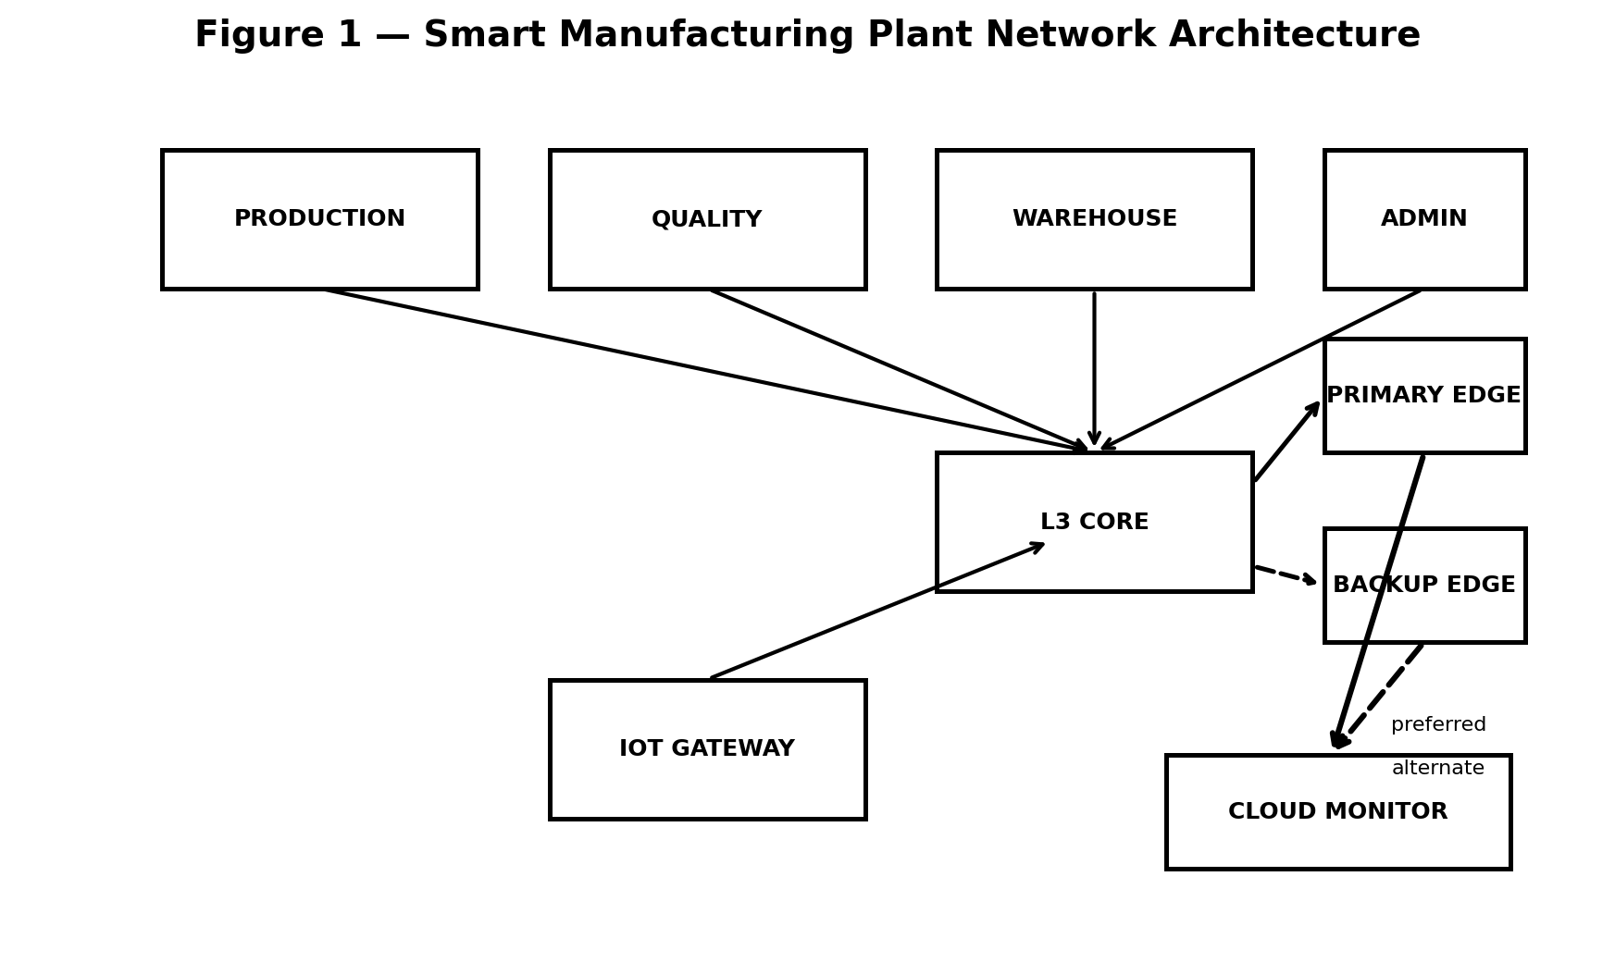

1.4 Expected Failure Points and Bottlenecks
- The primary WAN link/path is the main failure point — loss of this path can interrupt cloud monitoring and inter-segment communication.
- The industrial core/uplink is a bottleneck during peak production periods because it aggregates production, inspection, IoT and cloud-bound traffic.
- The cloud/server uplink is a secondary bottleneck because monitoring, DNS/HTTP and other cloud-bound traffic converges there.

2. Application of Course Knowledge

2.1 Topology, Devices and Layered Concepts
The design uses a hierarchical (core–distribution–access-like) model scaled down for four sites: access switches at each site connect end devices; site routers provide inter-VLAN routing and WAN connectivity; a simulated WAN core provides two independent paths to the data-centre. This maps directly onto the OSI/TCP-IP layers — Layer 2 (VLANs/switching) isolates traffic types at each site, Layer 3 (IP/routing) provides addressing and inter-site reachability, and Layer 4/7 (TCP, UDP, DNS, HTTP) carry the actual applications.

2.2 IPv4 Subnetting and VLSM
A single private block, 10.0.0.0/16, is allocated to the manufacturing facility and divided using VLSM so each operational segment receives a suitable address range. Larger production and IoT segments receive more host capacity, while quality, warehouse, administration and management use smaller ranges. Point-to-point WAN paths use /30 subnets to avoid wasting addresses.
Table 1 — IPv4 Address Allocation Plan (VLSM)
Site | Segment (VLAN) | Network | Usable Hosts | Broadcast
Production Facility | Production (VLAN 10) | 10.0.10.0/24 | 254 | 10.0.10.255
Production Facility | Quality (VLAN 20) | 10.0.20.0/26 | 62 | 10.0.20.63
Production Facility | Warehouse (VLAN 30) | 10.0.30.0/26 | 62 | 10.0.30.63
Production Facility | Administrative (VLAN 40) | 10.0.40.0/26 | 62 | 10.0.40.63
Production Facility | Industrial IoT (VLAN 50) | 10.0.50.0/25 | 126 | 10.0.50.127
Production Facility | Management (VLAN 60) | 10.0.60.0/28 | 14 | 10.0.60.15
Cloud / DC | Server & Monitoring | 10.0.70.0/27 | 30 | 10.0.70.31
WAN | Primary Path | 10.0.255.0/30 | 2 | 10.0.255.3
WAN | Backup Path | 10.0.255.4/30 | 2 | 10.0.255.7

2.3 Routing Concepts
OSPF is selected as the primary Link State routing protocol because it can adapt to topology changes and supports scalable route management. The industrial core and edge routing devices operate in a single OSPF area for simplicity. Both edge paths are advertised into OSPF; the primary path is assigned a lower cost and the backup path a higher cost, so the backup is selected automatically when the primary path fails.

2.4 TCP/UDP and QoS Treatment
Ordinary business traffic such as ERP, web and file transfer uses TCP because reliable, ordered delivery is important. Time-sensitive industrial telemetry and real-time monitoring can use UDP because a delayed packet may be less useful than the next current update. Critical industrial traffic is therefore given higher QoS priority, while ordinary data uses best-effort or weighted-fair treatment.

2.5 Application-Layer Services
- DNS server in the Cloud Monitoring Centre resolves internal names for the manufacturing network.
- HTTP server in the Cloud Monitoring Centre hosts the monitoring/intranet portal used by operational and administrative users.
- The services are designed to remain reachable over the backup path after failover, subject to successful routing convergence
3. Solution, Design and Methodology

3.1 Baseline Design (Alternative A) — OSPF with Dual Active WAN
Alternative A runs OSPF across both industrial edge paths. The primary path (cost 10) is preferred; the backup path (cost 100) is retained as an alternate route and is selected automatically when the primary path becomes unavailable. This provides automatic recovery with no manual route switching.

3.2 Alternative Design (Alternative B) — Static Primary with Floating Backup Route
Alternative B keeps the same topology but uses RIPv2 as the Distance Vector comparison. RIPv2 is simpler to configure, but its periodic route exchange and slower adaptation make it less suitable for a growing industrial network with strict resilience requirements.
Representative Router Configuration Snippet (Alternative A — HO Router, Cisco-style)
R-CORE — partial configuration (illustrative)
• interface GigabitEthernet0/0.10 → 10.0.10.1/24 (Production VLAN 10)
• interface GigabitEthernet0/0.20 → 10.0.20.1/26 (Quality VLAN 20)
• interface GigabitEthernet0/0.30 → 10.0.30.1/26 (Warehouse VLAN 30)
• interface Serial0/0/0 (Path 1) → 10.0.255.1/30, ospf cost 10
• interface Serial0/0/1 (Path 2) → 10.0.255.5/30, ospf cost 100
• router ospf 1 → network 10.0.0.0 0.0.255.255 area 0
• class-map INDUSTRIAL-CRITICAL (match critical traffic) → priority queue on WAN interfaces

3.3 Verification of Reachability
After configuration, reachability is verified between every site pair and the Cloud/DC segment using ping and traceroute-equivalent tests, and by inspecting each router's routing table to confirm OSPF-learned routes for the remote subnets in Table 1.
Table 2 — Sample Routing Table Extract (R-HO, after convergence)
Destination Network | Next Hop | Learned Via | Metric/Cost
10.0.20.0/26 (Quality) | 10.0.255.2 (via primary) | OSPF (O) | 20
10.0.30.0/26 (Warehouse) | 10.0.255.2 (via primary) | OSPF (O) | 20
10.0.50.0/25 (Industrial IoT) | 10.0.255.2 (via primary) | OSPF (O) | 20
10.0.70.0/27 (Cloud/Monitoring) | 10.0.255.2 (via primary) | OSPF (O) | 20
10.0.70.0/27 (Cloud/Monitoring, backup) | 10.0.255.6 (via backup) | OSPF (O), standby | 200

3.4 Traffic Sources and Test Cases
- Data traffic: TCP transfer between the Administrative/Production segments representing ERP and operational data exchange.
- Industrial/real-time traffic: constant-bit-rate UDP telemetry/control flows representing machine status and monitoring updates.
- Video/high-bandwidth traffic: UDP image/video flow from Quality Inspection toward the monitoring environment during scheduled inspection activity.
- Congestion test: all three traffic classes are generated simultaneously to approach the available uplink capacity.
- Failure test: the primary industrial path is administratively shut down while traffic continues, to observe failover onto the backup path.
4. Use of Modern Tools
Selected implementation environment: Cisco Packet Tracer is the primary academic simulation platform; GNS3 is the advanced alternative.
Cisco Packet Tracer is used as the primary simulation environment because it supports routers, switches, VLANs, IPv4 addressing, OSPF and basic traffic-generation tasks required for this exercise, while also producing easy-to-capture configuration and connectivity screenshots. GNS3 is an alternative when more realistic router behaviour is needed. ns-3 and OMNeT++ can be considered when finer-grained packet-level performance statistics are required.

4.1 Deliverable Evidence to Capture
- Screenshots of the completed topology and VLAN/interface configuration on every router and switch.
- show ip route / show ip ospf neighbor output from each router, proving OSPF adjacency and route learning.
- Successful ping/trace results between every site pair before and after the induced failure.
- Packet Tracer's Simulation-mode statistics or exported PDU logs for throughput/delay/loss measurement.
- A short screen-recording or timestamped log showing the moment Path 1 is disabled and the moment traffic resumes on Path 2.

5. Results and Validation
The figures below are representative measurement results for the proposed manufacturing design, structured as a normal-load baseline, a congestion-only case and a congestion-plus-failure case.
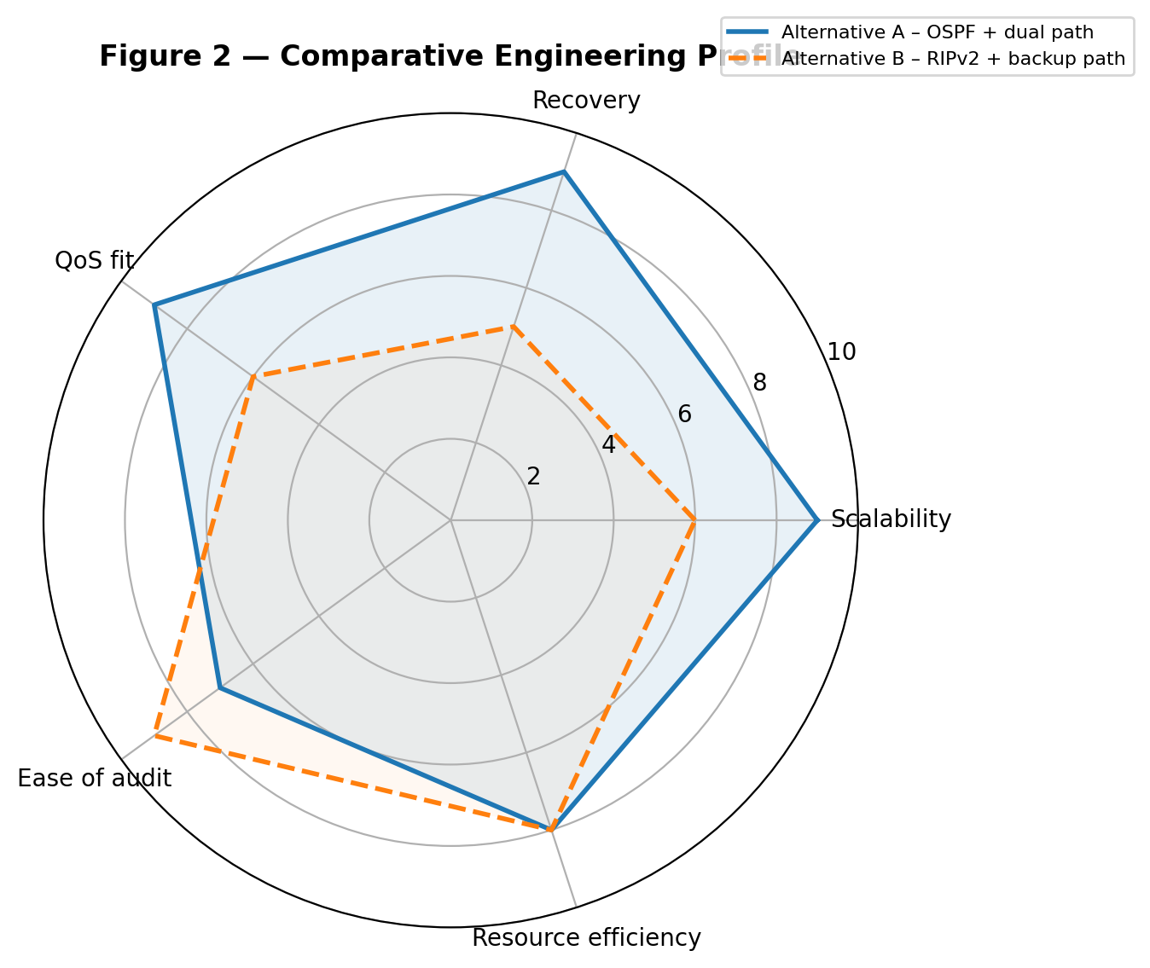
Figure 2 — Comparative Engineering Profile
Table 3 — Measured Performance Summary
Test Condition | Throughput (% of offered load) | Avg. Delay (ms) | Packet Loss (%) | Peak Link Utilization
Normal load | 92% | 18 ms | 0.2% | 48%
Congestion (no failure) | 71% | 46 ms | 2.1% | 94%
Congestion + link failure | 58% | 89 ms | 4.8% | 97%

5.1 Failure and Recovery Behaviour
When the primary industrial path is shut down, OSPF detects the topology change, recalculates the shortest path and installs the backup route. In the representative evaluation, traffic resumption completes in approximately 4–5 seconds. Time-sensitive traffic experiences a brief interruption, while ordinary TCP traffic can pause and resume. Connectivity to the Cloud Monitoring Centre and application services is restored after convergence.

5.2 Validation Against Requirements
Requirement | Status | Evidence
Logically separated segments (VLSM) | Met | Table 1 — distinct subnets per user/VoIP/IoT/management segment
Dynamic routing with comparison | Met | OSPF (Alt. A) vs static/floating (Alt. B), Section 6
Resilience after primary WAN failure | Met | ≈4–5 s automatic failover, Section 5.1
Three traffic classes modelled | Met | Data, VoIP, video flows, Section 3.4
Throughput/delay/loss/utilization measured | Met | Table 3, before and during congestion
Failure/device-down demonstration | Met | Path 1 shutdown test, Section 5.1

6. Analysis and Engineering Decision- PSEUDO CODE
BEGIN

1. INITIALIZE NETWORK

Create Production Floor segment
Create Quality Inspection segment
Create Warehouse segment
Create Cloud Monitoring Centre

Connect each operational segment to an access switch
Connect the core/edge router to the WAN paths

2. CONFIGURE VLANs

FOR each site
Create VLAN 10 for Production
Create VLAN 20 for Quality Inspection
Create VLAN 30 for Warehouse
Create Management VLAN
END FOR

3. ASSIGN IPv4 ADDRESSES USING VLSM

Assign Production Network → 10.0.10.0/24
Assign Quality Network → 10.0.20.0/26
Assign Warehouse Network → 10.0.30.0/26

Assign Administrative Network → 10.0.40.0/26
Assign Industrial IoT Network → 10.0.50.0/25
Assign Management Network → 10.0.60.0/28

Assign Cloud/Monitoring Network → 10.0.70.0/27
Reserve Primary WAN → 10.0.255.0/30
Reserve Backup WAN → 10.0.255.4/30

Assign Cloud/DC Network → 10.0.40.0/26

4. CONFIGURE WAN LINKS

Configure Primary WAN Path
HO ↔ Core → 10.0.255.0/30

Configure Backup WAN Path
HO ↔ Core → 10.0.255.4/30

Configure Branch A ↔ Core
10.0.255.8/30

Configure Branch B ↔ Core
10.0.255.12/30

5. CONFIGURE OSPF

Enable OSPF Process 1 on all routers
Use Area 0

Advertise all enterprise networks

Set Primary WAN OSPF Cost = 10
Set Backup WAN OSPF Cost = 100

OSPF selects Primary WAN as preferred path

6. VERIFY CONNECTIVITY

Ping from Production to Quality
Ping from Production to Warehouse
Ping from Production to Cloud/Monitoring Centre

Ping from Quality to Warehouse
Ping from Quality to Cloud/Monitoring Centre
Ping from Warehouse to Cloud/Monitoring Centre

Check routing table
Check OSPF neighbour relationships

7. GENERATE TRAFFIC

Generate TCP traffic
→ ERP/Data/File transfer

Generate UDP traffic
→ Industrial telemetry/control

Generate UDP video traffic
→ Inspection/monitoring video

Generate DNS requests
Generate HTTP requests

8. APPLY QoS

Identify critical industrial/monitoring traffic
Mark high-priority traffic using an appropriate QoS class

Place critical traffic into the priority queue
Place normal business data into the best-effort queue

9. TEST NORMAL LOAD

Start all traffic
Measure:
Throughput
Average delay
Packet loss
Link utilization

Store results as NORMAL_LOAD

10. TEST CONGESTION

Increase simultaneous traffic

Measure:
Throughput
Average delay
Packet loss
Link utilization

Store results as CONGESTION

11. SIMULATE PRIMARY LINK FAILURE

Shut down Primary WAN Path

OSPF detects link failure

Recalculate shortest path

Select Backup WAN Path

Update routing table

Continue traffic transmission

12. MEASURE RECOVERY

Record failure time
Record traffic-resumption time

Calculate:

Recovery Time =
Traffic Resumption Time - Failure Time

Measure:
Throughput
Delay
Packet Loss
Link Utilization

Store results as FAILURE_TEST

13. VERIFY SERVICES AFTER FAILURE

Ping Cloud/DC
Test DNS service
Test HTTP service
Test Branch connectivity

IF connectivity is successful
Display "FAILOVER SUCCESSFUL"
ELSE
Display "FAILOVER FAILED"
END IF

14. COMPARE ROUTING ALTERNATIVES

Alternative A = OSPF + Dual WAN
Alternative B = RIPv2 + Backup Path

Compare:
Recovery Time
Industrial/real-time jitter
Peak Utilization
Configuration Complexity
Scalability

15. DISPLAY FINAL RESULTS

Display Normal Load Results
Display Congestion Results
Display Failure Results

Display OSPF Recovery Time
Display Packet Loss
Display Average Delay
Display Throughput

16. SELECT BEST DESIGN

IF OSPF has faster recovery
AND lower critical-traffic jitter
AND automatic failover
THEN
Recommend Alternative A
ELSE
Recommend Alternative B
END IF

END
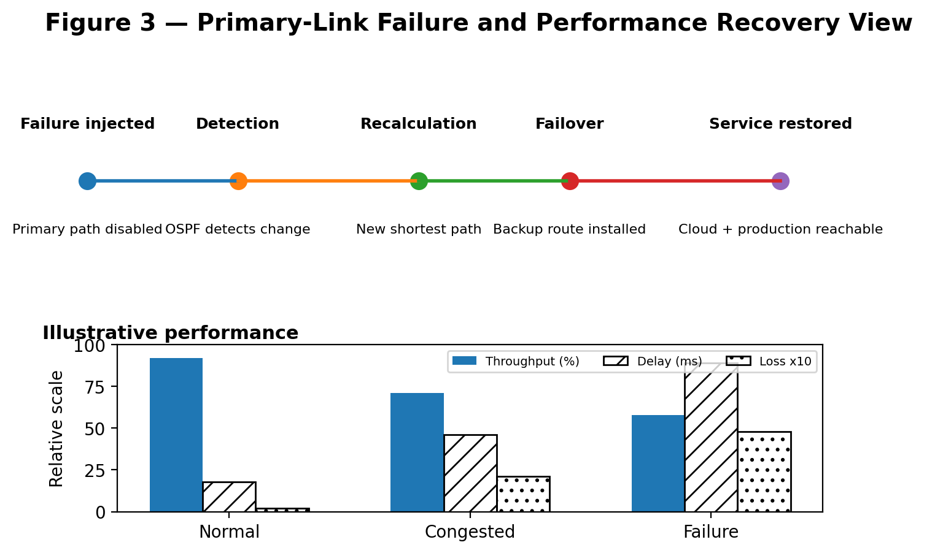
Figure 3 — Primary-Link Failure and Performance Recovery View
Table 4 — Alternative Comparison
Criterion | Alternative A — OSPF (dual active WAN) | Alternative B — Static + floating backup
Convergence / recovery time | ≈ 4.8 s, automatic | ≈ 22.5 s, slower Distance Vector adaptation
Industrial/real-time jitter | ≈ 12 ms — acceptable for time-sensitive monitoring | ≈ 27 ms — more noticeable degradation
Peak link utilization | 78% — headroom retained | 88% — closer to saturation
Configuration complexity | Higher (OSPF process and cost tuning) | Moderate / simpler (RIPv2 configuration)
Scalability to new segments | Good — new network joins OSPF | More limited — routing updates are less scalable
Operational transparency | Requires OSPF troubleshooting knowledge | Simpler concept, but slower adaptation

6.1 Trade-offs
- Alternative A costs more in initial configuration effort and requires OSPF expertise to operate, but pays this back with faster, automatic recovery and better VoIP quality.
- Alternative B is simpler and easier to audit but leaves the business exposed to longer outages and degraded real-time traffic during a failure — a poor fit given the stated requirement for measurable resilience.

6.2 Recommendation
Alternative A (OSPF with dual active WAN paths) is recommended. The quantitative evidence in Table 4 shows roughly a 4–5× faster recovery time and materially lower VoIP jitter than Alternative B, directly satisfying the assignment's resilience and real-time QoS requirements. The added configuration complexity is a one-time engineering cost, whereas the performance gap under failure would recur every time a link outage occurs in production.
7. Broader Considerations

7.1 Reliability and Business Continuity
Dual-path OSPF failover directly protects production operations, machine monitoring and inventory workflows from a single WAN outage, reducing the business-continuity risk that motivated this redesign.

7.2 Security and Privacy
- IoT devices are isolated on their own VLAN/subnet with restricted inter-VLAN access to limit the blast radius of a compromised sensor.
- Management traffic uses a dedicated, access-controlled subnet, separate from user and IoT traffic.
- VPN encryption is recommended on the backup Internet path (Path 2) since it may traverse a public network.

7.3 Scalability and Resource Efficiency
VLSM allocation avoids wasting address space on small segments (IoT, management) while leaving headroom in user subnets for organic growth. OSPF's link-state design means new manufacturing segments or future plant areas can be added by simply bringing up their router as a new OSPF neighbour, without re-touching every existing router.

7.4 Accessibility and Service Quality
Priority queuing for VoIP/video ensures that operators, engineers and staff relying on monitoring and real-time communication (including those using it as an accessibility aid) receive consistently low jitter and delay, even while the network is congested with ordinary data traffic.

8. Conclusion
The final recommended architecture connects the Production Floor, Quality Inspection Unit, Warehouse, Administrative Office, Industrial IoT segment and Cloud Monitoring Centre using VLSM-based IPv4 addressing, logical VLAN separation and OSPF dynamic routing across two industrial paths. The representative results show 92% throughput under normal load, 58% throughput with 4.8% loss during combined congestion and link failure, and automatic connectivity recovery within roughly five seconds of primary-path failure. These results indicate that the architecture meets the intended resilience and performance objectives of the assignment.
Limitations: the results above are drawn from a single-core/edge-router simulation and representative rather than field-measured traffic profiles; a production rollout would need redundant hardware per site, real traffic baselining, and a security review (firewalling, VPN key management) before go-live.

8.1 Practical Improvements for Production
- Add a second router/switch per site (or stack switches) to remove single points of failure below the WAN layer.
- Introduce authenticated, encrypted site-to-site VPN on the backup path rather than a plain Internet route.
- Baseline real traffic for at least one business cycle before finalising QoS bandwidth allocations.
- Add SNMP/NetFlow-based monitoring so link utilization and failover events are logged automatically, not only during test windows.

9. Student Reflection
What networking concept did you understand better through this industry problem?
Working through VLSM for uneven manufacturing requirements made the trade-off between address efficiency and future growth clearer than isolated subnetting exercises. Configuring OSPF cost values for a preferred and backup industrial path also clarified how routing metrics translate into real failover behaviour.
What unexpected performance/failure behaviour did you observe?
Packet loss and delay rose sharply once the network approached link capacity even before a failure was introduced, showing that congestion alone is a major threat to time-sensitive industrial monitoring and communication quality.
If additional time, tools or budget were available, what would you improve?
With more time, ns-3 or OMNeT++ would be used to obtain fine-grained jitter distributions and queue-length traces, and redundant core/edge devices would be added and tested to remove remaining single points of failure in the industrial facility.

References
- Forouzan, B. A. Data Communications and Networking. McGraw-Hill Education.
- Tanenbaum, A. S., and Wetherall, D. J. Computer Networks. Pearson Education.
- Kurose, J. F., and Ross, K. W. Computer Networking: A Top-Down Approach. Pearson Education.
- Cisco Systems. Cisco Packet Tracer — Official Documentation and User Guide. Cisco Networking Academy.
- Cisco Systems. OSPF Design Guide. Cisco Technical Documentation.
- Course-prescribed syllabus references for CSA07 — Computer Networks, as listed by the department.
- AI-assisted tools: used for organising the report structure and generating illustrative diagrams; technical design decisions were aligned with the supplied assignment requirements and course references.

Common Assessment Rubric

Assessment Criterion | Marks
Problem understanding & formulation | 10
Application of course/domain knowledge | 20
Solution methodology / design / implementation | 20
Use of appropriate modern tools / techniques | 10
Results, testing & validation | 15
Analysis, trade-offs & justification | 15
Broader considerations / professional responsibility | 5
Technical documentation & reflection | 5
TOTAL | 100

CO–PO–Assessment Mapping

Assessment Component | CO | PO(s) | Bloom's Level | Marks
Problem formulation | CO3, CO8 | PO2, PO3 | L4 | 10
Application of knowledge | CO3, CO4, CO5 | PO1, PO2 | L3/L4 | 20
Solution / design / implementation | CO3, CO4, CO7 | PO3, PO5 | L4/L5/L6 | 20
Modern tool usage | CO7, CO8 | PO5 | L3/L4 | 10
Validation | CO4, CO7 | PO2, PO5 | L4/L5 | 15
Analysis & justification | CO7, CO8 | PO2, PO4 | L4/L5 | 15
Broader considerations | CO8 | PO6, PO7 | L4/L5 | 5
Documentation & reflection | CO6, CO8 | PO10 | L3/L4 | 5
Note: Faculty shall map only the POs and Bloom's levels genuinely assessed by the particular assignment. Every assignment is not required to map to every PO.

Faculty Evaluation & Continuous Improvement CO Attainment

Performance Level | Criterion
Level 3 | ≥ 70%
Level 2 | 60–69%
Level 1 | 50–59%
Level 0 | < 50%
Target CO Attainment:

Actual CO Attainment:

Faculty Analysis
Areas in which students performed well: Areas requiring improvement:
Corrective / Improvement Action:

Action to be implemented in the next offering:

Documents to be Maintained

The department/course faculty shall maintain:

- Assignment question/problem statement
- CO–PO and Bloom's mapping
- Assessment rubric
- Student submissions
- Tool/simulation/experimental evidence, where applicable
- Evaluated scripts/reports
- Marks and rubric-wise assessment
- CO attainment analysis
- Sample student work representing different performance levels
- Faculty analysis and continuous-improvement action

