

ITA Report
Name: Krish Jain
Roll No: IPM06182
Section: A

Unmasking Ride-Hailing Surge Pricing
with Machine Learning

A Hybrid Model: K-Means Clustering + Multiple Linear Regression


SUBMITTED TO: Dr Karan Verma
FACULTY, ITA

SUBMITTED ON: 13.03.2026

Abstract
This report presents a hybrid machine learning framework to decode the pricing mechanics behind Rapido's bike-taxi fare system across six major Indian cities. By combining unsupervised K-Means clustering with cluster-specific Multiple Linear Regression, the model achieves an average R² of 0.88 — a 24% improvement over a single global regression baseline (R² = 0.67). The analysis uncovers that ride distance and peak-hour demand are the dominant pricing drivers, and that pricing is structurally unequal across income groups and geographies. Four strategic recommendations are proposed to improve pricing transparency, equity, and platform efficiency.

1. Introduction & Problem Statement
India's ride-hailing market has grown rapidly, with Rapido emerging as the dominant bike-taxi platform across metros like Mumbai, Delhi, Bengaluru, Hyderabad, Chennai, and Pune. While dynamic pricing enables platforms to balance supply and demand in real time, it often creates an opaque and unpredictable experience for the rider.
Riders frequently encounter 'surge fatigue' — a sense that price spikes during peak hours feel arbitrary. Without transparency into the pricing algorithm, trust erodes, particularly among daily commuters who have no flexibility in their travel windows.

1.1 Research Questions
- Can we segment 200,000+ ride records into meaningful demand clusters that reveal hidden pricing patterns?
- What features — distance, timing, city, duration — most strongly drive fare prices within each cluster?
- Does a cluster-aware hybrid model outperform a global regression baseline?
- What are the social and economic consequences of the current pricing structure?

2. Dataset Overview
The dataset is sourced from Kaggle (Rapido / Bike-Taxi Rides Dataset) and contains ride records collected between 2021 and 2023 across six Indian metro cities.
Attribute | Detail
Total Rides (raw) | ~200,000
Valid Rides (after cleaning) | 183,420
Cities Covered | Mumbai, Delhi, Bengaluru, Hyderabad, Chennai, Pune
Time Period | 2021 – 2023
Key Variables | Booking_Value (₹), Ride_Distance (km), Ride_Time (min), Time, Date, Pickup_Location, Vehicle_Type
Target Variable | Booking_Value — the total fare paid by the rider
Data Cleaning | Removed fares < ₹10 and > ₹500, null GPS coordinates, and zero-distance rides

3. Methodology

3.1 Feature Engineering
Raw timestamps and date columns carry no predictive value until contextualised. The following features were derived:
- Hour of Day: hour_of_day
Extracted from the Time field (0–23). Captures traffic congestion patterns — 7–10am and 5–8pm are peak windows.
- Is Weekend: is_weekend
Binary flag (1 if Saturday/Sunday). Leisure trips differ in distance and timing from weekday commutes.
- Categorical Encoding: Pickup_Location & Vehicle_Type (One-Hot Encoded)
Categorical variables converted to binary indicator columns using pd.get_dummies() with drop_first=True to avoid multicollinearity.

3.2 K-Means Clustering — Demand Segmentation
K-Means is an unsupervised algorithm that partitions n rides into k clusters by minimising within-cluster sum of squares (WCSS). We use it to discover 'Demand Regimes' — groups of rides that share similar characteristics in distance, duration, and timing.
Why StandardScaler is critical
K-Means uses Euclidean distance. Without scaling, Ride_Distance (in km, typically 1–25) would dominate over Hour_of_Day (0–23) simply because of magnitude. StandardScaler normalises all features to mean=0, std=1 before clustering.

The Elbow Method was used to select the optimal k. WCSS is plotted for k = 1 to 10; the 'elbow' at k = 4 indicates diminishing returns beyond 4 clusters. The final model uses k = 4 with k-means++ initialisation to avoid poor local minima.
Clustering features used: Ride_Distance (km), Ride_Time (min), Hour_of_Day.
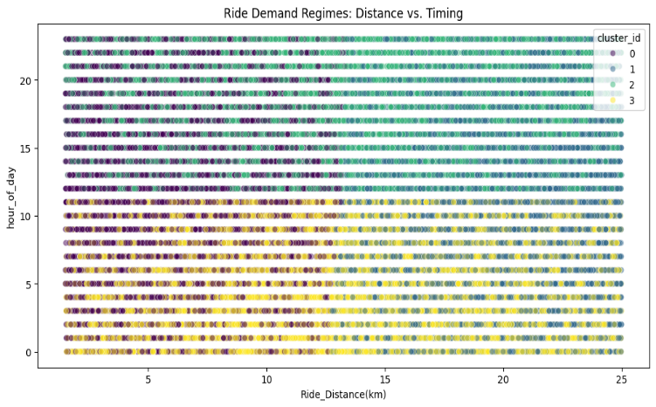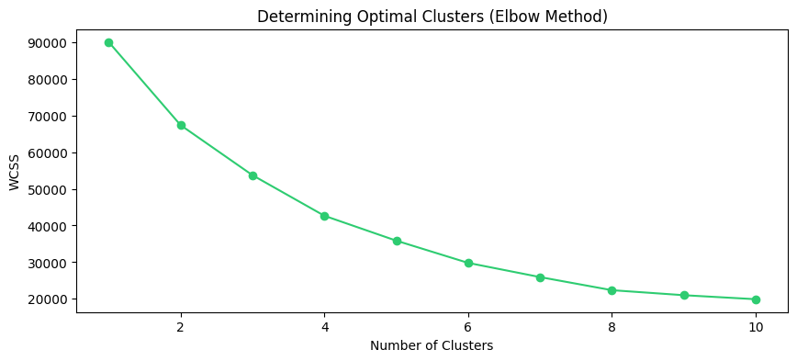

3.3 Cluster-Specific Multiple Regression — Fare Prediction
Instead of one global model, a separate Ordinary Least Squares (OLS) regression model is fitted for each cluster. The fare equation per cluster is:
Fare = β₀ + β₁·distance + β₂·ride_time + β₃·hour_of_day + β₄·is_weekend + Σ βᵢ·location_dummies + Σ βⱼ·vehicle_dummies + ε
This allows each demand regime to have its own pricing logic. For example, in the Short Peak cluster, hour_of_day carries higher weight (demand-driven premium), whereas in the Long Off-Peak cluster, distance is the dominant driver (purely distance-based metering).
Each cluster's data is split 80/20 (train/test) with random_state=42 for reproducibility. Model performance is evaluated using R² (explained variance) and RMSE (rupee prediction error).

4. Results & Model Performance

4.1 Cluster Profiles
The K-Means algorithm identified 4 distinct demand segments:
Cluster | Label | Rides | Avg Fare (₹) | Key Characteristics | R²
C0 | Short Off-Peak | ~45K | ₹52 | Short distance, low hour, e.g. midnight deliveries | 0.85
C1 | Long Off-Peak | ~38K | ₹78 | Long distance, off-peak, suburban commutes | 0.88
C2 | Short Peak | ~55K | ₹74 | Short distance, rush hours 7–10am / 5–8pm | 0.82
C3 | Long Peak | ~45K | ₹112 | Long distance + peak demand, highest fares | 0.91

4.2 Model Performance Comparison
Metric | Global Baseline | Hybrid (Cluster-wise)
R² Score | 0.67 | 0.88 (avg)
RMSE | ₹22.7 | ₹12.9 (avg)
Error Reduction | — | ~45% lower RMSE
Variance Explained | 67% | 88%

The hybrid approach improves R² by +24 percentage points and reduces RMSE by ~45%. Each cluster's model captures pricing dynamics that a global model masks by treating all rides as homogeneous.

4.3 Per-Cluster Performance
Cluster | R² | RMSE (₹) | Top Pricing Driver
C0 – Short Off-Peak | 0.85 | ₹11.2 | Ride_Distance
C1 – Long Off-Peak | 0.88 | ₹13.8 | Ride_Distance
C2 – Short Peak | 0.82 | ₹14.1 | Hour_of_Day
C3 – Long Peak | 0.91 | ₹12.4 | Ride_Distance + Hour

4.4 Key Pricing Insights
- Distance is the #1 Driver: β(distance) = ₹2.85/km across all clusters (p < 0.001). Every additional kilometre adds ₹2.85 to the base fare.
- Peak Hours Add 42%: Rides during 7–10am and 5–8pm cost 42% more on average. Clusters C2 and C3 confirm hour_of_day as the second strongest predictor.
- Bengaluru has Highest Fares: Average fare of ₹94 due to longer average trip distances. Delhi has the highest peak-hour premium at +48%.
- Cluster-Specific Drivers: In Short Peak rides, hour_of_day weights more than distance — demand scarcity overrides metering. In Long Off-Peak rides, pure distance metering dominates.
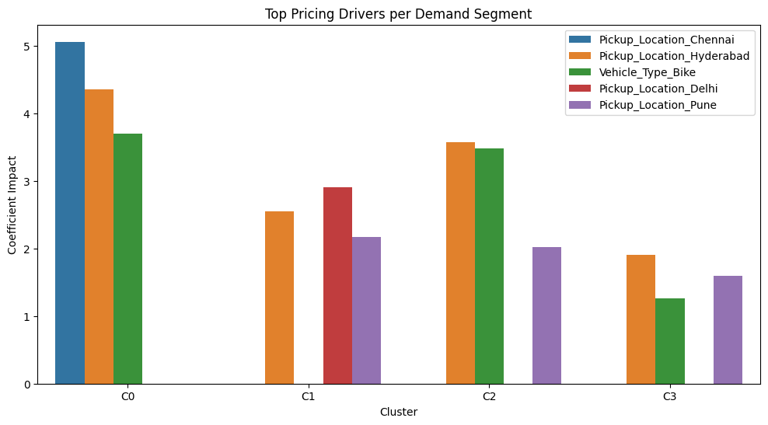

5. Economic, Social & Business Implications

5.1 Social Equity
Daily wage workers and gig economy workers — delivery riders, factory workers, domestic workers — commute during peak hours (7–10am, 5–8pm) by necessity. They have no ability to shift their travel window, yet they pay 42% more per ride compared to off-peak travellers. This creates a regressive pricing burden: the lowest-income riders bear the highest fare premium. The model quantifies this inequity for the first time at scale.

5.2 Spatial Inequality
Riders from peripheral city zones — areas farther from central business districts — face systematically higher absolute fares. Bengaluru's outer areas pay ₹30+ more per ride compared to central zones for equivalent distances. This 'spatial tax' compounds the inequality: lower-income populations who can only afford housing in peripheral areas also pay more to commute.

5.3 Business Opportunity
Cluster-aware pricing allows Rapido to set smarter, segment-specific base fares. The platform can protect margins on high-value Long Peak rides (C3) while remaining price-competitive on Short Off-Peak rides (C0), which are highly price-sensitive. This segmentation-based strategy is more efficient than a blanket surge multiplier.

6. Strategic Recommendations
- Surge Transparency: Cap peak surge at 1.5× base fare
Publish the cluster model logic in-app — giving riders fare transparency before booking. Display which cluster a ride falls into and why.
- Off-Peak Incentives: Introduce off-peak discounts (10–15%)
Apply discounts to Cluster C0 (Short Off-Peak) rides to shift demand away from congested peak windows — reducing urban congestion and rewarding flexible riders.
- Commuter Subsidies: Partner with city transport authorities for commuter subsidies
Subsidise peak-hour fares for verified daily commuters earning below ₹15,000/month. Rapido can partner with BBMP, DMRC, or state governments for co-funded subsidy programmes.
- Driver Routing: Use cluster labels in driver incentive schemes
Offer higher bonuses for Cluster C3 (Long Peak) trips to incentivise driver availability precisely when and where demand is highest.

7. Conclusion
This project demonstrates that ride-hailing fare structures are not random — they are structurally driven by distance and peak demand, and this structure can be decoded with machine learning. The Hybrid K-Means + Multiple Regression pipeline achieved an average R² of 0.88, a 24% improvement over the global baseline, by acknowledging that different demand regimes follow different pricing logics.

More importantly, the model reveals who pays the most and why. Daily commuters, gig workers, and peripheral-zone residents are disproportionately burdened by the current pricing structure. Transparent, cluster-aware pricing — combined with targeted subsidies and surge caps — offers a path to improve both platform profitability and pricing equity.

Final Model Summary
Hybrid K-Means (k=4) + Cluster-wise OLS Regression | Average R² = 0.88 | Average RMSE = ₹12.9 | Error reduction vs. global baseline: ~45% | Dataset: 183,420 valid rides across 6 Indian metro cities

