Synopsis
On
Seller Health & Intervention Platform

Group ID: BCAIAA61
Team Details
Enrolment No. | Name of Student | Class
ADT23SOCB0530 | KRISH JAIKISHAN JIYANI | LY AIA8
ADT23SOCB0341 | DEVANSHU VINOD KANNAKE | LY CORE 4
ADT23SOCB1207 | TANISHKA KISHOR UTTARKAR | LY AIA 2
ADT23SOCB0690 | PANTH HASMUKHBHAI DHORIYANI | LY AIA 7
Under the Guidance of
Prof. Sneha Singha
Department of Computer Science & Engineering
MIT School of Computing
Sem- 6 | A. Y. 2026-27

1. Title of the Project
Seller Health and Intervention Platform: An Explainable Seller Risk Analytics System for Ecommerce Marketplaces
2. Abstract
Multi seller ecommerce marketplaces depend on thousands of third-party sellers, and platform revenue is directly tied to their performance. Account management teams monitor seller signals such as dispatch performance, customer reviews, order volume, and payment activity in separate systems, and problems are usually noticed only after complaints or revenue loss have already occurred. Intervention is therefore reactive, and prioritization across a large seller base is manual and inconsistent.
The proposed system builds an explainable Seller Health Index on the public Olist Brazilian ecommerce dataset, which contains more than 100,000 real orders across 11 relational tables, including a companion marketing funnel dataset covering seller acquisition. An ETL layer integrates the tables into a seller month feature panel. Pillar level indicators are engineered for dispatch timeliness, customer experience, commercial momentum, and reliability, with review text mined through Natural Language Processing for complaint aspects. A gradient boosted model trained on rolling 90-day windows produces calibrated risk scores, and SHAP attribution explains the drivers behind every individual score. Scores are validated by walk forward back testing against realized outcomes, stratified into health tiers, and served through a Key Account Manager console with alerts, a ranked intervention queue, and order level drill down.
The system is expected to detect seller deterioration well before it appears in revenue, attribute delivery failures fairly between sellers and carriers, and convert scattered operational data into a prioritized, auditable action list for marketplace account teams.
3. Introduction / Background
In the marketplace business model, the platform owns the customer relationship while independent sellers’ own inventory and fulfilment. The health of the seller base is therefore a core business asset: when sellers ship late, receive poor reviews, or silently stop selling, the platform loses revenue, customer trust, and acquisition investment. Industry platforms such as Amazon Seller Central maintain internal account health systems for exactly this reason, but their scoring logic is proprietary and opaque.
In practice, the signals needed to judge seller health already exist inside marketplace databases. Order timestamps record how quickly a seller hands a parcel to the carrier. Reviews record what customers actually experienced. Order and payment tables record commercial momentum. The difficulty is that these signals live in separate tables, are examined separately, and are lagging by nature, so account teams learn about a failing seller only after the failure is complete.
Advances in machine learning and explainable AI make a different approach practical. Gradient boosted models can learn the patterns that precede seller decline from historical data, SHAP attribution can expose the reasoning behind every individual prediction, and modern analytical tooling allows the full pipeline to run on a standard laptop. The public Olist dataset, released on Kaggle by a real Brazilian marketplace, makes such a system reproducible and verifiable without access to proprietary company data. The proposed project combines these elements into a single, explainable seller risk analytics platform.
4. Problem Definition
Seller performance data in a marketplace is fragmented across delivery, review, order, and payment systems. Each signal is reviewed in isolation, and deterioration is detected only after complaints or revenue loss, by which point intervention is often too late. There is no unified, explainable indicator of which sellers are at risk, which factors are responsible, and which corrective action would matter most.
A further difficulty is attribution. A large share of late deliveries is caused by carrier transit rather than seller dispatch, yet the seller absorbs the negative review. Naive metrics therefore punish sellers for failures they did not cause. The problem is to construct a validated, explainable, seller level risk score that separates these causes, anticipates decline before it is visible in revenue, and translates the result into a prioritized intervention list for account managers.
5. Objectives
The main objectives of the proposed system are:
- To integrate 11 relational marketplace tables into a unified seller month feature panel through a reproducible ETL layer.
- To engineer pillar level indicators covering dispatch timeliness, customer experience, commercial momentum, and reliability.
- To separate seller caused dispatch delay from carrier transit delay using order timestamp decomposition.
- To mine review text for complaint aspects using Natural Language Processing.
- To train a gradient boosted model that predicts seller decline over a 90-day horizon.
- To validate the score through walk forward back testing against realized outcomes.
- To explain every score using SHAP attribution at the individual seller level.
- To deliver a Key Account Manager console with risk tiers, a ranked intervention queue, and order level drill down.
6. Scope of the Project
The project covers data engineering on the Olist ecommerce and marketing funnel datasets, construction of the seller month feature panel, pillar metric engineering, review aspect mining, risk model training and calibration, walk forward validation, and an interactive dashboard serving both a staff view and a seller facing score view. The seller acquisition funnel is analysed descriptively to connect lead source and segment with later activation and health.
The project is limited to the public Olist dataset, which serves as a proxy for a live marketplace. Intervention impact estimates are correlational and are stated as such; causal inference, real time streaming, direct integration with a production marketplace, and automated seller onboarding are outside the present scope and are identified as future work.

7. Literature Survey
Sr. No. | Author / Source | Year | Technology / System | Key Contribution | Limitation
1 | Ke et al., NeurIPS | 2017 | LightGBM (Gradient Boosting) | Efficient gradient boosted trees for tabular prediction tasks. | Not specific to marketplace analytics.
2 | Lundberg and Lee, NeurIPS | 2017 | SHAP (Explainable AI) | Unified attribution framework that explains individual model predictions. | Computation grows with model and data size.
3 | Olist, Kaggle | 2018 | Brazilian Ecommerce Public Dataset | 100k real orders across 9 relational tables with timestamps and reviews. | No churn labels; data ends in 2018.
4 | Olist, Kaggle | 2018 | Marketing Funnel Dataset | 8k leads and 842 closed deals joinable to sellers via seller id. | Covers a sample of sellers only.
5 | DuckDB Documentation | - | Analytical SQL Engine | Fast columnar analytics enabling the full ETL layer on one machine. | Single node processing.
6 | Streamlit Documentation | - | Dashboarding Framework | Rapid development of interactive analytical dashboards in Python. | Limited fine grained UI control.
7 | Amazon Seller Central (Existing System) | - | Account Health Monitoring | Production seller performance scoring on a live marketplace. | Proprietary and opaque scoring logic.
8 | Proposed System | 2026 | ML + SHAP + Walk Forward Validation | Explainable leading indicator of seller decline with a ranked intervention queue. | Intervention estimates are correlational.

8. Block Diagram
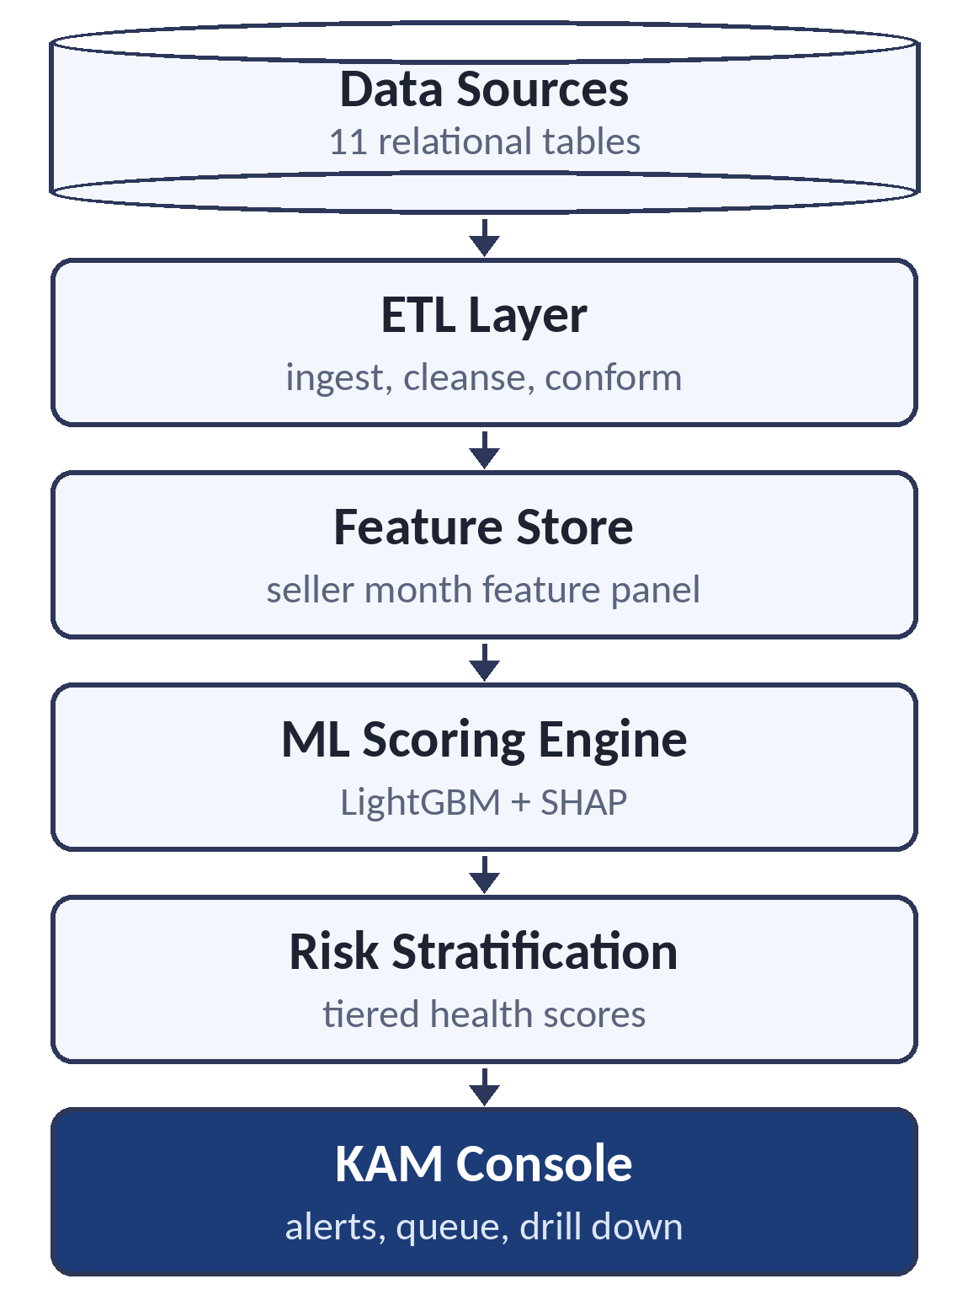
9. Proposed System
The proposed platform is an analytics pipeline and decision support application built entirely on real marketplace data. Raw tables covering orders, order items, payments, reviews, customers, products, sellers, geolocation, and the seller acquisition funnel are ingested into an ETL layer, where they are cleansed, joined, and validated with integrity checks at every stage. The result is materialized as a feature store at seller month grain, where each row describes one seller in one month using trailing 90-day windows.
Pillar indicators are computed on this panel. Dispatch timeliness measures whether the seller handed each parcel to the carrier by the contractual deadline, deliberately excluding carrier transit so sellers are not punished for courier failures. Customer experience combines review scores, statistically shrunk for low volume sellers, with complaint aspects mined from review text. Commercial momentum compares recent revenue and order velocity against the preceding period, and reliability tracks cancelled and unavailable orders as a stockout signal.
A gradient boosted classifier is trained to predict whether a seller will decline within the next 90 days, and its calibrated probability serves as the health score. SHAP attribution decomposes every individual score into pillar contributions, making each prediction auditable. Scores are validated through walk forward back testing, then stratified into healthy, watch, and at risk tiers. The Key Account Manager console presents tier movements, an intervention queue ranked by risk and revenue at stake, per seller driver breakdowns, and drill down from any number to the underlying orders and reviews that produced it.

System Modules
Module 1: Data Ingestion and ETL Layer
Ingests the 11 source tables, applies cleansing and integrity assertions, and materializes conformed staging tables.
Module 2: Feature Store
Builds the seller month panel with trailing window features and forward outcome labels, free of temporal leakage.
Module 3: Review NLP
Tags negative review text with complaint aspects such as delivery delay, product mismatch, and packaging.
Module 4: Risk Scoring Engine
Trains the gradient boosted model, calibrates probabilities, and computes SHAP attributions per seller.
Module 5: Validation Harness
Runs walk forward back tests across monthly origins and reports tier level lift against realized outcomes.
Module 6: Risk Stratification and Intervention Queue
Maps scores to health tiers and ranks sellers by risk and revenue at stake for account manager outreach.
Module 7: KAM Console
Streamlit dashboard with alerts, queue, driver breakdowns, seller facing score view, and order level drill down.
Advantages
- Detects seller deterioration before it appears in revenue
- Every score is auditable through SHAP driver attribution
- Fair attribution between seller dispatch and carrier transit
- Outreach prioritized by risk and revenue at stake
- Statistical shrinkage protects low volume sellers from noisy scores
- Fully reproducible on public data
10. System Requirements
Hardware Requirements
- Intel Core i5 Processor or above
- 8 GB RAM (16 GB recommended for model training)
- 256 GB Storage
- Internet Connection
Software Requirements
- Python
- DuckDB
- Pandas
- Scikit Learn
- LightGBM
- SHAP
- SpaCy
- Streamlit
- VS Code
- Git & GitHub
11. Methodology / Implementation Plan
Development Model
Agile Software Development Methodology
Implementation Phases
Phase 1: Requirement Analysis and Metric Specification
Phase 2: Data Profiling and Integrity Validation
Phase 3: ETL Layer and Feature Store Construction
Phase 4: Review NLP and Aspect Tagging
Phase 5: Risk Model Development and Calibration
Phase 6: Walk Forward Back testing and Evaluation
Phase 7: Dashboard Development
Phase 8: Testing, Documentation, and Deployment
Technologies Used
- Machine Learning (ML)
- Explainable AI (SHAP)
- Natural Language Processing (NLP)
- Data Engineering (ETL, Feature Store)
12. Expected Outcome
The system will deliver a validated leading indicator of seller decline together with a working decision support console. For every seller and month, the platform will produce a calibrated health score, a tier assignment, and an itemized driver breakdown, with each number traceable to the underlying orders and reviews.
The central deliverable is evidence backed claim of the form: sellers placed in the at risk tier declined at a measurably higher rate over the following 90 days than sellers in the healthy tier, established through walk forward back testing. Alongside the console, the project will document seller activation patterns from the acquisition funnel and quantify how much of customer perceived delivery lateness is attributable to carriers rather than sellers.
13. Applications / Use Cases
The proposed system can be used by:
- Marketplace Key Account Management teams
- Seller onboarding and activation teams
- Category and supply managers
- Ecommerce platform operations
- Logistics partner performance teams
- Seller analytics products and B2B SaaS tools
- Academic research on marketplace health
14. Future Scope
The system can be enhanced by introducing additional capabilities, such as:
- Causal estimation of intervention impact using difference in differences and propensity matching
- Capacity constrained optimization of the intervention queue against limited account manager hours
- Real time scoring on streaming order events
- A seller facing self-service portal with improvement guidance
- Generalization to other marketplaces and data schemas
- Automated alerting through messaging and CRM integrations
- Multilingual review aspect mining
15. References
1. Ke, G. et al. LightGBM: A Highly Efficient Gradient Boosting Decision Tree. NeurIPS, 2017.
2. Lundberg, S. and Lee, S. A Unified Approach to Interpreting Model Predictions. NeurIPS, 2017.
3. Olist. Brazilian Ecommerce Public Dataset. Kaggle. https://www.kaggle.com/datasets/olistbr/brazilian-ecommerce
4. Olist. Marketing Funnel Dataset. Kaggle. https://www.kaggle.com/datasets/olistbr/marketing-funnel-olist
5. DuckDB Documentation. https://duckdb.org/
6. Streamlit Documentation. https://streamlit.io/
7. SHAP Documentation. https://shap.readthedocs.io/

