**Populating student detail using Signal R**

**Purpose:**  To create an application that populate student data from database with auto refresh.

1. **SQL related actions**

Have designed a table ‘StudentDetail’ using SQL server for storing the data. Please find the folder ‘SQLScript’ for related script file

1. **Asp.Net related changes**

Have done the following changes in ‘StudentDetail’ Project.

1. Have used windows authentication and have added the following SqlDependency in Global.Asax file

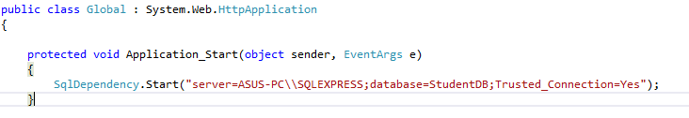

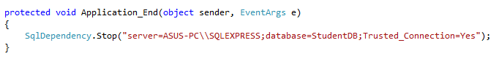

1. Installed the following packages using ‘Nuget’

Install-Package Microsoft.AspNet.SignalR –Pre

Install-Package Microsoft.AspNet.SignalR .SqlServer

Install-Package WebApiDoodle.SignalR (Face some script error while loading the signalr/hub and hence have added this package)

1. Added a new file ‘Startup.cs’ and have done owinstartup related configuration
2. Added a class file ‘StudentData’ to replicate the table structure
3. Added a SignalR Hub class ‘StudentHub’ and done the needed changes
4. Have done the html related changes in Dashboard.aspx to populate the data using SignalR
5. Run the application

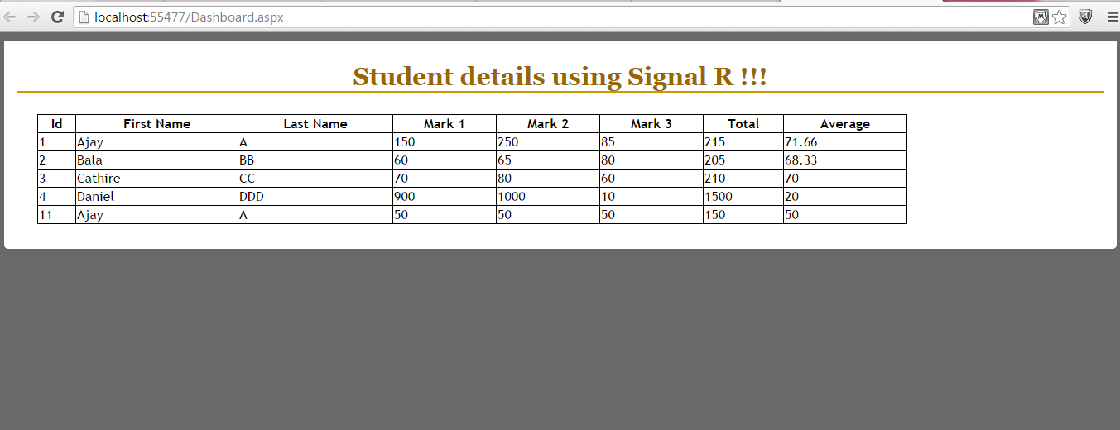

Viewing the dashboard page that populate the student details using SignalR !!!!

The data in the screen gets refreshed when there is some changes in backend.

**Note:**

Please change connection string in web config.