**Roll No : 28**

**Name : Krishna Kapadia**

**Subject : NodeJs**

**Assignment – 2**

**21/11/2020**

**// Directory Structure**

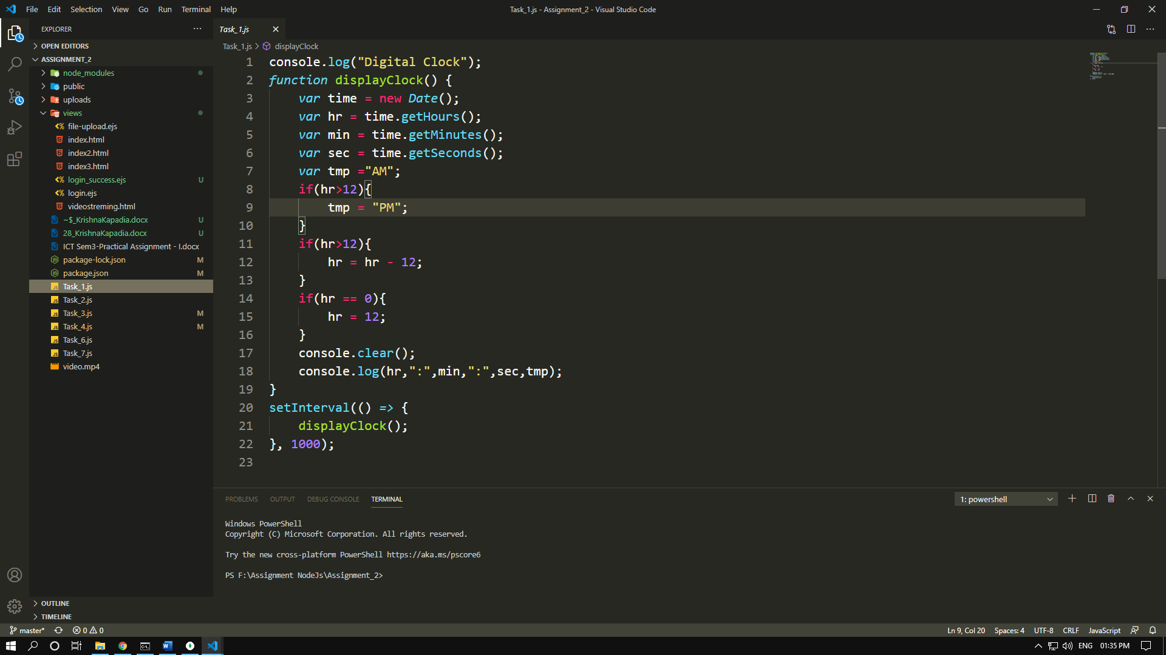

1. **Command line based digital clock with date and time.**

**Task_1.js**

console.log("Digital Clock");

function displayClock() {

var time = new Date();

var hr = time.getHours();

var min = time.getMinutes();

var sec = time.getSeconds();

var tmp ="AM";

if(hr>12){

tmp = "PM";

}

if(hr>12){

hr = hr - 12;

}

if(hr == 0){

hr = 12;

}

console.clear();

console.log(hr,":",min,":",sec,tmp);

}

setInterval(() => {

displayClock();

}, 1000);

// Output

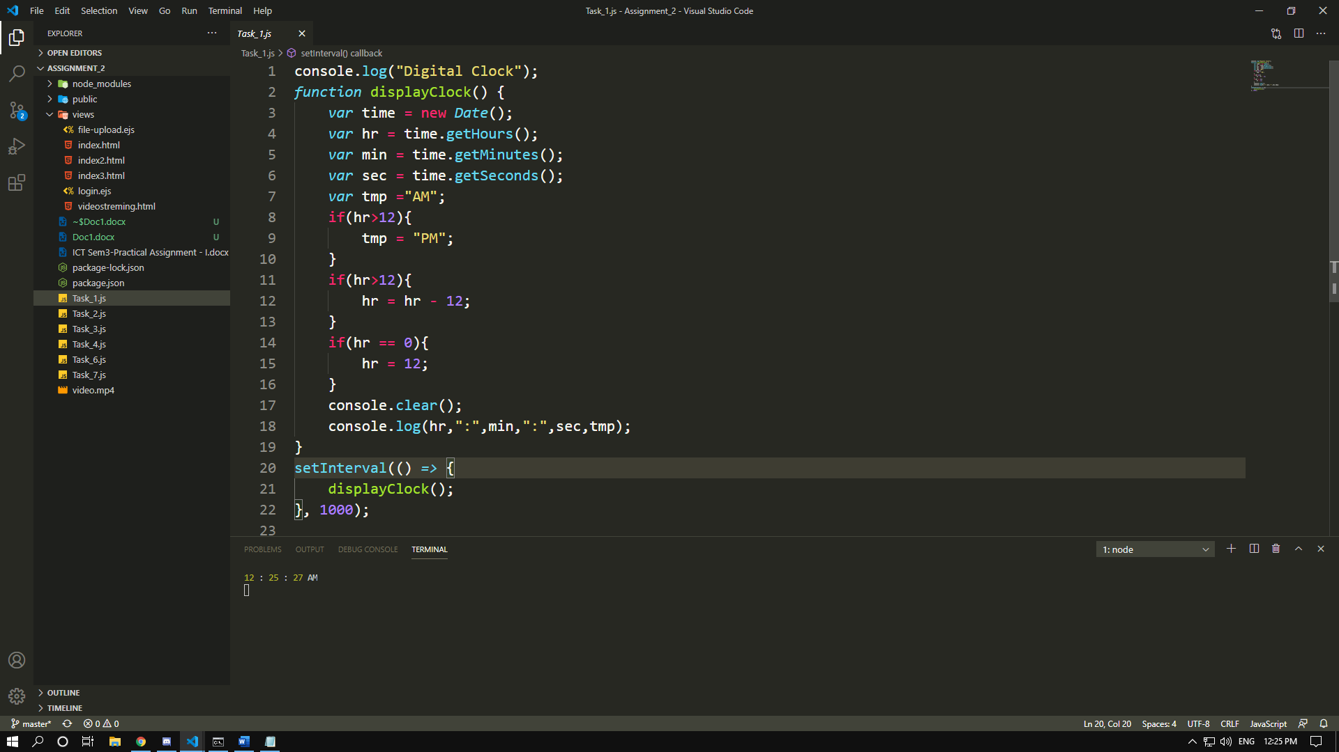

1. **Express File upload (single, multiple) with validations.**

**Task_2.js**

// Image Upload With Validation

const express = require('express');

const multer = require('multer');

var bodyParser = require('body-parser');

const path = require('path');

var upload = multer({ dest: 'uploads/' })

const app = express();

const port = 8080;

var router = express.Router();

router.use(express.static(__dirname+'/public'));

var Storage = multer.diskStorage({

destination: function (req, file, cb) {

if (file.mimetype !== 'image/jpeg') {

return cb('Invalid file format'); //cb(err)

}

cb(null, './public/uploads');

},

filename:(req,file,cb)=>{

cb(null,file.fieldname+"_"+Date.now()+path.extname(file.originalname));

}

});

var upload = multer({

storage:Storage

}).single('file');

app.set('view engine','ejs');

app.set('views', __dirname + '/views');

app.use(express.urlencoded({ extended: true }));

app.get("/",(req,res)=>{

res.render("file-upload");

});

app.post("/", upload,(req,res)=>{

console.log(req.file.filename);

res.render("file-upload");

})

app.listen(port,()=>{

console.log("Server is runningon port number:",port);

})

//Output

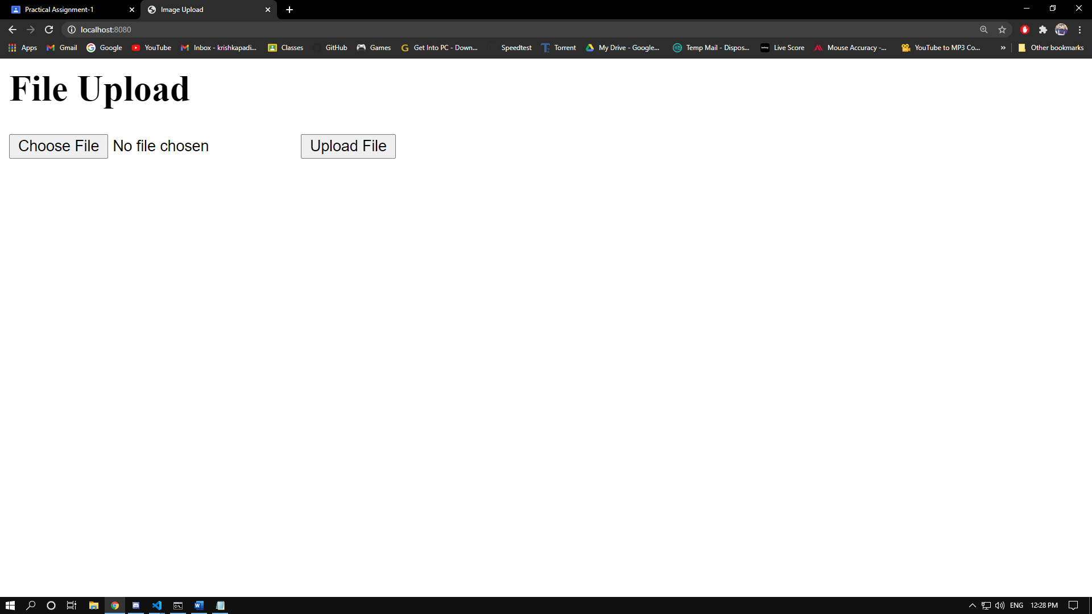

**3) Express Login application with file session store**

**Task_3.js**

// Session Login

const express = require('express');

var session = require('express-session');

var FileStore = require('session-file-store')(session);

const app = express();

const port = 8080;

app.set("view engine", "ejs");

app.use(express.urlencoded({ extended: true }));

app.get("/", (req, res) => {

res.render("login", { success: null, color: null });

});

app.use(session({

resave: true,

saveUninitialized: true,

secret: 'keyboard cat'

}));

app.post("/", (req, res) => {

var username = req.body.username;

var password = req.body.password;

if (username == "admin" && password == "admin") {

req.session.uname = username;

res.render("login", { success: "Login Successfull...", color: "Green" });

}

else {

res.render("login", { success: "Invalid Username or Password", color: "Red" });

}

});

app.listen(port);

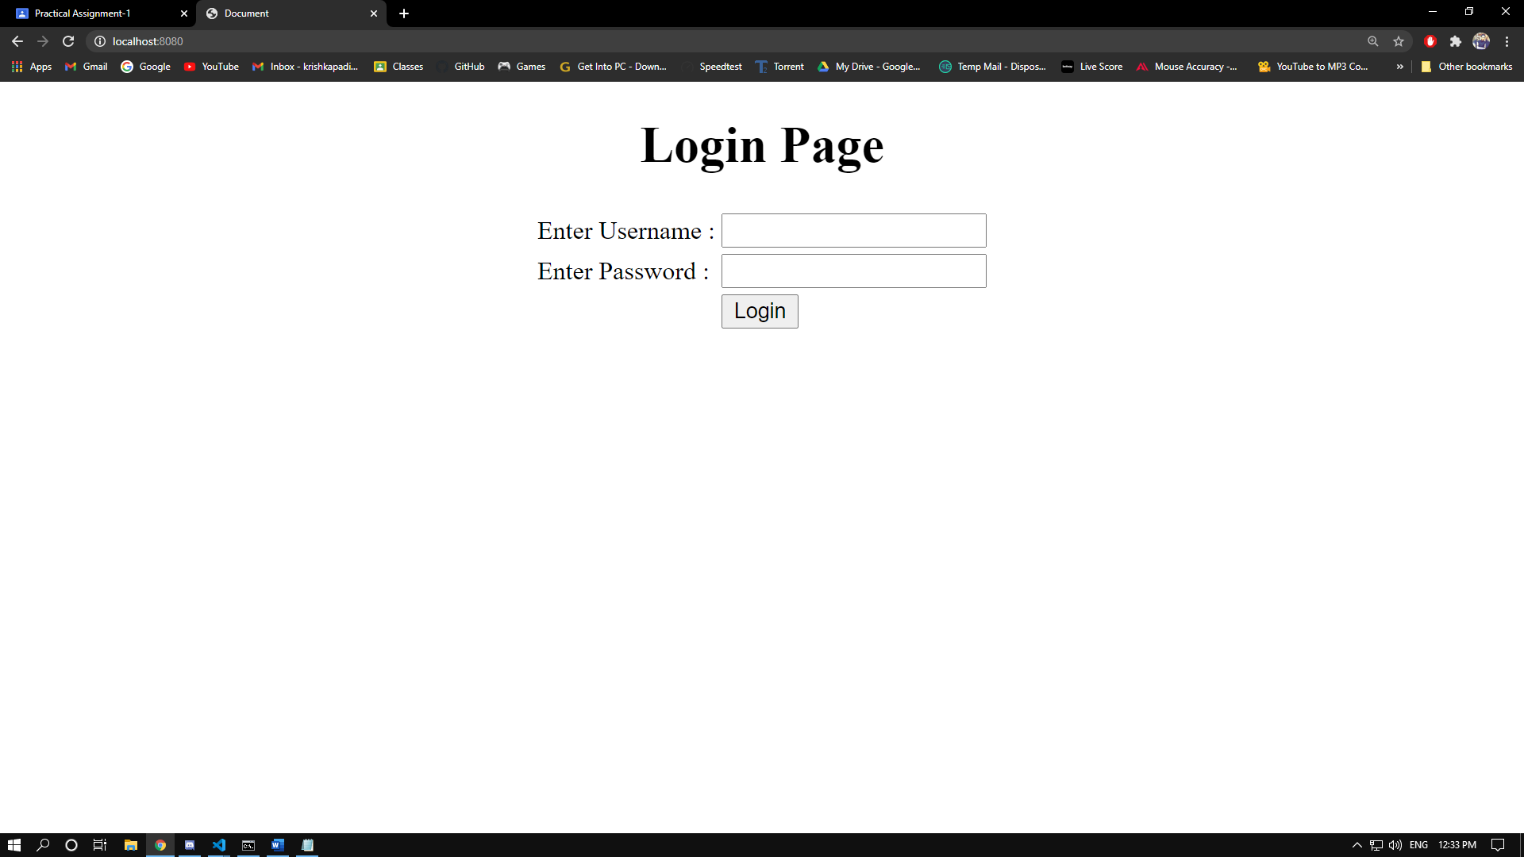

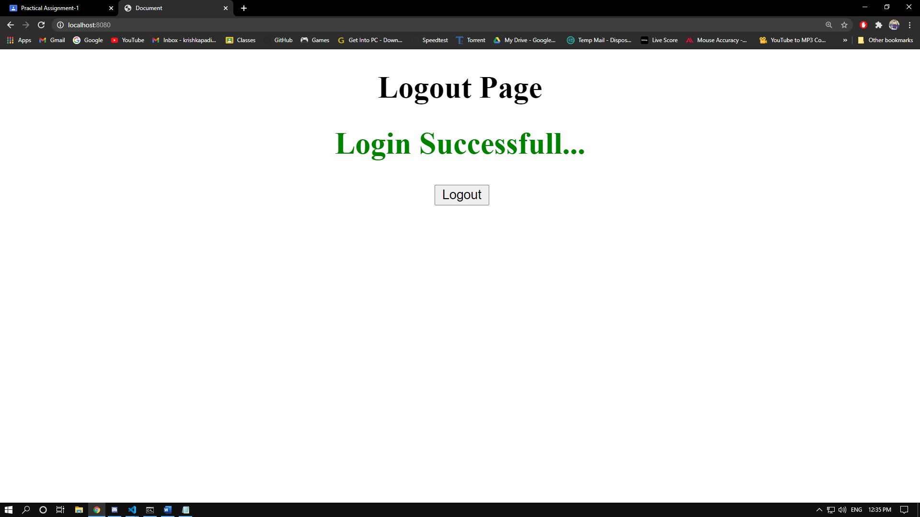

**4) Develop a Video streaming server using nodejs.**

**Task_4.js**

const express = require('express');

const app = express();

const fs = require('fs');

const port = 8080;

router.use(express.static(__dirname + '/public'));

app.get('/', (req, res) => {

res.sendFile(__dirname + "/views/videostreming.html");

});

app.get('/video', (req, res) => {

const range = req.headers.range;

if (!range) res.status(400).send("Requires Range Header");

const videoPath = "video.mp4";

const videoSize = fs.statSync("video.mp4").size;

const CHUNK_SIZE = 10 ** 6;

const start = Number(range.replace(/\D/g, ""));

const end = Math.min(start + CHUNK_SIZE, videoSize - 1);

const contentLength = end - start + 1

const headers = {

"Content-Range": `bytes ${start}-${end}/${videoSize}`,

"Accept-Ranges": "bytes",

"Content-Length": contentLength,

"Content-Type": "video/mp4",

};

res.writeHead(206, headers);

const videoStream = fs.createReadStream(videoPath, { start, end });

videoStream.pipe(res);

});

app.listen(port, () => {

console.log("Server is running on port number : ", port);

});

//Output

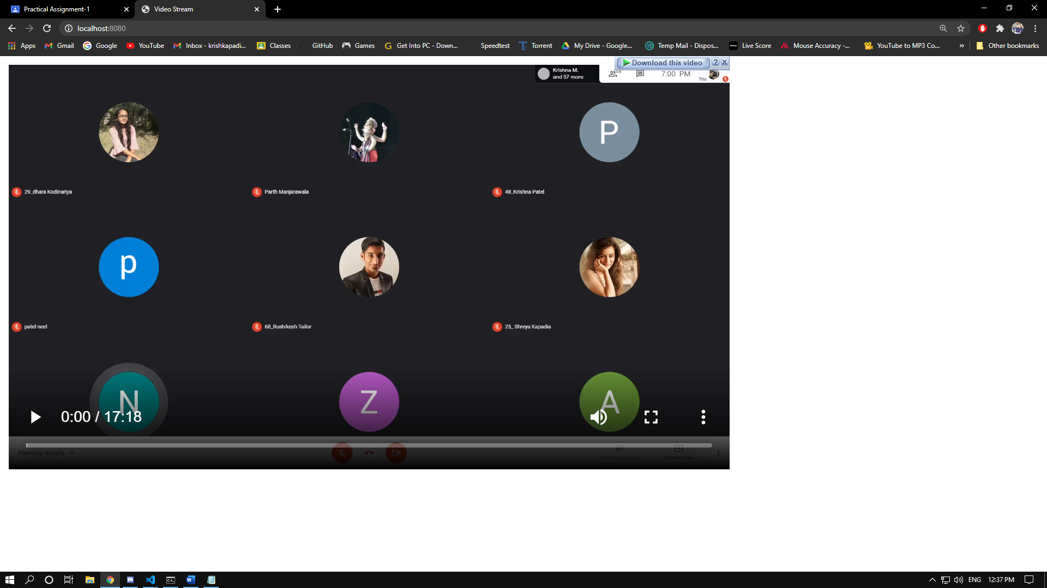

**5) Live cricket score application with websocket in nodejs.**

// Cant find API for cricket score

**6) Login, CRUD operations for students table with mongodb, express and any one template engine, Logout.**

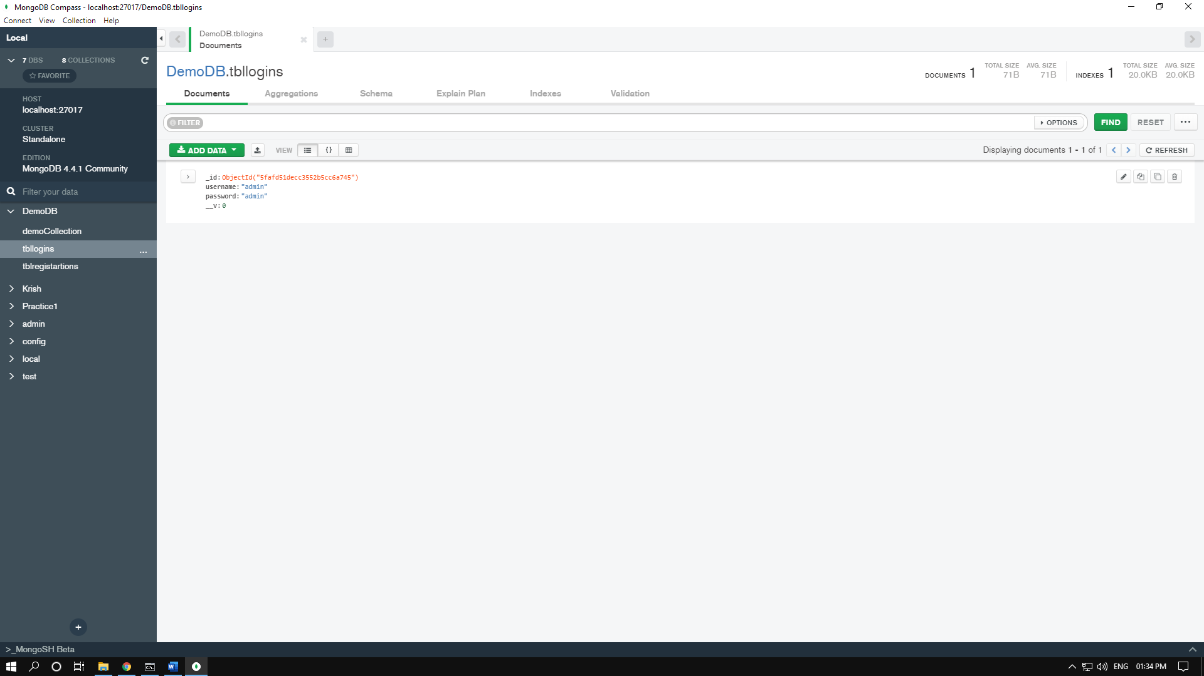

// Username : admin

// Password : admin

**Task_6.js**

const express = require('express');

const mongoose = require('mongoose');

const app = express();

const port = 8080;

// MongoDb Connection

mongoose.connect('mongodb://localhost/DemoDB', { useNewUrlParser: true, useUnifiedTopology: true });

// Connect With Database

const db = mongoose.connection;

db.on('error', console.error.bind(console, 'connection error:'));

db.once('open', function () {

console.log("Database Connection Successful.");

});

// Creating Schema

const tblLoginSchema = new mongoose.Schema({

username: String,

password: String

});

// Referencing Schema

const tblLogin = mongoose.model('tblLogin', tblLoginSchema);

// Inserting Demo record for login

// var tmp = new tblLogin({

// username : "admin",

// password:"admin"

// });

// tmp.save((err,data)=>{

// console.log("Insert Successfull");

// })

// Set View Engine

app.set("view engine", "ejs");

// Url Encoder

app.use(express.urlencoded({ extended: true }));

// Get Method

app.get("/", (req, res) => {

res.render("login", { success: null, color: null});

});

app.post("/", (req, res) => {

var msg = null;

var username = req.body.username;

var password = req.body.password;

tblLogin.findOne({ username: username, password: password }, (err, data) => {

if (data == null)

res.render("login", { success: "Invalid Username or Password" , color : "Red"});

else

res.render("login", { success: "Successfull Login", color: "Green"});

})

})

app.listen(port, () => {

console.log("Server is running on port number : ", port);

})





**7) Login, CRUD operations for students table with mongodb, express and frontend(html,css,javascript/jquery/angularjs), Logout.**

**Task_7.js**

// Username : admin

// Password : admin

const { urlencoded } = require('body-parser');

const express = require('express');

const mongoose = require('mongoose');

const app = express();

//var router = express.Router();

const port = 8080;

// MongoDb Connection

mongoose.connect('mongodb://localhost/DemoDB', { useNewUrlParser: true, useUnifiedTopology: true });

// Connect With Database

const db = mongoose.connection;

db.on('error', console.error.bind(console, 'connection error:'));

db.once('open', function () {

console.log("Database Connection Successful.");

});

// Creating Schema

const tblLoginSchema = new mongoose.Schema({

username: String,

password: String

});

// Referencing Schema

const tblLogin = mongoose.model('tblLogin', tblLoginSchema);

app.use(express.urlencoded({ extended: true }));

//router.use(express.static(__dirname + '/public'));

app.get("/",(req,res)=>{

res.sendFile(__dirname + "/views/index.html",{name : "Krishna"});

});

app.post("/", (req, res) => {

var username = req.body.username;

var password = req.body.password;

tblLogin.findOne({ username: username, password: password }, (err, data) => {

if (data == null)

{

//res.render("login", { success: "Invalid Username or Password", color: "Red" });

res.sendFile(__dirname + "/views/index2.html");

}

else

{

//res.render("login", { success: "Successfull Login", color: "Green" });

res.sendFile(__dirname + "/views/index3.html");

}

console.log(data);

})

});

app.listen(port,()=>{

console.log("Server is running on port number : ",port);

});



