TELCO CUSTOMER CHURN PREDICTION
Machine Learning Project Report

IBM Telco Customer Churn Dataset

Date Generated | 23 September 2026, 21:42
Dataset | 7,043 customers | 33 original features
Models Trained | Logistic Regression | Random Forest | Gradient Boosting
Best Model | Random Forest
Best ROC-AUC | 0.8539

1. Executive Summary
This report presents the end-to-end machine learning analysis of customer churn for a telecommunications provider using the IBM Telco Customer Churn dataset. The dataset contains 7,043 customer records with 33 original features spanning demographics, account information, subscribed services, and billing details. After feature engineering, 46 model-ready features were derived.
Three classification models were trained and evaluated: Logistic Regression, Random Forest, and Gradient Boosting. The best-performing model is Random Forest with a ROC-AUC of 0.8539, Accuracy of 0.8062, and F1 Score of 0.5956.
Total Customers | Churned | Retained | Churn Rate
7,043 | 1,869 | 5,174 | 26.5%

2. Problem Statement & Objectives
Customer churn — when a subscriber cancels their service — is one of the most critical and costly challenges for telecommunications companies. Acquiring a new customer is estimated to cost 5-25x more than retaining an existing one. The ability to predict churn before it happens enables targeted retention campaigns, personalised offers, and proactive customer success outreach.

Objectives
- Identify the key drivers of customer churn using exploratory data analysis.
- Engineer a clean, model-ready feature set from raw customer data.
- Train and compare multiple machine learning classifiers.
- Select the best model based on ROC-AUC and business-relevant metrics.
- Provide actionable, data-driven recommendations to reduce churn.
- Deploy an interactive prediction dashboard (Streamlit app) for business users.

3. Dataset Description
The IBM Telco Customer Churn dataset covers California-based subscribers of a fictional telecommunications company. Each record represents one customer with their demographic profile, subscribed services, contract and billing details, and whether they churned during the last month.

3.1 Dataset Statistics
Total Rows | 7,043
Original Features | 33
Model Features (engineered) | 46
Target Column | Churn Value (0 = Retained, 1 = Churned)
Retained Customers | 5,174 (73.5%)
Churned Customers | 1,869 (26.5%)
Avg Monthly Charges (Retained) | $61.27
Avg Monthly Charges (Churned) | $74.44

3.2 Feature Groups
Group | Features
Demographics | Gender, Senior Citizen, Partner, Dependents
Services | Phone Service, Multiple Lines, Internet Service, Online Security, Online Backup, Device Protection, Tech Support, Streaming TV, Streaming Movies
Account | Tenure Months, Contract, Paperless Billing, Payment Method
Charges | Monthly Charges, Total Charges
Leakage (dropped) | CustomerID, CLTV, Churn Score, Churn Reason, geo-coordinates

4. Exploratory Data Analysis

4.1 Churn Distribution
The dataset is imbalanced with a churn rate of 26.5%. Out of 7,043 customers, 1,869 churned and 5,174 were retained. This imbalance is important to consider when interpreting precision and recall metrics.
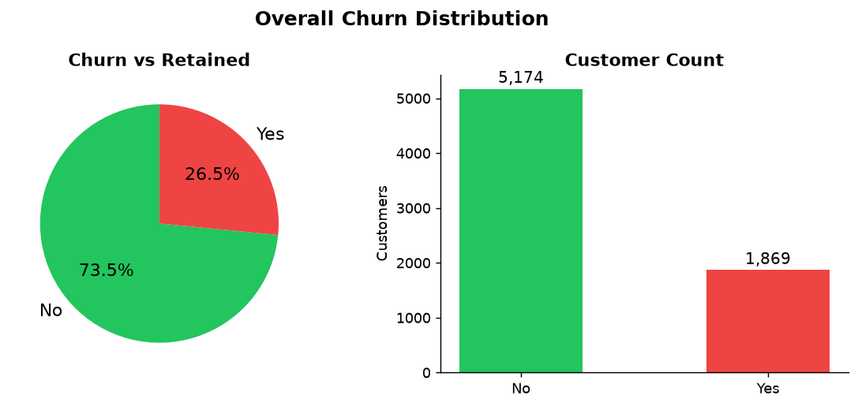
Figure: Churn vs Retained Distribution

4.2 Numeric Feature Distributions
Churned customers have significantly shorter average tenure (18.0 months) compared to retained customers (37.6 months). They also pay higher monthly charges on average ($74.44 vs $61.27), suggesting price sensitivity is a key churn driver.
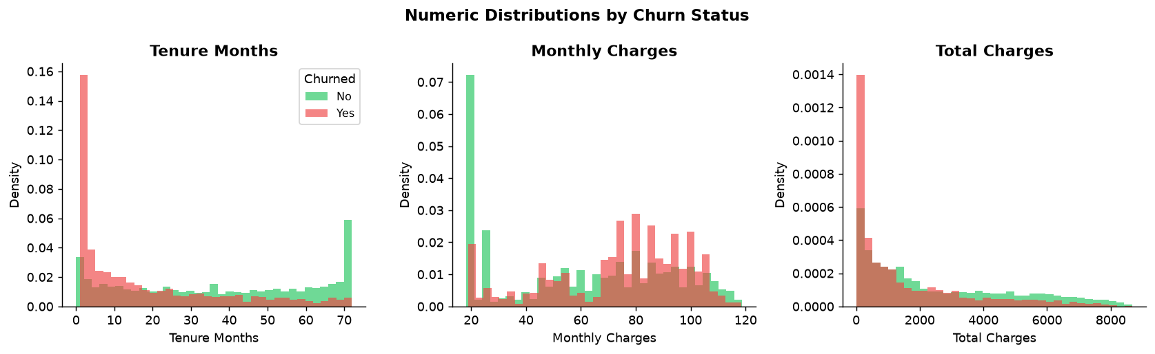
Figure: Numeric Feature Distributions by Churn Status

4.3 Contract Type Analysis
Month-to-month contract customers churn at 42.7%, compared to only 2.8% for two-year contract holders. Contract type is the single strongest structural predictor of churn.
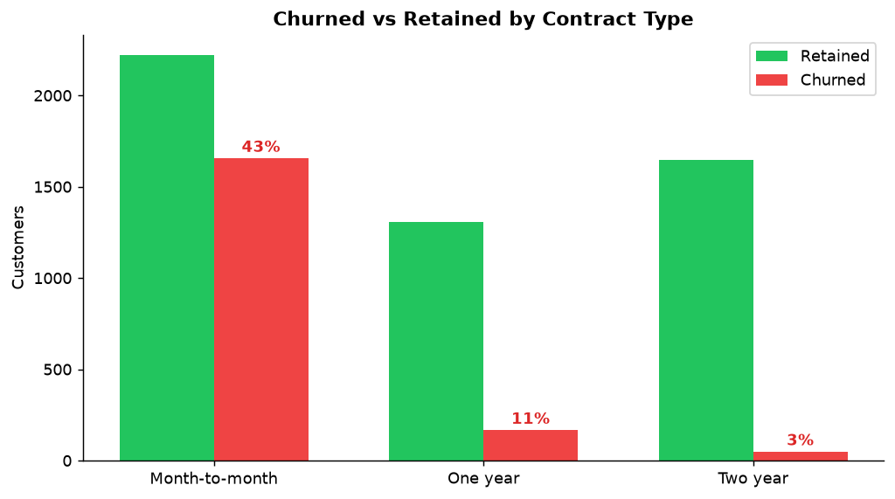
Figure: Churn Rate by Contract Type

4.4 Churn Reasons
Self-reported churn reasons reveal that competitor activity (better offers, devices, speeds) is the primary driver, followed by price concerns and service dissatisfaction.
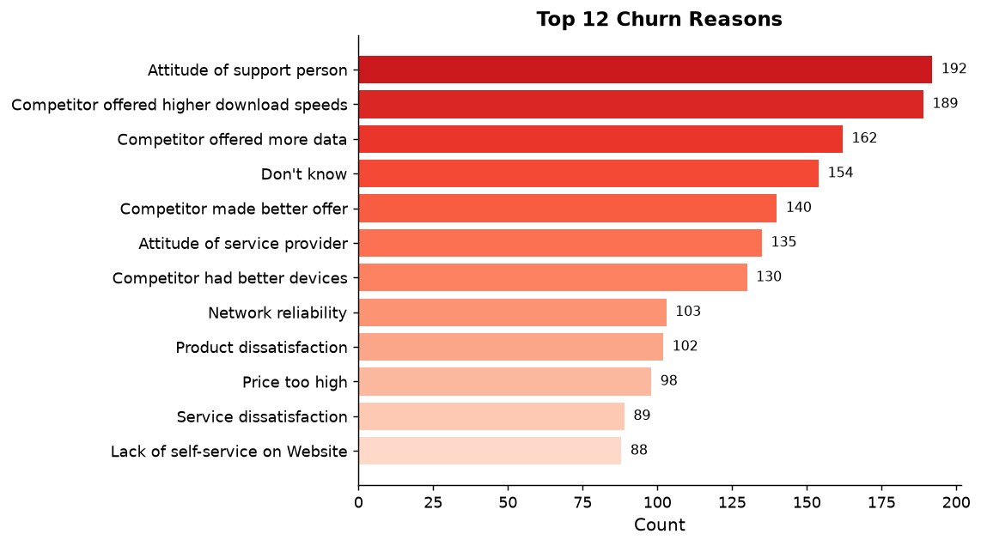
Figure: Top 12 Self-Reported Churn Reasons

4.5 Key EDA Findings
- Month-to-month contracts drive 43% churn vs 3% on two-year contracts.
- Churned customers average $74.44/month vs $61.27 for retained customers.
- Short-tenure customers (< 12 months) are the highest-risk segment.
- Customers without Online Security, Tech Support, or Device Protection churn at higher rates.
- Electronic check payment method correlates strongly with churn.
- Fiber optic internet service customers churn more than DSL subscribers.

5. Data Preprocessing & Feature Engineering
All preprocessing is performed in utils/preprocessing.py. The following steps transform the raw Excel data into a clean, fully numeric feature matrix suitable for machine learning.
Step | Detail
1. Drop leakage columns | CustomerID, CLTV, Churn Score, Churn Reason, Country, State, City, Zip Code, Lat Long, Latitude, Longitude, Churn Label
2. Type coercion | Total Charges cast to float; whitespace values become NaN
3. Impute missing values | NaN Total Charges filled with Monthly Charges (applicable to new customers with no billing history)
4. Binary encoding | 17 Yes/No columns mapped to 1/0: Senior Citizen, Partner, Dependents, Phone Service, Paperless Billing, and all service add-on columns
5. One-hot encoding | Multi-class columns expanded: Contract (3 cats), Internet Service (3), Payment Method (4), Multiple Lines (3) — producing 46 total features
6. Train/test split | 80% training / 20% test, stratified on Churn Value to preserve class balance

6. Model Architecture
Three models were trained using scikit-learn Pipelines. Each model was evaluated on the same hold-out test set (20% stratified split) to ensure a fair comparison.
Model | Pipeline Steps | Key Hyperparameters
Logistic Regression | StandardScaler → LogisticRegression | C=1.0, max_iter=1000, solver=lbfgs
Random Forest | RandomForestClassifier | n_estimators=200, max_depth=12, min_samples_leaf=5, n_jobs=-1
Gradient Boosting | GradientBoostingClassifier | n_estimators=150, learning_rate=0.1, max_depth=4

7. Model Evaluation

7.1 Metrics Comparison
All models are evaluated on Accuracy, Precision, Recall, F1 Score, and ROC-AUC. The best model (Random Forest, highlighted in green) achieves the highest ROC-AUC of 0.8539. (* = Best Model)
Metric | Logistic Regression | Random Forest * | Gradient Boosting
Accuracy | 0.7999 | 0.8062 | 0.7956
Precision | 0.6377 | 0.6678 | 0.6352
Recall | 0.5695 | 0.5374 | 0.5401
F1 Score | 0.6017 | 0.5956 | 0.5838
ROC-AUC | 0.8486 | 0.8539 | 0.8486

7.2 Metrics Visualisation
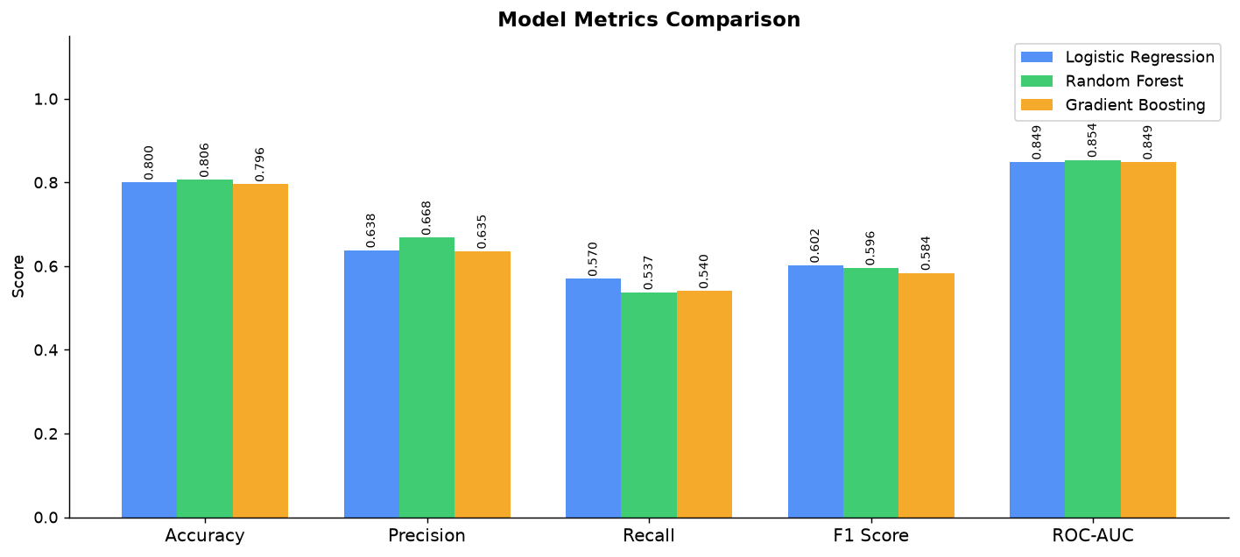
Figure: Model Metrics Comparison — All Models

7.3 ROC Curves
ROC-AUC measures the model's ability to discriminate between churners and retained customers across all decision thresholds. A value of 1.0 is perfect; 0.5 is random. All three models comfortably exceed 0.84.
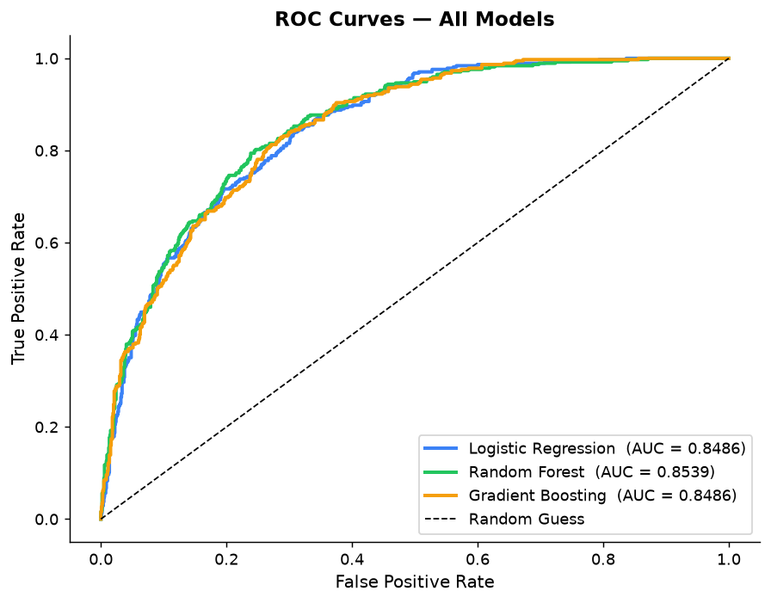
Figure: ROC Curves — All Three Models

7.4 Confusion Matrices
Confusion matrices show the breakdown of true positives (correctly predicted churners), false negatives (missed churners), false positives (false alarms), and true negatives on the 1,409-customer test set.

Logistic Regression
 | Pred: Retained | Pred: Churned
Act: Retained | 914 | 121
Act: Churned | 161 | 213

True Positives: 213 | True Negatives: 914 | False Positives: 121 | False Negatives: 161

Random Forest
 | Pred: Retained | Pred: Churned
Act: Retained | 935 | 100
Act: Churned | 173 | 201

True Positives: 201 | True Negatives: 935 | False Positives: 100 | False Negatives: 173

Gradient Boosting
 | Pred: Retained | Pred: Churned
Act: Retained | 919 | 116
Act: Churned | 172 | 202

True Positives: 202 | True Negatives: 919 | False Positives: 116 | False Negatives: 172

8. Feature Importances
Feature importances from tree-based models reveal which attributes most influence churn predictions. Tenure, Total Charges, and Contract type dominate for both Random Forest and Gradient Boosting.
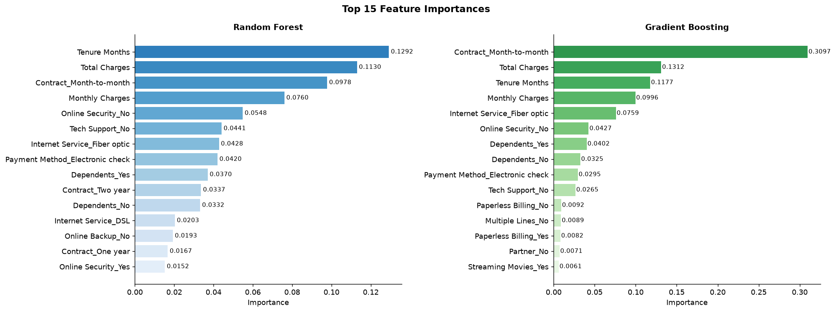
Figure: Top 15 Feature Importances (Tree Models)

Top 15 — Random Forest
Rank | Feature | Importance
1 | Tenure Months | 0.1292
2 | Total Charges | 0.1130
3 | Contract_Month-to-month | 0.0978
4 | Monthly Charges | 0.0760
5 | Online Security_No | 0.0548
6 | Tech Support_No | 0.0441
7 | Internet Service_Fiber optic | 0.0428
8 | Payment Method_Electronic check | 0.0420
9 | Dependents_Yes | 0.0370
10 | Contract_Two year | 0.0337
11 | Dependents_No | 0.0332
12 | Internet Service_DSL | 0.0203
13 | Online Backup_No | 0.0193
14 | Contract_One year | 0.0167
15 | Online Security_Yes | 0.0152

Top 15 — Gradient Boosting
Rank | Feature | Importance
1 | Contract_Month-to-month | 0.3097
2 | Total Charges | 0.1312
3 | Tenure Months | 0.1177
4 | Monthly Charges | 0.0996
5 | Internet Service_Fiber optic | 0.0759
6 | Online Security_No | 0.0427
7 | Dependents_Yes | 0.0402
8 | Dependents_No | 0.0325
9 | Payment Method_Electronic check | 0.0295
10 | Tech Support_No | 0.0265
11 | Paperless Billing_No | 0.0092
12 | Multiple Lines_No | 0.0089
13 | Paperless Billing_Yes | 0.0082
14 | Partner_No | 0.0071
15 | Streaming Movies_Yes | 0.0061

9. Business Recommendations

9.1 Target Month-to-Month Customers with Contract Upgrade Incentives
Month-to-month contract customers churn at 43% vs 3% on two-year contracts. Offering a 10-15% discount for committing to a one- or two-year contract is the single highest-impact retention lever.

9.2 Intervene Early in the Customer Lifecycle
Churned customers average only 18.0 months of tenure vs 37.6 months for retained customers. Implement a structured 90-day onboarding programme with a dedicated success manager for new subscribers.

9.3 Address Price Sensitivity with Loyalty Discounts
Churned customers pay $74.44/month on average vs $61.27 for retained customers. Introduce a tiered loyalty discount for customers who have been with the company for 6+ months and have monthly charges above $75.

9.4 Bundle Security and Support Add-Ons
Customers without Online Security, Tech Support, or Device Protection churn significantly more. Bundle these services into base plans or offer a 3-month free trial to increase perceived value and reduce switching intent.

9.5 Investigate Electronic Check Payment Customers
Electronic check payers show disproportionately high churn rates. Consider incentivising a switch to automatic payment methods (bank transfer or credit card) with a monthly bill credit, which also reduces payment failure risk.

9.6 Deploy Predictive Model for Monthly Scoring
Score the entire customer base monthly using the Random Forest model (ROC-AUC 0.8539). Route the top 30% highest-probability churners to a retention campaign queue for proactive outreach by the customer success team.

10. Application & Deployment
A full interactive Streamlit dashboard has been built as the frontend for this project. It allows business users to explore the data, compare model performance, and predict churn for individual customers without any coding knowledge.
Page | Description
Home | KPI dashboard, project overview, ML pipeline diagram
Exploratory Analysis | Interactive charts: distributions, breakdowns, heatmap, churn reasons
Model Performance | Metrics table, ROC curves, confusion matrices, feature importances
Predict Churn | Customer input form -> churn probability + risk badge + gauge chart
Dataset Viewer | Multi-filter table, column selector, CSV download

Running the Application
cd churn_prediction
pip install -r requirements.txt
streamlit run app.py
# Open http://localhost:8501 in your browser

11. Conclusion
This project successfully built a complete machine learning pipeline for predicting telecom customer churn. The Random Forest model is recommended for production deployment with a ROC-AUC of 0.8539 and Accuracy of 0.8062.
Tenure, Total Charges, Contract type, and the absence of security/support add-ons are the dominant churn predictors. Targeting month-to-month customers in the first 12 months of tenure — particularly those on fiber optic internet with high monthly charges — offers the greatest opportunity to reduce attrition.
The interactive Streamlit dashboard makes predictions and insights accessible to non-technical stakeholders, enabling data-driven retention decisions at scale. Monthly batch scoring of the customer base against the trained model is recommended as the first production deployment step.

12. Technical Appendix

12.1 Technology Stack
Layer | Library | Version
Frontend | Streamlit | 1.64.0
Visualisation | Plotly Express/GO | 7.1.0
ML Framework | scikit-learn | 1.9.1
Data Processing | pandas + openpyxl | 3.0.0 / 3.1.5
Numerics | NumPy | 2.4.2
Runtime | Python | 3.14.0

12.2 Project File Structure
churn_prediction/
app.py <- Streamlit entry point
train_model.py <- Standalone training CLI
generate_report.py <- HTML report generator
generate_docx_report.py <- This DOCX report generator
requirements.txt
data/
Telco_customer_churn.xlsx
models/
best_model.pkl random_forest.pkl
logistic_regression.pkl gradient_boosting.pkl
feature_columns.pkl
utils/
preprocessing.py
model.py
session.py
pages/
home.py eda.py model_performance.py
predict.py dataset_viewer.py

________________________________________________________________________________
Telco Customer Churn Prediction | Machine Learning Project Report | Generated 23 September 2026, 21:42 | Made with IBM Bob

