AI-POWERED AGRICULTURE CHATBOT USING NLP AND KNN
A project report submitted in partial fulfillment of the requirements for the award of the degree of
BACHELOR OF TECHNOLOGY
IN
CSE - DATA SCIENCE
Submitted By

Saka Pavankumar– 21B21A45D7
Siripana Gopi– 21B21A45D3
Polavarapu Dharmesh – 21B21A45E9
Akula Durga Prasad – 21B21A45D0
Marredi Satya Surya Kala – 22B25A4514


Under the Esteemed Guidance of
Mr. Sunkarapalli Srinivas, M.Tech,
Assistant Professor
DEPARTMENT OF CSE - ARTIFICIAL INTELLIGENCE AND
DATA SCIENCE
KAKINADA INSTITUTE OF ENGINEERING & TECHNOLOGY
(Approved by AICTE & Affiliated to JNT University Kakinada) Yanam Road, Korangi-533461, E.G. Dist. (A.P)
Phone no: 0884-234050, 2303400 Fax no: 0884-2303869

2021-2025

KAKINADA INSTITUTE OF ENGINEERING & TECHNOLOGY
(Approved by AICTE & Affiliated to JNT University Kakinada)
Yanam Road, Korangi-533461, E.G. Dist. (A.P) Phone no: 0884-234050, 2303400 Fax no: 0884-2303869

DEPARTMENT OF CSE - DATA SCIENCE



BONAFIDE CERTIFICATE

This is to certify that the project entitled “AI-POWERED AGRICULTURE CHATBOT USING NLP AND KNN” the bonafide record of work done by Kuncha Anusha , Pippalla Praneetha , Karaikudi Kusuma, Jillella Sreeja, Shaik Mohammad Jaffar in partial fulfillment of the requirement for the award of the degree of BACHELOR OF TECHNOLOGY in Computer Science & Engineering-AI&DS in Kakinada Institute of Engineering & Technology, Korangi, affiliated to Jawaharlal Nehru Technological University,
KAKINADA.

INTERNAL GUIDE HEAD OF THE DEPARTMENT

Mr.Sunkarapalli Srinivas , M.Tech Mr.Sunkarapalli Srinivas , M.Tech
Assistant Professor Associate Professor
Department of CSE-AI&DS Department of CSE-AI&DS

EXTERNAL EXAMINER

ACKNOWLEDGEMENT

I would like to take the privilege of the opportunity to express my gratitude for the Project work of “AI-POWERED AGRICULTURE CHATBOT USING NLP AND KNN” which enabled me to express my special thanks to our honorable Chairman of the institution Sri. P.V. Viswam.
I am thankful to Principal Prof. D Revati, who has shown keen interest in me and encouraged me by providing all the facilities to complete my project successfully.
I express my gratitude to our beloved Head of the Department of CSE – DS, Mr.Sunkarapalli Srinivas,M.Tech, Associate Professor for assisting me in completing my project work.
I am extremely thankful to my Project Review Committee who has been a source of inspiration for me throughout my project and for their valuable advice in making my project a success.
I express my sincere thanks to our beloved supervisor Mr.Sunkarapalli Srinivas, M.Tech , Associate Professor who has been a source of inspiration for me throughout my project and for his valuable pieces of advice in making my project a success.
I wish to express my sincere thanks to all teaching and non-teaching staff of the CSE – Artificial Intelligence and DATA SCIENCE Department. I wish to express my special thanks to all the faculty members of our college for their concern in subjects and their help throughout my course.
I am very thankful to my parents, and all my friends who had given me good cooperation and suggestions throughout this project and helped me in successful completion.
Saka Pavankumar– 21B21A45D7
Siripana Gopi– 21B21A45D3
Polavarapu Dharmesh – 21B21A45E9
Akula Durga Prasad – 21B21A45D0
Marredi Satya Surya Kala – 22B25A4514

DECLARATION

I am hereby declare that the project work entitled “AI-POWERED AGRICULTURE CHATBOT USING NLP AND KNN” Submitted to the Kakinada Institute of Engineering and Technology affiliated to JNTU Kakinada, a record of an original work done by me under the guidance of Mr.Sunkarapalli Srinivas, M.Tech, Assistant Professor in the Department of CSE - AI AND DS and this project work is submitted to the partial fulfillment of the requirements for the award of the degree of Bachelor of Technology in CSE – DS. The results embodied in this project have not been submitted to any other University or Institute for the award of any Degree or Diploma.

Saka Pavankumar– 21B21A45D7
Siripana Gopi– 21B21A45D3
Polavarapu Dharmesh – 21B21A45E9
Akula Durga Prasad – 21B21A45D0
Marredi Satya Surya Kala – 22B25A4514

ABSTRACT

Agriculture plays a vital role in India’s economy, contributing significantly to GDP and employment. However, farmers often face challenges due to limited access to timely and accurate agricultural information, including crop selection, pest control, irrigation practices, and government schemes. This information gap can lead to poor decision-making, reduced productivity, and financial losses.
AgriBot is an AI-powered agriculture chatbot designed to address these challenges by providing instant, reliable, and domain-specific guidance to farmers. The system utilizes Natural Language Processing (NLP) techniques combined with the K-Nearest Neighbors (KNN) algorithm and TF-IDF vectorization to understand user queries and deliver context-aware responses.
The chatbot covers a wide range of agricultural topics, including crop recommendations based on climate and soil type, seasonal farming practices, pest and disease management, irrigation methods, fertilizer usage, post-harvest techniques, and awareness of government agricultural schemes. The system is implemented using a full-stack architecture with a FastAPI backend, MongoDB database for storing user data and chat history, and a modern web-based user interface.
AgriBot features secure user authentication, persistent conversation storage, and an extensible dataset that supports CSV and Excel inputs for continuous knowledge expansion. The lightweight machine learning approach ensures fast response times and efficient deployment without requiring high computational resources.
This project demonstrates an effective and scalable solution for delivering agricultural knowledge through conversational AI, making technology more accessible to farmers and contributing to improved agricultural productivity and decision-making.

LIST OF FIGURES

FIGURE NO | TITLE | PAGE NO
Figure 3.2 | System Architecture | 21
Figure 3.3 | System Workflow | 23
Figure 5.1 | Generated Web Page Link | 45
Figure 5.2 | Web Page Interface | 45
Figure 5.3 | AgriBot Chat Interface Showing User Interaction | 46
Figure 5.4 | Model Training Pipeline | 47
Figure 5.5 | Request Flow | 47
Figure 5.6 | Dataset Topic Distribution | 48
Figure 5.7 | Security Architecture | 48

TABLE OF CONTENTS

CHAPTER | TITLE | PAGE NO
— | INTRODUCTION | 1–2
1.1 | Background | —
1.2 | Objectives of the Project | 3
— | LITERATURE SURVEY | 4–15
2.1 | Overview of Agriculture Chatbot Technologies | 4
2.2 | History and Evolution of Chatbots in Agriculture | 6
2.3 | Principles of Natural Language Processing (NLP) | 9
2.4 | Machine Learning Techniques in Chatbots (TF-IDF & KNN) | 11
2.5 | Existing Agriculture Chatbot Systems | 13
— | SYSTEM ARCHITECTURE | 16–27
3.1 | Overview of the Proposed System | 17
3.2 | Components and Modules | 18
3.3 | System Workflow | 22
3.4 | Integration and Interoperability | 23
3.5 | Security and Privacy Measures | 25
— | METHODOLOGY AND IMPLEMENTATION | 28–38
4.1 | Data Collection and Preprocessing | 29
4.2 | NLP Model and KNN Algorithm Selection | 31
4.3 | Description of Programming Languages and Frameworks Used | 33
4.4 | Approach to Chatbot Implementation | 36
— | RESULTS AND RECOMMENDATIONS | 39–48
5.1 | Project Summary | 40
5.2 | Improvements for Future Development | 41
5.3 | Potential Enhancements | 43
— | CONCLUSION | 49
— | BIBLIOGRAPHY | 50
— | APPENDIX | 51–57

CHAPTER 1
INTRODUCTION

CHAPTER 1 INTRODUCTION

1.1 BACKGROUND
Agriculture has long been the backbone of the Indian economy, playing a crucial role in ensuring food security, rural development, and economic stability. A significant portion of the population depends directly or indirectly on agriculture for their livelihood. Despite its importance, the sector faces numerous challenges such as climate change, soil degradation, pest infestations, water scarcity, and fluctuating market prices. These challenges make agricultural decision-making increasingly complex and risky for farmers.
One of the major issues faced by farmers, especially in rural areas, is the lack of timely access to accurate and expert agricultural information. Many farmers still rely on traditional knowledge, local practices, or word-of-mouth advice, which may not always be reliable or up-to-date. In addition, there is a significant gap in awareness regarding modern farming techniques, advanced irrigation methods, sustainable agricultural practices, and government schemes designed to support farmers financially and technically.
The advancement of Information and Communication Technology (ICT) has opened new opportunities to bridge this information gap. The increasing availability of smartphones, affordable internet connectivity, and digital literacy among farmers has made it possible to deliver real-time agricultural advisory services directly to users. Among various digital solutions, chatbot technology has gained attention due to its ability to simulate human-like conversations and provide instant responses to user queries.
Chatbots powered by Artificial Intelligence (AI) and Natural Language Processing (NLP) can understand user queries in natural language and provide relevant information efficiently. Unlike traditional systems, chatbots are available 24/7, scalable, and capable of handling multiple queries simultaneously. However, general-purpose chatbots are not always suitable for agriculture as they may lack domain-specific knowledge or require continuous internet connectivity and high computational resources.
To address these limitations, AgriBot is developed as a domain-specific, lightweight agriculture chatbot that focuses on delivering accurate and relevant information related to farming practices. The system utilizes machine learning techniques such as TF-IDF and K-Nearest Neighbors (KNN) to process user queries and provide appropriate responses based on a structured agricultural dataset. This approach ensures fast response times and efficient performance even on low-resource systems.
Furthermore, AgriBot integrates modern web technologies to provide a user-friendly interface, secure authentication, and persistent storage of user interactions. By combining AI-driven intelligence with practical agricultural knowledge, the system aims to empower farmers with reliable information, improve decision-making processes, and enhance overall productivity.
In conclusion, the development of AgriBot is motivated by the need to create an accessible, intelligent, and scalable solution that bridges the knowledge gap in agriculture. It represents a step towards digital transformation in farming, contributing to sustainable agricultural development and improved livelihoods for farmers.

1.2 Objectives of the Project
The primary objective of the AgriBot project is to design and develop an intelligent, user-friendly agriculture chatbot that provides accurate and timely information to farmers through a conversational interface. The system aims to bridge the gap between farmers and expert agricultural knowledge using modern technologies such as Natural Language Processing (NLP) and machine learning.

Primary Objectives
- To develop an AI-powered agriculture chatbot
Build a domain-specific chatbot capable of understanding natural language queries related to agriculture and providing relevant responses.
- To provide real-time agricultural guidance
Enable farmers to access information on crop selection, irrigation methods, fertilizers, pest control, and farming practices instantly.
- To implement NLP-based query processing
Use Natural Language Processing techniques to interpret user inputs and improve interaction quality.
- To apply machine learning algorithms for response prediction
Utilize TF-IDF vectorization and K-Nearest Neighbors (KNN) algorithm for accurate query classification and response generation.
- To create a comprehensive and extensible dataset
Develop a structured dataset covering various agricultural topics that can be expanded using CSV and Excel files.
- To design a secure and scalable system
Implement user authentication and data storage mechanisms to ensure secure access and maintain user interaction history.

Secondary Objectives
- To build an interactive and user-friendly interface
Develop a modern web-based interface that allows easy communication between users and the chatbot.
- To provide information on government agricultural schemes
Help farmers gain awareness about schemes, subsidies, and financial support programs.
- To ensure fast and efficient system performance
Design the system to deliver responses quickly with minimal computational resources.
- To support future enhancements and scalability
Create a flexible architecture that allows integration of advanced features such as voice input, multilingual support, and real-time APIs.

CHAPTER 2
LITERATURE SURVEY

CHAPTER 2 LITERATURE SURVEY

2.1 Overview of Agriculture Chatbot Technologies
Agriculture chatbot technology is an emerging application of Artificial Intelligence (AI) designed to provide farmers with instant, reliable, and accessible information through conversational interfaces. These chatbots simulate human-like interaction and assist users by answering queries related to crop management, soil health, irrigation, pest control, weather conditions, and government schemes.
With the advancement of digital technologies and increased smartphone usage in rural areas, agriculture chatbots have become an effective solution to bridge the information gap between farmers and agricultural experts. Unlike traditional advisory systems, chatbots provide 24/7 availability, real-time responses, and scalable communication, making them highly suitable for large-scale deployment.

Core Technologies Used in Agriculture Chatbots
- Artificial Intelligence (AI)
AI enables chatbots to mimic human intelligence by understanding user queries and generating meaningful responses. It forms the foundation of intelligent decision-making in chatbot systems.
- Natural Language Processing (NLP)
NLP allows the chatbot to understand and process human language. It involves tasks such as tokenization, stop-word removal, and intent recognition, enabling the system to interpret user queries accurately.
- Machine Learning (ML)
Machine learning algorithms help the chatbot learn from data and improve its performance over time. In agriculture chatbots, algorithms like K-Nearest Neighbors (KNN) are used to classify queries and retrieve relevant answers.
- Text Vectorization Techniques (TF-IDF)
TF-IDF (Term Frequency–Inverse Document Frequency) converts textual data into numerical form, allowing machine learning models to process and compare user queries effectively.
- Database Systems
Databases such as MongoDB are used to store user information, chat history, and agricultural datasets, enabling persistent and personalized interactions.
- Web Technologies
Frontend technologies like HTML, CSS, and JavaScript are used to create user-friendly interfaces, while backend frameworks such as FastAPI handle request processing and API communication.

Types of Agriculture Chatbots
- Rule-Based Chatbots
These chatbots operate on predefined rules and respond based on keyword matching. They are simple but limited in handling complex queries.
- AI-Based Chatbots
These use NLP and machine learning to understand context and provide more accurate, flexible, and intelligent responses.
- Hybrid Chatbots
A combination of rule-based and AI-based approaches, offering better performance and reliability.

Applications in Agriculture
Agriculture chatbots are used for various purposes, including:
- Crop recommendation based on climate and soil type
- Pest and disease identification and treatment
- Fertilizer and irrigation guidance
- Weather-based farming advice
- Information on government schemes and subsidies
- Post-harvest management practices

Advantages of Agriculture Chatbots
- Instant and 24/7 availability
- Easy access to expert knowledge
- Reduces dependency on intermediaries
- Supports multiple users simultaneously
- Cost-effective and scalable solution

2.2 History and Evolution of Chatbots in Agriculture
The development of chatbot technology has evolved significantly over the past few decades, transitioning from simple rule-based systems to advanced AI-driven conversational agents. This evolution has also influenced the agricultural sector, where chatbots are increasingly used to provide farmers with timely and accurate information.

Early Developments (1960s–1990s)
The concept of chatbots originated in the 1960s with the development of ELIZA, one of the first programs capable of simulating human conversation using predefined rules. During this period, chatbot systems were entirely rule-based, relying on pattern matching and scripted responses. Although these systems were limited in intelligence and flexibility, they laid the foundation for future conversational technologies.
In agriculture, early digital advisory systems were not chatbots but expert systems. These systems used predefined rules to assist farmers in decision-making, such as crop selection and pest control. However, they lacked natural language interaction and required users to input data in structured formats.

Growth of Web-Based Systems (2000s)
With the expansion of the internet in the early 2000s, web-based agricultural advisory platforms began to emerge. Farmers could access information through websites, forums, and email-based support systems. Some systems introduced basic chatbot-like features, but they were still largely rule-based and limited in handling complex queries.
During this period, governments and organizations started developing digital agriculture initiatives, providing farmers with online access to crop information, weather updates, and market prices. However, these systems required manual navigation and were not conversational.

Introduction of AI and NLP (2010s)
The 2010s marked a major shift with the integration of Artificial Intelligence (AI) and Natural Language Processing (NLP) into chatbot systems. Chatbots became capable of understanding user queries in natural language and providing more relevant responses.
In agriculture, AI-powered chatbots began to appear, offering services such as:
- Crop advisory based on soil and climate conditions
- Pest and disease identification
- Weather-based recommendations
- Information on government schemes
Machine learning algorithms enabled these chatbots to improve over time, making them more accurate and efficient compared to earlier rule-based systems.

Modern AI Chatbots (2020s–Present)
In recent years, chatbot technology has advanced rapidly with the development of deep learning and large language models (LLMs). Modern chatbots are capable of understanding context, handling complex queries, and engaging in more natural conversations.
Agriculture chatbots today are:
- Highly interactive and intelligent
- Capable of multilingual communication
- Integrated with mobile applications and messaging platforms
- Connected to real-time data sources such as weather APIs and market price systems
Additionally, some advanced systems incorporate image recognition for plant disease detection and voice-based interaction for better accessibility among farmers.

Evolution in Agricultural Applications
The evolution of chatbots in agriculture can be summarized as follows:
Stage | Technology | Characteristics
Early Stage | Rule-Based Systems | Predefined responses, limited interaction
Web Era | Online Advisory Platforms | Static information, no conversational interface
AI Era | NLP + Machine Learning | Intelligent responses, query understanding
Modern Era | Deep Learning & LLMs | Context-aware, multilingual, highly interactive

2.3 Principles of NLP
Natural Language Processing (NLP) is a branch of Artificial Intelligence (AI) that enables computers to understand, interpret, and respond to human language in a meaningful way. In the context of an agriculture chatbot like AgriBot, NLP plays a crucial role in analyzing user queries and generating accurate responses.
NLP combines techniques from linguistics, computer science, and machine learning to process textual data and convert it into a format that machines can understand.

Key Principles of NLP

1. Text Preprocessing
Text preprocessing is the first step in NLP, where raw input text is cleaned and prepared for further processing. It includes:
- Tokenization: Breaking text into words or tokens
- Lowercasing: Converting all text to lowercase
- Stop-word Removal: Removing common words like “is”, “the”, “and”
- Stemming/Lemmatization: Reducing words to their base form
Example:
“Best crops for the rainy season?” → [best, crops, rainy, season]

2. Text Representation
After preprocessing, text must be converted into numerical form so that machine learning models can process it.
- Bag of Words (BoW): Represents text based on word frequency
- TF-IDF (Term Frequency–Inverse Document Frequency): Assigns importance to words based on their frequency in a document and across documents
TF-IDF helps identify important words like “crop”, “soil”, or “irrigation” in agriculture-related queries.

3. Syntax and Semantics Analysis
NLP involves understanding both the structure and meaning of sentences:
- Syntax Analysis: Examines grammatical structure (word order, sentence formation)
- Semantic Analysis: Understands the meaning of words and sentences
Example:
“What crop grows in black soil?”
The system identifies:
- Subject → crop
- Context → black soil
- Intent → recommendation

4. Intent Recognition
Intent recognition is the process of identifying the purpose behind a user’s query.
Example:
- “How to grow rice?” → Crop Guide
- “What is PM-KISAN?” → Government Scheme
This helps the chatbot classify queries into categories and provide appropriate responses.

5. Named Entity Recognition (NER)
NER identifies important entities (keywords) in a sentence such as:
- Crop names (rice, wheat)
- Soil types (black soil, red soil)
- Locations or seasons
Example:
“Best crops for sandy soil in summer”
Entities → sandy soil, summer

6. Similarity Measurement
To find the most relevant response, NLP uses similarity measures between user queries and stored data.
- Cosine Similarity is commonly used with TF-IDF
- Helps match user queries with the closest question in the dataset

7. Response Generation
Once the query is understood, the chatbot generates a response:
- Retrieval-Based Approach: Selects the best answer from a dataset
- Generative Approach: Creates new responses using AI models
AgriBot uses a retrieval-based approach with KNN for fast and accurate responses.

Role of NLP in Agriculture Chatbots
In agriculture chatbots, NLP helps to:
- Understand farmer queries in natural language
- Handle different ways of asking the same question
- Provide accurate and context-aware responses
- Improve user interaction and experience

2.4 Machine Learning Techniques (TF-IDF & KNN)
Machine Learning (ML) plays a crucial role in enabling chatbots to understand user queries and provide relevant responses. In the AgriBot system, two key techniques are used: TF-IDF (Term Frequency–Inverse Document Frequency) for text representation and K-Nearest Neighbors (KNN) for classification and response retrieval. These techniques are lightweight, efficient, and well-suited for domain-specific chatbot applications.

1. TF-IDF (Term Frequency–Inverse Document Frequency)
TF-IDF is a numerical representation technique used to convert textual data into vectors that can be processed by machine learning algorithms. It helps identify the importance of words in a given document relative to a collection of documents.
TF(t,d) = (No. of times term t appears in document d) / (Total no. of terms in document d)

IDF(t) = log (Total no. of documents / No. of documents containing term t)

TF-IDF(t,d) = TF(t,d) × IDF(t)
Words that appear frequently in a specific query but rarely across the dataset receive higher TF-IDF scores, making them more significant for classification.

Advantages of TF-IDF
- Converts text into numerical format
- Highlights important keywords
- Reduces the impact of common words
- Simple and efficient for small to medium datasets

Example
Query: “Best crops for black soil”
Important words: crops, black soil
TF-IDF assigns higher weight to these terms, helping the model understand the query context.

2. K-Nearest Neighbors (KNN) Algorithm
KNN is a supervised machine learning algorithm used for classification and pattern recognition. It works by comparing a new input with existing data points and selecting the closest matches.

Working Principle of KNN
- Convert the user query into a TF-IDF vector
- Calculate the distance between the query and all training data points
- Identify the k nearest neighbors (most similar queries)
- Select the best match based on similarity
- Return the corresponding response

Distance Measurement
KNN uses cosine similarity for text data:
Cosine Similarity=A⋅B∣A∣×∣B∣\text{Cosine Similarity} = \frac{A \cdot B}{|A| \times |B|}Cosine Similarity=∣A∣×∣B∣A⋅B​
- Value close to 1 → highly similar
- Value close to 0 → less similar

Why KNN is Used in AgriBot
- Simple and easy to implement
- No complex training phase required
- Works well with TF-IDF vectors
- Suitable for small and structured datasets
- Provides accurate results for domain-specific queries

3. Integration of TF-IDF and KNN
In AgriBot, TF-IDF and KNN work together as follows:
- User enters a query
- NLP preprocessing is applied
- TF-IDF converts text into vector form
- KNN finds the most similar query in the dataset
- The corresponding answer is returned to the user

4. Advantages of This Approach
- Fast response time
- Lightweight and efficient
- Does not require high computational power
- Easy to update with new data
- Accurate for structured and domain-specific knowledge

5. Limitations
- Performance depends on dataset quality
- Not suitable for very large datasets
- Cannot generate new responses (retrieval-based only)
- Limited understanding of deep context
2.5 Existing Agriculture Chatbot Systems
In recent years, several agriculture chatbot systems have been developed worldwide to provide farmers with timely, accurate, and accessible information. These systems utilize Artificial Intelligence (AI), Natural Language Processing (NLP), and machine learning techniques to assist farmers in decision-making and improving productivity.
1. FarmerChat (Digital Green)
FarmerChat is one of the most widely used AI-powered agriculture chatbots designed for smallholder farmers. It provides real-time advisory services related to crop management, pest control, and farming techniques. The platform has been deployed across multiple countries and has handled millions of farmer queries, helping users make informed agricultural decisions.
2. Kisan e-Mitra (India Government Initiative)
Kisan e-Mitra is an AI-based chatbot developed to assist Indian farmers with information about government schemes such as PM-KISAN, crop insurance, and subsidies. It supports multiple Indian languages and provides 24/7 assistance to farmers, improving accessibility to government services.
3. Ama Krushi Chatbot (Odisha, India)
Ama Krushi is an AI-powered chatbot launched under a government-supported initiative to provide localized agricultural advisory services. It delivers recommendations in regional languages and has reached a large number of farmers by offering location-specific guidance.
4. SukhaRakshak Chatbot
SukhaRakshak is designed to help farmers manage drought-related challenges by providing personalized advisories. It assists farmers, agricultural officers, and policymakers in making decisions related to water management and climate risks.
5. AI-Based Farmer Assistance Chatbots (Research Systems)
Various research-based chatbot systems have been developed using frameworks like Rasa, deep learning, and NLP. These chatbots provide services such as crop recommendations, pest identification, weather forecasting, and soil analysis. They are designed to be cost-effective and scalable solutions for rural areas.

6. Modern AI Chatbots (Multilingual & Generative AI)
Recent advancements have introduced chatbot systems that use generative AI and large language models. These systems provide highly interactive and context-aware responses, support multiple languages, and can handle complex queries more effectively.

Comparison of Existing Systems
System | Technology Used | Key Focus
FarmerChat | AI + NLP | General farming advisory
Kisan e-Mitra | AI Chatbot | Government schemes
Ama Krushi | NLP + ML | Localized advisory
SukhaRakshak | AI | Climate drought management
Research Chatbots | NLP + ML | Crop, soil, pest guidance

CHAPTER 3
SYSTEM ARCHITECTURE

CHAPTER 3 SYSTEM ARCHITECTURE

3.1 Overview of the Proposed System
The proposed system, AgriBot, is an AI-powered agriculture chatbot designed to provide farmers with instant, accurate, and accessible information through a conversational interface. The system leverages Natural Language Processing (NLP) and Machine Learning (ML) techniques, specifically TF-IDF vectorization and the K-Nearest Neighbors (KNN) algorithm, to understand user queries and deliver relevant responses.
The primary goal of the system is to bridge the gap between farmers and expert agricultural knowledge by offering a 24/7 digital assistant that can answer queries related to crop selection, soil management, irrigation techniques, pest control, fertilizers, and government schemes.

System Description
AgriBot is designed as a full-stack web application consisting of three main layers:
- Frontend (User Interface)
The frontend provides a user-friendly chat interface where farmers can enter their queries in natural language. It is developed using HTML, CSS, and JavaScript, ensuring ease of use and accessibility across devices.
- Backend (Application Layer)
The backend is built using FastAPI, which handles user requests, processes queries, and communicates with the machine learning model. It also manages user authentication and API responses.
- Database (Data Layer)
MongoDB is used to store user information, chat history, and datasets. This ensures persistent storage and allows users to revisit previous conversations.

Working of the Proposed System
The system operates through the following steps:
- The user enters a query through the chatbot interface
- The query is sent to the backend server
- NLP techniques preprocess the input text
- TF-IDF converts the query into numerical vectors
- KNN algorithm finds the most similar query in the dataset
- The corresponding response is retrieved
- The response is sent back to the user and displayed on the interface
- The conversation is stored in the database for future reference

Key Features of the Proposed System
- AI-powered query understanding using NLP
- Fast and accurate response generation using TF-IDF and KNN
- User-friendly chat interface
- Secure user authentication system
- Persistent chat history using MongoDB
- Support for multiple agricultural domains
- Extensible dataset (CSV/Excel support)

Advantages of the Proposed System
- Provides real-time agricultural assistance
- Reduces dependency on manual advisory services
- Easy to use for farmers with minimal technical knowledge
- Cost-effective and scalable solution
- Can be deployed locally without high computational resources

3.2 Components and Modules
The AgriBot system is composed of several interconnected components and modules that work together to provide accurate and efficient responses to user queries. Each module performs a specific function to ensure smooth operation of the chatbot.

1. User Interface Module (Frontend)
This module provides the interaction layer between the user and the system.
Functions:
- Accepts user queries in natural language
- Displays chatbot responses
- Provides chat history view
- Handles login and registration
Technologies Used:
HTML, CSS, JavaScript

2. Authentication Module
This module ensures secure access to the system.
Functions:
- User registration and login
- Password encryption (bcrypt)
- Token-based authentication (JWT)
Benefits:
- Protects user data
- Ensures only authorized access

3. Chat Processing Module (Backend API)
This is the core module that handles communication between frontend and ML models.
Functions:
- Receives user queries via API
- Sends queries to NLP module
- Returns responses to frontend
Technology Used:
FastAPI

4. NLP Processing Module
This module processes and understands user input.
Functions:
- Text preprocessing (tokenization, stop-word removal)
- Query cleaning and normalization
- Feature extraction using TF-IDF

5. Machine Learning Module (KNN Model)
This module is responsible for finding the best response.
Functions:
- Converts query into vector form
- Compares with dataset using cosine similarity
- Identifies nearest neighbors
- Retrieves the most relevant answer

6. Database Module
This module stores all system data.
Functions:
- Stores user credentials
- Saves chat history
- Maintains dataset records
Technology Used:
MongoDB

7. Dataset Module
This module contains all agricultural knowledge.
Sources:
- Built-in dataset
- CSV files
- Excel files
Functions:
- Stores questions, answers, and intents
- Supports easy updates and expansion

8. Model Training Module (Offline)
This module is used to train the chatbot model.
Functions:
- Loads dataset
- Applies TF-IDF
- Trains KNN model
- Saves trained model files
System Architecture Diagram
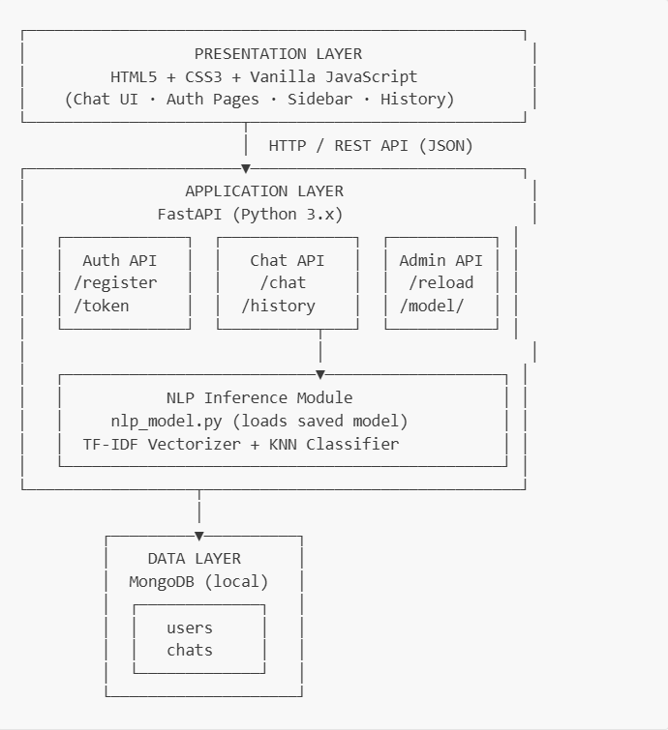Figure 3.2 System Architecture
3.3 System Workflow
The system workflow of AgriBot describes the sequence of steps involved in processing a user query and generating an appropriate response. It illustrates how different components of the system interact with each other to ensure smooth and efficient operation.
The workflow follows a structured pipeline starting from user input to response delivery and data storage.

Step-by-Step Workflow
- User Input
The user enters a query through the chatbot interface in natural language (e.g., “What crops grow in black soil?”).
- Request Sent to Backend
The query is sent from the frontend to the backend server (FastAPI) via an API request.
- Authentication Check
The system verifies the user’s identity using JWT authentication to ensure secure access.
- Text Preprocessing (NLP Module)
The input query is processed using NLP techniques:
  - Tokenization
  - Lowercasing
  - Stop-word removal
  - Cleaning and normalization
- Feature Extraction (TF-IDF)
The processed text is converted into a numerical vector using TF-IDF, enabling machine learning processing.
- Similarity Matching (KNN Algorithm)
The KNN model compares the input vector with stored dataset vectors:
  - Calculates similarity using cosine distance
  - Identifies the nearest neighbors
  - Selects the best matching query
- Response Retrieval
The system retrieves the corresponding answer from the dataset based on the closest match.
- Response Sent to User
The generated response is sent back to the frontend and displayed in the chat interface.
- Data Storage (Database)
The conversation (user query and bot response) is stored in MongoDB for future reference and history tracking.
- Display of Chat History
Users can view previous conversations, improving usability and personalization.

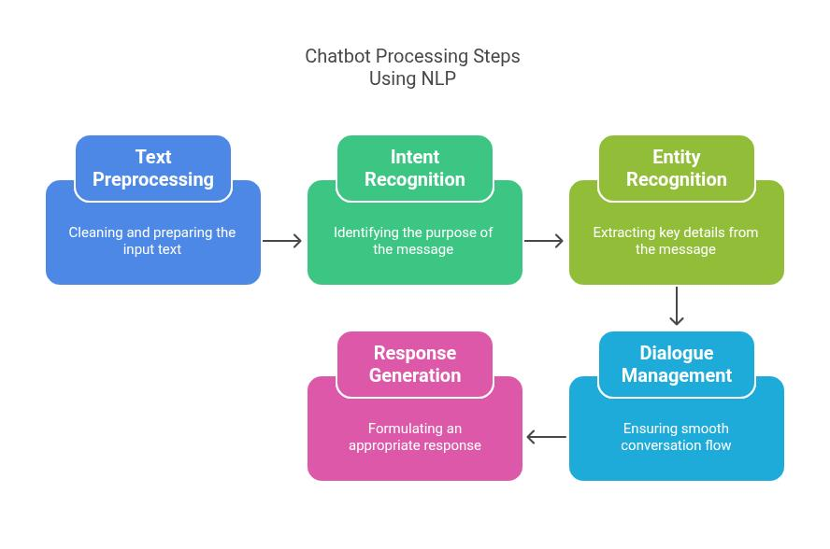
Figure 3.3 Work Flow

Key Characteristics of the Workflow
- Sequential Processing: Each step follows a defined order
- Real-Time Response: Fast processing ensures quick replies
- Modular Design: Each module works independently
- Secure Communication: Authentication ensures safe usage
- Data Persistence: Conversations are stored for future use

3.4 Integration and Interoperability
Integration and interoperability are essential aspects of the AgriBot system, ensuring that different components work together seamlessly and that the system can interact effectively with external technologies and services. A well-integrated system improves performance, scalability, and user experience.

Integration in AgriBot
Integration refers to the coordination and communication between various modules within the system. AgriBot integrates multiple components, including the frontend, backend, machine learning model, and database.

1. Frontend–Backend Integration
- The user interface communicates with the backend using REST APIs.
- User queries are sent from the frontend to the FastAPI server.
- Responses generated by the backend are returned and displayed in the chat interface.
This ensures smooth interaction between users and the system.

2. Backend–Machine Learning Model Integration
- The backend is connected to the NLP and KNN model.
- User queries are processed and passed to the trained model.
- The model returns the most relevant response to the backend.
This integration enables intelligent response generation.

3. Backend–Database Integration
- The backend communicates with MongoDB for data storage and retrieval.
- User credentials, chat history, and datasets are stored securely.
- The system retrieves past conversations when required.
This ensures data persistence and personalization.

4. Dataset Integration
- The system supports multiple data sources such as CSV and Excel files.
- New datasets can be easily added without modifying core code.
- The model can be retrained using updated data.
This provides flexibility and scalability.

Interoperability in AgriBot
Interoperability refers to the ability of the system to interact with external systems, platforms, or technologies.

1. Cross-Platform Compatibility
- AgriBot can be accessed through web browsers on desktops, laptops, and mobile devices.
- The system is designed to work across different operating systems.

2. API-Based Communication
- The use of REST APIs allows easy integration with other applications.
- AgriBot can be extended to mobile apps, third-party platforms, or messaging services.

3. External Data Integration (Future Scope)
- Weather APIs for real-time climate data
- Market price APIs for crop pricing information
- Government portals for scheme updates

4. Language and Regional Adaptability
- The system can be extended to support multiple languages.
- Enables communication with farmers from different regions.

Benefits of Integration and Interoperability
- Seamless communication between system components
- Improved system efficiency and performance
- Easy scalability and future enhancements
- Flexibility to integrate with external services
- Better user experience

3.5 Security and Privacy Measures
Security and privacy are critical aspects of the AgriBot system, as it handles user data, authentication details, and conversation history. Proper measures are implemented to ensure that user information is protected from unauthorized access, misuse, and data breaches.

1. User Authentication and Authorization
AgriBot uses a secure authentication mechanism to verify user identity.
- JWT (JSON Web Token) is used for authentication
- Users must log in to access chatbot services
- Each request is validated using a secure token

2. Password Security
- User passwords are not stored in plain text
- Passwords are encrypted using bcrypt hashing
- Even if the database is compromised, passwords remain secure

3. Data Encryption
- Sensitive data is protected during transmission
- HTTPS protocol (in deployment) ensures encrypted communication
- Prevents interception of data by unauthorized parties

4. Secure API Communication
- All communication between frontend and backend occurs via secure REST APIs
- Tokens are validated for every request
- Unauthorized requests are rejected with proper error responses

5. Database Security
- MongoDB stores user data and chat history securely
- Access to the database is restricted to authorized applications only
- Data is organized and managed to prevent unauthorized access

6. Protection Against Common Attacks
AgriBot is designed to handle common security threats:
- SQL Injection / NoSQL Injection Prevention
Input is treated as plain text and properly validated
- Cross-Site Scripting (XSS) Prevention
User inputs are sanitized before display
- Brute Force Protection
Authentication mechanisms can be extended with rate limiting

7. Data Privacy
- Only necessary user data is collected
- Chat history is stored securely and used only for improving user experience
- No sensitive personal data is shared with third parties

8. Session Management
- JWT tokens have an expiration time
- Users must re-authenticate after token expiry
- Reduces risk of session hijacking

9. Future Security Enhancements
- Multi-factor authentication (MFA)
- Role-based access control (Admin/User)
- End-to-end encryption
- Secure cloud deployment with firewalls

CHAPTER 4
METHODOLOGY AND IMPLEMENTATION

CHAPTER 4

METHODOLOGY AND IMPLEMENTATION

4.1 Data Collection and Preprocessing
Data collection and preprocessing are essential steps in building an effective agriculture chatbot. The quality and structure of the dataset directly influence the accuracy and performance of the machine learning model. In AgriBot, data is collected from multiple sources and carefully processed before being used for training.

1. Data Collection
The dataset used in AgriBot consists of agricultural questions and answers covering various topics such as crop selection, soil types, irrigation methods, fertilizers, pest control, and government schemes.

Sources of Data
- Built-in Dataset
A predefined set of question-answer pairs is included in the system to ensure basic functionality.
- CSV Files
Structured datasets stored in CSV format containing columns such as question, answer, and intent.
- Excel Files (.xlsx / .xls)
Additional datasets can be added in Excel format, allowing easy expansion of knowledge.
- Agricultural Knowledge Sources
Data may be collected from agricultural websites, research articles, and government portals.

Dataset Structure
Each record in the dataset contains:
- Question → User query
- Answer → Corresponding response
- Intent → Category of the query
Example:
Question: What crops grow in black soil?
Answer: Crops like cotton, wheat, and groundnut grow well in black soil.
Intent: soil_crop

2. Data Preprocessing
Before training the model, the collected data undergoes preprocessing to ensure consistency and improve performance.

a) Data Cleaning
- Removal of duplicate records
- Handling missing or incomplete values
- Correcting spelling and formatting errors

b) Text Normalization
- Convert all text to lowercase
- Remove punctuation and special characters
- Standardize words and phrases

c) Tokenization
- Split sentences into individual words (tokens)
Example:
“Best crops for sandy soil” → [best, crops, sandy, soil]

d) Stop-word Removal
- Remove common words like “is”, “the”, “and”
- Focus on meaningful keywords

e) Stemming/Lemmatization
- Convert words to their base form
Example:
“growing”, “grown” → “grow”

f) Feature Extraction Preparation
- Prepare cleaned text for TF-IDF vectorization
- Ensure consistency across all dataset entries

3. Data Deduplication
- Duplicate questions are removed to avoid bias
- Ensures each query is unique
- Improves model accuracy

4. Final Dataset Preparation
After preprocessing, the dataset is structured and ready for training:
- Cleaned and normalized text
- Properly labeled intents
- Balanced distribution across categories

5. Importance of Data Preprocessing
- Improves model accuracy
- Reduces noise and redundancy
- Enhances query understanding
- Ensures faster processing

4.2 NLP Model and KNN Algorithm Selection
The selection of appropriate Natural Language Processing (NLP) techniques and machine learning algorithms is crucial for building an efficient and accurate chatbot. In AgriBot, a combination of TF-IDF vectorization and the K-Nearest Neighbors (KNN) algorithm is chosen due to its simplicity, efficiency, and suitability for domain-specific applications.

1. NLP Model Selection
The NLP model in AgriBot is responsible for understanding user queries and converting them into a format that can be processed by machine learning algorithms.

a) Text Representation using TF-IDF
TF-IDF (Term Frequency–Inverse Document Frequency) is selected as the primary text vectorization technique.
Reasons for Selection:
- Converts text into numerical vectors
- Highlights important keywords in a query
- Reduces the impact of common words
- Lightweight and fast compared to deep learning models
Working:
- Each query is transformed into a vector based on word importance
- Words like “crop”, “soil”, and “irrigation” receive higher weights
- Enables comparison between user queries and dataset entries

b) Use of N-grams
- Both unigrams (single words) and bigrams (two-word combinations) are used
- Improves understanding of phrases
Example:
“drip irrigation” is treated as a meaningful phrase rather than separate words

2. KNN Algorithm Selection
K-Nearest Neighbors (KNN) is selected as the classification and retrieval algorithm for the chatbot.

a) Reasons for Choosing KNN
- Simple and easy to implement
- No complex training phase required
- Works effectively with TF-IDF vectors
- Suitable for small to medium-sized datasets
- Provides accurate results for domain-specific queries

b) Working of KNN in AgriBot
- The user query is converted into a TF-IDF vector
- The system calculates similarity with all dataset vectors
- The k nearest neighbors are identified (k = 5)
- The closest match is selected
- The corresponding answer is returned

c) Distance Metric
- Cosine similarity is used to measure similarity between vectors
Similarity=A⋅B∣A∣×∣B∣\text{Similarity} = \frac{A \cdot B}{|A| \times |B|}Similarity=∣A∣×∣B∣A⋅B​
- Values close to 1 indicate high similarity
- Ensures accurate matching of queries

3. Advantages of TF-IDF + KNN Approach
- Fast response time
- Low computational requirements
- Easy to implement and maintain
- High accuracy for structured datasets
- Suitable for offline and local deployment

4. Limitations
- Not suitable for very large datasets
- Cannot understand deep contextual meaning
- Does not generate new responses (retrieval-based)
- Performance depends on dataset quality

5. Justification of Selection
Compared to complex deep learning models (such as neural networks or transformers), the TF-IDF + KNN approach is:
- More efficient for small datasets
- Easier to deploy on low-resource systems
- Faster in real-time applications
- More interpretable and easier to debug

4.3 Description of Programming Languages and Frameworks Used
The development of AgriBot involves the use of various programming languages and frameworks to build a complete full-stack application. Each technology is selected based on its efficiency, flexibility, and suitability for implementing machine learning and web-based systems.

1. Python
Python is the primary programming language used for developing the backend and machine learning components of AgriBot.
Reasons for Selection:
- Simple and easy-to-understand syntax
- Extensive support for machine learning and NLP libraries
- Large developer community
Usage in Project:
- Implementing NLP and KNN algorithms
- Data preprocessing and model training
- Backend logic development

2. FastAPI
FastAPI is a modern Python framework used to build APIs for the application.
Features:
- High performance and fast execution
- Automatic API documentation (Swagger UI)
- Supports asynchronous programming
Usage in Project:
- Handling user requests and responses
- Connecting frontend with backend
- Managing authentication and API endpoints

3. Scikit-Learn
Scikit-learn is a machine learning library used for implementing the TF-IDF vectorizer and KNN algorithm.
Features:
- Easy-to-use ML algorithms
- Efficient data processing
- Reliable and widely used
Usage in Project:
- TF-IDF vectorization
- KNN model training and prediction

4. MongoDB
MongoDB is a NoSQL database used to store application data.
Features:
- Flexible schema (JSON-based storage)
- High scalability
- Easy integration with Python
Usage in Project:
- Storing user data (username, password)
- Saving chat history
- Managing dataset records

5. HTML (HyperText Markup Language)
HTML is used to design the structure of the web interface.
Usage in Project:
- Creating chatbot interface layout
- Designing login and registration pages

6. CSS (Cascading Style Sheets)
CSS is used to style the user interface and enhance visual appearance.
Usage in Project:
- Designing responsive layouts
- Applying colors, fonts, and animations
- Improving user experience

7. JavaScript
JavaScript is used to handle client-side logic and interaction.
Features:
- Dynamic content rendering
- Asynchronous API calls (Fetch API)
Usage in Project:
- Sending user queries to backend
- Displaying chatbot responses
- Managing chat interface dynamically

8. Supporting Libraries and Tools
- Pandas → Data handling and preprocessing
- NumPy → Numerical computations
- Joblib → Model saving and loading
- Passlib → Password hashing (bcrypt)
- python-jose → JWT authentication
Technology Stack Summary

Layer | Technologies Used
Frontend | HTML, CSS, JavaScript
Backend | Python, FastAPI
Machine Learning | Scikit-learn (TF-IDF, KNN)
Database | MongoDB
Security | JWT, bcrypt

4.4 Approach to Chatbot Implementation
The implementation of AgriBot follows a systematic approach that integrates Natural Language Processing (NLP), machine learning techniques, and web technologies to build an efficient and user-friendly agriculture chatbot. The approach focuses on designing a retrieval-based chatbot that provides accurate responses using a structured dataset.

1. Problem Understanding
The first step involves identifying the key challenges faced by farmers, such as lack of access to timely agricultural information. The chatbot is designed to address queries related to crops, soil, irrigation, fertilizers, pest control, and government schemes.

2. Dataset Preparation
- A dataset of question-answer pairs is created
- Each query is categorized into specific intents
- Data is collected from multiple sources such as CSV files, Excel files, and agricultural resources
- The dataset is cleaned and preprocessed

3. Text Preprocessing (NLP)
User input and dataset questions undergo preprocessing:
- Tokenization
- Lowercasing
- Stop-word removal
- Normalization
This step ensures that the text is standardized and ready for machine learning processing.

4. Feature Extraction using TF-IDF
- Text data is converted into numerical vectors
- TF-IDF assigns importance to relevant words
- Both unigrams and bigrams are used for better understanding

5. Model Implementation using KNN
- K-Nearest Neighbors (KNN) is used as the core algorithm
- The model compares user queries with dataset entries
- Cosine similarity is used to measure closeness
- The most relevant answer is selected based on similarity

6. Backend Development
- FastAPI is used to build REST APIs
- Handles user requests and responses
- Integrates NLP and ML modules
- Implements authentication and session management

7. Frontend Development
- A chat-based user interface is developed using HTML, CSS, and JavaScript
- Allows users to interact with the chatbot easily
- Displays messages dynamically

8. Database Integration
- MongoDB is used for storing user data and chat history
- Ensures data persistence
- Enables retrieval of previous conversations

9. Model Training and Deployment
- The model is trained using the prepared dataset
- Saved using serialization (Joblib)
- Loaded into the backend for real-time inference

10. Testing and Validation
- The chatbot is tested with various queries
- Accuracy and response quality are evaluated
- Errors and edge cases are handled

Key Characteristics of the Approach
- Retrieval-Based System → Uses predefined dataset responses
- Lightweight Model → Efficient for low-resource environments
- Modular Design → Easy to update and maintain
- Scalable Architecture → Supports future enhancements

CHAPTER 5
RESULTS AND RECOMMENDATIONS

CHAPTER 5

RESULTS AND RECOMMENDATIONS

5.1 Project Summary:
The AgriBot project is an AI-powered agriculture chatbot designed to provide farmers with instant, accurate, and accessible information through a conversational interface. The system aims to bridge the gap between farmers and expert agricultural knowledge by leveraging modern technologies such as Natural Language Processing (NLP) and Machine Learning (ML).
The chatbot is capable of understanding user queries related to various agricultural domains, including crop selection, soil management, irrigation techniques, fertilizers, pest control, and government schemes. By using TF-IDF vectorization and the K-Nearest Neighbors (KNN) algorithm, the system processes user input and retrieves the most relevant responses from a structured dataset.
The system is developed as a full-stack web application consisting of:
- A frontend interface for user interaction
- A backend server (FastAPI) for processing requests
- A machine learning model for query understanding
- A MongoDB database for storing user data and chat history
AgriBot follows a modular architecture that ensures scalability, flexibility, and ease of maintenance. The dataset used in the system is extensible, allowing new agricultural information to be added through CSV or Excel files without modifying the core system.
The chatbot provides several key features such as real-time responses, secure user authentication, persistent chat history, and support for multiple agricultural topics. It is designed to operate efficiently even on low-resource systems, making it suitable for deployment in rural and resource-constrained environments.
Overall, the AgriBot project demonstrates how AI-driven chatbot technology can be effectively applied in the agricultural domain to improve access to information, enhance decision-making, and support farmers in achieving better productivity and sustainability.

5.2 Improvements for Future Development
Although AgriBot provides an effective solution for delivering agricultural information, there is significant scope for further improvement and enhancement. Future developments can focus on increasing accuracy, expanding functionality, and improving accessibility for a wider range of users.

1. Multilingual Support
- Implement support for regional languages such as Telugu, Hindi, Tamil, and Kannada
- Enables farmers from different regions to interact in their native language
- Improves usability and accessibility

2. Voice-Based Interaction
- Integrate speech recognition for voice input
- Add text-to-speech functionality for responses
- Helps farmers with limited literacy

3. Advanced Machine Learning Models
- Replace or enhance KNN with advanced models such as:
  - Deep learning models
  - Transformer-based models (e.g., BERT)
- Improves understanding of complex and contextual queries

4. Image-Based Crop Disease Detection
- Allow users to upload images of crops
- Use computer vision models to detect diseases
- Provide treatment suggestions

5. Real-Time Data Integration
- Integrate external APIs for:
  - Weather updates
  - Market prices
  - Soil data
- Provides dynamic and up-to-date recommendations

6. Mobile Application Development
- Develop Android/iOS mobile apps
- Provide offline features for low connectivity areas
- Increase reach among farmers

7. Personalized Recommendations
- Use user history and location data
- Provide customized suggestions based on:
  - Crop type
  - Soil condition
  - Climate

8. Integration with Government Services
- Direct integration with agricultural portals
- Provide real-time updates on schemes and subsidies
- Enable application tracking

9. Improved Security Features
- Implement multi-factor authentication (MFA)
- Add role-based access control
- Enhance data encryption mechanisms

10. Scalability and Cloud Deployment
- Deploy system on cloud platforms (AWS, Azure, GCP)
- Handle large-scale user traffic
- Improve performance and availability

5.3 Potential Enhancements
The AgriBot system provides a strong foundation for delivering agricultural knowledge through a chatbot interface. However, there are several potential enhancements that can further improve its functionality, usability, and overall impact. These enhancements focus on expanding features, improving intelligence, and increasing user engagement.

1. Multimodal Interaction
- Support multiple input types such as text, voice, and images
- Enable farmers to upload crop images for better diagnosis
- Improve interaction flexibility and user experience

2. Integration with IoT Devices
- Connect with sensors for real-time data collection
- Monitor soil moisture, temperature, and humidity
- Provide automated recommendations based on live data

3. Predictive Analytics
- Use machine learning models to predict:
  - Crop yield
  - Weather impact
  - Pest outbreaks
- Helps farmers make proactive decisions

4. Location-Based Services
- Provide recommendations based on user location
- Suggest suitable crops, fertilizers, and irrigation methods
- Improve accuracy of advice

5. Offline Functionality
- Enable chatbot access without continuous internet connection
- Store essential data locally
- Useful for rural areas with limited connectivity

6. Integration with Market Platforms
- Provide real-time crop prices
- Suggest best markets for selling produce
- Improve farmers’ income opportunities

7. Advanced Personalization
- Maintain user profiles with farming history
- Provide tailored recommendations
- Improve relevance of responses

8. Chatbot Learning and Feedback System
- Allow users to give feedback on responses
- Continuously improve the dataset and model
- Enhance accuracy over time

9. Multilingual and Regional Customization
- Expand language support
- Adapt responses based on regional farming practices
- Increase adoption among diverse users

10. Integration with Government and Financial Services
- Provide direct links to apply for schemes
- Offer loan and subsidy information
- Track application status

Outputs:

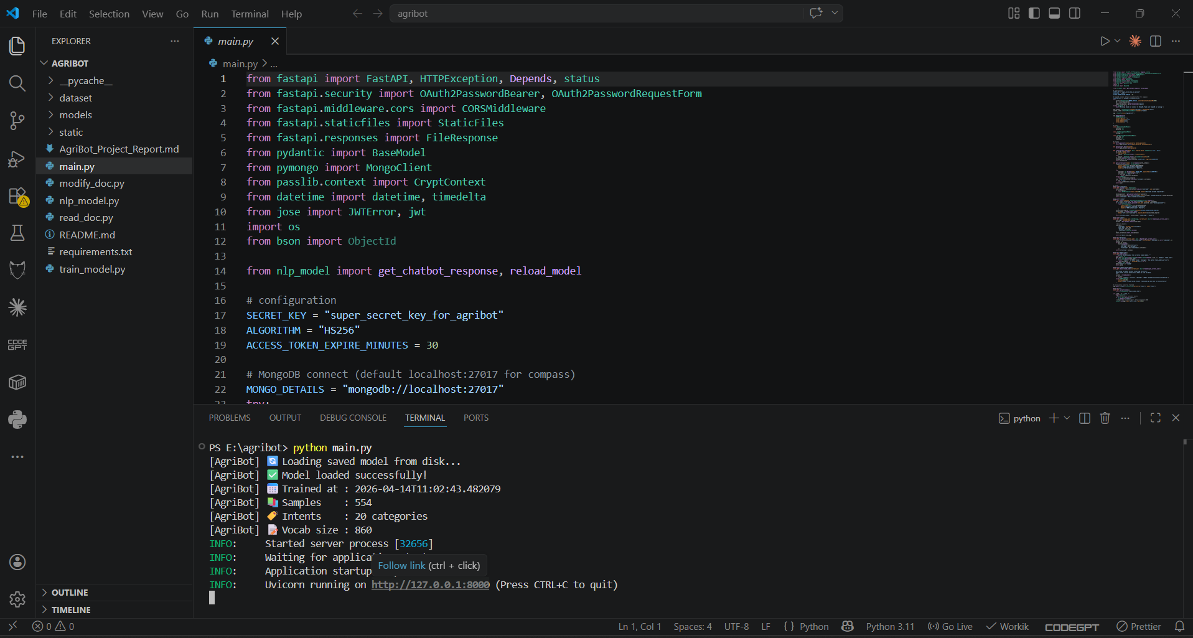
Figure 5.1 Generates a web page link

- After running the code successfully it generates a link to follow the web page.

- Simply click the following link to visit the web page.

- Then the page will appear like this (fig 5.2).

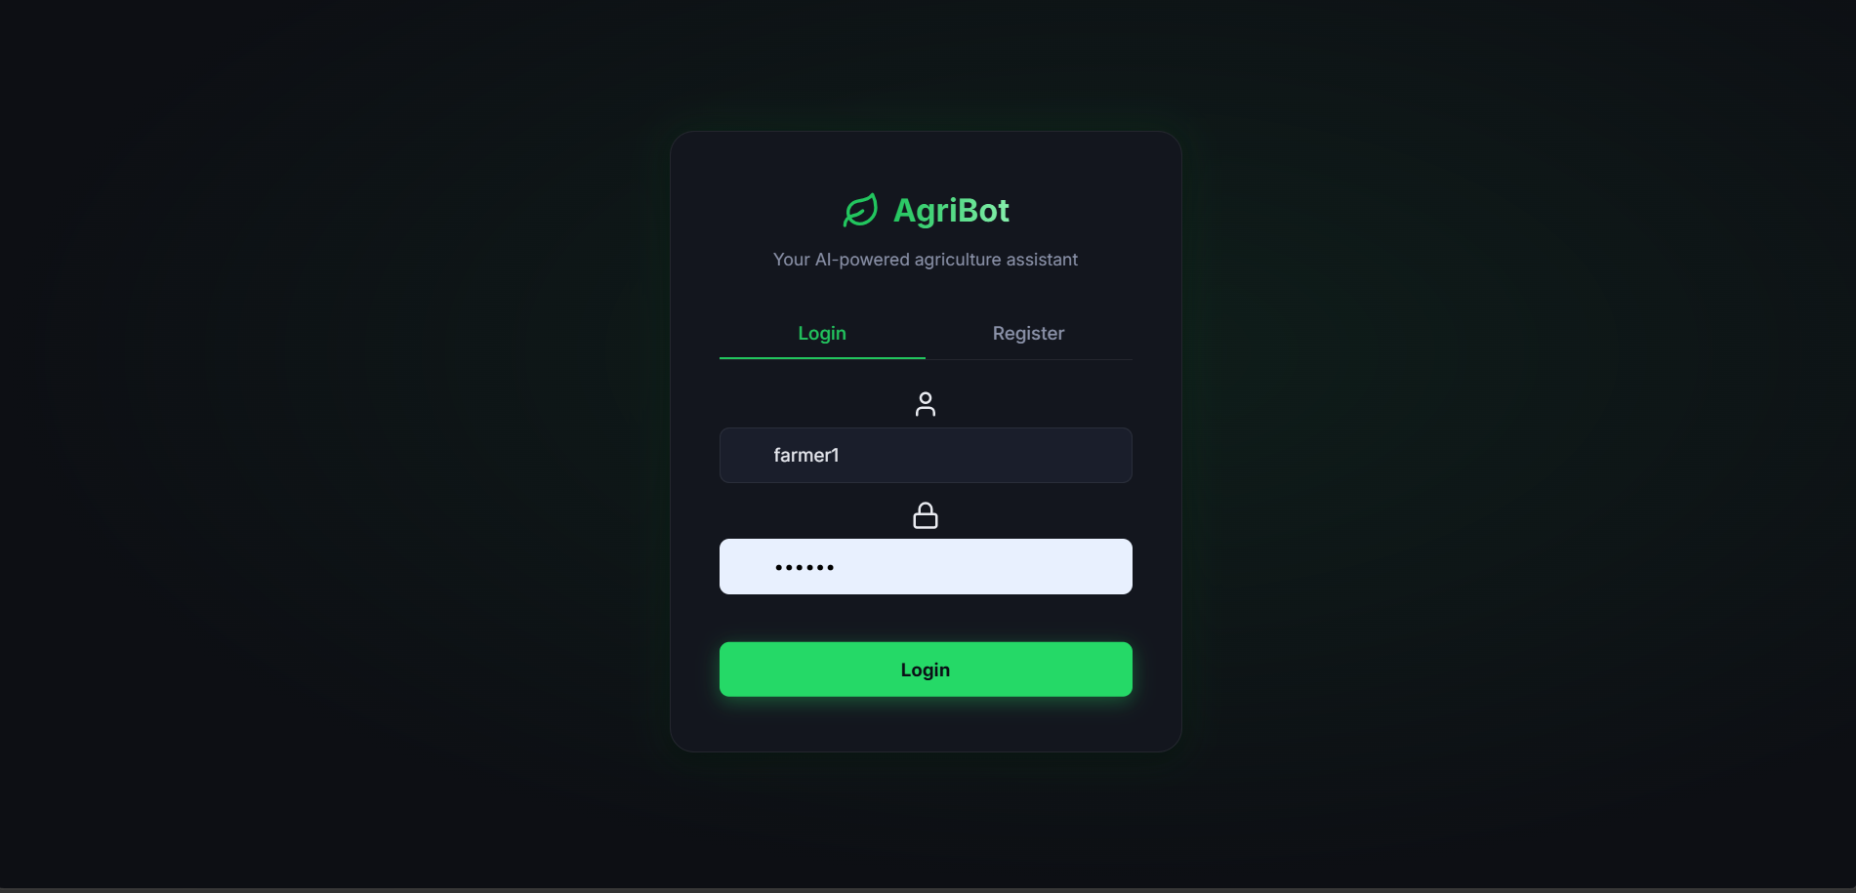
Figure 5.2 Web page interface

- Now if you are a new user you have to enroll your face by giving you name and user ID like shown in the figure 5.3

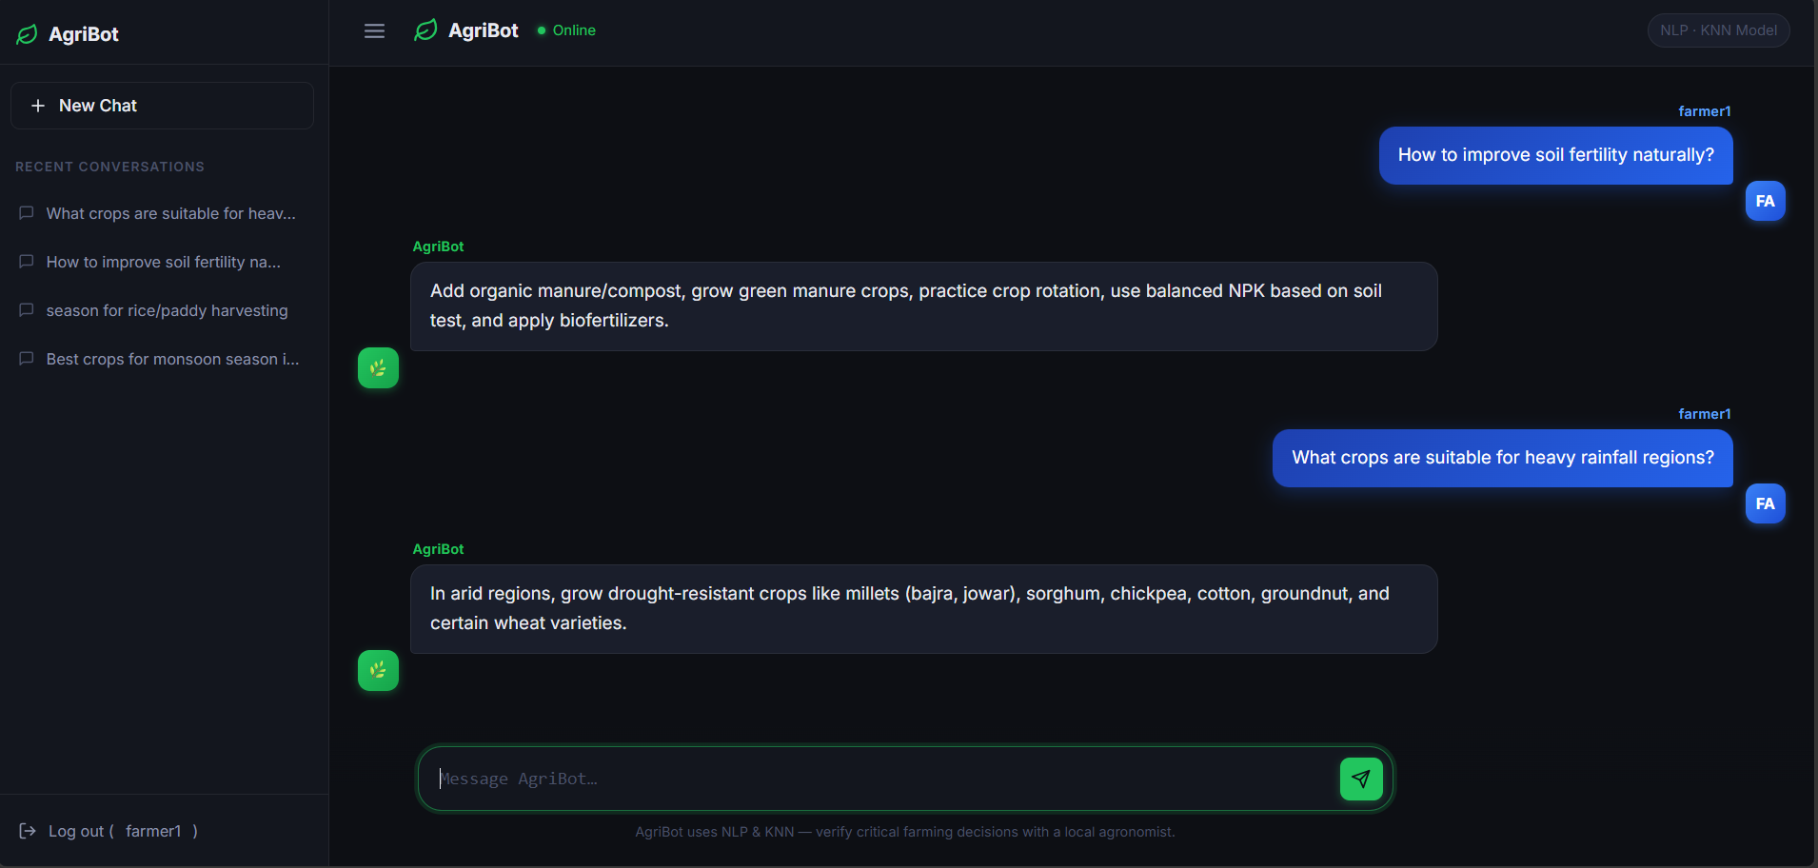
Figure 5.3 AgriBot Chat Interface Showing User Interaction

- During the chatbot interaction process, the system accepts user queries, processes them using NLP techniques, and retrieves the most relevant responses using the trained KNN model, as shown in Figure 5.4.

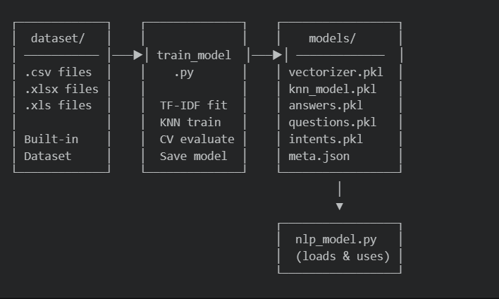
Figure 5.4 Model Training Pipeline

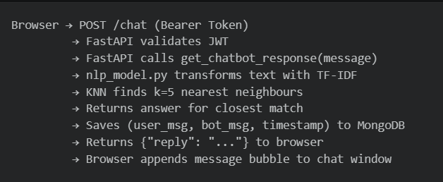
Figure 5.5 Request Flow

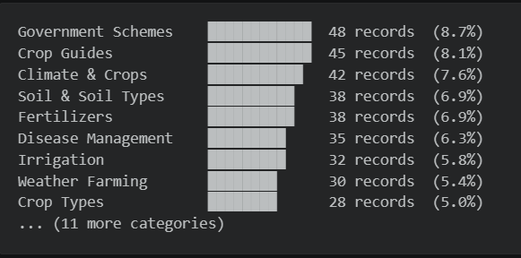
Figure 5.6 Dataset Topic Distribution

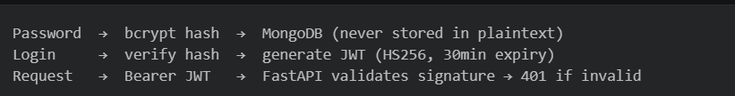
Figure 5.7 Security Architecture

CONCLUSION
The AgriBot project successfully demonstrates the application of Artificial Intelligence and Natural Language Processing in the agricultural domain. The system provides a user-friendly, efficient, and scalable solution to deliver agricultural knowledge through a conversational chatbot interface.
By integrating TF-IDF vectorization and the K-Nearest Neighbors (KNN) algorithm, AgriBot is able to understand user queries and provide accurate, relevant responses in real time. The system effectively covers various agricultural topics such as crop selection, soil management, irrigation, fertilizers, pest control, and government schemes, making it a comprehensive digital assistant for farmers.
The use of a full-stack architecture with FastAPI, MongoDB, and web technologies ensures smooth interaction, secure data handling, and persistent storage of user conversations. The modular design of the system allows easy updates, scalability, and integration of new features without major modifications.
One of the key strengths of AgriBot is its lightweight and efficient implementation, which makes it suitable for deployment in resource-constrained environments, especially rural areas. The extensible dataset and simple retraining process further enhance its adaptability to changing agricultural needs.
Although the current system performs effectively, there is scope for further improvement through advanced technologies such as multilingual support, voice interaction, real-time data integration, and deep learning models.
In conclusion, AgriBot represents a significant step towards smart agriculture, enabling farmers to access reliable information quickly and make informed decisions. The project highlights the potential of AI-driven solutions in transforming traditional farming practices and contributing to increased productivity and sustainability in agriculture.

BIBLIOGRAPHY
1.Pedregosa, F., Varoquaux, G., Gramfort, A., et al. (2011).
Scikit-learn: Machine Learning in Python. Journal of Machine Learning Research, 12, 2825–2830.
- Ramírez, S. (2018).
FastAPI Documentation. Available at: https://fastapi.tiangolo.com
- MongoDB Inc. (2024).
MongoDB Documentation. Available at: https://www.mongodb.com/docs
- Salton, G., & McGill, M. J. (1983).
Introduction to Modern Information Retrieval. McGraw-Hill.
- Cover, T., & Hart, P. (1967).
Nearest Neighbor Pattern Classification. IEEE Transactions on Information Theory, 13(1), 21–27.
- Ministry of Agriculture & Farmers' Welfare, Government of India (2024).
Agricultural Statistics and Reports. Available at: https://agricoop.nic.in
- ICAR (Indian Council of Agricultural Research) (2023).
Handbook of Agriculture. New Delhi, India.
- Digital Green (2024).
FarmerChat Platform. Available at: https://www.digitalgreen.org
- Devlin, J., Chang, M. W., Lee, K., & Toutanova, K. (2018).
BERT: Pre-training of Deep Bidirectional Transformers for Language Understanding. arXiv:1810.04805
- Mikolov, T., Chen, K., Corrado, G., & Dean, J. (2013).
Efficient Estimation of Word Representations in Vector Space. arXiv:1301.3781
- OpenWeather (2024).
Weather API Documentation. Available at: https://openweathermap.org/api
- eNAM (National Agriculture Market) (2024).
Official Portal. Available at: https://enam.gov.in
- NABARD (2024).
National Bank for Agriculture and Rural Development Reports. Available at: https://www.nabard.org
- Python Software Foundation (2024).
Python Documentation. Available at: https://docs.python.org
- NumPy Developers (2024).
NumPy Documentation. Available at: https://numpy.org/doc

APPENDIX

SOURCE CODE
from fastapi import FastAPI, HTTPException, Depends, status
from fastapi.security import OAuth2PasswordBearer, OAuth2PasswordRequestForm
from fastapi.middleware.cors import CORSMiddleware
from fastapi.staticfiles import StaticFiles
from fastapi.responses import FileResponse
from pydantic import BaseModel
from pymongo import MongoClient
from passlib.context import CryptContext
from datetime import datetime, timedelta
from jose import JWTError, jwt
import os
from bson import ObjectId

from nlp_model import get_chatbot_response, reload_model

# configuration
SECRET_KEY = "super_secret_key_for_agribot"
ALGORITHM = "HS256"
ACCESS_TOKEN_EXPIRE_MINUTES = 30

# MongoDB connect (default localhost:27017 for compass)
MONGO_DETAILS = "mongodb://localhost:27017"
try:
client = MongoClient(MONGO_DETAILS, serverSelectionTimeoutMS=5000)
db = client.agribot_db
users_collection = db.get_collection("users")
chats_collection = db.get_collection("chats")
except Exception as e:
print("Warning: Could not connect to MongoDB. Make sure MongoDB is running.")

pwd_context = CryptContext(schemes=["bcrypt"], deprecated="auto")
oauth2_scheme = OAuth2PasswordBearer(tokenUrl="token")

app = FastAPI(title="AgriBot API")

app.add_middleware(
CORSMiddleware,
allow_origins=["*"],
allow_credentials=True,
allow_methods=["*"],
allow_headers=["*"],
)

# Models
class UserCreate(BaseModel):
username: str
password: str

class ChatMessage(BaseModel):
message: str

class ChatHistoryResponse(BaseModel):
user_msg: str
bot_msg: str
timestamp: str

# Helpers
def verify_password(plain_password, hashed_password):
return pwd_context.verify(plain_password, hashed_password)

def get_password_hash(password):
return pwd_context.hash(password)

def create_access_token(data: dict, expires_delta: timedelta | None = None):
to_encode = data.copy()
if expires_delta:
expire = datetime.utcnow() + expires_delta
else:
expire = datetime.utcnow() + timedelta(minutes=15)
to_encode.update({"exp": expire})
encoded_jwt = jwt.encode(to_encode, SECRET_KEY, algorithm=ALGORITHM)
return encoded_jwt

def get_current_user(token: str = Depends(oauth2_scheme)):
credentials_exception = HTTPException(
status_code=status.HTTP_401_UNAUTHORIZED,
detail="Could not validate credentials",
headers={"WWW-Authenticate": "Bearer"},
)
try:
payload = jwt.decode(token, SECRET_KEY, algorithms=[ALGORITHM])
username: str = payload.get("sub")
if username is None:
raise credentials_exception
except JWTError:
raise credentials_exception
user = users_collection.find_one({"username": username})
if user is None:
raise credentials_exception
return user

# Routes
@app.post("/register")
async def register(user: UserCreate):
existing_user = users_collection.find_one({"username": user.username})
if existing_user:
raise HTTPException(status_code=400, detail="Username already registered")

hashed_password = get_password_hash(user.password)
users_collection.insert_one({"username": user.username, "hashed_password": hashed_password})
return {"message": "User created successfully"}

@app.post("/token")
async def login(form_data: OAuth2PasswordRequestForm = Depends()):
user = users_collection.find_one({"username": form_data.username})
if not user or not verify_password(form_data.password, user["hashed_password"]):
raise HTTPException(
status_code=status.HTTP_401_UNAUTHORIZED,
detail="Incorrect username or password",
headers={"WWW-Authenticate": "Bearer"},
)
access_token_expires = timedelta(minutes=ACCESS_TOKEN_EXPIRE_MINUTES)
access_token = create_access_token(
data={"sub": user["username"]}, expires_delta=access_token_expires
)
return {"access_token": access_token, "token_type": "bearer"}

@app.post("/chat")
async def chat(message_data: ChatMessage, current_user: dict = Depends(get_current_user)):
user_msg = message_data.message
bot_msg = get_chatbot_response(user_msg)

# Save to history
chat_doc = {
"username": current_user["username"],
"user_msg": user_msg,
"bot_msg": bot_msg,
"timestamp": datetime.utcnow()
}
chats_collection.insert_one(chat_doc)

return {"reply": bot_msg}

@app.get("/history")
async def get_history(current_user: dict = Depends(get_current_user)):
cursor = chats_collection.find({"username": current_user["username"]}).sort("timestamp", 1)
history = []
for doc in cursor:
history.append({
"user_msg": doc["user_msg"],
"bot_msg": doc["bot_msg"],
"timestamp": doc["timestamp"].isoformat()
})
return {"history": history}

@app.get("/model/info")
async def model_info():
"""Returns metadata about the currently loaded model."""
import json, os
meta_path = os.path.join(os.path.dirname(os.path.abspath(__file__)), "models", "meta.json")
if not os.path.exists(meta_path):
return {"status": "no model found", "message": "Run python train_model.py first"}
with open(meta_path, "r", encoding="utf-8") as f:
meta = json.load(f)
meta["status"] = "loaded"
return meta

@app.post("/admin/reload-model")
async def admin_reload_model(current_user: dict = Depends(get_current_user)):
"""
Hot-reload the model without restarting the server.
Useful after running python train_model.py with new data.
"""
success = reload_model()
if success:
return {"status": "success", "message": "Model reloaded successfully from disk."}
raise HTTPException(
status_code=503,
detail="Model reload failed. Ensure train_model.py has been run successfully."
)

# Serve static files for frontend
app.mount("/static", StaticFiles(directory="static"), name="static")

@app.get("/")
async def serve_frontend():
return FileResponse("static/index.html")

if __name__ == "__main__":
import uvicorn
# Make sure static directory exists
if not os.path.exists("static"):
os.makedirs("static")
# ✅ Open this in your browser: http://localhost:8000
uvicorn.run(app, host="127.0.0.1", port=8000)

