import java.util.Scanner;
class book{
int book_id;
String title;
String author;
double price;
static int book_number=0;
book(int b,String t,String a,double p){
book_id=b;
title=t;
author=a;
price=p;
book_number++;
}
static int getbook_number(){
return book_number;
}
void display(){
System.out.println("Books details are:"+"Book id is:"+book_id+" "+"Title is:"+title+" "+"Author is:"+author+" "+"Price is:"+price);
}
void search(int id){
if(id==book_id){
System.out.println("Book id is found");
}
else{
System.out.println("Book id is not availabl;e!!!");
}
}
void search(String BN){
if(BN.equalsIgnoreCase(title)){
System.out.println("Book title is found");
}
else{
System.out.println("Book title is not available!!!");
}
}
book accept(book ob){
if(price>ob.price){
return this;
//System.out.println("Book 1 is costilier");
}
else{
return ob;
}
}
}
class b_run{
public static void main(String arg[]){
book b1=new book(14,"abc","Mr.K",1450);
book b2=new book(18,"xyz","Mr.R",700);
book b3=new book(7,"lmn","Mr.B",550);
b1.display();
b2.display();
b3.display();
b1.search(14);
b2.search("pqr");
book b4=b1.accept(b3);
System.out.println(b4.title +" is costlier");
System.out.println("Total number of books are:" + book.book_number);
System.out.println();
}
}

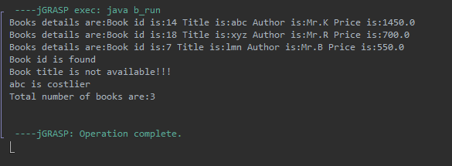
Name:Krish Kumar Gupta
USN:1BF25CS127

