CST 2406

04/05/2016

Krishna Lama

***Scope Definition (FAST Phase 1):***

Everest mobile USA’s project is initiated very lately and member service system project is still underway. In order to achieve the desire goal of assigned project, a system of this project uses the information system along with its every possible system class includes Transaction Processing System, Management Information System, Executive information System, Decision Supportive System, Expert System, communication and collaboration System and Office automation System. Requirements gathering of the project has not been completed and the detailed scope have been defined for the project. At this stage, project constraints, deliverables and acceptance criteria need to be documented. In this phase an assigned project manager conducting initial activities to collect everyone’s perspective on the system to find out the potential achievement. This system also has both Front Office Information System and Back Office Information System which literally supports various external and internal business functions to fulfil its goal.

Using the information system in project it is much easier to build the visual framework of project to avoid unnecessary too much work and detail early. Besides, Information System will be made every single process of system easier to be done. It helps to analyze, design and problem solving the business requirement, and achieve the targeted goal. The estimated time of compliance is a year from launched date if at least 50 employees carry out activities for this project. The cost of this project is 10 million US dollars.

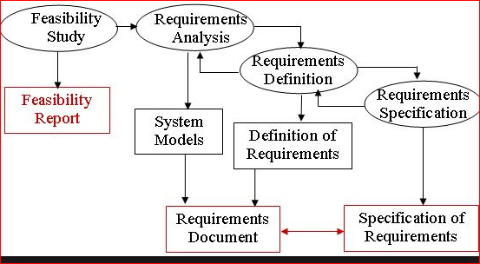

***Problem Analysis (FAST Phase 2):***

No matter what information system is currently being used, there is always an existing system which has its own terminology, history, culture, and nuances. The goal of the problem analysis phase is to study and understand the problem domain well enough to thoroughly analyze its problems, opportunities and constraints. The problem analysis phase typically includes the following tasks:

(1) Understand the problem domain;

(2) Analyze problems and opportunities;

(3) analyze business processes;

(4) establish system improvement objectives;

(5) Update or refine the project plan;

(6) Communicate findings and recommendations. In other word this phase is by the statement, "Don't try to fix it unless you understand it."

-Problems come in a variety of shapes and sizes. For example; reducing the duration of project compliance if hiring few more people to support the system team.

Qualification for beginner: Will this project system team be able to address the financial aid federal qualification if required?

-Hiring employee: will hiring employees could help the better performance of the system, or else exceed the total cost of project.

-Threats for New beginner: The mobile company is highly concentrated. Since the startup cost is very high and a few existing major company’s which has already been operating with distinguish strategies that control 75% of total today market, the beginner has to go through massive hardship to sustain in market.

- Threat of substitute products and services: The cell phone market is increasing very fast with today’s ever-emerging technology and innovation in improving cell phones.e.g. Some major operators are upgrading their networks to advance wireless and other third and fourth generation services along with GPS and entertaining technology. So with the technology the company has could compete the market?

-Dealing with Suppliers: Mobile phone operators provide such a high volume order that suppliers have not been considered the relationship which could lead the new beginner end up being in low bargaining position. Phone carriers tending to seek for even more features in the handsets and increase the pressure on Suppliers with the reverse auction.

***Requirements Analysis (FAST Phase 3):***

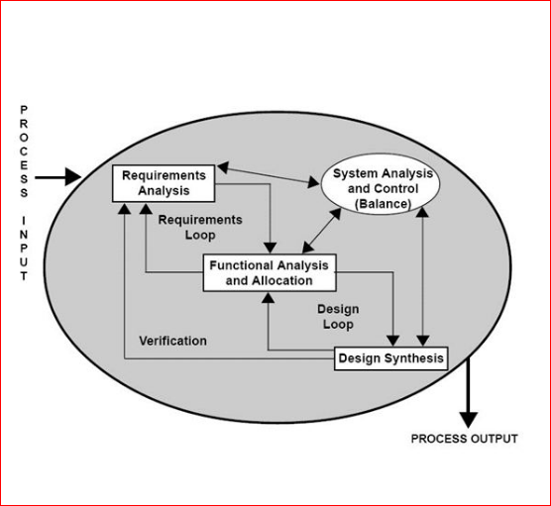

Every new activity, every new product, every new project in the workplace is created in response to a business need. A focused and detailed business requirements analysis can help us avoid problems like these. This is the process of discovering, analyzing, defining, and documenting the requirements that are related to a specific business objective. In Requirement Analysis phase, we need to define and prioritize the business requirements in according to the real world market needs. In this phase consist of system users, systems analyst and project managers to determine business requirements that are based on the business's goals, processes, need for business information and system interface requirements. System designers are omitted in order to avoid the consideration of any technical potential or solutions as they are dependent on system analysts to validate with the users to define business requirements before applying any technological design. Everest mobile USA already has established procedures and methodologies for conducting business requirements analyses, which may have been optimized specifically for this organization.

Analysis Objectives of Everest Mobile USA

* Identify customer’s needs.
* Evaluate system for feasibility.
* Perform economic and technical analysis.
* Allocate functions to system elements.
* Establish schedule and constraints.
* Create system definitions.

However, the requirement analysis phases typically includes different tasks from Identifying and expressing its system model to communicate the requirement statement where the proposed system should provide utility and functionality that falls into four categories for specific internal or external functional requirement includes;

1. Features used to administer the system;

* A deeper understanding of Mobile Audience (Learn how customers are using Everest mobile site or app and understand their device-specific needs, wants, intents and expectations.)
* Service using telephone orders, mail upgrading to automate the ordering process by developing an online system.
* Identify IT processes that support each of the business processes includes

Modify priorities of existing order, add or remove user privileges, update users information, create store associates passwords,reset password,creat or delete user account

1. Features used by the clients;

* Select the mobile plan and handsets, designs, and number of mobiles.
* Log in and enter the delivery address.
* Specify the time of delivery
* Revise or delete their orders.
* Check Status
* Check loyalty points

1. Strategic and Analytic Functionality;

* List the name and address of Suppliers and prioritize them
* List the clients and their address and prioritize them.
* Gather daily, weekly, monthly and quarterly sales report.
* Summarize sales activities by region, states and country.
* Summarize client’s feedback.

1. Suppliers Functionality;

* List the clients name and address.
* Categorize the clients.
* Receive the orders.
* Submit the invoice.
* Send the orders.

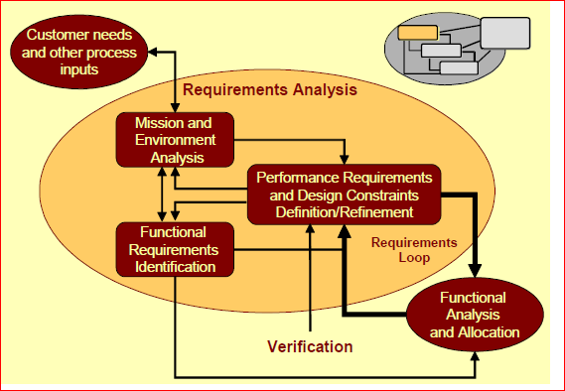

***Logical Design (FAST Phase 4):***

The logical design phase is normally interpreted business requirements into system models to show the system independent of any possible technical solution. In this phase include system analysts, system users and the project managers. Usually project managers need to ensure that system model meets in standards, structured analysis and design. System analyst can draw system models to classify in logical data models, logical process models and logical interface models that represent data and information requirements (Knowledge), business processes requirements (Process) and system interface requirements (Communication).

A logical data model describes the data in as much detail as possible, without regard to how they will be physical implemented in the database. Features of a logical data model include:

Includes all entities and relationships among them.

All attributes for each entity are specified.

The primary key for each entity is specified.

Foreign keys (keys identifying the relationship between different entities) are specified.

Normalization occurs at this level.

The steps for designing the logical data model are as follows:

Specify primary keys for all entities.

Find the relationships between different entities.

Find all attributes for each entity.

Resolve many-to-many relationships.

Normalization.

The figure below is an example of a logical data model.

***Logical data model of Everest Mobile***

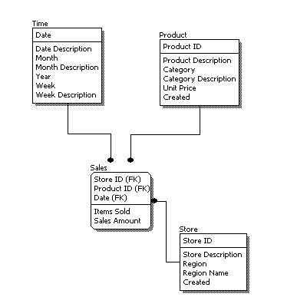

***A Process Model of the Everest Mobile proposed System***

The process modeling is an important building block in a systems development activities as it defines what’s going on now, and what should be going on in the new system. Of course, narrative explanation of the processes is one way to do; more and more organizations rely on visual presentation of systems.

