Experiment 10

Student Name: Krish Latawa UID: 24BAI70541
Branch: CSE - AIML Section/Group: 24AIT_KRG G1
Semester: 4 Date of Performance: 17/4/26
Subject Name: DBMS Subject Code: 24CSH-298

Aim

To design a trigger that automatically implements the functionality of a primary key, ensuring unique identification of records without manual intervention.

Software Requirements
- Database Management System:
  - Oracle Database Express Edition (Oracle XE)
  - PostgreSQL Database
- Database Administration Tool / Client Tool:
  - Oracle SQL Developer (for Oracle XE)
  - pgAdmin (for PostgreSQL)

Objectives

To create a database trigger that automatically enforces primary key constraints or generates unique key values, replicating the functionality of a stored procedure.

Problem Statement
In enterprise databases, primary keys must be unique for every record. Manual assignment of keys can lead to errors.
Design a trigger that:
Automatically generates or enforces a primary key value during record insertion.
Implements the logic similar to a stored procedure.
Demonstrates automated primary key functionality for a table.
(Industry relevance: Amazon, Flipkart, Oracle)

Theory

A trigger can be designed to automatically enforce the functionality of a primary key by ensuring that each record inserted into a table is uniquely identifiable without requiring manual checks. This is achieved by defining a trigger that activates before or after an insert operation and validates whether the incoming data violates uniqueness constraints. If a duplicate value is detected in the designated key column, the trigger can prevent the insertion or raise an error, thereby maintaining data integrity. Additionally, such a trigger can be used to generate unique values dynamically (for example, using sequences or custom logic) when a primary key is not explicitly provided. This approach helps in maintaining consistency, avoiding redundancy, and ensuring that each record can be uniquely referenced within the database system.

Practical/Experiment Steps
- Identify the table requiring automated primary key enforcement.
- Design a trigger that activates before insert operations.
- Ensure that every new record receives a unique primary key automatically.
- Validate the trigger by inserting multiple records and verifying unique keys.

Procedure
- Create the table
Define a table without explicitly enforcing a primary key constraint (or assume you want custom control).
- Identify the key column
Choose the column that should behave like a primary key (e.g., id).
- Write a BEFORE INSERT trigger
Create a trigger that fires before inserting a new record.
- Check for duplicate values
Inside the trigger, query the table to see if the incoming key value already exists.
- Handle duplicates
If a duplicate is found, raise an error and prevent insertion.
- (Optional) Auto-generate key
If no key is provided, assign a unique value automatically (e.g., using MAX(id)+1 or a sequence).
- Test the trigger
Insert records to verify:
- Unique values are accepted
- Duplicate values are rejected

Code
-- Step 1: Create table
CREATE TABLE students (
id INT,
name VARCHAR(50)
);

-- Step 2: Create trigger function
CREATE OR REPLACE FUNCTION check_unique_id()
RETURNS TRIGGER AS $$
BEGIN

-- Step 3: Auto-generate ID if NULL
IF NEW.id IS NULL THEN
SELECT COALESCE(MAX(id), 0) + 1 INTO NEW.id FROM students;
END IF;

-- Step 4: Check for duplicate ID
IF EXISTS (SELECT 1 FROM students WHERE id = NEW.id) THEN
RAISE EXCEPTION 'Duplicate ID not allowed!';
END IF;

RETURN NEW;
END;
$$ LANGUAGE plpgsql;

-- Step 5: Create trigger
CREATE TRIGGER before_insert_students
BEFORE INSERT ON students
FOR EACH ROW
EXECUTE FUNCTION check_unique_id();

-- Step 6: Testing
INSERT INTO students VALUES (101, 'Krish'); -- Works
INSERT INTO students VALUES (102, 'Rahul'); -- Error
INSERT INTO students VALUES (NULL, 'Aman'); -- Auto-generated ID
Input/Output Analysis

SQL INPUT QUERIES:-
CREATE TABLE students (
id INT,
name VARCHAR(50)
);

OUTPUT:-
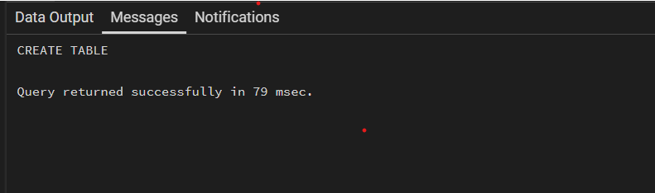

SQL INPUT QUERIES:-
-- Step 2: Create trigger function
CREATE OR REPLACE FUNCTION check_unique_id()
RETURNS TRIGGER AS $$
BEGIN

-- Step 3: Auto-generate ID if NULL
IF NEW.id IS NULL THEN
SELECT COALESCE(MAX(id), 0) + 1 INTO NEW.id FROM students;
END IF;

-- Step 4: Check for duplicate ID
IF EXISTS (SELECT 1 FROM students WHERE id = NEW.id) THEN
RAISE EXCEPTION 'Duplicate ID not allowed!';
END IF;

RETURN NEW;
END;
$$ LANGUAGE plpgsql;

OUTPUT:-
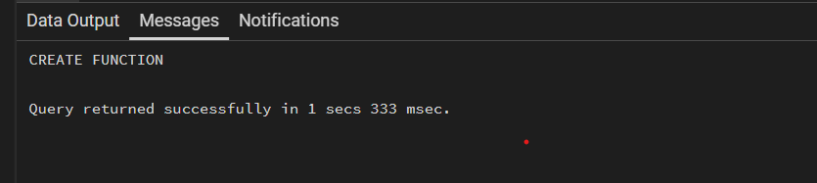

SQL INPUT QUERIES:-
-- Step 5: Create trigger
CREATE TRIGGER before_insert_students
BEFORE INSERT ON students
FOR EACH ROW
EXECUTE FUNCTION check_unique_id();

OUTPUT:-
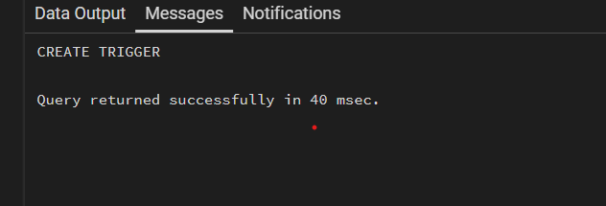

SQL INPUT QUERIES:-
-- Step 6: Testing
INSERT INTO students VALUES (101, 'Krish'); -- Works
INSERT INTO students VALUES (102, 'Rahul'); -- Error
INSERT INTO students VALUES (NULL, 'Aman'); -- Auto-generated ID

OUTPUT:-
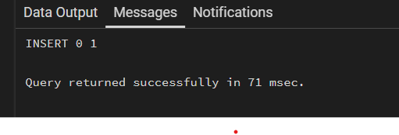

Learning Outcomes
- After completing this experiment, the learner will be able to:
- Understand the purpose and working of database triggers.
- Implement automated primary key functionality using triggers.
- Ensure data integrity without manual key assignment.
- Apply trigger-based automation in real-world enterprise applications such as Amazon, Flipkart, and Oracle.

