

EASLY CHAT APPLICATION
By

KRISH MANAVADARIYA (25MCA090) AYAZ DARJADA (25MCA005)

Under Guidance of
Internal Guide
MUBINA MALIK

Submitted to

Smt. Chandaben Mohanbhai Patel Institute of Computer Applications CHARUSAT
Changa

April 2026

Accredited with Grade A+ by NAAC,
CHAROTAR UNIVERSITY OF SCIENCE AND TECHNOLOGY
Changa

Acknowledgement
Knowledge in itself is a continuous process. At this moment of our substantial enhancement, We rarely find words to express our gratitude towards those who were constantly involved with us.
The completion of any inter disciplinary project depends upon coordination, cooperation and combined efforts of several resources of knowledge, creativity, skill, energy and time. The work being accomplished now, we feel our sincerest urge to recall and knowledge through these lines, trying our best to give full credit wherever it deserves.
We would like to thank our project guide Mr./Ms./Dr. , Principal Dr. Dharmendra Patel and Dean Dr. Sanskruti Patel who advised and gave us moral support through the duration of our project. Without their constant encouragement we could not have been able to achieve what we have.
It’s our good fortune that we had support and well wishes of many. We are thankful to all and those names which have been forgotten to acknowledge here but contributions have not gone unnoticed.

With Sincere Regards,
Krish Manavadariya (25MCA090)
Ayaz Darjada(25MCA005)

Table of Contents

Sr. No |  | Subject | Page Number
1 |  | Project Profile & Company Profile
2 |  | Introduction to tools
3 |  | System Study
 | 1. | Existing System
 | 2. | Proposed System
 | 3. | Scope of the Proposed System
 | 4. | Aim and Objective of the Proposed System
 | 5. | Feasibility Study
 |  | Operational Feasibility
 |  | Technical Feasibility
 |  | Economical Feasibility
4 |  | System Analysis
Requirements Specification (along with
System Modules)
 |  | Use Case Diagram
 |  | Activity Diagram
 |  | Class Diagram
 |  | OR
System FlowChart
Functional Decomposition Diagram DFD
- Context Level DFD
- First Level, Second Level ….
5 |  | System Design
 |  | Data Dictionary
 |  | Screen Layouts
 |  | Reports
6 |  | System Testing
 |  | Testing Strategies
 |  | Test Cases
7 |  | Future Enhancement
8 |  | Bibliography/References
9 |  | Reporting Report (to be collected from  respective internal guide)

PROJECT PROFILE

Project Profile
Project Name: Easly - Chat App Type of Application: Web Application
Project Description: The project is a web-based application designed for Easly-Chat
is a real-time messaging application that enables users to chat with friends, manage friend
requests, create group chats, and view online status for easy and instant communication.

Team Size: 2

Front End: React.js, Tailwind CSS, Material UI (MUI), Redux Toolkit, RTK Query

Back End: Node.js, MongoDB ,Cloudinary

Development Tools used: Vs code, Postman, MongoDB compass,

INTRODUCTION TO TOOLS

Introduction to Tools

Front End Tool:

  - In web development, the front-end of a website or web application is responsible for providing the user interface and user experience. The front-end is built using several technologies such as React.js, Redux Toolkit and Tailwind CSS. These technologies work together to create a seamless and interactive experience for users.

  - React.js: React.js is a JavaScript library for building user interface. It uses a component-based architecture. React.js create a virtual DOM to update only parts of page that need to change rather than reloading entire page. This makes React applications fast and responsive.

  - Tailwind CSS: Tailwind CSS is CSS framework that provides utility classes to build designs. It does not provide pre-designed components like Bootstrap. Tailwind CSS provides classes to design UI exactly as you want. Tailwind CSS provides customizations as you want.

    - Back End Tool:

  - Node.js: Node.js is a runtime environment for JavaScript which is built on Chrome’s V8 engine. It allows developers to execute JavaScript code on server-side. It is open-source, event-driven. Developers can develop server-side application, handle HTTP requests and connect with database using Node.js.

  - MongoDB: MongoDB is a NoSQL type database which can store and manage the data. MongoDB is document base database. MongoDB is highly flexible and scalable database. Data store in form of JSON-like documents with schema. MongoDB uses a query language that enables developers to create, read, update, and delete data using JavaScript-style object notation

SYSTEM STUDY

- Existing System:

- Traditional communication methods often do not provide real-time message delivery.
- Users need to refresh the application to receive new messages in many systems.
- Limited support for instant online/offline status updates.
- Group communication and member management are often difficult to manage.
- No efficient way to track unread (pending) messages.
- Friend management features such as sending and accepting friend requests are not available in basic messaging systems.
- Communication is less interactive and less efficient for collaborative discussions.

- Proposed System:
  - The following are one users of the system: -
    - User
- Authentication:
    - User registration and secure login.
    - Protected routes to ensure authorized access.

- Friend Management:
    - Send friend requests.
    - Accept friend requests.
    - View friend list.

- Personal Chat:
- Real-time one-to-one messaging.
- Instant message delivery using Socket.io.
- View conversation history.
- Display unread (pending) message count.

- Group Chat:
- Create chat groups.
- Add members to groups.
- Delete groups.
- Real-time group messaging.

- Real-Time Features:
- Display users' online/offline status.
- Instant message synchronization without page refresh.
- Live updates for messages and notifications.

- Scope of Proposed System:
- Real-time digital communication platform.
- Instant one-to-one and group messaging.
- Friend request and contact management.
- Online/offline user status tracking.
- Unread message notifications.
- Scalable and responsive web application for personal and collaborative communication.

- Aims and Objective of Proposed System:
- Provide fast and reliable real-time communication.
- Enable secure user authentication and friend management.
- Support one-to-one and group conversations.
- Display users' online status and unread message counts.
- Deliver a simple, responsive, and user-friendly messaging experience.
- Improve collaboration through efficient and organized communication.

- Feasibility Study:

  - Operational Feasibility: -
  - The system provides a simple and user-friendly interface for real-time communication.
  - Users can send and receive messages instantly without refreshing the page.
  - The system supports one-to-one chats as well as group conversations.
  - Users can manage friends by sending and accepting friend requests.
  - The application displays online/offline status and unread message counts in real time, improving the overall user experience.

  - Technical Feasibility: -
    - The system is developed using modern web technologies such as React.js, Node.js, MongoDB, Socket.io, Redux Toolkit, and Tailwind CSS.
    - It supports both desktop and mobile devices through a responsive user interface.
    - Real-time communication is achieved using Socket.io, ensuring instant message delivery.
    - Secure user authentication and protected routes ensure that only authorized users can access the application.

  - Economical Feasibility: -
    - The application is developed using open-source technologies, reducing development costs.
    - The system reduces communication delays by enabling instant messaging.
    - The scalable architecture allows future enhancements without significant additional cost.

SYSTEM ANALYSIS

- System Requirement Specification

- Authentication Module:

    - User registration.
    - Secure login with email and password.
    - Protected routes for authenticated users.
    - Secure logout functionality.

- Friend Management Module:

- Send friend requests.
- Accept friend requests.
- View friend list.
- Manage user connections.

- Personal Chat Module:

- Real-time one-to-one messaging.
- Instant message delivery and receiving.
- Display chat history.
- Show unread (pending) message count.
- Display online/offline status of users.
- Your message contains inappropriate content.

- Group Module:

- Create new chat groups.
- Add members to a group.
- View group members.
- Remove group member
- Delete group.
- Manage group conversations.

- Real-Time Notification Module:

- Display real-time online/offline user status.
- Show unread message notifications.
- Instantly update new messages without page refresh.
- Synchronize chat data in real time using Socket.io.

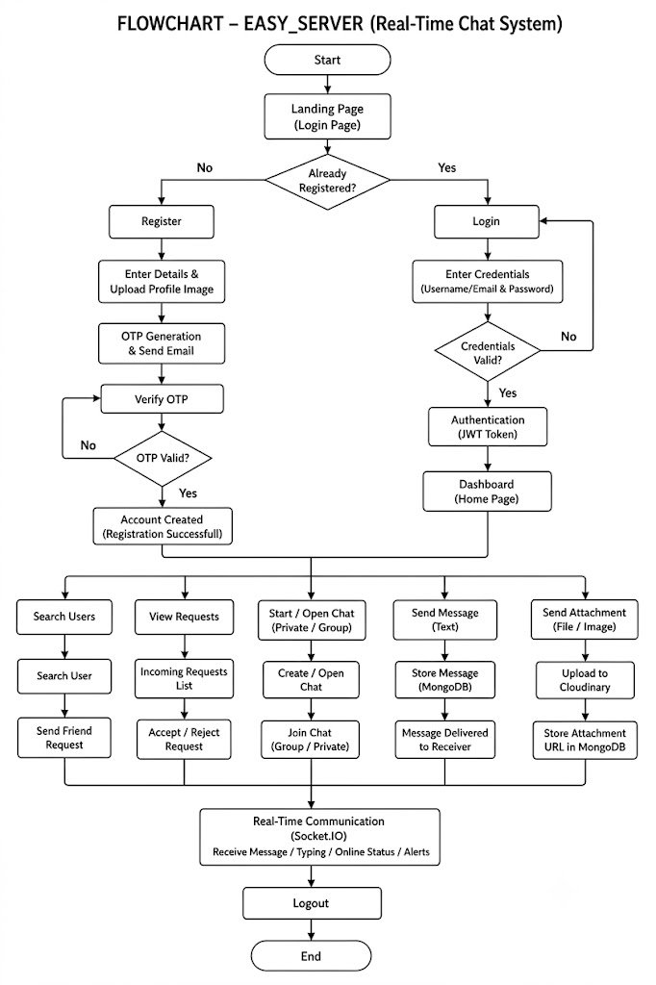
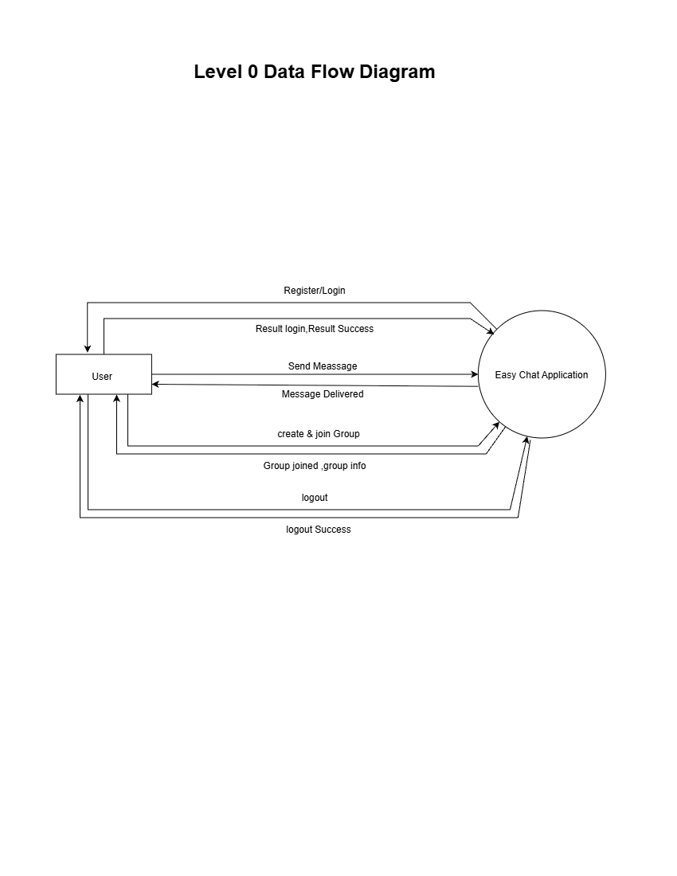

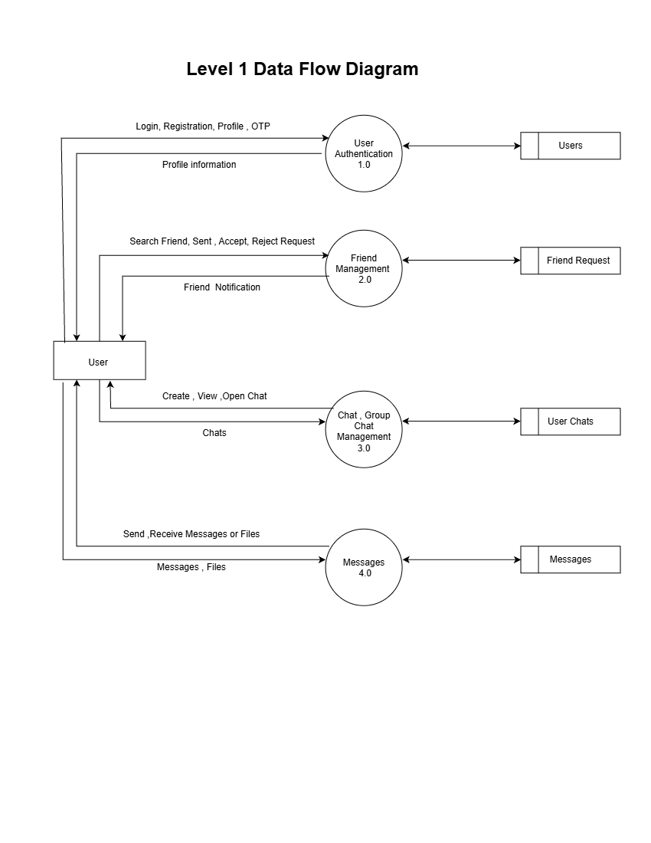

SYSTEM DESIGN

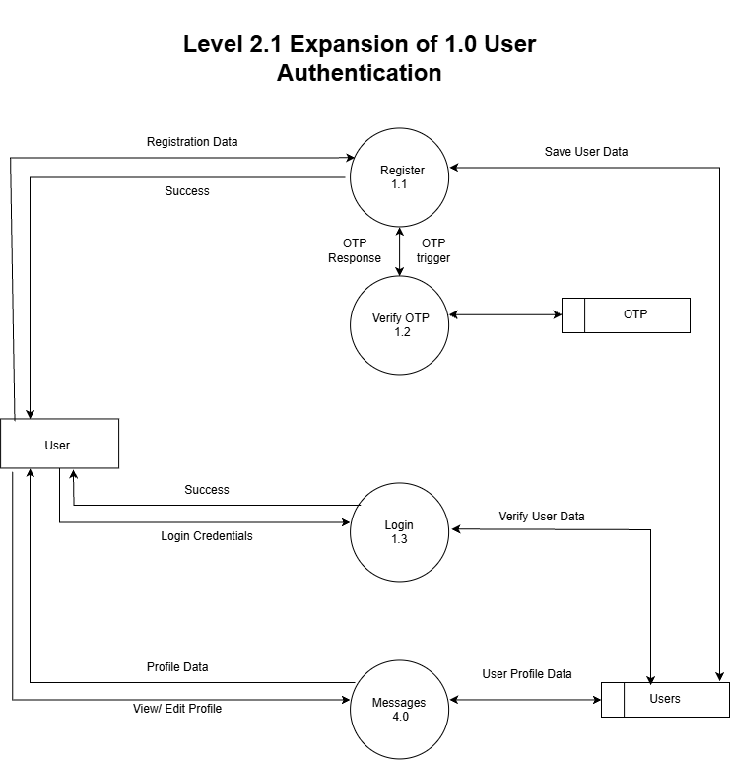

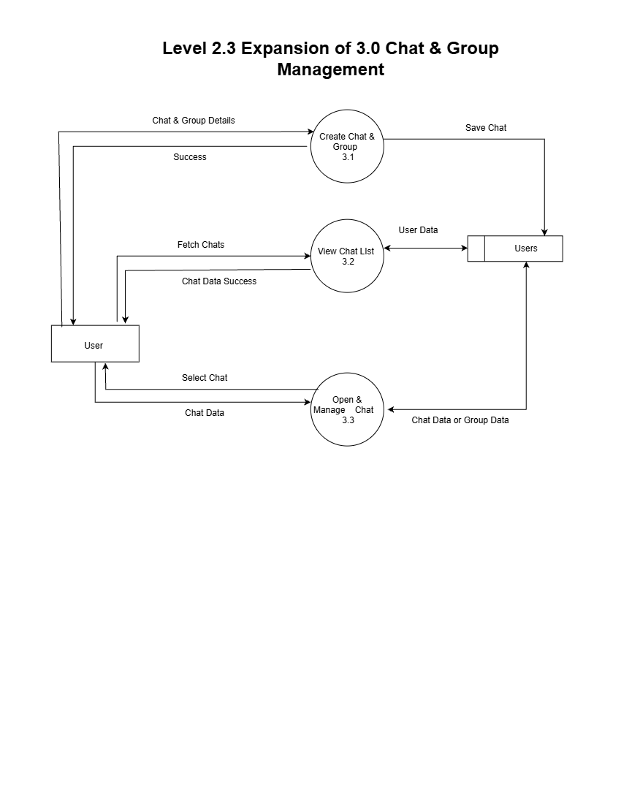

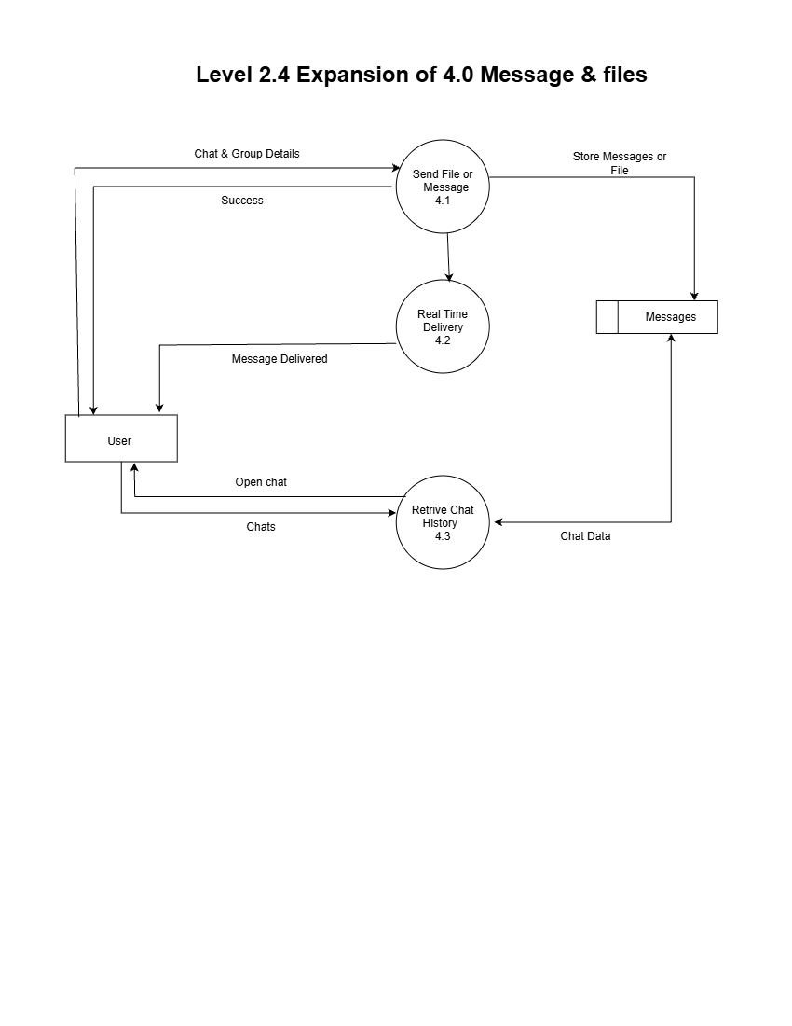

- Data Dictionary:-

- User Table:
Column | Type | Constraint | Enum
Name | String | Required | -
userverified | Boolean | Optional | Default: false
username | String | Required | -
Email | String | Required,Unique | -
password | String | Required | select: false
avatar.public_id | String | Required | -
avatar.url | Boolean | Required | -
bio | String | Required | -

- Chat Table:
Column | Type | Constraint | Enum
Name | Sting | Required | -
groupchat | Boolean | Optional | Default: false
creator | ObjectId | Optional | Ref: "Users"
member | Array of ObjectId | Optional | Ref: "Users"
timestamps | Auto-generated | Required | CreatedAt, UpdatedAt

- Message Table:

Column | Type | Constraint | Enum
content | String | Optional | -
attachments.public_id | String | Required | -
attachments.url | String | Required | -
sender | ObjectId | Required | Ref: "Users"
chat | ObjectId | Required | Ref: "Users"
timestamps | Auto-generated | Required | CreatedAt, UpdatedAt

- OTP Table:

Column | Type | Constraint | Enum
email | String | Required | -
category | String | Required | Enum: ["register", "forget-password"]
Otp | Number | - | Enum: tokenStatus
timestamps | Auto-generated | Required | CreatedAt, UpdatedAt

- Request Table:

Column | Type | Constraint | Enum
status | String | Optional | Enum: ["pending", "accepted", "rejected"], Default: "pending"
sender | ObjectId | Required | Ref: "Users"
chat | ObjectId | Optional | Ref: "Users"
receiver | ObjectId | Required | Ref: "Users"
timestamps | Auto-generated | Required | CreatedAt, UpdatedAt

- Screen Layouts

  - SingUp Page: -
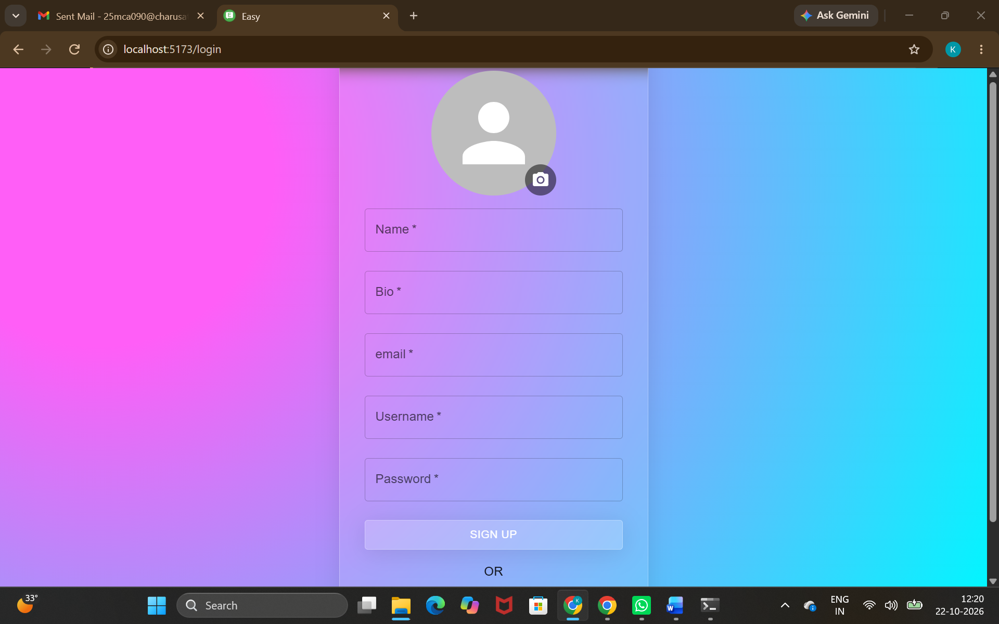

  - Login Page: -
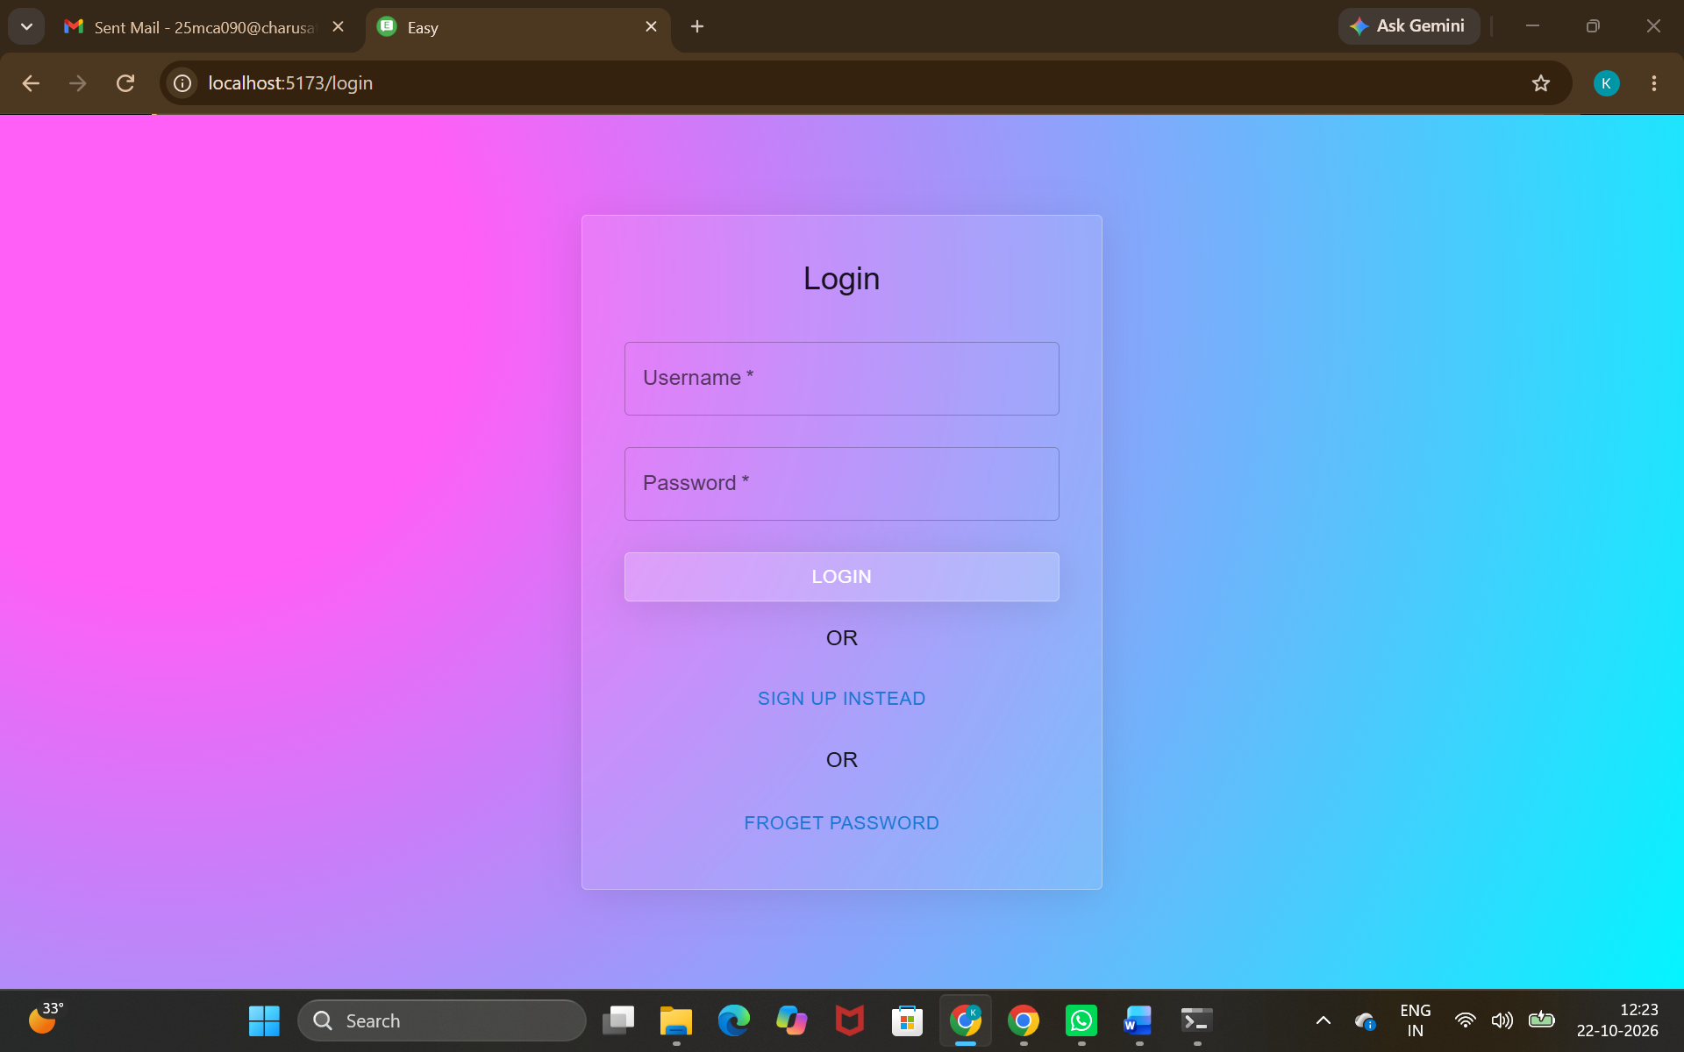

  - Forgot password: -
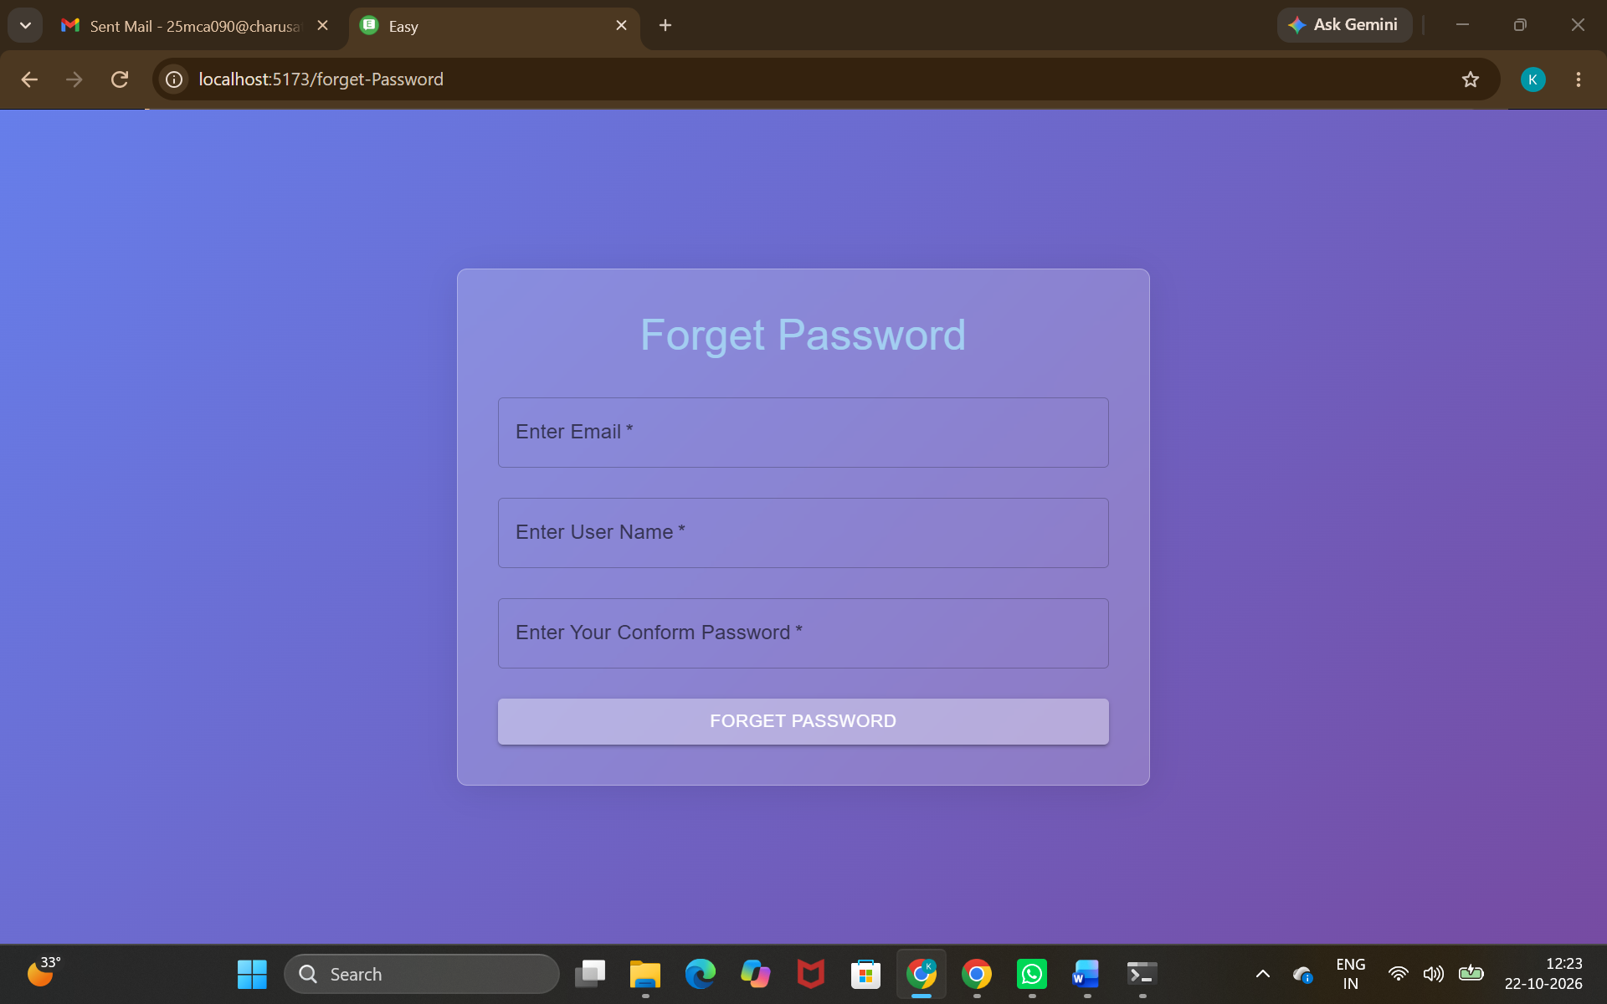

  - Dashboard Page: -
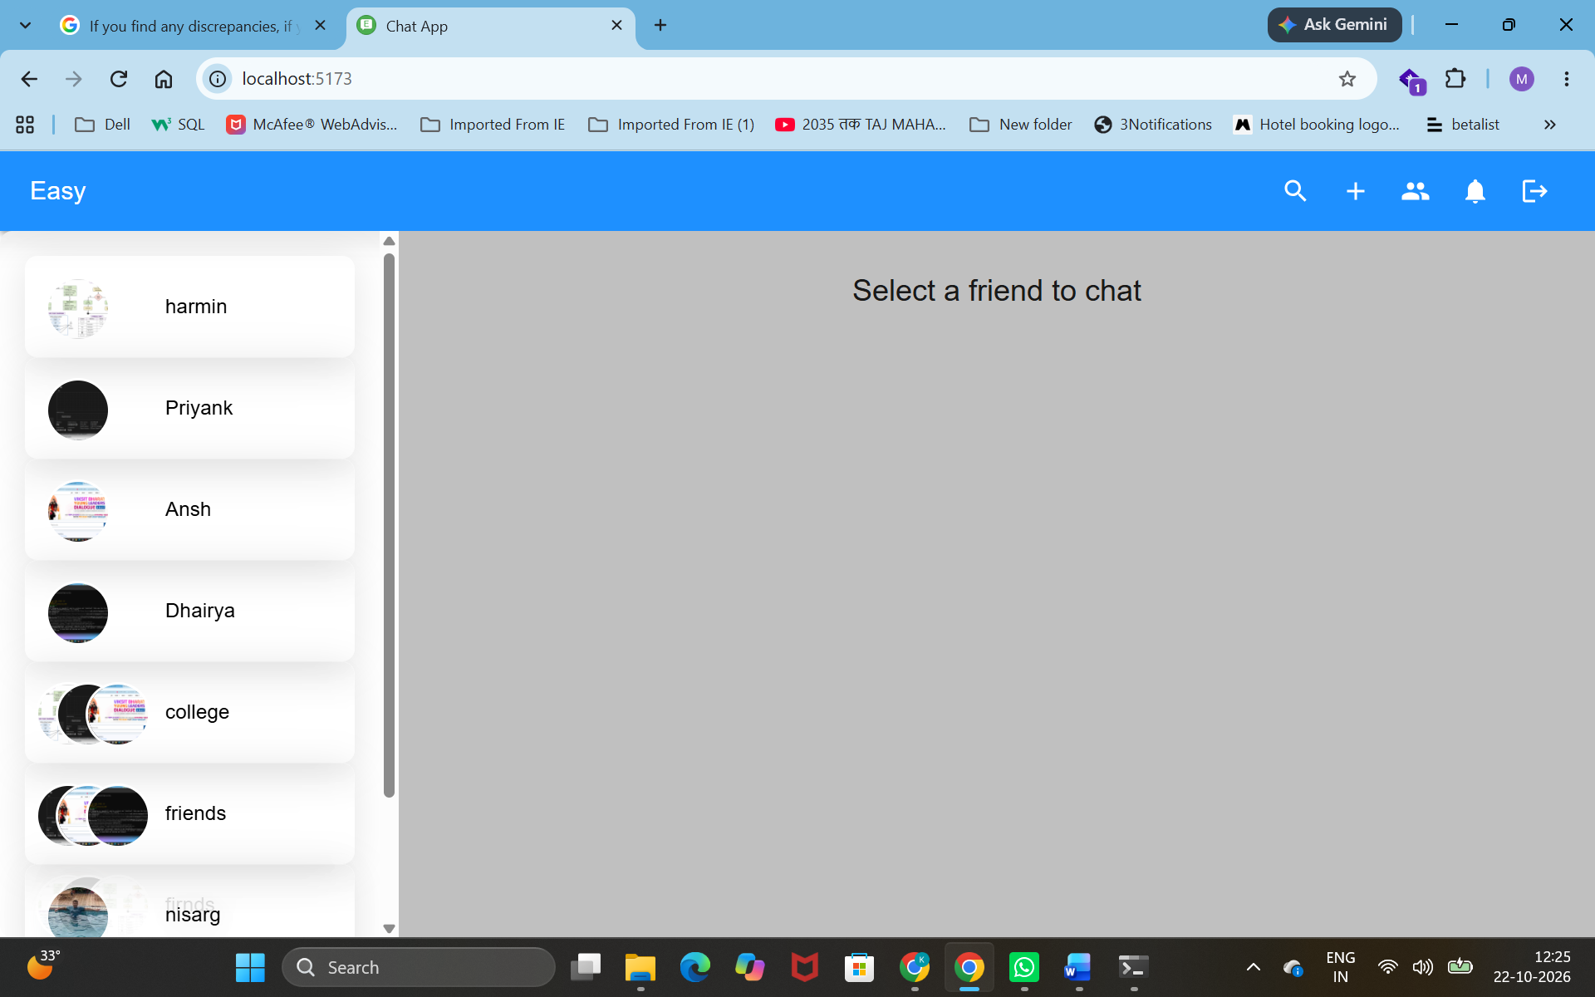

  - Friend Request Page: -
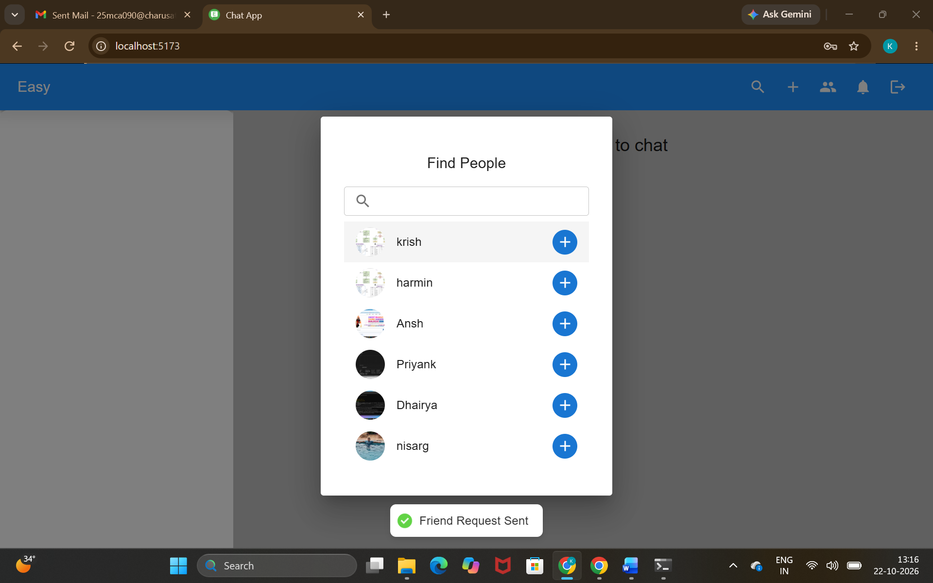

  - Notifications: -
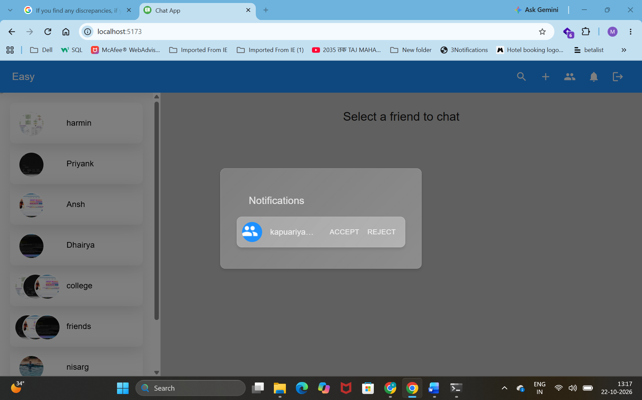

  - Friend Chat Page: -
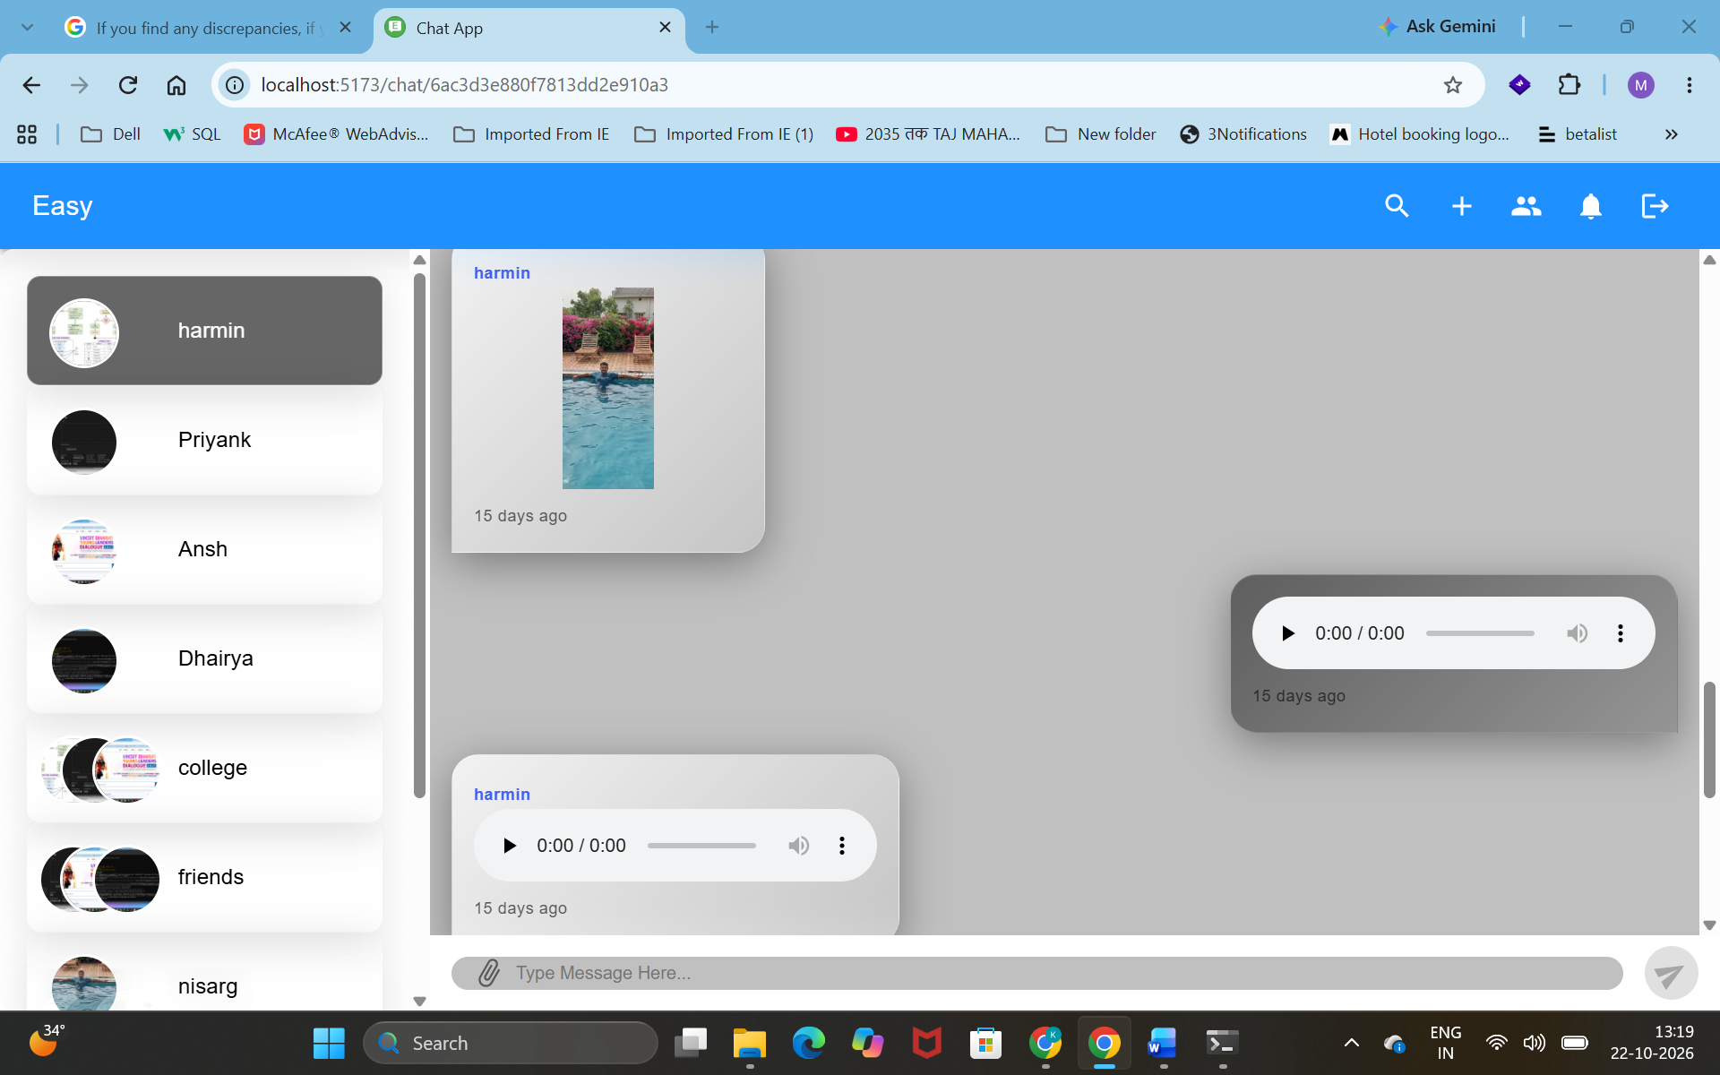

  - Group Creation Page: -
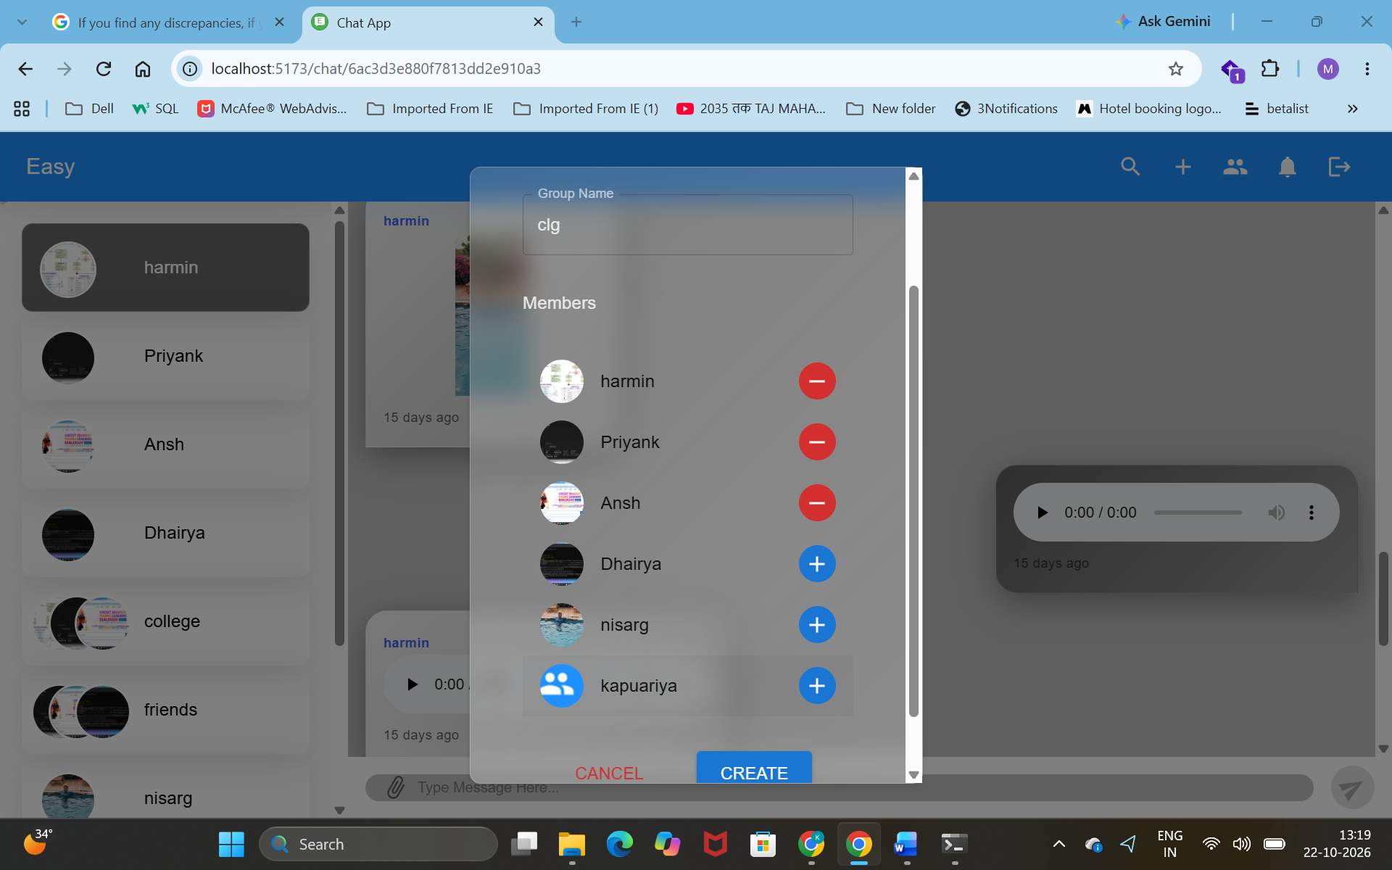

  - Group Page: -
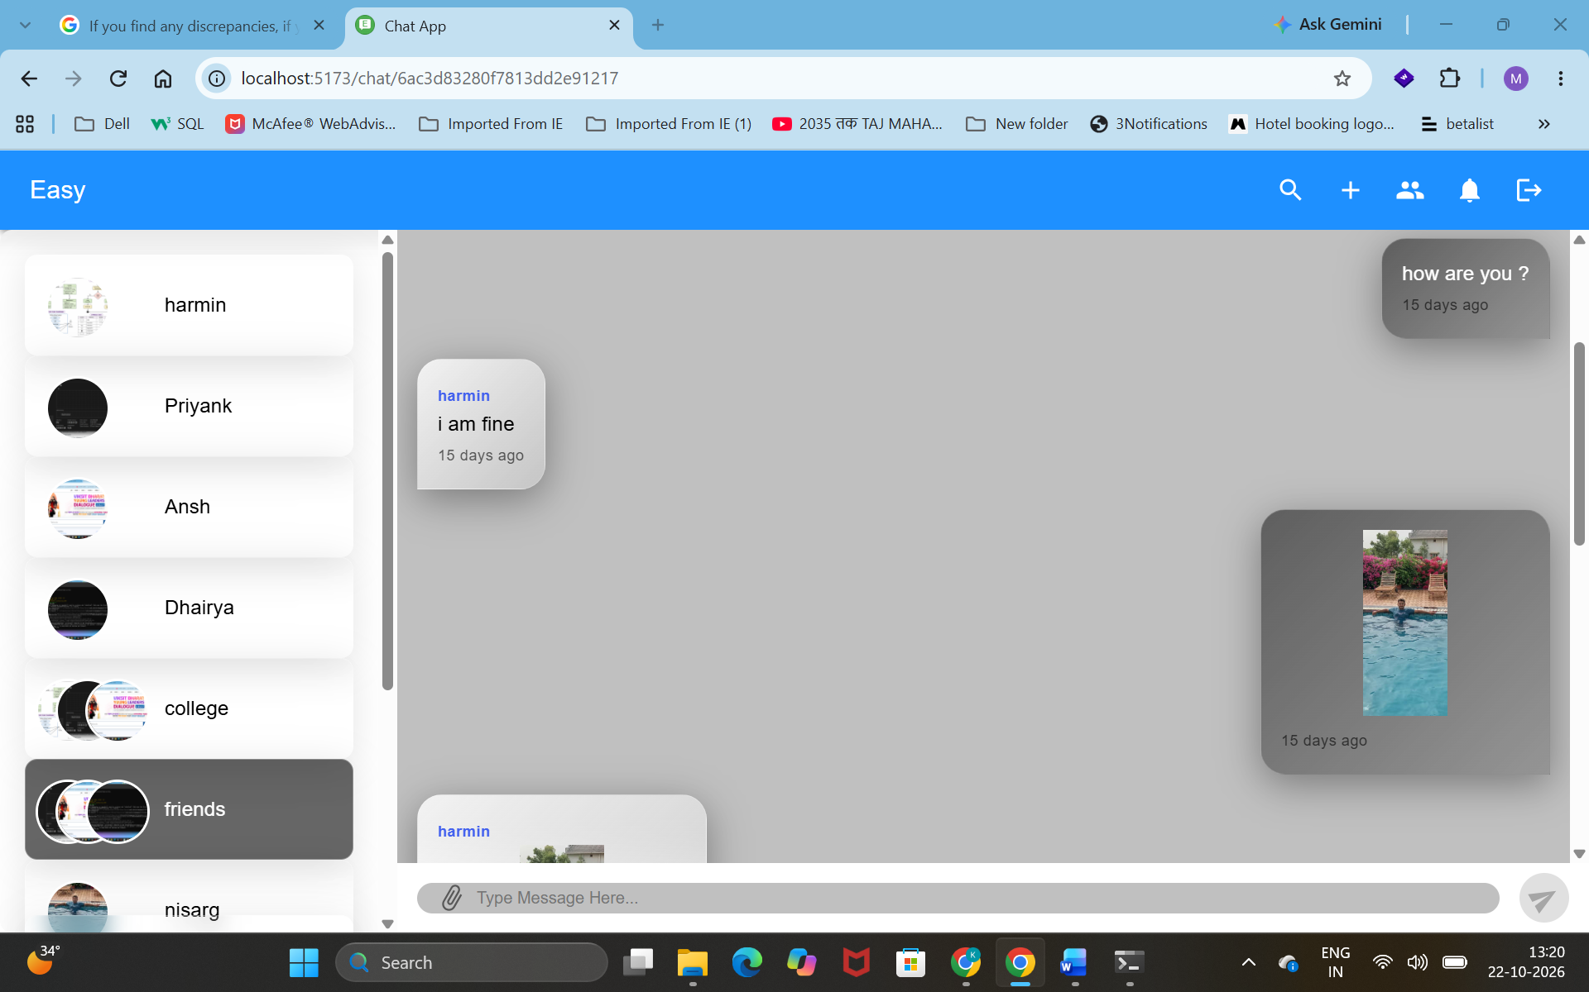

  - Manage group: -
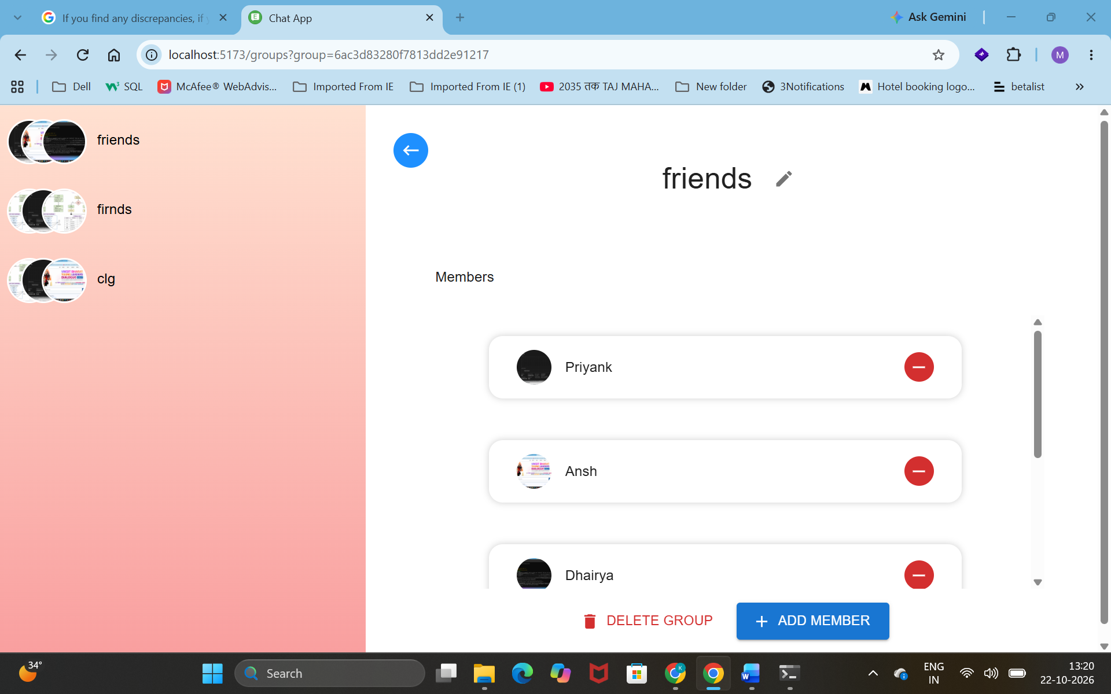

SYSTEM TESTING

- Black Box Testing:

Sr. No. | Test Case | Input | Expected Output | Actual Output | Status
1 | Registration | Valid Name, Username, Email and Password | User Registered Successfully | User Registered Successfully | Pass
2 | Registration | Invalid Email | Registration Failed | Invalid Email Address | Pass
3 | Registration | Existing Email | Registration Failed | Email Already Exists | Pass
4 | Registration | Empty Required Fields | Validation Error | Required Fields Missing | Pass
5 | Registration | Existing Username | Registration Failed | User Registered Successfully | Fail
6 | OTP Verification | Valid OTP | Account Verified Successfully | Account Verified Successfully | Pass
7 | OTP Verification | Invalid OTP | Verification Failed | Invalid OTP | Pass
8 | OTP Verification | Expired OTP | Verification Failed | Account Verified Successfully | Fail
9 | Login | Valid Email and Password | Login Successful | Login Successful | Pass
10 | Login | Invalid Password | Login Failed | Incorrect Password | Pass
11 | Login | Unregistered Email | Login Failed | User Not Found | Pass
12 | Login | Empty Email and Password | Validation Error | Required Fields Missing | Pass
13 | Login | Unverified Account | Login Failed | Login Successful | Fail
14 | Forgot Password | Registered Email | OTP Sent Successfully | OTP Sent Successfully | Pass
15 | Forgot Password | Unregistered Email | OTP Not Sent | User Not Found | Pass
16 | Reset Password | Valid OTP and New Password | Password Reset Successfully | Password Reset Successfully | Pass
17 | Reset Password | Invalid OTP | Password Reset Failed | Invalid OTP | Pass
18 | Reset Password | Empty New Password | Validation Error | Password Reset Successfully | Fail
19 | Update Profile | Valid Name, Bio and Avatar | Profile Updated Successfully | Profile Updated Successfully | Pass
20 | Update Profile | Invalid Avatar File | Profile Update Failed | Profile Updated Successfully | Fail

Sr. No. | Test Case | Input | Expected Output | Actual Output | Status
21 | Send Friend Request | Valid User | Friend Request Sent | Friend Request Sent Successfully | Pass
22 | Send Friend Request | Non-existing User | Request Failed | User Not Found | Pass
23 | Send Friend Request | Already Sent Request | Request Failed | Friend Request Sent Successfully | Fail
24 | Accept Friend Request | Pending Friend Request | Friend Added Successfully | Friend Added Successfully | Pass
25 | Reject Friend Request | Pending Friend Request | Request Rejected | Request Rejected Successfully | Pass
26 | Search User | Valid Username | Matching Users Displayed | Matching Users Displayed | Pass
27 | Search User | Non-existing Username | No Matching Users Found | Matching Users Displayed | Fail
28 | One-to-One Chat | Abuse | Message not Delivered | Your message contains inappropriate content. | Fail
29 | Send Image | Valid Image File | Image Sent Successfully | Image Sent Successfully | Pass
30 | Send Image | Invalid Image File | Image Upload Failed | Image Uploaded Successfully | Fail
31 | One -to-one chat | hi | Message delivered successfully | Message delivered | pass

FUTURE ENHANCEMENT

- Future Enhancement
  - Video and voice calling between two friends

  - More detailed privacy settings, such as blocking users and controlling profile visibility.

  - Enable message editing, deletion, and reply functionality.

  - Introduce customizable themes, including dark mode and chat personalization.

  - Allow users to pin important chats and archive conversations.

BIBLIOGRAPHY/ REFERENCES

  - https://www.mongodb.com/
  - https://lucide.dev/
  - https://www.youtube.com/
  - https://tailwindcss.com/

THANK YOU

