CS249 Programming Assignment 1 - Krishna Mula - 019109220

To run this server:
1. run the Makefile, using the command "make".
2. To start the server, use the command: ./server -document_root <document-root> -port <port-number>

This is a web server in C. This takes in a document root, and port number, and starts the server on said port number. It accepts simple GET requests.

This supports persistent connections in HTTP/1.1, and sets a timeout dynamically, based on the number of active threads. This supports status codes such as 200, 400, 403, etc.

We support HTML, CSS, Images, GIF's, PNGs, webp, etc.

The files supported are:

1. server.c
2. Makefile
3. Readme.txt

I'm attaching some screenshots from the browser, showing how the browser accesses the web server.

This is when the browser tries to access the home page (/index.html). We can see the Response headers.

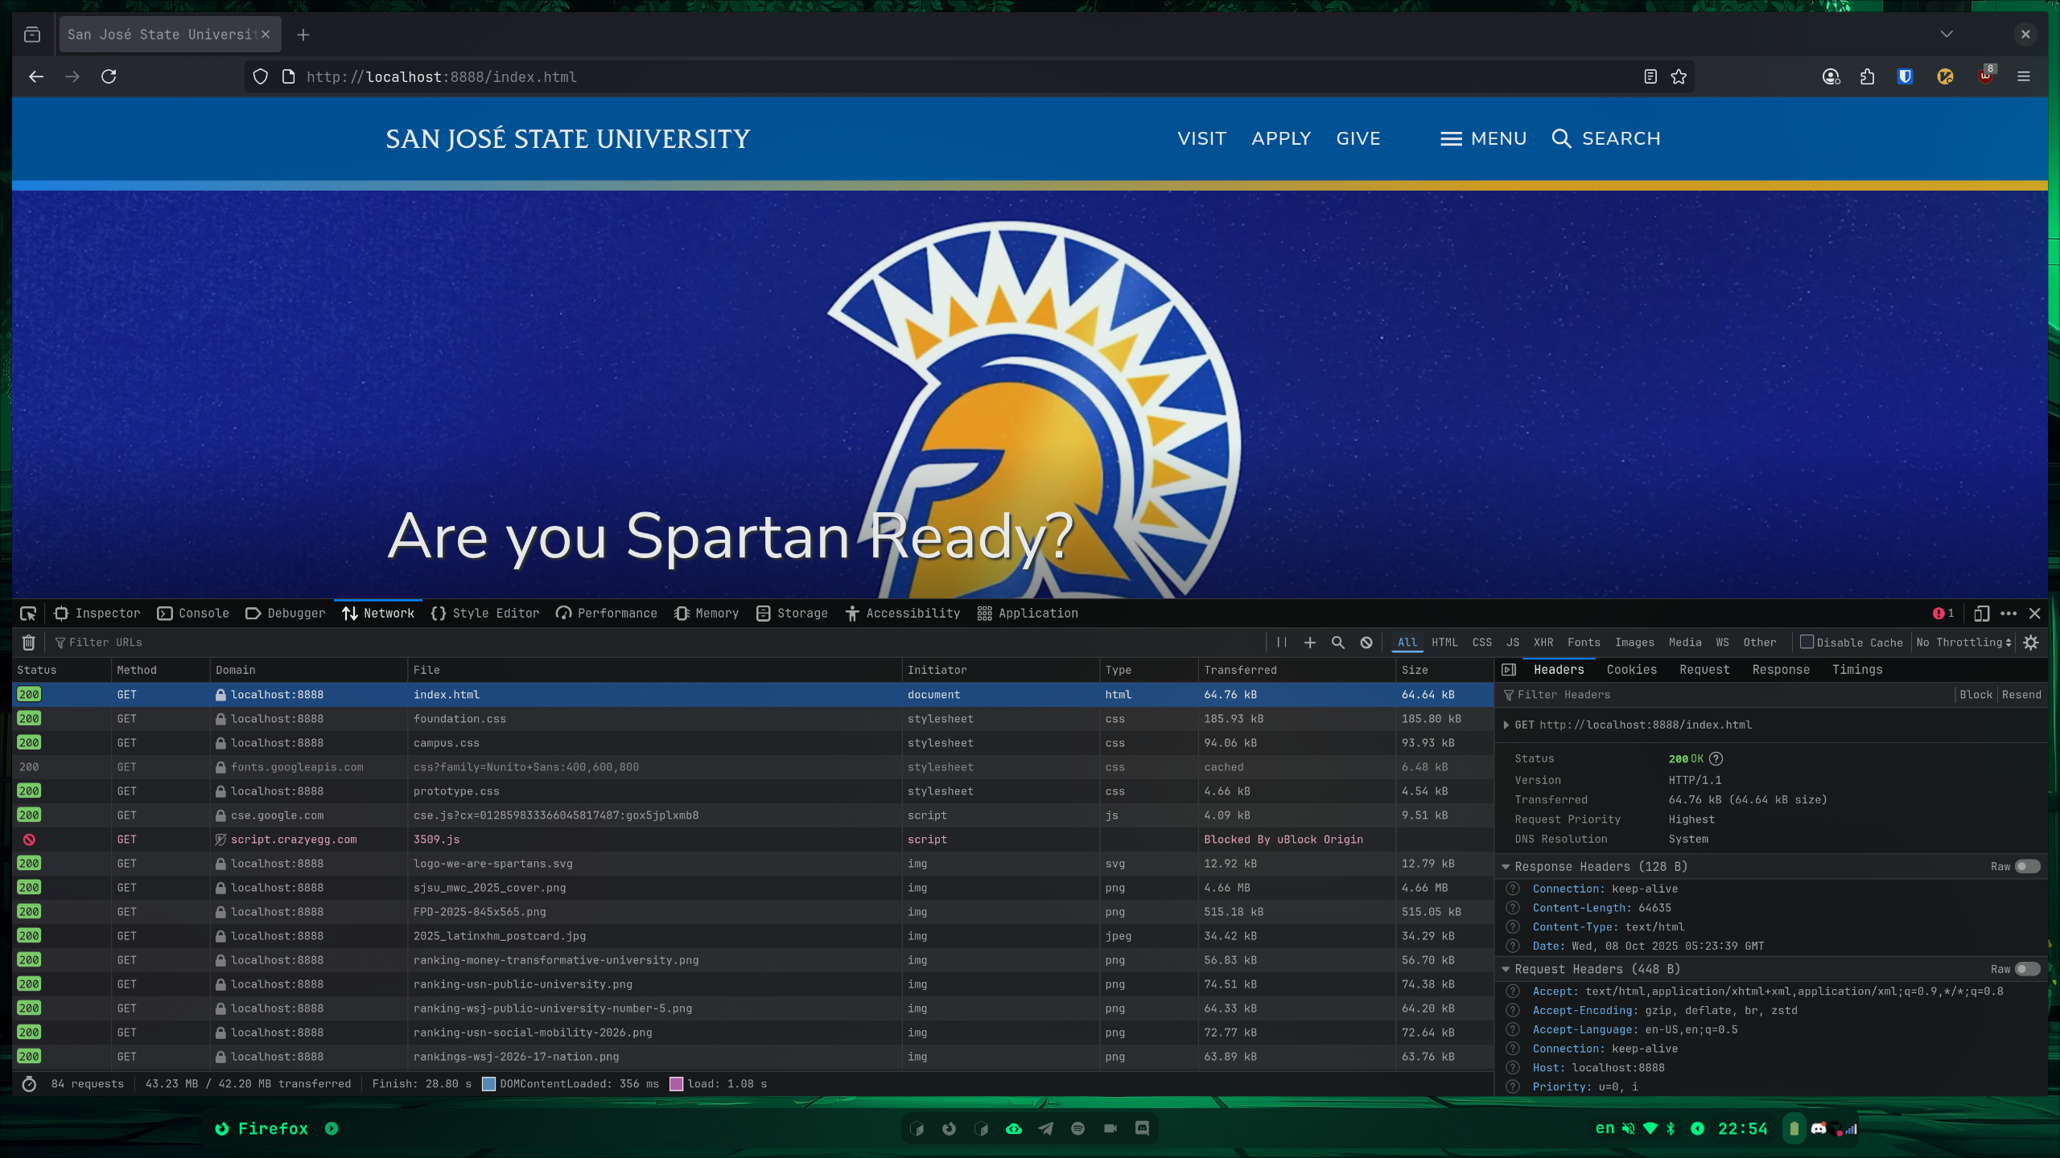

This is the browser accessing the Visit page (/visit/index.php.html).

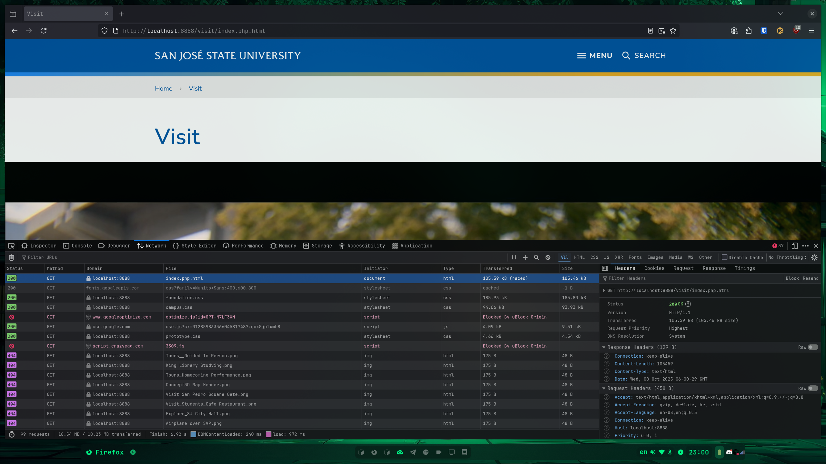

This is when the browser tries to access a page that doesn’t exist.



