GIT BASH

* OPEN THE GIT BASH

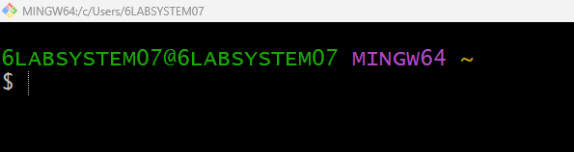

* CREATE A NEW DIRECTORY

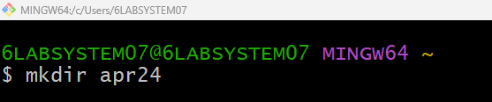

* CREATE A NEW FOLDER

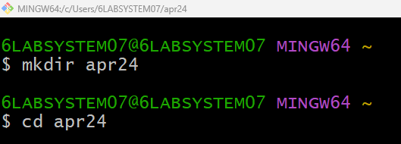

* GIT INSTALATION

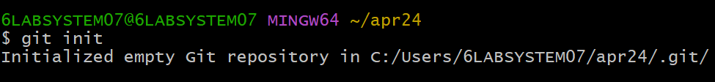

* CREATE A NEW FILE



* WRITE A CODE

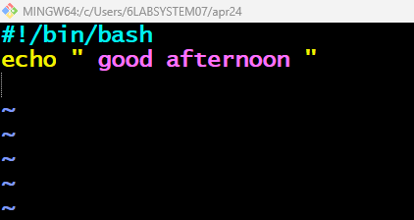

* CAT-WE CAN DISPLAY THE PROGRAM

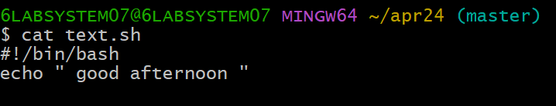

* BASH-TO EXECUTE A PROGRAM

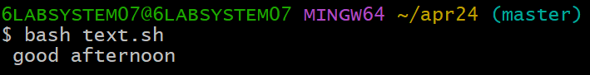

* TO SHOW THE GIT STATUS

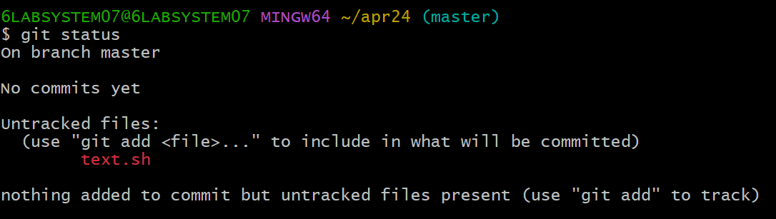

* GIT ADD



* Git COMMIT

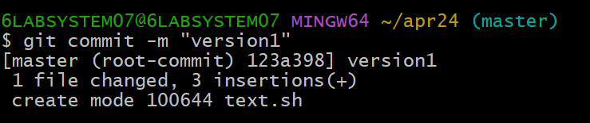

* GO TO GIT HUB
* GIT HUB REPOSITORY

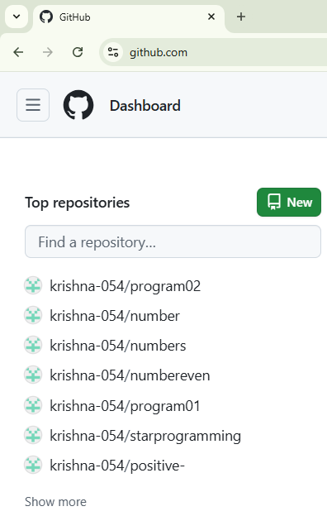

* TO CREATE REPOSITORY

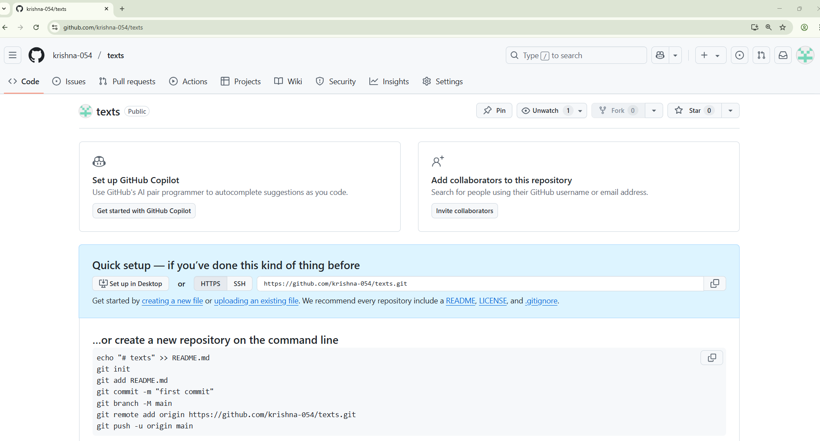

* COPY THE LAST THREE COMMANDS

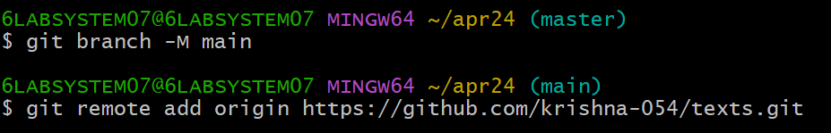

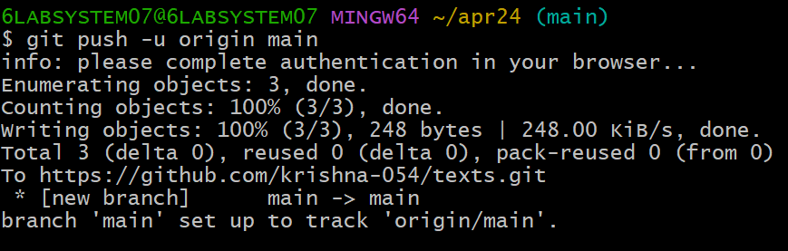

* TO SHOW THE CODE IN GIT HUB ACCOUNT

