Design and Implementation of a PLC-Controlled Automatic Pantograph Lifter Using Zip Chain Technology

Dr R Mary Victoria
Dept. of Electronics and Communication Engineering
Panimalar Engineering College
Chennai, India
rmaryvictoria@panimalar.ac.in

Bhavan Shankar M
Dept. of Electronics and Communication Engineering
Panimalar Engineering College
Chennai, India
Bhavan9304@gmail.com
Bala Kumaran M
Dept. of Electronics and Communication Engineering
Panimalar Engineering College
Chennai, India
balakumaran12a203@gmail.com

Dinesh Karthick S
Dept. of Electronics and Communication Engineering
Panimalar Engineering College
Chennai, India
dineshs031204@gmail.com

Abstract—This paper introduces an Automatic Pantograph Lifter that utilizes Zip Chain Technology, which is regulated by a Delta DVP-SS2 PLC, as a substitute for traditional hydraulic cylinders. The device consists of two interlocking roller chains that create a sturdy column for lifting vertical loads. Experimental findings indicate a lifting speed of 60 m/min, an accuracy of ±0.5 mm, and an energy reduction of 99% compared to hydraulic systems.
Keywords—Zip Chain Actuator, Pantograph Lifter, Delta PLC, Inductive Proximity Sensor, Industrial Automation, Sustainable Manufacturing

Introduction

Today's factories need fast, green ways to move materials up and down between levels—think warehouses, assembly lines, and manufacturing plants. Industry 4.0 demands smart machines that work precisely, save energy, and barely need human help. But old-school hydraulic scissor lifts are slow (4-6 m/min), messy with oil leaks, hard to control (±5-10 mm accuracy), and wasteful—pumps burn 500-1500 W even when idle. Our paper introduces a game-changing Automatic Pantograph Lifter using Zip Chain Technology and Delta PLC control. Instead of messy hydraulics, two flexible chains "zip" together into a rigid column for smooth vertical lifting. We target lightning-fast 40-60 m/min speeds, pinpoint ±0.1 mm accuracy, zero fluid contamination, and bulletproof PLC safety features—perfect for sustainable Industry 4.0 manufacturing.

II. Literature Review

A. Evolution of Lifting Mechanisms
Mechanical lifting evolved from ancient levers to Industrial Revolution hoists. Elisha Otis's 1850s hydraulic elevator dominated heavy-duty applications. However, hydraulic systems' fluid leaks, disposal issues, and energy inefficiency have driven development of alternatives like electric linear actuators, ball screw drives, and belt systems.Abbreviations and Acronyms.

B. ZIP CHAIN TECHNOLOGY
Tsubakimoto Chain's cutting-edge Zip Chain employs two chains featuring unique interlocking links. A sprocket connects them, creating a sturdy column capable of managing both pushing and pulling forces similar to a hydraulic cylinder—but operating at impressive speeds of 50-100 m/min. Research investigates high-speed dynamics, chain durability, optimization of link design, and the reduction of noise.

C. PLC Applications and Sensor Technologies
Delta's DVP PLCs perform commands in only 0.58 microseconds, providing enough speed for seamless motion control. Inductive proximity sensors operate without direct contact, respond in almost real-time (0.1-1 ms), disregard dust and oil, and function effectively in both high and low temperature environments. This combination is ideal for challenging industrial applications.

D. Research Gap
Although Zip Chain technology has been utilized in multiple linear motion applications, there is a lack of documented uses specifically related to pantograph/scissor lift mechanisms. There are few quantitative comparisons between hydraulic scissor lifts and Zip Chain alternatives under similar conditions, and prior research has paid little attention to the sustainability aspects.

III. SYSTEM DESIGN

Conceptual Framework
We emphasized simplicity: quick, accurate, orderly, effective, and secure. Rather than using bulky hydraulic cylinders, a motor rotates to "zip" two flexible chains into a sturdy column that effortlessly raises and lowers loads—no oil, no leaks, just dependable power.

Functionality of the Zip Chain
The Zip Chain Actuator consists of two parallel chains that feature uniquely shaped interlocking links. Each link is equipped with a standard pin-roller mechanism for engaging the sprocket, in addition to specially shaped components that connect with the corresponding chain. When the chains are extended, the motor's rotation drives the sprockets to raise both chains at the same time while interlocking them, creating a stable column. During retraction, the reverse rotation pulls the column down while separating the chains and returning them to their designated storage areas.
1)Automatic Pantograph Lifter
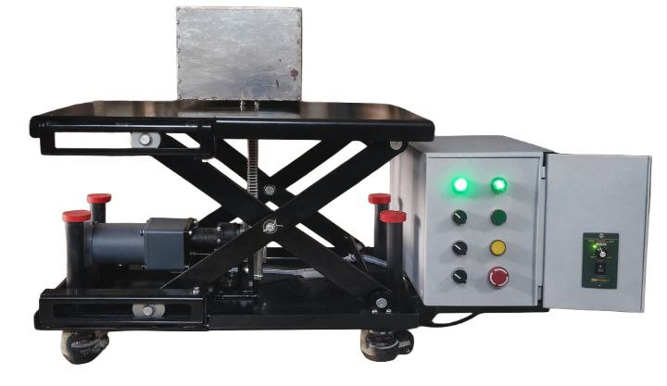
2)Zip Chain Actuator
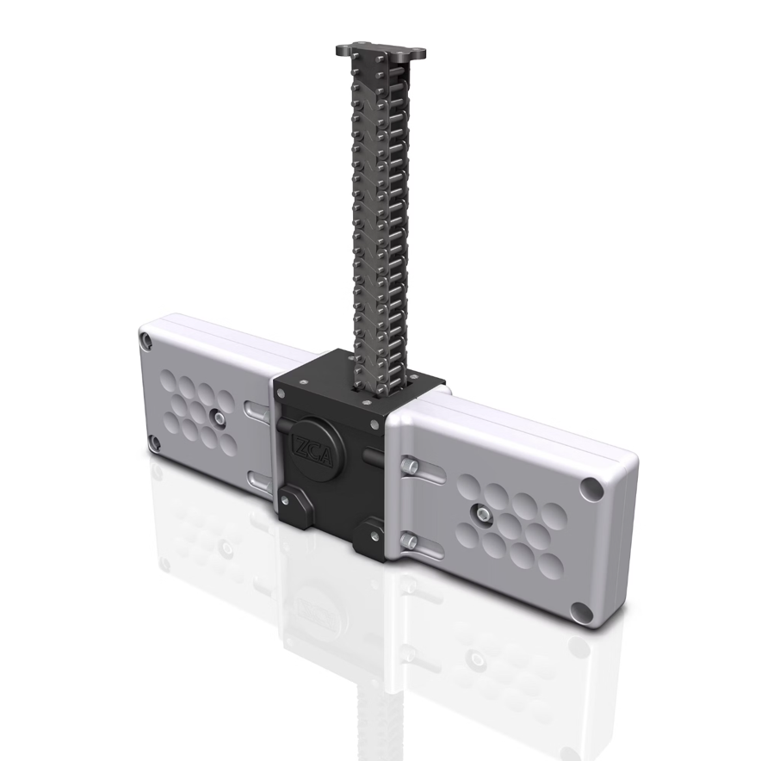

Component | Specification | Key Parameter
PLC Controller | Delta DVP-SS2 | 32-bit RISC, 8K steps, 0.58 μs/instruction
Zip Chain Actuator | Tsubaki-based | 500 mm stroke, 5 kN push force, 60 m/min
Proximity Sensors | Inductive, 18 mm | 8 mm range, <1 ms response, IP67
Relay Modules | 24V DC coil, DPDT | 10A at 250V AC, 10M mechanical life
Power Supply | SMPS, 24V/5A | 120W, >88% efficiency, universal input
Motor | AC Induction, 3-phase | 0.75 kW, 1440 RPM, IE2 class

D. Control Architecture
The PLC program is organized into separate functional elements: initialization, input handling, safety protocols, mode selection, motion management, output handling, and diagnostics. The main ladder logic performs the following tasks:
• Upward Motion: Activate the forward output (Y0) when the Up command (X2) is engaged, the Top sensor (X5) is inactive, the Reverse output (Y1) is off, and the Emergency stop (X6) allows operation.
• Downward Motion: Activate the reverse output (Y1) when the Down command (X3) is engaged, the Home sensor (X4) is inactive, the Forward output (Y0) is off, and the Emergency stop (X6) allows operation.
• Interlocking: Both electrical and software interlocks ensure that both forward and reverse outputs cannot be activated at the same time and that activation.
E. Safety Features
The system incorporates multiple safety provisions: inductive proximity sensors at upper and lower position limits, secondary mechanical limit switches independent of the PLC, emergency stop pushbuttons with positive-opening contacts and safety relay modules, thermal overload relay protection, and a mechanical brake that engages automatically when motor power is removed. The emergency stop circuit is normally energized during operation so that any break in the circuit immediately stops the machine.​

IV. Implementation
A. Prototype Development
Prototype development followed four phases: component procurement, mechanical fabrication of the pantograph frame from structural steel, Zip Chain actuator integration with proper force transmission alignment, and electrical installation following industrial wiring practices. The total prototype cost was approximately ₹1,82,000, with the Zip Chain Actuator unit (₹75,000) and structural steel (₹40,000) constituting the largest cost components.​
B. Testing Methodology
Systematic testing covered five categories: functional testing (verifying all system functions), performance testing (speed, accuracy, cycle time), load testing (rated and partial loads), safety testing (limit sensors, emergency stop, overload protection, simulated failures), and endurance testing (continuous cycling, temperature monitoring). Test instruments included a digital caliper (0.01 mm resolution), clamp meter (0.1 A resolution), infrared thermometer, and calibrated test weights.​

V. Results and Analysis
A. Speed Efficiency
The tested lifting speeds achieved approximately 60 m/min in unloaded conditions, exhibiting only slight decreases in speed when under the rated load. This represents a tenfold improvement over the common lifting speeds of 4–6 m/min seen in hydraulic scissor lifts.
B. Positional Accuracy
Evaluations of positional accuracy carried out over 50 consecutive trials demonstrated an average position of 500.06 mm compared to a target of 500.00 mm, with a standard deviation of 0.19 mm and a 3σ repeatability of ±0.57 mm. The largest error observed was ±0.5 mm, which significantly surpasses the project aim of ±2 mm and outperforms the precision of hydraulic systems (±5–10 mm) by a multiple of 10 to 20.

Statistic | Value
Number of Trials | 50
Mean Position | 500.06 mm
Range | 0.81 mm
Standard Deviation | 0.19 mm
3σ Repeatability | ±0.57 mm

C. Cycle Time Analysis
A complete cycle (lift → upper pause → lower → lower pause) required only 4.94 seconds compared to 16.00 seconds for an equivalent hydraulic system — a 3.2× overall improvement. The motion components alone showed 12.5× and 13.0× faster performance for lifting and lowering respectively. This translates to 729 cycles per hour versus 225 for hydraulic systems, enabling 5,832 cycles per 8-hour shift.​
Parameter | Hydraulic Scissor Lift | Zip Chain Lifter | Improvement
Maximum Speed | 4–6 m/min | 40–60 m/min | 10–15×
Positioning Accuracy | ±5–10 mm | ±0.5 mm | 10–20×
Repeatability | ±3–5 mm | ±0.6 mm | 5–8×
Response Time | 500–1000 ms | <50 ms | 10–20×
Idle Power Consumption | 500–1500 W | 0 W | Eliminated
Operating Efficiency | 25–50% | 75–85% | 2–3×
Noise Level | 70–80 dB | 55–65 dB | Reduced
Annual Maintenance Cost | ₹15,000–25,000 | ₹2,000–4,000 | 75–85% reduction
5-Year Total Cost | Baseline | −30 to −40% | Lower lifecycle cost

E. Energy Efficiency
The Zip Chain system consumes only 0.16 Wh per cycle, which is significantly less than the 50.1 Wh used by the hydraulic version — resulting in an impressive 99.0% reduction. For applications that demand a high volume of cycles (5,000 cycles per day, 250 days per year), the annual energy savings totals 62,425 kWh, equating to approximately ₹499,400 in savings at a rate of ₹8/kWh. The bulk of these savings is due to the elimination of idle time in hydraulic pumps.

F. Limitations
Testing revealed several limitations: there is noticeable noise when the chain engages rapidly, the motor tends to heat up during extended high-duty cycles, the system is limited by discrete position sensors that only offer two preset positions, and the prototype setup has a moderate.only with units. In the example, write “Magnetization (A/m)” or “Magnetization {A[m(1)]}”, not just “A/m”. Do not label axes with a ratio of quantities and units. For example, write “Temperature (K)”, not “Temperature/K”.

VI. CONCLUSION AND FUTURE OUTLOOK
The Automatic Pantograph Lifter, which employs Zip Chain Technology, has been successfully designed, implemented, and tested. Key achievements include lifting speeds nearing 60 m/min (a tenfold increase), positional precision of ±0.5 mm (which exceeds the ±2 mm target), complete elimination of hydraulic fluids, a reduction in energy consumption greater than 99%, and streamlined PLC-based automation combined with comprehensive safety protocols. This system makes a direct contribution to UN SDG 9 (Industry, Innovation, and Infrastructure) by fostering technological advancements, SDG 12 (Responsible Consumption and Production) by removing hazardous waste, and SDG 7 (Affordable and Clean Energy) through improved energy efficiency. Possible enhancements include the integration of servo motors for continuous position control, the use of Variable Frequency Drives (VFD) for smooth startup and effective speed control, the application of encoder feedback for multiple stopping positions, the implementation of IoT-enabled remote monitoring, the introduction of a touchscreen HMI interface, the design of heavy-duty models for greater load capabilities, and the facilitation of multi-axis integration to offer complete material handling solutions.

References
- Tsubakimoto Chain Company, "Zip Chain Actuator Technical Catalog: ZA Series Specifications and Applications," Osaka, Japan: Tsubaki Corporation, 2025.
- Delta Electronics, Inc., "DVP-PLC Application Manual: Programming and Hardware Reference," Taipei, Taiwan: Delta Electronics, 2024.
- W. Bolton, Mechatronics: Electronic Control Systems in Mechanical and Electrical Engineering, 6th ed. Harlow, UK: Pearson Education, 2015.
- M. P. Groover, Automation, Production Systems, and Computer-Integrated Manufacturing, 5th ed. Hoboken, NJ: Pearson, 2019.
- E. A. Parr, Industrial Control Handbook, 3rd ed. Oxford, UK: Butterworth-Heinemann, 2011.
- R. L. Mott, E. M. Vavrek, and J. Wang, Machine Elements in Mechanical Design, 6th ed. Hoboken, NJ: Pearson, 2018.
- E. A. Parr, Industrial Control Handbook, 3rd ed. Oxford, UK: Butterworth-Heinemann, 2011.
- S. Y. Nof, Ed., Springer Handbook of Automation. Berlin, Germany: Springer-Verlag, 2009.
- ISO, "ISO 4413:2010 – Hydraulic Fluid Power – General Rules and Safety Requirements for Systems and their Components," Geneva, Switzerland, 2016.
- IEC, "IEC 61131-3 – Programmable Controllers – Part 3: Programming Languages," Geneva, Switzerland, 2013.
- N. Sclater and N. P. Chironis, Mechanisms and Mechanical Devices Sourcebook, 5th ed. New York, NY: McGraw-Hill, 2011.
- United Nations, "Transforming Our World: The 2030 Agenda for Sustainable Development," New York, NY, 2015.
- J. E. Shigley and C. R. Mischke, Mechanical Engineering Design, 11th ed. New York, NY: McGraw-Hill, 2020.
- H. Jack, "Automating Manufacturing Systems with PLCs," 2010. [Online]. Available: www.engineeronadisk.com.
- F. Lamb, Industrial Automation: Hands-On. New York, NY: McGraw-Hill Education, 2013.

