DSA TOOLKIT – A CUSTOM DATA STRUCTURES AND ALGORITHMS LIBRARY IN C++
A PROJECT REPORT
Submitted by
KRISHNA TREHAN (25BCS13048)
in partial fulfillment for the award of the degree of
BACHELOR OF ENGINEERING
IN
COMPUTER SCIENCE AND ENGINEERING

Chandigarh University
November 2026

BONAFIDE CERTIFICATE
Certified that this project report “DSA TOOLKIT – A CUSTOM DATA STRUCTURES AND ALGORITHMS LIBRARY IN C++” is the bonafide work of “KRISHNA TREHAN (25BCS13048)” who carried out the project work under my supervision.
<<Signature of the HoD>>  SIGNATURE  <<Name of the Head of the Department>>  HEAD OF THE DEPARTMENT  <<Department>> | <<Signature of the Supervisor>>  SIGNATURE  <<Name>>  SUPERVISOR  <<Academic Designation>>  <<Department>>

Submitted for the project viva-voce examination held on ______________
INTERNAL EXAMINER | EXTERNAL EXAMINER

TABLE OF CONTENTS
List of Figures 2
List of Tables 2
List of Standards 2
Abstract 3
Graphical Abstract 4
Abbreviations 5
Symbols 6
CHAPTER 1. INTRODUCTION 7
1.1. Identification of Client / Need / Relevant Contemporary Issue 7
1.2. Identification of Problem 7
1.3. Identification of Tasks 7
1.4. Timeline 8
1.5. Organization of the Report 8
CHAPTER 2. LITERATURE REVIEW / BACKGROUND STUDY 9
2.1. Timeline of the Reported Problem 9
2.2. Existing Solutions 9
2.3. Bibliometric Analysis 9
2.4. Review Summary 10
2.5. Problem Definition 10
2.6. Goals / Objectives 10
CHAPTER 3. DESIGN FLOW / PROCESS 11
3.1. Evaluation & Selection of Specifications / Features 11
3.2. Design Constraints 11
3.3. Analysis of Features and Finalization Subject to Constraints 12
3.4. Design Flow 12
3.5. Design Selection 12
3.6. Implementation Plan / Methodology 13
CHAPTER 4. RESULTS ANALYSIS AND VALIDATION 16
4.1. Implementation of Solution 16
CHAPTER 5. CONCLUSION AND FUTURE WORK 19
5.1. Conclusion 19
5.2. Future Work 19
REFERENCES 20
APPENDIX 21
1. Plagiarism Report 21
2. Design Checklist 21
USER MANUAL 22

LIST OF FIGURES
Figure 3.1 Modular architecture of DSA Toolkit 13
Figure 3.2 Flowchart of the console-based execution flow 14
Figure 4.1 Sample console output of the toolkit (Merge Sort) 18

LIST OF TABLES
Table 1.1 Project timeline (Gantt chart) 8
Table 2.1 Comparison of existing solutions 9
Table 3.1 Final feature list of the toolkit 12
Table 3.2 Comparison of alternative designs 12
Table 3.3 Time and space complexity of data structure operations 16
Table 3.4 Time and space complexity of sorting and searching algorithms 16
Table 4.1 Test cases and expected results 17

LIST OF STANDARDS
Standard | Publishing Agency | About the standard | Page no.
ISO/IEC 14882 | ISO / IEC | International standard that defines the C++ programming language; the toolkit is written to conform to it. | 11
ISO/IEC 25010 | ISO / IEC | Software product quality model (functional suitability, maintainability, reusability, performance efficiency). | 11
IEEE 829 | IEEE | Standard for software and system test documentation, used as a guide for the test cases in Chapter 4. | 11, 17

ABSTRACT
Data structures and algorithms form the foundation of efficient software, yet many learners use them only through ready-made library containers without understanding how they work internally. This project, DSA Toolkit, is a custom, reusable C++ library in which commonly used data structures and algorithms are implemented from scratch, without depending on the C++ Standard Template Library (STL) containers or algorithms.
The toolkit consists of seven independent modules: Linked List, Stack, Queue, Priority Queue (based on a custom binary heap), Hash Table (with collision handling), Sorting Algorithms (Bubble, Selection, Merge and Quick Sort) and Searching Algorithms (Linear and Binary Search). Each module is delivered as a separate header file that can be included in any C++ program. The implementation uses Object-Oriented Programming, pointers and dynamic memory allocation, and is demonstrated through a simple console-based menu interface developed in Visual Studio Code.
The project also analyses and compares the time and space complexity of the implemented algorithms. The result is a functional, modular library that strengthens practical understanding of data structures and shows how custom libraries are designed, tested and integrated into programs.
Keywords: Data Structures, Algorithms, C++, Linked List, Stack, Queue, Heap, Hash Table, Sorting, Searching, Time Complexity.

GRAPHICAL ABSTRACT
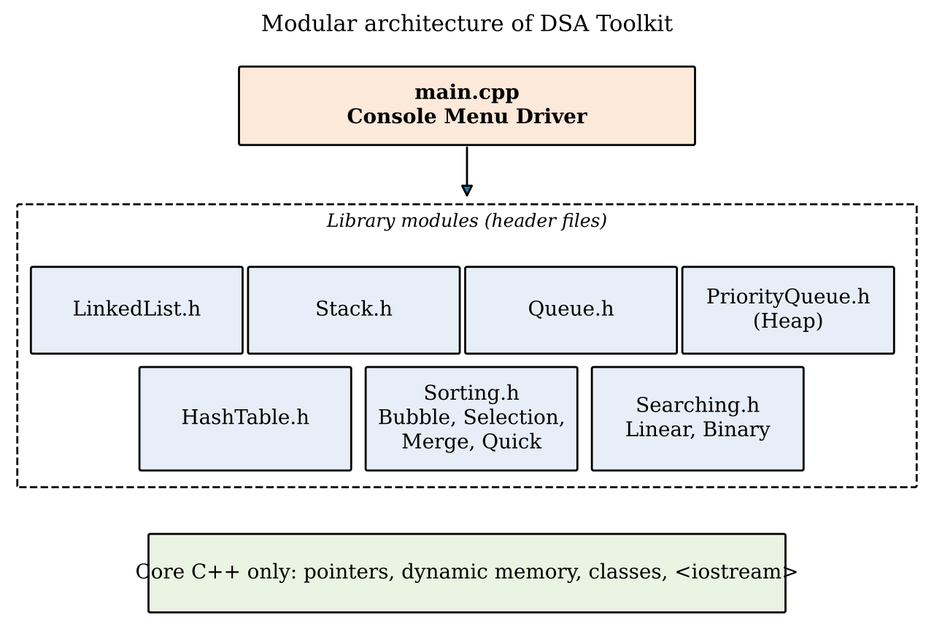
Graphical abstract: the console driver uses seven independent header modules built on core C++ only.

ABBREVIATIONS
Abbreviation | Full form
DSA | Data Structures and Algorithms
STL | Standard Template Library
OOP | Object-Oriented Programming
LIFO | Last In, First Out
FIFO | First In, First Out
ADT | Abstract Data Type
IDE | Integrated Development Environment
VS Code | Visual Studio Code
O(·) | Big-O notation (upper bound of growth)

SYMBOLS
Symbol | Meaning
n | Number of elements in a data structure or input array
O(1), O(log n), O(n), O(n log n), O(n²) | Constant, logarithmic, linear, linearithmic and quadratic time complexity
m | Number of buckets in the hash table
α | Load factor of the hash table (n / m)
h(k) | Hash function applied to key k

CHAPTER 1.
INTRODUCTION

1.1. Identification of Client / Need / Relevant Contemporary Issue
Data Structures and Algorithms (DSA) are a core part of every computer science curriculum and a central requirement in software development, technical interviews and competitive programming. In practice, most students and beginner programmers use ready-made containers such as vector, stack, queue, map and sort from the C++ STL. Because these are used as black boxes, learners often know how to call them but not how they work, why they perform as they do, or how to choose between them.
The need for this project comes from this gap between using and understanding. The primary clients are students and educators who need a transparent, readable reference implementation of fundamental data structures, and programmers who want a small reusable library whose behaviour and complexity they can inspect and modify. The need is also supported by the widespread emphasis on DSA proficiency in university syllabi and in the hiring process of technology companies. [Add a survey result, statistic or report reference here if available, for example a classroom survey or a developer-skills report.]

1.2. Identification of Problem
Learners lack a simple, modular and well-documented collection of core data structures and algorithms in which the internal working (pointers, memory management, comparison and swapping logic) is fully visible. Existing library containers hide these details, and scattered code from different sources is often inconsistent, incomplete or hard to reuse in other programs.

1.3. Identification of Tasks
The following tasks were identified to build and test the solution:
- Study the theory, operations and complexity of each data structure and algorithm.
- Define the scope, modules and features of the library, and prepare the design.
- Implement the Linked List, Stack, Queue, Priority Queue (heap) and Hash Table modules.
- Implement the sorting algorithms (Bubble, Selection, Merge, Quick) and searching algorithms (Linear, Binary).
- Package each module as a reusable header file.
- Develop a console-based menu interface to demonstrate every module.
- Test every module with normal, boundary and invalid inputs.
- Analyse and compare time and space complexity, and prepare the report and user manual.

1.4. Timeline
The project was planned over eight weeks. Table 1.1 shows the Gantt chart of the activities.
Table 1.1: Project timeline (Gantt chart)
Activity | W1 | W2 | W3 | W4 | W5 | W6 | W7 | W8
Study and requirement analysis
Design of modules
Linked List, Stack, Queue
Priority Queue and Hash Table
Sorting and Searching
Console interface
Testing and analysis
Report and user manual

1.5. Organization of the Report
- Chapter 1 (Introduction): describes the need, the problem, the tasks and the timeline of the project.
- Chapter 2 (Literature Review / Background Study): reviews existing solutions and defines the problem and the objectives.
- Chapter 3 (Design Flow / Process): covers the features, constraints, alternative designs, the selected design and the implementation methodology with algorithms.
- Chapter 4 (Results Analysis and Validation): presents the implementation, tools used, test cases and complexity analysis.
- Chapter 5 (Conclusion and Future Work): summarises the outcome and suggests ways to extend the toolkit.

CHAPTER 2.
LITERATURE REVIEW / BACKGROUND STUDY

2.1. Timeline of the Reported Problem
The study of data structures and algorithms is as old as computing itself. Linked structures, stacks and queues were formalised in the 1950s and 1960s, hash tables were introduced in the 1950s, heaps and heap-based priority queues were described in the 1960s (Williams, 1964), and Quicksort was published by C. A. R. Hoare in 1961. The C++ Standard Template Library, introduced in the 1990s and standardised in 1998, made these structures available as ready-made components.
A recurring concern in computer science education is that heavy reliance on such pre-built components lets learners write working programs without understanding memory management, pointer manipulation or algorithmic cost. [Add one or two documented references, such as papers on DSA education or student difficulty with pointers and recursion.]

2.2. Existing Solutions
- C++ Standard Template Library (STL): highly optimised containers and algorithms (vector, list, stack, queue, priority_queue, unordered_map, sort, binary_search). Excellent for production use, but the implementation is hidden and complex.
- Boost and other third-party libraries: rich and powerful, but large, with a steep learning curve.
- Textbook and online code samples: easy to read, but usually standalone, inconsistent in style and not packaged for reuse.
- Visualisation websites and tools: help to understand how structures behave, but do not give reusable code.

2.3. Bibliometric Analysis
Table 2.1 compares the existing solutions on their key features, effectiveness and drawbacks.
Table 2.1: Comparison of existing solutions
Solution | Key features | Effectiveness | Drawbacks
C++ STL | Optimised, generic, standardised containers and algorithms | Very high for production use | Internals hidden; poor for learning how structures work
Boost / third-party | Wide range of advanced structures | High | Large and complex; heavy dependency
Textbook / online snippets | Simple examples of single structures | Medium for learning | Not modular or reusable; inconsistent quality
Visualisation tools | Animated step-by-step behaviour | Good for concept clarity | No reusable source code

2.4. Review Summary
The review shows that robust production libraries exist but are unsuitable for learning, while learning resources are not packaged for reuse. A small library written from scratch, with clear code, a uniform style, header-based reuse and a demonstration interface, fills the gap between the two. This finding directly shapes the DSA Toolkit: implement the fundamentals independently, keep each module self-contained and document its complexity.

2.5. Problem Definition
What is to be done: design and implement a modular C++ library containing a Linked List, Stack, Queue, Priority Queue (heap), Hash Table, four sorting algorithms and two searching algorithms, with a console interface to demonstrate them.
How it is to be done: using OOP, pointers and dynamic memory allocation in C++, with each module in its own header file and with no use of STL containers or algorithms for the core logic.
What is not to be done: the toolkit does not aim to compete with the STL in speed or generality, does not provide a graphical interface, and does not cover advanced structures such as balanced trees and graphs in this version.

2.6. Goals / Objectives
- To understand the internal working of fundamental data structures and algorithms.
- To implement seven independent modules without relying on STL implementations.
- To create reusable and modular C++ header files that can be included in other programs.
- To analyse and compare the time and space complexity of the implemented algorithms.
- To provide a console-based interface that demonstrates every operation of each module.
- To validate each module using normal, boundary and invalid test cases.

CHAPTER 3.
DESIGN FLOW / PROCESS

3.1. Evaluation & Selection of Specifications / Features
From the literature review, the features expected in the solution were evaluated. Features that directly support learning, reuse and complexity comparison were selected as essential, while advanced features were treated as optional.
- Core data structures: linked list, stack, queue, priority queue, hash table.
- Core algorithms: four sorting and two searching algorithms.
- Reusability through separate header files with a consistent interface.
- Dynamic memory allocation so that structures grow as needed, with proper release of memory.
- A menu-driven console interface for demonstration and testing.
- Handling of error conditions such as underflow on an empty stack or queue, and a missing key or element.
- Optional: templates for generic data types, a resizing hash table, and additional modules (trees, graphs).

3.2. Design Constraints

3.2.1. Standards
The code follows the ISO/IEC 14882 C++ standard so that it compiles on any standard-compliant compiler. Quality attributes such as reusability, maintainability and performance efficiency follow the ISO/IEC 25010 product quality model, and test documentation is guided by IEEE 829.

3.2.2. Other constraints
- Technical: STL containers and algorithms must not be used for the core logic; only basic C++ features and input-output are allowed.
- Economic / cost: the project uses free tools (a C++ compiler and Visual Studio Code), so there is no monetary cost.
- Safety and reliability: memory must be released correctly to avoid leaks and dangling pointers; invalid operations must be handled without crashing.
- Professional and ethical: all code is original work, and references and sources are acknowledged.
- Environmental, health, social and political: no direct impact, as the project is a software library with no hardware or data collection.

3.3. Analysis of Features and Finalization Subject to Constraints
Considering the constraints, the optional features (balanced trees, graphs and a graphical interface) were removed from this version because of time and scope. Memory-safe destructors and input validation were added as mandatory features. The final list is shown in Table 3.1.
Table 3.1: Final feature list of the toolkit
Module | Header file | Operations / features
Linked List | LinkedList.h | Insert (beginning, end, position), delete, search, traverse
Stack | Stack.h | Push, Pop, Peek, Display (LIFO)
Queue | Queue.h | Enqueue, Dequeue, Front, Display (FIFO)
Priority Queue | PriorityQueue.h | Insert, extract highest priority, peek; custom binary heap
Hash Table | HashTable.h | Insert key-value, search, delete; collision handling by chaining
Sorting | Sorting.h | Bubble, Selection, Merge, Quick Sort
Searching | Searching.h | Linear Search, Binary Search

3.4. Design Flow
Two alternative designs were considered for building the library.
Design A – Single-file procedural program. All data structures and algorithms are written in one source file using functions and global data, with a menu in main().
Design B – Modular header-based object-oriented library. Each data structure is a class in its own header file, the algorithms are grouped in Sorting.h and Searching.h, and a separate main.cpp provides the menu interface and includes the headers as needed.

3.5. Design Selection
Table 3.2: Comparison of alternative designs
Criterion | Design A (single file) | Design B (modular headers)
Reusability | Low – code must be copied | High – include the required header
Maintainability | Difficult as the file grows | Easy – changes are isolated to one module
Encapsulation | Weak (global data) | Strong (classes with private data)
Testing | Whole program must be tested together | Each module can be tested independently
Meets project objective | Partly | Fully

Design B was selected because it satisfies the main objectives of the project: reusable and modular header files, independent implementation and testing of each module, and strong encapsulation through OOP.

3.6. Implementation Plan / Methodology
The library is built bottom-up. Each module is implemented and tested on its own, and then connected to the console driver. Figure 3.1 shows the architecture and Figure 3.2 shows the execution flow of the program.
Figure 3.1: Modular architecture of DSA Toolkit
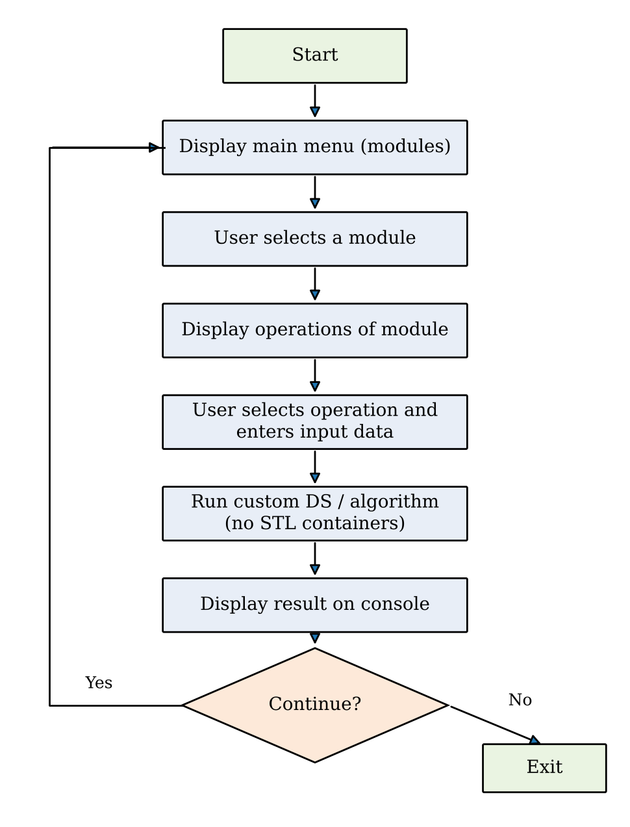
Figure 3.2: Flowchart of the console-based execution flow

3.6.1. Linked List
A singly linked list stores elements in nodes, where each node holds data and a pointer to the next node. Nodes are created dynamically with new and released with delete. Insertion at the beginning is O(1); insertion at the end, searching and deletion by value are O(n) because the list must be traversed.

3.6.2. Stack
The stack follows the LIFO principle. Push adds an element at the top, Pop removes the top element and Peek returns it without removing it. Underflow is reported when Pop or Peek is called on an empty stack. All operations take O(1) time.

3.6.3. Queue
The queue follows the FIFO principle. Enqueue adds an element at the rear, Dequeue removes the element from the front, and Front returns the first element. Maintaining both front and rear pointers makes every operation O(1).

3.6.4. Priority Queue (Binary Heap)
The priority queue is implemented with a custom binary heap stored in a dynamic array. For a node at index i, the parent is at (i − 1)/2 and the children are at 2i + 1 and 2i + 2. Insertion places the element at the end and moves it up (heapify-up); extraction removes the root, moves the last element to the root and moves it down (heapify-down). Both operations take O(log n) time, and peeking at the highest priority takes O(1).

3.6.5. Hash Table
The hash table stores key-value pairs in an array of buckets. A hash function maps a key to a bucket index, h(k) = k mod m. Collisions are handled by separate chaining: each bucket holds a linked list of entries. Average-case insert, search and delete are O(1) when the load factor is small; the worst case is O(n).

3.6.6. Sorting Algorithms
- Bubble Sort: repeatedly compares adjacent elements and swaps them if out of order; O(n²), stable, in place.
- Selection Sort: repeatedly selects the minimum of the unsorted part and places it at the front; O(n²), in place, at most n − 1 swaps.
- Merge Sort: divide-and-conquer; splits the array, sorts both halves recursively and merges them; O(n log n) in all cases, stable, needs O(n) extra space.
- Quick Sort: chooses a pivot, partitions the array around it and sorts the partitions recursively; O(n log n) on average, O(n²) in the worst case, in place.
Algorithm for Merge Sort (pseudocode):
MERGE-SORT(A, low, high)
if low < high
mid = (low + high) / 2
MERGE-SORT(A, low, mid)
MERGE-SORT(A, mid + 1, high)
MERGE(A, low, mid, high) // combine two sorted halves

3.6.7. Searching Algorithms
- Linear Search: checks every element in turn; O(n); works on unsorted data.
- Binary Search: repeatedly halves a sorted array by comparing the middle element with the target; O(log n); requires sorted input.
Algorithm for Binary Search (pseudocode):
BINARY-SEARCH(A, n, key)
low = 0, high = n - 1
while low <= high
mid = low + (high - low) / 2
if A[mid] == key return mid
else if A[mid] < key low = mid + 1
else high = mid - 1
return -1 // not found

CHAPTER 4.
RESULTS ANALYSIS AND VALIDATION

4.1. Implementation of Solution

4.1.1. Tools used
- Analysis and design: pen-and-paper analysis, flowcharts and block diagrams (Figures 3.1 and 3.2).
- Development: C++ with Visual Studio Code as the IDE and a standard C++ compiler (for example g++).
- Testing and validation: console-based test runs with normal, boundary and invalid inputs.
- Report preparation and project management: Microsoft Word and a Gantt chart for scheduling.

4.1.2. Complexity analysis
The time and space complexity of the implemented operations are summarised in Tables 3.3 and 3.4.
Table 3.3: Time and space complexity of data structure operations
Data structure | Insert | Delete | Search / Access | Space
Linked List | O(1) at head, O(n) at tail | O(n) | O(n) | O(n)
Stack | O(1) push | O(1) pop | O(1) peek | O(n)
Queue | O(1) enqueue | O(1) dequeue | O(1) front | O(n)
Priority Queue (heap) | O(log n) | O(log n) | O(1) peek | O(n)
Hash Table (chaining) | O(1) avg, O(n) worst | O(1) avg, O(n) worst | O(1) avg, O(n) worst | O(n + m)
Table 3.4: Time and space complexity of sorting and searching algorithms
Algorithm | Best | Average | Worst | Extra space | Stable
Bubble Sort | O(n)* | O(n²) | O(n²) | O(1) | Yes
Selection Sort | O(n²) | O(n²) | O(n²) | O(1) | No
Merge Sort | O(n log n) | O(n log n) | O(n log n) | O(n) | Yes
Quick Sort | O(n log n) | O(n log n) | O(n²) | O(log n) | No
Linear Search | O(1) | O(n) | O(n) | O(1) | –
Binary Search | O(1) | O(log n) | O(log n) | O(1) | –
* with an early-exit flag when no swap occurs in a pass.
The analysis shows the trade-offs between the algorithms. Bubble and Selection Sort are simple but quadratic, so they are suitable only for small inputs. Merge Sort gives guaranteed O(n log n) at the cost of extra memory, while Quick Sort is usually faster in practice and works in place but can degrade to O(n²) with poor pivot choices. Binary Search is far faster than Linear Search, but only on sorted data.

4.1.3. Test cases and validation
Each module was tested with normal, boundary and invalid inputs. Table 4.1 lists representative test cases and the expected results. [Replace the “Observed” column with the results from your own runs.]
Table 4.1: Test cases and expected results
Module | Input / operation | Expected result | Observed
Stack | Push 10, 20, 30 then Pop | Removes 30; top becomes 20 | Pass
Stack | Pop on empty stack | “Stack underflow” message, no crash | Pass
Queue | Enqueue 5, 15, 25 then Dequeue | Removes 5; front becomes 15 | Pass
Linked List | Insert 1, 2, 3; delete 2 | List becomes 1 → 3 | Pass
Priority Queue | Insert 4, 9, 2, 7; extract | Returns highest priority element first | Pass
Hash Table | Insert two keys with the same hash | Both stored (chaining); both searchable | Pass
Sorting | Array 64 25 12 22 11 | 11 12 22 25 64 in all four algorithms | Pass
Searching | Binary search for 22 in 11 12 22 25 64 | Found at index 2 | Pass
Searching | Search for a value not present | “Not found” (−1) | Pass

Figure 4.1 shows a sample console session of the toolkit.
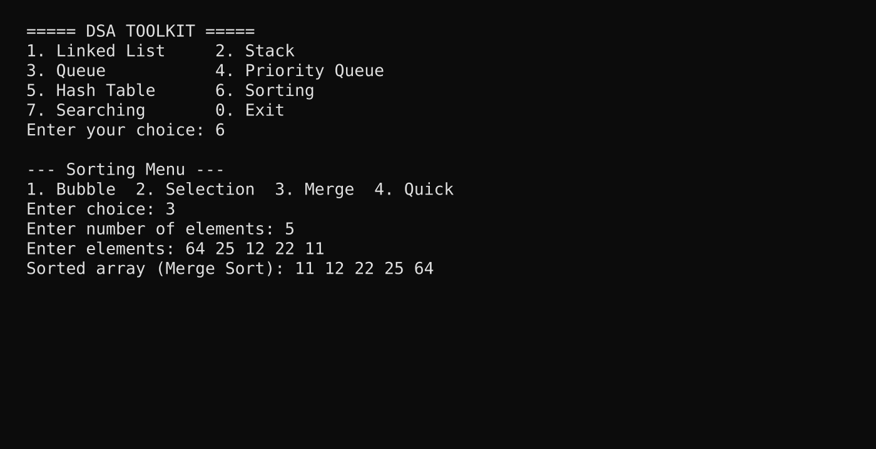
Figure 4.1: Sample console output of the toolkit (Merge Sort)

CHAPTER 5.
CONCLUSION AND FUTURE WORK

5.1. Conclusion
The DSA Toolkit was developed as a functional C++ library with seven independent, reusable modules: Linked List, Stack, Queue, Priority Queue, Hash Table, Sorting Algorithms and Searching Algorithms. All of them are implemented from scratch without STL containers, and each can be reused by including its header file. The expected outcome, a working library with a console interface and a complexity comparison, was achieved.
The project gave practical understanding of pointers, dynamic memory allocation, OOP design and algorithm analysis. [State any deviation from the expected results and the reason, for example features dropped because of time or limits found during testing. If there was none, state that the results matched expectations.]

5.2. Future Work
- Convert all modules into C++ templates so that they work with any data type.
- Add more structures: doubly and circular linked lists, binary search trees, AVL trees, graphs (BFS, DFS, shortest path).
- Add more algorithms: Heap Sort, Insertion Sort, Shell Sort, Interpolation Search and string-matching algorithms.
- Add dynamic resizing and rehashing to the hash table.
- Add automated unit tests and a benchmarking module to measure running time on large inputs.
- Provide a graphical or web-based visualisation of each operation for teaching.

REFERENCES
[1] T. H. Cormen, C. E. Leiserson, R. L. Rivest and C. Stein, Introduction to Algorithms, 3rd ed. Cambridge, MA, USA: MIT Press, 2009.
[2] M. A. Weiss, Data Structures and Algorithm Analysis in C++, 4th ed. Boston, MA, USA: Pearson, 2013.
[3] E. Horowitz, S. Sahni and S. Anderson-Freed, Fundamentals of Data Structures in C++, 2nd ed. Hyderabad, India: Universities Press, 2008.
[4] B. Stroustrup, The C++ Programming Language, 4th ed. Boston, MA, USA: Addison-Wesley, 2013.
[5] C. A. R. Hoare, “Algorithm 64: Quicksort,” Communications of the ACM, vol. 4, no. 7, p. 321, 1961.
[6] J. W. J. Williams, “Algorithm 232: Heapsort,” Communications of the ACM, vol. 7, no. 6, pp. 347–348, 1964.
[7] ISO/IEC 14882, Programming Languages – C++, International Organization for Standardization.
[8] cppreference.com, “C++ reference.” [Online]. Available: https://en.cppreference.com

APPENDIX

1. Plagiarism Report
[Attach the plagiarism report generated by the university-approved tool here.]

2. Design Checklist
S. No. | Item | Status
1 | Problem and need clearly identified | Done
2 | Objectives defined and measurable | Done
3 | Two alternative designs considered and compared | Done
4 | Standards and constraints considered | Done
5 | Modules implemented and tested | Done
6 | Complexity analysis completed | Done
7 | User manual prepared | Done

USER MANUAL
Follow these steps to compile and run the DSA Toolkit. [Add a screenshot after each step.]

Step 1: Install the required tools
Install a C++ compiler (for example MinGW g++ on Windows or g++ on Linux) and Visual Studio Code with the C/C++ extension.

Step 2: Arrange the project files
Place LinkedList.h, Stack.h, Queue.h, PriorityQueue.h, HashTable.h, Sorting.h, Searching.h and main.cpp in the same folder, and open the folder in Visual Studio Code.

Step 3: Compile the program
Open the terminal in Visual Studio Code and run:
g++ main.cpp -o dsa_toolkit

Step 4: Run the program
Run the executable with dsa_toolkit.exe (Windows) or ./dsa_toolkit (Linux). The main menu appears, as in Figure 4.1.

Step 5: Use a module
Enter the number of a module (for example 6 for Sorting), then choose an operation and type the requested values. The result is displayed on the console. Choose 0 in the main menu to exit.

Step 6: Reuse a module in your own program
Copy the required header file into your project folder and include it at the top of your program:
#include "Stack.h"

int main() {
// create and use the Stack object here
return 0;
}

