DOCKER DEVOPS ASSIGNMENT

1. Introduction
The objective of this assignment is to containerize a full-stack web application consisting of a Node.js/Express frontend and a Python/Flask backend using Docker and Docker Compose.
The application provides a student registration form where users can enter their name, email address, and course. The Express frontend receives the submitted form data and forwards it to the Flask backend. The Flask backend validates the information and returns a JSON response. The frontend then displays the result to the user.
Docker is used to package each application and its dependencies into separate containers. Docker Compose manages both containers and connects them through a shared network.
The source code is published to GitHub, and the frontend and backend Docker images are published to Docker Hub.
1.1 Objectives
The main objectives of this assignment are:
- Develop a frontend using Node.js and Express.
- Develop a backend using Python and Flask.
- Create a student registration form.
- Connect the frontend to the backend through HTTP requests.
- Create separate Dockerfiles for the frontend and backend.
- Use Docker Compose to run both services together.
- Test the containerized application.
- Publish the source code to GitHub.
- Publish the Docker images to Docker Hub.
- Document the implementation and testing process with screenshots.

2. Technologies Used
Technology | Purpose
Node.js | JavaScript runtime for the frontend server
Express.js | Web framework for the frontend
Python | Programming language for the backend
Flask | Backend web framework
HTML and CSS | Student registration form and styling
Docker | Builds and runs application containers
Docker Compose | Manages multiple containers
Git | Version control
GitHub | Source code hosting
Docker Hub | Docker image registry
PowerShell | Executing commands on Windows
Visual Studio Code | Writing and managing project files

3. Project Folder Structure
The project is organized into separate frontend and backend folders.
The project directory is named Docker_KrishnaShinde.

4. Backend Implementation Using Flask
4.1 Overview
The backend is developed using Flask, a lightweight Python web framework. It receives student information, validates the submitted fields, and returns a JSON response.
The backend exposes two endpoints:
- GET / — Returns a message confirming that the Flask application is running.
- POST /submit — Accepts student information in JSON format and validates the required fields.
4.2 Backend Files
The backend folder contains:
- app.py — Main Flask application.
- requirements.txt — Python dependencies.
- Dockerfile — Instructions to build the backend image.
4.3 Backend Dependencies
The requirements.txt file contains:
flask
This dependency is installed when the backend Docker image is built.
4.4 Backend Execution
The backend can be run locally using the following commands from the project root:
python -m venv .venv
.\.venv\Scripts\Activate.ps1
python -m pip install -r backend\requirements.txt
python backend\app.py
The Flask server runs on port 5000.
The health-check endpoint can be accessed at:
http://127.0.0.1:5000/
The expected response is a JSON message indicating that the Flask backend is running successfully.
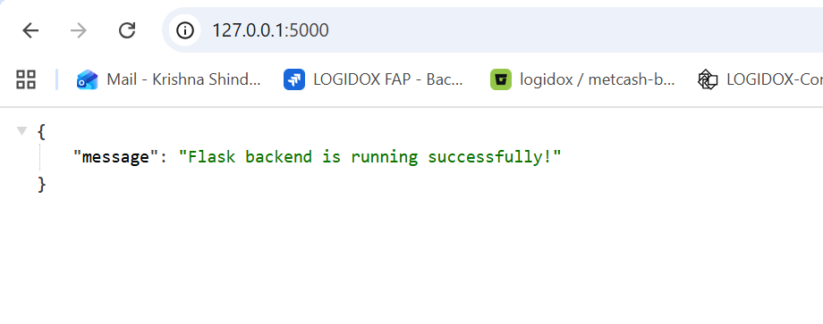
Figure 1: Flask backend started successfully and listening on port 5000.
4.5 Backend Validation
The /submit endpoint expects a POST request containing the following fields:
- Name
- Email
- Course
If all required fields are present, the backend returns a success message and the submitted student details. If a required field is missing, the backend returns an HTTP 400 response.
Opening /submit directly in a browser sends a GET request and results in a Method Not Allowed response. This is expected because the endpoint is designed to accept POST requests.
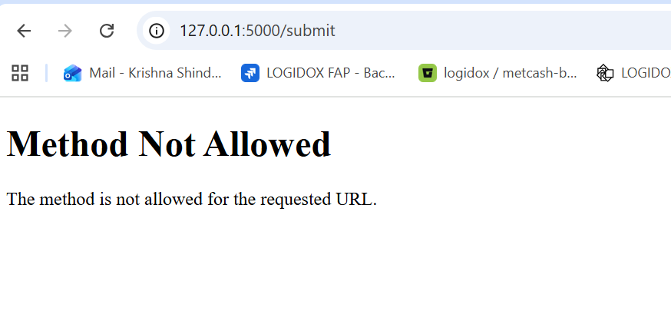
Figure 2: Testing the backend form-submission endpoint.

5. Frontend Implementation Using Node.js and Express
5.1 Overview
The frontend is developed using Node.js and Express. It provides a student registration form with fields for name, email address, and course.
The form sends its data to an Express POST route. Express forwards the information to the Flask backend as a JSON request and displays the backend response.
5.2 Frontend Files
The frontend folder contains:
- server.js — Express server and form-handling logic.
- package.json — Project metadata, scripts, and dependencies.
- package-lock.json — Records the installed dependency versions.
- Dockerfile — Instructions to build the frontend image.
5.3 Installing Dependencies
The Express dependency is installed using:
cd frontend
npm install
The npm install command installs the dependencies declared in package.json and generates package-lock.json when needed.
The frontend can be started locally using:
npm start
The Express server runs on port 3000.
5.4 Student Registration Form
The frontend form contains the following fields:
- Full Name
- Email Address
- Course
The available course options include DevOps, Python, Data Science, and Web Development.
The form uses HTML validation to require the fields and checks that the email address follows the expected email format.
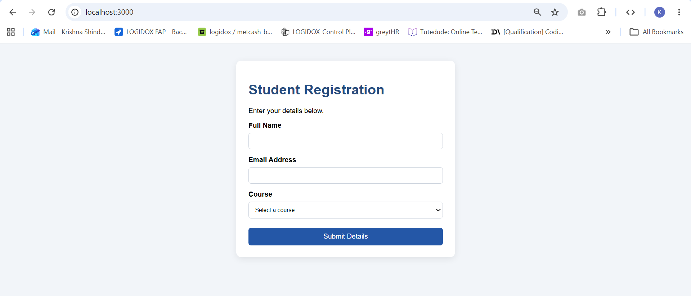
Figure 3: Student registration form displayed in the browser at http://localhost:3000/.
5.5 Form Submission Workflow
When a user submits the form:
- The browser sends the form data to the Express /submit route.
- Express validates that the required values are present.
- Express forwards the information to the Flask /submit endpoint using an HTTP POST request.
- Flask validates the received fields.
- Flask returns a JSON response.
- Express displays the response and the submitted student information.
This architecture separates the user interface from the backend processing logic.
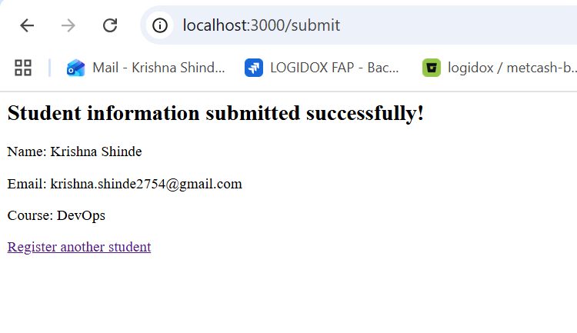
Figure 4: Successful submission of student information through the Express frontend and Flask backend.

6. Docker Configuration
6.1 Overview
Docker packages each application into an image containing its runtime, dependencies, and application code.
Two Docker images are used:
- Frontend image — Node.js and Express application.
- Backend image — Python and Flask application.
Each image has a separate Dockerfile.
6.2 Frontend Dockerfile
The frontend Dockerfile uses a Node.js Alpine base image.
FROM node:22-alpine

WORKDIR /app

COPY package*.json ./

RUN npm install --omit=dev

COPY server.js ./

EXPOSE 3000

CMD ["npm", "start"]
Explanation
- FROM node:22-alpine selects the Node.js base image.
- WORKDIR /app sets the working directory inside the container.
- COPY package*.json ./ copies the package manifest and lockfile, if available.
- RUN npm install --omit=dev installs production dependencies.
- COPY server.js ./ copies the Express application.
- EXPOSE 3000 documents the frontend listening port.
- CMD ["npm", "start"] starts the Express server.
6.3 Backend Dockerfile
The backend Dockerfile uses a Python base image.
FROM python:3.12-slim

WORKDIR /app

COPY requirements.txt ./

RUN pip install --no-cache-dir -r requirements.txt

COPY app.py ./

EXPOSE 5000

CMD ["python", "app.py"]
Explanation
- FROM python:3.12-slim selects the Python base image.
- WORKDIR /app sets the container's working directory.
- COPY requirements.txt ./ copies the dependency file.
- RUN pip install --no-cache-dir -r requirements.txt installs Flask.
- COPY app.py ./ copies the Flask application.
- EXPOSE 5000 documents the backend listening port.
- CMD ["python", "app.py"] starts the Flask server.

7. Docker Compose Configuration
7.1 Purpose
Docker Compose is used to define and manage both services through one YAML configuration file.
The file docker-compose.yaml is stored in the project root.
7.2 Docker Compose File
services:
backend:
build:
context: ./backend
image: krishna-backend:1.0
container_name: flask_backend
ports:
- "5000:5000"
restart: unless-stopped

frontend:
build:
context: ./frontend
image: krishna-frontend:1.0
container_name: node_frontend
ports:
- "3000:3000"
environment:
BACKEND_URL: http://backend:5000
PORT: 3000
depends_on:
- backend
restart: unless-stopped
7.3 Explanation
- services defines the applications managed by Compose.
- backend builds the Flask image using backend/Dockerfile.
- frontend builds the Express image using frontend/Dockerfile.
- ports maps container ports to host ports.
- BACKEND_URL specifies the Flask service URL from inside the frontend container.
- depends_on specifies that the backend container should start before the frontend.
- restart: unless-stopped configures the containers to restart unless explicitly stopped.
Docker Compose creates a shared network by default. The frontend can reach Flask using the service name backend and port 5000.
The depends_on setting controls startup order but does not guarantee application readiness.
7.4 Docker Compose Commands
The configuration can be checked with:
docker compose config
Build both images:
docker compose build
Start both containers:
docker compose up -d
View running services:
docker compose ps
View logs:
docker compose logs
Stop and remove the containers:
docker compose down
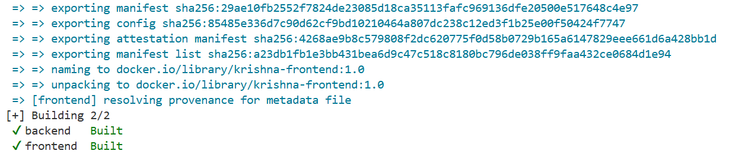Figure 5: Docker Compose successfully building the frontend and backend images.
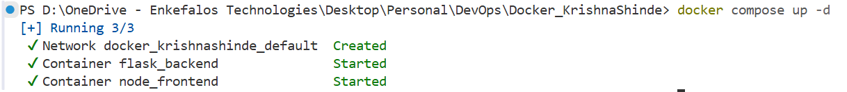Figure 6: Docker Compose showing both frontend and backend containers running.

8. Application Testing
8.1 Frontend Testing
The frontend is accessed using:
http://localhost:3000/
The browser should display the student registration form.
8.2 Backend Testing
The backend health-check endpoint is accessed using:
http://localhost:5000/
The endpoint should return a JSON message indicating that the Flask server is running.
8.3 Form Submission Testing
A sample form submission can use:
Field | Sample Value
Name | Krishna
Email | krishna@example.com
Course | DevOps
When the form is submitted, Express forwards the data to Flask. Flask validates the information and returns the submitted values along with a success message.
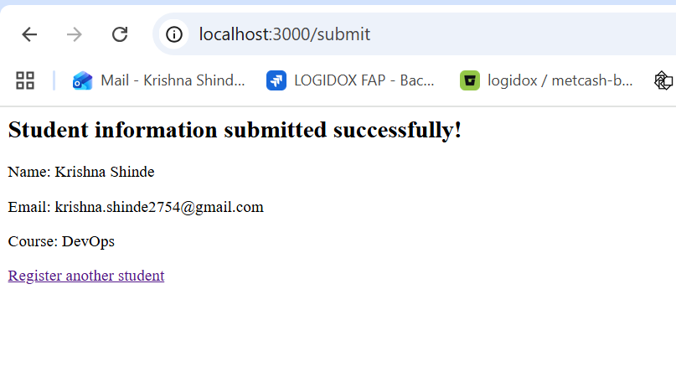
Figure 7: End-to-end testing of the student registration form with both applications running in Docker containers.
8.4 Validation Testing
The application checks whether the required name, email, and course fields are present.
If required fields are missing, the request is rejected with a validation response. HTML form validation also prevents ordinary submission of empty required fields in the browser.
The application is a demonstration project and does not save the submitted information to a database.

9. Docker Images
9.1 Building the Images
Docker Compose builds two images based on the configured Dockerfiles.
The images can be listed using:
docker images
The expected image names before publishing are:
- krishna-backend:1.0
- krishna-frontend:1.0
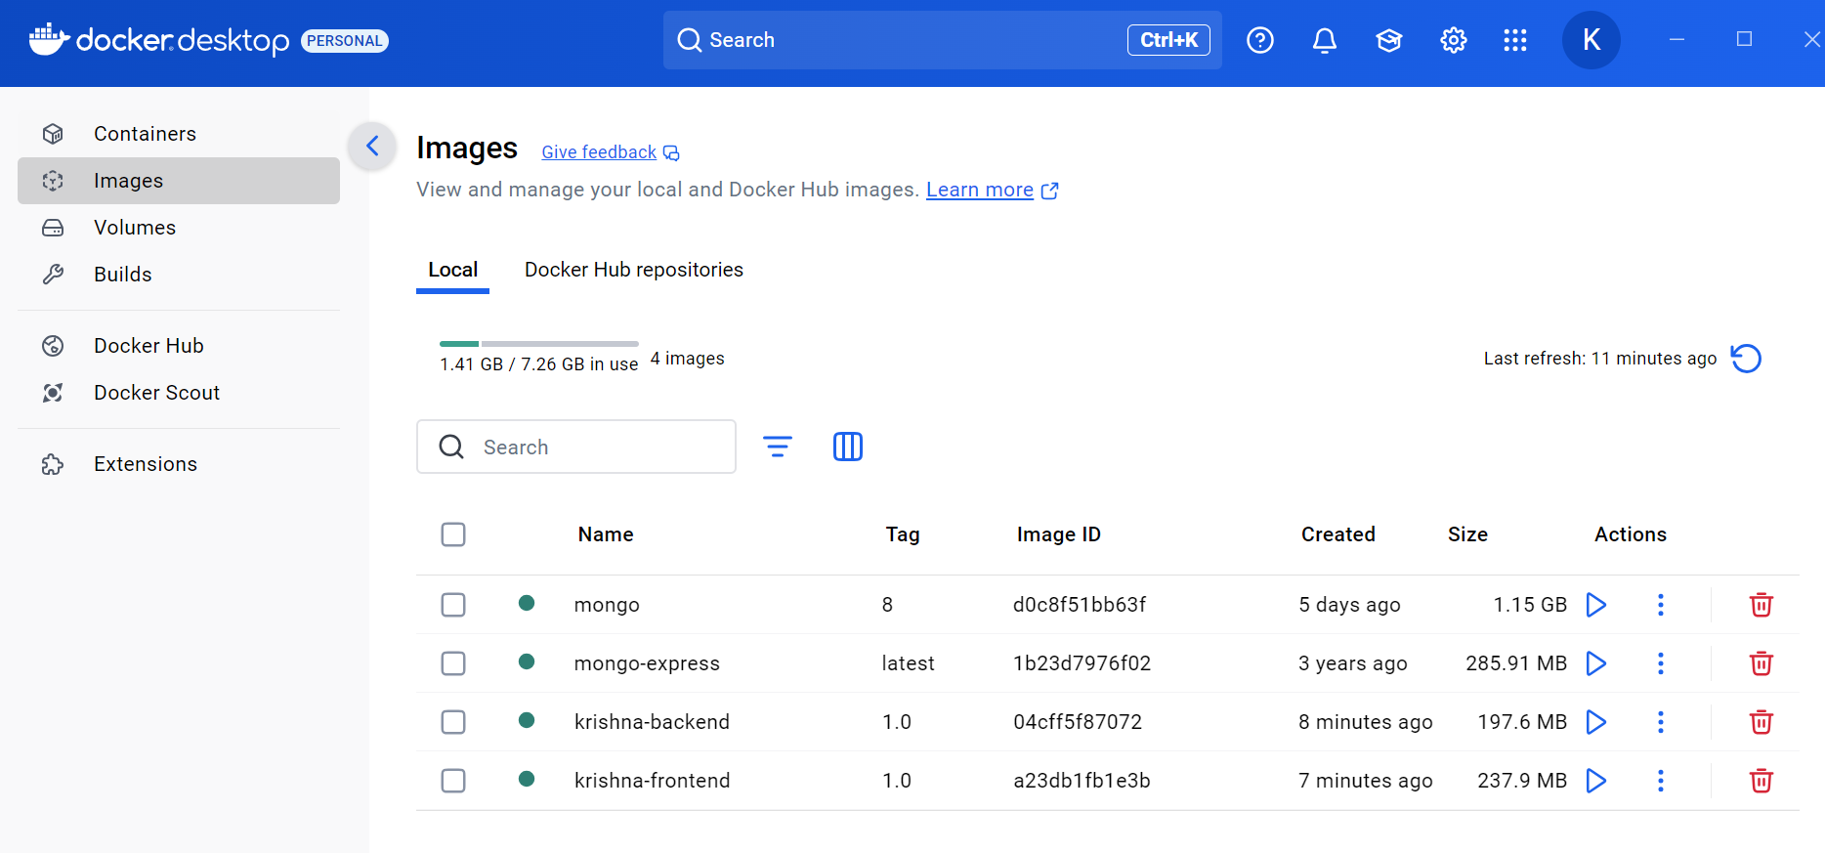
Figure 8: Locally built frontend and backend Docker images.
9.2 Docker Hub Links
Backend repository: https://hub.docker.com/r/krishnashinde/krishna-backend
Frontend repository: https://hub.docker.com/r/krishnashinde/krishna-frontend

10 GitHub Repository Link
Repository URL: https://github.com/krishna-280792shinde/docker-tutorial

11. Conclusion
This assignment demonstrates the containerization of a full-stack student registration application using Docker and Docker Compose.
The frontend is developed using Node.js and Express, while the backend is implemented using Python and Flask. Dockerfiles define the build process for both applications, and Docker Compose manages the services and connects them through a shared network.
The project also demonstrates source code management using GitHub and image distribution using Docker Hub.

