KUBERNETES DEVOPS ASSIGNMENT

1. Introduction
The objective of this assignment is to deploy a full-stack web application in a local Kubernetes cluster using Minikube.
The application consists of two components:
- Express.js Frontend: Provides a student registration form that accepts a student's name, email address, and course.
- Flask Backend: Receives registration data from the frontend through an HTTP POST request and returns a JSON response.
Both applications are containerized using Docker. Kubernetes Deployment and Service resources are used to run the applications, manage their pods, and enable communication between the frontend and backend.
Minikube provides a local Kubernetes environment for developing, testing, and learning Kubernetes deployment concepts without requiring a cloud-based cluster.

2. Objectives
The main objectives of this assignment are:
- Understand the fundamentals of Kubernetes.
- Set up a local Kubernetes cluster using Minikube.
- Containerize the frontend and backend applications using Docker.
- Create Kubernetes Deployment manifests.
- Create Kubernetes Service manifests.
- Deploy both applications to the Kubernetes cluster.
- Configure communication between the frontend and backend.
- Verify the status of Kubernetes nodes, pods, and services.
- Test the full-stack application through a web browser.
- Maintain the project in a GitHub repository.
- Document the implementation with screenshots and commands.

3. Technologies Used
Technology | Purpose
Python | Backend programming language
Flask | Backend web framework
Node.js | JavaScript runtime
Express.js | Frontend web server
Docker | Containerization
Docker Desktop | Local container runtime
Minikube | Local Kubernetes cluster
kubectl | Kubernetes command-line interface
Kubernetes YAML | Deployment and Service configuration
Git | Version control
GitHub | Source code hosting
Microsoft Word | Project documentation

4. Project Architecture
The application follows a frontend-backend architecture.
The Express frontend displays the student registration form. When the user submits the form, the frontend sends the information to the Flask backend. The backend validates the submitted fields and returns a response.
Kubernetes manages the applications through Deployments and Services.
Application flow:
Browser → Frontend Service → Express Frontend Pod → Backend Service → Flask Backend Pod
The frontend Service exposes the application to the host machine through a NodePort. The backend Service uses the ClusterIP type, allowing internal communication from the frontend to the backend.
Architecture components:
- Frontend Deployment: Manages Express frontend pods.
- Frontend Service: Exposes the frontend application.
- Backend Deployment: Manages Flask backend pods.
- Backend Service: Provides an internal network endpoint for the backend.

5. Environment Setup
The development environment uses Windows PowerShell, Docker Desktop, Minikube, and kubectl.
5.1 Verify Docker
The following command checks the installed Docker version:
docker --version
The Docker engine can be checked using:
docker info
Docker Desktop must be running before starting Minikube with the Docker driver.
5.2 Verify Minikube
The following command displays the installed Minikube version:
minikube version
5.3 Verify kubectl
The following command checks the Kubernetes command-line client:
kubectl version --client
5.4 Start the Kubernetes Cluster
The local Kubernetes cluster is started using:
minikube start --driver=docker
This command starts Minikube using Docker as the container driver.
5.5 Verify Cluster Status
The cluster status is checked with:
minikube status
The Kubernetes nodes are listed using:
kubectl get nodes
The Kubernetes system pods are checked using:
kubectl get pods -A
A successful setup should show a Minikube node with the status Ready.
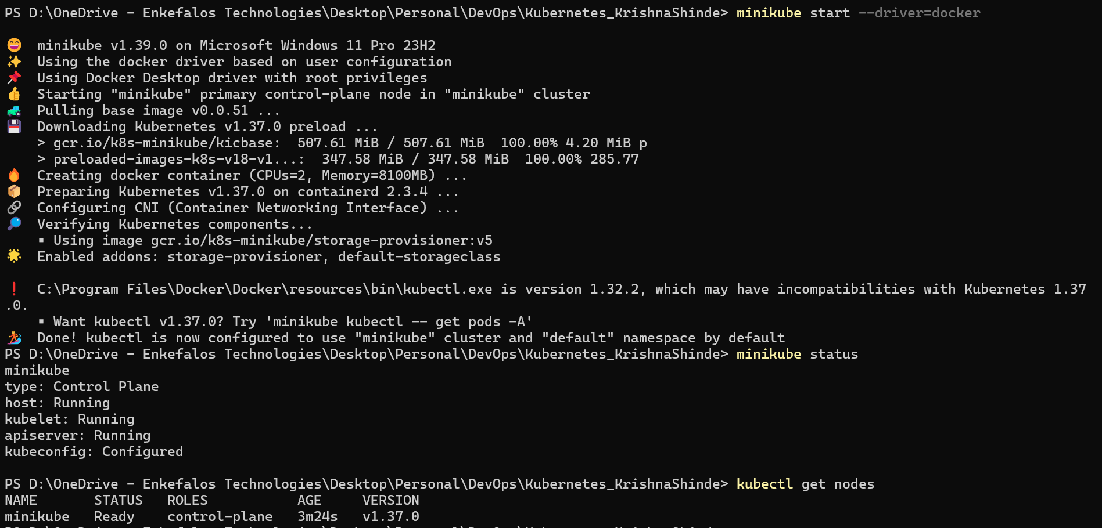

6. Application Containerization
Both applications use Dockerfiles to define how their container images are built.
6.1 Flask Backend Dockerfile
File: backend/Dockerfile
FROM python:3.12-slim

WORKDIR /app

COPY requirements.txt ./

RUN pip install --no-cache-dir -r requirements.txt

COPY app.py ./

EXPOSE 5000

CMD ["python", "app.py"]
Explanation:
- FROM specifies the Python base image.
- WORKDIR sets the working directory inside the container.
- COPY copies the dependency file and application source code.
- RUN installs the required Python packages.
- EXPOSE documents the backend's listening port.
- CMD starts the Flask application.
6.2 Express Frontend Dockerfile
File: frontend/Dockerfile
FROM node:22-alpine

WORKDIR /app

COPY package*.json ./

RUN npm install --omit=dev

COPY server.js ./

EXPOSE 3000

CMD ["npm", "start"]
Explanation:
- FROM specifies the Node.js base image.
- WORKDIR defines the container's working directory.
- COPY transfers the dependency files and source code.
- RUN installs production dependencies.
- EXPOSE documents the frontend port.
- CMD starts the Express server.

7. Build and Load Docker Images
The Docker images must be available to the Minikube cluster before the application can be deployed.
Navigate to the project directory:
Build the backend image:
docker build -t krishna-backend:1.0 .\backend
Build the frontend image:
docker build -t krishna-frontend:1.0 .\frontend
Verify the images:
docker images
Load the backend image into Minikube:
minikube image load krishna-backend:1.0
Load the frontend image into Minikube:
minikube image load krishna-frontend:1.0
Verify that the images are available in Minikube:
minikube image ls
These steps make the local images available to Kubernetes without requiring them to be pulled from a public registry.
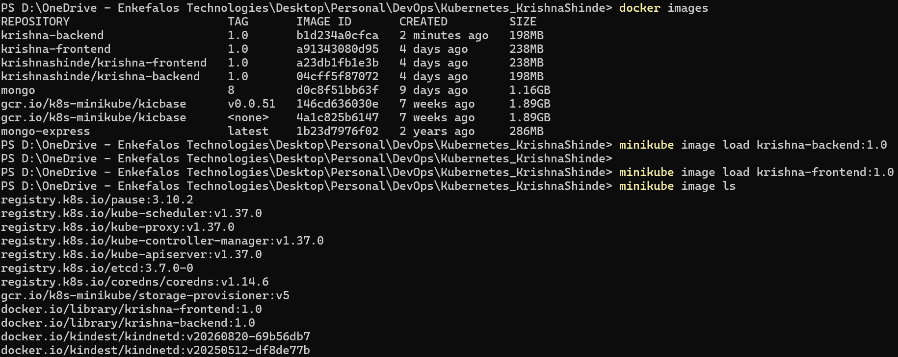8. Kubernetes Deployment and Service Manifests
Kubernetes manifests describe how applications should run and how they communicate.
The following four YAML files define the backend Deployment, backend Service, frontend Deployment, and frontend Service.
8.1 Backend Deployment
File: k8s/backend-deployment.yaml
apiVersion: apps/v1
kind: Deployment
metadata:
name: backend-deployment
spec:
replicas: 1
selector:
matchLabels:
app: backend
template:
metadata:
labels:
app: backend
spec:
containers:
- name: flask-backend
image: krishna-backend:1.0
imagePullPolicy: IfNotPresent
ports:
- containerPort: 5000
Explanation:
- apiVersion identifies the Kubernetes API version.
- kind: Deployment defines a Deployment resource.
- replicas: 1 requests one backend pod.
- selector identifies the pods managed by the Deployment.
- image specifies the backend container image.
- containerPort specifies the application's listening port.
8.2 Backend Service
File: k8s/backend-service.yaml
apiVersion: v1
kind: Service
metadata:
name: backend-service
spec:
type: ClusterIP
selector:
app: backend
ports:
- port: 5000
targetPort: 5000
protocol: TCP
Explanation:
The backend Service provides a stable internal address for the Flask application.
The frontend accesses the backend through:
http://backend-service:5000
The ClusterIP type exposes the backend inside the Kubernetes cluster.
8.3 Frontend Deployment
File: k8s/frontend-deployment.yaml
apiVersion: apps/v1
kind: Deployment
metadata:
name: frontend-deployment
spec:
replicas: 1
selector:
matchLabels:
app: frontend
template:
metadata:
labels:
app: frontend
spec:
containers:
- name: express-frontend
image: krishna-frontend:1.0
imagePullPolicy: IfNotPresent
ports:
- containerPort: 3000
env:
- name: BACKEND_URL
value: "http://backend-service:5000"
- name: PORT
value: "3000"
Explanation:
- The Deployment manages the Express frontend pod.
- The frontend uses the locally loaded Docker image.
- BACKEND_URL specifies the backend Service address.
- PORT configures the frontend to listen on port 3000.
Important: The backend URL uses the Kubernetes Service name rather than localhost. Inside a container, localhost refers to that same container, not another application's pod.
8.4 Frontend Service
File: k8s/frontend-service.yaml
apiVersion: v1
kind: Service
metadata:
name: frontend-service
spec:
type: NodePort
selector:
app: frontend
ports:
- port: 3000
targetPort: 3000
nodePort: 30080
protocol: TCP
Explanation:
The frontend Service exposes the Express application through NodePort 30080.
This allows the application to be accessed through Minikube's service URL or an equivalent supported local access method.

9. Deploy the Applications
After creating all four YAML files, navigate to the project root:
Apply the backend Deployment:
kubectl apply -f .\k8s\backend-deployment.yaml
Apply the backend Service:
kubectl apply -f .\k8s\backend-service.yaml
Apply the frontend Deployment:
kubectl apply -f .\k8s\frontend-deployment.yaml
Apply the frontend Service:
kubectl apply -f .\k8s\frontend-service.yaml
These commands create or update the Kubernetes resources defined in the YAML files.
Verify the resources:
kubectl get deployments
kubectl get pods
kubectl get services
Wait until both application pods are running and the Deployment readiness counts indicate that the requested replicas are available.
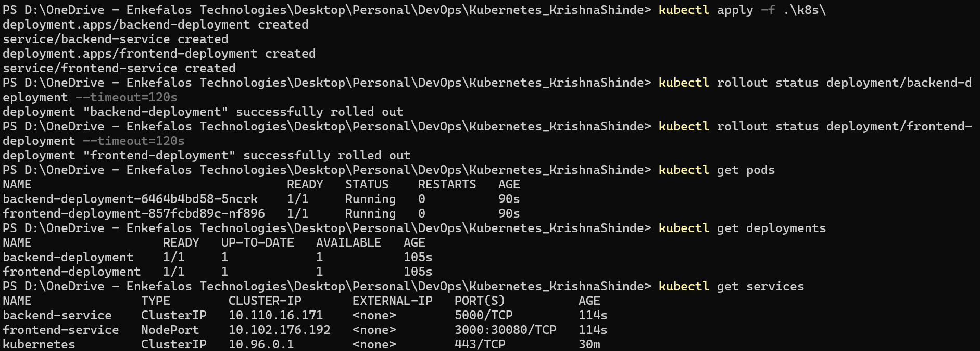
10. Verify Application Deployment
10.1 Check Deployment Status
Run:
kubectl rollout status deployment/backend-deployment
kubectl rollout status deployment/frontend-deployment
These commands wait for the respective Deployments to complete their rollout.
10.2 Check Pod Details
Run:
kubectl get pods -o wide
This command displays the pods, their status, restart counts, and node placement.
10.3 Check Application Logs
Backend logs:
kubectl logs deployment/backend-deployment
Frontend logs:
kubectl logs deployment/frontend-deployment
Logs help identify startup problems, failed requests, and communication errors.
10.4 Check the Backend Through Port Forwarding
To test the Flask backend independently, run:
kubectl port-forward service/backend-service 5000:5000
Keep this terminal open and open a separate PowerShell window. Test the backend endpoint:
Invoke-RestMethod http://127.0.0.1:5000/
The backend should return a JSON response containing a message that indicates the Flask application is running.
Stop port forwarding with Ctrl+C when finished.

11. Access and Test the Frontend
To obtain the frontend's Minikube URL, run:
minikube service frontend-service --url
Open the URL returned by the command in a web browser.
If Minikube provides a URL using a local address, use that exact URL. Depending on the Windows and Docker configuration, the service command may need to remain running in the terminal.
The student registration page should display fields for:
- Full Name
- Email Address
- Course
Enter sample information and submit the form.
For example:
- Full Name: Test Student
- Email Address: student@example.com
- Course: DevOps
After submission, the Express frontend should send the data to the Flask backend. If the request succeeds, the page should display the successful submission message and the submitted details.
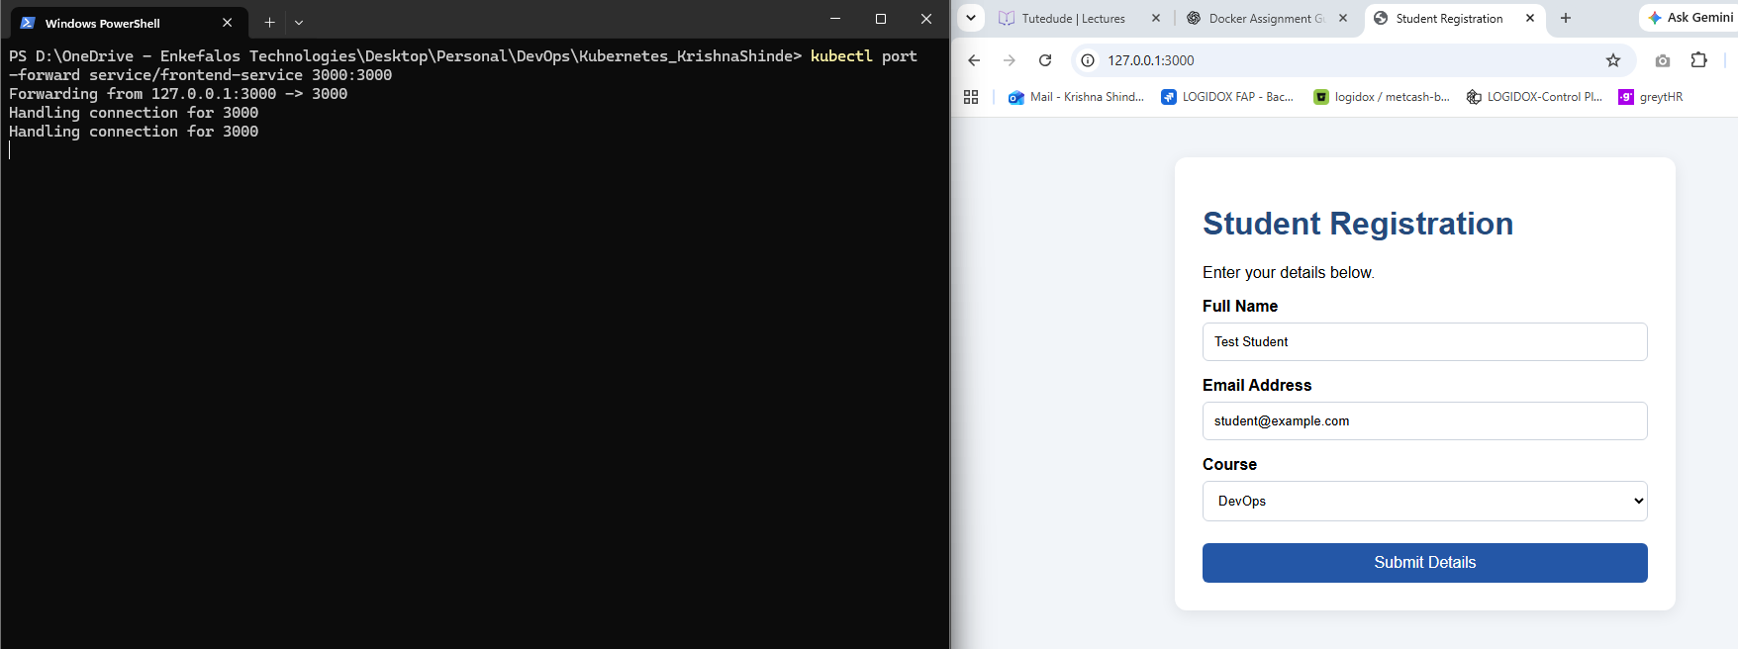 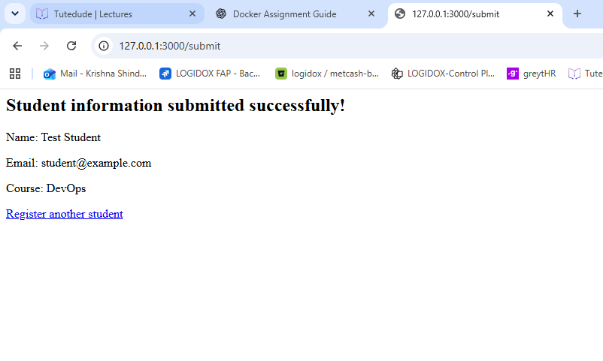12. GitHub Repository
GitHub is used to maintain the project source code and Kubernetes manifests.
Initialize Git from the project root if the repository has not already been initialized:
git init
Create a .gitignore file to exclude generated dependencies and temporary files.
Example .gitignore:
# Node.js dependencies
frontend/node_modules/

# Python generated files
__pycache__/
*.py[cod]
.venv/
venv/

# Environment variables and secrets
.env
.env.*

# Editors and operating system
.vscode/
.DS_Store
Thumbs.db
Check the repository status:
git status
Stage the project files:
git add .
Create a commit:
git commit -m "Add Kubernetes Minikube deployment"
Create a new GitHub repository named Kubernetes_KrishnaShinde and connect it using the repository URL provided by GitHub.
For example, replace the placeholder below with your actual GitHub repository URL:
git remote add origin https://github.com/YOUR_GITHUB_USERNAME/Kubernetes_KrishnaShinde.git
If the remote already exists, check it with:
git remote -v
Push the project:
git branch -M main
git push -u origin main
Verify that the application source files, Dockerfiles, Kubernetes manifests, and README are visible in the GitHub repository.
GitHub Repository Link: https://github.com/krishna-280792shinde/kubernetes

13. Learning Outcomes
Through this assignment, I aim to demonstrate an understanding of:
- The purpose of Kubernetes in container orchestration.
- How Minikube provides a local Kubernetes environment.
- How Docker images are built and made available to Kubernetes.
- How Deployments manage application pods.
- How Services expose applications and provide internal communication.
- How Kubernetes environment variables configure application connectivity.
- How to verify pods, deployments, and services using kubectl.
- How to troubleshoot container and application startup problems.
- How to maintain source code and configuration files using GitHub.

14. Conclusion
This assignment demonstrates how a full-stack web application can be containerized and deployed to a local Kubernetes cluster using Minikube.
The Express frontend provides the user interface, while the Flask backend processes submitted registration data. Docker provides the application images, and Kubernetes Deployments and Services manage application execution and networking.
The final deliverables include the complete source code, Dockerfiles, Kubernetes YAML manifests, documentation, GitHub repository link, and compressed ZIP archive.

