Terraform DevOps Assignment

1. Introduction
The objective of this assignment is to understand and implement Infrastructure as Code (IaC) using Terraform to deploy web applications on Amazon Web Services (AWS).
The project uses a Flask backend developed in Python and an Express frontend developed using Node.js. The applications are deployed using three different architectures.
- Deploying both applications on a single EC2 instance.
- Deploying the applications on two separate EC2 instances.
- Deploying the applications as Docker containers using Amazon ECR, Amazon ECS, a VPC, and an Application Load Balancer.
Terraform is used to define, provision, update, and manage the infrastructure. User-data scripts automate application setup on EC2 instances, while Docker packages the applications into containers for the third deployment.
This assignment demonstrates how infrastructure automation can simplify application deployment, improve consistency, and make cloud infrastructure easier to manage.

2. Objectives
The main objectives of this assignment are:
- Understand the fundamentals of Terraform and Infrastructure as Code.
- Create and manage AWS resources using Terraform configuration files.
- Deploy a Flask backend and an Express frontend on a single EC2 instance.
- Deploy Flask and Express on separate EC2 instances.
- Configure VPCs, subnets, route tables, and security groups.
- Automate application installation and startup using user-data scripts.
- Build Docker images for the Flask backend and Express frontend.
- Store Docker images in Amazon Elastic Container Registry (ECR).
- Deploy containers using Amazon Elastic Container Service (ECS).
- Configure an Application Load Balancer (ALB) to route requests.
- Use Terraform variables, outputs, validation, and state management.
- Document the implementation with commands, screenshots, and explanations.

3. Tools and Technologies Used
The following tools and technologies are used in this project:
Technology | Purpose
Terraform | Infrastructure as Code and AWS resource management
Amazon EC2 | Virtual machines for application hosting
Amazon VPC | Network isolation and configuration
Security Groups | Control inbound and outbound network traffic
Python | Programming language for the Flask backend
Flask | Backend web framework
Node.js | JavaScript runtime for the frontend server
Express.js | Frontend web server framework
Docker | Containerization of applications
Amazon ECR | Storage for Docker images
Amazon ECS | Container orchestration
AWS Fargate | Serverless container compute
Application Load Balancer | Distributes HTTP requests to application services
Git | Source-code version control
GitHub | Remote source-code repository
Microsoft Word | Project documentation

4. Project Folder Structure
The project is organized into separate directories for each deployment configuration.
The exact project structure may vary slightly depending on the final implementation. Each deployment configuration is maintained separately to simplify testing and resource cleanup.

5. Prerequisites and Environment Setup
Before beginning the deployment, the required tools and AWS credentials must be configured.
The prerequisites include:
- Terraform CLI installed on the local computer.
- AWS CLI installed and configured.
- Valid AWS credentials with the necessary permissions.
- Python installed for the Flask application.
- Node.js and npm installed for the Express application.
- Docker Desktop installed and running for container deployment.
- Git installed for version control.
- An AWS region selected for resource deployment.
The following commands can be used to verify the installed tools.
terraform -version
aws --version
aws sts get-caller-identity
python --version
node --version
npm --version
docker --version
git --version
The AWS identity command verifies which AWS account and IAM identity are being used by the CLI.

PART 1: Deploy Flask and Express on a Single EC2 Instance

6. Objective
The objective of Part 1 is to deploy the Flask backend and Express frontend on a single Amazon EC2 instance using Terraform.
Terraform provisions the EC2 instance and its security group. A user-data script installs the required dependencies and starts both applications automatically.
The applications run on separate ports:
- Flask backend: Port 5000
- Express frontend: Port 3000
This approach demonstrates how multiple web applications can run on one virtual machine.

7. Terraform Configuration
The Terraform configuration defines the AWS provider, EC2 instance, security group, and output values.
The configuration is organized into the following files:
main.tf: Defines AWS resources such as the security group and EC2 instance.
variables.tf: Defines configurable values such as the AWS region, instance type, and application ports.
outputs.tf: Displays useful information after deployment, such as the EC2 public IP address and application URLs.
Terraform variables make the configuration reusable, while outputs simplify application access and testing.

8. Initialize and Validate Terraform
Terraform must be initialized before it can deploy the infrastructure.
The following commands are executed from the Part 1 directory.
terraform init
This command initializes Terraform and downloads the required provider plugins.
terraform fmt -recursive
This command formats the Terraform configuration files according to standard formatting conventions.
terraform validate
This command checks whether the Terraform configuration is syntactically valid and internally consistent.
terraform plan
This command displays the infrastructure changes Terraform intends to make.
terraform apply
This command applies the configuration and creates the required AWS resources after confirmation.
The Terraform plan must be reviewed before applying changes to ensure that the intended resources and configurations are correct.
Screenshot:
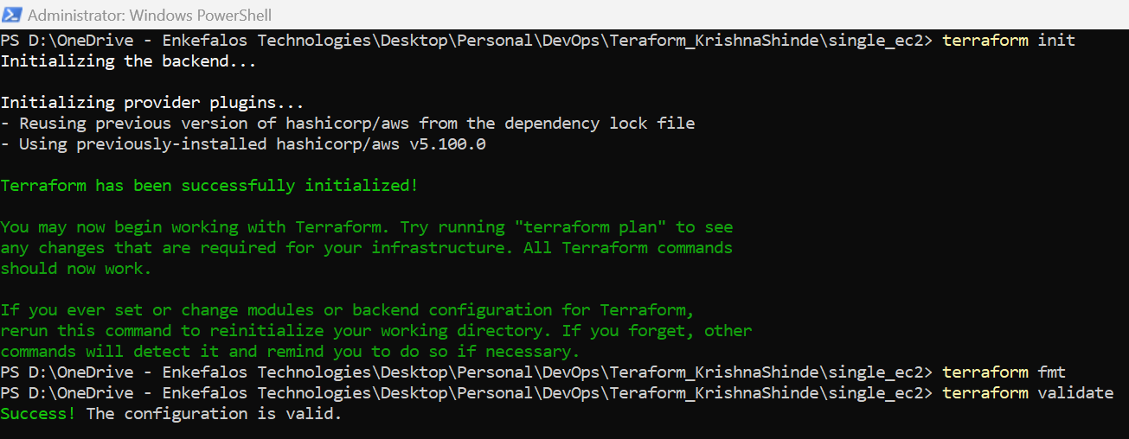

Terraform Apply
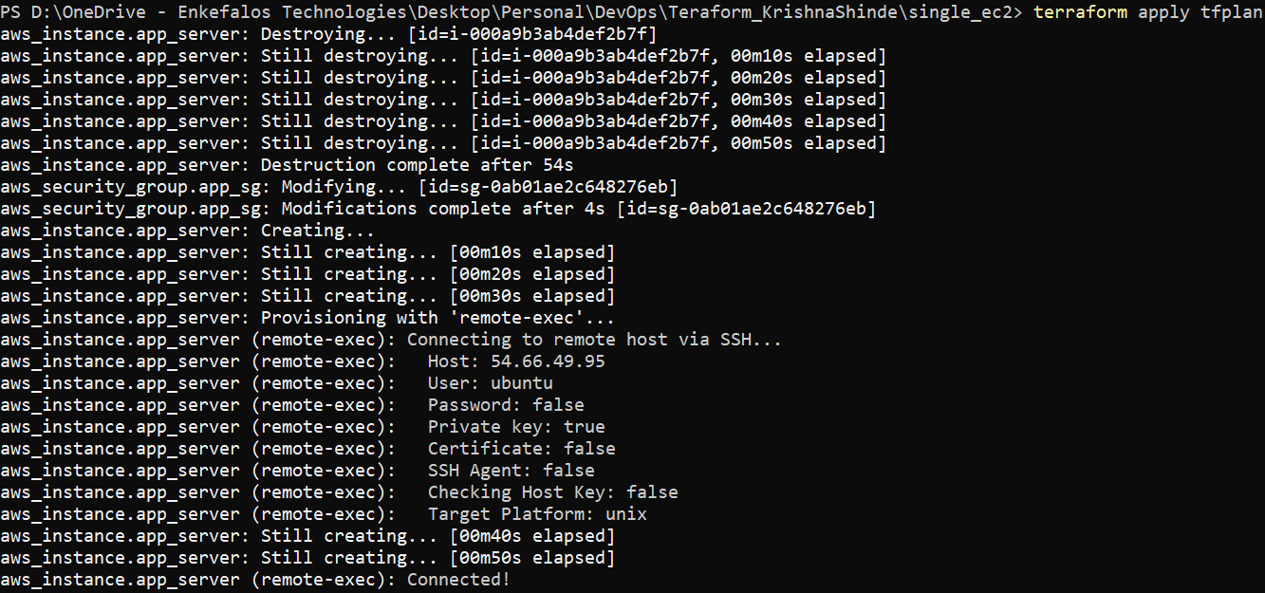
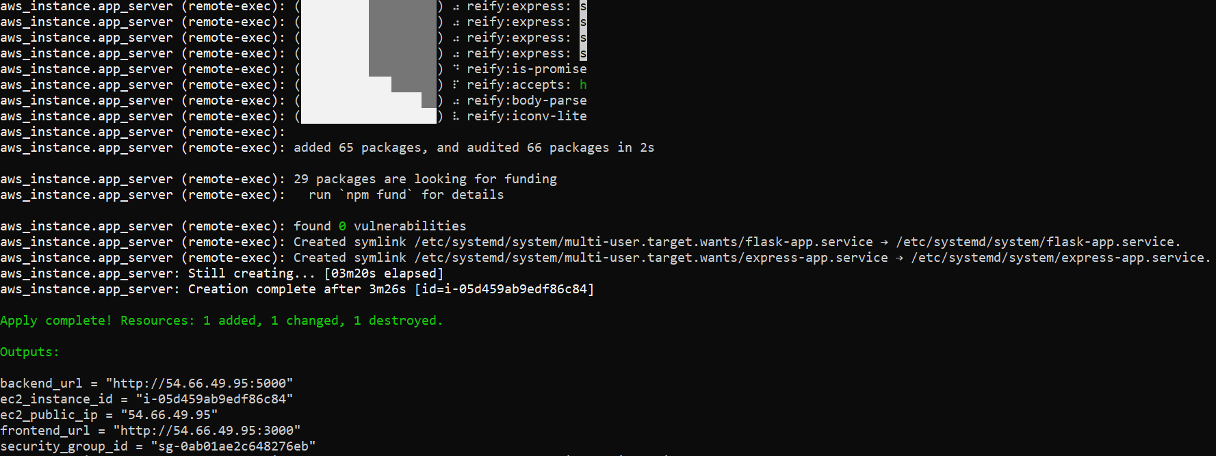

9. Application Deployment and Testing
After Terraform creates the EC2 instance, the user-data script configures the server and starts the Flask and Express applications.
The public IP address is obtained from the Terraform output or the EC2 console.
The Express frontend is accessed using:
http://<EC2-PUBLIC-IP>:3000
The Flask backend is tested using:
http://<EC2-PUBLIC-IP>:5000
The exact backend endpoint depends on the routes implemented in the Flask application.
The security group must permit inbound traffic on the required application ports. SSH access, if needed, should be restricted to the user's IP address.
Testing confirms whether both applications are reachable from a browser or an API testing tool.
EC2 Instance Running
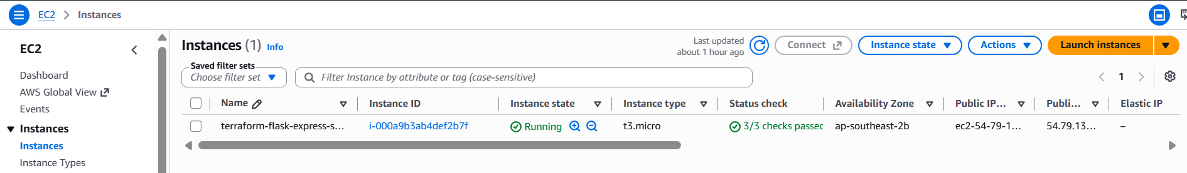 Frontend Running
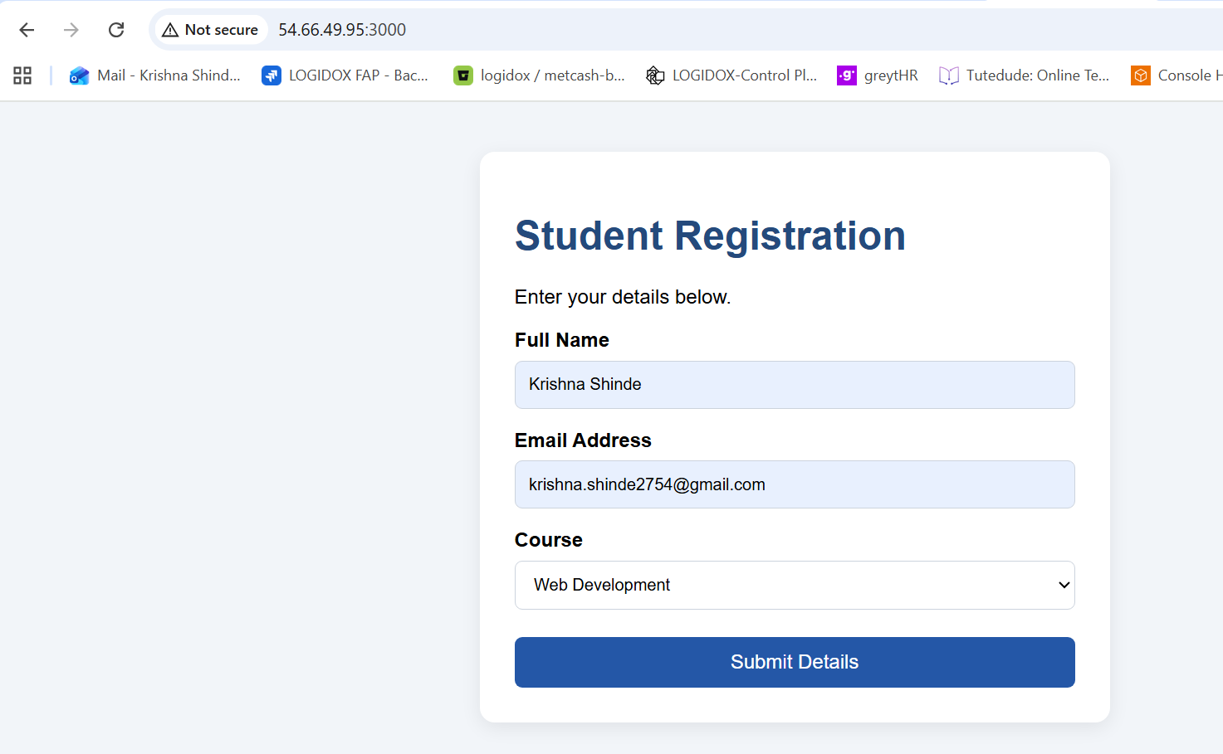Screenshot 9: Flask Backend API Test
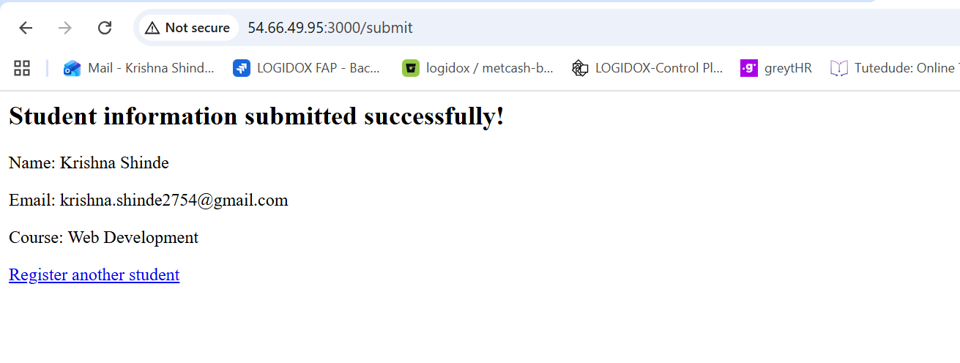10. Result of Part 1
The first deployment demonstrates how Terraform can provision an EC2 instance and automate application setup.
The Flask backend and Express frontend are configured to run on separate ports on the same instance.
Result: Record the EC2 instance ID, public IP address, frontend URL, and successful backend API test result.

PART 2: Deploy Flask and Express on Separate EC2 Instances

11. Objective
The objective of Part 2 is to deploy the Flask backend and Express frontend on two separate EC2 instances using Terraform.
One instance hosts the Flask backend, and the other hosts the Express frontend.
This architecture separates the application components and demonstrates how networking and security groups can control communication between services.
The Terraform configuration provisions the required EC2 instances, VPC resources, subnet configuration, routing, and security groups.

12. Networking and Security Configuration
The deployment requires suitable network resources to enable communication between the applications.
The main components include:
VPC: Provides the network environment for the EC2 instances.
Subnets: Define the network ranges in which the instances are deployed.
Route tables: Control how traffic is routed within the VPC and, where configured, to the internet.
Internet gateway: Provides internet connectivity for resources in appropriately configured public subnets.
Security groups: Control inbound and outbound traffic to the instances.
The Express frontend must be able to communicate with the Flask backend through the backend's reachable address and port.
Security group rules should expose the frontend to the required external traffic while limiting backend access to the necessary sources. Where practical, backend access should be restricted to the frontend instance's security group rather than opened to the entire internet.

13. Terraform Configuration and Deployment
The Part 2 configuration defines two EC2 instances and the networking resources required by the deployment.
The user-data scripts install the required dependencies and start the relevant application on each instance.
The Terraform workflow uses the following commands.
terraform init
terraform fmt -recursive
terraform validate
terraform plan
terraform apply
The plan is reviewed before applying the changes.
After deployment, Terraform outputs or the AWS console provide the instance details needed for testing.
Screenshots:
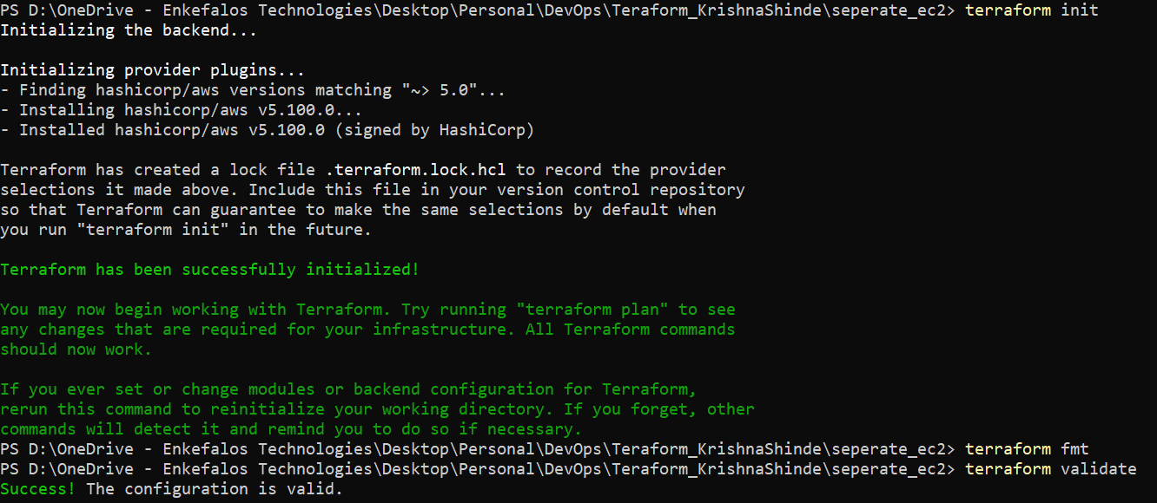
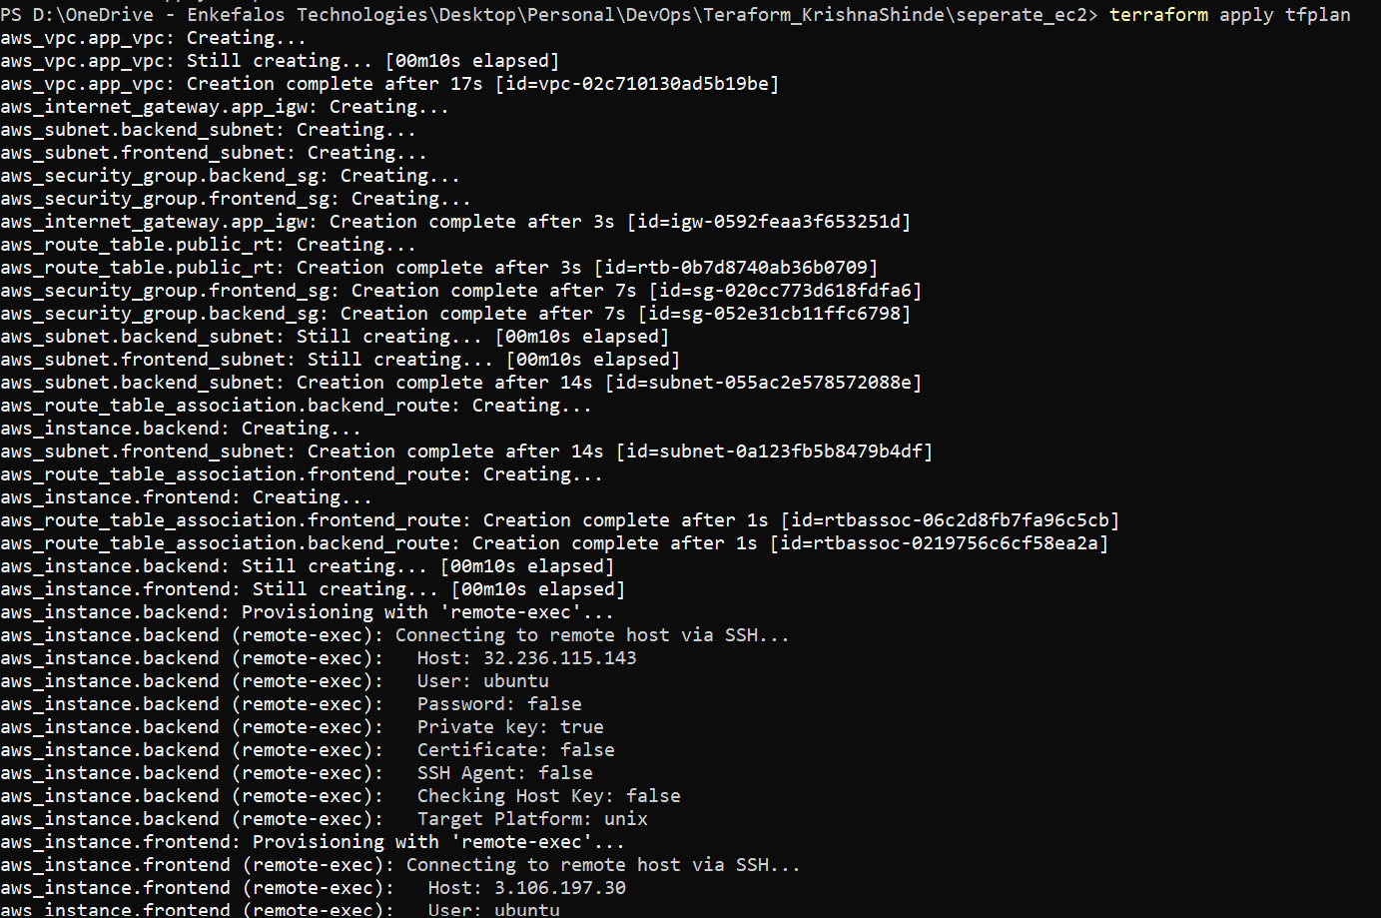
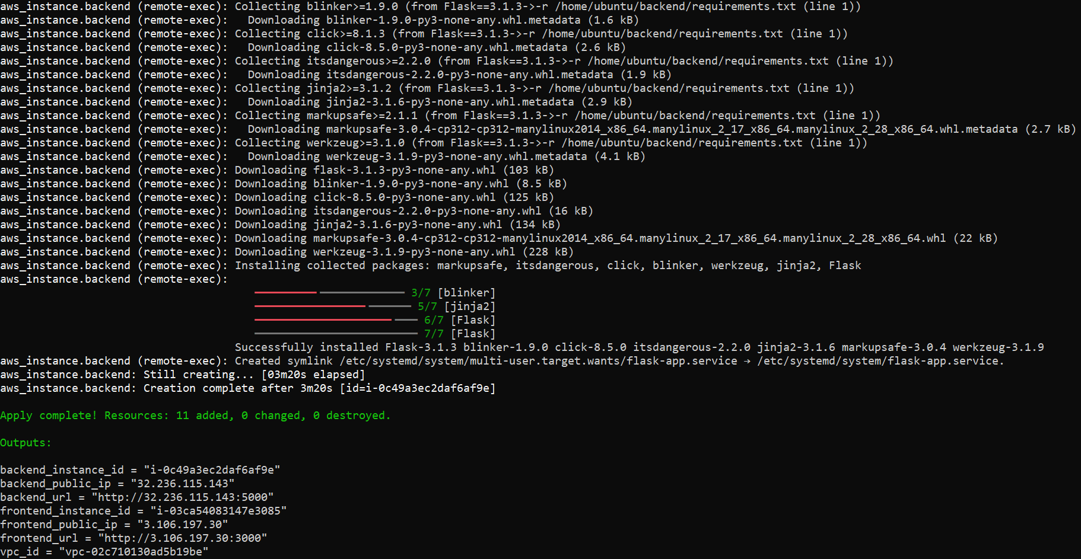

14. Application Deployment and Testing
After deployment, both instances should be running.
The Express frontend is accessed through the frontend instance's public IP address:
http://<FRONTEND-PUBLIC-IP>:3000
The Flask backend is tested through its configured endpoint:
http://<BACKEND-PUBLIC-IP>:5000
The exact API route depends on the Flask application.
The tests verify that the frontend and backend are reachable and that any required frontend-to-backend communication works correctly.
Frontend and Backend EC2 Instances Running
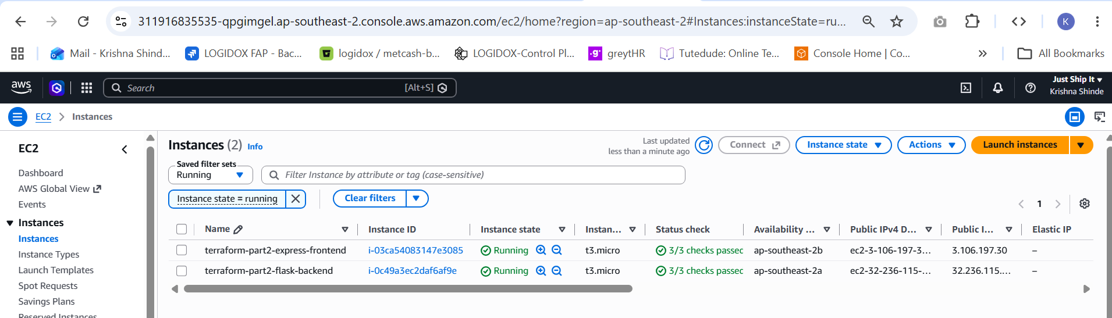
Express Frontend Test
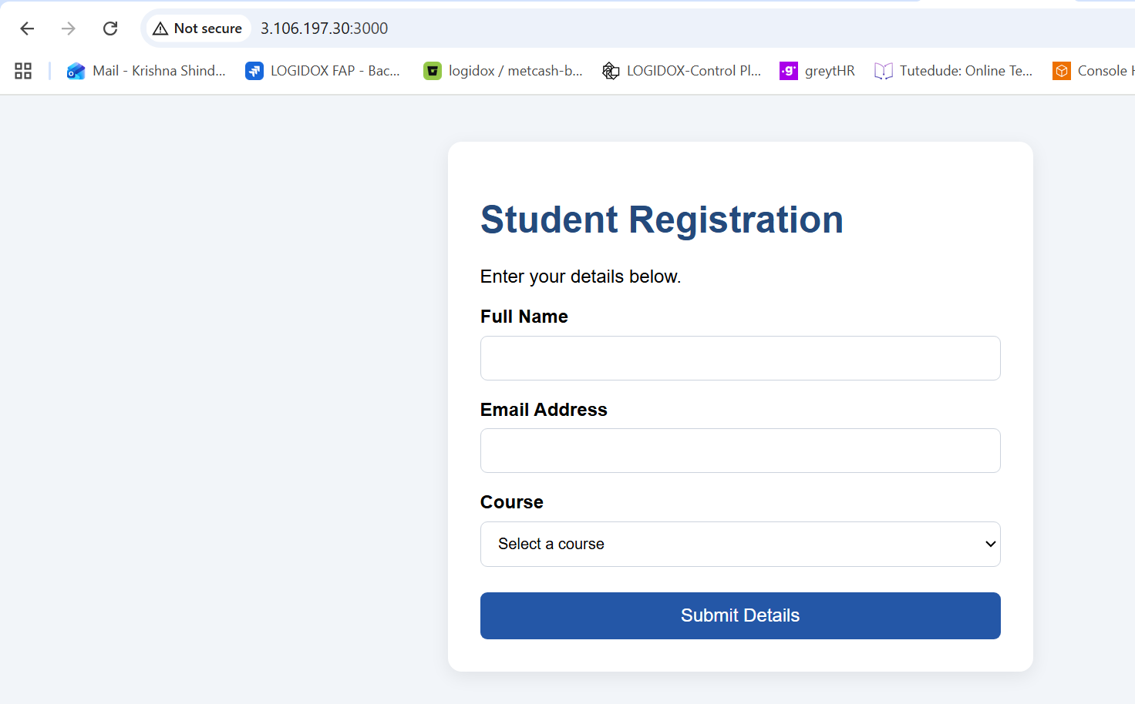
Frontend-to-Backend Communication
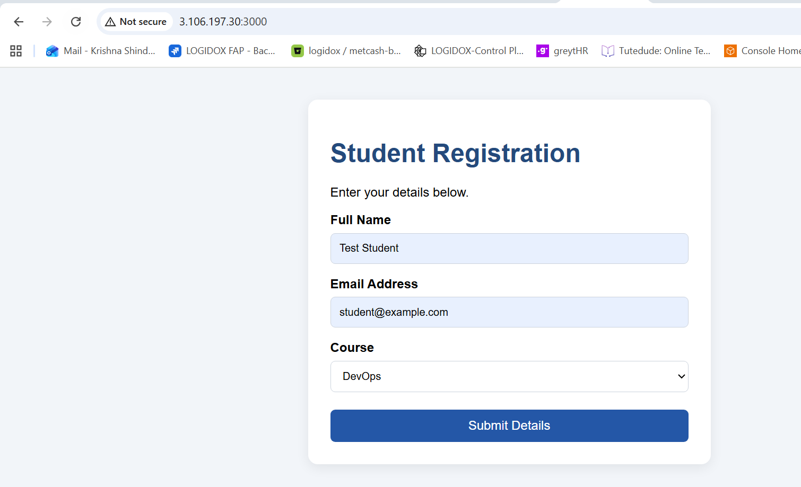
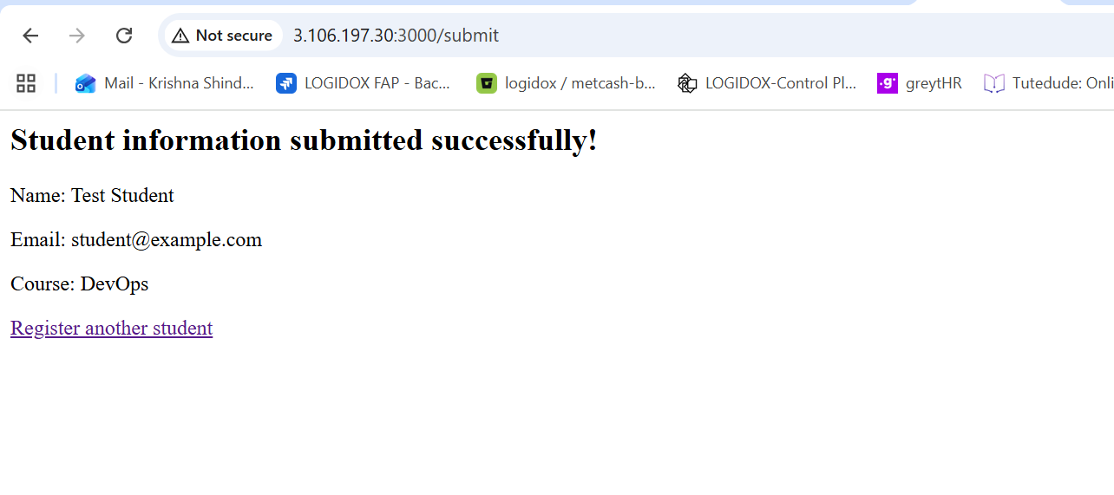

15. Result of Part 2
The second deployment demonstrates how the frontend and backend can run on separate EC2 instances.
Terraform manages the infrastructure, while the VPC, routing, and security groups provide the required network connectivity and traffic controls.

PART 3: Deploy Docker Containers Using ECR, ECS, VPC, and ALB

16. Objective
The objective of Part 3 is to deploy the Flask backend and Express frontend as Docker containers using AWS container services and Terraform.
The applications are packaged into Docker images and stored in Amazon Elastic Container Registry (ECR).
Amazon Elastic Container Service (ECS) runs the containers using AWS Fargate. Terraform manages the infrastructure, including the VPC, networking, ECS cluster, task definitions, services, and Application Load Balancer.
The load balancer provides an external entry point and routes incoming requests to the appropriate application service according to the configured listener rules.

17. Docker Image Creation
Docker is used to package the Flask backend and Express frontend with their dependencies.
The backend Docker image contains the Flask application and its Python dependencies.
The frontend Docker image contains the Express application and its Node.js dependencies.
The Dockerfiles specify the base images, application files, dependency installation, and startup commands.
The images are built locally and tested before they are pushed to ECR.
Example build commands, to be adjusted to the actual project structure, are:
docker build -t krishna-flask-backend:latest .\backend
docker build -t krishna-express-frontend:latest .\frontend
The resulting images can be checked using:
docker images
Docker Images Built Successfully
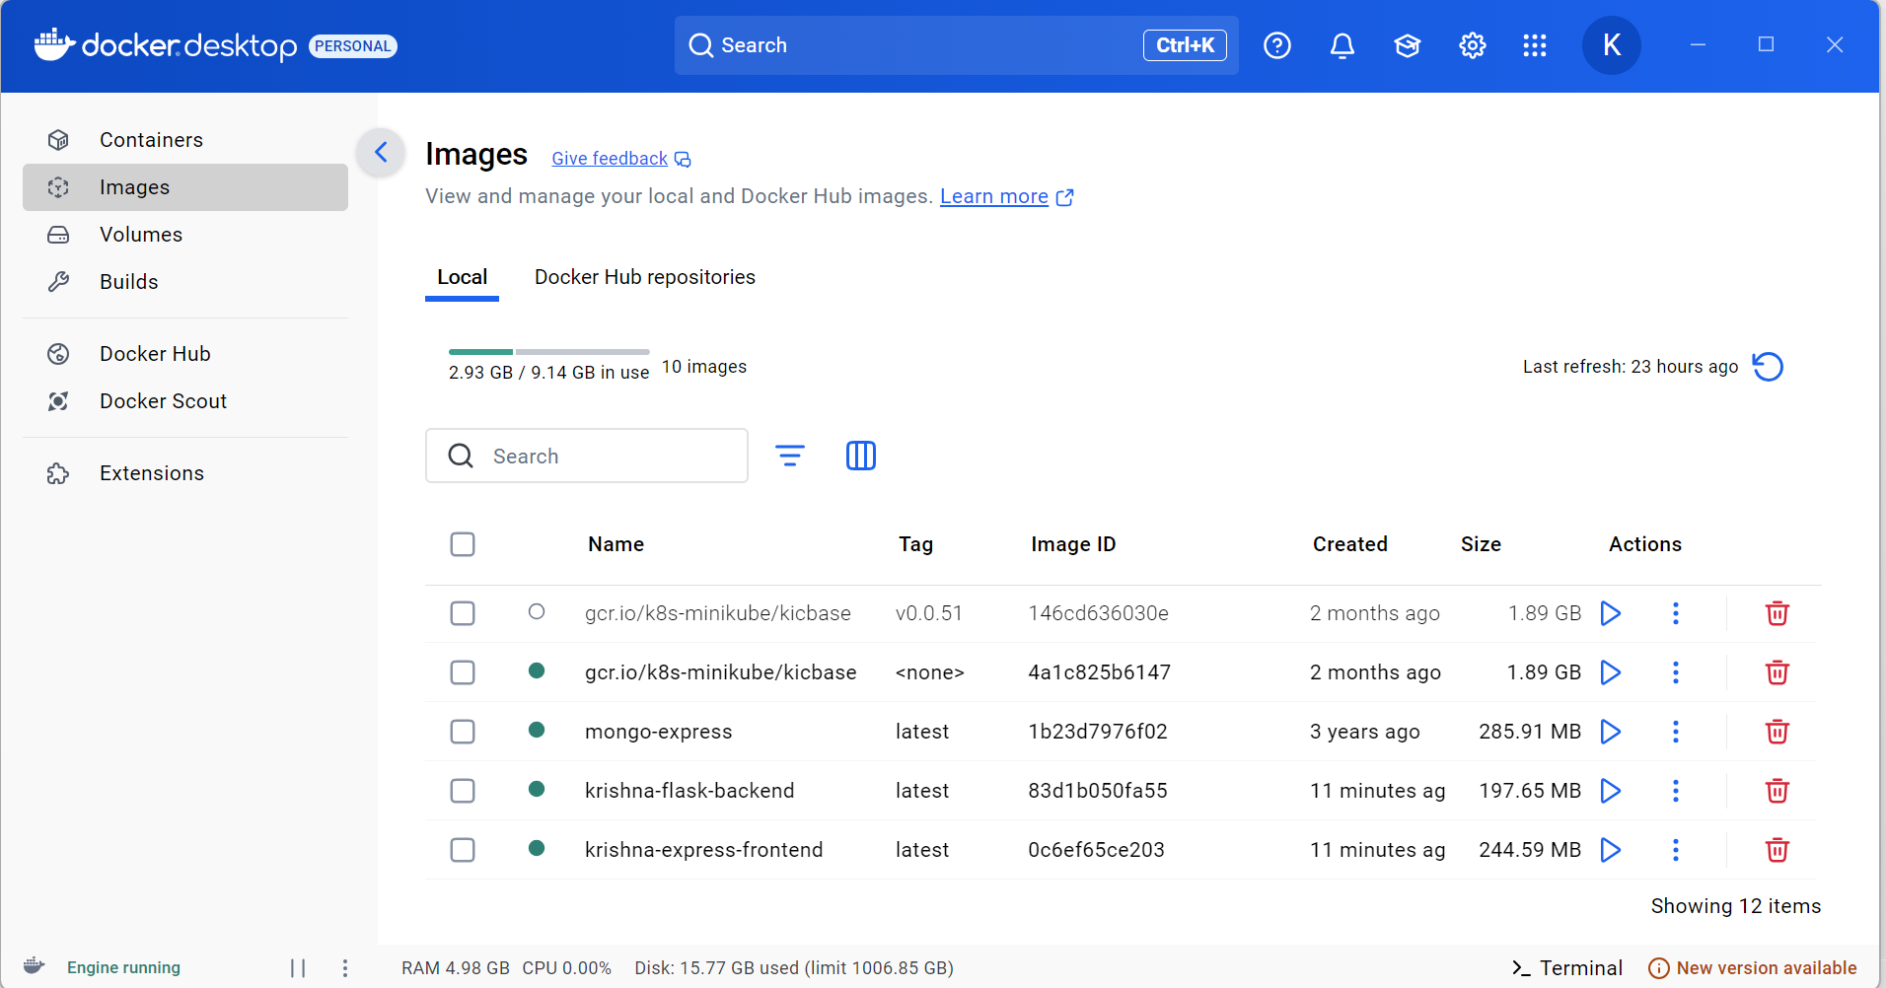
18. Amazon ECR Repository Setup
Amazon ECR is used to store the Docker images so that ECS can retrieve them during deployment.
Terraform creates two ECR repositories:
- krishna-flask-backend
- krishna-express-frontend
After creating the repositories, Docker authenticates to the ECR registry. The local images are tagged with the correct repository URIs and pushed to AWS.
The registry URI must be taken from the actual AWS account and Terraform outputs rather than copied from an example.
ECR Repositories Created
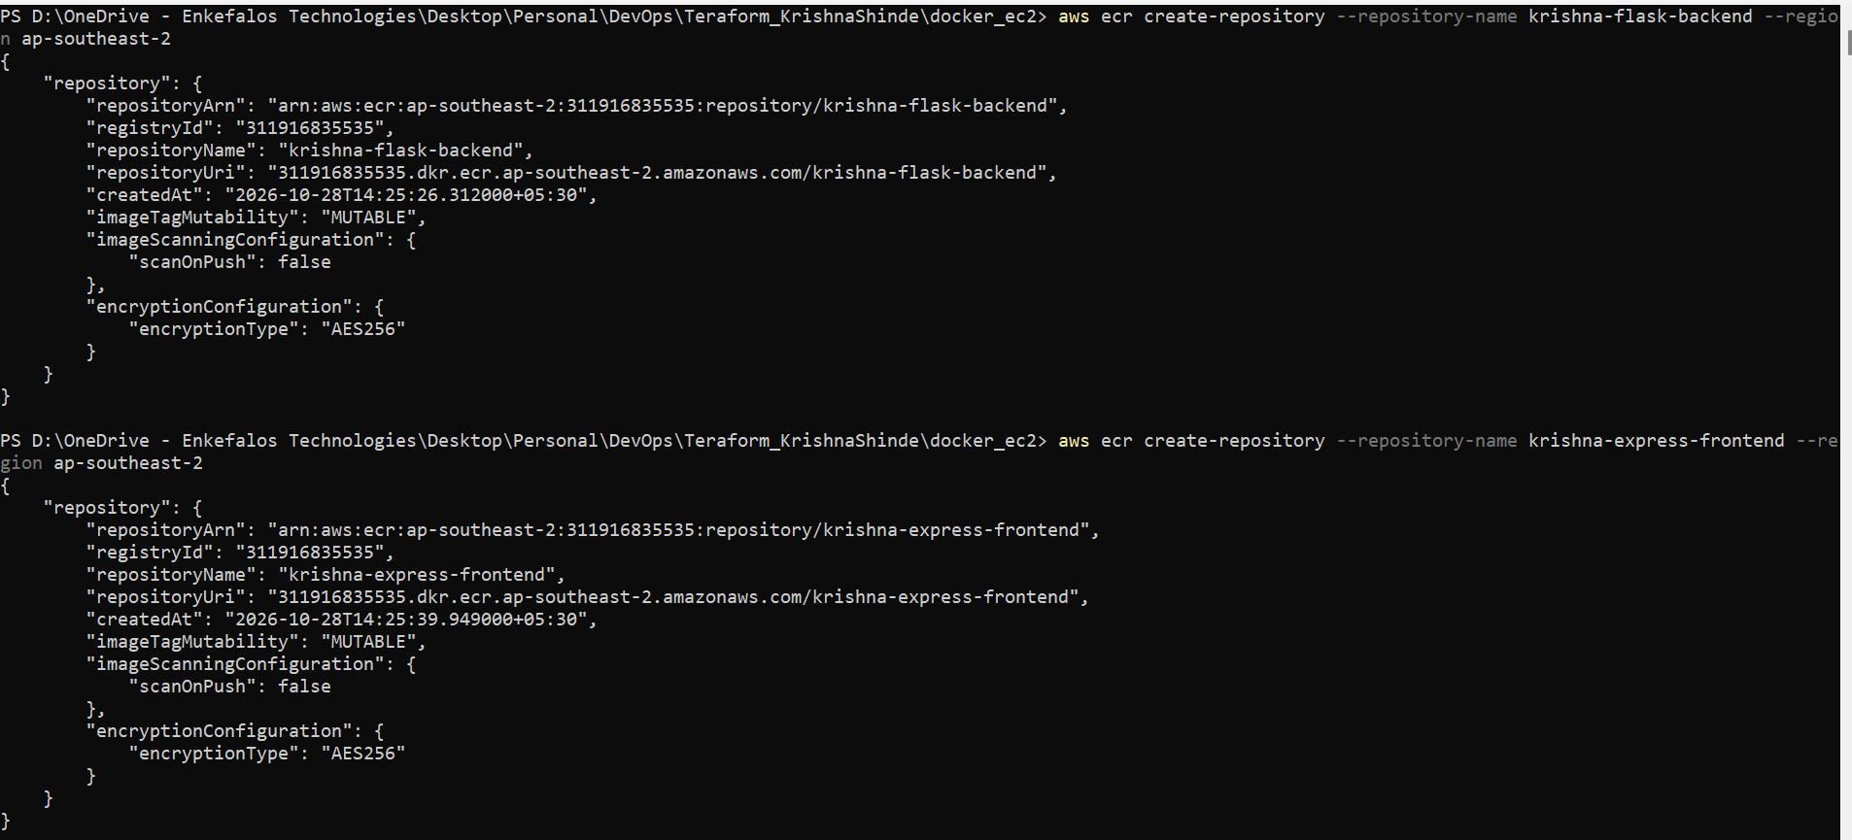 Docker Images Pushed to ECR
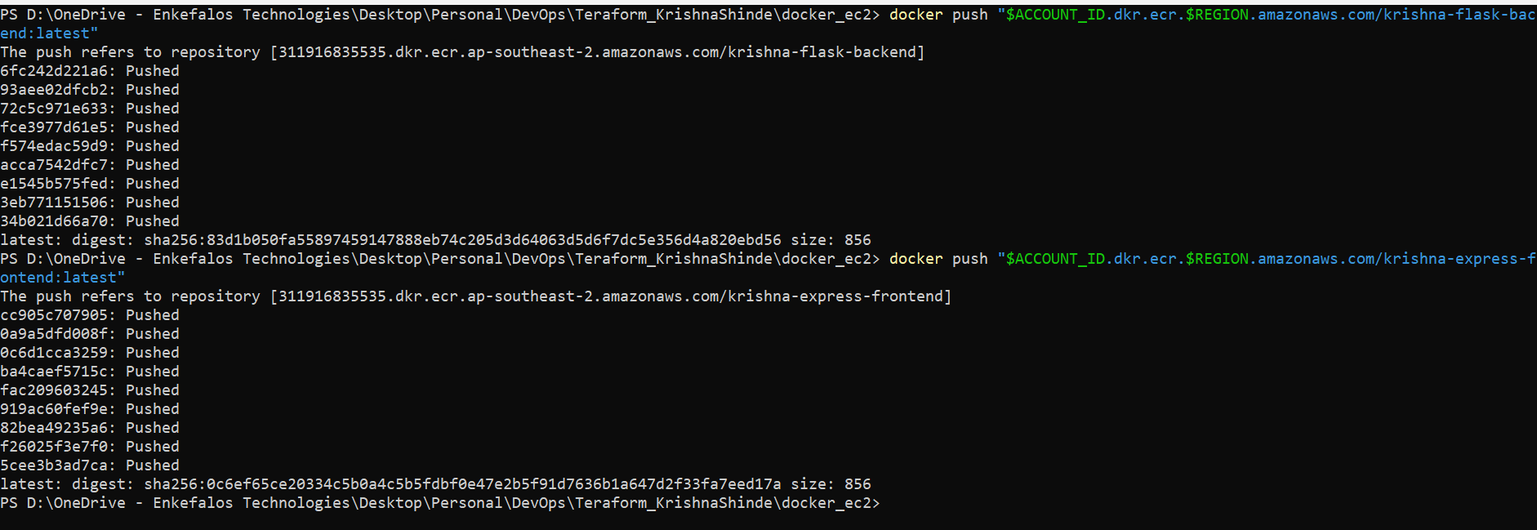

19. VPC and Networking Configuration
Terraform provisions the network resources required for ECS and the Application Load Balancer.
These resources may include:
- VPC
- Public and private subnets
- Internet gateway
- Route tables and routes
- Security groups
- Network configuration for ECS tasks
- Load balancer security group
The exact subnet arrangement depends on the deployment design.
For a cost-conscious Fargate deployment, we will select a networking configuration that supports the required internet access and service communication without creating unnecessary resources.
The security groups should permit external HTTP traffic to the load balancer while allowing application traffic from the load balancer to the appropriate ECS services.

20. ECS Cluster and Task Definitions
Amazon ECS manages the containerized applications.
Terraform creates an ECS cluster and task definitions for the Flask backend and Express frontend.
Each task definition specifies the container image, required CPU and memory, container port, logging configuration, and other application settings.
The Flask container listens on its configured application port, while the Express container listens on its configured port.
The ECS services maintain the desired number of running tasks.
AWS Fargate runs the containers without requiring the user to manage the underlying EC2 container hosts.

21. Application Load Balancer Configuration
The Application Load Balancer provides a single entry point for incoming HTTP requests.
Terraform configures the ALB, listener, target groups, and listener rules.
The target groups direct requests to the relevant ECS service.
For example, the routing design may send frontend requests to the Express service and API requests to the Flask service. The actual path patterns and target ports must match the application's routes and container configuration.
Health checks allow the load balancer to determine whether the application targets are responding correctly.
Screenshots:
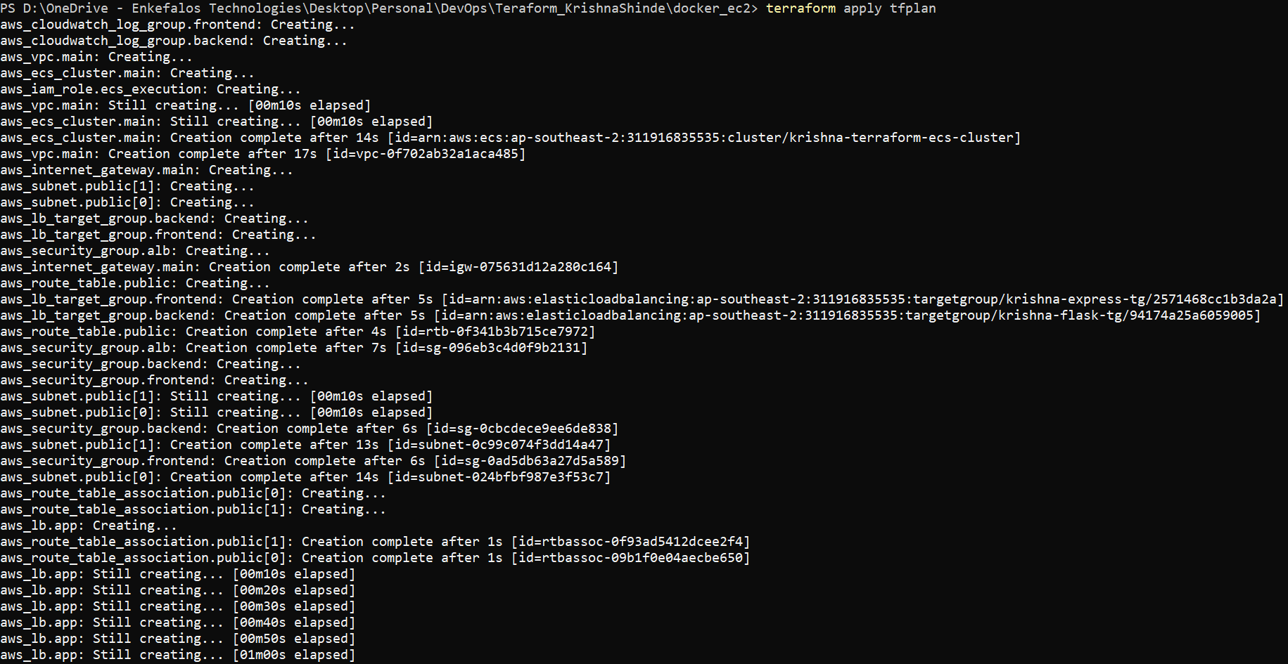
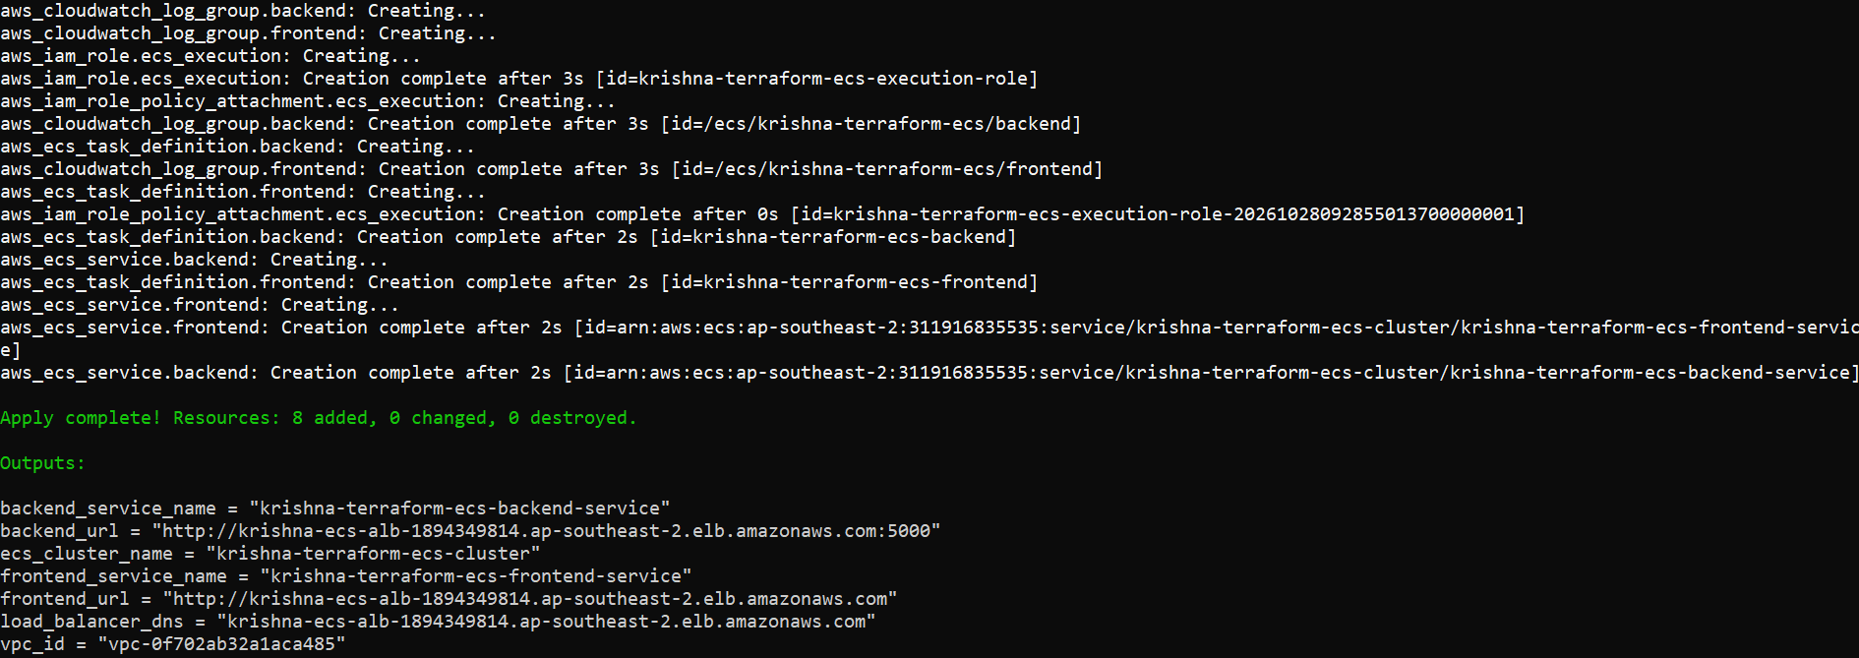

22. Application Testing Through the Load Balancer
After the ECS services are running and the load balancer targets are healthy, the application is tested using the ALB DNS name.
The frontend is accessed through:
http://<ALB-DNS-NAME>
The backend API is tested through the appropriate route configured in the ALB listener rules, for example:
http://<ALB-DNS-NAME>/<CONFIGURED-API-PATH>
The actual API path depends on the Flask application and the routing rules.
The tests verify that the load balancer can reach the services and route requests correctly.
Frontend Running Through ALB
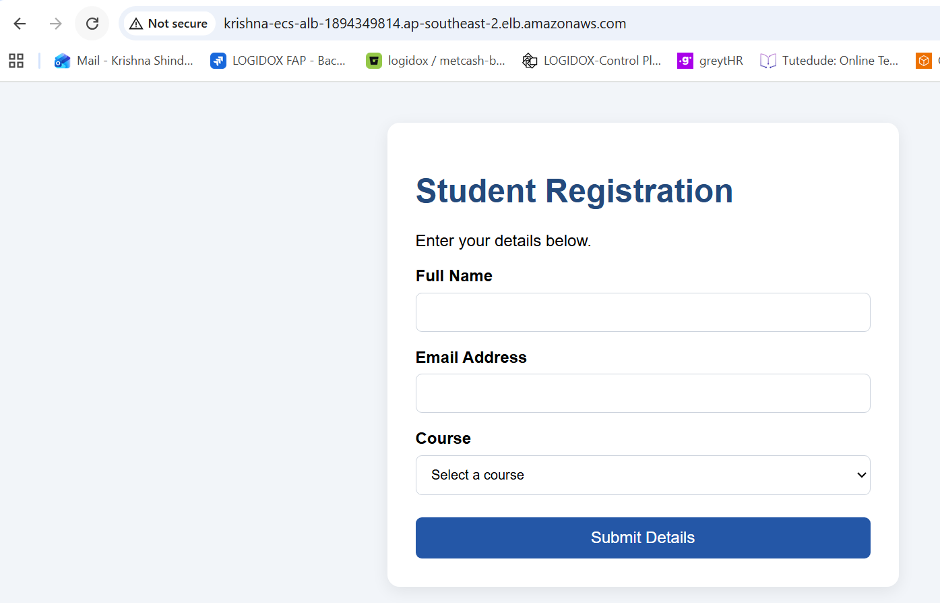
Backend API Through ALB
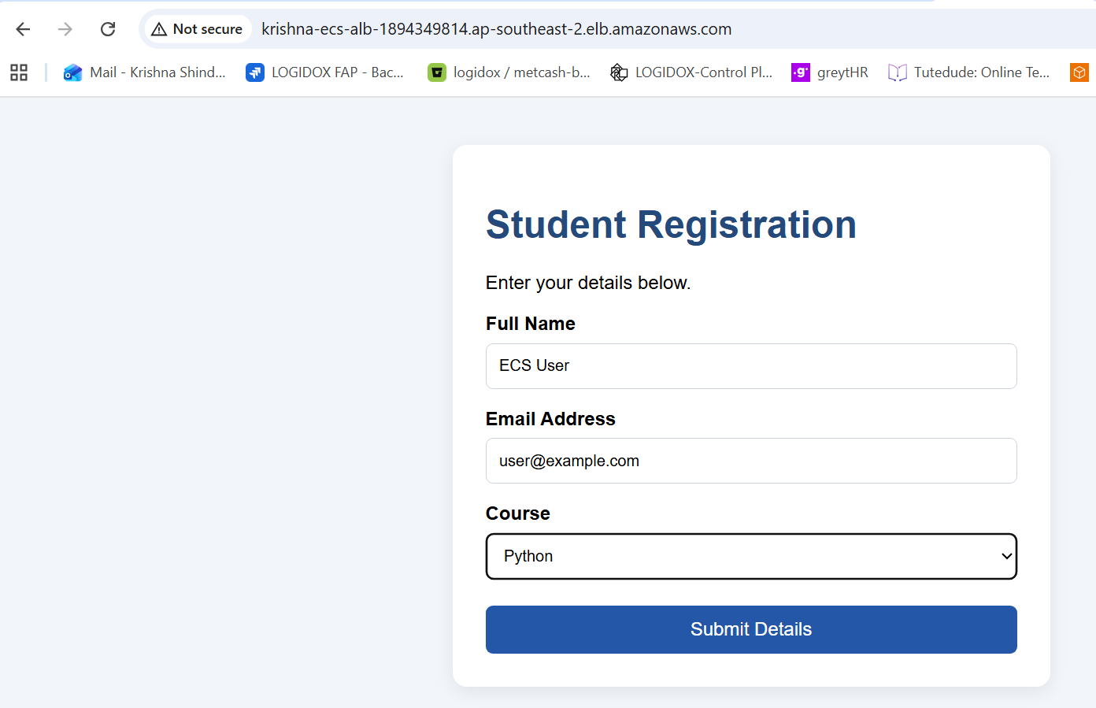
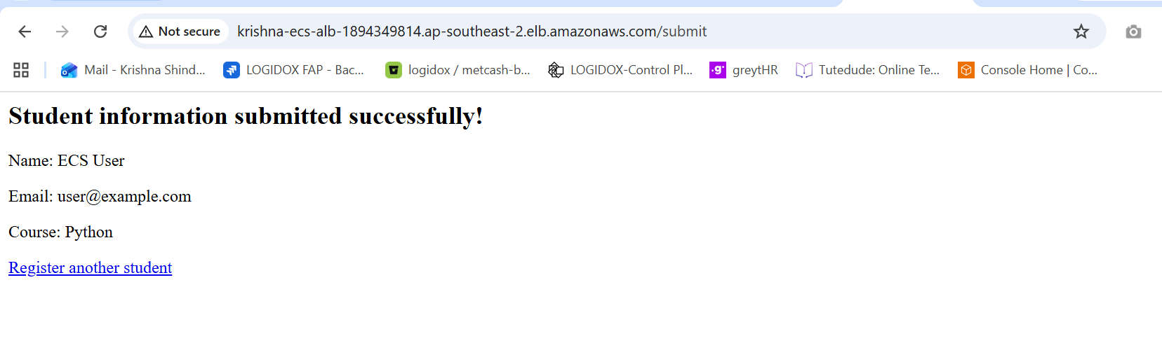
Successful ECS Deployment
[Insert screenshot showing the relevant Terraform outputs and ECS service status after successful deployment.]

23. Result of Part 3
The third deployment demonstrates containerized application deployment using Docker, ECR, ECS Fargate, VPC networking, and an Application Load Balancer.
Terraform manages the required AWS infrastructure, while ECS runs the containerized applications.
The ALB provides a common entry point and routes traffic according to the configured listener rules.
Result:
Record the ECR repository URIs, ECS cluster and service names, ALB DNS name, target health status, and successful application test results.

24. Terraform State Management and Best Practices
Terraform state tracks the resources managed by a Terraform configuration.
State management is important because Terraform uses state to compare the existing infrastructure with the desired configuration.
The project follows these practices:
- Use variables.tf to define configurable values.
- Use outputs.tf to expose useful deployment information.
- Use terraform fmt to maintain consistent formatting.
- Use terraform validate to validate configurations.
- Use terraform plan to review proposed changes.
- Use terraform apply to deploy resources.
- Use terraform destroy to remove resources that are no longer needed.
- Keep credentials and sensitive values out of source control.
- Restrict security group access to the required ports and sources.
- Use an S3 backend for remote state when the bucket and permissions have been configured.
- Enable suitable access controls and state-locking support for the selected backend configuration.
- Avoid committing Terraform state files or sensitive variable files to GitHub.
The S3 backend must be configured and prepared before Terraform is initialized against it. Backend state files should be protected because they may contain sensitive infrastructure information.
Screenshot 36: Terraform Validation and State Configuration
[Insert screenshot showing successful Terraform validation and the relevant state/backend configuration, with sensitive details hidden.]
25. GitHub Repository
The completed project source code is maintained in a GitHub repository.
The repository includes:
- Terraform configuration files.
- Flask backend source code.
- Express frontend source code.
- Dockerfiles.
- User-data scripts.
- README.md.
- Project documentation.
- Other required project files.
Before uploading the project, sensitive files such as AWS credentials, Terraform state files, and populated secret variable files must be excluded.
The following commands can be used to initialize Git and upload the project after the files are ready.
git init
git add .
git commit -m "Add Terraform DevOps assignment"
git branch -M main
Configure the actual GitHub repository URL:
git remote add origin <YOUR-GITHUB-REPOSITORY-URL>
Push the project:
git push -u origin main
If the Git repository and remote already exist, check their current configuration before running the initialization or remote commands again.
GitHub Repository Link: [Paste the actual GitHub repository URL here.]
Screenshot 37: GitHub Repository
[Insert screenshot showing the GitHub repository and the uploaded project files.]
29. README.md Documentation
The README.md file explains how to set up, deploy, test, and clean up the Terraform project.
It includes:
- Project overview and objectives.
- Prerequisites.
- Project directory structure.
- AWS region configuration.
- Instructions for each of the three deployment configurations.
- Terraform initialization, validation, planning, and deployment commands.
- Docker image build and ECR push instructions.
- Application testing instructions.
- Terraform state management notes.
- Cleanup instructions.
- Troubleshooting guidance.
- GitHub repository information.
The README should match the final Terraform source code and the commands used during the actual deployment.
Screenshot 38: README.md
[Insert screenshot showing the README.md file in the editor or GitHub repository.]
31. Conclusion
This assignment demonstrates the use of Terraform to automate AWS infrastructure provisioning and application deployment.
The first part deploys Flask and Express on a single EC2 instance. The second part separates the applications across two EC2 instances and configures the required networking and security controls. The third part packages the applications into Docker containers and deploys them using ECR, ECS Fargate, VPC networking, and an Application Load Balancer.
The project demonstrates Infrastructure as Code, automated deployment, containerization, cloud networking, application testing, state management, and source-code version control.
The final submission includes the Terraform source code, application files, Docker configuration, README.md, screenshots, documentation, and GitHub repository link in a single ZIP archive.

