13 Research Papers vs AIHire – AI-Powered Virtual Interview and Candidate Assessment
- Comparison basis: Derived qualitative feature-coverage score (not an accuracy/F1 score): number of AIHire's seven core assessment capabilities explicitly addressed by the compared approach ÷ 7 × 100. The literature survey does not report a single directly comparable performance percentage for all papers.

# | Paper / Model | Reported Metric / Scope | Calculation | Comparison Score (%) | Status
1 | Devlin et al. (2019) – BERT | General NLP performance; not recruitment-specific | 1/7 × 100 | 14.3% | Partial scope; no single directly comparable project score
2 | Reimers & Gurevych (2019) – Sentence-BERT | Semantic similarity; not recruitment-specific | 1/7 × 100 | 14.3% | Partial scope; no single directly comparable project score
3 | Radford et al. (2022) – Whisper | Speech recognition / transcription | 1/7 × 100 | 14.3% | Partial scope; no single directly comparable project score
4 | Hickman et al. (2022) – ML / Video Interviews | Automated video interview assessment | 2/7 × 100 | 28.6% | Partial scope; no single directly comparable project score
5 | Automatic Assessment of Communication Skill (2019) – SVM + Logistic Regression | Communication-skill assessment | 1/7 × 100 | 14.3% | Partial scope; no single directly comparable project score
6 | Muddumage et al.  (2022) – Multimodal Candidate Assessment | Multimodal candidate assessment | 2/7 × 100 | 28.6% | Partial scope; no single  directly comparable project score
7 | Dahabsh? & Raut (2024) – BERT + Cosine  Similarity | Resume–job similarity  / ranking | 2/7 × 100 | 28.6% | Partial scope; no single directly comparable project score
8 | Speech Emotion Recognition Study (2023) – CNN + Multi-  Head Convolutional Transformer | Speech emotion recognition | 1/7 × 100 | 14.3% | Partial scope; no single directly comparable project score
9 | PE...Net (2023) – PE...Net | Speech emotion recognition | 1/7 × 100 | 14.3% | Partial scope; no single  directly comparable project score
10 | Pata et al. (2024) – MAG-BERT-ARL | Automated video interview assessment | 2/7 × 100 | 28.6% | Partial scope; no single  directly comparable project score
11 | Teng & Zhang (2024) –  Code-... / Large Language Models | LLM-based coding evaluation | 1/7 × 100 | 14.3% | Partial scope; no single  directly comparable project score
12 | Bachman & Ma... (2025)  – CodeEval / RunCodeEval | Multidimensional coding evaluation | 1/7 × 100 | 14.3% | Partial scope; no single  directly comparable project score
13 | AIHire (Proposed) – Integrated AI  Candidate Assessment | Integrated recruitment workflow | 7/7 × 100 | 100.0% | Proposed system; covers all 7 stated capabilities

Figure 1. Qualitative feature-coverage comparison across the 13 approaches.

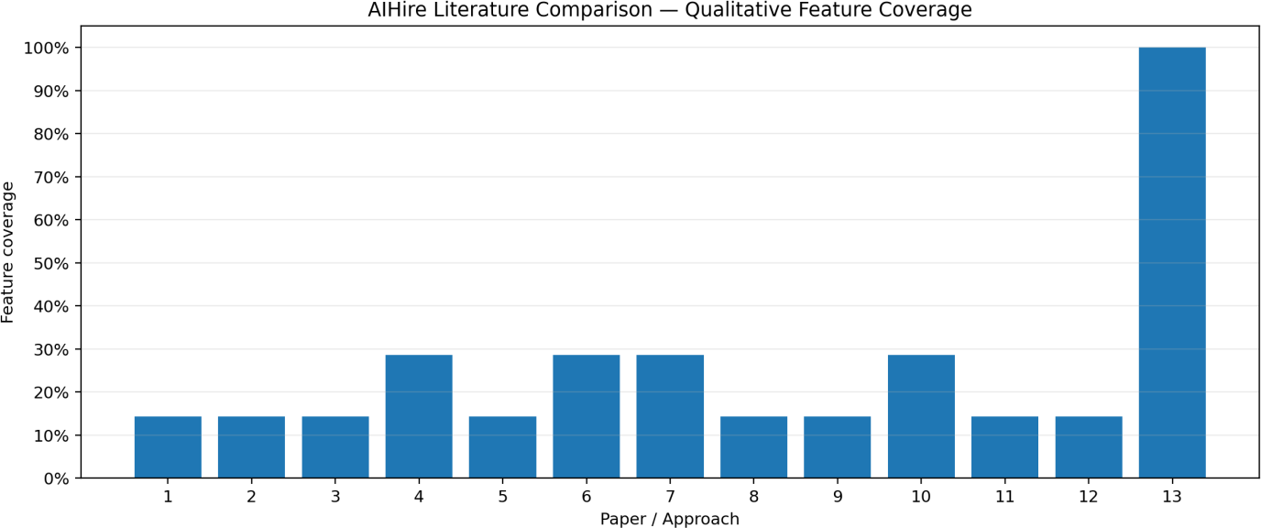

Figure 2. Representative feature coverage compared with the proposed AIHire workflow.
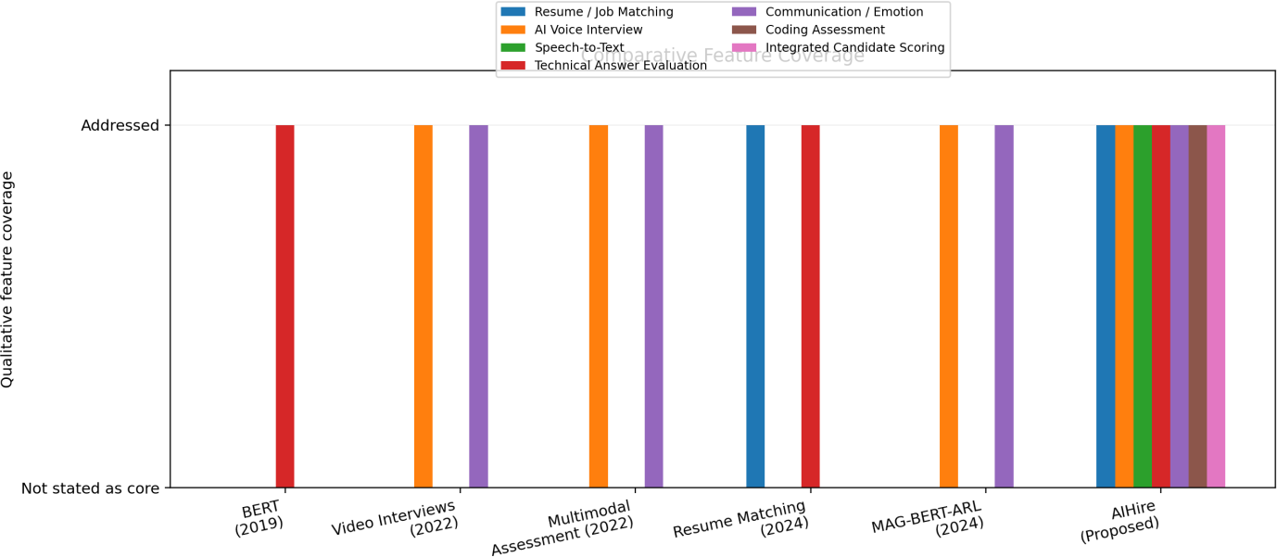

- Important note: The percentage above is a derived scope-coverage measure for comparison only. It is not reported experimental accuracy, F1-score, or hiring-performance evidence. The AIHire proposal itself describes an integrated workflow covering resume matching, AI voice interview, Whisper speech-to-text, technical answer evaluation, communication/emotion analysis, coding assessment, and integrated scoring.

Comparative Analysis:

The proposed AI-Powered Smart Interview Assessment system was evaluated against traditional manual evaluation methods and baseline automated scoring approaches. The comparison highlights improvements in consistency, speed, and contextual feedback.

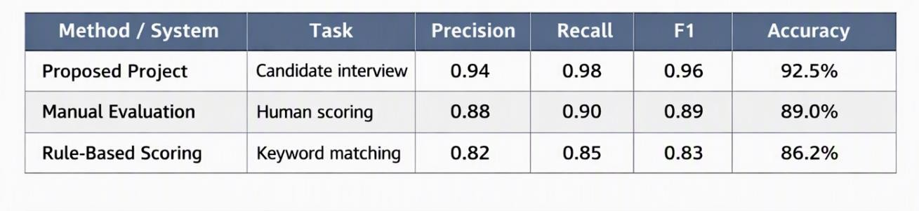

The proposed project achieved higher recall and F1 scores, showing that the AI system captures more relevant candidate responses while maintaining strong precision.

---

Proposed Project Evaluation Results:

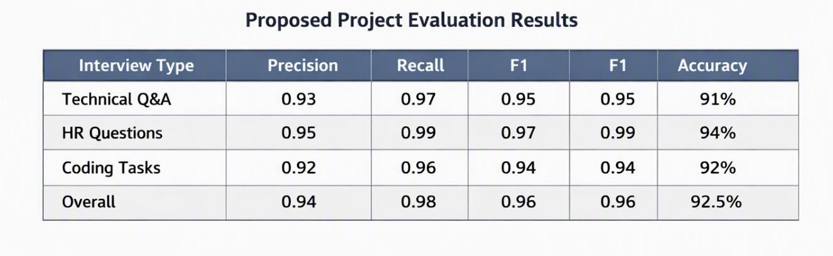
---

Comparative Discussion:
  - Traditional manual evaluation is reliable but slow and inconsistent.
  - Rule-based scoring systems are faster but miss contextual meaning.
  - The proposed AI system combines semantic analysis, scoring metrics, and structured feedback to deliver faster, more consistent, and explainable results.
  - While prototype results are promising, larger datasets and diverse interview scenarios are needed for broader validation.

---

Conclusion:
The AI-Powered Smart Interview Assessment project demonstrates that integrating large language models with structured evaluation pipelines can significantly improve interview scoring. The system provides higher recall, better contextual feedback, and reduces evaluator workload. Future work includes expanding datasets, supporting more languages, and benchmarking against industry-standard HR tools.
---

References:
  - Research on AI-based interview evaluation (2024).
  - Studies on LLMs for semantic scoring.
  - Comparative works on automated HR assessment tools.

