Assignment 3:
KRISHNA SANAGAVARAPU

Instructions for running the code and screenshots:

- Navigate to the folder language_detector/ in the submission zip:
- language_detetor_1.py is the code that implements bigrams language model.
- language_detector.py is the code that implements bigram language model with snowball stemming.
- language_detector_tri.py is the code that implements tri gram language model.
- language_detector_tri_stem.py is the code that implements tri gram language model with snowball stemming.

Requirements to run the code: python, matplotlib and nltk

Preprocessing: The entire data while training and testing is preprocessed by lowercasing, eliminating special characters and adding $ to start and end of each token.

Screen shots:

1) language model with bigrams:

- The bigram model implemented with Laplace smoothing predicts all English documents as English and Spanish documents as Spanish.
- This model identifies French document as English.
  - This could be due to bigrams in French being similar to the bigrams in English rather than Spanish

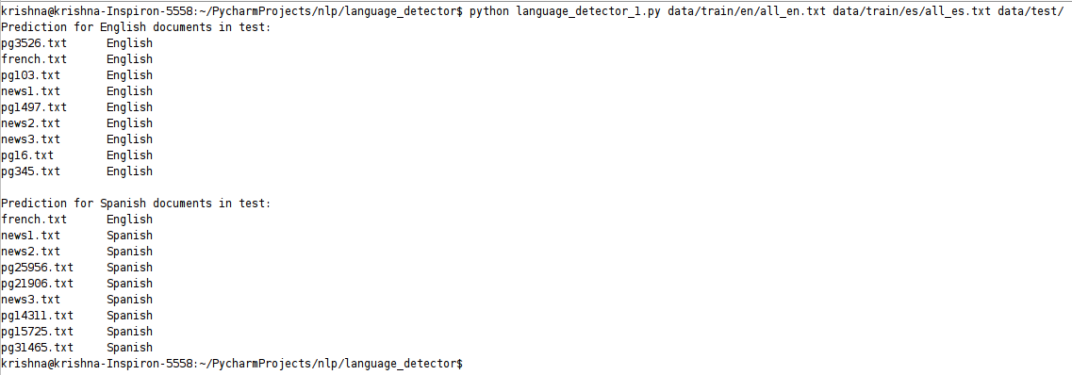

2)language model with bigrams and stemming:

- The bigram model implemented with Laplace smoothing and stemming predicts 7 out of 8 English documents as English and all Spanish documents as Spanish.
- This model identifies French document as English.
  - This could be due to bigrams in French after stemming are similar to the bigrams in English rather than Spanish
- Snowball stemmer with both English and Spanish is used, but gives poor results
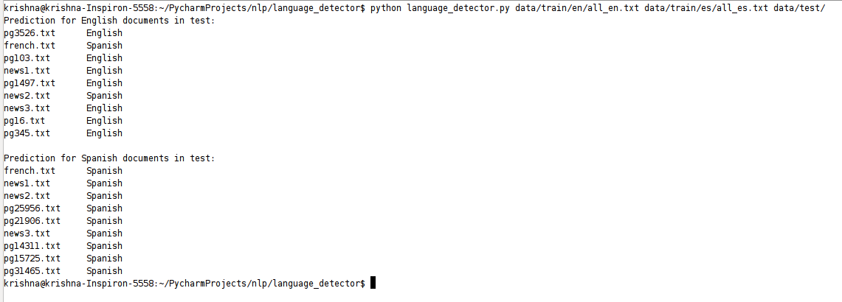
3)language model with trigrams:

- The trigram model implemented with Laplace smoothing predicts all English documents as English and Spanish documents as Spanish.
- This model identifies French document as English.
  - This could be due to bigrams in French being similar to the bigrams in English rather than Spanish

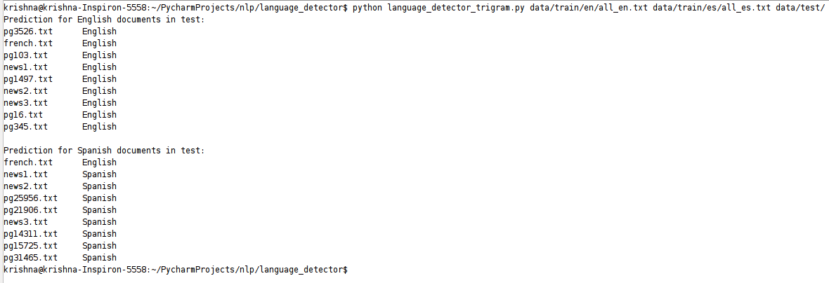

4)language model with trigrams and stemming:

- The trigram model implemented with Laplace smoothing and stemming predicts all English documents as English and 3 out of 8 Spanish documents as Spanish.
- This model identifies French document as English.
  - This could be due to trigrams in French after stemming are similar to the trigrams in English rather than Spanish
- Snowball stemmer with both English and Spanish is used, but gives poor results

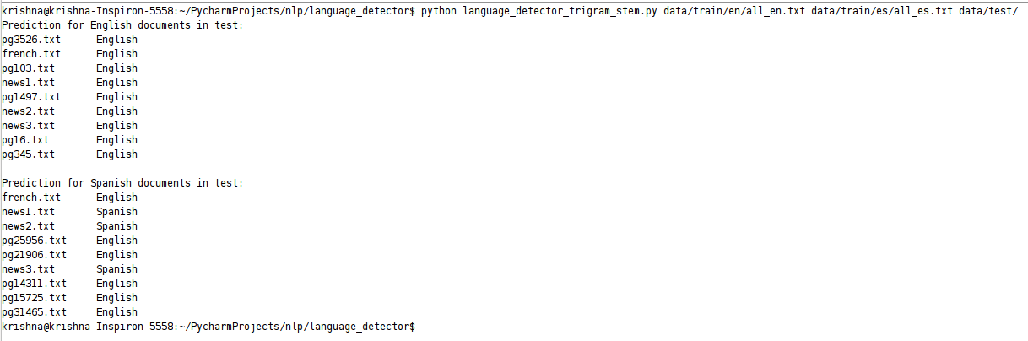
Observations:

Q: Take a look at the test documents for English and Spanish. Are documents written in only one language?

No, some text in Spanish documents is written in English (copyright metadata). However due to higher Spanish content the models predict the text as Spanish.

Q: What is the minimum number of tokens you need to process to always make the right prediction when testing? You can try with 100 tokens, 200 tokens, etc.; you do not need an exact number.

With the experiments performed, we need about 50 – 60 % of the data always to make a right prediction.

Q: If you create several models for English and Spanish (e.g., using different training data), how can you compare them?

We can compare different models built by seeing the prediction probabilities and comparing the values.
We can decide by calculating the difference between the probability values. The bigger the difference the better the model for the predictions. Because if the difference between the probability scores gives an evidence that the model can be used to predict particular language and not for other languages.

Q: Can you train with less training data and still get the right predictions? How does training size affect predictions during testing? A graph showing how probabilities change is the best way to answer this questions (along with an interpretation of the graph).

Graphs:

Below are the graphs plotted for prababilities vs training for both spanish and english models.

