PROJECT ON FOREST FIRE ACCIDENT PREDICTION USING MACHINE LEARNING

Abstract:
This Project is based on the Forest Fire Prediction. In this Project we will use the Python Language and Machine Learning Techniques. By Using both of these techniques we will predict that in which part or area of a Forest the fire may take place in the Future. We will be using the Data Visualization and Neural Network.
We will be using Supervised Learning and Unsupervised Learning and Semi Supervised Learning. We will be Collecting the data from different resources from different websites. We will be also doing the analysis of 5 year’s Data of Different Places and Different Countries.

Keywords:
Python, Anaconda, Machine Learning Techniques, Supervised Learning, Neural Networks

Introduction:
Machine Learning (ML) is the scientific study of algorithms and statistical models that computer systems use in order to perform a specific task effectively without using explicit instructions, relying on patterns and inference instead. It is seen as a subset of Artificial Intelligence (AI).
IMPORTANCE OF MACHINE LEARNING:
Consider some of the instances where machine learning is applied: the self-driving Google car, cyber fraud detection, online recommendation engines—like friend suggestions on Facebook, Netflix showcasing the movies and shows you might like, and “more items to consider” and “get yourself a little something” on Amazon—are all examples of applied machine learning. All these examples echo the vital role machine learning has begun to take in today’s data-rich world.

Machines can aid in filtering useful pieces of information that help in major advancements, and we are already seeing how this technology is being implemented in a wide variety of industries.

With the constant evolution of the field, there has been a subsequent rise in the uses, demands, and importance of machine learning. Big data has become quite a buzzword in the last few years; that’s in part due to increased sophistication of machine learning, which helps analyze those big chunks of big data. Machine learning has also changed the way data extraction, and interpretation is done by involving automatic sets of generic methods that have replaced traditional statistical techniques.

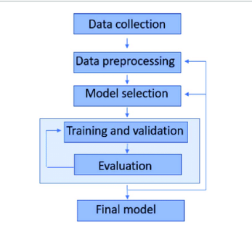

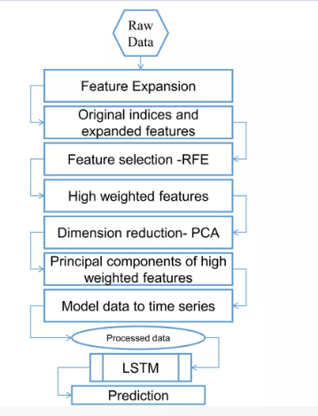

Types of Machine Learning :
- Supervised Learning
- Unsupervised Learning
- Semi – Supervised Learning

- Supervised Learning:
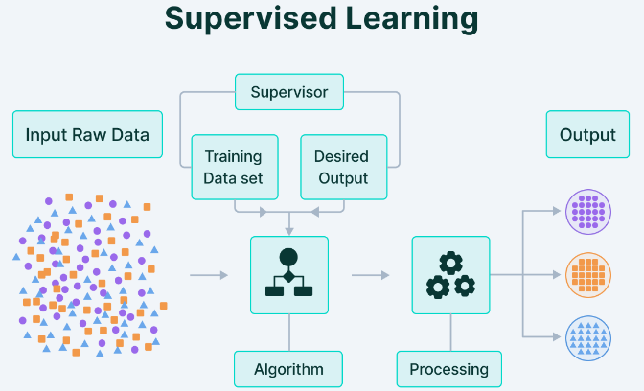

B.) Unsupervised Learning:

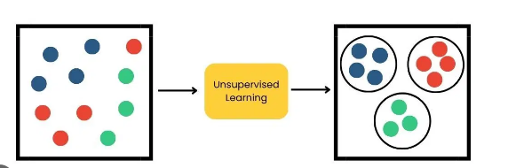

- Semi-Supervised Learning:

