INVERTIS INSTITUTE OF COMPUTER APPLICATIONS



A Project Synopsis

On

**Drowsiness Detection System**

Submitted in Fulfillment of the Requirement for the Degree of Master of Computer Applications

Invertis University, Bareilly

**Project Guide: Submitted By:** Mrs. Shivangi Ghildiyal Shruti Sachdeva Assistant Professor LMC2018017 Department of Computer Applications

**Objective And Scope**

Driver drowsiness detection is a car safety technology which prevents accidents when the driver is getting drowsy. Various studies have suggested that around 20% of all road accidents are fatigue-related, up to 50% on certain roads. Driver fatigue is a significant factor in a large number of vehicle accidents. Recent statistics estimate that annually 1,200 deaths and 76,000 injuries can be attributed to fatigue related crashes.

The development of technologies for detecting or preventing drowsiness at the wheel is a major challenge in the field of accident avoidance systems. Because of the hazard that drowsiness presents on the road, methods need to be developed for counteracting its affects. Driver inattention might be the result of a lack of alertness when driving due to driver drowsiness and distraction.

Driver distraction occurs when an object or event draws a person’s attention away from the driving task. Unlike driver distraction, driver drowsiness involves no triggering event but, instead, is characterized by a progressive withdrawal of attention from the road and traffic demands. Both driver drowsiness and distraction, however, might have the same effects, i.e., decreased driving performance, longer reaction time, and an increased risk of crash involvement. Based on Acquisition of video from the camera that is in front of driver perform real-time processing of an incoming video stream in order to infer the driver’s level of fatigue if the drowsiness is Estimated then it will give the alert by sensing the eyes.

**Process Description**

**Proposed Method**

There are several different algorithms and methods for eye tracking, and monitoring. Most of them in some way relate to features of the eye (typically reflections from the eye) within a video image of the driver. The original aim of this project was to use the retinal reflection as a means to finding the eyes on the face, and then using the absence of this reflection as a way of detecting when the eyes are closed. Applying this algorithm on consecutive video frames may aid in the calculation of eye closure period. Eye closure period for drowsy drivers are longer than normal blinking. It is also very little longer time could result in severe crash. So we will warn the driver as soon as closed eye is detected.

**Block Diagram**

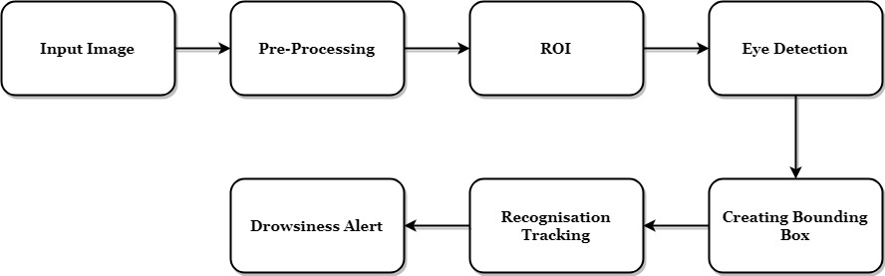

**Resources And Limitations**

**1. Hardware Requirements**

* Camera
* Personal computer

**2. Software Requirements**

* Python 2.7 or above versions
* Anaconda software

**3. Use Case Diagram**

**4. Sequence Diagram**

**5. Data Flow Diagram**

* DFD (level-0)
* DFD (level-1)
* DFD (level-2)

**6.** **Limitations**

The limitations of the system are as follows:

* Dependence on ambient light
* Orientation of face
* Poor detection with spectacles
* Problem with multiple faces

**7. Advantages**

* Region of interest is clear to identify
* Bounding box creation and tracking

**8. Applications**

* Real time tracking applications
* Classification of small particles

**Conclusion**

The driver abnormality monitoring system developed is capable of detecting drowsiness, drunken and reckless behaviours of driver in a short time. The Drowsiness Detection System developed based on eye closure of the driver can differentiate normal eye blink and drowsiness and detect the drowsiness while driving. The proposed system can prevent the accidents due to the sleepiness while driving. Information about the head and eyes position is obtained through various self-developed image processing algorithms. During the monitoring, the system is able to decide if the eyes are opened or closed. When the eyes have been closed for too long, a warning signal is issued.