SATYA GROUP OF INSITITUTIONS



Submitted by:- Submitted to:-

Sharad Mourya

**Content**

|  |  |  |
| --- | --- | --- |
| CHAPTER_No. | TITLE | PAGE No. |
| 1 | Overview Of Project |  |
|  | 1.1 System Requirement |  |
|  | 1.2 Software Requirement |  |
|  | 1.3 Hardware Requirement |  |
| 2 | Objectives |  |
| 3 | Introduction |  |
| 4 | Methodology |  |
| 5 | Image Processing |  |
| 6 | Future |  |
| 7 | References |  |

**OVERVIEW OF PROJECT**

Nowadays the driver safety in the car is one of the most wanted system to avoid accidents. Our main objective of the project is to ensure the safety system. For enhancing the safety, we are detecting the eye blinks of the driver and estimating the driver status and control the car accident accordingly.

Aim of this project is implementing the system as a prototype by capturing the live images of the eyes and fed them in to the Micro controller in which the MATLAB software is used to process the process the video and convert it in to frames and process it accordingly. Some customized algorithms are coded in MATLAB for image segmentation of eyes from the entire image and image recognition of the eyes and face position.

Drowsiness detection is a safety technology that can prevent accidents that are caused by drivers who fell asleep while driving. The objective of this project is to build a drowsiness detection system that will detect that a person's eyes are closed for a few seconds.

With this Python project, we will be making a drowsiness detecting device. A countless number of people drive on the highway day and night. Taxi drivers, bus drivers, truck drivers and people traveling long-distance suffer from lack of sleep. Due to which it becomes very dangerous to drive when feeling sleepy.

The majority of accidents happen due to the drowsiness of the driver. So, to prevent these accidents we will build a system using Python, OpenCV, and Keras which will alert the driver when he feels sleepy.

**System Requirement: -**

* **Operating System: -** Windows, Linux, Mac

**Software Requirement: -**

The requirement for this Python project is a webcam through which we will capture images. You need to have Python (3.6 version recommended) installed on your system, then using pip, you can install the necessary packages.

* Python 3.7 or above
* Open CV
* TensorFlow
* Keras
* Pygame

**Hardware Requirement: -**

* Intel Pentium i3 processor or equivalent or higher
* 4gb RAM or Higher
* 500gb HDD or Higher
* Network Connectivity

**OBJECTIVES**

Nowadays the driver safety in the car is one of the most wanted system to avoid accidents. Our objective of the project is to ensure the safety system. For enhancing the safety, we are detecting the eye blinks of the driver and estimating the driver status and control the car accordingly.

**INTRODUCTION**

Aim of this project is implementing the system as a prototype by capturing the live images of the eyes and fed them in to the Microcontroller in which the MATLAB software is used to process the video and convert it in to frames and process it accordingly. Some customized algorithms are coded in MATLAB for image segmentation of eyes from the entire image and image recognition of the eyes and face position.

On the whole, by sensing the eye blinks we can decide if the eye blinks are more than the driver is very sleepy, Drinking and it will automatically turn off the vehicle, if the driver is showing the left eye ball position than the left indicator of the car is turned on and so on.

**BLOCK DIAGRAM**

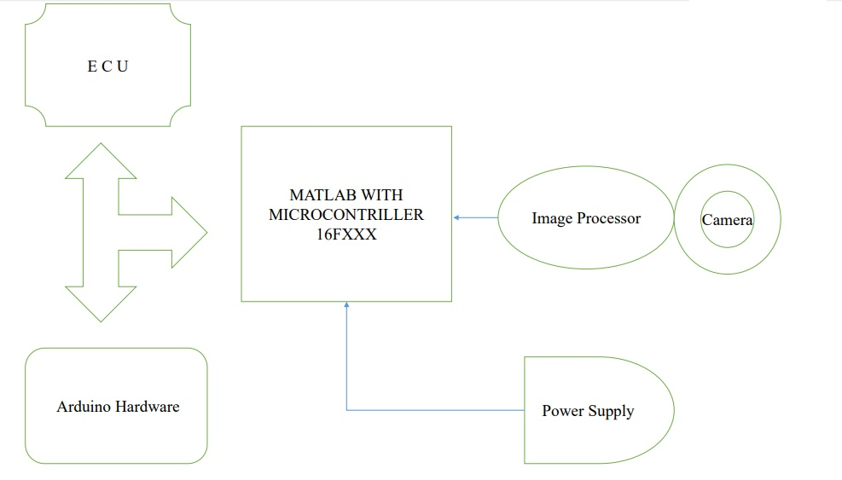

**Methodology**

The eye blinks of the driver and estimating the driver status and control the car accordingly. We are implementing the system as a prototype by capturing the live images of the eyes and fed them in to the Microcontroller in which the MATLAB software is used to process the video and convert it in to frames and process it accordingly. Some customized algorithms are coded in MATLAB for image segmentation of eyes from the entire image and image recognition of the eyes and face position. On the whole, by sensing the eye blinks we can decide if the eye blinks are more than the driver is very sleepy, Drinking and it will automatically turn off the vehicle, if the driver is showing the left eye ball position than the left indicator of the car is turned on and so on.

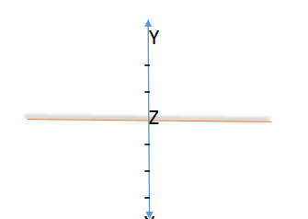

**Image Processing**

1. A lot of way can be developed to find pupils in the given area surrounding the eyes. It can also be done using hue or saturation, which leads controlled conditions given to good results , but it highly depends on the current light situation.
2. Thus, another way is used to find the pupils. A picture of the pupil runs over the current picture area and tries to find the place with the highest accordance. Different pupils where used for testing and the best result were gained by pupils directly from the tester, which was not really surprising.
3. Obtaining them is not that simple that simple thought. We name this algorithm is called Eagle Eye Safety. Which requires too much calculating time to be used in real time environment's, but is fact enough for getting pupils

**FUTURE**

* Anti-drowsiness Alarm
* Make Easy drive
* Drink and Drive reduction
* Medical accent
* Directly interface to any Hardware using Arduino
* Low cost
* High Security
* This program can use for Aircraft Also

**Reference**

1. Open CV - <https://docs.opencv.org/master/d9/df8/tutorial_root.html>
2. Tensor Flow - <https://www.tensorflow.org/tutorials>
3. Pygame - <https://www.edureka.co/blog/pygame-tutorial>