Supplementary Data
DroPhenix: an integrated, statistically rigorous web platform for multi-assay *Drosophila* phenotyping and actuarial cross-strain compound ranking
Gunanathan K. and Sivaramakrishnan V.
All values below are produced by the runnable scripts shipped with the software and are exactly reproducible: `validation/run_all.py` (per-module validation), `validation/comparison_study.py` (cross-tool benchmark; writes `validation/comparison_report.md`), and `validation/demo_unequal_n.py` (unequal-N demonstration).

Supplementary Table S1. Complete head-to-head comparison with established tools
Every quantitative comparison performed, on identical benchmark data (Freireich 1963 6-MP trial; PlantGrowth; a known 24-h rhythm; a fixed effect-size set). "Agree" = within the stated tolerance. Two method-note rows (marked note) are reported for completeness and are not counted as discrepancies.
Domain | Metric | DroPhenix | Reference tool | Reference | Agree
Survival | Median 6-MP (weeks) | 23.0 | lifelines | 23.0 | yes
Survival | Median Placebo (weeks) | 8.0 | lifelines | 8.0 | yes
Survival | Log-rank χ² | 16.7929 | lifelines | 16.79294 | yes
Survival | Log-rank p-value | 4.2×10⁻⁵ | lifelines | 4.2×10⁻⁵ | yes
Survival | Cox HR Breslow (vs published 4.523) | 4.5231 | Klein–Moeschberger 2003 | 4.523 | yes
Survival | Cox HR Efron (tie-method note) | 4.5231 | lifelines (Efron) | 4.81687 | note
Statistics | One-way ANOVA F | 4.8461 | scipy | 4.84609 | yes
Statistics | ANOVA p-value | 0.01591 | scipy | 0.01591 | yes
Statistics | Kruskal–Wallis H | 7.9882 | scipy | 7.98823 | yes
Statistics | One-way ANOVA F | 4.8461 | pingouin | 4.84609 | yes
Statistics | Hedges' g (trt2 vs ctrl) | 0.91404 | pingouin | 0.91404 | yes
Meta-analysis | Pooled effect (fixed) | 0.41034 | statsmodels | 0.41034 | yes
Meta-analysis | Pooled effect (DL random) | 0.42883 | statsmodels | 0.42883 | yes
Meta-analysis | Heterogeneity I² (%) | 27.72586 | statsmodels | 27.72586 | yes
Circadian | Dominant period (h) [true 24] | 24.0 | ground truth | 24.0 | yes
Circadian | Dominant period (h) | 24.0 | astropy (Lomb–Scargle) | 23.96404 | yes
R: survival | Median 6-MP | 23.0 | R survfit | 23.0 | yes
R: survival | Median Placebo | 8.0 | R survfit | 8.0 | yes
R: survival | Log-rank χ² | 16.7929 | R survdiff | 16.79294 | yes
R: survival | Log-rank p-value | 4.2×10⁻⁵ | R survdiff | 4.2×10⁻⁵ | yes
R: survival | Cox HR (Breslow) | 4.5231 | R coxph(breslow) | 4.52307 | yes
R: stats | ANOVA F | 4.8461 | R aov | 4.84609 | yes
R: stats | ANOVA p-value | 0.01591 | R aov | 0.01591 | yes
R: stats | Kruskal–Wallis H | 7.9882 | R kruskal.test | 7.98823 | yes
Circadian | Dominant period (h) | 24.0 | pyBOAT (wavelet) | 23.9598 | yes
Survival | scikit-survival (note) | — | scikit-survival | not installable (no C toolchain / no Python 3.13 wheel) | note

24/24 quantitative comparisons agree within tolerance (Pearson r = 1.0000 across DroPhenix vs reference values). The two note rows are the Efron tie-method value and the un-buildable scikit-survival package; survival is independently cross-validated against R survival (Breslow) and lifelines (Efron).

Supplementary Table S2. Per-module validation against published benchmarks / analytic ground truth
Each row is an automated test in validation/ (all pass).
Module / script | Benchmark (source) | Reproduced result
validate_stats | PlantGrowth ANOVA/Kruskal (Dobson 1983) | F=4.846, p=0.01591; H=7.988; Cohen's d, Hedges' g, BH hand-checked
validate_survival | Freireich 1963 6-MP leukemia trial | median 23/8 wk; log-rank χ²=16.793; Gehan–Breslow 13.458; Cox HR 4.523
validate_ymaze | Buchanan/de Bivort 2015; Lewis 2017 | turn-bias mean 0.50; 23.5% extreme; alternation chance 50%; individuality sig vs null
validate_dams | Konopka & Benzer 1971; Sokolove–Bushell 1978; Hendricks/Shaw 2000 | periods 24/19/28 h; 100% sensitivity, 0% false-positive; exact 4↔5-min sleep boundary
validate_video | synthetic ground-truth climbing clips | exact fly counts and PI (8/4→33.3; 3/9→−50)
validate_larval | known-velocity clip; Gargano 2005 | exact recovered speed; WT ≈1 mm s⁻¹
validate_grooming | Qiao 2018 | exact bout arithmetic; WT ≈13% time grooming
validate_metrics | analytic ground truth (5 sample sets) | MDR k-recovery Pearson r=0.989, median R²=0.99; SDQ, TSW exact; CRI ordinal
validate_trajectory | known shape families (4 seeds) | DTW clustering purity = 1.0 (2 clusters)
validate_drug_ranking | statsmodels meta-analysis | inverse-variance/DL pooling exact; ranking A>B>C; unequal-N flagged
validate_synthetic | unified cohort coherence | disease-selective drug effect on all four assays
demo_unequal_n | Monte-Carlo simulation | see Supplementary Note S1

Supplementary Note S1. Unequal-N cross-strain compound comparison
Worked example — one compound vs vehicle in four disease strains of unequal size. Per-strain effect is Hedges' g; precision weight wᵢ = 1/Var(gᵢ).
Strain | n (per arm) | Hedges' g | Var(g) | Weight (%)
TDP43 | 3 | 0.394 | 0.446 | 19.6
SOD1 | 4 | 0.074 | 0.379 | 23.1
FUS | 5 | 0.371 | 0.335 | 26.1
HTT-Q93 | 7 | 0.840 | 0.280 | 31.2

Naïve equal-weight mean of g = 0.420; inverse-variance pooled (fixed) = 0.453; DerSimonian–Laird random-effects pooled = 0.453 (Q = 0.943, τ² = 0.000, I² = 0.0%). The larger strain carries proportionally more weight; the small n = 3 strain is down-weighted rather than dominating or being discarded.
Estimator efficiency (simulation) — 3000 simulations, true g = 0.7, strain sizes {3, 7, 5, 4, 9}:
Estimator | RMSE | Sampling variance | 95% CI coverage
Naïve equal-weight mean | 0.334 | 0.111 | —
Inverse-variance pooled | 0.267 | 0.066 | 95.8%

Inverse-variance pooling reduces RMSE by 19.9% and is well-calibrated (coverage ≈ nominal), confirming it is the efficient, correct estimator under unequal N (Figure 2).

Supplementary Note S2. Literature-referenced reference datasets (≥3 per assay)
To exercise every module on data tied to the literature, the repository ships
reference_datasets/ with three datasets per assay, in each module's upload-template
format, generated and analysed by reference_datasets/build_and_run.py (provenance in
reference_datasets/PROVENANCE.md, results in reference_datasets/RESULTS.md). Survival
sample 1 is the real Freireich et al. (1963) raw 6-MP data; circadian sample 1 uses the
real Konopka & Benzer (1971) free-running periods (24/19/28 h). The remaining datasets
are simulated from text-verified published parameters (alternation chance 50%, Lewis 2017;
turn-bias mean 0.50 and 23.5% extreme, Buchanan/de Bivort 2015; wild-type lifespan median
≈50 d, Linford 2013; larval speed ≈1 mm s⁻¹; grooming ≈13% of time, Qiao 2018), each cited
in PROVENANCE.md and clearly labelled as simulated (machine-readable raw supplements were
not retrievable for those assays). **All 18 datasets reproduce the cited published
expectation** when run through DroPhenix.

Supplementary Figures
Analysis results produced live by the DroPhenix modules on the literature-referenced reference datasets (Supplementary Note S2). Colour-blind-safe (Okabe-Ito) palette; single Arial font.
Figure S1. Climbing (negative geotaxis). Endpoint Performance Index (PI = 2·%climbed − 100) by group for three disease-model datasets (PD α-synuclein, ALS TDP-43, HD polyQ). In every dataset wild-type PI exceeds the disease-model vehicle and the drug partially rescues.
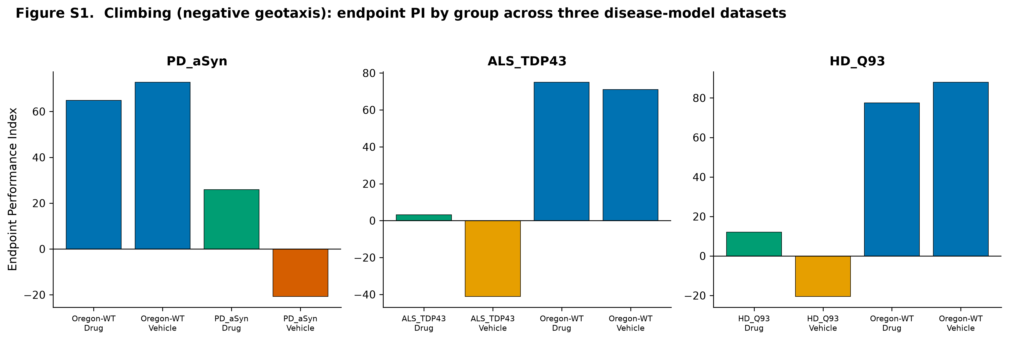
Figure S2. Lifespan. Kaplan–Meier survival curves; sample 1 is the real Freireich et al. (1963) 6-MP trial (median 23 vs 8 weeks), samples 2–3 are Gompertz fly cohorts (wild-type median ≈50 d; disease shorter; drug extends).
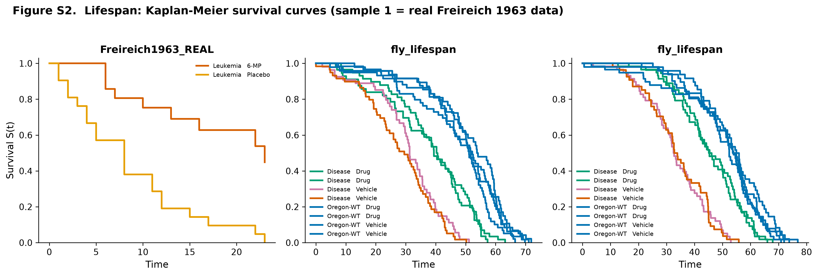
Figure S3. Y-maze. Mean spontaneous alternation (± SEM) per genotype against the 50% chance line (Lewis 2017); wild-type alternates above chance and above the memory-mutant cohorts.
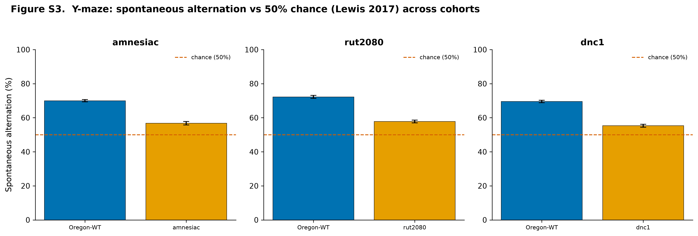
Figure S4. DAMS circadian period. Chi-square (Sokolove–Bushell) periodograms for wild-type, per-short and per-long, recovering the Konopka & Benzer (1971) periods of 24, 19 and 28 h respectively; dashed line = Bonferroni-corrected significance threshold.
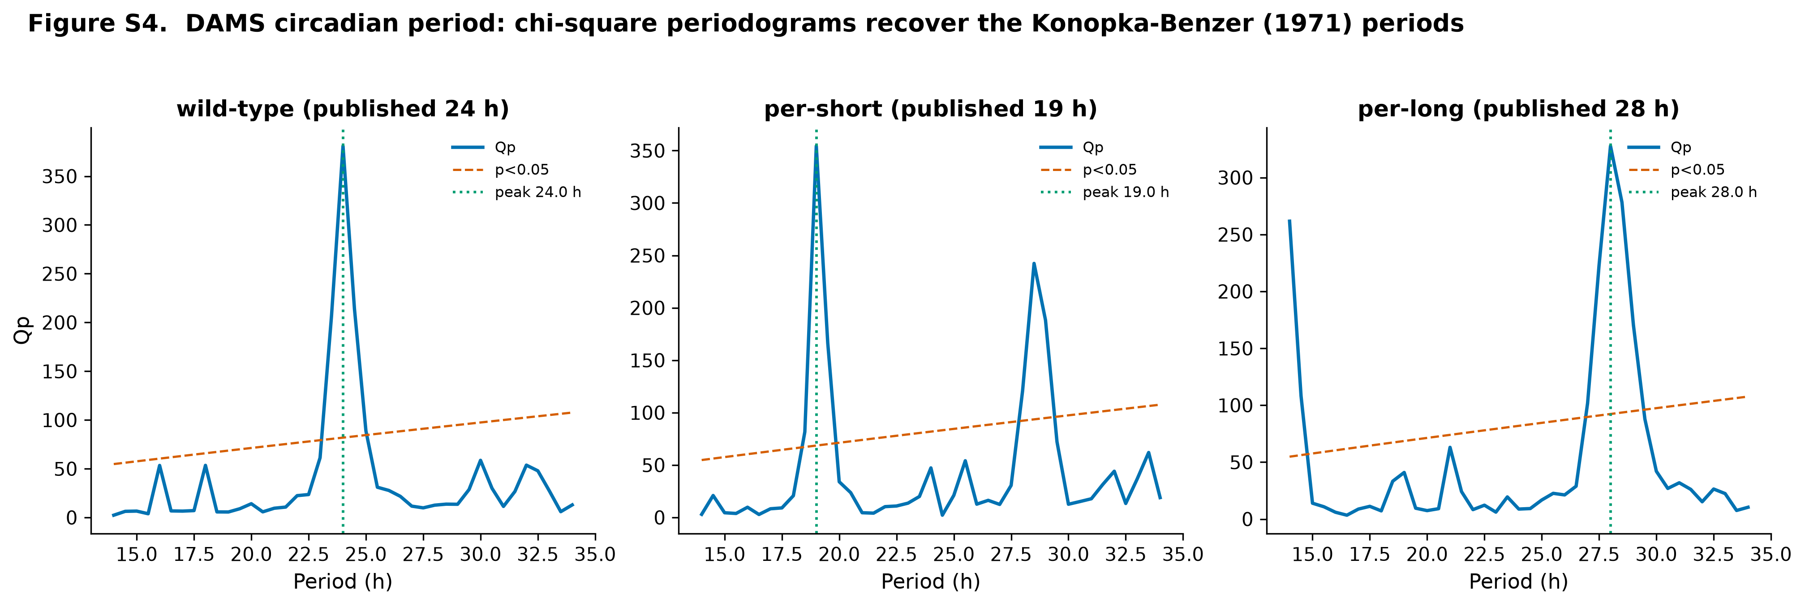
Figure S5. Larval crawling. Mean crawling speed (± SEM) by genotype for three disease contrasts; wild-type ≈1 mm s⁻¹, disease models slower, drug partially restored.
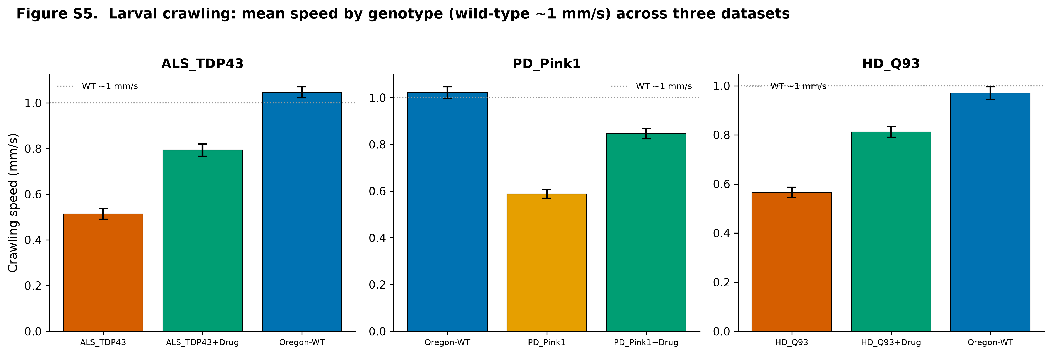
Figure S6. Grooming. Percentage of time grooming (± SEM) by genotype; wild-type ≈13% (Qiao 2018), reduced in the disease models and partially restored by drug.
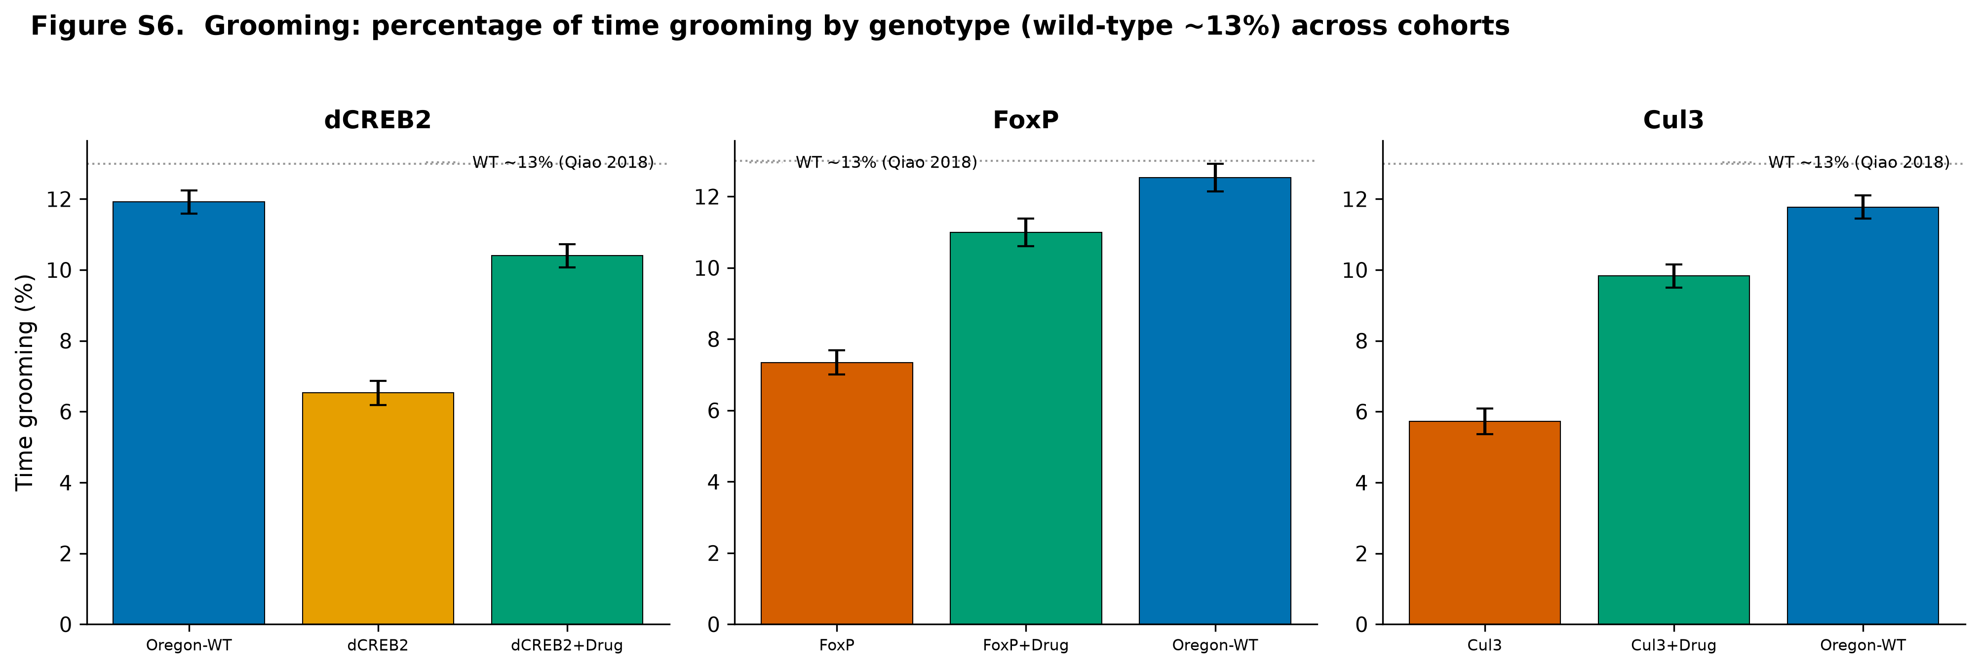

Supplementary Methods: formula summary
Quantity | Formula
Performance Index | PI = 2·(climbed/total)·100 − 100
Kaplan–Meier | Ŝ(t) = Π_{tᵢ≤t}(1 − dᵢ/nᵢ); Greenwood Var = Ŝ(t)²·Σ dᵢ/[nᵢ(nᵢ−dᵢ)]
Log-rank (Mantel–Cox) | χ² = (Σ(O₁ⱼ − E₁ⱼ))² / Σ V₁ⱼ; df = G−1
Cox PH | h(t\
χ² periodogram | Q_P = N′·K·Σ_h(X̄_h−X̄)² / Σ(Xᵢ−X̄)² ~ χ²_{p−1}; Bonferroni across periods
Sleep | bout = ≥5 consecutive min of zero activity
Spontaneous alternation | %alt = 100·(alternation triads)/(entries−2); chance = 50%
Turn bias | b = R/(R+L); individuality: observed MAD vs binomial-null MAD
Motor Decline Rate | PI(age) = PI₀·e^(−k·age); Δk = k_vehicle − k_drug
Hedges' g | g = J·(x̄_t−x̄_c)/s_p, J = 1 − 3/[4(n₁+n₂)−9]
Var(g) | J²·[(n₁+n₂)/(n₁n₂) + g²/(2(n₁+n₂−2))]
Inverse-variance pooling | g_pooled = Σwᵢgᵢ/Σwᵢ, wᵢ = 1/Var(gᵢ), Var = 1/Σwᵢ
DerSimonian–Laird | τ² = max(0,(Q−(k−1))/C); wᵢ* = 1/(Var(gᵢ)+τ²); I² = max(0,(Q−(k−1))/Q)

