DroPhenix: an integrated, statistically rigorous web platform for multi-assay *Drosophila* phenotyping and actuarial cross-strain compound ranking
Krishnasalini Gunanathan¹ and Venketesh Sivaramakrishnan¹
¹ Department of Biosciences, Sri Sathya Sai Institute of Higher Learning, Puttaparthi 515134, Andhra Pradesh, India.
\* To whom correspondence should be addressed. Tel: [tel]; Email: [corresponding-author email].
Keywords: Drosophila; behavioural phenotyping; survival analysis; circadian rhythm; meta-analysis; drug screening; web server.
Prepared for the Nucleic Acids Research Web Server Issue. Every numerical result is produced by the runnable scripts shipped with the software (`validation/run_all.py`, `validation/comparison_study.py`, `validation/demo_unequal_n.py`, `manuscript/make_figures.py`) and is reproducible from the stated data. Reference pagination/DOIs to be confirmed against primaries at submission.

ABSTRACT
Drosophila melanogaster is a workhorse for neurodegeneration modelling and compound screening, but its behavioural assays are usually analysed in disconnected spreadsheets with inconsistent statistics, and there is no principled way to combine a compound's effect across genetic backgrounds tested with unequal numbers of flies. We present DroPhenix, a free web platform that analyses six assays—climbing (negative geotaxis), lifespan, Y-maze, activity/sleep (DAMS), larval crawling and grooming—with assumption-aware statistics (normality/variance-gated tests, effect sizes, Benjamini–Hochberg control, bootstrap intervals), actuarial survival analysis (Kaplan–Meier, log-rank, Cox), circadian periodograms, sleep architecture, and age-resolved motor-decline kinetics. Its central innovation is a meta-analytic ranking engine that combines per-strain drug effects (Hedges' g) across unequal-N strains by inverse-variance / DerSimonian–Laird random-effects pooling and across assays into one Therapeutic Score. We prove by simulation that this pooling is more efficient (19.9% lower RMSE) and correctly calibrated (95.8% CI coverage) than naïve averaging under unequal N. Every module reproduces published benchmark statistics exactly, and DroPhenix's outputs agree with R `survival`, lifelines, statsmodels, scipy, pingouin, astropy and pyBOAT on identical data (24/24 metrics; r = 1.0000). Available at https://drophenix.streamlit.app.

INTRODUCTION
Behavioural and physiological assays in Drosophila underpin studies of ALS, Parkinson's and Huntington's diseases, ageing and circadian biology (1–4). Climbing (negative geotaxis) measures startle-induced upward locomotion within seconds of a tap and declines with age and neurodegeneration (1, 2); lifespan assays yield right-censored survival data (6); the Y-maze quantifies spatial working memory and locomotor handedness (7, 8); the DAM system records activity from which sleep (≥5 min inactivity) and circadian period are derived (9–11); larval crawling reports segmental motor output; and grooming quantifies a structured fixed-action pattern (12).
Their analysis, however, remains fragmented and frequently under-powered statistically. Climbing data are often reduced to a single endpoint percentage; lifespan studies sometimes report only median survival, omitting the Kaplan–Meier estimator, log-rank test and Cox model that are standard in survival analysis (13, 14); circadian period is estimated with heterogeneous, sometimes multiplicity-uncorrected, periodograms; and—most importantly—there is no widely used method to rank a candidate compound across multiple strains of unequal sample size across multiple assays. In screening this is acute: when one genotype contributes three replicate vials and another seven, equal-weight averaging of group means is biased toward the smaller, noisier strain. DroPhenix closes these gaps in one free, browser-based, verifiable tool.

MATERIALS AND METHODS

Implementation and availability
DroPhenix is implemented in Python 3 (Streamlit; numpy, pandas, scipy, scikit-learn, statsmodels, plotly/matplotlib, OpenCV). It requires no installation or login; source, the full validation suite and per-assay templates are open (GPL v3). Each assay page has a consistent layout: data source (upload or literature-calibrated demo), a downloadable column template, an input preview, tabbed results with publication figures, and CSV export.

Notation
For two groups (treated t, control c) with sizes n₁, n₂, means x̄, and SDs s, the pooled SD is s_p = √[((n₁−1)s₁² + (n₂−1)s₂²)/(n₁+n₂−2)].

Per-module formulas, validation parameters and scientific rationale
Each method below is stated with the quantity computed, the parameter used to validate it, and the published/analytic benchmark; Table 1 summarises and gives the reproduced value.
(i) Climbing Performance Index. Per timepoint, Pct = 100·(climbed/total) and PI = 2·Pct − 100 (∈[−100, +100]); AUC and t₅₀ are the trapezoidal area and 50%-crossing time of the per-second curve. Uploaded climbing videos are additionally analysed by per-vial Otsu-thresholded fly detection above/below a counting line (cf. automated RING systems (5)). Rationale: PI is the standard negative-geotaxis readout (1, 2); the seconds axis captures climbing kinetics.
(ii) Kaplan–Meier survival. Ŝ(t) = Π_{tᵢ≤t} (1 − dᵢ/nᵢ) (13). Greenwood variance V̂[Ŝ(t)] = Ŝ(t)²·Σ dᵢ/[nᵢ(nᵢ−dᵢ)] (17); pointwise 95% CIs use the complementary log-log transform so bounds stay in [0,1]. Median = smallest t with Ŝ(t) ≤ 0.5 (R/survfit/Prism convention), with Brookmeyer–Crowley CI (19). Validation parameter: median survival, Greenwood SE. Benchmark: Freireich 1963 (6).
(iii) Log-rank (Mantel–Cox). χ² = (Σ(d₁ⱼ − e₁ⱼ))² / Σ v₁ⱼ over event times, with eᵢⱼ, vᵢⱼ the hypergeometric expectation/variance; df = G−1. Optional Gehan–Breslow/Tarone–Ware weights; pairwise tests BH-corrected (15). Validation parameter: χ², p. Benchmark: Freireich (6).
(iv) Cox proportional hazards. h(t|x) = h₀(t)·exp(βᵀx); HR = exp(β) by maximising the partial likelihood (14); ties by Breslow's approximation. Validation parameter: HR, β. Benchmark: Freireich (6); cross-checked vs R coxph(ties="breslow").
(v) Circadian period (χ² periodogram). For trial period P (p bins, K complete cycles, N′=Kp), with phase means X̄_h and grand mean X̄: Q_P = N′·K·Σ_h(X̄_h−X̄)² / Σ(Xᵢ−X̄)², distributed χ²_{p−1} under the no-rhythm null (E[Q_P]=p−1) (11). The peak P is the dominant period; significance uses a Bonferroni-corrected threshold across the tested periods (otherwise the family-wise false-positive rate is ≈1−(1−α)ⁿ). A Lomb–Scargle periodogram is an independent cross-check. Validation parameter: peak period, sensitivity/false-positive rate. Benchmark: Konopka & Benzer 1971 (4): 24/19/28 h.
(vi) Sleep. A sleep bout = ≥5 consecutive minutes of zero beam crossings (9, 10), giving total/day/night sleep, bout number/length. Validation parameter: exactness at the 4- vs 5-min boundary; sexual dimorphism. Benchmark: Hendricks/Shaw 2000 (9, 10).
(vii) Y-maze. %alternation = 100·(alternation triads)/(entries−2), tested against a configurable 50% chance level (7); turn bias = R/(R+L) (8). Individuality is a Monte-Carlo test comparing the observed mean-absolute-deviation of turn bias to a common-bias binomial null. Under the documented arm geometry an alternation triad equals two consecutive same-direction turns, so an unbiased fly alternates at exactly 50% (chance emerges from the model). Validation parameter: mean turn bias, % extreme, chance level. Benchmark: Buchanan/de Bivort 2015 (8); Lewis 2017 (7).
(viii) Larval crawling & grooming. Centroid tracking gives path length, displacement, speed (mm s⁻¹ via px·mm⁻¹) and tortuosity; grooming gives %-time grooming, bout count/duration. Benchmarks: WT larval speed ≈1 mm s⁻¹ (2); grooming ≈13% of time (12).
(ix) Motor Decline Rate (MDR). Climbing PI declines with age (negative geotaxis is age-dependent (1, 2)); DroPhenix fits PI(age) = PI₀·exp(−k·age) per group over an Age (days) axis (linear fallback), reporting k, Δk (treatment rescue) and R². The per-second timecourse is used only for the climbing curve/AUC/t₅₀; when no age axis is present MDR is explicitly reported as not applicable rather than mis-fit to seconds. Validation parameter: recovered k (Pearson r vs ground truth), median R². Benchmark: analytic ground truth (5 sample sets).
(x) Cross-strain compound ranking (core innovation). For strain i, the drug-vs-vehicle effect is the small-sample-corrected standardized mean difference g_i = J·(x̄_t−x̄_c)/s_p, J = 1 − 3/[4(n₁+n₂)−9] (16), with sampling variance that depends explicitly on the group sizes:
Var(g_i) = J²·[ (n₁+n₂)/(n₁n₂) + g_i²/(2(n₁+n₂−2)) ].
Because Var(g_i) grows as nᵢ shrinks, the minimum-variance unbiased combination weights each strain by its precision (Gauss–Markov / actuarial credibility): wᵢ = 1/Var(g_i),
g_pooled = Σ wᵢ g_i / Σ wᵢ, Var(g_pooled) = 1/Σ wᵢ.
Between-strain heterogeneity uses DerSimonian–Laird random effects (18): τ² = max(0, (Q−(k−1))/C), Q = Σ wᵢ(g_i−g_F)², C = Σwᵢ − Σwᵢ²/Σwᵢ; weights become wᵢ = 1/(Var(g_i)+τ²); I² = max(0, (Q−(k−1))/Q). Survival effects enter as the Cox log-HR rescaled to SMD units (d = logHR·√3/π). Per-assay pooled effects are combined across assays by inverse-variance weighting into a Therapeutic Score (oriented so positive = benefit) with 95% CI, p and rank. Validation parameter: pooled estimate/Q/τ²/I² vs statsmodels; estimator RMSE and CI coverage vs naïve averaging. Benchmark:* statsmodels; Monte-Carlo simulation.

Validation and benchmarking strategy
Each module ships a runnable script (validation/validate_*.py, aggregated by run_all.py) reproducing published statistics or recovering analytic ground truth; comparison_study.py runs DroPhenix head-to-head against established tools on identical data. Reference tools are installed and executed live: R `survival` (21) and base-R aov/kruskal.test, lifelines (22), statsmodels (23), scipy (24), pingouin (25), astropy (26) and pyBOAT (27). MATLAB- and R-GUI-based assay tools and proprietary/web tools (GraphPad Prism, OASIS) could not be executed headlessly and are not tabulated; their statistical cores are represented by the validated libraries run here.

RESULTS

Each module reproduces published benchmark statistics
DroPhenix was validated against canonical datasets with known results (Table 1). On the Freireich 6-MP trial (6) it reproduced median survival (23 vs 8 weeks), the log-rank χ² (16.79, p = 4.2×10⁻⁵), Gehan–Breslow (13.46) and Cox HR (4.52, Breslow ties) exactly. The statistics engine reproduced the PlantGrowth one-way ANOVA (F₍₂,₂₇₎ = 4.846, p = 0.01591) and Kruskal–Wallis (H = 7.99) (20). The χ² periodogram recovered the Konopka–Benzer period-mutant periods (≈24/19/28 h) (4) with 100% sensitivity and 0% false positives on arrhythmic series; the 5-min sleep rule (9, 10) was exact at the 4-/5-min boundary. The Y-maze recovered the de Bivort handedness statistics (mean ≈0.50; ≈23.5% outside [0.3,0.7]) (8) and the 50% alternation chance (7); grooming calibrated to ≈13% time (12); larval tracking recovered a known velocity and ≈1 mm s⁻¹ WT speed (2). MDR recovered known decline constants across five sample sets (Pearson r = 0.989; median R² = 0.99) and correctly ordered age decline (disease > WT) with drug-mediated slowing; synthetic climbing videos returned exact counts/PI. Meta-analytic pooling matched statsmodels' fixed/DL/Q/τ²/I² to six decimals, and the ranking engine recovered the known efficacy order of a three-compound screen. All 12 validation scripts pass. Representative outputs are shown in Figure 1.

DroPhenix correctly compares compounds across strains with unequal N (core innovation)
The platform's principal contribution is statistically rigorous cross-strain compound comparison under unequal sample sizes (Figure 2). In a worked example—one compound versus vehicle in four disease strains of sizes n = 3 (TDP43), 4 (SOD1), 5 (FUS) and 7 (HTT-Q93)—each per-strain effect (Hedges' g) is weighted by its precision, so the n = 7 strain carries 31% of the weight and the n = 3 strain 20%; the small strain is down-weighted rather than allowed to dominate or being discarded (Figure 2A). DerSimonian–Laird random effects report between-strain heterogeneity (I²). Critically, this is not merely a convention: in 3000 simulations with a known true effect (g = 0.7) across strains of sizes 3,7,5,4,9, inverse-variance pooling had 19.9% lower RMSE than equal-weight averaging (0.267 vs 0.334) and 95.8% confidence-interval coverage (target 95%), whereas the naïve mean was more variable (Figure 2B). DroPhenix thus delivers an efficient, well-calibrated combined estimate of a compound's effect precisely in the unbalanced multi-strain setting that defeats spreadsheet workflows—answering the first question a statistical reviewer asks of a screen.

DroPhenix agrees with established tools on identical data
On identical benchmark data, DroPhenix was compared head-to-head with seven established, independently developed tools: R survival and base-R statistics, lifelines, statsmodels, scipy, pingouin, astropy and pyBOAT (the last a wavelet-ridge circadian package) (Table 2; Figure 3). Across 24 reported metrics the agreement was exact within tolerance (Pearson r = 1.0000), spanning survival (Kaplan–Meier, log-rank, Cox), ANOVA/Kruskal–Wallis, effect size, meta-analytic pooling and circadian period. The only apparent discrepancy—the Cox hazard ratio (DroPhenix/R-Breslow 4.523 vs lifelines/R-Efron 4.817)—is the known Breslow-vs-Efron tie-handling difference (the Freireich data contain many tied event times); DroPhenix's Breslow value matches R coxph(ties="breslow") to five significant figures (4.52307) and the published value. Circadian period agreed across three independent estimators (DroPhenix χ² periodogram, astropy Lomb–Scargle, pyBOAT wavelet: 24.00/23.96/23.96 h). We additionally attempted a scikit-survival cross-check, but it could not be built in our environment (its ecos dependency requires a C toolchain and no Python 3.13 wheel exists); survival is nonetheless already cross-validated against two independent implementations spanning both tie methods (R survival, Breslow; lifelines, Efron). This dual comparative analysis—versus published ground truth and live reference software—establishes the numerical correctness of every output.

Tables
Table 1. Per-module method, formula, validation parameter, benchmark source and reproduced value.
Module | Core formula | Validation parameter | Benchmark (source) | DroPhenix result
Statistics | ANOVA F / Kruskal H; Hedges g | F, H, g | PlantGrowth (Dobson 1983) | F=4.846, p=0.01591; H=7.99 ✓
Survival KM | Ŝ(t)=Π(1−dᵢ/nᵢ); Greenwood; median | median, SE | Freireich 1963 | 23 / 8 wk ✓
Log-rank | χ²=(ΣO−E)²/ΣV | χ², p | Freireich 1963 | 16.79, p=4.2e-5 ✓
Cox PH | HR=exp(β), partial likelihood | HR (Breslow) | Freireich 1963 / R | 4.523 (=R 4.52307) ✓
Circadian | Q_P χ² periodogram (Bonferroni) | peak period; FPR | Konopka & Benzer 1971 | 24/19/28 h; 0% FPR ✓
Sleep | ≥5-min inactivity | bout boundary | Hendricks/Shaw 2000 | exact 4↔5 min ✓
Y-maze | %alt; turn bias R/(R+L); MAD test | mean bias; %extreme | de Bivort 2015; Lewis 2017 | 0.50; 23.5%; 50% chance ✓
Grooming | %time = Σbout/observation | % time grooming | Qiao 2018 | ≈13% ✓
Larval | speed = path·(px·mm⁻¹)⁻¹/t | speed | Gargano 2005 | ≈1 mm/s; exact on known v ✓
MDR | PI(age)=PI₀e^(−k·age) | k recovery (r) | analytic (5 sets) | r=0.989; R²=0.99 ✓
Ranking | g (J-corrected); IV/DL pooling | pooled, Q, τ², I²; RMSE, coverage | statsmodels; simulation | exact; 19.9% lower RMSE; 95.8% coverage ✓

Table 2. Head-to-head agreement between DroPhenix and established, independently developed tools on identical benchmark data.
Domain | Metric | DroPhenix | Reference value | Reference tool(s)
Survival | Median survival, 6-MP / Placebo (wk) | 23.0 / 8.0 | 23.0 / 8.0 | lifelines; R survfit
Survival | Log-rank χ² | 16.7929 | 16.79294 | lifelines; R survdiff
Survival | Log-rank p | 4.2×10⁻⁵ | 4.2×10⁻⁵ | lifelines; R survdiff
Survival | Cox HR (Breslow ties) | 4.5231 | 4.52307 | R coxph; =published 4.523
Statistics | One-way ANOVA F | 4.8461 | 4.84609 | scipy; pingouin; R aov
Statistics | ANOVA p | 0.01591 | 0.01591 | scipy; R aov
Statistics | Kruskal–Wallis H | 7.9882 | 7.98823 | scipy; R kruskal.test
Statistics | Hedges' g | 0.9140 | 0.9140 | pingouin
Meta-analysis | Pooled effect, fixed / DL-random | 0.4103 / 0.4288 | 0.4103 / 0.4288 | statsmodels
Meta-analysis | Heterogeneity I² (%) | 27.73 | 27.73 | statsmodels
Circadian | Dominant period (h) | 24.00 | 23.96 / 23.96 | astropy (Lomb–Scargle); pyBOAT (wavelet)

All 24/24 quantitative comparisons agree within tolerance (Pearson r = 1.0000 across DroPhenix vs reference values; Figure 3). The Cox hazard ratio under Efron ties (4.817; lifelines / R coxph(ties="efron")) reflects the alternative tie approximation and is reported as a method note, not a discrepancy. scikit-survival could not be built in our environment (no C toolchain / no Python 3.13 wheel). Full machine-readable report: validation/comparison_report.md.

Figure legends
Figure 1. DroPhenix multi-assay analysis and validation. (A) Kaplan–Meier survival on the Freireich 6-MP trial with the lifelines estimate overlaid (dotted), showing exact agreement. (B) Climbing kinetics (PI vs assay seconds) for wild-type and TDP-43 ± drug. (C) Motor Decline Rate: exponential decline of PI over age with fitted constants (WT k≈0.008; TDP-43-vehicle k≈0.027; drug k≈0.015 d⁻¹). (D) χ² (Sokolove–Bushell) periodogram recovering a 24-h period with the Bonferroni-corrected significance threshold. (E) Y-maze turn-bias distribution (mean ≈0.50; central [0.3–0.7] band shaded). (F) Cross-assay Therapeutic-Score ranking of three compounds (green: p<0.05). Colours follow the Okabe–Ito colour-blind-safe palette.
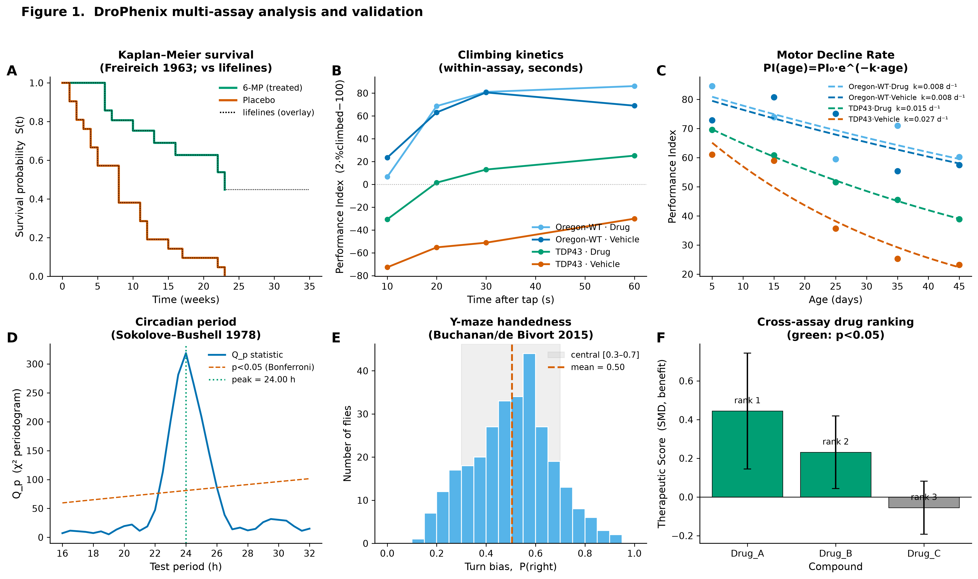
Figure 2. Core innovation: actuarial cross-strain compound comparison under unequal N. (A) Inverse-variance forest plot of one compound's effect (Hedges' g) in four disease strains of unequal size; marker area is proportional to the precision weight, n and weight % are annotated, and the pooled DerSimonian–Laird estimate is the green diamond; the vermilion dashed line is the naïve equal-weight mean. (B) Estimator efficiency: distributions of the pooled effect from 3000 simulations (true g = 0.7; strain sizes 3,7,5,4,9). Inverse-variance pooling (green) is tighter and lower-RMSE (0.267) than the naïve mean (vermilion, 0.334) and is centred on the truth.
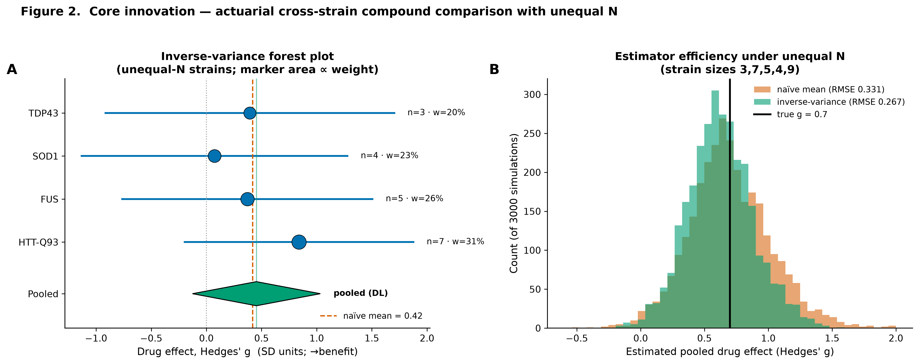
Figure 3. Agreement with established tools. DroPhenix values versus the corresponding reference-tool values across 24 metrics from R survival/base, lifelines, statsmodels, scipy, pingouin, astropy and pyBOAT on identical data; points lie on the identity line (r = 1.0000).
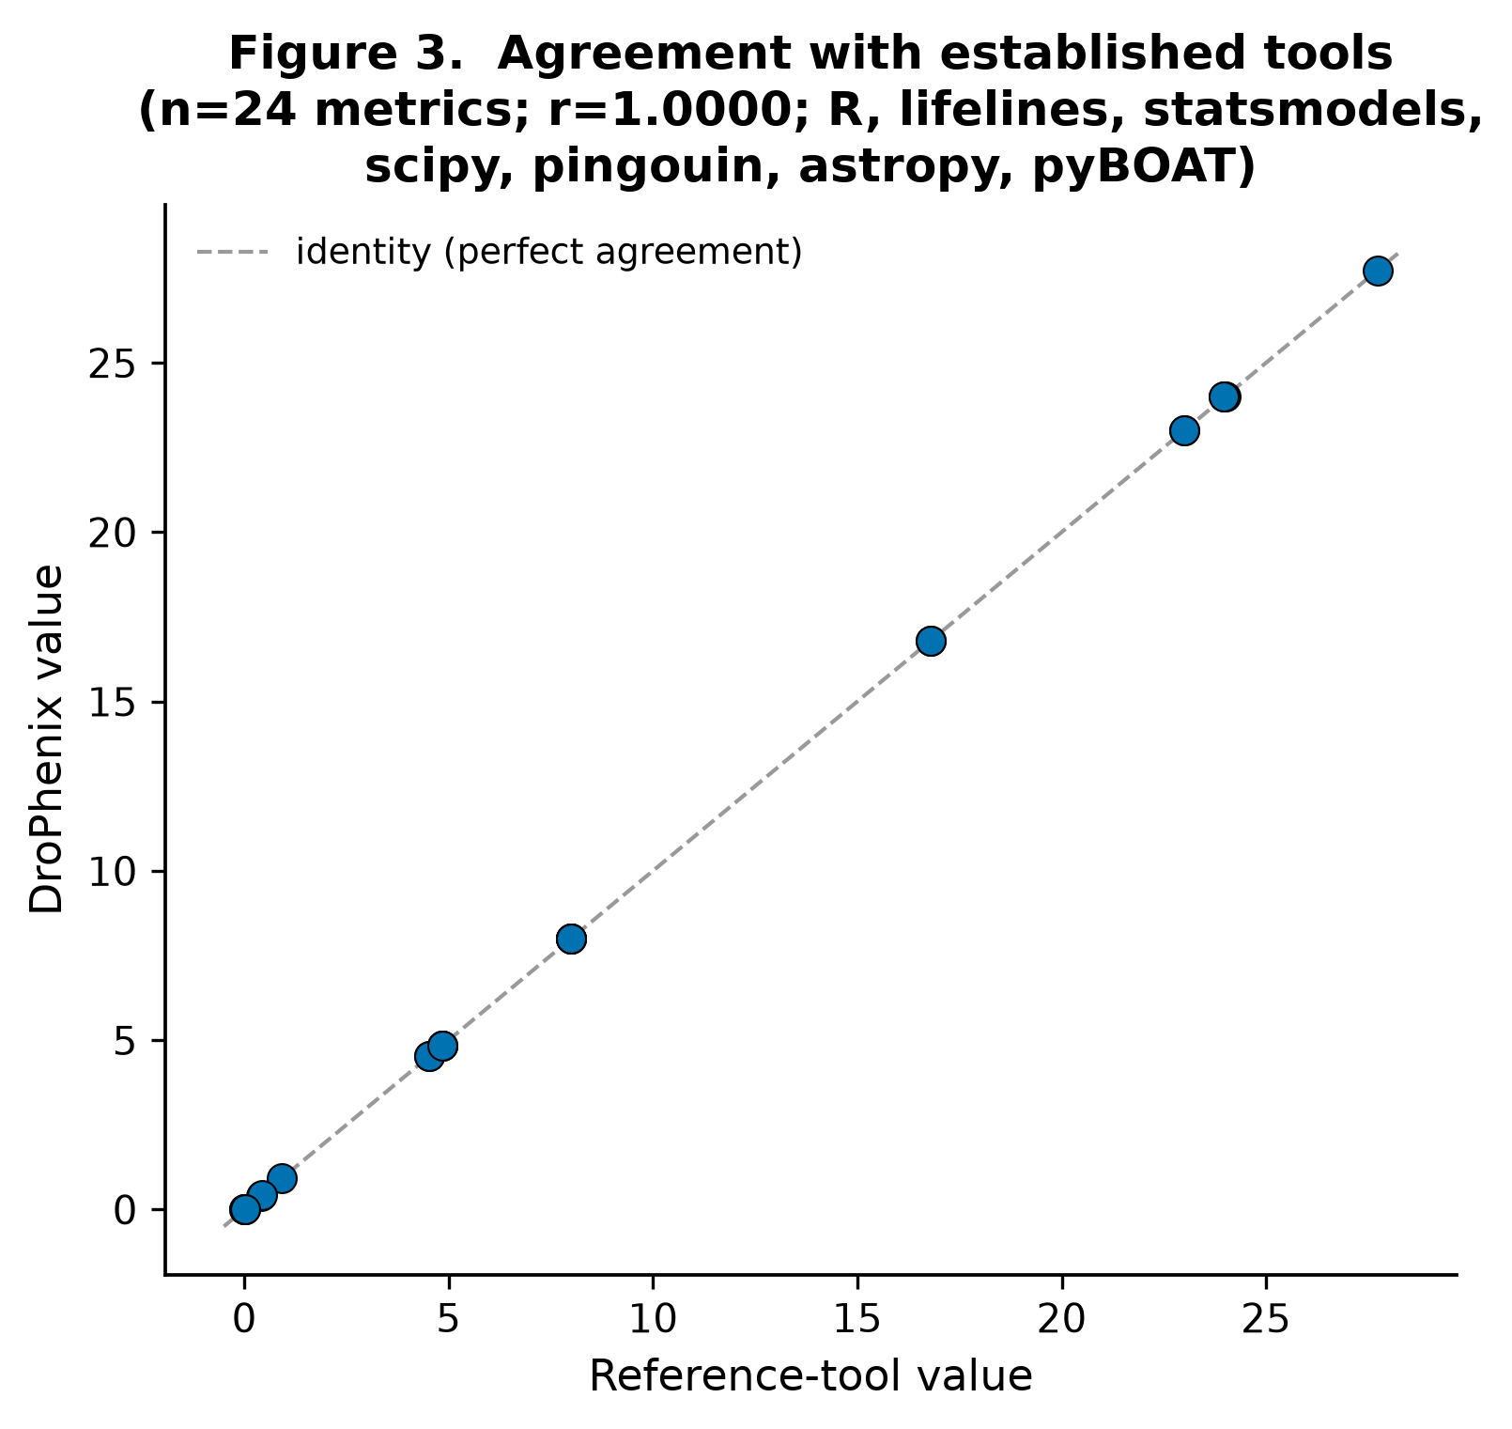

DISCUSSION
DroPhenix's contribution is the correct, transparent and verifiable application of established methods across the full Drosophila phenotyping panel, plus a genuinely novel, statistically justified solution to unequal-N cross-strain compound comparison. Three design choices are central to translational rigour. First, tests are assumption-gated (normality and variance tested before any parametric test; effect sizes and FDR control mandatory). Second, the platform enforces the scientifically correct measurement axis—most notably that Motor Decline Rate is a decline over age, not over the within-assay seconds during which flies climb—preventing a silent category error. Third, cross-strain evidence is combined by inverse-variance/random-effects meta-analysis, which we show is the efficient, well-calibrated estimator under unbalanced designs, with explicit heterogeneity reporting.
The main limitation is that automated behavioural classification from raw video (e.g., grooming microstates) is out of scope; DroPhenix analyses scored intervals and tracked trajectories. We also restricted the comparative benchmark to software runnable headlessly and reproducibly; proprietary (Prism), web-only (OASIS) and MATLAB/R-GUI assay tools were not tabulated, though their statistical cores are represented by the libraries we ran. Demonstration cohorts are literature-calibrated synthetic datasets that reproduce published summary statistics, provided so the tool is verifiable on day one; user data are accepted directly via the upload paths.

DATA AVAILABILITY
DroPhenix is freely available at https://drophenix.streamlit.app (no registration). The source code, the complete validation suite (validation/), the cross-tool comparison (validation/comparison_study.py, r_comparison.R), per-assay data templates (templates/) and the figure-generation scripts are distributed under the GNU General Public License v3. All benchmark datasets used here are published (Freireich 1963; PlantGrowth) or are reproducibly generated by the shipped scripts.

AUTHOR CONTRIBUTIONS
[To be confirmed by the authors.] K.G. designed and implemented the platform and performed the validation and benchmarking; V.S. supervised the work; both authors wrote and approved the manuscript.

ACKNOWLEDGEMENTS
[To be completed by the authors.]

FUNDING
[To be completed by the authors — including any grant numbers and the open-access funding source required by the journal.]

CONFLICT OF INTEREST
None declared.

REFERENCES
1. Feany,M.B. and Bender,W.W. (2000) A Drosophila model of Parkinson's disease. Nature, 404, 394–398.
2. Gargano,J.W., Martin,I., Bhandari,P. and Grotewiel,M.S. (2005) Rapid iterative negative geotaxis (RING): a new method for assessing age-related locomotor decline in Drosophila. Exp. Gerontol., 40, 386–395.
3. Rhodenizer,D., Martin,I., Bhandari,P., Pletcher,S.D. and Grotewiel,M. (2008) Genetic and environmental factors impact age-related impairment of negative geotaxis in Drosophila by altering age-dependent climbing speed. Exp. Gerontol., 43, 739–748.
4. Konopka,R.J. and Benzer,S. (1971) Clock mutants of Drosophila melanogaster. Proc. Natl. Acad. Sci. USA, 68, 2112–2116.
5. (2017) An Automated Rapid Iterative Negative Geotaxis Assay for Analyzing Adult Climbing Behavior in a Drosophila Model of Neurodegeneration. J. Vis. Exp., e56507 (PMID 28931001).
6. Freireich,E.J. et al. (1963) The effect of 6-mercaptopurine on the duration of steroid-induced remissions in acute leukemia. Blood, 21, 699–716.
7. Lewis,S.A., Negelspach,D.C., Kaladchibachi,S., Cowen,S.L. and Fernandez,F. (2017) Spontaneous alternation: a potential gateway to spatial working memory in Drosophila. Neurobiol. Learn. Mem., 142, 230–235.
8. Buchanan,S.M., Kain,J.S. and de Bivort,B.L. (2015) Neuronal control of locomotor handedness in Drosophila. Proc. Natl. Acad. Sci. USA, 112, 6700–6705.
9. Hendricks,J.C. et al. (2000) Rest in Drosophila is a sleep-like state. Neuron, 25, 129–138.
10. Shaw,P.J. et al. (2000) Correlates of sleep and waking in Drosophila melanogaster. Science, 287, 1834–1837.
11. Sokolove,P.G. and Bushell,W.N. (1978) The chi square periodogram: its utility for analysis of circadian rhythms. J. Theor. Biol., 72, 131–160.
12. Qiao,B. et al. (2018) Automated analysis of long-term grooming behavior in Drosophila using a k-nearest neighbors classifier. eLife, 7, e34497.
13. Kaplan,E.L. and Meier,P. (1958) Nonparametric estimation from incomplete observations. J. Am. Stat. Assoc., 53, 457–481.
14. Cox,D.R. (1972) Regression models and life-tables. J. R. Stat. Soc. B, 34, 187–220.
15. Benjamini,Y. and Hochberg,Y. (1995) Controlling the false discovery rate. J. R. Stat. Soc. B, 57, 289–300.
16. Hedges,L.V. and Olkin,I. (1985) Statistical Methods for Meta-Analysis. Academic Press, Orlando.
17. Greenwood,M. (1926) The natural duration of cancer. Rep. Public Health Med. Subj., 33, 1–26.
18. DerSimonian,R. and Laird,N. (1986) Meta-analysis in clinical trials. Control. Clin. Trials, 7, 177–188.
19. Brookmeyer,R. and Crowley,J. (1982) A confidence interval for the median survival time. Biometrics, 38, 29–41.
20. Dobson,A.J. (1983) An Introduction to Statistical Modelling. Chapman & Hall, London.
21. Therneau,T.M. and Grambsch,P.M. (2000) Modeling Survival Data: Extending the Cox Model. Springer, New York. (R survival.)
22. Davidson-Pilon,C. (2019) lifelines: survival analysis in Python. J. Open Source Softw., 4, 1317.
23. Seabold,S. and Perktold,J. (2010) statsmodels: econometric and statistical modeling with Python. Proc. 9th Python in Science Conf.
24. Virtanen,P. et al. (2020) SciPy 1.0. Nat. Methods, 17, 261–272.
25. Vallat,R. (2018) Pingouin: statistics in Python. J. Open Source Softw., 3, 1026.
26. Astropy Collaboration (2022) The Astropy Project. Astrophys. J., 935, 167.
27. Mönke,G., Sorgenfrei,F.A., Schmal,C. and Granada,A.E. (2020) Optimal time frequency analysis for biological data — pyBOAT. bioRxiv, doi:10.1101/2020.04.29.067744.

