Table of Contents

BrainSafe AI: Technical Report
Generated 2026-08-20 from the deployed panel at commit 120f2c7. Every figure in this document is read from an artefact in this repository at generation time. None is typed in. Regenerate with python src/brainsafe/analysis/build_technical_report.py.

1. What the system is
BrainSafe AI takes one small molecule, given as a SMILES string or a resolvable compound name, and answers four questions about it in a single pass:
- Exposure. Does it reach the brain, and at what free concentration?
- Engagement. What does it bind there?
- Consequence. What conditions does that mechanism touch?
- Developability. What would stop it being a drug?
The system is 75 fitted estimators, 70 of them deployed, trained on 228,200 measured compound-endpoint records. It is not one model. Section 4 explains why that is a design decision rather than an accident, and section 5 explains how the pieces produce one answer.

1.1 Composition
family | task | estimators
binder | classification | 52
exposure | classification | 3
exposure | regression | 7
safety | classification | 1
target | classification | 6
target | regression | 6

2. The endpoints

2.1 What each estimator predicts, and how well
Metrics are not comparable across the table. AUROC is used for classification, where 0.5 is chance; R² for regression, where 0.5 is a respectable fit. The scaffold column is the honest one: it is measured with whole Bemis-Murcko scaffold classes withheld from training, so it reports generalisation to chemistry the model has not seen, while the random column reports interpolation within chemistry it has.
All 75 estimators (click to expand)
model | family | predicts | task | algorithm | n_train | n_positive | metric | random_split | scaffold_split | calibration | deployed
A2A | target | potency, pChEMBL | regression | RandomForest, 300 trees, min_samples_leaf=2, seed 42 | 6743 |  | R2 | 0.7231 | 0.6205 | none | True
AChE | target | probability of activity | classification | RandomForest, 300 trees, min_samples_leaf=2, seed 42 | 5125 | 3014.0 | AUROC | 0.9659 | 0.9212 | isotonic, out-of-fold | True
antioxidant_DPPH | target | potency, pChEMBL | regression | RandomForest, 300 trees, min_samples_leaf=2, seed 42 | 2782 |  | R2 | 0.6589 | 0.4153 | none | True
BACE1 | target | probability of activity | classification | RandomForest, 300 trees, min_samples_leaf=2, seed 42 | 8207 | 7096.0 | AUROC | 0.9764 | 0.9648 | isotonic, out-of-fold | True
BBB | exposure | probability of activity | classification | RandomForest, 300 trees, min_samples_leaf=2, seed 42 | 3901 | 2473.0 | AUROC | 0.899 | 0.8777 | isotonic, out-of-fold | True
BChE | target | probability of activity | classification | RandomForest, 300 trees, min_samples_leaf=2, seed 42 | 3278 | 1760.0 | AUROC | 0.9724 | 0.9451 | isotonic, out-of-fold | True
D2 | target | potency, pChEMBL | regression | RandomForest, 300 trees, min_samples_leaf=2, seed 42 | 7905 |  | R2 | 0.6403 | 0.5311 | none | True
GSK3B | target | probability of activity | classification | RandomForest, 300 trees, min_samples_leaf=2, seed 42 | 5439 | 4056.0 | AUROC | 0.9649 | 0.9425 | isotonic, out-of-fold | True
hERG | safety | probability of activity | classification | RandomForest, 300 trees, min_samples_leaf=2, seed 42 | 9933 | 2370.0 | AUROC | 0.9565 | 0.927 | isotonic, out-of-fold | True
HT2A | target | potency, pChEMBL | regression | RandomForest, 300 trees, min_samples_leaf=2, seed 42 | 6075 |  | R2 | 0.6996 | 0.556 | none | True
MAO_A | target | probability of activity | classification | RandomForest, 300 trees, min_samples_leaf=2, seed 42 | 3585 | 857.0 | AUROC | 0.9619 | 0.9059 | isotonic, out-of-fold | True
MAO_B | target | probability of activity | classification | RandomForest, 300 trees, min_samples_leaf=2, seed 42 | 4534 | 2299.0 | AUROC | 0.963 | 0.917 | isotonic, out-of-fold | True
pka_basic | target | pKa | regression | RandomForest, 300 trees, min_samples_leaf=2, seed 42 | 6384 |  | R2 |  |  | none | True
SERT | target | potency, pChEMBL | regression | RandomForest, 300 trees, min_samples_leaf=2, seed 42 | 4479 |  | R2 | 0.6897 | 0.4612 | none | True
A1_binder | binder | probability this compound binds this target | classification | RandomForest, 300 trees, min_samples_leaf=4, seed 42 | 7352 | 1523.0 | AUROC vs measured non-binders |  | 0.914 | sigmoid, prefit | True
A2A_binder | binder | probability this compound binds this target | classification | RandomForest, 300 trees, min_samples_leaf=4, seed 42 | 15636 | 3333.0 | AUROC vs measured non-binders |  | 0.949 | sigmoid, prefit | True
CB1_binder | binder | probability this compound binds this target | classification | RandomForest, 300 trees, min_samples_leaf=4, seed 42 | 10198 | 2158.0 | AUROC vs measured non-binders |  | 0.949 | sigmoid, prefit | True
CGRP_binder | binder | probability this compound binds this target | classification | RandomForest, 300 trees, min_samples_leaf=4, seed 42 | 2251 | 454.0 | AUROC vs measured non-binders |  | 0.985 | sigmoid, prefit | True
COX2_binder | binder | probability this compound binds this target | classification | RandomForest, 300 trees, min_samples_leaf=4, seed 42 | 4429 | 883.0 | AUROC vs measured non-binders |  | 0.783 | sigmoid, prefit | True
CSF1R_binder | binder | probability this compound binds this target | classification | RandomForest, 300 trees, min_samples_leaf=4, seed 42 | 6772 | 1420.0 | AUROC vs measured non-binders |  | 0.95 | sigmoid, prefit | True
Cav3_2_binder | binder | probability this compound binds this target | classification | RandomForest, 300 trees, min_samples_leaf=4, seed 42 | 1325 | 272.0 | AUROC vs measured non-binders |  | 0.982 | sigmoid, prefit | True
D2_binder | binder | probability this compound binds this target | classification | RandomForest, 300 trees, min_samples_leaf=4, seed 42 | 13861 | 2890.0 | AUROC vs measured non-binders |  | 0.872 | sigmoid, prefit | True
D3_binder | binder | probability this compound binds this target | classification | RandomForest, 300 trees, min_samples_leaf=4, seed 42 | 15831 | 3450.0 | AUROC vs measured non-binders |  | 0.956 | sigmoid, prefit | True
DAT_binder | binder | probability this compound binds this target | classification | RandomForest, 300 trees, min_samples_leaf=4, seed 42 | 5113 | 1102.0 | AUROC vs measured non-binders |  | 0.959 | sigmoid, prefit | True
DHODH_binder | binder | probability this compound binds this target | classification | RandomForest, 300 trees, min_samples_leaf=4, seed 42 | 3619 | 730.0 | AUROC vs measured non-binders |  | 0.966 | sigmoid, prefit | True
GABA_A_binder | binder | probability this compound binds this target | classification | RandomForest, 300 trees, min_samples_leaf=4, seed 42 | 771 | 168.0 | AUROC vs measured non-binders |  | 0.719 | sigmoid, prefit | True
GBA1_binder | binder | probability this compound binds this target | classification | RandomForest, 300 trees, min_samples_leaf=4, seed 42 | 441 | 81.0 | AUROC vs measured non-binders |  | 0.932 | sigmoid, prefit | True
GluA2_binder | binder | probability this compound binds this target | classification | RandomForest, 300 trees, min_samples_leaf=4, seed 42 | 68 | 68.0 | AUROC vs measured non-binders |  | 0.696 | sigmoid, prefit | False
GluN2B_binder | binder | probability this compound binds this target | classification | RandomForest, 300 trees, min_samples_leaf=4, seed 42 | 3461 | 749.0 | AUROC vs measured non-binders |  | 0.761 | sigmoid, prefit | True
H3_binder | binder | probability this compound binds this target | classification | RandomForest, 300 trees, min_samples_leaf=4, seed 42 | 12295 | 2659.0 | AUROC vs measured non-binders |  | 0.978 | sigmoid, prefit | True
HDAC1_binder | binder | probability this compound binds this target | classification | RandomForest, 300 trees, min_samples_leaf=4, seed 42 | 11728 | 2563.0 | AUROC vs measured non-binders |  | 0.96 | sigmoid, prefit | True
HDAC6_binder | binder | probability this compound binds this target | classification | RandomForest, 300 trees, min_samples_leaf=4, seed 42 | 14155 | 3010.0 | AUROC vs measured non-binders |  | 0.975 | sigmoid, prefit | True
HT1A_binder | binder | probability this compound binds this target | classification | RandomForest, 300 trees, min_samples_leaf=4, seed 42 | 14179 | 3070.0 | AUROC vs measured non-binders |  | 0.936 | sigmoid, prefit | True
HT2A_binder | binder | probability this compound binds this target | classification | RandomForest, 300 trees, min_samples_leaf=4, seed 42 | 14369 | 2918.0 | AUROC vs measured non-binders |  | 0.925 | sigmoid, prefit | True
HT6_binder | binder | probability this compound binds this target | classification | RandomForest, 300 trees, min_samples_leaf=4, seed 42 | 10532 | 2309.0 | AUROC vs measured non-binders |  | 0.96 | sigmoid, prefit | True
HT7_binder | binder | probability this compound binds this target | classification | RandomForest, 300 trees, min_samples_leaf=4, seed 42 | 5623 | 1189.0 | AUROC vs measured non-binders |  | 0.947 | sigmoid, prefit | True
KEAP1_binder | binder | probability this compound binds this target | classification | RandomForest, 300 trees, min_samples_leaf=4, seed 42 | 463 | 97.0 | AUROC vs measured non-binders |  | 0.88 | sigmoid, prefit | True
LRRK2_binder | binder | probability this compound binds this target | classification | RandomForest, 300 trees, min_samples_leaf=4, seed 42 | 4470 | 951.0 | AUROC vs measured non-binders |  | 0.968 | sigmoid, prefit | True
MT1_binder | binder | probability this compound binds this target | classification | RandomForest, 300 trees, min_samples_leaf=4, seed 42 | 2670 | 579.0 | AUROC vs measured non-binders |  | 0.896 | sigmoid, prefit | True
NET_binder | binder | probability this compound binds this target | classification | RandomForest, 300 trees, min_samples_leaf=4, seed 42 | 5933 | 1217.0 | AUROC vs measured non-binders |  | 0.92 | sigmoid, prefit | True
NFKB1_binder | binder | probability this compound binds this target | classification | RandomForest, 300 trees, min_samples_leaf=4, seed 42 | 102 | 39.0 | AUROC vs measured non-binders |  | 0.459 | sigmoid, prefit | False
NLRP3_binder | binder | probability this compound binds this target | classification | RandomForest, 300 trees, min_samples_leaf=4, seed 42 | 843 | 177.0 | AUROC vs measured non-binders |  | 0.93 | sigmoid, prefit | True
NR3C1_binder | binder | probability this compound binds this target | classification | RandomForest, 300 trees, min_samples_leaf=4, seed 42 | 37 | 60.0 | AUROC vs measured non-binders |  | 0.41 | sigmoid, prefit | False
NRF2_binder | binder | probability this compound binds this target | classification | RandomForest, 300 trees, min_samples_leaf=4, seed 42 | 285 | 70.0 | AUROC vs measured non-binders |  | 0.789 | sigmoid, prefit | False
Nav1_1_binder | binder | probability this compound binds this target | classification | RandomForest, 300 trees, min_samples_leaf=4, seed 42 | 227 | 40.0 | AUROC vs measured non-binders |  | 0.952 | sigmoid, prefit | False
Nav1_5_binder | binder | probability this compound binds this target | classification | RandomForest, 300 trees, min_samples_leaf=4, seed 42 | 870 | 207.0 | AUROC vs measured non-binders |  | 0.921 | sigmoid, prefit | True
Nav1_6_binder | binder | probability this compound binds this target | classification | RandomForest, 300 trees, min_samples_leaf=4, seed 42 | 1027 | 199.0 | AUROC vs measured non-binders |  | 0.862 | sigmoid, prefit | True
Nav1_7_binder | binder | probability this compound binds this target | classification | RandomForest, 300 trees, min_samples_leaf=4, seed 42 | 10397 | 2165.0 | AUROC vs measured non-binders |  | 0.957 | sigmoid, prefit | True
Nav1_8_binder | binder | probability this compound binds this target | classification | RandomForest, 300 trees, min_samples_leaf=4, seed 42 | 1030 | 181.0 | AUROC vs measured non-binders |  | 0.956 | sigmoid, prefit | True
OPRK1_binder | binder | probability this compound binds this target | classification | RandomForest, 300 trees, min_samples_leaf=4, seed 42 | 11642 | 2465.0 | AUROC vs measured non-binders |  | 0.945 | sigmoid, prefit | True
OPRM1_binder | binder | probability this compound binds this target | classification | RandomForest, 300 trees, min_samples_leaf=4, seed 42 | 14058 | 2904.0 | AUROC vs measured non-binders |  | 0.954 | sigmoid, prefit | True
OX1_binder | binder | probability this compound binds this target | classification | RandomForest, 300 trees, min_samples_leaf=4, seed 42 | 12724 | 2788.0 | AUROC vs measured non-binders |  | 0.964 | sigmoid, prefit | True
OX2_binder | binder | probability this compound binds this target | classification | RandomForest, 300 trees, min_samples_leaf=4, seed 42 | 14679 | 3123.0 | AUROC vs measured non-binders |  | 0.964 | sigmoid, prefit | True
P2X7_binder | binder | probability this compound binds this target | classification | RandomForest, 300 trees, min_samples_leaf=4, seed 42 | 11122 | 2308.0 | AUROC vs measured non-binders |  | 0.813 | sigmoid, prefit | True
PDE10A_binder | binder | probability this compound binds this target | classification | RandomForest, 300 trees, min_samples_leaf=4, seed 42 | 15463 | 3211.0 | AUROC vs measured non-binders |  | 0.962 | sigmoid, prefit | True
PDE4B_binder | binder | probability this compound binds this target | classification | RandomForest, 300 trees, min_samples_leaf=4, seed 42 | 4332 | 948.0 | AUROC vs measured non-binders |  | 0.966 | sigmoid, prefit | True
RIPK1_binder | binder | probability this compound binds this target | classification | RandomForest, 300 trees, min_samples_leaf=4, seed 42 | 5619 | 1149.0 | AUROC vs measured non-binders |  | 0.966 | sigmoid, prefit | True
SERT_binder | binder | probability this compound binds this target | classification | RandomForest, 300 trees, min_samples_leaf=4, seed 42 | 11429 | 2516.0 | AUROC vs measured non-binders |  | 0.945 | sigmoid, prefit | True
SIRT1_binder | binder | probability this compound binds this target | classification | RandomForest, 300 trees, min_samples_leaf=4, seed 42 | 276 | 125.0 | AUROC vs measured non-binders |  | 0.792 | sigmoid, prefit | True
Sigma1_binder | binder | probability this compound binds this target | classification | RandomForest, 300 trees, min_samples_leaf=4, seed 42 | 7427 | 1643.0 | AUROC vs measured non-binders |  | 0.881 | sigmoid, prefit | True
TAAR1_binder | binder | probability this compound binds this target | classification | RandomForest, 300 trees, min_samples_leaf=4, seed 42 | 82 | 162.0 | AUROC vs measured non-binders |  | 0.78 | sigmoid, prefit | True
a3b4nAChR_binder | binder | probability this compound binds this target | classification | RandomForest, 300 trees, min_samples_leaf=4, seed 42 | 760 | 166.0 | AUROC vs measured non-binders |  | 0.974 | sigmoid, prefit | True
a4b2nAChR_binder | binder | probability this compound binds this target | classification | RandomForest, 300 trees, min_samples_leaf=4, seed 42 | 1835 | 407.0 | AUROC vs measured non-binders |  | 0.923 | sigmoid, prefit | True
a7nAChR_binder | binder | probability this compound binds this target | classification | RandomForest, 300 trees, min_samples_leaf=4, seed 42 | 1285 | 274.0 | AUROC vs measured non-binders |  | 0.763 | sigmoid, prefit | True
mGluR5_binder | binder | probability this compound binds this target | classification | RandomForest, 300 trees, min_samples_leaf=4, seed 42 | 4511 | 911.0 | AUROC vs measured non-binders |  | 0.893 | sigmoid, prefit | True
mTOR_binder | binder | probability this compound binds this target | classification | RandomForest, 300 trees, min_samples_leaf=4, seed 42 | 11510 | 2558.0 | AUROC vs measured non-binders |  | 0.983 | sigmoid, prefit | True
adme_caco2_permeability | exposure | measured value | regression | RandomForest, 300 trees, min_samples_leaf=2, seed 42 | 897 |  | R2 | 0.7359 | 0.5818 | none | True
adme_clearance_hepatocyte | exposure | measured value | regression | RandomForest, 300 trees, min_samples_leaf=2, seed 42 | 1020 |  | R2 | 0.2302 | 0.2062 | none | True
adme_kpuu | exposure | measured value | regression | RandomForest, 300 trees, min_samples_leaf=2, seed 42 | 566 |  | R2 | 0.4056 | 0.3523 | none | True
adme_lipophilicity | exposure | measured value | regression | RandomForest, 300 trees, min_samples_leaf=2, seed 42 | 4200 |  | R2 | 0.6389 | 0.5659 | none | True
adme_logbb | exposure | measured value | regression | RandomForest, 300 trees, min_samples_leaf=2, seed 42 | 1058 |  | R2 | 0.5836 | 0.4131 | none | True
adme_pgp_inhibition | exposure | probability | classification | RandomForest, 300 trees, min_samples_leaf=2, seed 42 | 1212 |  | AUROC | 0.9549 | 0.9346 | none | True
adme_pgp_substrate | exposure | probability | classification | RandomForest, 300 trees, min_samples_leaf=2, seed 42 | 1371 |  | AUROC | 0.8561 | 0.807 | none | True
adme_plasma_protein_binding | exposure | measured value | regression | RandomForest, 300 trees, min_samples_leaf=2, seed 42 | 1797 |  | R2 | 0.4336 | 0.3645 | none | True
adme_solubility | exposure | measured value | regression | RandomForest, 300 trees, min_samples_leaf=2, seed 42 | 9573 |  | R2 | 0.8008 | 0.7263 | none | True

2.2 Where the measurements came from
Every endpoint is trained on its own measured set. No value is imputed, no qualitative annotation is used as a label, and nothing is shared between endpoints except the featurisation.
Per-endpoint data provenance (click to expand)
endpoint | compounds | actives | inactives | sources
A1 | 4508 | 3788 | 720 | ChEMBL (4,007), ChEMBL_inactive (501)
A2A | 7001 | 6190 | 811 | ChEMBL (3,126), BindingDB+ChEMBL (2,420), BindingDB (875), ChEMBL_inactive (580)
AChE | 5318 | 3169 | 2149 | ChEMBL (2,924), BindingDB+ChEMBL (1,318), ChEMBL_inactive (938), BindingDB (138)
BACE1 | 8962 | 7726 | 1236 | ChEMBL (4,459), BindingDB+ChEMBL (3,642), ChEMBL_inactive (473), BindingDB (388)
BBB | 7807 | 4956 | 2851
BChE | 3386 | 1840 | 1546 | ChEMBL (1,744), BindingDB+ChEMBL (798), ChEMBL_inactive (771), BindingDB (73)
CB1 | 7635 | 4404 | 3231 | ChEMBL (4,613), ChEMBL_inactive (3,022)
CGRP | 806 | 761 | 45 | ChEMBL (787), ChEMBL_inactive (19)
COX2 | 4031 | 2492 | 1539 | ChEMBL (3,185), ChEMBL_inactive (846)
CSF1R | 2598 | 2396 | 202 | ChEMBL (2,432), ChEMBL_inactive (166)
Cav3_2 | 772 | 633 | 139 | ChEMBL (666), ChEMBL_inactive (106)
D2 | 8548 | 7405 | 1143 | ChEMBL (4,080), BindingDB+ChEMBL (3,419), ChEMBL_inactive (877), BindingDB (172)
D3 | 5894 | 5462 | 432 | ChEMBL (5,647), ChEMBL_inactive (247)
DAT | 3173 | 2380 | 793 | ChEMBL (2,692), ChEMBL_inactive (481)
DHODH | 2079 | 1421 | 658 | ChEMBL (1,566), ChEMBL_inactive (513)
GABAA_a5 | 684 | 672 | 12 | ChEMBL (676), ChEMBL_inactive (8)
GABA_A | 399 | 326 | 73 | ChEMBL (348), ChEMBL_inactive (51)
GBA1 | 772 | 292 | 480 | ChEMBL (554), ChEMBL_inactive (218)
GSK3B | 5640 | 4232 | 1408 | ChEMBL (2,545), BindingDB+ChEMBL (1,505), ChEMBL_inactive (1,063), BindingDB (527)
GluA2 | 234 | 97 | 137 | ChEMBL (183), ChEMBL_inactive (51)
GluN2B | 1615 | 1548 | 67 | ChEMBL (1,580), ChEMBL_inactive (35)
H3 | 4405 | 4022 | 383 | ChEMBL (4,198), ChEMBL_inactive (207)
HDAC1 | 7415 | 5796 | 1619 | ChEMBL (6,367), ChEMBL_inactive (1,048)
HDAC6 | 6501 | 5366 | 1135 | ChEMBL (5,612), ChEMBL_inactive (889)
HT1A | 5742 | 5220 | 522 | ChEMBL (5,414), ChEMBL_inactive (328)
HT2A | 6393 | 5755 | 638 | ChEMBL (2,854), BindingDB+ChEMBL (2,359), BindingDB (623), ChEMBL_inactive (557)
HT6 | 3979 | 3766 | 213 | ChEMBL (3,823), ChEMBL_inactive (156)
HT7 | 2741 | 2441 | 300 | ChEMBL (2,556), ChEMBL_inactive (185)
KEAP1 | 387 | 216 | 171 | ChEMBL (323), ChEMBL_inactive (64)
LRRK2 | 1570 | 1460 | 110 | ChEMBL (1,478), ChEMBL_inactive (92)
MAO_A | 3789 | 903 | 2886 | ChEMBL (1,787), ChEMBL_inactive (1,565), BindingDB+ChEMBL (339), BindingDB (98)
MAO_B | 4806 | 2425 | 2381 | ChEMBL (2,511), ChEMBL_inactive (1,190), BindingDB+ChEMBL (941), BindingDB (164)
MT1 | 1020 | 939 | 81 | ChEMBL (969), ChEMBL_inactive (51)
NET | 3315 | 2801 | 514 | ChEMBL (3,067), ChEMBL_inactive (248)
NFKB1 | 263 | 58 | 205 | NPASS3.0 (263)
NLRP3 | 660 | 428 | 232 | ChEMBL (487), ChEMBL_inactive (173)
NR3C1 | 140 | 66 | 74 | NPASS3.0 (140)
NRF2 | 651 | 81 | 570 | NPASS3.0 (651)
Nav1_1 | 519 | 65 | 454 | ChEMBL (425), ChEMBL_inactive (94)
Nav1_5 | 1983 | 242 | 1741 | ChEMBL_inactive (1,150), ChEMBL (833)
Nav1_6 | 785 | 681 | 104 | ChEMBL (726), ChEMBL_inactive (59)
Nav1_7 | 6153 | 5415 | 738 | ChEMBL (5,752), ChEMBL_inactive (401)
Nav1_8 | 567 | 501 | 66 | ChEMBL (540), ChEMBL_inactive (27)
OPRK1 | 5855 | 4857 | 998 | ChEMBL (5,167), ChEMBL_inactive (688)
OPRM1 | 7086 | 5743 | 1343 | ChEMBL (6,109), ChEMBL_inactive (977)
OX1.chembl_only | 5240 | 5159 | 81 | ChEMBL (5,240)
OX1 | 5735 | 5159 | 576 | ChEMBL (5,240), ChEMBL_inactive (462), PubChem_HTS (33)
OX2.chembl_only | 6227 | 6207 | 20 | ChEMBL (6,227)
OX2 | 6894 | 6207 | 687 | ChEMBL (6,227), ChEMBL_inactive (663), PubChem_HTS (4)
P2X7 | 4528 | 4358 | 170 | ChEMBL (4,401), ChEMBL_inactive (127)
PDE10A | 5295 | 5052 | 243 | ChEMBL (5,112), ChEMBL_inactive (183)
PDE4B | 2044 | 1712 | 332 | ChEMBL (1,938), ChEMBL_inactive (106)
RIPK1 | 3251 | 2349 | 902 | ChEMBL (3,068), ChEMBL_inactive (183)
SERT | 4924 | 4362 | 562 | ChEMBL (2,611), BindingDB+ChEMBL (1,811), ChEMBL_inactive (417), BindingDB (85)
SIRT1 | 715 | 162 | 553 | ChEMBL (515), ChEMBL_inactive (200)
Sigma1 | 2905 | 2793 | 112 | ChEMBL (2,838), ChEMBL_inactive (67)
TAAR1 | 403 | 238 | 165 | ChEMBL (303), ChEMBL_inactive (100)
a3b4nAChR | 694 | 398 | 296 | ChEMBL (585), ChEMBL_inactive (109)
a4b2nAChR | 1150 | 796 | 354 | ChEMBL (942), ChEMBL_inactive (208)
a7nAChR | 1208 | 823 | 385 | ChEMBL (1,004), ChEMBL_inactive (204)
hERG | 10276 | 2428 | 7848 | ChEMBL (5,875), ChEMBL_inactive (4,401)
mGluR5 | 2902 | 2375 | 527 | ChEMBL (2,434), ChEMBL_inactive (468)
mTOR | 5222 | 4108 | 1114 | ChEMBL (4,484), ChEMBL_inactive (738)
Sources. Protein-target activity is pooled at compound level from ChEMBL pChEMBL values and BindingDB. Blood-brain-barrier labels come from B3DB augmented with FDA-curated approved drugs. The ADME endpoints use measured sets from Therapeutics Data Commons, MoleculeNet, B3DB and ChEMBL.
The negative class is recovered, not simulated. A bioactivity record describes what was found to bind. A compound assayed and found inactive is frequently deposited only as a censored bound, standard_relation > with no pChEMBL value, and the conventional query, which filters on pChEMBL, discards exactly those rows. Training on what survives that filter gives a positive class drawn from measurement and a negative class drawn from property-matched decoys.
A censored bound settles a label whenever the entire interval it defines falls on one side of the activity cut. IC50 > 10 uM places the true potency strictly below pChEMBL 5.0 and is a measured non-binder. IC50 > 100 nM spans both classes and is discarded as undecidable rather than guessed at. Recovering these added 21,994 measured non-binders across 57 endpoints.

2.3 Why these endpoints
The panel is organised around the four questions in section 1, in the order a candidate must satisfy them. Exposure is modelled first, because a molecule that reaches no free concentration in brain tissue cannot act centrally however potent it is.
Axis | Targets | Why it is in a CNS panel
Cholinergic | AChE, BChE, α7-nAChR, α4β2-nAChR, α3β4-nAChR, H3, 5-HT6, PDE4B | Acetylcholinesterase inhibition remains the mainstay symptomatic treatment in Alzheimer’s disease
Amyloid and tau | BACE1, GSK-3β | The two principal disease-modifying hypotheses, and the source of the field’s most expensive failures
Parkinson’s | MAO-B, LRRK2, GBA1, PDE10A | MAO-B inhibition is established symptomatic therapy; LRRK2 and GBA1 are the commonest genetic risk loci
Monoaminergic | D2, D3, DAT, NET, SERT, 5-HT1A, 5-HT2A, 5-HT7, TAAR1 | Depression, psychosis and ADHD pharmacology is almost entirely monoaminergic
Opioid, cannabinoid, sigma | μ-opioid, κ-opioid, CB1, Sigma-1 | Analgesia and addiction liability
Sleep and circadian | OX1, OX2, MT1 | The orexin receptors are the target of the newest approved insomnia class
Neuroinflammation | NLRP3, P2X7, COX-2, CSF1R, RIPK1 | Implicated across several neurodegenerative conditions rather than tied to one
Epigenetic, proteostasis | HDAC1, HDAC6, SIRT1, mTOR, KEAP1 | HDAC removal modifies pathology in Huntington’s models; KEAP1-NRF2 is the antioxidant axis
Glutamate, GABA | GluN2B, mGluR5, GABA-A | Excitotoxicity and seizure control
Ion channels | Nav1.5, Nav1.6, Nav1.7, Nav1.8, Cav3.2 | Pain-selective channels, plus Nav1.5 as a cardiac safety readout
Migraine, MS | CGRP receptor, DHODH | Both have approved small-molecule agents acting on these targets
Safety | hERG | A leading cause of late-stage cardiovascular attrition through QT prolongation
Correlation to drug discovery. The panel answers the triage question a medicinal chemist asks before committing bench time: of a set of compounds, which are worth making. That question is not “what is the affinity” but “is there a mechanism, does the compound arrive, and is there a liability that will kill it later”. Each of the four axes exists because attrition happens on it.

3. Algorithms and definitions

3.1 Representation
Each compound is reduced to its largest organic fragment, neutralised, sanitised, and represented as a fixed 1,036-column vector:
- 1,024 bits: a folded ECFP-4 (Morgan, radius 2) fingerprint. Each bit records that some substructure environment hashing to that index is present. Folding means a set bit does not identify which environment, only that one collided there.
- 12 descriptors: molecular weight, cLogP, TPSA, hydrogen-bond donors, hydrogen-bond acceptors, rotatable bonds, aromatic rings, fraction sp3, ring count, heavy atoms, formal charge, QED.
Chirality is excluded, so two enantiomers produce byte-identical rows. Rows identical in feature space are therefore collapsed before any split; leaving them in place would put copies of one compound on both sides of a fold.
Neutralisation is part of the representation, not a detail. Removing a counter-ion without it leaves the parent carrying the charge the salt gave it. Measured on the models this server previously deployed, haloperidol hydrochloride returned a barrier probability of 0.613 against 0.993 for the free base, and an hERG probability of 0.295 against 0.914 — a user who pasted the salt form lost a cardiac liability flag on a compound that has one. Only protonation states are undone; a permanent charge, such as a quaternary ammonium, is kept, because that charge is precisely what stops such compounds crossing the barrier.

3.1.1 How one endpoint is trained
The pipeline is one chain, shown in two halves because it is fifteen steps long. The first half turns raw deposited measurements into a labelled training table; the second turns that table into a deployed endpoint, or withholds it.
Stage 1: from deposited measurements to a labelled table.
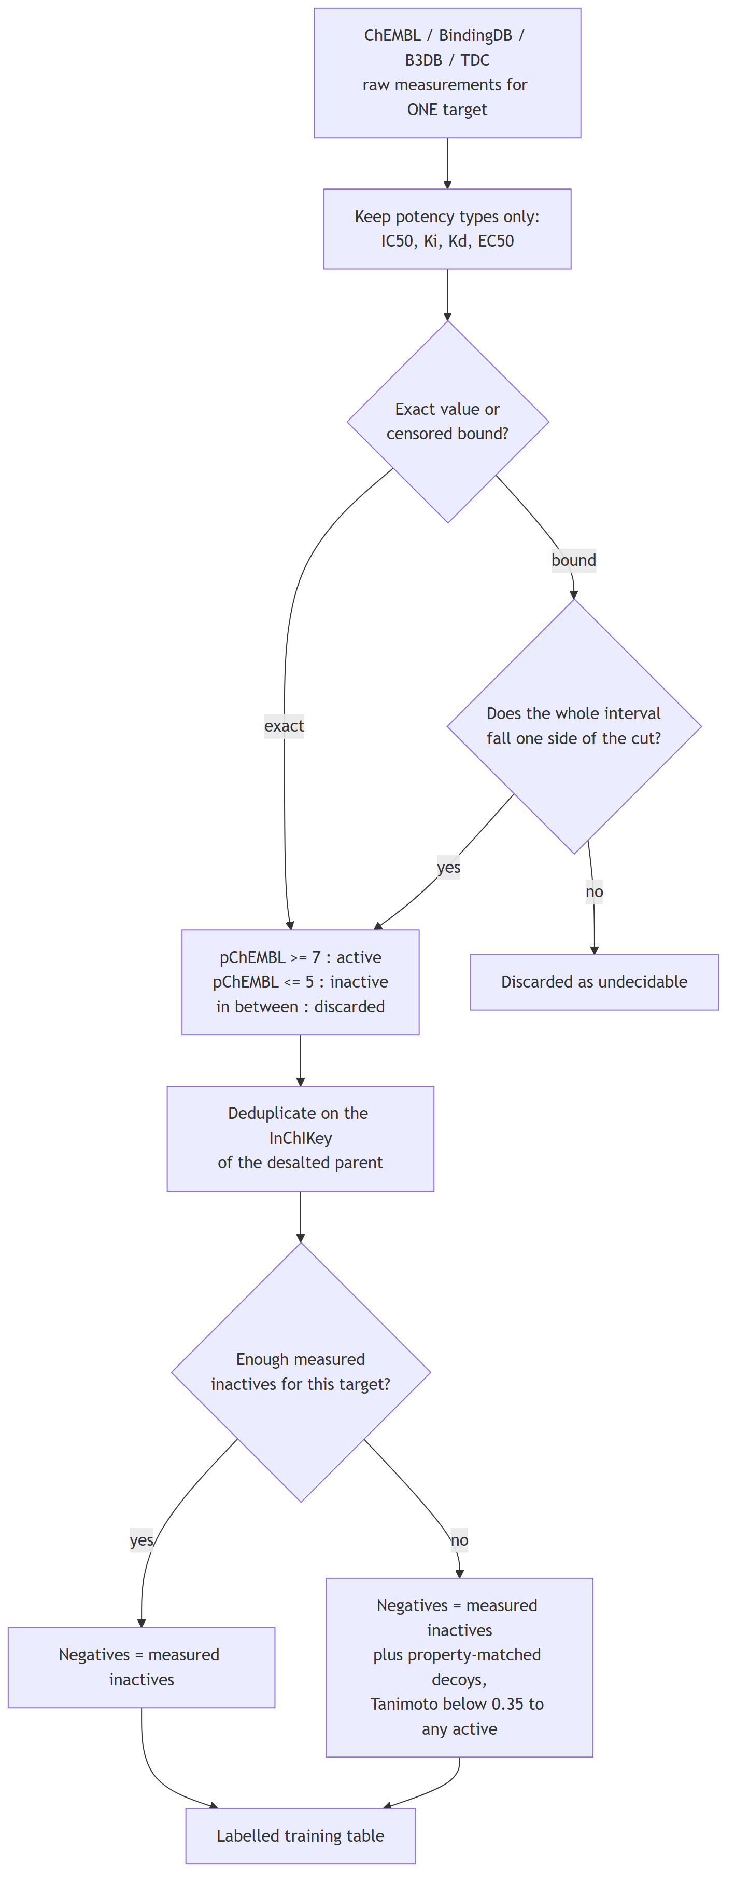
Flowchart 1
Stage 2: from the table to a deployed endpoint, or not.
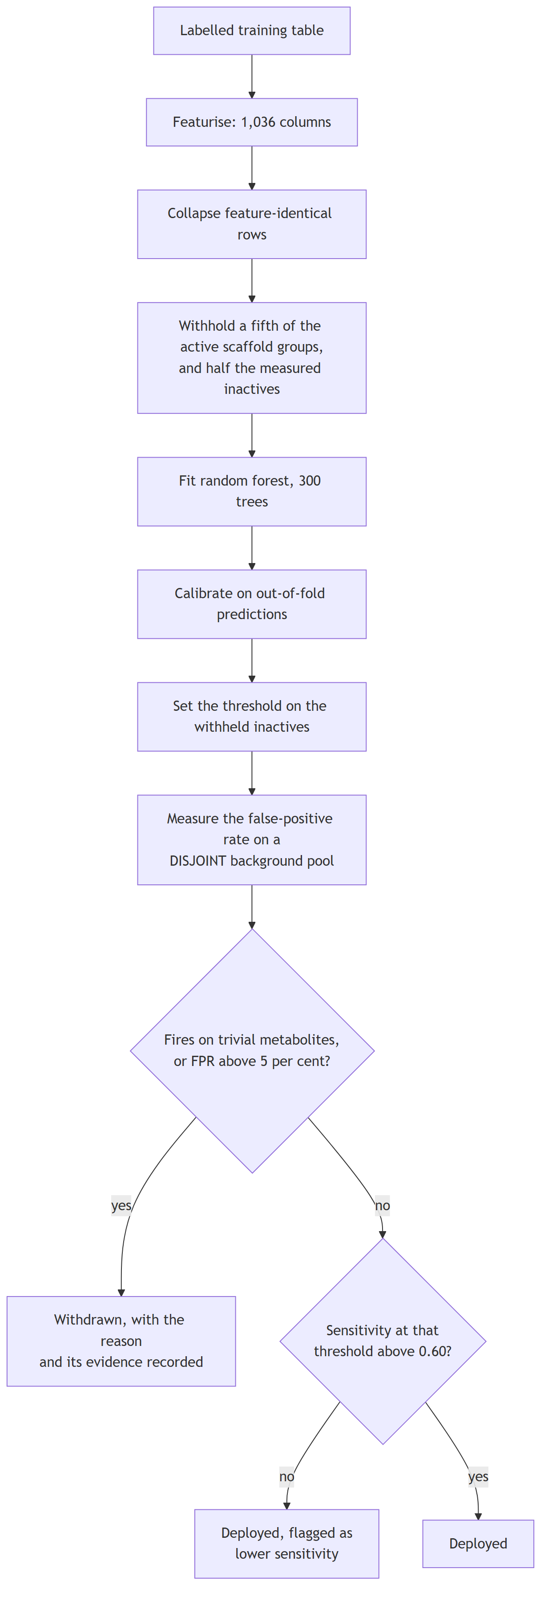
Flowchart 2
Every endpoint goes through this independently. Nothing crosses between them except the featurisation, which is identical by construction.

3.2 The estimator
A random forest of 300 trees per endpoint, min_samples_leaf 2 for the core classifiers and 4 for the binder panel, class_weight="balanced", random_state=42.
A random forest is an ensemble of decision trees, each grown on a bootstrap resample of the training rows and, at each split, choosing among a random subset of features. Averaging their votes reduces the variance a single deep tree would have. It suits this problem for three reasons: it handles a sparse binary fingerprint beside twelve continuous descriptors without scaling; it does not extrapolate, which is the correct behaviour when a query is unlike anything measured; and it is exactly explainable by TreeSHAP rather than approximately.

3.3 Calibration
A forest’s vote share is not a probability. Calibration maps it to one.
- Core classifiers use isotonic regression fitted on out-of-fold predictions, so no compound contributes to the calibrator that scores it. Isotonic fits a free monotonic step function.
- Binder models use Platt scaling (a logistic fit), because the withheld set for one target is often too small to fit a step function without overfitting it.
Measured over the 8 measured-label classifiers, mean expected calibration error falls from 0.0801 raw to 0.0147 after isotonic calibration.
endpoint | brier_raw | brier_calibrated | ece_raw | ece_calibrated
BBB | 0.1289 | 0.1358 | 0.0657 | 0.0412
AChE | 0.081 | 0.0702 | 0.0942 | 0.011
BChE | 0.0708 | 0.0647 | 0.0735 | 0.0127
BACE1 | 0.0397 | 0.0358 | 0.0497 | 0.0049
GSK3B | 0.0734 | 0.0669 | 0.0847 | 0.0175
MAO_A | 0.0709 | 0.0609 | 0.094 | 0.0089
MAO_B | 0.0848 | 0.077 | 0.0881 | 0.0148
hERG | 0.0717 | 0.0632 | 0.0911 | 0.0069

3.4 Conformal prediction
A calibrated probability still says nothing about how confident the model is for this compound. A Mondrian conformal predictor converts the applicability domain from a caveat into a coverage statement: at a 0.90 target, the prediction set contains the truth about 90 per cent of the time, and it is measured rather than assumed.
Empirical coverage runs 0.889 to 0.921 against the 0.90 target.
endpoint | n_test | target_coverage | empirical_coverage | avg_set_size
BBB | 1561 | 0.9 | 0.904 | 1.013
AChE | 1064 | 0.9 | 0.921 | 1.019
BChE | 678 | 0.9 | 0.917 | 1.009
BACE1 | 1793 | 0.9 | 0.906 | 1.007
GSK3B | 1128 | 0.9 | 0.908 | 1.03
MAO_A | 758 | 0.9 | 0.889 | 1.012
MAO_B | 962 | 0.9 | 0.899 | 1.025
hERG | 2056 | 0.9 | 0.904 | 1.079

3.5 Applicability domain
The maximum ECFP-4 Tanimoto similarity of the query to that endpoint’s own measured chemistry, reported with the nearest measured analogue and its structure.
- In domain, T ≥ 0.50: the query sits among measured chemistry.
- Near domain, 0.30 ≤ T < 0.50.
- Out of domain, T < 0.30: predictive power falls close to chance and the server says so.

3.6 Thresholds, and why they are measured on a different sample
A binder model returns a probability; a call requires a cut. Choosing that cut as a quantile of a sample and then measuring the false-positive rate on the same sample cannot fail: the rate restates the quantile.
The background library of 158,890 compounds is therefore partitioned into three disjoint pools by a stable hash of the canonical structure, so a compound’s pool is a property of the molecule and never depends on run order:
Pool | Compounds | Purpose
Decoy | 95,515 | supply property-matched negatives during training
Threshold | 31,694 | set the decision cut
Evaluation | 31,681 | measure the false-positive rate the cut actually achieves
That the measured rate can now disagree with its target is the evidence that it is a measurement.

4. Why 70 models and not one
This is the question most often asked of the design, and it has a specific answer.

4.1 The alternative, and why it fails
The obvious alternative is one multi-task model: a single network with one output per endpoint, trained on all the data at once. It is rejected here for reasons that are about the data, not about preference.
The label matrix is almost entirely missing. 228,200 measurements spread over 63 endpoints and roughly 169,000 unique compounds would fill under two per cent of a compound-by-endpoint matrix. A compound measured at AChE has almost never been measured at OX2. Multi-task learning shares strength across tasks; with a matrix this sparse it mostly shares absence, and a missing measurement is not a negative result.
The negative class means different things per endpoint. For a target with recovered censored bounds, a negative is a compound measured and found inactive. For a target without them, a negative is a property-matched decoy, which is an assumption. Pooling those into one loss silently averages a measurement with an assumption.
The endpoints have incompatible base rates. Some sets are 90 per cent active, an artefact of the deposition query rather than of the chemistry. A shared output layer propagates one endpoint’s class imbalance into another’s decision boundary.
A per-endpoint threshold is required and could not be honest otherwise. Each endpoint’s cut is set on held-out measured inactives for that endpoint and verified on a disjoint background pool. That is only definable per endpoint.
Failure stays local. Five endpoints were trained, tested and withdrawn. In an independent panel a withdrawal removes one output. In a shared-weight model the same data would have influenced every other endpoint’s representation, and withdrawing it cleanly would not be possible.

4.2 What independence costs
It is not free, and the honest statement of the cost is this: a multi-task model can borrow statistical strength for a small endpoint from a large related one. The smallest deployed set here has 387 compounds and would plausibly benefit. That benefit is forgone deliberately, because the price is a shared representation in which no endpoint’s threshold, negative class or withdrawal is independently defensible.

5. How 70 independent models answer one question
The estimators are independent in fitting. They are not independent in use: the output is assembled in a fixed order, and each stage constrains the next.
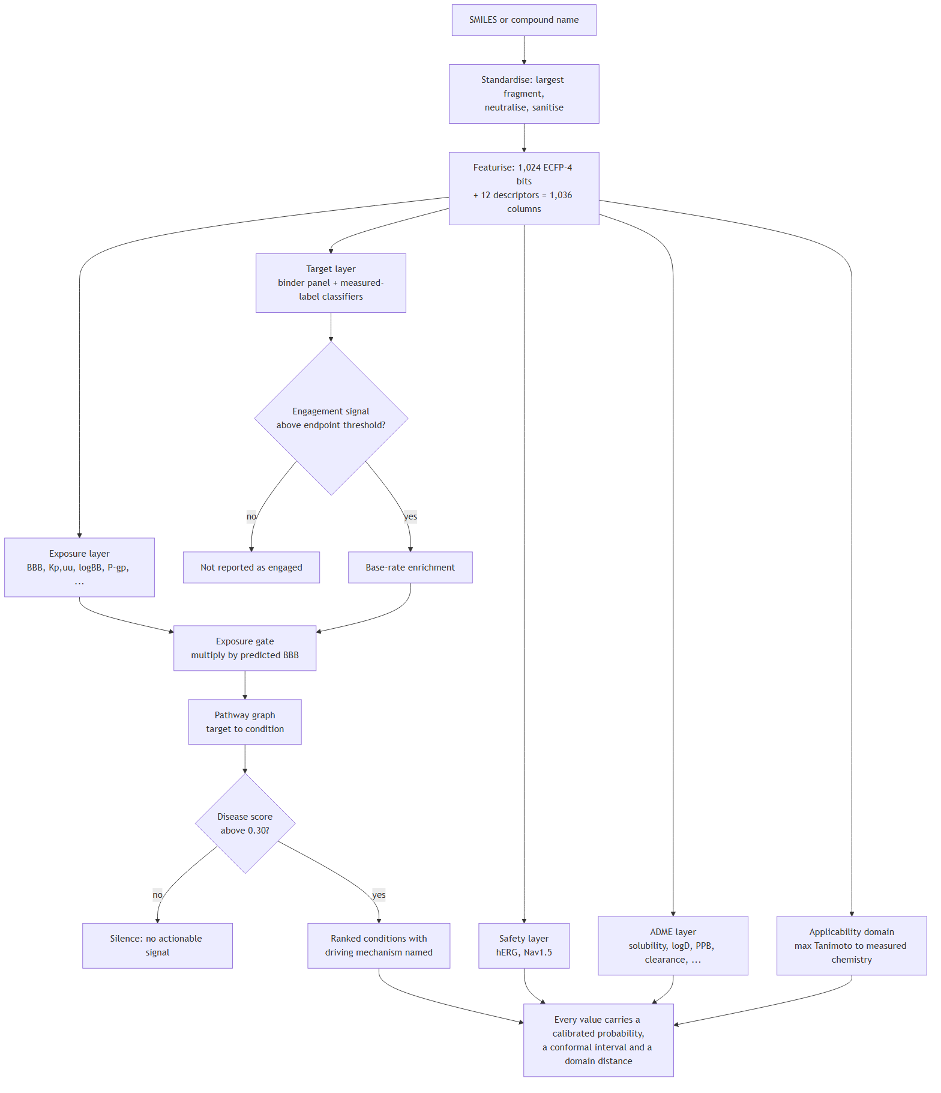
Flowchart 3
The logic, stated plainly.
- Each model answers only its own question. The AChE model knows nothing about hERG.
- Engagement is put on a common scale. A calibrated probability is not comparable between targets, because each has its own threshold and its own base rate. Each target’s probability is converted to an engagement signal: distance above that target’s own reporting threshold, rescaled to 0–1. That is the only quantity compared across targets.
- Base-rate enrichment, not raw probability. Several training sets are active-heavy, so a high probability may say more about the endpoint than about the compound. A target is scored by how far it sits above its own base rate.
- Exposure gates everything. Each target’s contribution is multiplied by predicted blood-brain-barrier penetration. A potent binder that does not reach the brain contributes nothing. This is the one place where the models are combined multiplicatively, and it encodes a pharmacological fact: potency at an unreachable target is not activity.
- The pathway graph maps mechanism to condition. A curated, versioned graph anchored to KEGG, Reactome and IUPHAR maps each target to the conditions it informs. A disease score is the strongest engaged mechanism for that condition scaled by exposure, not a sum, so one target explains the score and can be named.
- Silence is a result. Below a disease score of 0.30 nothing is reported. Silence means no modelled mechanism cleared its threshold; it is not a claim of inactivity.
The models are therefore combined by a stated rule, not by a learned one. Nothing is fitted on top of the panel. That is deliberate: a meta-model over seventy outputs would need its own training set of compounds labelled with ground-truth disease relevance, which does not exist.

6. Validation: everything that was done
Validation here is arranged so that each test answers a question the previous one cannot.
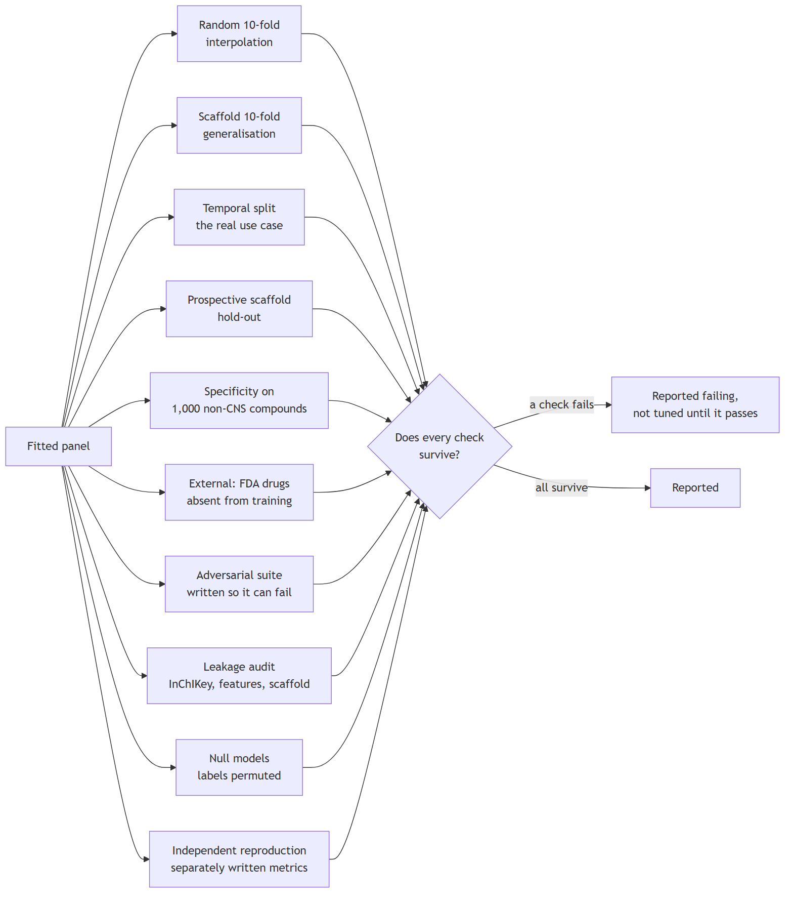
Flowchart 4

6.1 Cross-validation, two regimes
Every endpoint is cross-validated ten-fold in two regimes, and the distance between them is the honest statement of how far a model travels.
- Random 10-fold splits compounds at random. It measures interpolation within known chemistry.
- Scaffold-grouped 10-fold withholds entire Bemis-Murcko scaffold classes. A held-out compound is therefore structurally distinct from everything trained on, which is the situation a user is actually in.
Across the measured-label classifiers: mean AUROC 0.9575 random and 0.9252 scaffold.
endpoint | task | split | n | roc_auc_mean | roc_auc_sd | pr_auc_mean | pr_auc_sd | mcc_mean | mcc_sd | f1_mean | f1_sd | balanced_acc_mean | balanced_acc_sd | r2_mean | r2_sd | rmse_mean | rmse_sd | mae_mean | mae_sd | spearman_mean | spearman_sd
BBB | classification | random | 3901 | 0.899 | 0.0161 | 0.9389 | 0.0107 | 0.608 | 0.0504 | 0.8633 | 0.0168 | 0.7956 | 0.0266
BBB | classification | scaffold | 3901 | 0.8777 | 0.0336 | 0.9219 | 0.0281 | 0.5699 | 0.0786 | 0.8502 | 0.0369 | 0.7748 | 0.0426
AChE | classification | random | 5125 | 0.9659 | 0.0057 | 0.975 | 0.0045 | 0.8084 | 0.0262 | 0.9202 | 0.011 | 0.9051 | 0.0135
AChE | classification | scaffold | 5125 | 0.9212 | 0.0206 | 0.9463 | 0.0131 | 0.6631 | 0.0476 | 0.8567 | 0.0249 | 0.8332 | 0.0246
BChE | classification | random | 3278 | 0.9724 | 0.008 | 0.9776 | 0.0075 | 0.8228 | 0.0313 | 0.9154 | 0.015 | 0.9119 | 0.0159
BChE | classification | scaffold | 3278 | 0.9451 | 0.0155 | 0.9578 | 0.0167 | 0.7454 | 0.0655 | 0.875 | 0.0386 | 0.8752 | 0.0328
BACE1 | classification | random | 8207 | 0.9764 | 0.0104 | 0.9959 | 0.0021 | 0.7923 | 0.0445 | 0.972 | 0.0058 | 0.8953 | 0.0258
BACE1 | classification | scaffold | 8207 | 0.9648 | 0.0093 | 0.9941 | 0.0015 | 0.736 | 0.0675 | 0.965 | 0.0094 | 0.8688 | 0.0375
GSK3B | classification | random | 5439 | 0.9649 | 0.0065 | 0.9878 | 0.0027 | 0.7618 | 0.0185 | 0.9405 | 0.0047 | 0.8755 | 0.0118
GSK3B | classification | scaffold | 5439 | 0.9425 | 0.0236 | 0.9784 | 0.0116 | 0.6993 | 0.0561 | 0.925 | 0.0193 | 0.8428 | 0.0269
MAO_A | classification | random | 3585 | 0.9619 | 0.0124 | 0.9096 | 0.0214 | 0.7826 | 0.0547 | 0.8296 | 0.0442 | 0.877 | 0.0328
MAO_A | classification | scaffold | 3585 | 0.9059 | 0.0303 | 0.7908 | 0.0737 | 0.6268 | 0.0867 | 0.685 | 0.0888 | 0.7767 | 0.0541
MAO_B | classification | random | 4534 | 0.963 | 0.0075 | 0.9634 | 0.008 | 0.7923 | 0.0284 | 0.899 | 0.014 | 0.8957 | 0.0142
MAO_B | classification | scaffold | 4534 | 0.917 | 0.0294 | 0.9068 | 0.05 | 0.6728 | 0.0668 | 0.8357 | 0.0523 | 0.8346 | 0.0345
hERG | classification | random | 9933 | 0.9565 | 0.0077 | 0.9037 | 0.0155 | 0.7702 | 0.0169 | 0.8151 | 0.0138 | 0.8593 | 0.0107
hERG | classification | scaffold | 9933 | 0.927 | 0.0271 | 0.8453 | 0.0393 | 0.6805 | 0.0518 | 0.7321 | 0.0502 | 0.8019 | 0.0337
D2 | regression | random | 7905 |  |  |  |  |  |  |  |  |  |  | 0.6403 | 0.0243 | 0.6796 | 0.0257 | 0.4837 | 0.0145 | 0.7979 | 0.0128
D2 | regression | scaffold | 7905 |  |  |  |  |  |  |  |  |  |  | 0.5311 | 0.0287 | 0.773 | 0.0481 | 0.5631 | 0.0433 | 0.7237 | 0.0365
A2A | regression | random | 6743 |  |  |  |  |  |  |  |  |  |  | 0.7231 | 0.0255 | 0.6882 | 0.0262 | 0.4956 | 0.0164 | 0.8421 | 0.017
A2A | regression | scaffold | 6743 |  |  |  |  |  |  |  |  |  |  | 0.6205 | 0.0485 | 0.7995 | 0.0341 | 0.5929 | 0.0233 | 0.7827 | 0.0376
HT2A | regression | random | 6075 |  |  |  |  |  |  |  |  |  |  | 0.6996 | 0.0166 | 0.6727 | 0.0209 | 0.4859 | 0.0167 | 0.8401 | 0.0104
HT2A | regression | scaffold | 6075 |  |  |  |  |  |  |  |  |  |  | 0.556 | 0.0656 | 0.8091 | 0.0685 | 0.5997 | 0.0533 | 0.7465 | 0.0546
SERT | regression | random | 4479 |  |  |  |  |  |  |  |  |  |  | 0.6897 | 0.0273 | 0.7064 | 0.0294 | 0.5139 | 0.0181 | 0.8179 | 0.0159
SERT | regression | scaffold | 4479 |  |  |  |  |  |  |  |  |  |  | 0.4612 | 0.0987 | 0.9143 | 0.102 | 0.6733 | 0.0591 | 0.6969 | 0.0763
antioxidant_DPPH | regression | random | 2782 |  |  |  |  |  |  |  |  |  |  | 0.6589 | 0.0508 | 0.4608 | 0.0184 | 0.309 | 0.0132 | 0.8064 | 0.0286
antioxidant_DPPH | regression | scaffold | 2782 |  |  |  |  |  |  |  |  |  |  | 0.4153 | 0.1491 | 0.5865 | 0.0789 | 0.4188 | 0.0519 | 0.64 | 0.1059

6.2 Temporal validation
The hardest realistic test: train on compounds published before a cut-off year, test on those published after it. This reproduces the actual use case, predicting chemistry that did not exist when the model was fitted.
AUROC 0.720 to 0.910 across 7 endpoints.
endpoint | task | cutoff_year | n_train | n_test | metric | score
AChE | classification | 2020 | 4141 | 1028 | auroc | 0.761
BChE | classification | 2021 | 2696 | 617 | auroc | 0.801
BACE1 | classification | 2017 | 6901 | 1673 | auroc | 0.91
GSK3B | classification | 2021 | 4205 | 546 | auroc | 0.764
MAO_A | classification | 2020 | 2859 | 819 | auroc | 0.727
MAO_B | classification | 2020 | 3719 | 923 | auroc | 0.843
hERG | classification | 2020 | 8158 | 2059 | auroc | 0.72

6.3 Prospective scaffold hold-out
Whole scaffold classes withheld before training, then recall measured on them at the deployed threshold. Median per-target recall 0.815 across 39 targets whose decision threshold did not collapse. Targets are excluded only for a degenerate threshold, never for poor recall.

6.4 Specificity: does it stay quiet when it should?
1,000 compounds with no recorded activity at any modelled target were scored through the deployed pipeline. 949 returned no actionable disease signal: specificity 0.949 (95% CI 0.934 to 0.961).
These compounds are presumed inactive because nothing is recorded about them, not proven inactive, so this is a lower bound.

6.5 External validation
The barrier model tested on FDA-curated approved drugs absent from the training source by InChIKey.
set | n | n_permeable | auroc | accuracy | balanced_accuracy | sensitivity | specificity
FDA-curated, not in B3DB by InChIKey | 306 | 203 | 0.7645 | 0.732 | 0.7119 | 0.7734 | 0.6505
FDA-curated, also distinguishable from training in feature space | 241 | 171 | 0.7934 | 0.7344 | 0.7116 | 0.7661 | 0.6571
of which: feature-identical to a training compound | 65 | 32 | 0.7102 | 0.7231 | 0.7244 | 0.8125 | 0.6364
The row that supports an external claim is the second: compounds absent by InChIKey and distinguishable from training in feature space. The third row is the memorisation the first contains.

6.6 Adversarial checks
Each written so that it could fail. 5 of 6 pass.
check | result | detail
No test compound is feature-identical to a training compound (MAO_A, BBB) | PASS | worst fold shares 0 compound(s) with its training set (want 0); before deduplication the same folds would share 4, which is the leak deduplication exists to remove
No duplicate compound survives into training | PASS | 0 duplicate rows reach a model; 15,104 exist in the tables before deduplication (worst BBB at 3,773), which is correct chemistry, since stereoisomers are distinct compounds the stereo-blind featuriser cannot separate
Reproducible retrain (MAO_A scaffold AUROC) | PASS | retrained 0.906 vs reported 0.906
Predictions are not constant (BBB over 200 drugs) | PASS | probability std 0.293, range 0.01-0.99
BBB ranks permeable drugs above non-permeable ones (external, unseen) | PASS | n=241 (171 permeable), AUROC 0.793, Mann-Whitney p=4.43e-13
The domain flag separates non-drug-like chemistry from unseen drugs | FAIL | median max-similarity: unseen drugs 0.44 vs non-drug-like 0.48 (n=32), Mann-Whitney p=8.75e-01; only 22% of non-drug-like structures fall below the AD_THRESHOLD of 0.3
The failing check is reported at the same size as the others and is not tuned until it passes. It is a finding about the applicability-domain flag: the conformal interval and the nearest-analogue distance, rather than the flag, should be read as the statement of confidence.

6.7 Leakage and null models
Leakage. Folds were rebuilt and the index sets interrogated directly. On the deduplicated matrix the pipeline fits, no InChIKey, no feature vector and no scaffold appears on both sides of any fold. On the raw table the feature-vector overlap reaches 544, which is precisely what deduplication removes.
Null models. With labels permuted, the same pipeline on the same folds returns mean AUROC 0.4938 random and 0.4921 scaffold, worst single endpoint 0.5174. Whole scaffold classes do not carry enough class-frequency information for a label-free model to beat chance, so the scaffold figures are not inflated by that route.
Independent reproduction. The entire cross-validation was re-run from the endpoint tables and scored with separately written metric code. All 26 core values reproduced, maximum deviation 4.7 × 10⁻⁵.

7. What if we had done it differently
Honest comparison requires measuring the alternatives rather than asserting that the choice was right.

7.1 Other model families
Five families were compared under identical cross-validation on both split regimes. Two are baselines a reader is entitled to demand.
endpoint | HistGradientBoosting | LogisticRegression | RandomForest | XGBoost | kNN read-across
AChE | 0.9241 | 0.8397 | 0.9148 | 0.9129 | 0.8804
BACE1 | 0.9609 | 0.9123 | 0.9635 | 0.9597 | 0.9194
BBB | 0.8564 | 0.7435 | 0.8756 | 0.8683 | 0.8264
BChE | 0.9319 | 0.8694 | 0.9426 | 0.9317 | 0.9047
GSK3B | 0.931 | 0.8387 | 0.9368 | 0.931 | 0.8986
MAO_A | 0.8791 | 0.8058 | 0.8943 | 0.8857 | 0.8752
MAO_B | 0.9092 | 0.8094 | 0.9124 | 0.9088 | 0.866
hERG | 0.9268 | 0.863 | 0.9299 | 0.9266 | 0.8922
Random forest was selected, and the margin over the read-across baseline is +0.0384 mean AUROC on the scaffold split across 8 classification endpoints.
What each alternative would have cost:
- k-nearest-neighbour read-across is what a medicinal chemist does by eye: find the most similar measured compounds and assume the query behaves like them. It is the most important baseline, because if the model cannot beat it the model is an expensive lookup table. It loses on every endpoint, but not by a large margin, which is itself informative: much of the signal is similarity.
- L2 logistic regression is linear in the fingerprint. It loses most where activity depends on combinations of substructures rather than their presence, which is most targets.
- XGBoost and histogram gradient boosting are genuinely close, and the honest statement is that the forest does not sweep them. Histogram gradient boosting is ahead of the forest on 3 of 8 endpoints on the random split and on 1 of 8 on the scaffold split; the forest’s mean margin over it is +0.0023 random and +0.0063 scaffold, which is inside the fold-to-fold spread. XGBoost is behind on every endpoint but only by +0.0046 and +0.0056 on average. The forest was selected on three grounds that are not about the mean: it is the most stable of the three under hyperparameters, it does not extrapolate, which is the behaviour wanted at the edge of the applicability domain, and TreeSHAP is exact for it rather than approximate. On this evidence a reader is entitled to say that boosting would have served about as well.
- A graph neural network was benchmarked separately and did not outperform the random forest on any tested endpoint, which is consistent with the fingerprint-plus-descriptor representation being sufficient at this data scale. Deep models need far more data per task than these endpoints have.

7.2 Would a simpler representation have done?
Note. This table was computed on 2026-07-21, before the current panel was refitted, so its absolute values describe the previous estimators. It is retained because the comparison it makes is between methods on identical data, which the refit does not change, and it is marked rather than silently reprinted.
The 1,036-column vector is two blocks. Each was tested alone.
endpoint | task | block | metric | mean | sd
BBB | classification | fingerprint_only | roc_auc | 0.9556 | 0.0057
BBB | classification | descriptors_only | roc_auc | 0.9498 | 0.0092
BBB | classification | combined | roc_auc | 0.9586 | 0.0068
AChE | classification | fingerprint_only | roc_auc | 0.9568 | 0.0106
AChE | classification | descriptors_only | roc_auc | 0.8987 | 0.0089
AChE | classification | combined | roc_auc | 0.9599 | 0.0084
BChE | classification | fingerprint_only | roc_auc | 0.9579 | 0.0091
BChE | classification | descriptors_only | roc_auc | 0.9173 | 0.0193
BChE | classification | combined | roc_auc | 0.9632 | 0.0089
BACE1 | classification | fingerprint_only | roc_auc | 0.9637 | 0.0068
BACE1 | classification | descriptors_only | roc_auc | 0.9149 | 0.0168
BACE1 | classification | combined | roc_auc | 0.9653 | 0.0067
GSK3B | classification | fingerprint_only | roc_auc | 0.9656 | 0.0065
GSK3B | classification | descriptors_only | roc_auc | 0.9089 | 0.0197
GSK3B | classification | combined | roc_auc | 0.9676 | 0.0069
MAO_A | classification | fingerprint_only | roc_auc | 0.9417 | 0.0106
MAO_A | classification | descriptors_only | roc_auc | 0.8747 | 0.0208
MAO_A | classification | combined | roc_auc | 0.9457 | 0.0128
MAO_B | classification | fingerprint_only | roc_auc | 0.9466 | 0.0039
MAO_B | classification | descriptors_only | roc_auc | 0.9007 | 0.0109
MAO_B | classification | combined | roc_auc | 0.9507 | 0.0036
hERG | classification | fingerprint_only | roc_auc | 0.9455 | 0.0032
hERG | classification | descriptors_only | roc_auc | 0.8923 | 0.0096
hERG | classification | combined | roc_auc | 0.9523 | 0.0035
D2 | regression | fingerprint_only | r2 | 0.5838 | 0.0227
D2 | regression | descriptors_only | r2 | 0.356 | 0.0211
D2 | regression | combined | r2 | 0.5856 | 0.0172
A2A | regression | fingerprint_only | r2 | 0.6728 | 0.0173
A2A | regression | descriptors_only | r2 | 0.4797 | 0.0052
A2A | regression | combined | r2 | 0.6742 | 0.0173
HT2A | regression | fingerprint_only | r2 | 0.615 | 0.0221
HT2A | regression | descriptors_only | r2 | 0.448 | 0.0163
HT2A | regression | combined | r2 | 0.6241 | 0.0197
SERT | regression | fingerprint_only | r2 | 0.5843 | 0.0252
SERT | regression | descriptors_only | r2 | 0.4293 | 0.0421
SERT | regression | combined | r2 | 0.595 | 0.0229
antioxidant_DPPH | regression | fingerprint_only | r2 | 0.6563 | 0.0544
antioxidant_DPPH | regression | descriptors_only | r2 | 0.4152 | 0.0411
antioxidant_DPPH | regression | combined | r2 | 0.6544 | 0.0526
The combination beats either block alone on most endpoints, but the margin over the fingerprint alone is small. The twelve descriptors earn their place mainly on the exposure endpoints, where physicochemistry is the mechanism, and contribute least where binding is substructure-driven.

7.3 Would more data have helped?
Note. This table was computed on 2026-07-21, before the current panel was refitted, so its absolute values describe the previous estimators. It is retained because the comparison it makes is between methods on identical data, which the refit does not change, and it is marked rather than silently reprinted.
Performance against training-set fraction.
endpoint | task | train_fraction | n_train | n_test | metric | score
BBB | classification | 0.1 | 955 | 1269 | roc_auc | 0.8473
BBB | classification | 0.25 | 1877 | 1269 | roc_auc | 0.9023
BBB | classification | 0.5 | 3205 | 1269 | roc_auc | 0.9166
BBB | classification | 0.75 | 4776 | 1269 | roc_auc | 0.922
BBB | classification | 1.0 | 6536 | 1269 | roc_auc | 0.9213
MAO_A | classification | 0.1 | 187 | 541 | roc_auc | 0.5063
MAO_A | classification | 0.25 | 505 | 541 | roc_auc | 0.5918
MAO_A | classification | 0.5 | 940 | 541 | roc_auc | 0.7846
MAO_A | classification | 0.75 | 1310 | 541 | roc_auc | 0.7792
MAO_A | classification | 1.0 | 1687 | 541 | roc_auc | 0.8005
BACE1 | classification | 0.1 | 788 | 1604 | roc_auc | 0.8845
BACE1 | classification | 0.25 | 1880 | 1604 | roc_auc | 0.9072
BACE1 | classification | 0.5 | 3466 | 1604 | roc_auc | 0.9248
BACE1 | classification | 0.75 | 5213 | 1604 | roc_auc | 0.934
BACE1 | classification | 1.0 | 6897 | 1604 | roc_auc | 0.9417
A2A | regression | 0.1 | 481 | 1207 | r2 | 0.3449
A2A | regression | 0.25 | 1292 | 1207 | r2 | 0.3921
A2A | regression | 0.5 | 3013 | 1207 | r2 | 0.4523
A2A | regression | 0.75 | 4367 | 1207 | r2 | 0.4853
A2A | regression | 1.0 | 5578 | 1207 | r2 | 0.4895
The curves flatten well before the full training set, which is the argument against expecting a larger pull to change the result, and the argument for the effort having gone into the negative class instead.

7.4 Approaches deliberately not taken
- Docking or physics-based scoring. Requires a structure per target, is orders of magnitude slower, and does not produce a calibrated probability. It answers a different question.
- Training on qualitative annotation. ChEMBL carries curator-assigned activity comments. Using them would multiply the training data, and would make the model a restatement of a curator’s opinion rather than of a measurement.
- A learned meta-model over the panel. Would need compounds labelled with ground-truth disease relevance. That set does not exist, so the combination rule is stated rather than fitted.
- Fine-tuning a pretrained chemical language model. Plausible, and untested here. It is the most defensible thing an unconvinced reader could ask for next.

8. Known limitations
Stated because a tool that reports only what works cannot be checked.
- The applicability-domain flag fails its own adversarial test. It does not separate non-drug-like chemistry from unseen drugs. Read the conformal interval and the nearest-analogue distance instead.
- Specificity is a lower bound. It rests on compounds presumed inactive because nothing is recorded about them, drawn from within the reference library, so it does not bound behaviour on genuinely distant chemistry.
- Natural-product chemistry is largely outside the training library, whose median fraction-sp3 is 0.36. Extending the panel to targets natural products are actually assayed against was attempted, and the three endpoints added all failed and were withdrawn.
- The disease layer does not predict indication. 27 of the 52 targets in the pathway graph drive more than one condition. It does not beat a frequency baseline at any reporting depth, and reporting more conditions widens the gap rather than closing it. It is a route from a mechanism to the conditions that mechanism touches.
- Chirality is not represented. Two enantiomers give identical predictions.
- Agonism and antagonism are not distinguished. Both bind, and the models are trained on binding.

8.1 Endpoints trained and withdrawn
endpoint | AUROC vs measured inactives | sensitivity | why withdrawn
GluA2 | 0.696 | 0.103 | fires on glucose and atenolol at its calibrated threshold of 0.629, reaching 0.719 on a trivial molecule, with a random-chemistry false-positive rate of 0.072 and a sensitivity of
Nav1_1 | 0.952 | 0.12 | fires on glucose, urea, glycine, lactate and atenolol at its calibrated threshold of 0.571, with a random-chemistry false-positive rate of 0.080. Holding 5 per cent on random chemi
NRF2 | 0.789 | 0.545 | added to test natural-product coverage. Its random-chemistry false-positive rate is 0.057, above the 5 per cent the panel holds to, and reaching that rate would need a threshold of
NFKB1 | 0.459 | 0.0 | added to test natural-product coverage. Fires on glucose, urea, acetate, glycine and lactate at its calibrated threshold of 0.416, and scores AUROC 0.459 against its own held-out m
NR3C1 | 0.41 | 0.167 | added to test natural-product coverage. It passes the specificity audit, firing on no trivial molecule, and fails on discrimination instead: AUROC 0.410 against its own held-out me
Withdrawal is re-derived whenever the panel is refitted rather than carried forward, because it is a claim about a particular fit. When the panel was last retrained, Cav3.2 stopped failing and was reinstated while GluA2 began failing and was withdrawn.

9. Glossary

9.1 Quantities the server reports
Term | Definition
BBB penetration | Calibrated probability that the compound crosses the blood-brain barrier, from measured brain-to-blood partition data
Kp,uu | Ratio of unbound drug in brain to unbound drug in plasma. Above ~0.3 a meaningful free concentration reaches the target; below 0.1 it does not, whatever the total brain level
logBB | Total brain-to-plasma ratio. Less informative than Kp,uu because it counts drug bound to tissue, which cannot engage a target
Binder probability | Calibrated probability that the compound binds the named target at pChEMBL ≥ 7 (~100 nM). Not comparable between targets: each has its own threshold
Engagement signal | Distance above a target’s own reporting threshold, rescaled to 0–1. The only engagement quantity comparable across targets, and what the disease layer consumes
Base-rate enrichment | How far a prediction sits above what the training set would give by chance. Zero means the prediction is no better than the base rate
Disease relevance score | Strongest engaged mechanism for that condition, multiplied by predicted barrier penetration. Ranks conditions by mechanism; not a probability of clinical efficacy
Applicability domain | Maximum Tanimoto similarity to the nearest measured training compound
CNS MPO | A desirability score over six physicochemical properties associated with central exposure. A drug-likeness heuristic, not a model of activity

9.2 Statistics and methods
Term | Definition and how it is calculated
AUROC | Area under the receiver-operating characteristic curve. The probability that a randomly chosen active is ranked above a randomly chosen inactive. 0.5 is chance, 1.0 is perfect. Threshold-free
R² | Coefficient of determination: the fraction of variance in the measured value explained by the prediction. 0 means no better than predicting the mean; can be negative
Sensitivity (recall) | TP / (TP + FN). Of the compounds that truly bind, the fraction the model calls
Specificity | TN / (TN + FP). Of the compounds that truly do not bind, the fraction the model correctly stays quiet about
PPV (precision) | TP / (TP + FP). Of the compounds the model calls, the fraction that truly bind. Depends on prevalence, which is why it is quoted at stated prevalences
MCC | Matthews correlation coefficient. A balanced single number for a confusion matrix that stays honest under class imbalance, unlike accuracy
ECE | Expected calibration error. Predictions are binned by confidence; ECE is the average absolute gap between confidence and observed accuracy in each bin, weighted by bin size. 0 means a stated 80 per cent is right 80 per cent of the time
Brier score | Mean squared difference between predicted probability and outcome. Lower is better; combines calibration and discrimination
Conformal coverage | The fraction of held-out compounds whose true label falls in the prediction set. At a 0.90 target, coverage near 0.90 means the uncertainty statement is honest
Tanimoto similarity | Intersection over union of two fingerprints’ set bits. 1.0 is identical bit patterns; ~0.3 is the point where predictive power approaches chance here
pChEMBL | −log₁₀ of a molar potency (IC50, Ki, Kd, EC50). pChEMBL 7 = 100 nM; 6 = 1 µM; 5 = 10 µM. Higher is more potent
Bemis-Murcko scaffold | A molecule reduced to its ring systems and the linkers between them, with side chains stripped. Grouping by this is what makes a scaffold split withhold a structural class
ECFP-4 | Extended-connectivity fingerprint, diameter 4 (Morgan radius 2). Each atom’s circular environment is hashed to a bit
Folding | Hashing a large bit space into a fixed 1,024. Two different environments can collide on one bit, so a set bit means “some environment hashing here is present”
Out-of-fold prediction | A prediction for a compound made by a model that did not see it during fitting. Calibrating on these is what stops a compound contributing to the calibrator that scores it
Censored bound | A measurement recorded as an inequality (> 10 µM) rather than a value. It settles a label only when the whole interval it defines falls on one side of the activity cut
Decoy | A compound property-matched to the actives but assumed inactive. An assumption, not a measurement, which is why measured inactives are preferred wherever they exist
Class weight balanced | Each class is weighted inversely to its frequency, so a 90-per-cent-active endpoint does not train a model that simply says “active”

10. Reproducing this
What | Command
Everything downstream of the models | python tools/reproduce.py
Refit the whole panel (hours) | make train
Check every artefact is newer than its inputs | python tools/check_freshness.py
Check the panel is self-consistent | python src/brainsafe/panel.py
Regenerate this document | python src/brainsafe/analysis/build_technical_report.py
Random seed is 42 throughout. The panel registry at models_rf/binder_modes.json is the single definition of what the system consists of; every script reads it rather than carrying its own list.

Annex: figures
Figure A1. Endpoint selection. (A) Data volume against cross-validated discrimination across the panel. (B) The condition that actually decides deployment: whether a threshold exists that recovers actives without firing on unrelated chemistry. Endpoints that rank well can still be withheld. (C) The same data bar applied to every candidate target surveyed.
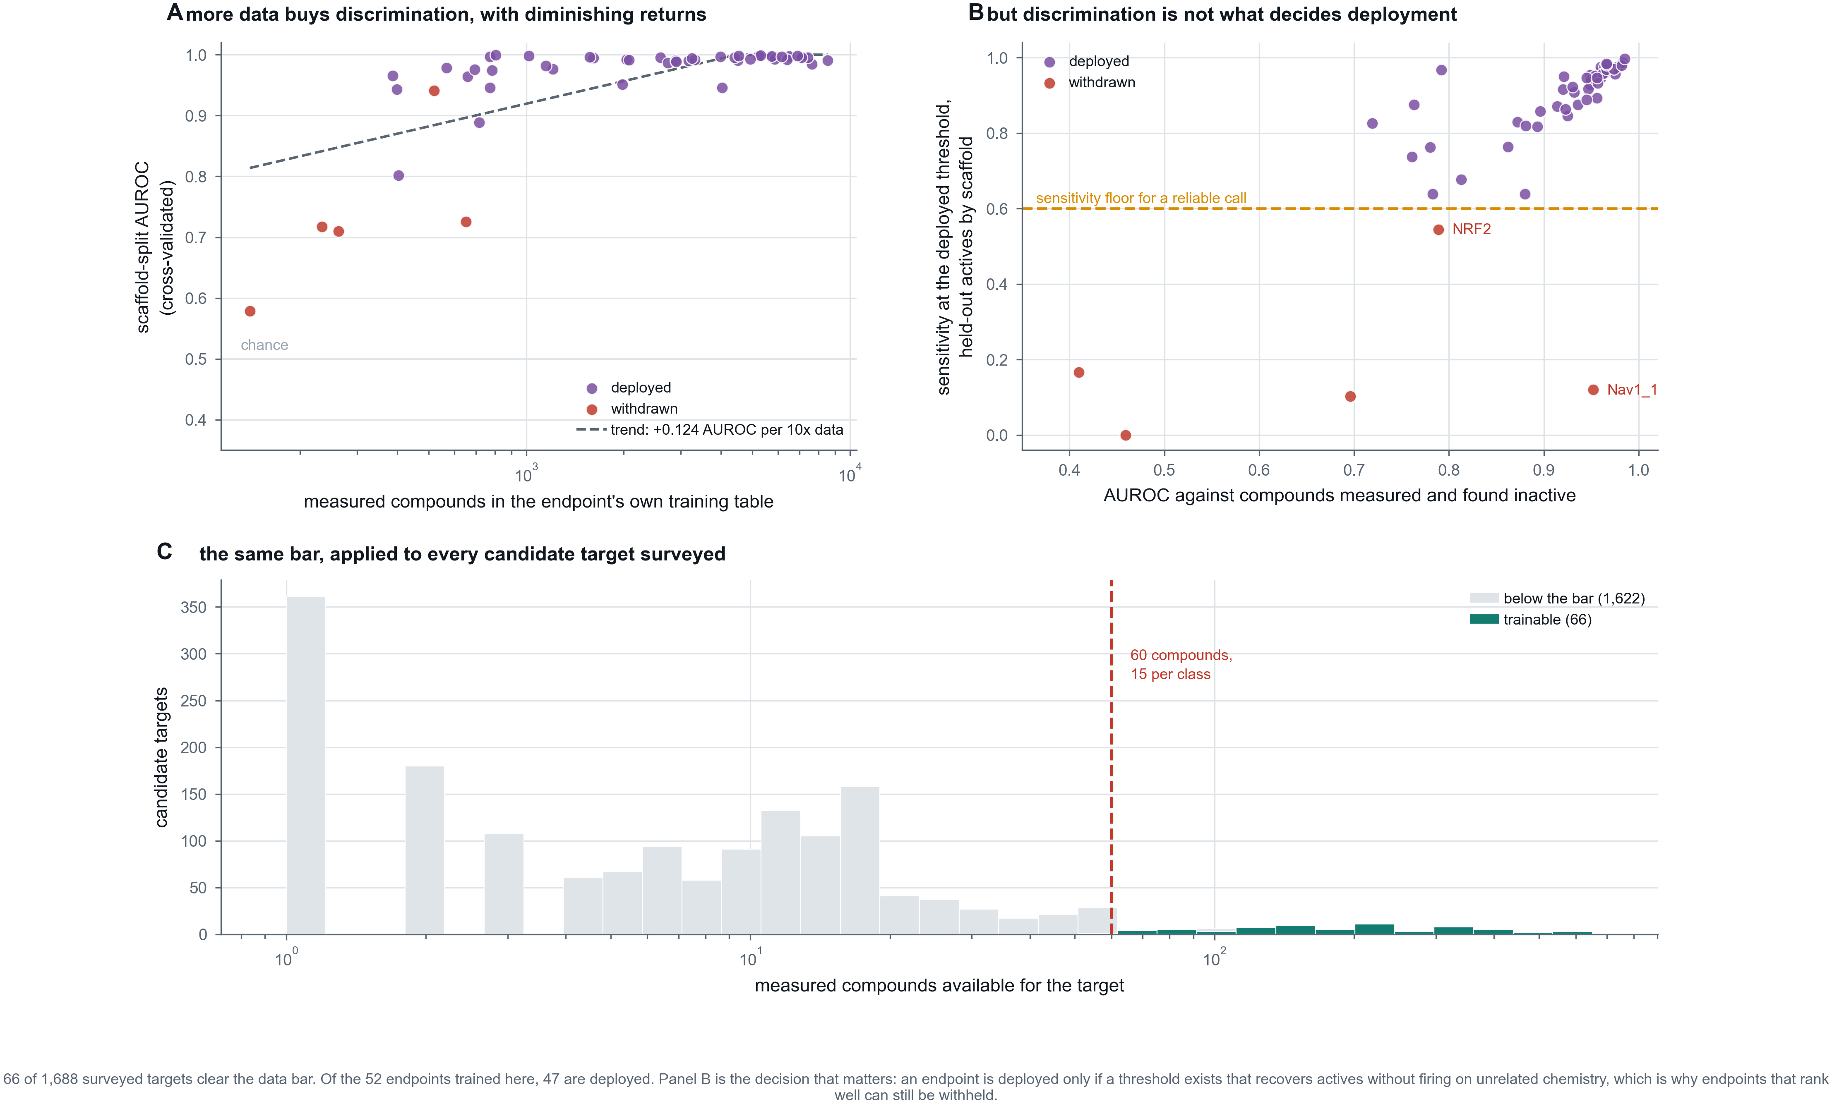
Figure A1
Figure A2. How a query is answered. Every target score is admitted only in proportion to the predicted probability that the compound reaches the brain, and surviving scores are ranked by enrichment over each endpoint’s base rate rather than by raw probability.
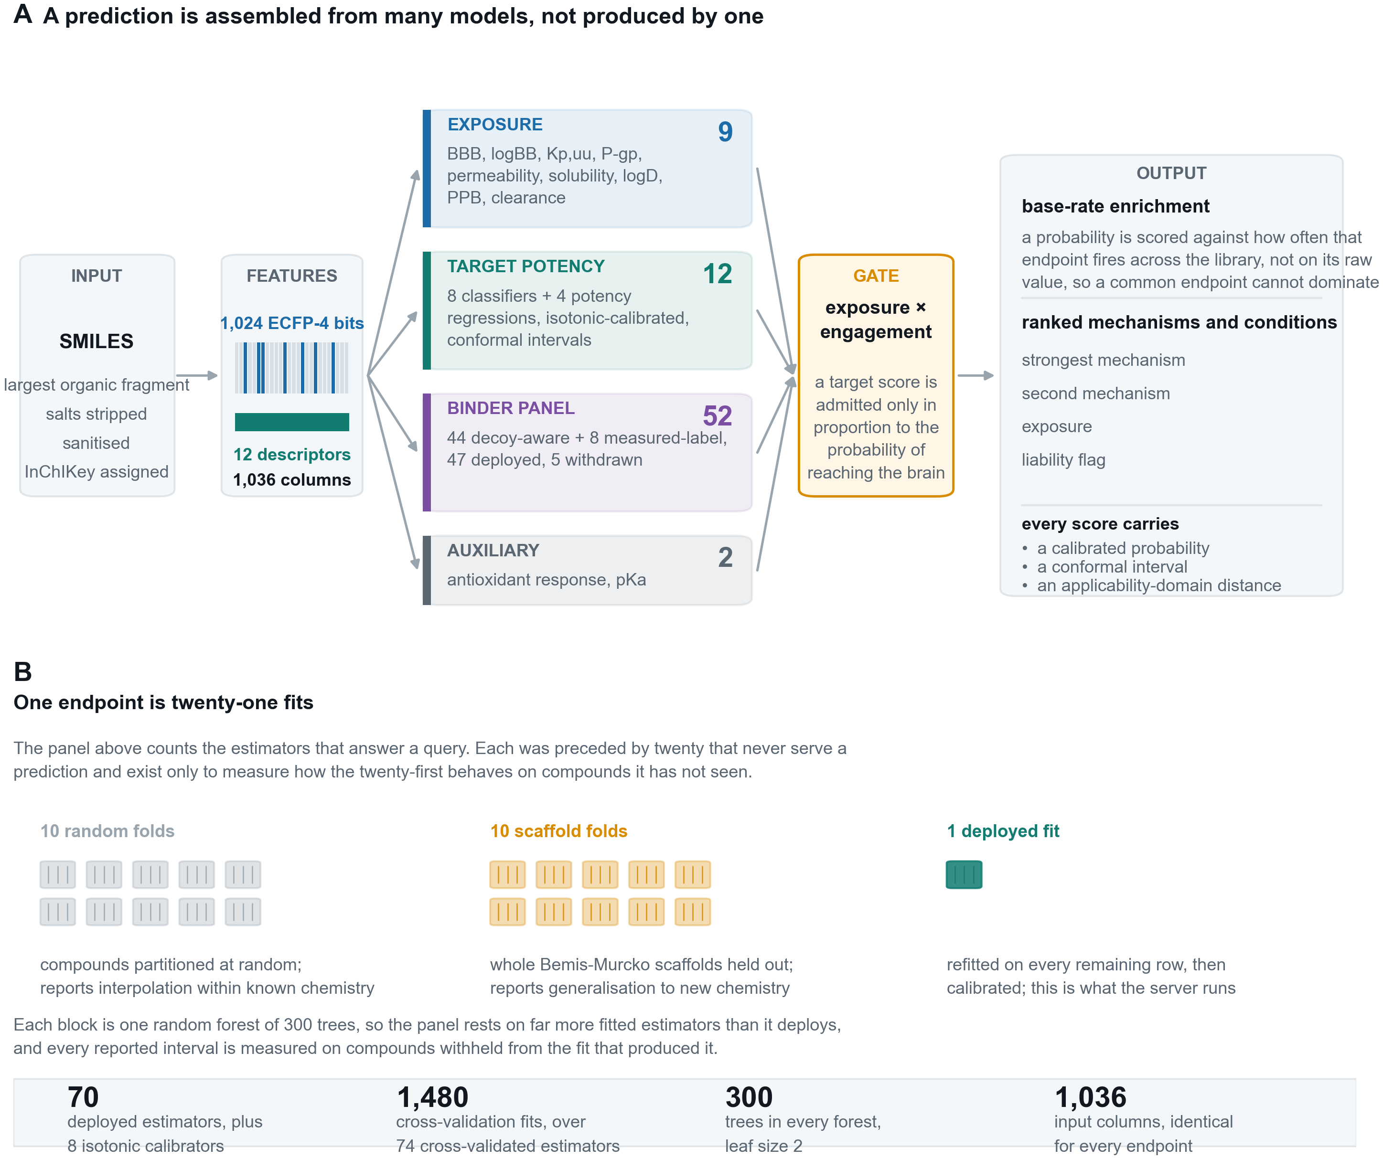
Figure A2
Figure A3. The panel, one mark per estimator, so that no claim rests on a mean a reader cannot check. Marker shape carries the metric: AUROC and R-squared both run to 1.0 and are not the same quantity.
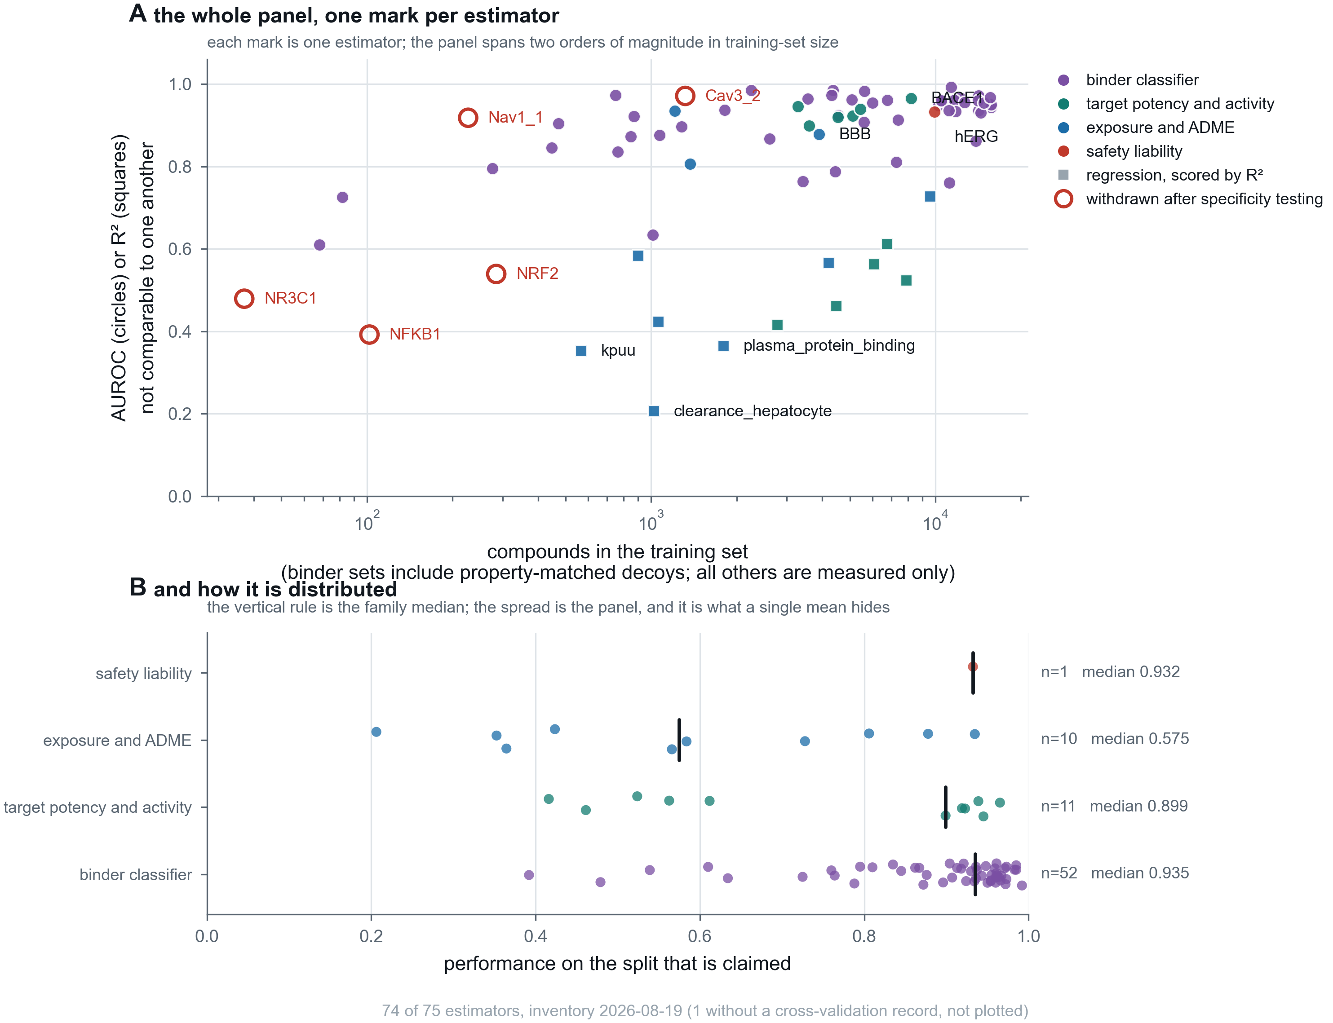
Figure A3
Figure A4. Four validations that a cross-validated score cannot replace: calibration, recall on withheld scaffold classes, specificity on chemistry the server should stay quiet about, and the adversarial suite including the check that fails.
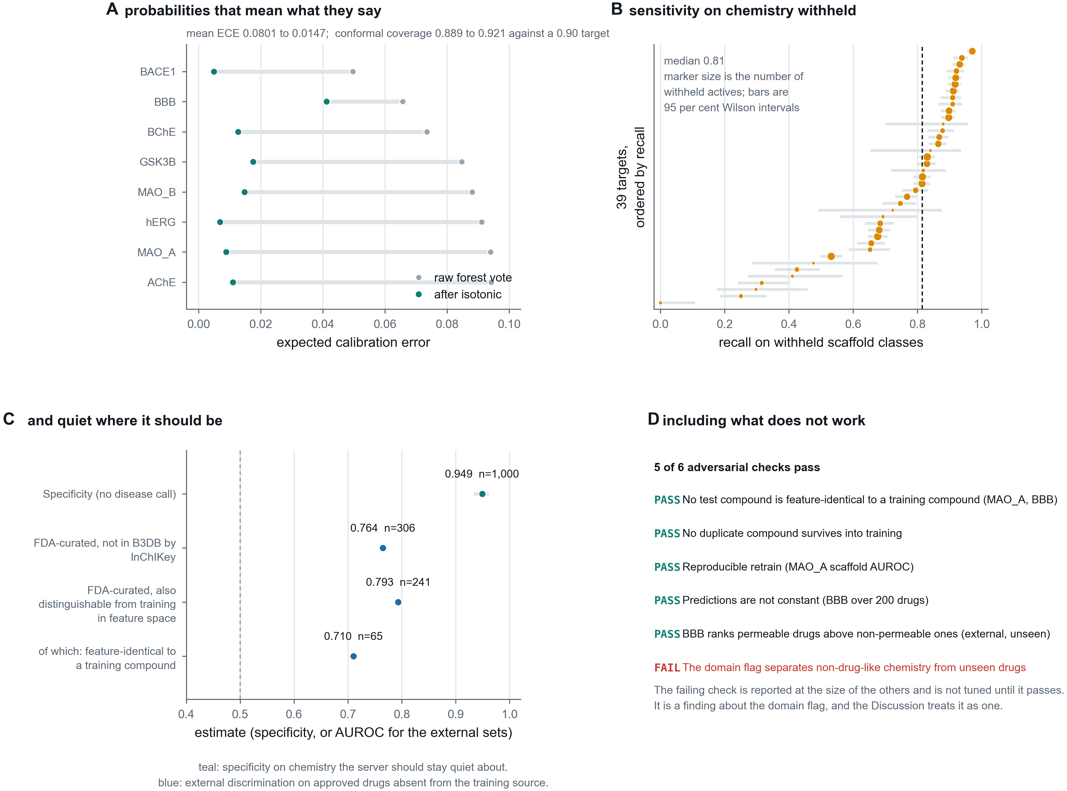
Figure A4
Figure A5. Every binder endpoint named, deployed and withdrawn alike, with what it discriminates and what it recovers.
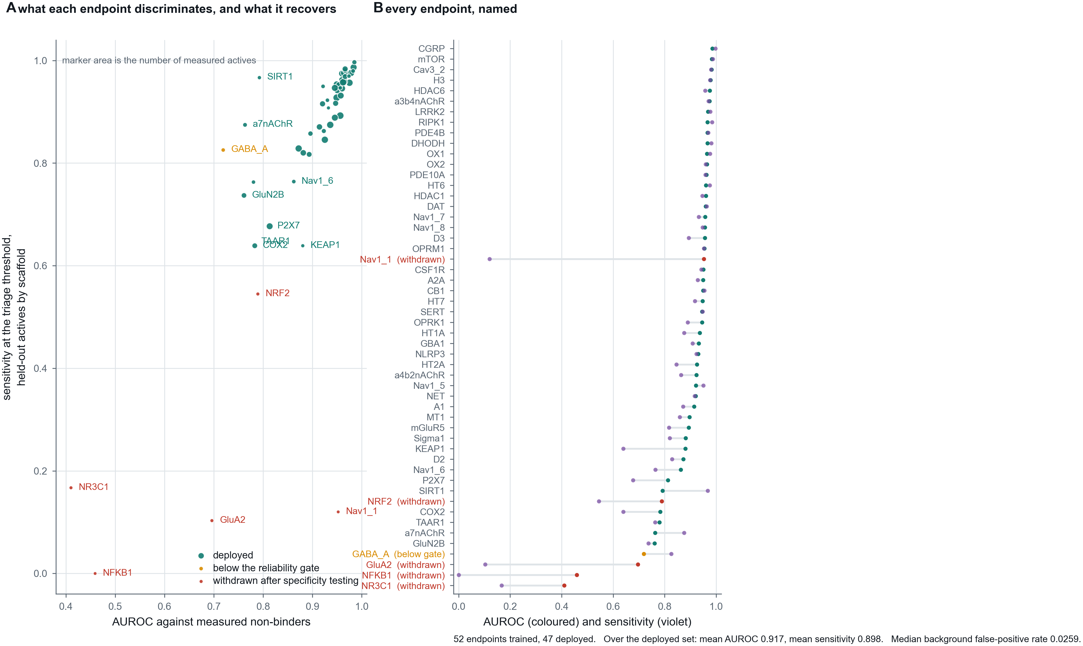
Figure A5
Figure A6. Recovery of the measured negative class from censored bounds, and its effect per endpoint.
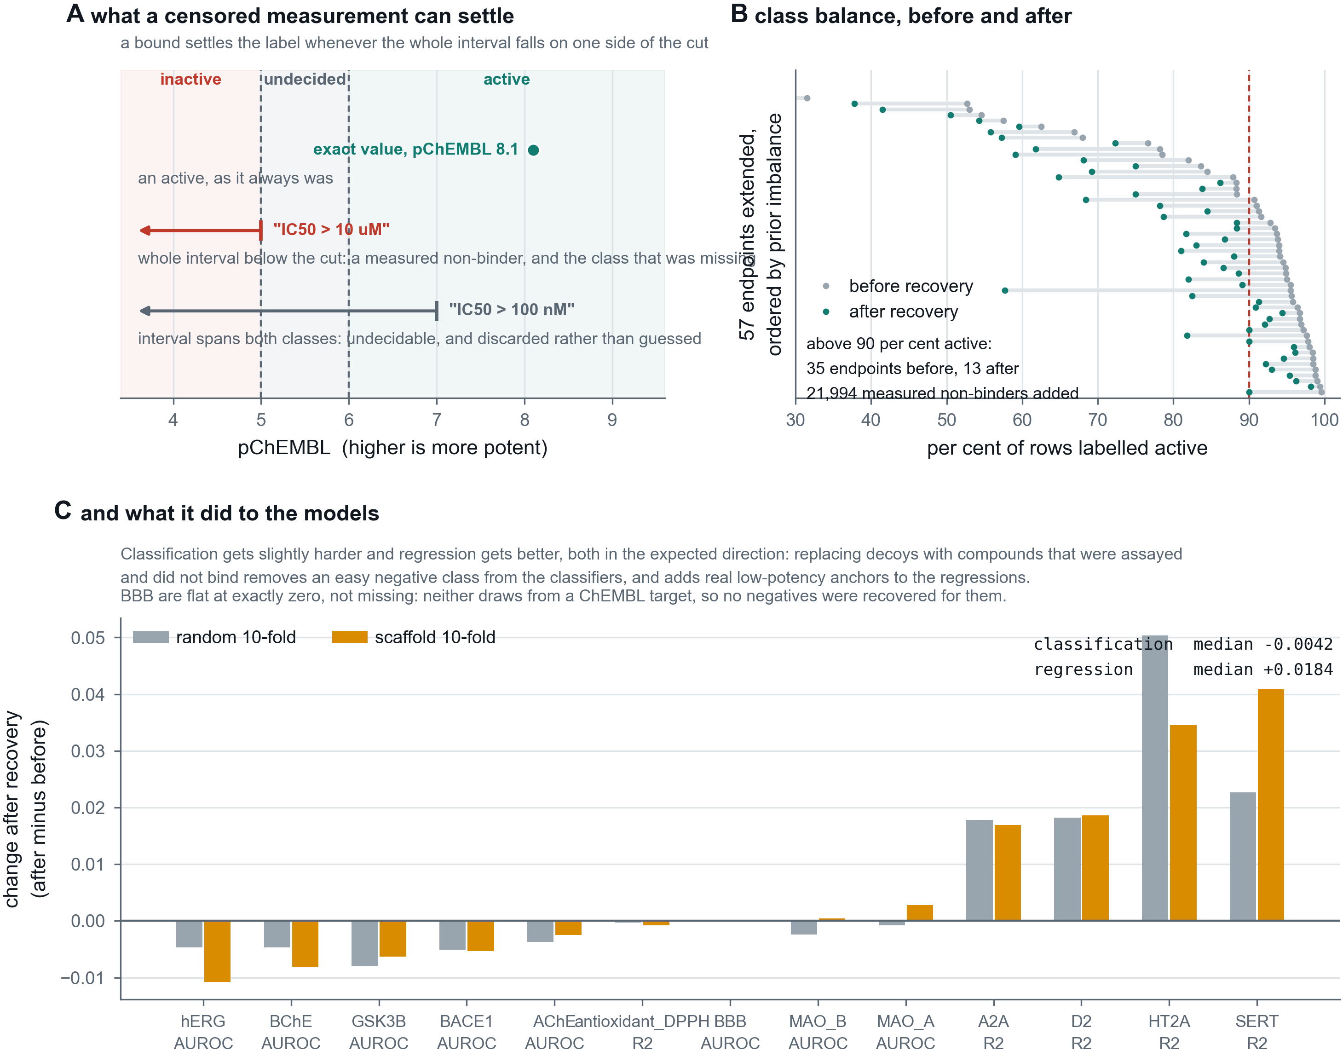
Figure A6

