Supplementary Information
BrainSafe AI: a calibrated, exposure-gated web server for multi-endpoint prediction of small-molecule action in the human brain
Krishnasalini Gunanathan, Raghunatha Sarma, Sai Shyam, Ramya E. M., Venketesh Sivaramakrishnan
This document contains the three validation figures referred to in the main text as Supplementary Figures S1 to S3, and Supplementary Table S1. All three figures, and the table, are generated directly from the repository’s own results tables and model registry (https://github.com/krishna-g-999/brainsafe-ai) and reproduce with the commands named beside each.

Supplementary Figure S1
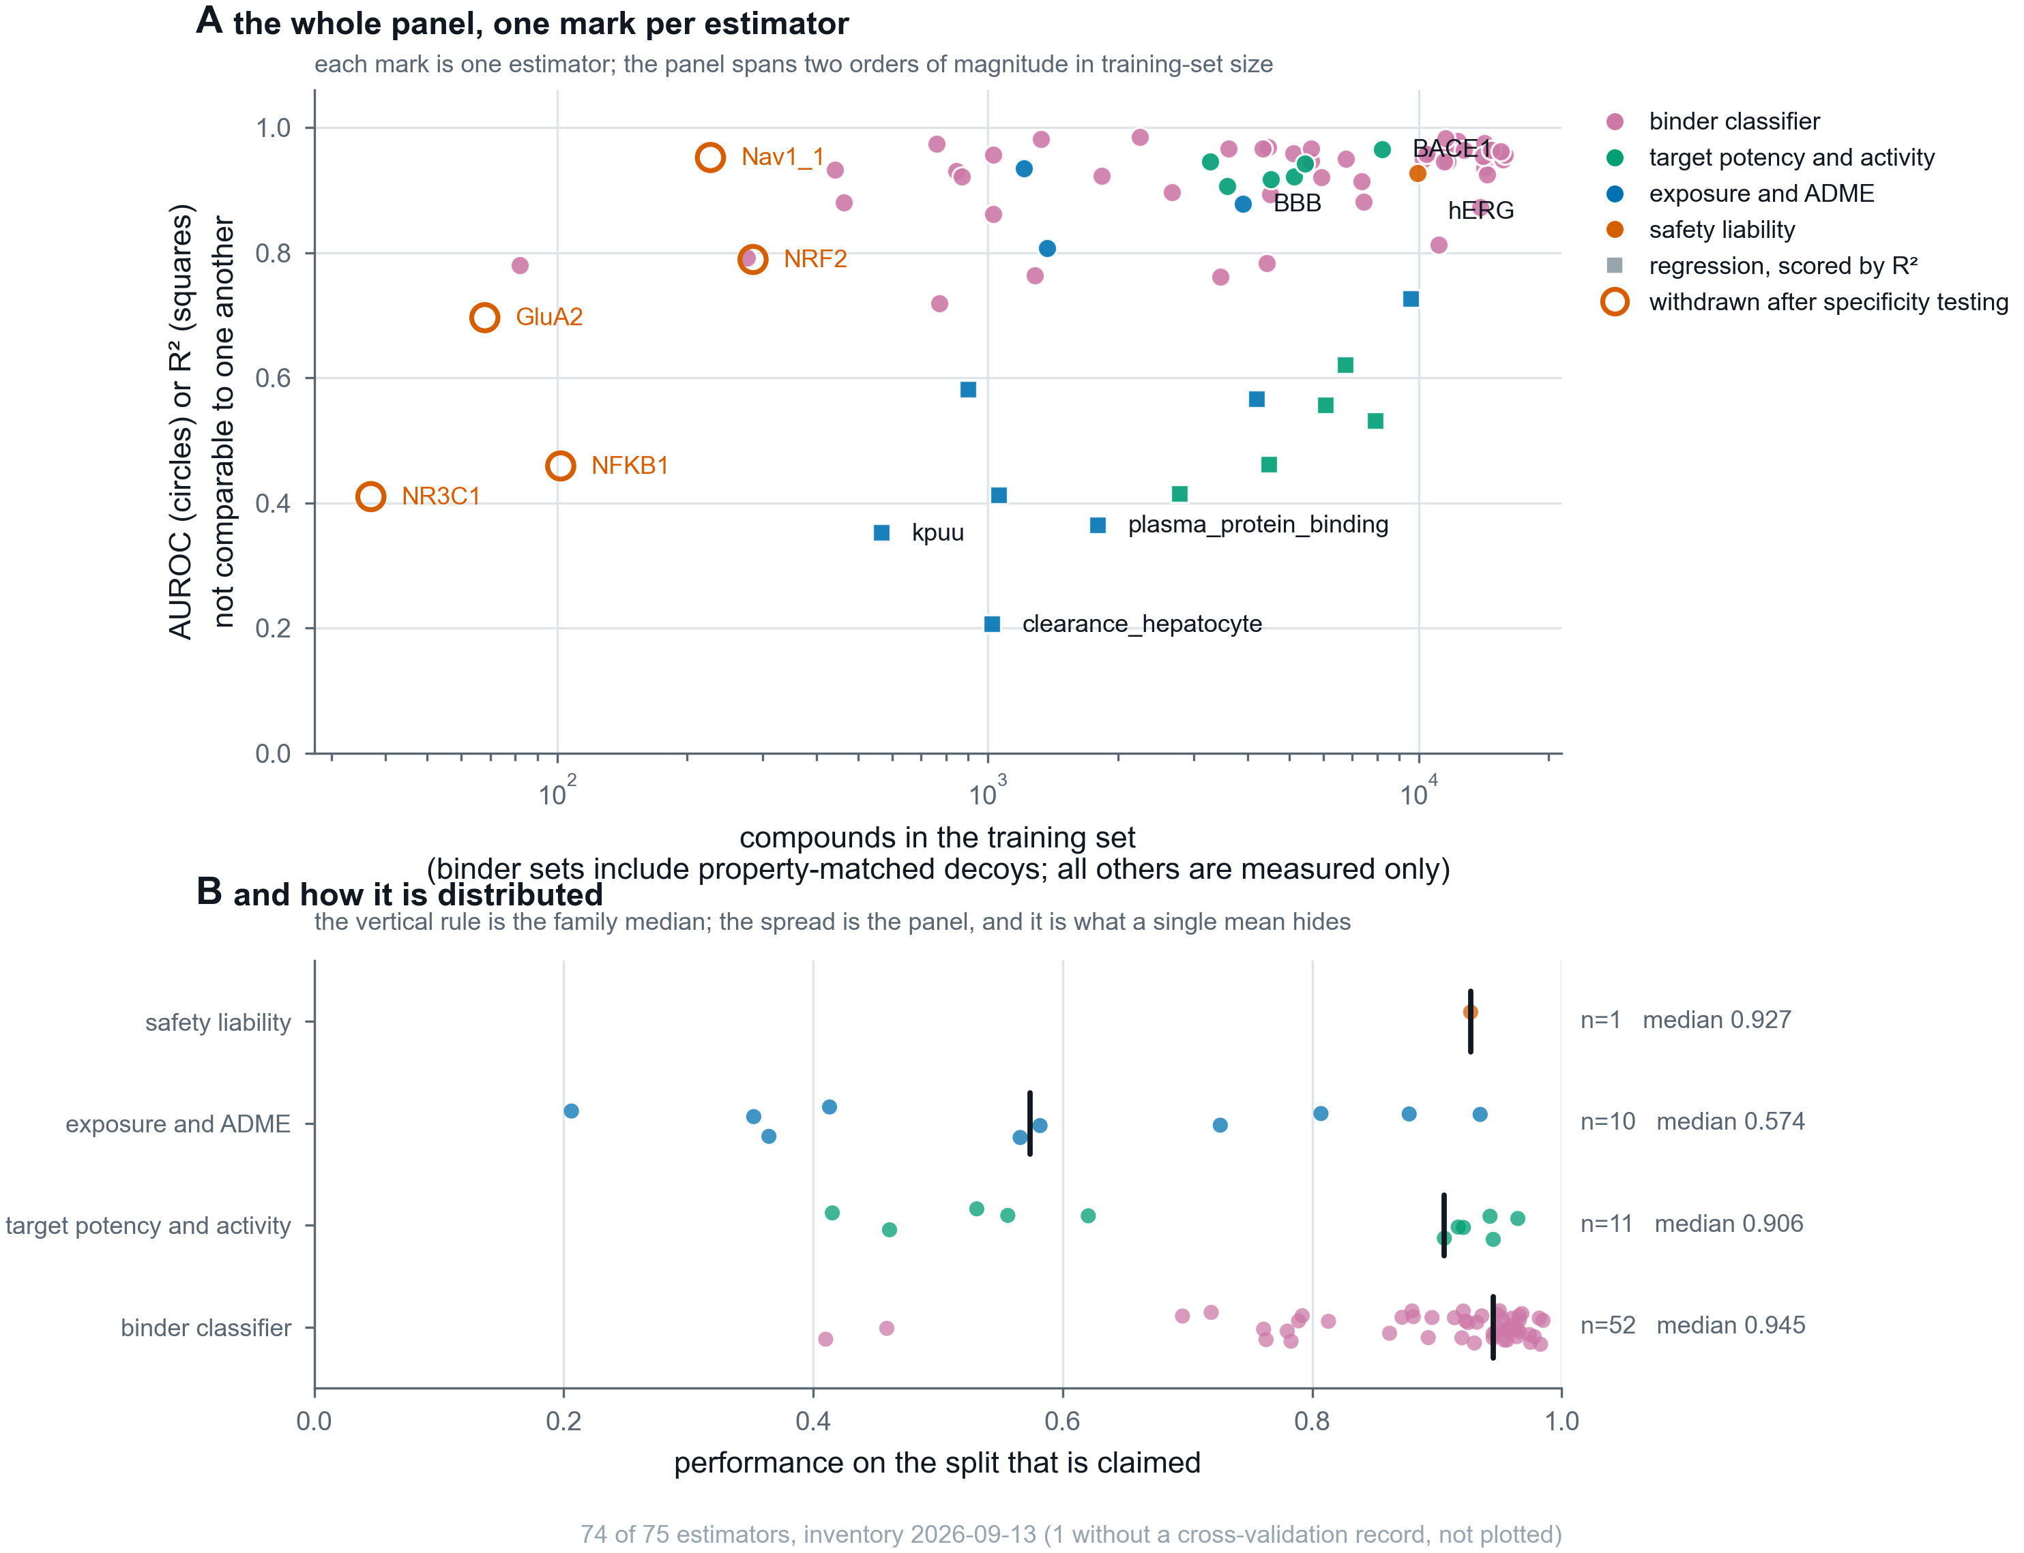
Supplementary Figure S1
Supplementary Figure S1. The panel, one mark per estimator, so that no claim rests on a mean a reader cannot check. (A) Every estimator, deployed or withdrawn, placed by the number of compounds it was trained on and by the performance claimed for it, coloured by model family. Marker shape carries the metric: AUROC and R² both run to 1.0 and are not the same quantity, since 0.5 is chance for one and a respectable fit for the other, so they are distinguished rather than averaged. The five estimators withdrawn after specificity testing are drawn in outline, because a panel showing only what survived is a selection rather than an inventory. Training sets span two orders of magnitude, from 37 to 15,831 rows; binder training sets include property-matched decoys while the others are measured compounds only, which the axis states. (B) The same population by family, with the family median marked. The spread is the point: the binder classifiers have a median of 0.945 while the exposure and ADME family, which mixes AUROC and R² endpoints, has a median of 0.574, and a single panel average would describe neither. Reproduces with python src/brainsafe/figures/fig09_model_atlas.py.
Supplementary Table S1, the complete inventory behind this figure (training-set composition, validation scheme, calibration and fitting date for every one of the 75 estimators), is results/tables/MODEL_INVENTORY.csv, submitted as a separate CSV file alongside this document.

Supplementary Figure S2
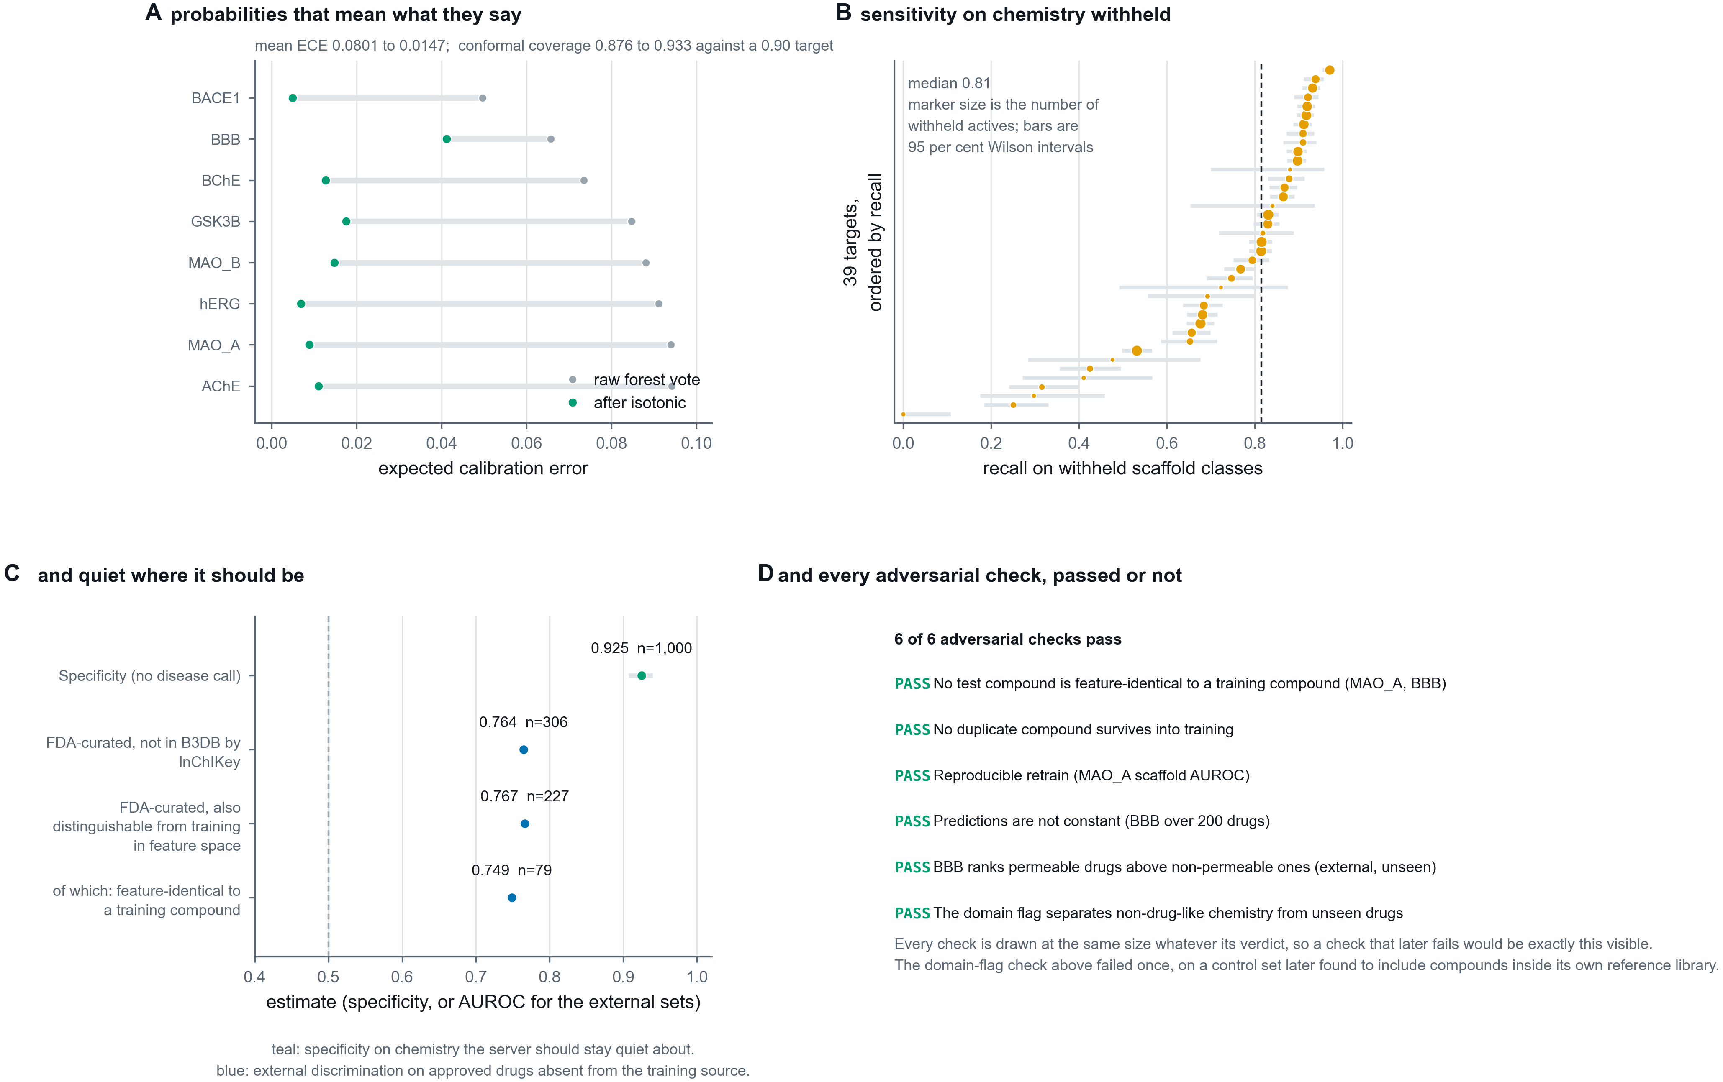
Supplementary Figure S2
Supplementary Figure S2. Four validations that a cross-validated score cannot replace. (A) Expected calibration error before and after isotonic regression fitted on out-of-fold predictions, so no compound contributes to the calibrator that scores it. (B) Recall on whole scaffold classes withheld before training, with 95 per cent Wilson intervals and marker area proportional to the number of withheld actives, so an interval that is wide because the evidence is thin looks thin. (C) Specificity on chemistry the server should stay quiet about, and external discrimination on approved drugs absent from the training source. (D) The adversarial suite, in which each check was written so that it could fail. All six pass, one of them, the applicability-domain flag, only after its controls were corrected rather than its criterion retuned; every check is drawn at the same size whatever its verdict, so a future failure would be exactly this visible. Reproduces with python src/brainsafe/figures/fig06_validation.py.

Supplementary Figure S3
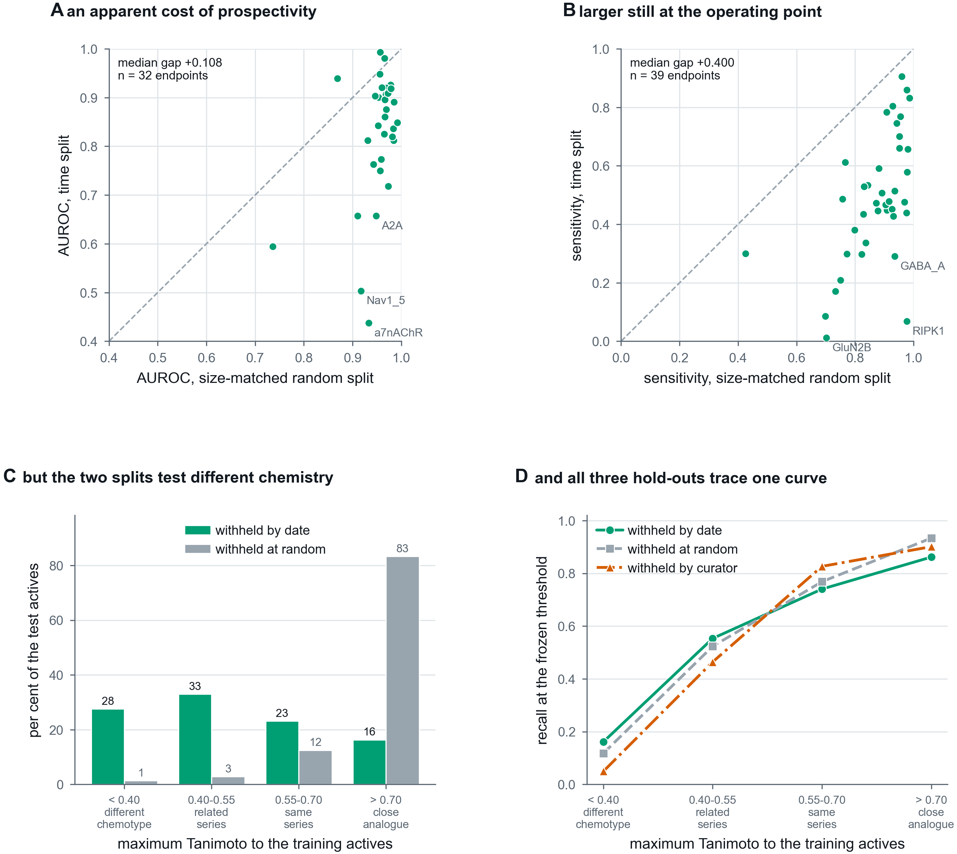
Supplementary Figure S3
Supplementary Figure S3. External validation, and an apparent temporal decay that is a composition effect. (A) Per endpoint, AUROC under a size-matched random split against AUROC under a time split that withholds the most recent quarter of the data and freezes the decision threshold before the cutoff. The size match matters: a time split trains on less data as well as none of the future, so without a control at the same n a drop cannot be attributed to either. (B) The same comparison for sensitivity at the frozen operating point, where the gap is larger. (C) Why the gap exists. A random split of medicinal-chemistry data holds out mostly close analogues of its own training set, because the published record is series; a time split does not. The two are not testing comparable populations. (D) The resolution. Recall against maximum Tanimoto similarity to the training actives, for three test sets built by unrelated rules: withheld by publication date, withheld at random, and withheld by curator, the last being compounds deposited in BindingDB and absent from ChEMBL. They trace one curve, so recall is a function of chemical distance rather than of how the set was held out, and the expected sensitivity for a submitted compound is knowable at query time. Reproduces with python src/brainsafe/figures/fig11_external_validation.py.

