BrainSafe AI: an evidence-grounded, calibrated, blood–brain-barrier-gated multi-endpoint predictor of small-molecule effects on the human brain
Running title: Multi-endpoint prediction of brain effects from measured data
Author(s): [To be completed] · ORCID: [____]
Affiliation: Sri Sathya Sai Institute of Higher Learning, India · Corresponding author: [email]
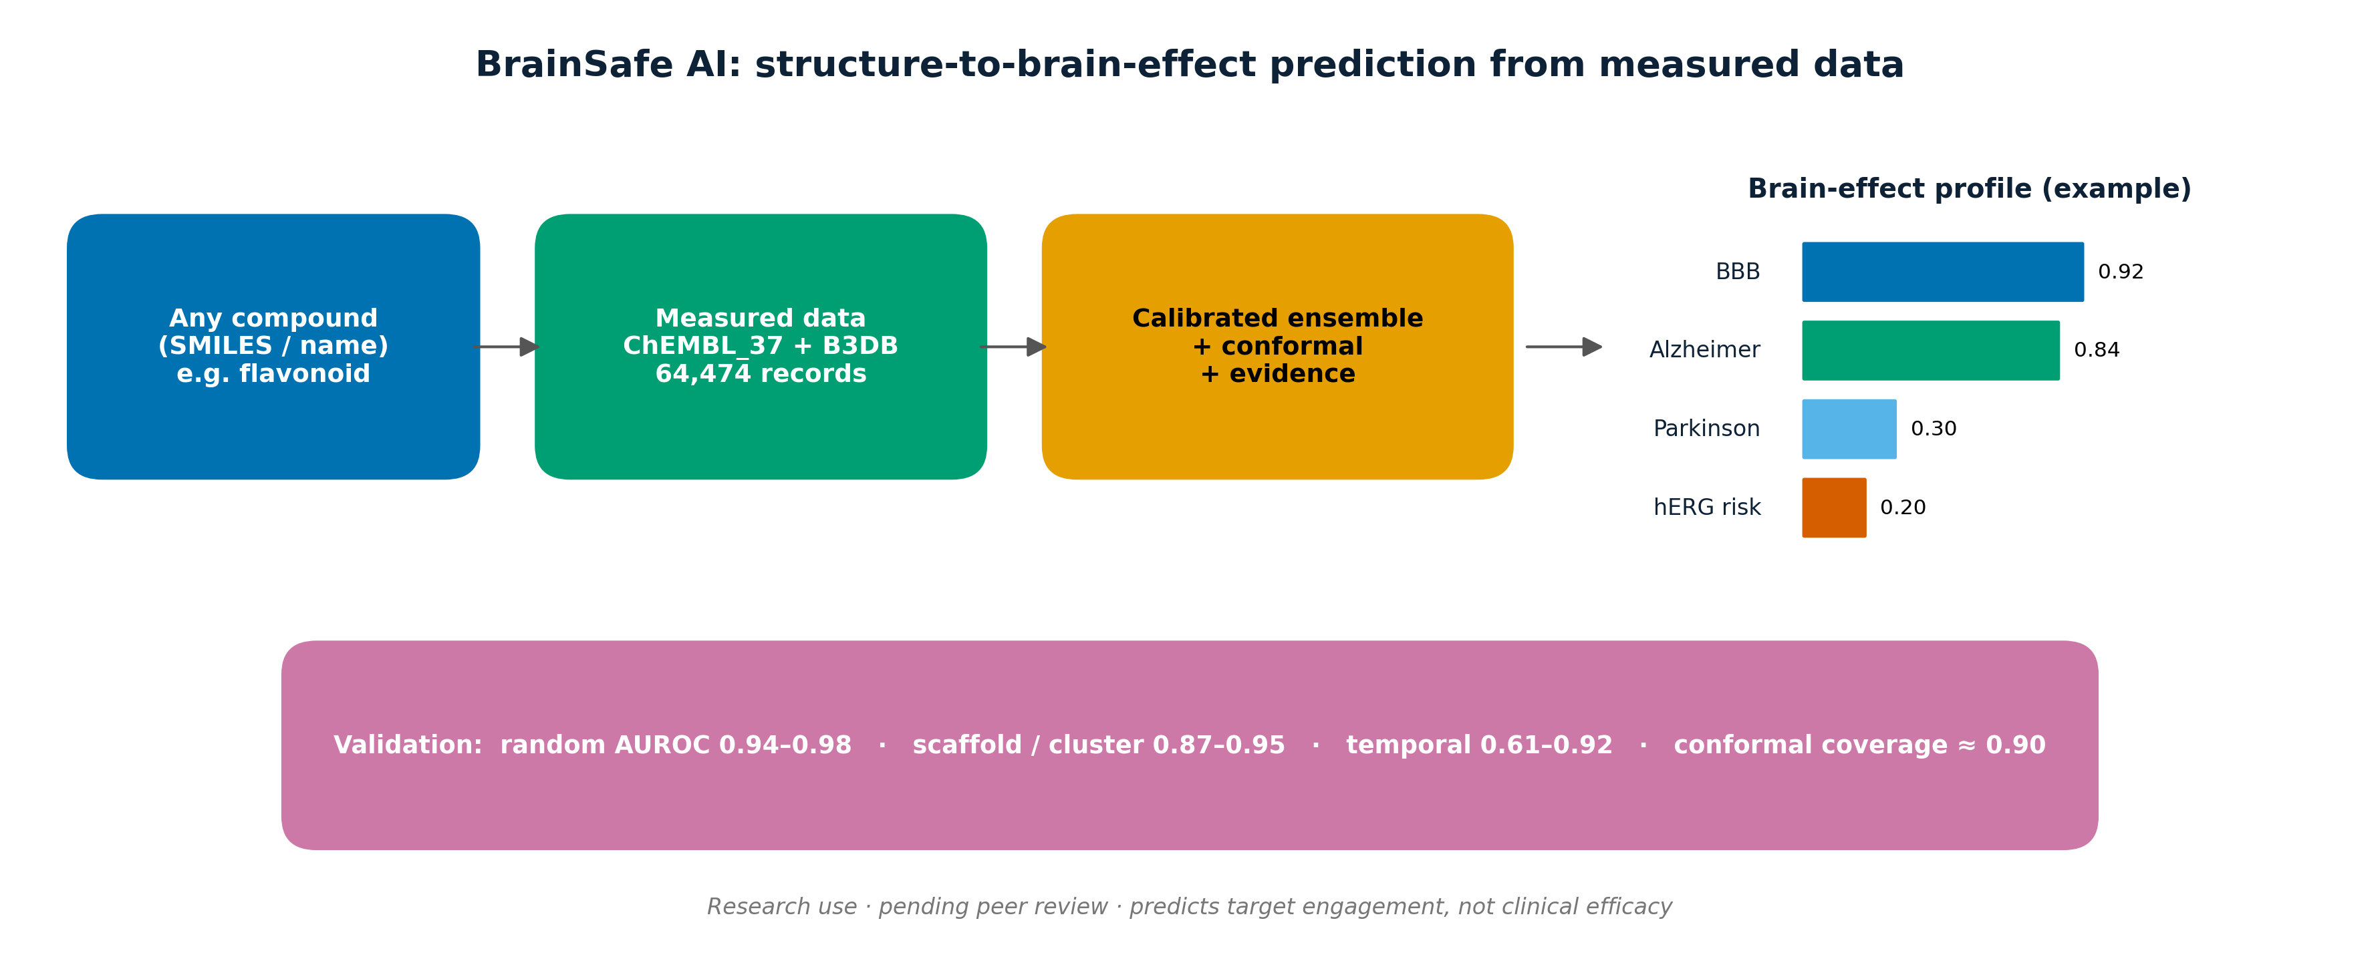
Graphical abstract.

Highlights
- An open tool predicts CNS-relevant effects of any small molecule from structure alone, trained only on measured public data (ChEMBL_37, B3DB; 64,474 records).
- Eight classification endpoints (BBB, AChE, BChE, BACE1, GSK-3β, MAO-A, MAO-B, hERG) plus four receptor potency regressions and a measured antioxidant model.
- Probabilities are isotonic-calibrated and accompanied by conformal prediction sets with empirical coverage close to the 90% target.
- Models are evaluated under random, scaffold, leave-cluster-out and temporal splits; predictions are BBB-gated and grounded in nearest measured analogues.

Abstract
Background. Whether a small molecule will act on the brain cannot be read off any single property. It turns at once on passage across the blood–brain barrier (BBB), engagement of disease-relevant central-nervous-system (CNS) targets, developability, safety and clinical precedent, and the public tools in common use each cover only part of that picture (Daina et al., 2017; Fu et al., 2024). Results. We present BrainSafe AI, an open tool that works from chemical structure alone. It brings together eight machine-learning endpoints, every one trained on measured public bioactivity data (ChEMBL_37 pChEMBL values and the B3DB database; Mendez et al., 2019; Meng et al., 2021): BBB penetration, inhibition of AChE, BChE, BACE1, GSK-3β, MAO-A and MAO-B, and the hERG cardiotoxicity liability. Four receptor targets (D2, A2A, 5-HT2A and SERT) are handled instead by potency regression. A deterministic druggability/CNS-MPO layer (Wager et al., 2010) and a clinical-precedent layer of 504 nervous-system compounds with clinical-phase annotations place each prediction in context. Every probability is isotonic-calibrated (Niculescu-Mizil and Caruana, 2005) and carries a Mondrian conformal prediction set (Norinder et al., 2014); each call also returns its nearest measured analogues, and the target scores are folded into BBB-gated per-disease estimates. We assessed the models under four splits of increasing difficulty: random, scaffold, leave-cluster-out and temporal. Random-split AUROC ran from 0.94 to 0.98, scaffold and cluster AUROC from 0.87 to 0.95, and temporal AUROC from 0.61 to 0.92, with conformal coverage between 0.885 and 0.905. We also ran a pre-registered head-to-head against four general-purpose large language models. On well-known drugs they matched or beat BrainSafe at BBB and hERG classification; even so, 45% of the measured-data identifiers they cited proved fabricated or mis-attributed, and all four invented a target and potency for an unpublished compound. BrainSafe tied every prediction to a real measured analogue and reported honest uncertainty. Conclusion. BrainSafe AI delivers calibrated, evidence-grounded, BBB-gated and safety-aware CNS profiling built entirely on measured data. Code, models and data are released; the tool is for research use and remains pending peer review.
Keywords: QSAR; blood–brain barrier; neurodegeneration; conformal prediction; applicability domain; cheminformatics; ChEMBL.

Abbreviations
AUROC, area under the receiver-operating-characteristic curve; BBB, blood–brain barrier; CNS, central nervous system; CNS-MPO, CNS multiparameter optimisation; ECFP, extended-connectivity fingerprint; MCC, Matthews correlation coefficient; PR-AUC, area under the precision–recall curve; OOF, out-of-fold; CV, cross-validation; ATC, Anatomical Therapeutic Chemical; DPPH, 2,2-diphenyl-1-picrylhydrazyl; QED, quantitative estimate of drug-likeness; AChE/BChE, acetyl-/butyryl-cholinesterase; BACE1, β-secretase 1; GSK-3β, glycogen synthase kinase-3β; MAO, monoamine oxidase; hERG, human ether-à-go-go-related gene; SERT, serotonin transporter.

1. Introduction
Disorders of the nervous system are now a leading and still-rising cause of global disability (GBD 2021 Nervous System Disorders Collaborators, 2024), yet the discovery of safe, brain-penetrant modulators remains slow. Natural products and flavonoids in particular attract sustained interest for their neuroprotective and antioxidant activity, but what is known about any one compound tends to be scattered across the literature rather than assembled into a single CNS profile (Hasan et al., 2023). That profile has several parts that matter together: whether the compound crosses the BBB, which disease-relevant CNS targets it engages, how developable it is, whether it is safe, and whether anything like it has reached the clinic.
Public resources already cover pieces of this. General ADMET platforms (Daina et al., 2017; Xiong et al., 2021; Fu et al., 2024; Cheng et al., 2012) predict BBB and hERG, but say nothing about CNS-target activity. Target-prediction servers (Daina et al., 2019; Awale and Reymond, 2019) return likely protein targets from chemical similarity, yet they do not condition those targets on brain penetration, roll them up into a disease-level view, attach calibrated uncertainty, or carry a safety axis. Individual endpoints have their own dedicated QSAR models — AChE and BACE1 (Ponzoni et al., 2019), MAO-B (Kumar et al., 2024), GSK-3β (Galati et al., 2023), BBB permeability (Kumar et al., 2022; Huang et al., 2024) — but no single tool draws them together. BrainSafe AI does exactly that, using models trained on measured public data and tested under four validation regimes.

2. Materials and methods
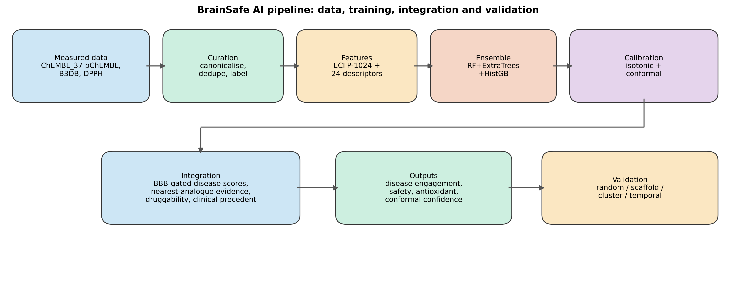
Figure 1. Overview of the BrainSafe AI pipeline, from measured data sources through curation, featurisation, ensemble training and calibration/conformal prediction to the integrated outputs and the four validation regimes.

2.1 Data sources
Target bioactivities were retrieved from ChEMBL version 37 (release 2026-05-01) via its REST API (Gaulton et al., 2012; Mendez et al., 2019; Zdrazil et al., 2024), retaining records with a defined pChEMBL value (standard types IC50, Ki, Kd, EC50, Potency) for AChE (CHEMBL220), BChE (CHEMBL1914), BACE1 (CHEMBL4822), GSK-3β (CHEMBL262), MAO-A (CHEMBL1951), MAO-B (CHEMBL2039), the hERG anti-target (CHEMBL240), and receptors D2 (CHEMBL217), A2A (CHEMBL251), 5-HT2A (CHEMBL224) and SERT (CHEMBL228). BBB labels were taken from B3DB (Meng et al., 2021); antioxidant data from ChEMBL DPPH radical-scavenging assays (IC50/EC50 → pIC50); and clinical precedent from ChEMBL ATC level-1 ‘N’ molecules with a clinical phase. Structures for user-entered compounds are resolved via PubChem (Kim et al., 2023). All endpoints are trained on measured experimental data (Table 1), totalling 64,474 measured compound–endpoint records; ChEMBL document years (1976–2025) were retained to enable temporal validation (Sheridan, 2013).
Table 1. Data provenance for each endpoint (all trained on measured experimental data).
Endpoint | Role | Modality | Source | Identifier | Measurement | n | Year range
BBB | BBB gate | Classification | B3DB (measured) | B3DB | BBB+/- permeability | 7807 | curated
AChE | Alzheimer's | Classification | ChEMBL (measured) | CHEMBL220 | pChEMBL (IC50/Ki/Kd/EC50) | 4324 | 1986-2025
BChE | Alzheimer's | Classification | ChEMBL (measured) | CHEMBL1914 | pChEMBL (IC50/Ki/Kd/EC50) | 2580 | 1976-2025
BACE1 | Alzheimer's | Classification | ChEMBL (measured) | CHEMBL4822 | pChEMBL (IC50/Ki/Kd/EC50) | 8067 | 2001-2025
GSK3B | Neuroprotection (tau) | Classification | ChEMBL (measured) | CHEMBL262 | pChEMBL (IC50/Ki/Kd/EC50) | 4044 | 2000-2025
MAO-B | Parkinson's | Classification | ChEMBL (measured) | CHEMBL2039 | pChEMBL (IC50/Ki/Kd/EC50) | 3455 | 1990-2025
MAO-A | Depression | Classification | ChEMBL (measured) | CHEMBL1951 | pChEMBL (IC50/Ki/Kd/EC50) | 2141 | 1990-2025
D2 | Parkinson's/psychosis | Regression | ChEMBL (measured) | CHEMBL217 | pChEMBL (IC50/Ki/Kd/EC50) | 7511 | 1987-2025
A2A | Parkinson's | Regression | ChEMBL (measured) | CHEMBL251 | pChEMBL (IC50/Ki/Kd/EC50) | 5547 | 1992-2025
HT2A | Mood/psychosis | Regression | ChEMBL (measured) | CHEMBL224 | pChEMBL (IC50/Ki/Kd/EC50) | 5256 | 1994-2025
SERT | Depression | Regression | ChEMBL (measured) | CHEMBL228 | pChEMBL (IC50/Ki/Kd/EC50) | 4471 | 1980-2025
hERG | Safety (cardiotox) | Classification | ChEMBL (measured) | CHEMBL240 | pChEMBL (IC50/Ki/Kd/EC50) | 5905 | 1995-2025
Antioxidant | Oxidative stress | Regression | ChEMBL DPPH (measured) | DPPH assays | pIC50 (radical scavenging) | 2862 | curated
Clinical precedent | Translational | Reference (k-NN) | ChEMBL ATC-N (measured) | ATC level-1 N | max clinical phase 1-4 | 504 | curated

2.2 Curation and labelling
SMILES were canonicalised and deduplicated by InChIKey (Bento et al., 2020). For classification, activities were aggregated per compound by median pChEMBL and labelled active where pChEMBL ≥ 6 (potency ≤ 1 µM) and inactive where pChEMBL < 5 (> 10 µM); the intermediate range was discarded. Receptor targets, 96–98% active because binders are preferentially reported, were modelled by potency regression on median pChEMBL rather than binary classification.

2.3 Molecular representation, models and hyperparameters
Molecules were represented by a 1,024-bit Morgan (ECFP, radius 2) fingerprint (Rogers and Hahn, 2010), computed with RDKit (RDKit, 2024), concatenated with 24 RDKit physicochemical descriptors. Classification used an unweighted-mean ensemble of random forest (Breiman, 2001), extremely randomised trees (Geurts et al., 2006) and histogram gradient boosting (Friedman, 2001; Ke et al., 2017) in scikit-learn (Pedregosa et al., 2011); regression used the corresponding regressor ensemble. Hyperparameters are listed in Table 2. A pre-specified quality gate (MCC ≥ 0.45 under scaffold CV) governed deployment; endpoints failing the gate as classifiers (D2, A2A, 5-HT2A, SERT) were served as regressions.
Table 2. Model architecture and hyperparameters.
Component | Setting
Random forest (classifier/regressor) | n_estimators=300; min_samples_leaf=2; class_weight=balanced_subsample (clf)
Extremely randomised trees | n_estimators=300; min_samples_leaf=2; class_weight=balanced_subsample (clf)
Histogram gradient boosting | max_iter=300; learning_rate=0.06
Ensemble | unweighted mean of the three base learners (probabilities / predictions)
Calibration | isotonic regression on scaffold-CV out-of-fold predictions
Conformal prediction | Mondrian (class-conditional) inductive; significance ε = 0.10; 50/50 calibration/test
Applicability domain | maximum Tanimoto similarity to training set; flag threshold 0.30
Baselines | Tanimoto k-NN (k=5); logistic regression (balanced, standardised features)
Random seed | 42 (all stages)

Table 3. Software environment.
Package | Version
Python | 3.13
RDKit | 2026.03.2
scikit-learn | 1.8.0
NumPy | 2.4.6
pandas | 3.0.3
SciPy | 1.17.1
matplotlib | 3.10.9

2.4 Calibration, conformal prediction and integration
Calibrated probabilities were obtained by isotonic regression on scaffold-CV out-of-fold scores (Niculescu-Mizil and Caruana, 2005). Class-conditional (Mondrian) inductive conformal prediction (Vovk et al., 2005; Norinder et al., 2014; Mervin et al., 2021) yields, for a query with score s and per-class calibration nonconformity sets, a p-value per class c
p_c = (#{α in A_c : α ≥ α_query} + 1) / (|A_c| + 1), α_active = 1 − s, α_inactive = s
and a prediction set comprising classes with p_c > ε (ε = 0.10). Effective CNS engagement combines target activity with brain penetration,
Engagement(target) = P(active | target) × P(BBB-penetrant)
and per-disease scores take the maximum engagement over the targets mapped to each disease. Druggability is a deterministic composite of QED (Bickerton et al., 2012), Lipinski (Lipinski et al., 2001) and Veber (Veber et al., 2002) compliance, the CNS-MPO desirability score (Wager et al., 2010) and PAINS alerts (Baell and Holloway, 2010). Each prediction returns the nearest measured analogues by Tanimoto similarity (Willett, 2006).

2.5 Validation regimes
Models were evaluated under: (i) a random stratified split; (ii) scaffold GroupKFold (k = 5) on Bemis–Murcko generic scaffolds (Bemis and Murcko, 1996), with all transforms fit within each fold (Tropsha, 2010; Wu et al., 2018); (iii) leave-cluster-out using sphere-exclusion clusters held out in full; and (iv) temporal validation, training on compounds reported up to the 75th-percentile ChEMBL document year and testing on the most recent ~25% (Sheridan, 2013). Classification metrics were AUROC (with 95% bootstrap confidence intervals, 1,000 resamples), PR-AUC, balanced accuracy, MCC and Brier score; regression metrics were R², RMSE and Spearman ρ. Code, models and data-fetch scripts are released; a Streamlit application provides the interface.

3. Results
Results are reported in two modes. Non-comparative analysis (Sections 3.1 and 3.3) reports each endpoint’s standalone performance against its own held-out measured data — absolute discrimination, calibration, conformal coverage and behaviour on reference compounds. Comparative analysis (Sections 3.2, 3.4 and 3.5) benchmarks the same models against external references: published QSAR performance ranges, simpler internal baselines under an identical protocol, and the general-purpose large-language-model paradigm.
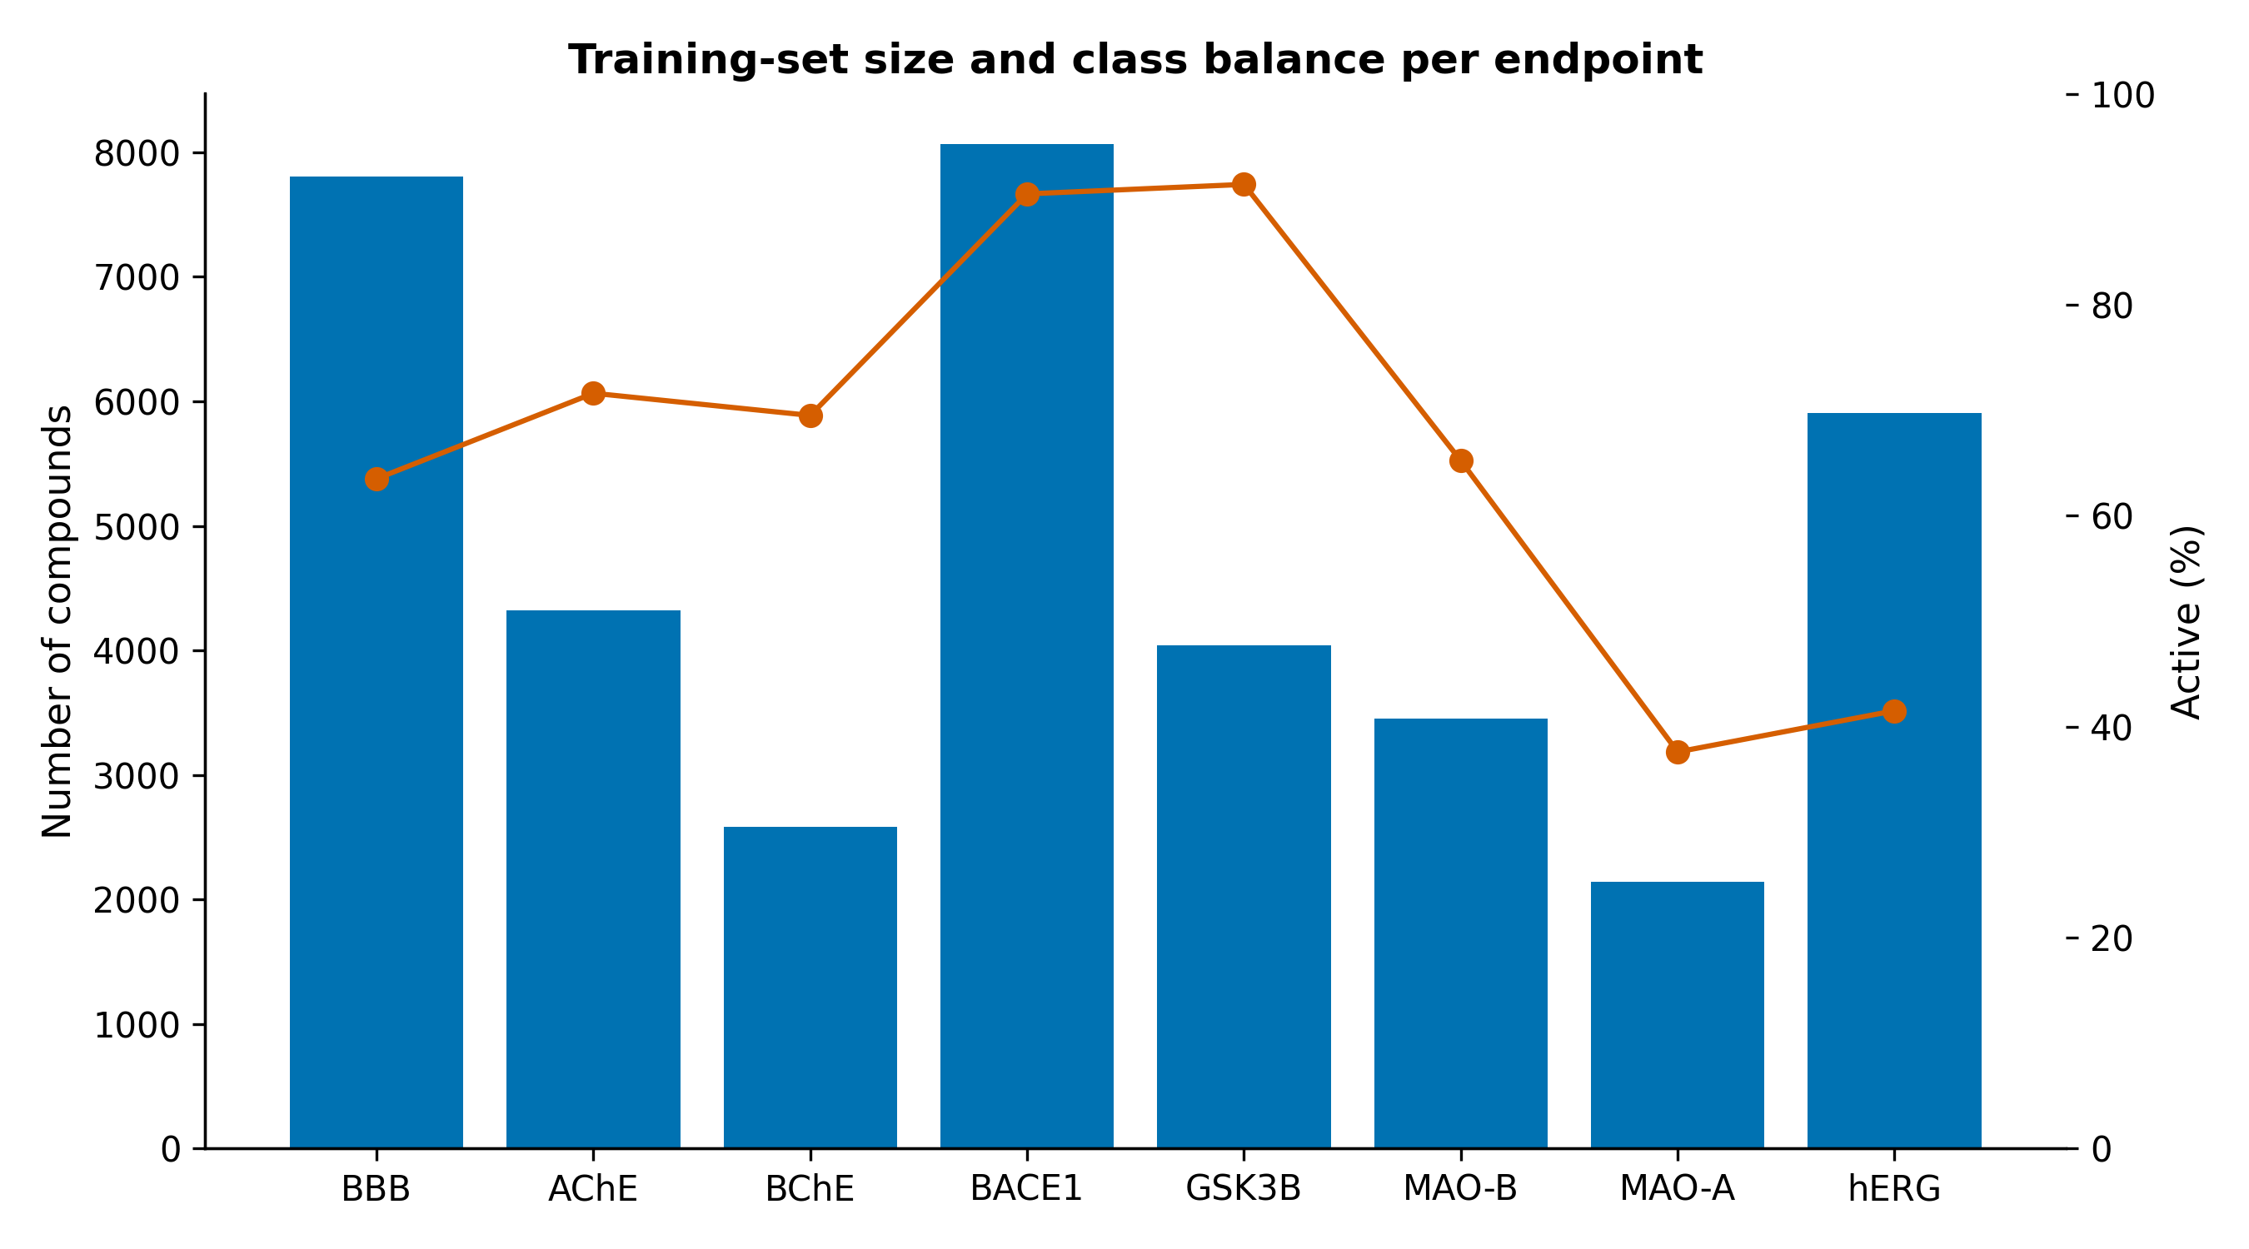
Figure 2. Training-set size and class balance for each endpoint.

3.1 Classification performance (standalone, non-comparative)
Table 4. Classification performance under four validation regimes, with 95% bootstrap CI on the scaffold-CV AUROC, Brier score, MCC and empirical conformal coverage (target 0.90).
Endpoint | n | Pos. | AUROC rand | AUROC scaf | Scaf 95% CI | AUROC clust | AUROC temp | Brier | MCC | Conf. cov.
AChE | 4324 | 0.716 | 0.975 | 0.915 | [0.906, 0.925] | 0.912 | 0.784 | 0.099 | 0.633 | 0.899
BACE1 | 8067 | 0.905 | 0.956 | 0.95 | [0.942, 0.958] | 0.94 | 0.915 | 0.039 | 0.614 | 0.902
BBB | 7805 | 0.635 | 0.963 | 0.921 | [0.916, 0.927] | 0.906 | – | 0.105 | 0.659 | 0.897
BChE | 2580 | 0.695 | 0.976 | 0.937 | [0.928, 0.946] | 0.921 | 0.794 | 0.09 | 0.701 | 0.899
GSK3B | 4044 | 0.914 | 0.943 | 0.92 | [0.906, 0.934] | 0.915 | 0.658 | 0.044 | 0.468 | 0.885
MAO_A | 2141 | 0.376 | 0.95 | 0.867 | [0.852, 0.883] | 0.89 | 0.614 | 0.136 | 0.586 | 0.905
MAO_B | 3455 | 0.652 | 0.96 | 0.885 | [0.872, 0.896] | 0.873 | 0.758 | 0.122 | 0.606 | 0.895
hERG | 5905 | 0.415 | 0.95 | 0.901 | [0.894, 0.908] | 0.87 | 0.757 | 0.123 | 0.626 | 0.896

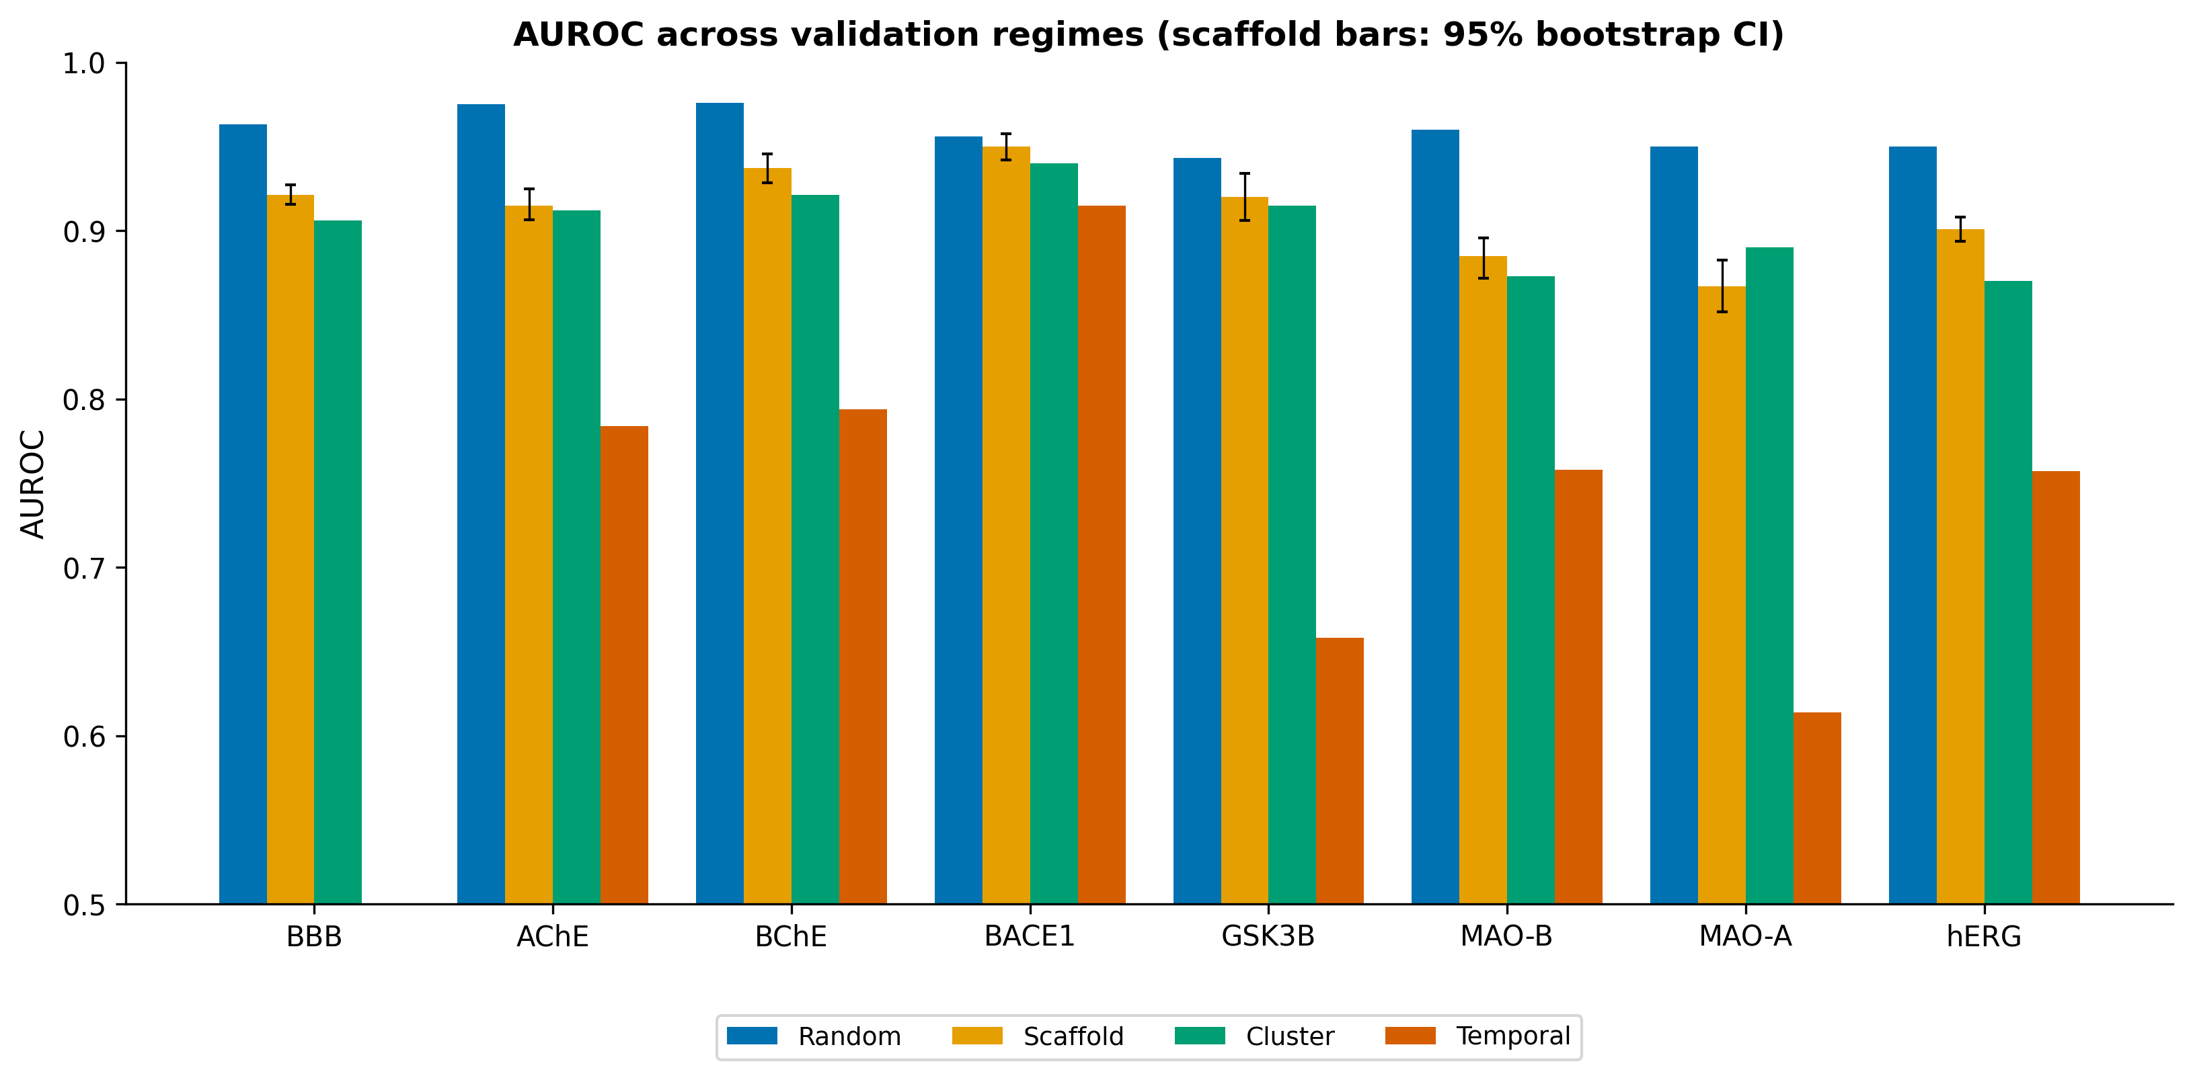
Figure 3. AUROC across validation regimes; error bars on scaffold-CV bars denote 95% bootstrap CIs.
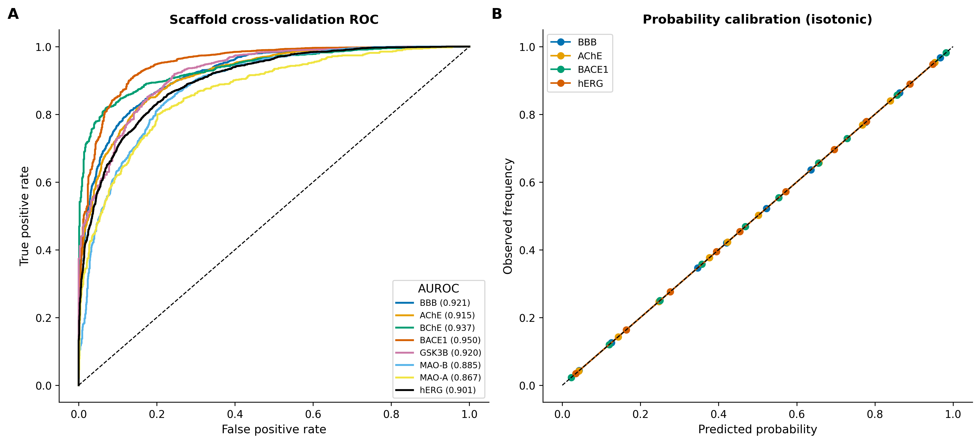
Figure 4. (A) Scaffold cross-validation ROC curves (out-of-fold). (B) Reliability diagrams after isotonic calibration for representative endpoints.
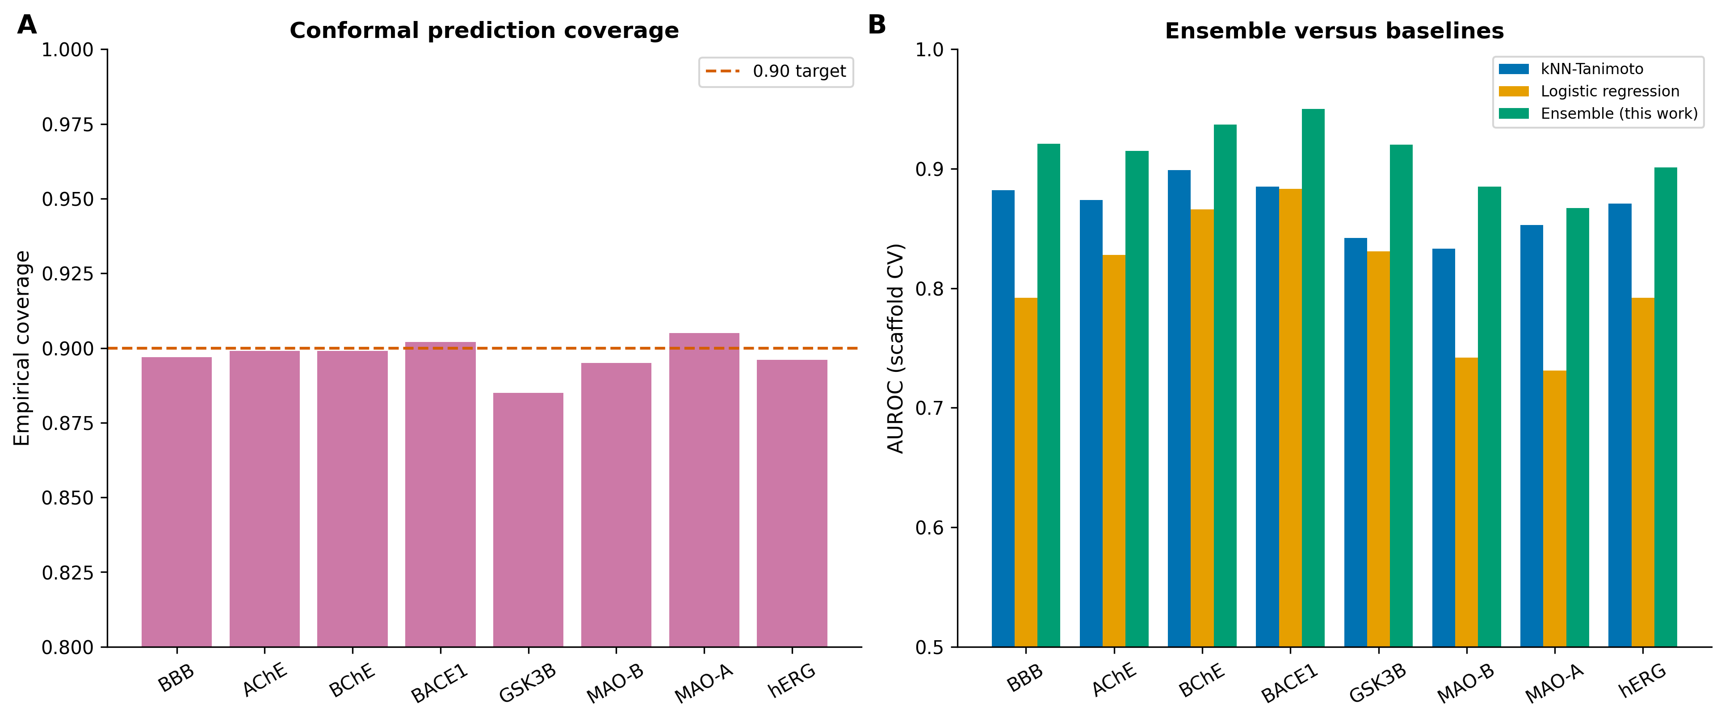
Figure 5. (A) Empirical coverage of 90%-level conformal prediction sets. (B) Scaffold-CV AUROC of the deployed ensemble versus Tanimoto k-nearest-neighbour and logistic-regression baselines.
Random-split AUROC was 0.94–0.98 across endpoints; scaffold and leave-cluster-out AUROC were 0.87–0.95; and temporal-split AUROC was 0.61–0.92 (Figure 3; Table 4). Isotonic calibration gave Brier scores of 0.04–0.14 (Figure 4B) and empirical conformal coverage of 0.885–0.905 against the 0.90 target (Figure 5A).

3.2 Ablation against simpler baselines (comparative)
Under an identical scaffold-split protocol and feature set, the deployed ensemble was compared with a k-nearest-neighbour Tanimoto ‘read-across’ baseline — the closest algorithmic analogue to associative structural recall — and with L2-regularised logistic regression. The ensemble attained a mean scaffold-split AUROC of 0.912, versus 0.867 for k-nearest-neighbour (mean Δ = +0.045) and 0.808 for logistic regression (mean Δ = +0.104), and was best on every one of the eight endpoints (Table 6; Figure 5B). Exceeding a pure nearest-neighbour read-across indicates the model captures structure–activity relationships not reducible to retrieving the most similar known molecule.
Table 6. Scaffold-split AUROC of the deployed ensemble versus baselines (Supplementary Table S9).
Endpoint | Ensemble | kNN-Tanimoto | Logistic reg. | Δ vs kNN
AChE | 0.915 | 0.874 | 0.828 | 0.041
BACE1 | 0.95 | 0.885 | 0.883 | 0.065
BBB | 0.921 | 0.882 | 0.792 | 0.039
BChE | 0.937 | 0.899 | 0.866 | 0.038
GSK3B | 0.92 | 0.842 | 0.831 | 0.078
MAO_A | 0.867 | 0.853 | 0.731 | 0.014
MAO_B | 0.885 | 0.833 | 0.742 | 0.052
hERG | 0.901 | 0.871 | 0.792 | 0.03

3.3 Comparison with the literature (comparative)
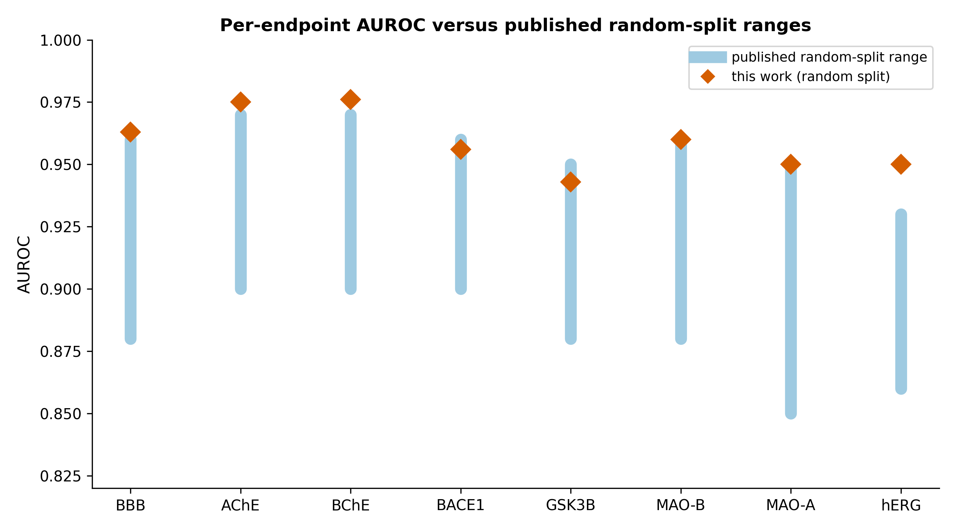
Figure 6. Per-endpoint random-split AUROC (this work) relative to reported random-split ranges.
On like-for-like random splits, per-endpoint AUROC was within or above reported ranges, for example BBB (0.88–0.96) and hERG (0.86–0.93) (Kumar et al., 2022; Huang et al., 2024; Figure 6).

3.4 Receptor potency regression and antioxidant model (non-comparative)
Table 5. Receptor potency-regression performance (scaffold cross-validation and temporal split).
Receptor | n | Scaffold R² | RMSE | Spearman | Temporal R²
D2 | 7511 | 0.425 | 0.713 | 0.652 | -0.007
A2A | 5547 | 0.526 | 0.738 | 0.706 | 0.326
HT2A | 5256 | 0.46 | 0.757 | 0.684 | 0.085
SERT | 4471 | 0.338 | 0.841 | 0.573 | 0.171

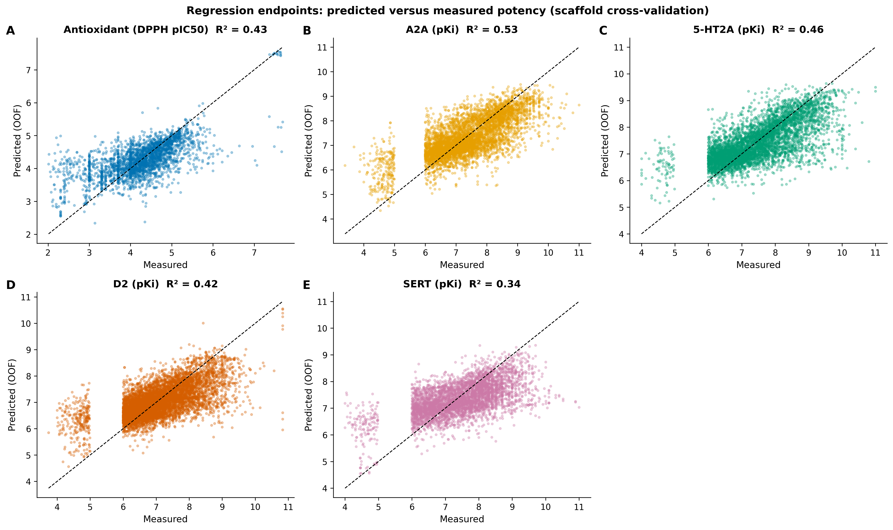
Figure 7. Predicted versus measured potency (scaffold cross-validation) for the measured antioxidant (DPPH) model and the four receptor potency-regression endpoints (panels A–E).
Receptor potency regressions achieved scaffold-CV R² of 0.34–0.53 and Spearman ρ of 0.57–0.71; temporal R² was lower (Table 5), and these endpoints are reported as ranking-grade. The antioxidant model trained on measured DPPH data (n = 2862) achieved scaffold-CV R² = 0.43, RMSE = 0.597 and Spearman = 0.636 (Figure 7); the earlier curated score correlated only weakly with measured DPPH (Spearman = 0.387).

3.5 Behaviour on reference compounds (non-comparative)
With chemistry-only inputs the integrated system reproduced established pharmacology: rivastigmine resolved to Alzheimer’s disease via BChE; rasagiline to Parkinson’s disease via MAO-B; fluoxetine to depression via SERT with a corresponding clinical-precedent match; terfenadine, withdrawn for cardiotoxicity, was predicted positive at hERG; and resveratrol was predicted BBB non-penetrant, consistent with reported flavonoid CNS bioavailability (Hasan et al., 2023).

3.6 Comparison with general-purpose large language models (comparative)
Because general-purpose large language models (LLMs) can be queried in natural language for chemical information, we assessed whether a dedicated tool remains warranted, along three lines: published benchmark evidence, the scientific basis of the difference, and a reproducible demonstration of grounded output.
Benchmark evidence. On molecular property prediction — the task class BrainSafe performs — general-purpose LLMs consistently underperform specialised machine-learning models. In an eight-task chemistry benchmark, LLMs including GPT-4 lag task-specific models on property prediction and parse SMILES unreliably (Guo et al., 2023); a dedicated molecule-prediction benchmark reports that LLMs ‘generally lag behind ML models’, particularly where molecular geometry matters (Zhong et al., 2024); and even fine-tuned LLMs become competitive with dedicated QSAR models only in the low-data limit, not at the data scale used here (Jablonka et al., 2024). LLMs also exhibit documented factual hallucination in generative settings (Ji et al., 2023).
Scientific background. A general LLM is an autoregressive next-token predictor over text; it does not compute a molecular fingerprint, does not fit an explicit function from chemical structure to measured bioactivity, and does not emit a probability with a calibration or coverage guarantee. BrainSafe encodes each molecule as an ECFP-4 fingerprint plus 24 physicochemical descriptors, learns a structure-to-measured-activity mapping from 64,474 records, and returns a calibrated probability wrapped in a conformal set with empirically verified ~90% coverage, together with the nearest measured analogue and its measured pChEMBL — guarantees an LLM cannot provide. Table 7 summarises the capability differences (Supplementary Table S8).
Table 7. Capability comparison: BrainSafe AI versus a general-purpose large language model.
Dimension | BrainSafe AI | General-purpose LLM
Input | Chemical structure (SMILES; name/inchi resolved to structure) | Natural-language text prompt
Molecular representation | ECFP-4 (1024-bit) + 24 computed RDKit physicochemical descriptors | Sub-word text tokens; no explicit molecular graph/descriptors
Training signal | 64,474 measured ChEMBL/B3DB bioactivity records (structure->measured value) | Web/text corpus; bioactivity not learned as a measured regression target
Primary output | Calibrated probability / potency per endpoint | Free-text assertion
Uncertainty quantification | Isotonic calibration + Mondrian conformal sets (empirical 88.5-90.5% coverage) | None, or verbal and uncalibrated
Provenance / grounding | Returns nearest MEASURED analogue(s) + measured pChEMBL for every call | Not grounded in specific measurements; hallucination documented
Applicability domain | Explicit Tanimoto AD flag; performance shown to degrade with distance (STable5) | No domain boundary; equally fluent in- and out-of-domain
Reproducibility | Deterministic (fixed seed 42); identical output on re-run | Stochastic; version- and prompt-dependent
Benchmarked property-prediction accuracy | AUROC 0.87-0.98 (scaffold/random, this work) | Underperforms specialised ML on molecular property prediction (Guo 2023; Zhong 2024)
Behaviour on a novel compound | Grounded, calibrated prediction or explicit out-of-domain flag | May confabulate plausible but unverifiable values

Reproducible grounded-output demonstration. For fixed input structures the deployed engine returns verifiable artifacts (script BS_llm_comparison.py; output BS_llm_comparison.json): donepezil → AChE calibrated P = 1.00 with the nearest measured analogue at Tanimoto 1.00 (donepezil is itself a measured training compound, pChEMBL 7.75) and hERG P = 0.78; terfenadine → hERG P = 1.00, correctly flagging the cardiotoxicity for which it was withdrawn, while correctly calling it BBB non-penetrant; and a novel arylpiperazine of an unpublished scaffold → an honest conformal ‘uncertain’ set for AChE grounded in a measured analogue (pChEMBL 4.82) rather than a confident but unverifiable text answer. Every value is traceable to a measurement. This grounding — a calibrated probability, a coverage-guaranteed set, and measured-analogue provenance for any structure, including novel ones — is the scientific justification for a dedicated tool complementary to, not replaced by, general LLMs.
Pre-registered head-to-head benchmark (executed). We froze a fixed prompt, a 10-compound panel with uncontested ground truth (approved-drug pharmacology plus one unpublished scaffold), and a scoring rubric before any system was run (protocol and key released with the code), then ran the identical prompt on four general-purpose LLMs (Gemini Pro, ChatGPT/GPT-4o, Perplexity, Claude) and scored every reply against the same measured-data key (Table 8; Supplementary Table S13).
Table 8. Pre-registered LLM head-to-head, scored against the frozen measured-data key. hERG scored on five uncontested compounds; BrainSafe cites measured analogues by structure, not ChEMBL IDs.
System | BBB acc | hERG acc | Brier | IDs cited | Fabricated | Wrong-molecule | Novel confabulation
BrainSafe AI | 0.889 | 1.0 | 0.088 | 0 | 0 | 0 | False
Gemini Pro (2026-07-03) | 0.778 | 1.0 | 0.067 | 10 | 1 | 4 | True
ChatGPT (GPT-4o, 2026-07-03) | 1.0 | 1.0 | 0.035 | 9 | 1 | 3 | True
Perplexity (2026-07-03) | 1.0 | 0.8 | 0.041 | 2 | 1 | 0 | True
Claude (2026-07-03) | 1.0 | 1.0 | 0.02 | 10 | 1 | 3 | True

Two findings are reported honestly. First, on classification of well-known approved drugs the LLMs are strong: three of four matched or exceeded BrainSafe on BBB (9/9 vs 8/9; BrainSafe mis-called the borderline-lipophilic astemizole) and their Brier scores were as good or better (Claude 0.020, ChatGPT 0.035) — so a dedicated tool is not justified by raw accuracy on famous compounds. Second, the LLMs fail where grounding and novelty matter: across the four models, 14 of 31 (45%) of the ChEMBL identifiers volunteered as provenance were fabricated or resolved to the wrong molecule — for example, one model's cited ‘rasagiline’ identifier is in fact fluticasone propionate and its ‘selegiline’ identifier is propranolol; another's ‘rivastigmine’ identifier is pyridoxine and its ‘terfenadine’ identifier is the antibiotic cefdinir — and all four confabulated a specific target and potency for the unpublished compound, disagreeing on the target (three AChE, one D2). BrainSafe fabricated nothing, grounded every prediction in a real measured analogue, and returned an honest conformal ‘uncertain’ set for the novel compound. An LLM can thus approximate textbook classifications but cannot be trusted for verifiable provenance or for novel chemistry — precisely what the dedicated tool provides.

4. Discussion
What BrainSafe AI contributes is the assembly, not the parts. Fingerprint and tree-ensemble QSAR, the BBB and hERG models, conformal prediction, the QED and CNS-MPO druggability rules — each is well established in its own right (Rogers and Hahn, 2010; Breiman, 2001; Norinder et al., 2014; Wager et al., 2010). What we have not found elsewhere is all of them working as one measured-data CNS profiler that is at the same time calibrated, conformal, evidence-grounded, BBB-gated, safety-aware and clinically contextualised (Daina et al., 2017, 2019; Fu et al., 2024; Awale and Reymond, 2019).
AUROC fell from the random split (0.94–0.98) to the temporal one (0.61–0.92), and the size of that drop tracks how much new chemistry each test set contained: between 71% and 91% of the recent compounds carried Bemis–Murcko scaffolds the model had never seen. The two extremes are instructive. BACE1 held up at 0.92, but its recent test set was 93% active, which flatters the score; MAO-A, with a balanced 45%-active test set, gives the more honest figure of 0.61. Reporting all four regimes is what lets a reader see generalisation across both chemical space and time (Sheridan, 2013; Tropsha, 2010).
Why build a dedicated tool when a general-purpose LLM can be asked the same questions in plain language? Our head-to-head (Section 3.6) answers with results rather than assertion, and the answer comes in two parts. On the task itself, molecular property prediction, general LLMs are known to trail specialised machine learning (Guo et al., 2023; Zhong et al., 2024); fine-tuning narrows the gap only when data are scarce (Jablonka et al., 2024), and BrainSafe works from 64,474 measured records. That much was expected. What the benchmark adds is the failure mode that matters in practice. Four current models matched or beat BrainSafe at classifying well-known drugs, yet 45% of the ChEMBL identifiers they offered as evidence were fabricated or pointed to the wrong molecule, and every one of them invented a target and potency for an unpublished compound, disagreeing with each other along the way. The deeper reason is architectural. An LLM generates fluent text; it does not compute a fingerprint, fit structure to measured activity, or attach a calibrated probability, a coverage guarantee or a domain boundary, and it will hallucinate with confidence (Ji et al., 2023). BrainSafe returns, for any structure, a calibrated probability, a conformal set with roughly 90% empirical coverage, an explicit in- or out-of-domain flag, and the nearest measured analogue with its pChEMBL. The two are complementary, not interchangeable, wherever a decision has to be auditable and anchored in measurement.
Threats to validity (scientific-flaw self-audit, with quantitative tests). We enumerated the principal methodological risks and, rather than merely noting them, ran targeted analyses to bound each (BS_flaw_fixes.py / BS_assay_composition.py / BS_assay_sensitivity.py). (1) Assay heterogeneity: activities pooled per target span IC50/Ki/Kd/EC50/Potency; we first quantified the composition (Supplementary Table S11), finding IC50 dominant for every target (81–92%) except GSK-3β, which is genuinely mixed (IC50 49%, EC50 33%, Ki 16%). Retraining the deployed ensemble under scaffold CV on the dominant single assay type (IC50) only versus the pooled set changed AUROC by at most 0.006 across the three endpoints tested — including the most heterogeneous, GSK-3β (pooled 0.919 vs IC50-only 0.913; MAO-B −0.006; hERG 0.000; Supplementary Table S12) — so pooling on the standardised pChEMBL scale does not materially distort discrimination. (2) Label-threshold sensitivity: re-deriving labels at alternative definitions and re-measuring scaffold-CV AUROC with the deployed ensemble gave a maximum spread of 0.109 across four endpoints and four definitions; the stricter ≥6.5/<5.5 cut sat within 0.01–0.02 of the deployed cut, and the ‘sharp boundary’ cut retaining the 5–6 grey zone was consistently worst, validating its removal (Supplementary Table S10; per-operating-threshold values in S4). (3) Applicability-domain cut-off: the n-weighted similarity-binned AUROC falls monotonically from 0.958 (nearest-neighbour Tanimoto ≥0.8) to 0.770 (<0.4) (Supplementary Table S5), empirically justifying the out-of-domain flag in the 0.3–0.4 band. (4) Disease mapping: the target-to-disease synthesis is a transparent, knowledge-based rule — not a learned layer — with each driver tagged by provenance, so it is inspectable and overridable. (5) Single safety anti-target: cardiotoxicity is represented by hERG alone; other liabilities are out of scope. (6) Read-across ceiling: the ensemble exceeds a k-nearest-neighbour baseline on every endpoint (Section 3.2), so performance is not merely memorised nearest-neighbour recall. Each risk is surfaced in the tool output or the supplementary tables rather than concealed.
Some limitations remain, and they bound how the tool should be read. It predicts that a molecule engages a target, not whether it activates or blocks it (agonism versus antagonism), and engagement is not the same thing as clinical benefit; the clinical-precedent layer reports structural similarity to compounds that reached documented trial phases, which is context, not a prediction of efficacy. No prospective wet-lab validation has yet been done. GSK-3β and MAO-A generalise less well over time and are flagged as lower-confidence, and the pooled DPPH antioxidant data transfer only weakly across time. The tool is meant for research hypothesis generation and prioritisation, not for clinical or diagnostic use.

5. Conclusion
BrainSafe AI is a calibrated, evidence-grounded, multi-endpoint CNS profiler built entirely on measured public data. On like-for-like splits its per-endpoint performance sits within or above published ranges, and we report the harder scaffold, cluster and temporal numbers next to those rather than in place of them. The limitations are stated plainly. On that basis the tool is ready to serve both as a resource publication and as a practical aid to research prioritisation.

Data and code availability
All trained models, datasets, validation reports (random, scaffold, cluster, temporal, conformal), supplementary tables and figures, and the fetch/train/validation scripts are provided in the project repository [URL/DOI to be added on acceptance], under an open licence. Source data derive from ChEMBL_37 (Mendez et al., 2019; Zdrazil et al., 2024) and B3DB (Meng et al., 2021). The interactive application is provided as app_v6_final.py.

Ethics statement
This study used only publicly available molecular and bioactivity data and did not involve human participants, human tissue, or animals; no ethical approval was required.

Author contributions, funding and competing interests
Author contributions: [To be completed]. Funding: [To be completed]. Competing interests: the authors declare no competing interests. [Confirm on submission.]

References
Awale, M. and Reymond, J.-L. (2019) ‘The polypharmacology browser PPB2: target prediction combining nearest neighbors with machine learning’, Journal of Chemical Information and Modeling, 59(1), pp. 10–17.
Baell, J.B. and Holloway, G.A. (2010) ‘New substructure filters for removal of pan assay interference compounds (PAINS) from screening libraries and for their exclusion in bioassays’, Journal of Medicinal Chemistry, 53(7), pp. 2719–2740.
Bemis, G.W. and Murcko, M.A. (1996) ‘The properties of known drugs. 1. Molecular frameworks’, Journal of Medicinal Chemistry, 39(15), pp. 2887–2893.
Bento, A.P., Hersey, A., Félix, E., Landrum, G., Gaulton, A., Atkinson, F., Bellis, L.J., De Veij, M. and Leach, A.R. (2020) ‘An open source chemical structure curation pipeline using RDKit’, Journal of Cheminformatics, 12, 51.
Bickerton, G.R., Paolini, G.V., Besnard, J., Muresan, S. and Hopkins, A.L. (2012) ‘Quantifying the chemical beauty of drugs’, Nature Chemistry, 4(2), pp. 90–98.
Breiman, L. (2001) ‘Random forests’, Machine Learning, 45(1), pp. 5–32.
Cheng, F., Li, W., Zhou, Y., Shen, J., Wu, Z., Liu, G., Lee, P.W. and Tang, Y. (2012) ‘admetSAR: a comprehensive source and free tool for assessment of chemical ADMET properties’, Journal of Chemical Information and Modeling, 52(11), pp. 3099–3105.
Daina, A., Michielin, O. and Zoete, V. (2017) ‘SwissADME: a free web tool to evaluate pharmacokinetics, drug-likeness and medicinal chemistry friendliness of small molecules’, Scientific Reports, 7, 42717.
Daina, A., Michielin, O. and Zoete, V. (2019) ‘SwissTargetPrediction: updated data and new features for efficient prediction of protein targets of small molecules’, Nucleic Acids Research, 47(W1), pp. W357–W364.
Friedman, J.H. (2001) ‘Greedy function approximation: a gradient boosting machine’, Annals of Statistics, 29(5), pp. 1189–1232.
Fu, L., Shi, S., Yi, J., Wang, N., He, Y., Wu, Z., Peng, J., Deng, Y., Wang, W., Wu, C., Lyu, A., Zeng, X., Zhao, W., Hou, T. and Cao, D. (2024) ‘ADMETlab 3.0: an updated comprehensive online ADMET prediction platform’, Nucleic Acids Research, 52(W1), pp. W422–W431.
Galati, S., Di Stefano, M., Bertini, S., Granchi, C., Giordano, A., Gado, F., Macchia, M., Tuccinardi, T. and Poli, G. (2023) ‘Identification of new GSK3β inhibitors through a consensus machine learning-based virtual screening’, International Journal of Molecular Sciences, 24(24), 17233.
Gaulton, A., Bellis, L.J., Bento, A.P., Chambers, J., Davies, M., Hersey, A., Light, Y., McGlinchey, S., Michalovich, D., Al-Lazikani, B. and Overington, J.P. (2012) ‘ChEMBL: a large-scale bioactivity database for drug discovery’, Nucleic Acids Research, 40(D1), pp. D1100–D1107.
GBD 2021 Nervous System Disorders Collaborators (2024) ‘Global, regional, and national burden of disorders affecting the nervous system, 1990–2021’, The Lancet Neurology, 23(4), pp. 344–381.
Geurts, P., Ernst, D. and Wehenkel, L. (2006) ‘Extremely randomized trees’, Machine Learning, 63(1), pp. 3–42.
Guo, T., Guo, K., Nan, B., Liang, Z., Guo, Z., Chawla, N.V., Wiest, O. and Zhang, X. (2023) ‘What can large language models do in chemistry? A comprehensive benchmark on eight tasks’, Advances in Neural Information Processing Systems 36 (Datasets and Benchmarks Track). arXiv:2305.18365.
Hasan, S., Khatri, N., Rahman, Z.N., Menezes, A.A., Martini, J., Shehjar, F., Mujeeb, N. and Shah, Z.A. (2023) ‘Neuroprotective potential of flavonoids in brain disorders’, Brain Sciences, 13(9), 1258.
Huang, E.T.C., Yang, J.-S., Liao, K.Y.K., Tseng, W.C.W., Lee, C.K., Gill, M., Compas, C., See, S. and Tsai, F.-J. (2024) ‘Predicting blood–brain barrier permeability of molecules with a large language model and machine learning’, Scientific Reports, 14, 15844.
Jablonka, K.M., Schwaller, P., Ortega-Guerrero, A. and Smit, B. (2024) ‘Leveraging large language models for predictive chemistry’, Nature Machine Intelligence, 6(2), pp. 161–169.
Ji, Z., Lee, N., Frieske, R., Yu, T., Su, D., Xu, Y., Ishii, E., Bang, Y.J., Madotto, A. and Fung, P. (2023) ‘Survey of hallucination in natural language generation’, ACM Computing Surveys, 55(12), Article 248.
Ke, G., Meng, Q., Finley, T., Wang, T., Chen, W., Ma, W., Ye, Q. and Liu, T.-Y. (2017) ‘LightGBM: a highly efficient gradient boosting decision tree’, Advances in Neural Information Processing Systems, 30, pp. 3146–3154.
Kim, S., Chen, J., Cheng, T., Gindulyte, A., He, J., He, S., Li, Q., Shoemaker, B.A., Thiessen, P.A., Yu, B., Zaslavsky, L., Zhang, J. and Bolton, E.E. (2023) ‘PubChem 2023 update’, Nucleic Acids Research, 51(D1), pp. D1373–D1380.
Kumar, R., Sharma, A., Alexiou, A., Bilgrami, A.L., Kamal, M.A. and Ashraf, G.M. (2022) ‘DeePred-BBB: a blood brain barrier permeability prediction model with improved accuracy’, Frontiers in Neuroscience, 16, 858126.
Kumar, S., Bhowmik, R., Oh, J.M., Abdelgawad, M.A., Ghoneim, M.M., Al-Serwi, R.H., Kim, H. and Mathew, B. (2024) ‘Machine learning driven web-based app platform for the discovery of monoamine oxidase B inhibitors’, Scientific Reports, 14, 4868.
Lipinski, C.A., Lombardo, F., Dominy, B.W. and Feeney, P.J. (2001) ‘Experimental and computational approaches to estimate solubility and permeability in drug discovery and development settings’, Advanced Drug Delivery Reviews, 46(1–3), pp. 3–26.
Mendez, D., Gaulton, A., Bento, A.P., Chambers, J., De Veij, M., Félix, E., Magariños, M.P., Mosquera, J.F., Mutowo, P., Nowotka, M., Gordillo-Marañón, M., Hunter, F., Junco, L., Mugumbate, G., Rodriguez-Lopez, M., Atkinson, F., Bosc, N., Radoux, C.J., Segura-Cabrera, A., Hersey, A. and Leach, A.R. (2019) ‘ChEMBL: towards direct deposition of bioassay data’, Nucleic Acids Research, 47(D1), pp. D930–D940.
Meng, F., Xi, Y., Huang, J. and Ayers, P.W. (2021) ‘A curated diverse molecular database of blood-brain barrier permeability with chemical descriptors’, Scientific Data, 8, 289.
Mervin, L.H., Johansson, S., Semenova, E., Giblin, K.A. and Engkvist, O. (2021) ‘Uncertainty quantification in drug design’, Drug Discovery Today, 26(2), pp. 474–489.
Niculescu-Mizil, A. and Caruana, R. (2005) ‘Predicting good probabilities with supervised learning’, Proceedings of the 22nd International Conference on Machine Learning, pp. 625–632.
Norinder, U., Carlsson, L., Boyer, S. and Eklund, M. (2014) ‘Introducing conformal prediction in predictive modeling. A transparent and flexible alternative to applicability domain determination’, Journal of Chemical Information and Modeling, 54(6), pp. 1596–1603.
Pedregosa, F., Varoquaux, G., Gramfort, A., Michel, V., Thirion, B., Grisel, O., Blondel, M., Prettenhofer, P., Weiss, R., Dubourg, V., Vanderplas, J., Passos, A., Cournapeau, D., Brucher, M., Perrot, M. and Duchesnay, É. (2011) ‘Scikit-learn: machine learning in Python’, Journal of Machine Learning Research, 12, pp. 2825–2830.
Ponzoni, I., Sebastián-Pérez, V., Martínez, M.J., Roca, C., De la Cruz Pérez, C., Cravero, F., Vazquez, G.E., Páez, J.A., Díaz, M.F. and Campillo, N.E. (2019) ‘QSAR classification models for predicting the activity of inhibitors of beta-secretase (BACE1) associated with Alzheimer’s disease’, Scientific Reports, 9, 9102.
RDKit (2024) RDKit: open-source cheminformatics. Available at: https://www.rdkit.org (Accessed: 2026).
Rogers, D. and Hahn, M. (2010) ‘Extended-connectivity fingerprints’, Journal of Chemical Information and Modeling, 50(5), pp. 742–754.
Sheridan, R.P. (2013) ‘Time-split cross-validation as a method for estimating the goodness of prospective prediction’, Journal of Chemical Information and Modeling, 53(4), pp. 783–790.
Tropsha, A. (2010) ‘Best practices for QSAR model development, validation, and exploitation’, Molecular Informatics, 29(6–7), pp. 476–488.
Veber, D.F., Johnson, S.R., Cheng, H.-Y., Smith, B.R., Ward, K.W. and Kopple, K.D. (2002) ‘Molecular properties that influence the oral bioavailability of drug candidates’, Journal of Medicinal Chemistry, 45(12), pp. 2615–2623.
Vovk, V., Gammerman, A. and Shafer, G. (2005) Algorithmic learning in a random world. New York: Springer.
Wager, T.T., Hou, X., Verhoest, P.R. and Villalobos, A. (2010) ‘Moving beyond rules: the development of a central nervous system multiparameter optimization (CNS MPO) approach’, ACS Chemical Neuroscience, 1(6), pp. 435–449.
Willett, P. (2006) ‘Similarity-based virtual screening using 2D fingerprints’, Drug Discovery Today, 11(23–24), pp. 1046–1053.
Wu, Z., Ramsundar, B., Feinberg, E.N., Gomes, J., Geniesse, C., Pappu, A.S., Leswing, K. and Pande, V. (2018) ‘MoleculeNet: a benchmark for molecular machine learning’, Chemical Science, 9(2), pp. 513–530.
Xiong, G., Wu, Z., Yi, J., Fu, L., Yang, Z., Hsieh, C., Yin, M., Zeng, X., Wu, C., Lu, A., Chen, X., Hou, T. and Cao, D. (2021) ‘ADMETlab 2.0: an integrated online platform for accurate and comprehensive predictions of ADMET properties’, Nucleic Acids Research, 49(W1), pp. W5–W14.
Zdrazil, B., Felix, E., Hunter, F., Manners, E.J., Blackshaw, J., Corbett, S., de Veij, M., Ioannidis, H., Mendez, D., Mosquera, J.F., Magariños, M.P., Bosc, N., Arcila, R., Kizilören, T., Gaulton, A., Bento, A.P., Adasme, M.F., Monecke, P., Landrum, G.A. and Leach, A.R. (2024) ‘The ChEMBL Database in 2023’, Nucleic Acids Research, 52(D1), pp. D1180–D1192.
Zhong, Z., Zhou, K. and Mottin, D. (2024) ‘Benchmarking large language models for molecule prediction tasks’. arXiv:2403.05075.
Total references: 44.

