BrainSafe AI: a calibrated, exposure-gated web server for multi-endpoint prediction of small-molecule action in the human brain
Authors: Krishnasalini Gunanathan¹, Raghunatha Sarma¹, Sai Shyam¹, Ramya E. M.¹, Venketesh Sivaramakrishnan¹
¹Sri Sathya Sai Institute of Higher Learning (SSSIHL), Puttaparthi, Andhra Pradesh 515134, India
Correspondence: Prof. Venketesh Sivaramakrishnan, svenketesh@sssihl.edu.in
Manuscript type: NAR Web Server Issue.
Graphical abstract: submitted as a separate file, manuscript/figures/GraphicalAbstract.png (and .pdf).
Key Points
- BrainSafe AI profiles small-molecule mechanism in the human brain from structure alone, gating every target score by predicted exposure so potency at a target a compound cannot reach contributes nothing to the output.
- Its 74 cross-validated estimators are each validated under both random and scaffold-grouped splits and carry a calibrated probability, the core classifiers additionally reporting a conformal interval.
- The negative class is recovered from compounds measured and found inactive rather than simulated with decoys, and every validation is reported whichever way it falls, which led to withdrawing two endpoints that could not separate a real ligand from an unrelated metabolite.

Abstract
BrainSafe AI predicts, from structure alone, how a small molecule may act on the human brain. For a submitted SMILES string or compound name it returns engagement of 54 molecular targets spanning the principal neurodegenerative, psychiatric, neuroinflammatory, analgesic and sleep-related mechanisms, predicted blood-brain barrier penetration, nine ADME and exposure endpoints including a directly modelled unbound brain-to-plasma ratio, and two cardiac safety liabilities. Every target score is admitted only in proportion to predicted brain exposure, so potency at a target a compound cannot reach contributes nothing, and engaged targets are traced through a curated pathway graph to the conditions those mechanisms touch. The server is built on 75 estimators, 70 deployed, trained on 228,200 measured compound-endpoint records from ChEMBL (1), BindingDB (2) and B3DB (3). Under scaffold-grouped 10-fold cross-validation the measured-label classifiers reach a mean AUROC of 0.925 (0.958 under a random split), and expected calibration error falls from 0.0801 to 0.0147 after isotonic calibration (4). The binder panel is validated against compounds tested at the same target and found inactive rather than against decoys, reaching a mean AUROC of 0.917. Every prediction carries a calibrated probability, a conformal interval, and an applicability-domain distance to the nearest measured analogue, and the server reports silence rather than a guess for compounds outside its competence: on non-CNS chemistry its specificity is 0.925 (95% CI 0.907 to 0.940). Disease-level scores are presented as a route from a mechanism to the conditions it touches, not as an indication prediction. BrainSafe AI is freely available without registration at https://huggingface.co/spaces/Krishnag999/brainsafe-ai, with source code, trained models and every validation artefact at https://github.com/krishna-g-999/brainsafe-ai.

Introduction
Central nervous system drug discovery fails more often, and later, than any other therapeutic area. Two reasons dominate: a compound potent at its target may never reach the brain, and a compound that reaches the brain may engage more than the target it was designed for. Existing servers address these questions separately. ADMET platforms predict barrier penetration without saying what the compound would do on arrival; target-prediction servers rank probable targets without asking whether the compound can reach them.
BrainSafe AI answers both in one pass, and couples them: a target score is admitted only in proportion to predicted exposure (Figure 1). It reports what it cannot do as prominently as what it can. Five endpoints were trained, tested and withdrawn because no threshold separated real ligands from trivial chemistry; every validation is written so that it could fail and is reported whichever way it falls; and the recall achieved on chemistry distant from the training set is reported beside every result rather than left to be discovered.

Materials and Methods
Training data. Labels are measured experimental values only, never qualitative annotation. Potency data are ChEMBL pChEMBL values augmented with BindingDB affinities pooled at compound level; blood-brain barrier labels come from B3DB augmented with FDA-curated approved drugs; the nine ADME endpoints use measured sets from Therapeutics Data Commons (5), MoleculeNet (6), B3DB and ChEMBL. The panel holds 228,200 measured compound-endpoint records over 169,341 unique compounds keyed by the InChIKey of the desalted parent. Each endpoint is trained on its own measured set alone; across the deployed panel those sets hold a median of 3,789 rows and span 387 compounds (KEAP1) to 10,276 (hERG). That set is every deployed model owning a table in data/endpoints, the barrier model included; excluding it, since it is an exposure rather than a target endpoint, gives 54 tables and a median of 3,587.
Recovery of the negative class. A compound assayed and found inactive is often deposited only as a censored bound, and the conventional query discards exactly those rows, leaving a training set of actives against synthetic decoys. A bound settles a label when the whole interval it defines falls on one side of the activity cut, and is discarded as undecidable when it spans both. Recovering these returned experimentally tested non-binders to 57 endpoints.
Representation. Each compound is a 1,036-column vector: a 1,024-bit folded ECFP-4 fingerprint (7) and twelve physicochemical descriptors. Structures are reduced to the largest organic fragment and neutralised. Neutralisation is part of the representation rather than a detail of it, because a drug and its salt must give the same answer: removing a counter-ion without it leaves the parent carrying the salt’s charge, and haloperidol hydrochloride then scored a barrier probability of 0.613 against 0.993 for the free base. A permanent charge is retained, because a quaternary ammonium’s charge is precisely what prevents it crossing. Chirality is excluded, so two enantiomers give identical rows; rows identical in feature space are collapsed before any split. Of 228,198 training structures, 40.8 per cent carry a stereocentre, but where one skeleton appears as several stereoisomers measured at the same endpoint the labels agree in 94.6 per cent of 8,013 cases, so the share of the panel where chirality could change a class call is 0.19 per cent.
Models. A random forest (8) is fitted per endpoint. That choice was made on a like-for-like comparison over thirteen core endpoints against XGBoost (9), histogram gradient boosting, L2 logistic regression and a nearest-neighbour read-across, and against a graph neural network on four of them, which the forest won on all four. Under the scaffold split the forest is best on seven of eight classification endpoints, losing AChE to histogram gradient boosting, and on none of the five regressions, where boosting scores higher. It was deployed for its stability under hyperparameters, for not extrapolating beyond the training range, and because TreeSHAP (10) is exact for it rather than approximate. Classifiers are isotonically calibrated (4) on out-of-fold predictions, so no compound contributes to the calibrator that scores it. Binder models use Platt scaling (11), the withheld set for one target often being too small to fit a step function.
Thresholds. The background library is partitioned into three disjoint pools by a stable hash of the structure: one supplies property-matched decoys (12), one sets thresholds, one measures the false-positive rate. Choosing a threshold as a quantile of a sample and then measuring the rate on that same sample restates the target rather than testing it.
Exposure gating and the disease layer. A target score is admitted in proportion to predicted barrier penetration. Engaged targets are traced through a curated graph anchored to KEGG (13), Reactome (14) and IUPHAR (15) to the conditions they touch. The graph’s edge weights were ablated and carry no predictive information beyond the topology (curated 0.7901, uniform 0.7897, permuted 0.7874), so they are reported as structure rather than as tuned parameters.

Results
Cross-validation. The panel and its per-endpoint performance are shown in Figure 2. Under random 10-fold cross-validation the measured-label classifiers reach a mean AUROC of 0.958 (0.899 to 0.976); under a scaffold-grouped split that withholds entire structural classes, 0.925 (0.878 to 0.965). Expected calibration error falls from 0.0801 to 0.0147 after isotonic calibration, and conformal prediction (16) on the eight core classifiers, on the deduplicated matrix the classifiers are trained on, achieves empirical coverage of 0.876 to 0.933 against a 0.90 target, with mean set size from 0.956 to 1.215 on a two-class problem where 1.0 is a confident single label (Figure 3A).
The binder panel. The 52 binder classifiers are validated not against the decoys used to train them but against compounds experimentally tested at the same target and found inactive. Across the 47 deployed they reach a mean AUROC of 0.917 and a mean sensitivity of 0.764, both on actives withheld by scaffold. Both are means over 47 endpoints and the spread is wide: AUROC ranges from 0.719 at GABA-A to 0.985 at CGRP, sensitivity from 0.303 at GABA-A to 0.993 at CGRP with a median of 0.835.
That sensitivity figure carries a correction we report rather than leave for a reader to find. Four scripts write it in sequence, and the last scored every active in the endpoint table, so roughly four fifths of the scoring set were compounds the model had been fitted on, while the field’s own basis annotation went on reading that the measurement was held out. The panel mean was published as 0.898 against a held-out 0.764, an inflation of 0.134. The registry has been recomputed from the scaffold-held-out partition, it agrees with the threshold table on all 47 deployed endpoints, and a regression test fails if any endpoint reports sensitivity on an undeclared basis. Six endpoints fall below the reliability gate on the corrected figure, against one before; each holds its background false-positive rate at or below target, so each is weak rather than misleading and stays deployed with a low-power marker on any negative call. Five further endpoints are withdrawn outright for firing on trivial metabolites at every usable threshold.
Leakage and null models. On the deduplicated matrix the pipeline fits, no InChIKey, no feature vector and no scaffold appears on both sides of any fold. With labels permuted the same pipeline returns a mean AUROC of 0.496 (random) and 0.503 (scaffold) over the eight core classifiers, every one of the sixteen values within 0.02 of chance and a smallest margin over its own null 19-fold larger than the largest such departure.
External and prospective validation. The barrier model was tested on FDA-curated approved drugs absent from B3DB by InChIKey: AUROC 0.764 on all 306, and 0.767 on the 227 also distinguishable from training in feature space, once compounds the featuriser cannot tell apart from a training row are also excluded. For the target panel no external set of comparable size exists, because for most of these targets the public measured chemistry is the training set. Two kinds of independence were therefore constructed, with every model refitted rather than scored. By date: each endpoint refitted on its pre-cutoff rows with its decision threshold also frozen before the cutoff, and tested on compounds first published afterwards; 39 of 47 deployed endpoints qualify, giving 45,244 test compounds. By curator: compounds deposited in BindingDB and absent from ChEMBL, withheld entirely (Figure 5).
Read in aggregate the time split suggests prospective decay, with mean AUROC 0.823 against 0.951 for a size-matched random control. It is not decay. The false-positive rate on background chemistry is unchanged, and the gap closes once test compounds are stratified by maximum Tanimoto similarity to the training actives. A random split of medicinal-chemistry data holds out 83 per cent close analogues of its own training set, because the published record is series; a time split holds out 28 per cent chemistry below Tanimoto 0.40. Three test sets built by unrelated rules trace one recall curve: 0.16, 0.55, 0.74 and 0.86 by date across four novelty bands, against 0.12, 0.52, 0.77 and 0.93 at random and 0.05, 0.46, 0.83 and 0.90 by curator. Recall is therefore a function of chemical distance rather than of publication date, and the expected recall for a submitted compound is reported at query time.
Specificity. One thousand compounds with no recorded activity at any modelled target were scored through the deployed pipeline; 925 returned no actionable disease signal, a specificity of 0.925 (95% CI 0.907 to 0.940). These compounds are presumed inactive because nothing is recorded about them, not proven inactive, so this is a lower bound.
Adversarial checks and falsification. Six checks were written so that each could fail, and all six pass. The domain-flag check initially failed and passes only after its control set was corrected: 28 of the original controls are measured compounds inside the flag’s own reference library, where calling them in domain is truthful rather than a failure. The passing criterion was not moved. A further falsification analysis found that the curated edge weights add nothing beyond topology (curated 0.7901, uniform 0.7897, permuted 0.7874); that silence at a target reflects the operating point rather than a non-discriminative model, every target separating its own actives at AUROC 0.91 or better; and that engaged targets are not independent observations, 37 firing targets spanning only 16 independent directions. It also found a deployed endpoint calling common metabolites binders at its calibrated threshold, and that endpoint is withdrawn.
Use case. A worked profile and the silence behaviour are shown in Figure 4. For donepezil the server returns AChE engagement at 1.00 against a training base rate of 0.596, barrier penetration 0.991, and Alzheimer’s disease as the top condition at 0.991 with AChE named as the driver. It also returns a hERG probability of 0.734, an enrichment of 0.652 over a 0.236 base rate, so the compound that scores highest on the efficacy axis carries a liability a medicinal chemist would need to see. For atenolol, a beta-blocker optimised not to enter the brain, every target probability sits below its base rate and the top condition scores exactly 0, well below the reporting threshold: the server is correctly silent.

Discussion
BrainSafe AI couples exposure and engagement in one pass, and reports the confidence of each. Its distinguishing choices are that the negative class is recovered from measurement rather than simulated, that thresholds are measured on a pool disjoint from the one that set them, and that target scores are gated by predicted exposure.
Five limitations bound its use. First, the applicability-domain flag is a weak discriminator of non-drug-like chemistry: in the adversarial check it scores genuinely absent chemistry at a median maximum similarity of 0.47 against 0.57 for unseen approved drugs (n = 25, one-sided Mann-Whitney p = 1.8e-03), but at a threshold rejecting a tenth of genuine drugs it catches only a fifth of distant chemistry. What it does predict well is sensitivity, the distance it measures being the variable recall tracks. Second, recall on chemistry beyond Tanimoto 0.40 is near 0.16, so a negative result on a novel scaffold is close to uninformative, and the server reports the expected recall beside it. Third, the specificity estimate rests on compounds presumed rather than proven inactive. Fourth, terpenoid and steroidal natural products are largely outside the training library, whose median fraction-sp3 is 0.34, and such compounds are flagged as outside the domain. Fifth, the disease layer does not predict indication: 27 of the 51 targets in the pathway graph drive more than one condition, and what selects among them, dose, regimen and patient population, is not present in a structure.
The server does not distinguish an agonist from an antagonist. The training label is a potency value measuring affinity, which an agonist and an antagonist at the same receptor can share, and ChEMBL’s action_type field appears nowhere in this project’s data. The honest description of what the panel predicts is engagement, not modulation.

Data availability
BrainSafe AI is freely available without registration or login at https://huggingface.co/spaces/Krishnag999/brainsafe-ai, served over HTTPS; no submitted structure is retained beyond the lifetime of its request. Source code, trained models, every training table and every validation artefact are at https://github.com/krishna-g-999/brainsafe-ai under the MIT licence; underlying data retain their own sources’ licences. Trained estimators and the raw API responses are deposited separately with a manifest recording the SHA-256 of every file. [TO BE SUPPLIED BEFORE SUBMISSION] the archive deposit’s own DOI.

Funding
[TO BE SUPPLIED]

Conflict of interest
None declared.

References
Every entry was resolved by a live query against CrossRef or Europe PMC and accepted only on a title match, or, where the identity is known and the registered title is a short form, by resolving the DOI and confirming the title and first author. The requested title, the matched title and the score are recorded in manuscript/references_verified.json, so the list can be re-checked mechanically. None is written from memory. A PubMed Central or PubMed abstract link is given where NCBI indexes the work (manuscript/references_links.json); neither exists for a work outside PubMed’s coverage, which is expected for some conference proceedings and for the software citations.
- Zdrazil B, Felix E, Hunter F et al. The ChEMBL Database in 2023: a drug discovery platform spanning multiple bioactivity data types and time periods. Nucleic Acids Research. 2024. doi:10.1093/nar/gkad1004. https://pmc.ncbi.nlm.nih.gov/articles/PMC10767899/ https://pubmed.ncbi.nlm.nih.gov/37933841/
- Gilson M, Liu T, Baitaluk M et al. BindingDB in 2015: A public database for medicinal chemistry, computational chemistry and systems pharmacology. Nucleic Acids Research. 2016. doi:10.1093/nar/gkv1072. https://pmc.ncbi.nlm.nih.gov/articles/PMC4702793/ https://pubmed.ncbi.nlm.nih.gov/26481362/
- Meng F, Xi Y, Huang J et al. A curated diverse molecular database of blood-brain barrier permeability with chemical descriptors. Scientific Data. 2021. doi:10.1038/s41597-021-01069-5. https://pmc.ncbi.nlm.nih.gov/articles/PMC8556334/ https://pubmed.ncbi.nlm.nih.gov/34716354/
- Niculescu-Mizil A, Caruana R. Predicting good probabilities with supervised learning. Proceedings of the 22nd international conference on Machine learning - ICML ’05. 2005. doi:10.1145/1102351.1102430.
- Huang K, Fu T, Gao W, Zhao Y, Roohani Y, Leskovec J, Coley CW, Xiao C, Sun J, Zitnik M. Artificial intelligence foundation for therapeutic science. Nature chemical biology. 2022. doi:10.1038/s41589-022-01131-2. https://pmc.ncbi.nlm.nih.gov/articles/PMC9529840/ https://pubmed.ncbi.nlm.nih.gov/36131149/
- Wu Z, Ramsundar B, Feinberg E et al. MoleculeNet: a benchmark for molecular machine learning. Chemical Science. 2018. doi:10.1039/c7sc02664a. https://pmc.ncbi.nlm.nih.gov/articles/PMC5868307/ https://pubmed.ncbi.nlm.nih.gov/29629118/
- Rogers D, Hahn M. Extended-Connectivity Fingerprints. Journal of Chemical Information and Modeling. 2010. doi:10.1021/ci100050t. https://pubmed.ncbi.nlm.nih.gov/20426451/
- Breiman L. Random Forests. Machine Learning. 2001. doi:10.1023/a:1010933404324.
- Chen T, Guestrin C. XGBoost: A Scalable Tree Boosting System. Proceedings of the 22nd ACM SIGKDD International Conference on Knowledge Discovery and Data Mining. 2016. doi:10.1145/2939672.2939785.
- Lundberg S, Erion G, Chen H et al. From local explanations to global understanding with explainable AI for trees. Nature Machine Intelligence. 2020. doi:10.1038/s42256-019-0138-9. https://pmc.ncbi.nlm.nih.gov/articles/PMC7326367/ https://pubmed.ncbi.nlm.nih.gov/32607472/
- Lin H, Lin C, Weng R. A note on Platt’s probabilistic outputs for support vector machines. Machine Learning. 2007. doi:10.1007/s10994-007-5018-6.
- Mysinger M, Carchia M, Irwin J et al. Directory of Useful Decoys, Enhanced (DUD-E): Better Ligands and Decoys for Better Benchmarking. Journal of Medicinal Chemistry. 2012. doi:10.1021/jm300687e. https://pmc.ncbi.nlm.nih.gov/articles/PMC3405771/ https://pubmed.ncbi.nlm.nih.gov/22716043/
- Kanehisa M, Goto S. KEGG: kyoto encyclopedia of genes and genomes. Nucleic acids research. 2000. doi:10.1093/nar/28.1.27. https://pmc.ncbi.nlm.nih.gov/articles/PMC102409/ https://pubmed.ncbi.nlm.nih.gov/10592173/
- Milacic M, Beavers D, Conley P, Gong C, Gillespie M, Griss J, Haw R, Jassal B, Matthews L, May B, Petryszak R, Ragueneau E, Rothfels K, Sevilla C, Shamovsky V, Stephan R, Tiwari K, Varusai T, Weiser J, Wright A, Wu G, Stein L, Hermjakob H, D’Eustachio P. The Reactome Pathway Knowledgebase 2024. Nucleic acids research. 2024. doi:10.1093/nar/gkad1025. https://pmc.ncbi.nlm.nih.gov/articles/PMC10767911/ https://pubmed.ncbi.nlm.nih.gov/37941124/
- Harding SD, Armstrong JF, Faccenda E, Southan C, Alexander SPH, Davenport AP, Spedding M, Davies JA. The IUPHAR/BPS Guide to PHARMACOLOGY in 2024. Nucleic acids research. 2024. doi:10.1093/nar/gkad944. https://pmc.ncbi.nlm.nih.gov/articles/PMC10767925/ https://pubmed.ncbi.nlm.nih.gov/37897341/
- Norinder U, Carlsson L, Boyer S et al. Introducing Conformal Prediction in Predictive Modeling. A Transparent and Flexible Alternative to Applicability Domain Determination. Journal of Chemical Information and Modeling. 2014. doi:10.1021/ci5001168. https://pubmed.ncbi.nlm.nih.gov/24797111/
- Wilson E. Probable Inference, the Law of Succession, and Statistical Inference. Journal of the American Statistical Association. 1927. doi:10.1080/01621459.1927.10502953.

Figure legends
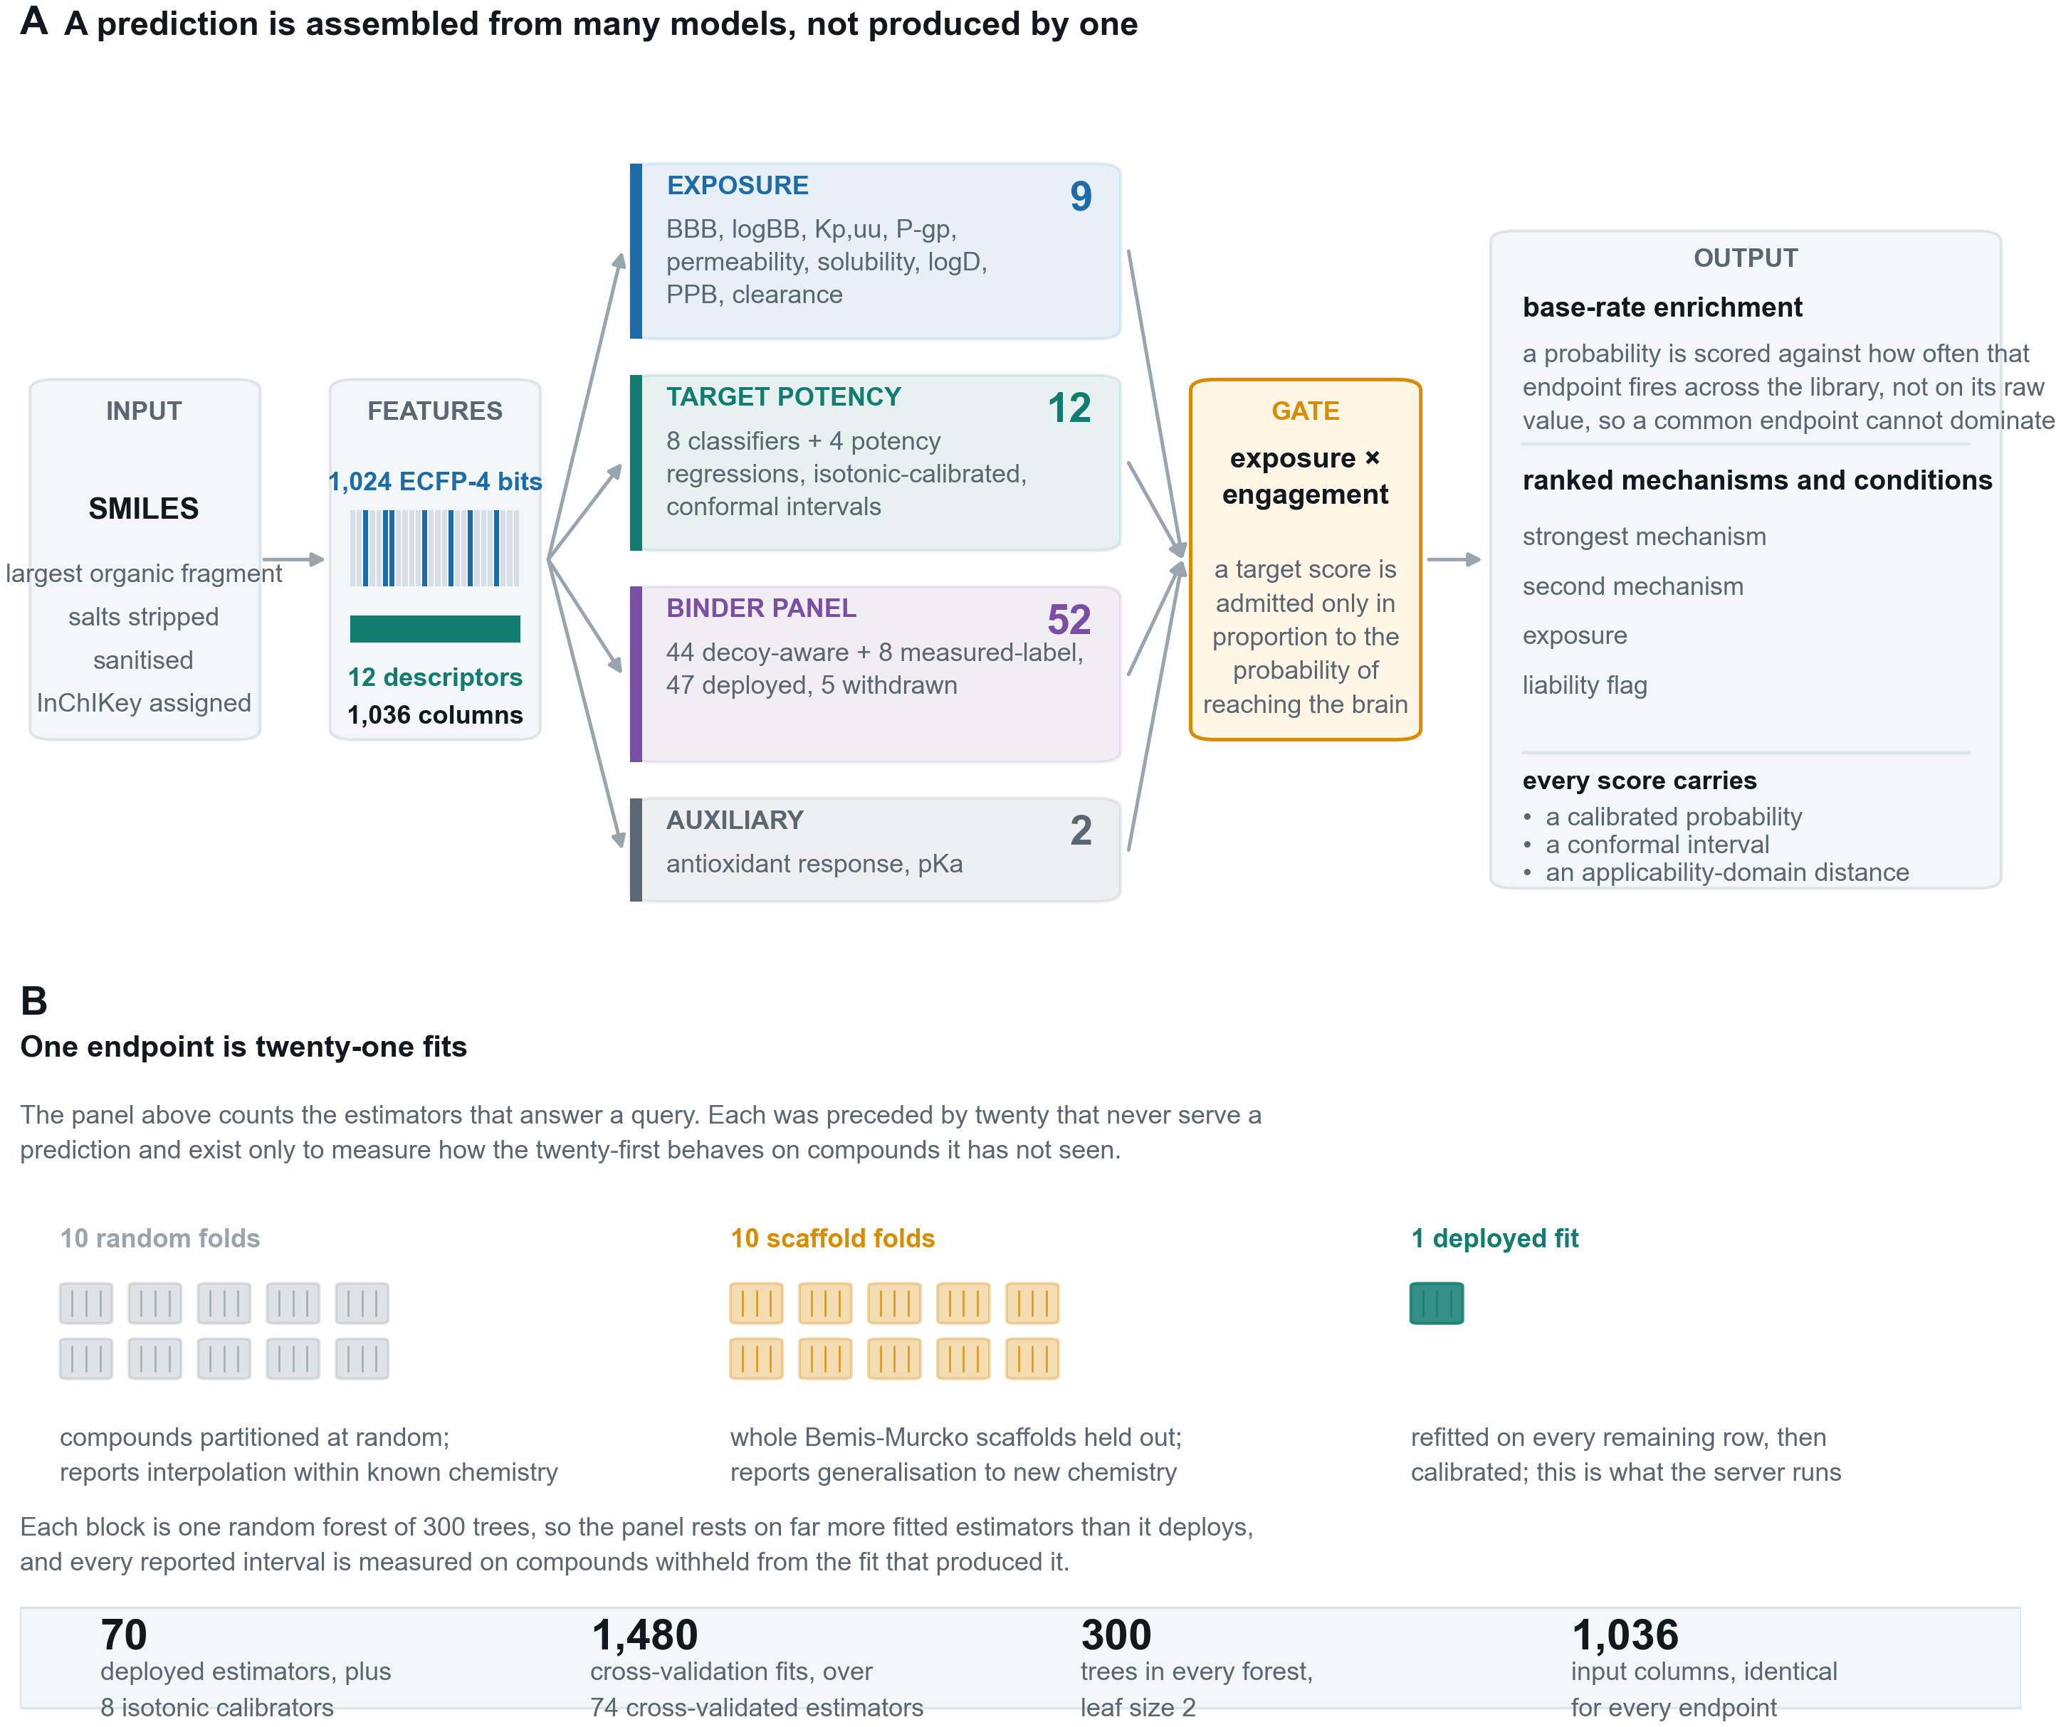
Figure 1
Figure 1. How a query is answered. (A) A submitted structure is standardised and represented as one fixed 1,036-column vector, scored by four model families, as MODEL_INVENTORY.csv defines them: the 52-endpoint binder panel of which 47 are deployed, twelve target potency and activity endpoints, the ten-endpoint exposure and ADME layer including the barrier model itself, and the single hERG safety classifier. Every target score is admitted only in proportion to the predicted probability that the compound reaches the brain, and surviving scores are ranked by enrichment over each endpoint’s base rate rather than by raw probability. Every reported value carries a calibrated probability and an applicability-domain distance, and the eight core classifiers additionally report a conformal interval. (B) The counts in (A) are trained estimators, 75 in total, of which 70 are deployed. Each was preceded by twenty fits that never serve a prediction and exist only to measure how the twenty-first behaves on withheld compounds, 1,480 across the panel.
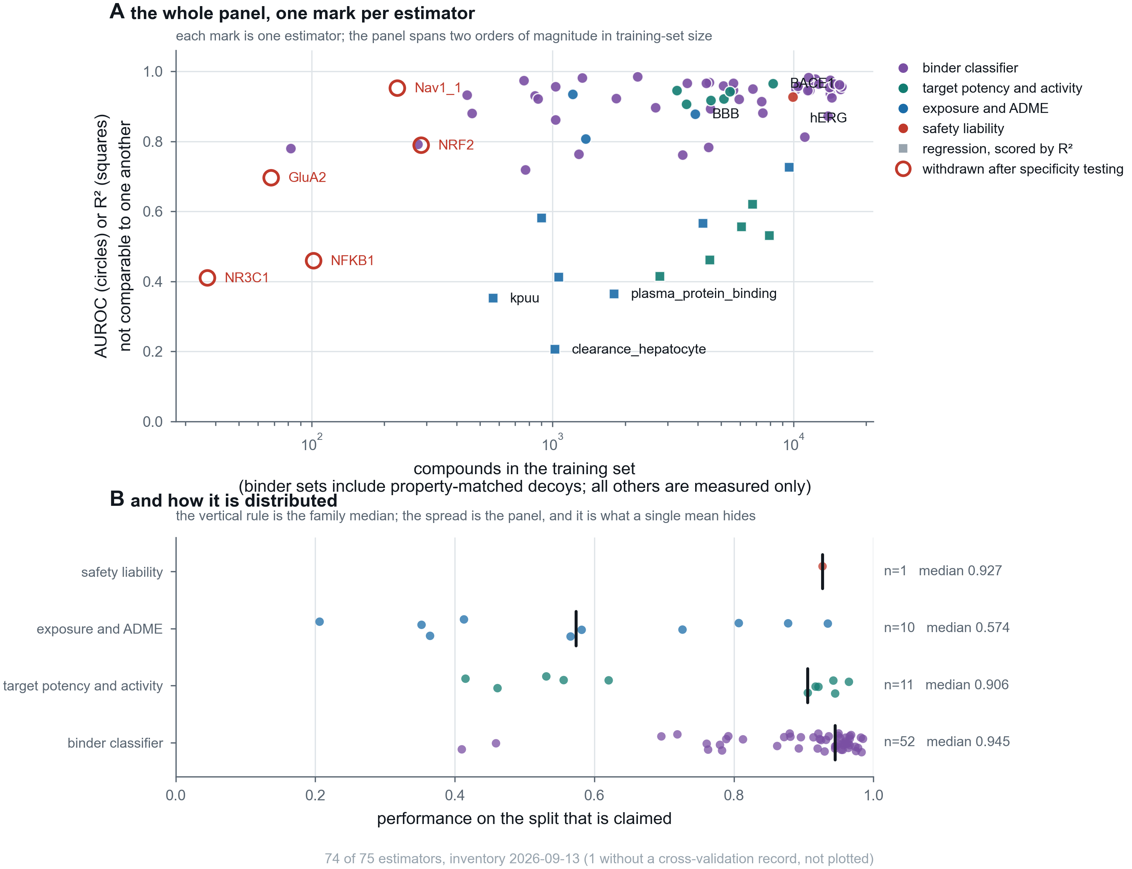
Figure 2
Figure 2. The panel, one mark per estimator, so that no claim rests on a mean a reader cannot check. (A) Every estimator, deployed or withdrawn, placed by the number of compounds it was trained on and by the performance claimed for it, coloured by model family. Marker shape carries the metric: AUROC and R² both run to 1.0 and are not the same quantity, since 0.5 is chance for one and a respectable fit for the other, so they are distinguished rather than averaged. The five estimators withdrawn after specificity testing are drawn in outline, because a panel showing only what survived is a selection rather than an inventory. Training sets span two orders of magnitude, from 37 to 15,831 rows; binder training sets include property-matched decoys while the others are measured compounds only, which the axis states. (B) The same population by family, with the family median marked. The spread is the point: the binder classifiers have a median of 0.945 while the exposure and ADME family, which mixes AUROC and R² endpoints, has a median of 0.574, and a single panel average would describe neither. The complete inventory, with training-set composition, validation scheme, calibration and fitting date for every estimator, is Supplementary Table S1.
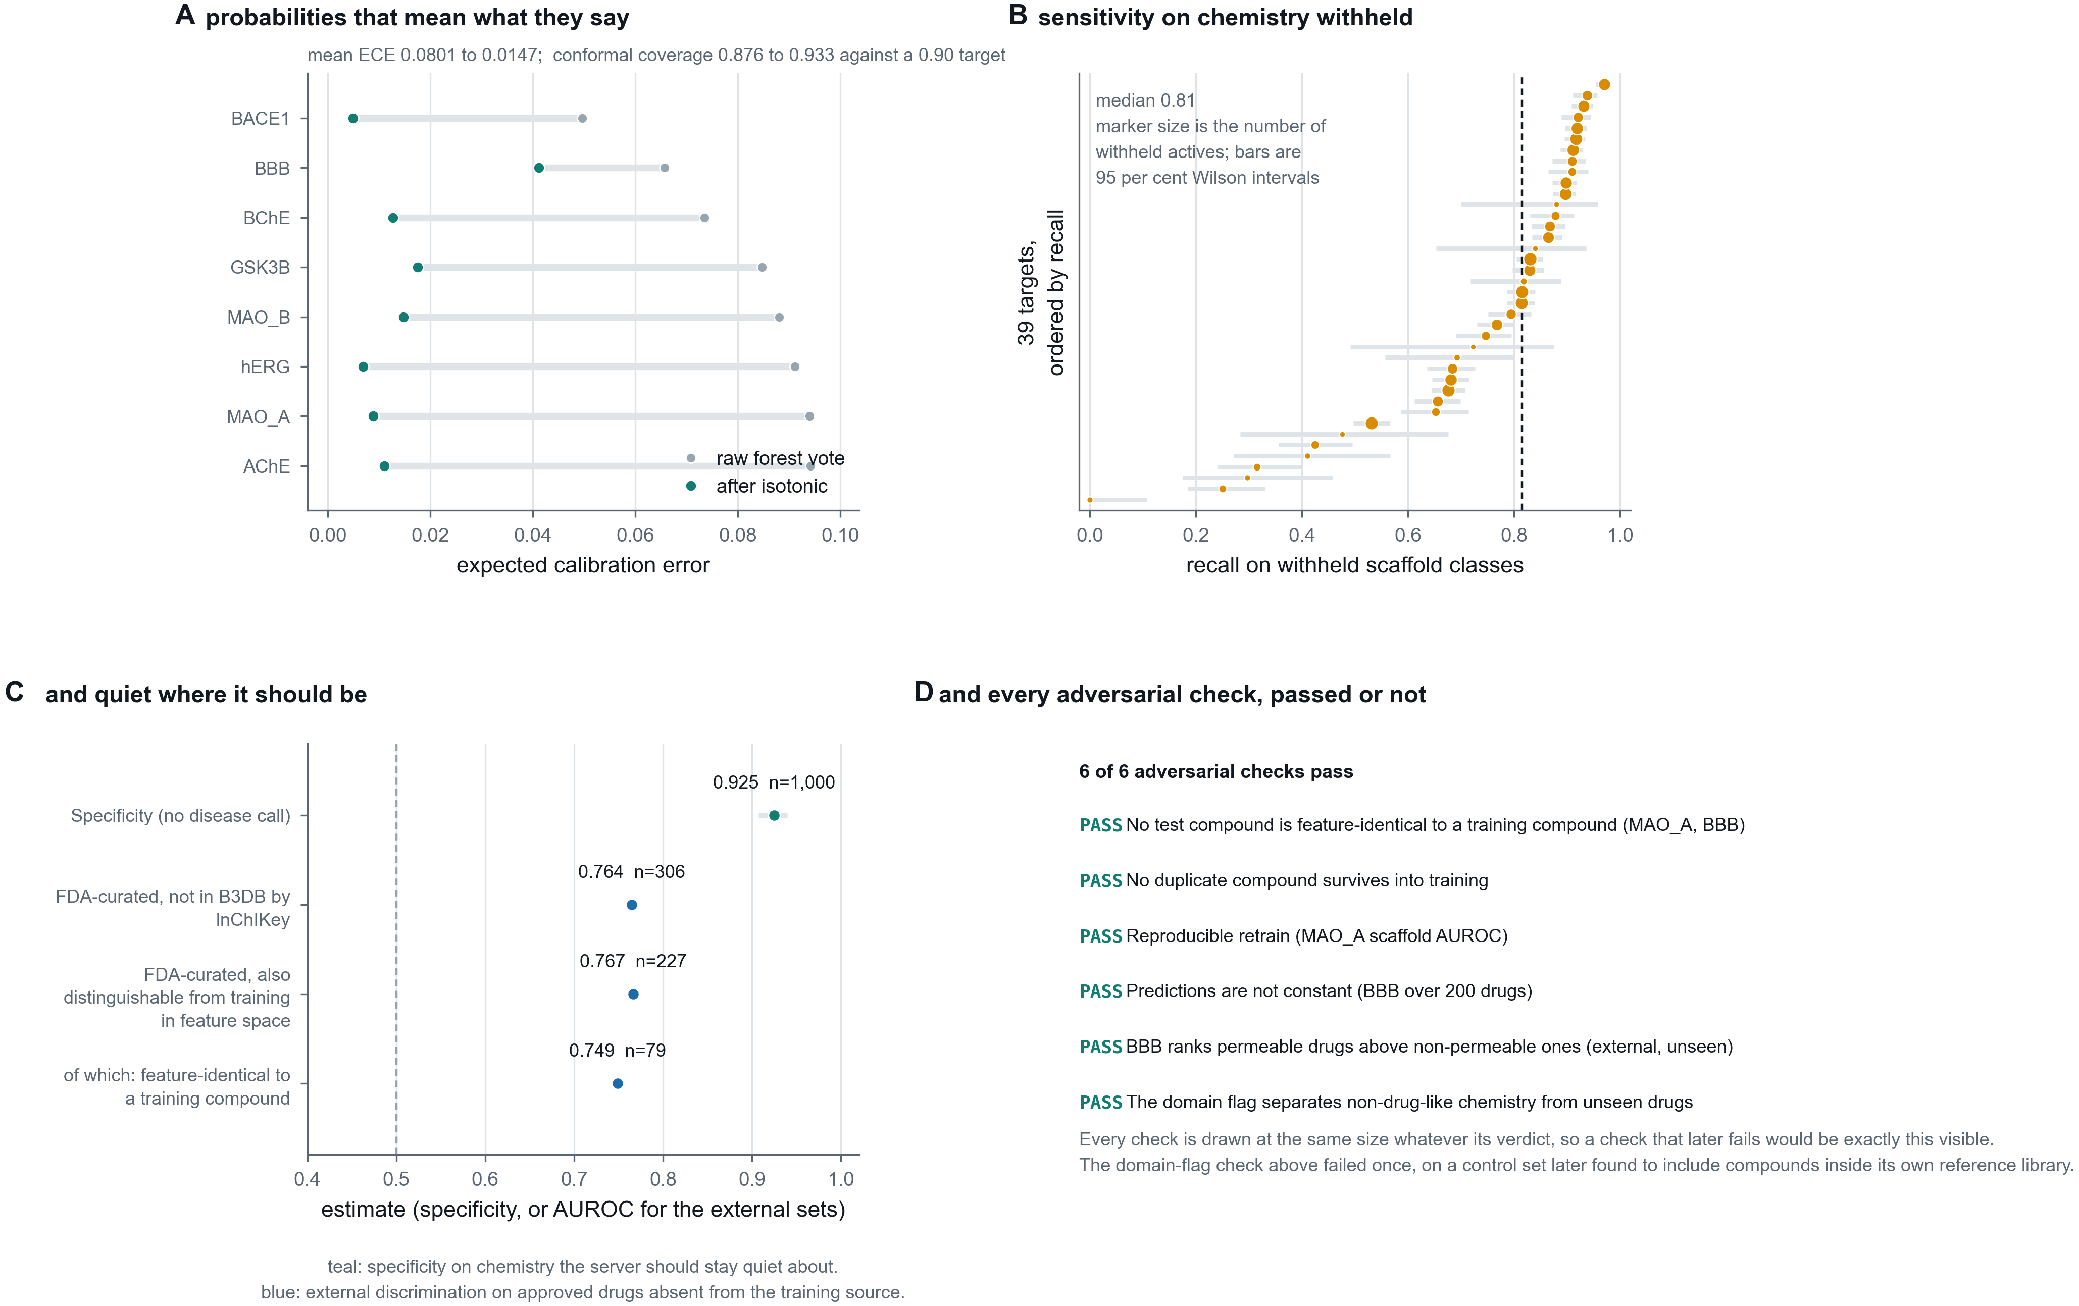
Figure 3
Figure 3. Four validations that a cross-validated score cannot replace. (A) Expected calibration error before and after isotonic regression fitted on out-of-fold predictions, so no compound contributes to the calibrator that scores it. (B) Recall on whole scaffold classes withheld before training, with 95 per cent Wilson intervals (17) and marker area proportional to the number of withheld actives, so an interval that is wide because the evidence is thin looks thin. (C) Specificity on chemistry the server should stay quiet about, and external discrimination on approved drugs absent from the training source. (D) The adversarial suite, in which each check was written so that it could fail. All six pass, one of them, the applicability-domain flag, only after its controls were corrected rather than its criterion retuned; every check is drawn at the same size whatever its verdict, so a future failure would be exactly this visible.
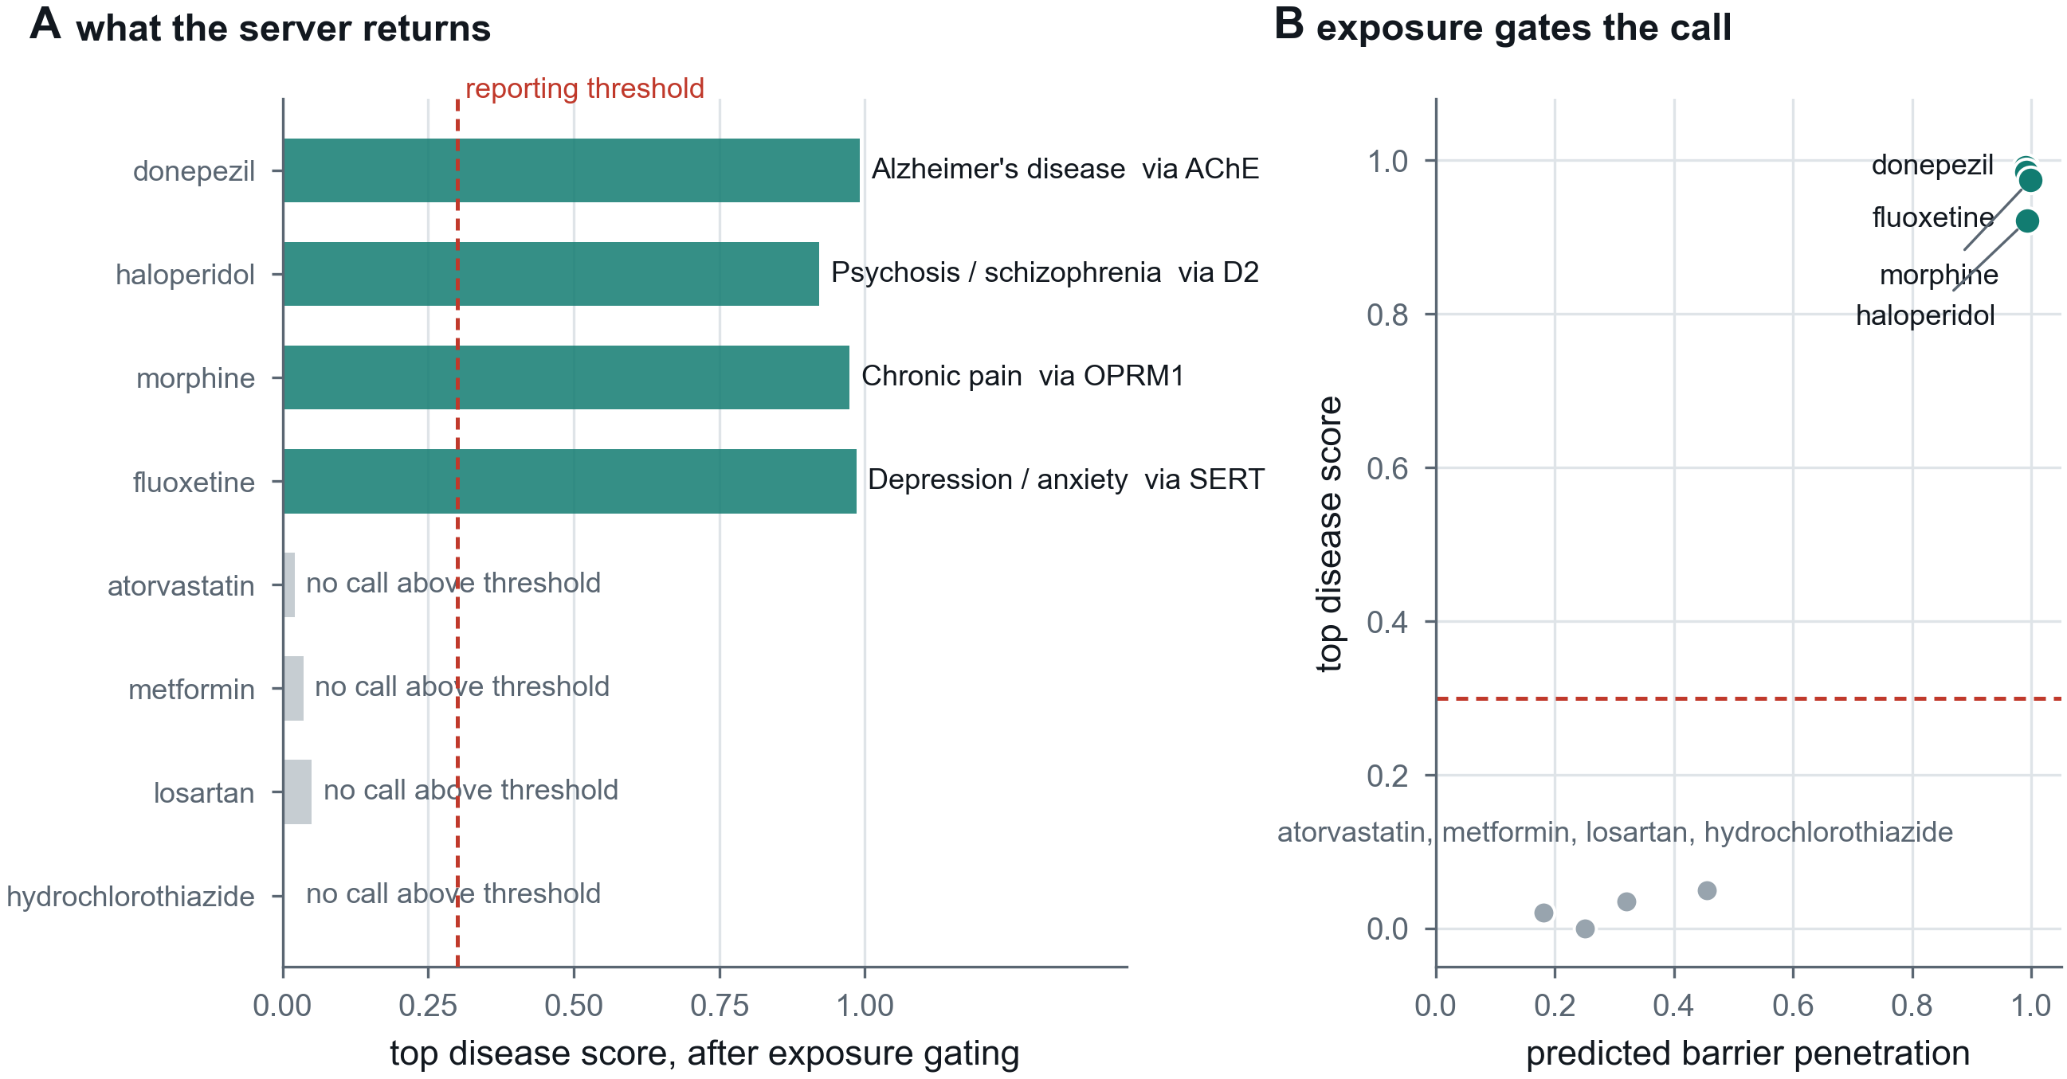
Figure 4
Figure 4. A worked profile and the silence behaviour. For four approved CNS drugs the server recovers the pharmacologically correct driving mechanism and the corresponding condition; for four peripherally acting compounds no disease score reaches the reporting threshold. Bars are disease scores after exposure gating, and the driving target is named beside each. The two behaviours are the same design decision seen from opposite sides: a target score is admitted only in proportion to predicted barrier penetration, so a compound that does not arrive cannot generate a disease call.
Supplementary figures, each named by the file it is generated into so that the number and the artefact cannot come apart:
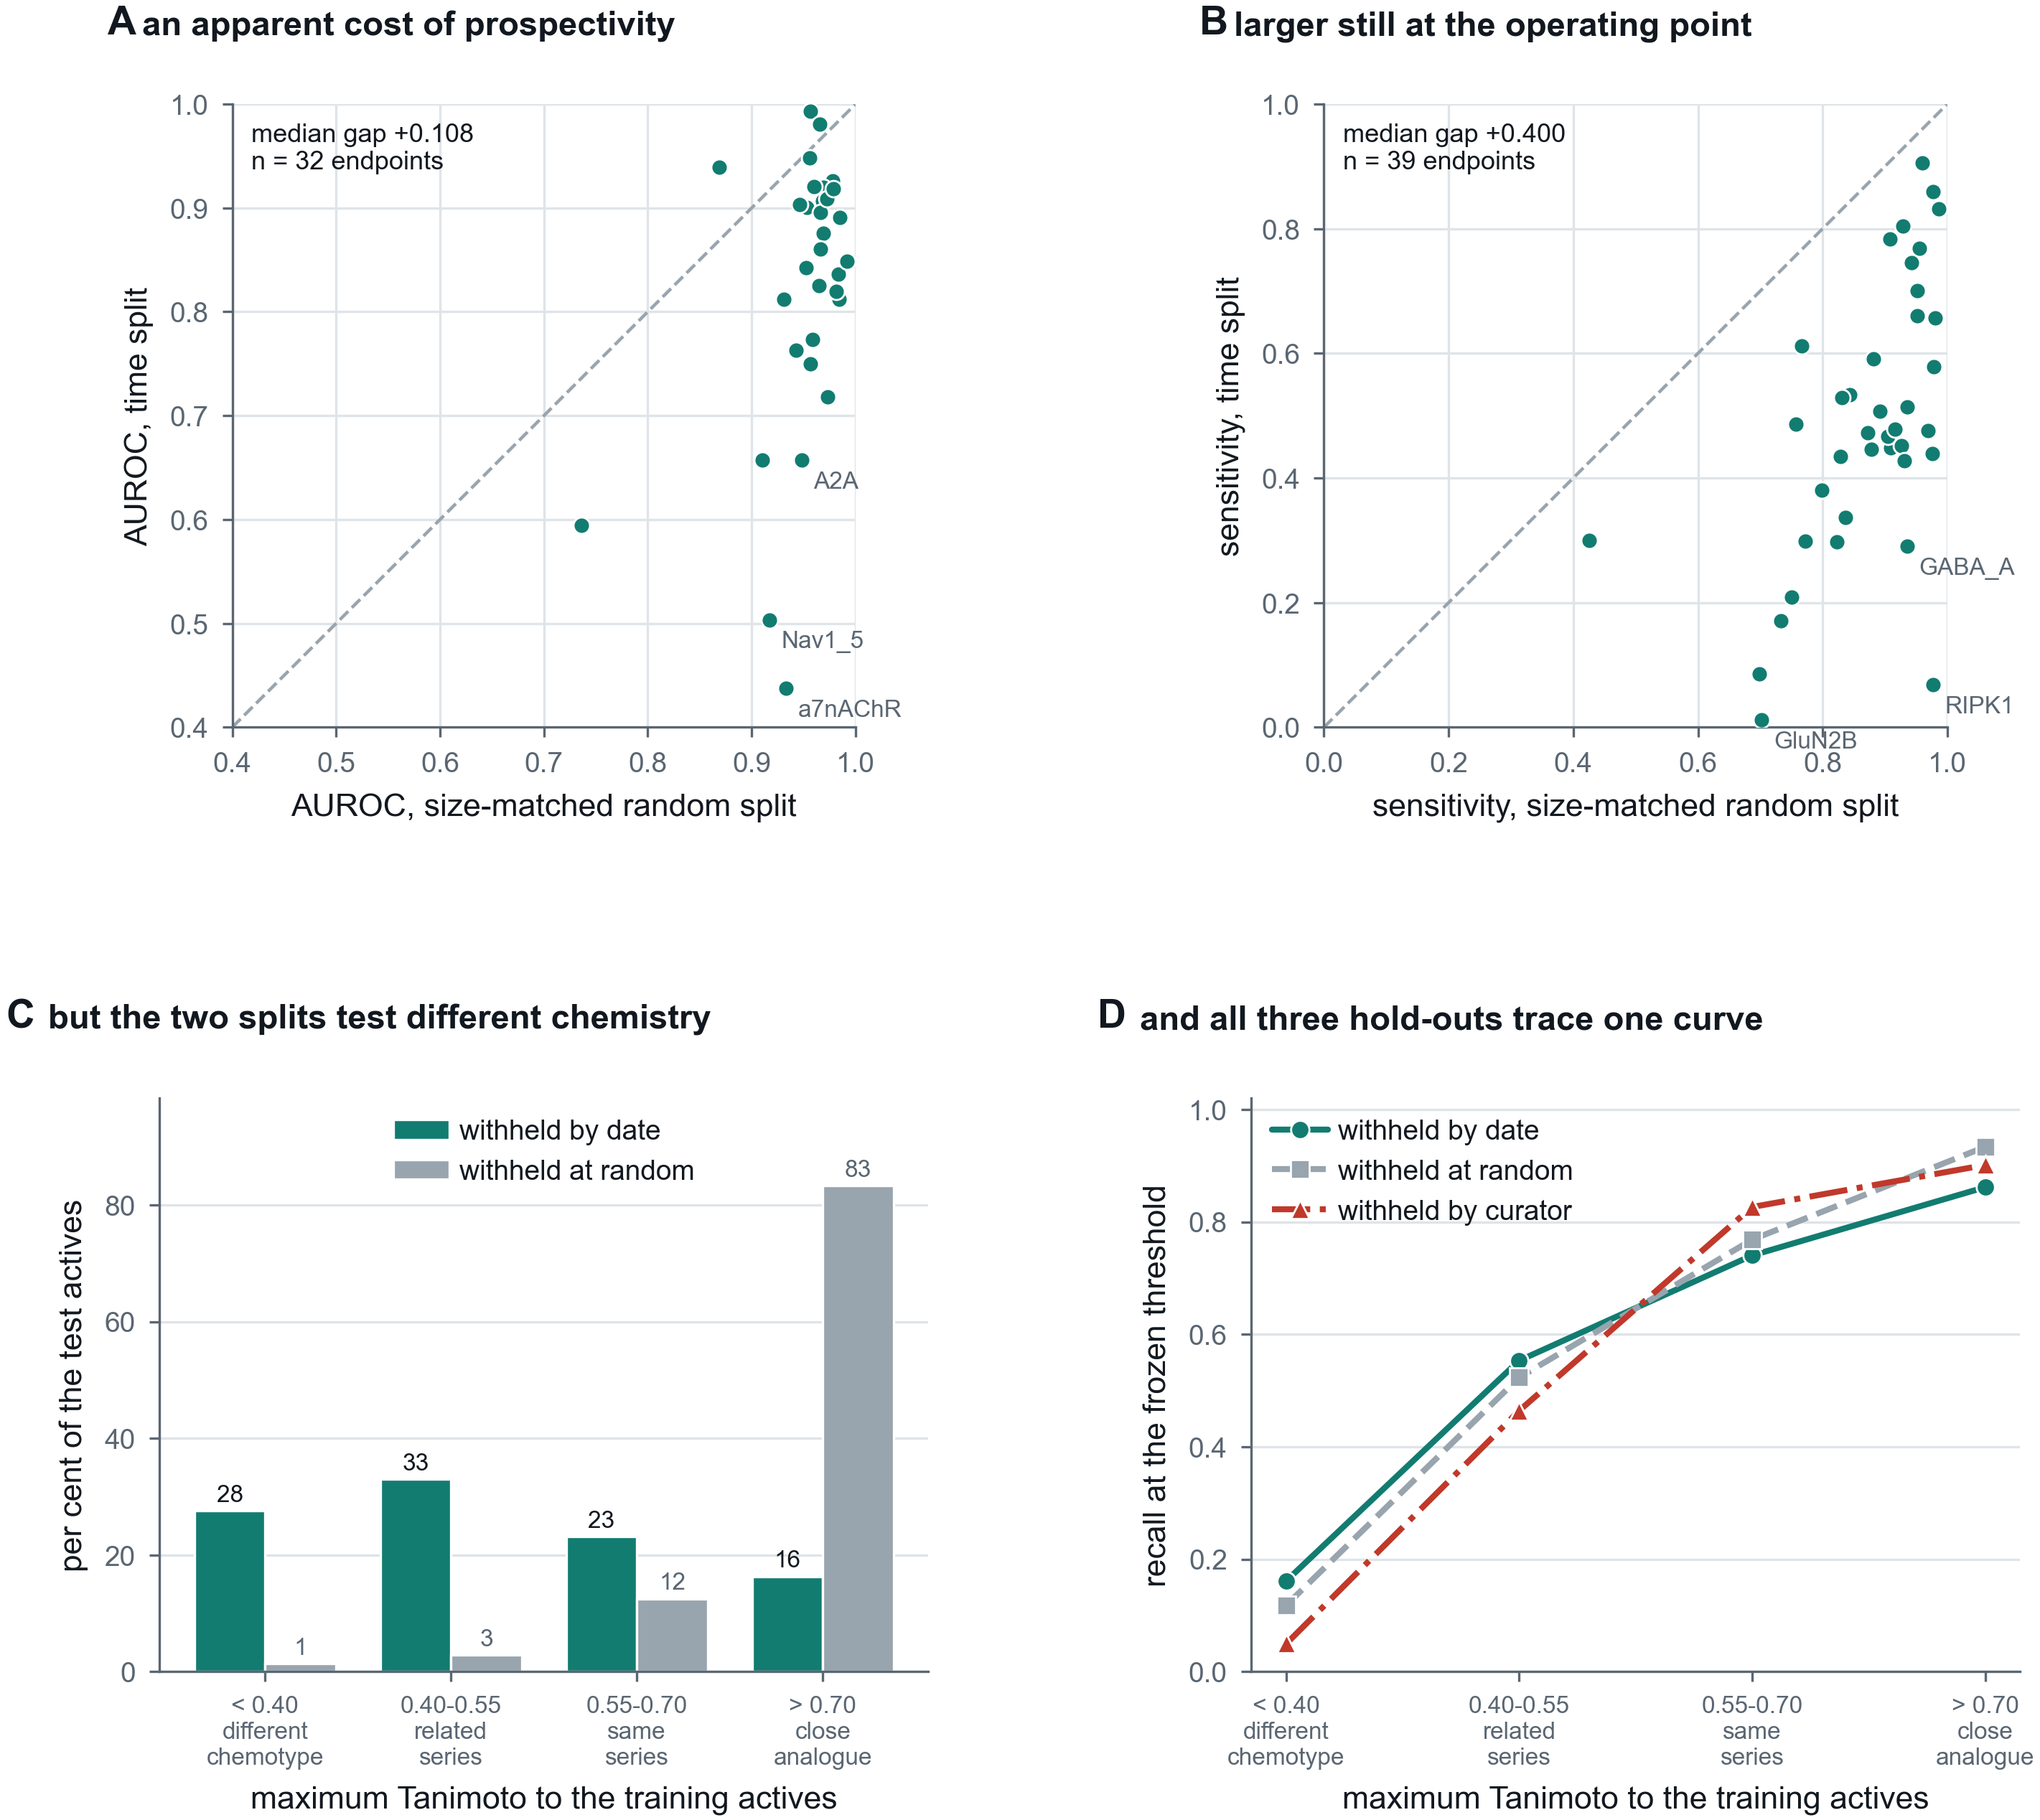
Figure 5
Figure 5. External validation, and an apparent temporal decay that is a composition effect. (A) Per endpoint, AUROC under a size-matched random split against AUROC under a time split that withholds the most recent quarter of the data and freezes the decision threshold before the cutoff. The size match matters: a time split trains on less data as well as none of the future, so without a control at the same n a drop cannot be attributed to either. (B) The same comparison for sensitivity at the frozen operating point, where the gap is larger. (C) Why the gap exists. A random split of medicinal-chemistry data holds out mostly close analogues of its own training set, because the published record is series; a time split does not. The two are not testing comparable populations. (D) The resolution. Recall against maximum Tanimoto similarity to the training actives, for three test sets built by unrelated rules: withheld by publication date, withheld at random, and withheld by curator, the last being compounds deposited in BindingDB and absent from ChEMBL. They trace one curve, so recall is a function of chemical distance rather than of how the set was held out, and the expected sensitivity for a submitted compound is knowable at query time.

