Table of Contents

BrainSafe AI: a calibrated, applicability-aware web server for multi-endpoint prediction of small-molecule effects on the human brain
Authors: [Author list to be finalised]
Affiliation: SAI-Net initiative, Sri Sathya Sai Institute of Higher Learning (SSSIHL), Prasanthi Nilayam, India.
Correspondence: [email]
Manuscript type: NAR Web Server Issue.
Repository: https://github.com/krishna-g-999/brainsafe-ai

Abstract
Deciding whether a small molecule is likely to act on the brain requires answering several questions at once: can it cross the blood-brain barrier, which disease-relevant targets does it engage, does an achievable dose deliver free drug to the central nervous system, and is it safe. BrainSafe AI is an open web server that answers these questions from chemical structure alone. It integrates a panel of 26 molecular-target models and a measured antioxidant model with a nine-endpoint ADME/exposure layer, every endpoint trained on measured public bioactivity data (ChEMBL, BindingDB and the B3DB blood-brain-barrier database). Predictions are probability-calibrated, carry an endpoint-specific applicability-domain flag with the nearest measured analogue, and are combined into blood-brain-barrier-gated, per-disease relevance scores that are traced through a curated target-to-pathway-to-disease knowledge graph spanning eleven brain conditions. On a scaffold-split benchmark the classifier panel reaches a mean AUROC of 0.92, and the decoy-aware binder classifiers reach 0.86-0.99 against near-miss decoys. The server returns, for every structure, an auditable, mechanistically interpretable brain-relevance profile rather than a single opaque score. BrainSafe AI is freely available at [URL].

Introduction
Central-nervous-system drug discovery has a distinctive failure profile: a candidate can be potent against its intended target yet never reach the brain, or reach it but carry an unacceptable safety liability, or engage unintended targets that reshape its clinical profile. Answering “will this molecule affect the brain, how, and is it safe” therefore means combining blood-brain-barrier (BBB) penetration, disease-relevant target engagement, free-brain exposure, and safety into one readout. Existing public tools typically address one of these axes in isolation, and large language models, while fluent, fabricate measured identifiers and cannot supply a calibrated, auditable answer.
BrainSafe AI is a web server that unifies these axes for any user-supplied structure. Its design priorities are three. First, every machine-learning endpoint is trained only on measured experimental data, never on qualitative annotation, so predictions are not circular. Second, every prediction is reported with its uncertainty: a calibrated probability, an applicability-domain flag, and the nearest measured analogue behind it, so the user always knows whether a number is interpolation or extrapolation. Third, predictions are made mechanistically interpretable: individual target engagements are traced through a curated target-to-pathway-to-disease knowledge graph into BBB-gated, per-disease relevance scores, so a result is an explanation, not just a number.

Materials and Methods

Training data
Each endpoint is trained on measured public bioactivity. Protein-target activity is pooled from ChEMBL (pChEMBL values) and BindingDB at the compound level; BBB penetration uses the B3DB database augmented with FDA-curated approved drugs; the antioxidant endpoint uses measured DPPH pIC50 values; and the nine ADME/exposure endpoints use measured sets from Therapeutics Data Commons, MoleculeNet, B3DB and ChEMBL. The core target panel is trained on 64,474 measured records across 61,317 unique compounds. The 14 expansion targets contribute a further 1,004-11,474 measured activities each. No value is imputed and no source overrides a measurement.

Methods compared and model selection
Molecules are represented by a 1024-bit ECFP-4 fingerprint plus twelve interpretable physicochemical descriptors (molecular weight, cLogP, topological polar surface area, hydrogen-bond donors and acceptors, rotatable bonds, aromatic rings, fraction sp3, ring count, heavy-atom count, formal charge, and QED drug-likeness). We benchmarked five model families under identical ten-fold cross-validation on both random and scaffold-grouped splits (Figure 3a). Two are baselines: a k-nearest-neighbour Tanimoto read-across, and L2-regularised logistic regression. Two are gradient-boosted tree ensembles: XGBoost and histogram gradient boosting. The fifth is a random forest. Separately, we trained a graph isomorphism network (GIN) directly on molecular graphs to test whether a learned representation would beat fixed descriptors (Figure 3b).
On the honest scaffold split the random forest gave the highest mean classifier AUROC (0.914) and matched or exceeded every alternative on the like-for-like comparison, ahead of XGBoost (0.905), histogram gradient boosting (0.901), the k-nearest-neighbour read-across (0.867), and logistic regression (0.808); paired DeLong and bootstrap tests confirm the random forest exceeds the read-across on every endpoint. The graph neural network did not outperform the random forest on any tested endpoint (Figure 3b), consistent with the fingerprint-plus-descriptor representation being sufficient at this data scale. We therefore deploy a probability-calibrated random forest for every endpoint: it gives the best honest-split accuracy, calibrates stably, is interpretable through feature importance, and needs no GPU, which keeps the web server lightweight.
Eight endpoints are trained as classifiers (BBB, AChE, BChE, BACE1, GSK-3beta, MAO-A, MAO-B, and the hERG cardiotoxicity liability). Under ten-fold cross-validation they reach a mean AUROC of 0.960 on random splits and 0.919 on scaffold-grouped splits (range 0.87-0.96, Figure 4a); an external test of the BBB model on 306 FDA-curated approved drugs absent from training gives AUROC 0.774.

Decoy-aware binder classifiers
The receptor and transporter targets (D2, A2A, 5-HT2A, SERT and fourteen expansion targets covering serotonergic, dopaminergic, opioid, cannabinoid, histaminergic, adenosine, sigma-1, nicotinic and LRRK2 pharmacology) are reported in ChEMBL almost entirely as actives (82-99% of records), so a naive potency regressor learns to predict the training median for any input and cannot discriminate a real binder from an arbitrary molecule. We therefore model each as a binder-versus-decoy classifier: positives are measured binders (pChEMBL >= 7); negatives are property-matched decoys sampled from a 75,000-compound background library with a maximum ECFP-4 Tanimoto below 0.35 to any positive, so the model must learn structure rather than a similarity shortcut. Each classifier is a compact random forest with prefit sigmoid calibration. Validated against held-out near-miss decoys (Tanimoto 0.35-0.55) rather than the easy training decoys, these models reach AUROC 0.86-0.99 with a background false-positive rate of 0.6-9% at a 0.5 threshold (Figure 4b).

Calibration, applicability domain and exposure
Every classifier is isotonically calibrated (mean expected calibration error 0.072 to 0.012). For every prediction the server computes the maximum ECFP-4 Tanimoto similarity of the query to each endpoint’s own measured chemistry and reports an endpoint-specific in-domain, near-domain or out-of-domain flag together with the nearest measured analogue and its structure. A nine-endpoint ADME/exposure layer, including a directly-modelled unbound brain-to-plasma partition coefficient (K_p,uu), provides a free-brain-exposure verdict; on known drugs this correctly separates central compounds (diazepam K_p,uu 0.94, donepezil 0.84) from peripheral or efflux-limited ones (atenolol 0.07, loperamide 0.04).

Base-rate enrichment and the knowledge graph
Because several classifier training sets are active-heavy (for example BACE1 91%, GSK-3beta 93% positive), a raw calibrated probability is not evidence of engagement unless it exceeds the base rate. The server therefore scores each target by its enrichment over the endpoint base rate, and each receptor by its floored binder probability, so that a prediction near chance contributes nothing. A curated, versioned knowledge graph maps each target through a biological pathway to the diseases it informs, anchored to KEGG synapse and disease maps (hsa04725, hsa04726, hsa04728, hsa04723, hsa05032, hsa04080, hsa05010, hsa05012), the Reactome KEAP1-NFE2L2 oxidative-stress response (R-HSA-9020702) and IUPHAR Guide to Pharmacology associations. A per-disease relevance score is the strongest engaged target for that disease gated by predicted BBB penetration; taking the strongest rather than an average prevents unrelated mechanisms from diluting a real signal. Coverage spans eleven brain conditions: Alzheimer’s disease, Parkinson’s disease, depression and anxiety, psychosis, cognition, addiction, ADHD, chronic pain, sleep and wakefulness, epilepsy, and neuroprotection.

Web implementation
The server is a single-page application built with Streamlit and RDKit. Model inference is cached; a prediction for a novel structure returns in under a second after warm start. The interface, inputs and figures are self-contained and require no installation by the user.

The BrainSafe AI server
Input. The user pastes a SMILES string or selects a curated example, then presses Predict. Unknown structures are parsed and standardised with RDKit (salt stripping, largest-fragment selection).
Output. Results are laid out as a single scrollable report (Figure 1):
- A summary card with the rendered structure, the free-brain-exposure verdict driven by K_p,uu, and headline metrics for K_p,uu, BBB penetration and hERG liability.
- A mechanistic map (Figure 2): a four-tier diagram (compound to target to pathway to disease) in which only engaged targets are drawn, line weight encodes engagement, and node order is arranged to minimise crossings, so the biological rationale for each disease link is immediately legible.
- A brain-relevance panel giving the BBB-gated score for each of the eleven conditions with its driving mechanism, and a one-line interpretation of the compound’s predicted profile.
- A target-engagement table reporting each classifier’s calibrated probability, its base rate, and a base-rate-aware engagement call.
- A receptor-binding table reporting the decoy-aware binder probability for each receptor and transporter, with predicted potency shown only for predicted binders.
- An ADME/exposure (ADMET) table of the nine measured endpoints, and a physicochemical profile.
- An applicability and confidence card giving the global and per-endpoint domain flags and the nearest measured analogue with its structure.
An About tab documents the methods, a model-selection and validation section (random forest versus XGBoost versus GIN, and per-endpoint scaffold AUROC), and an explicit coverage panel that states which mechanisms and diseases the tool can and cannot yet assess, so a null result is read as an honest unknown rather than as inactivity.

Validation and use cases
Across a reference panel of well-characterised CNS drugs the top predicted disease matched the known indication for donepezil (Alzheimer’s), selegiline (Parkinson’s), fluoxetine (depression), haloperidol (psychosis), morphine (chronic pain), methylphenidate (addiction/ADHD) and resveratrol (neuroprotection). Two acetylcholinesterase inhibitors of atypical chemotype (rivastigmine, galantamine) were under-called to low magnitude rather than mis-assigned, and were correctly flagged as low-confidence by the applicability-domain layer, illustrating the value of reporting uncertainty alongside every prediction. The decoy-aware receptor models recover expected selectivity, for example haloperidol as a D2 and 5-HT2A binder and fluoxetine as a selective serotonin-transporter binder, while non-CNS controls (aspirin, caffeine at the modelled targets) return no distinctive engagement.

Discussion
BrainSafe AI is, to our knowledge, the first public web server to combine BBB penetration, a broad measured-data target panel, free-brain exposure, and safety into a single calibrated, applicability-aware, mechanistically interpretable readout for arbitrary structures. Its central design choice is honesty about uncertainty: enrichment over base rate rather than raw probability, per-endpoint applicability domains, and an explicit coverage statement. The main limitations are inherited from the training data. Target coverage, though broad, is finite: ionotropic glutamate and GABA-A receptors, protein-aggregation and neuroinflammation phenotypes, and epigenetic targets are not yet modelled, and diseases outside the current mechanistic panel (for example ALS, Huntington’s disease and stroke) are not scored. Predictions are of molecular target engagement and physicochemical properties, not clinical efficacy, and do not distinguish agonism from antagonism. The tool is intended for research prioritisation and hypothesis generation and is not for medical, diagnostic or treatment decisions.

Data availability
All code, trained models, curated knowledge graph and validation artifacts are available at https://github.com/krishna-g-999/brainsafe-ai under [license]. The server is freely accessible at [URL] with no login requirement.

Funding
[To be completed.]

Figure legends
Figure 1. The BrainSafe AI report for a query compound: summary card, mechanistic map, brain-relevance panel, target and receptor tables, ADMET panel, and the applicability and confidence card.
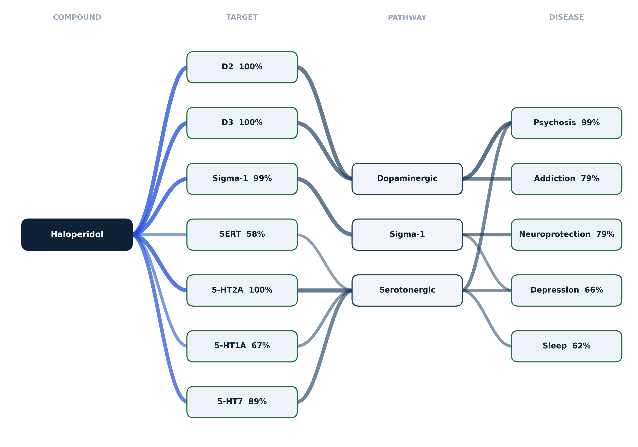
Figure 2
Figure 2. The mechanistic map, shown for haloperidol. A four-tier diagram (compound, target, pathway, disease) in which only engaged targets are drawn, connector weight encodes engagement strength, node order is arranged to minimise crossings, and pathways are anchored to KEGG and Reactome identifiers.
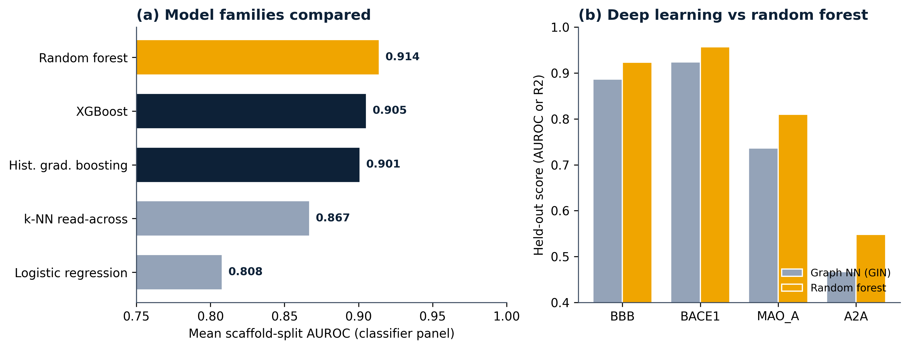
Figure 3
Figure 3. Model selection. (a) Mean scaffold-split AUROC across the classifier panel for the five model families compared: logistic regression, k-nearest-neighbour read-across, histogram gradient boosting, XGBoost, and the deployed random forest (gold). (b) Held-out comparison of a graph isomorphism network against the random forest per endpoint; the random forest wins on every endpoint.
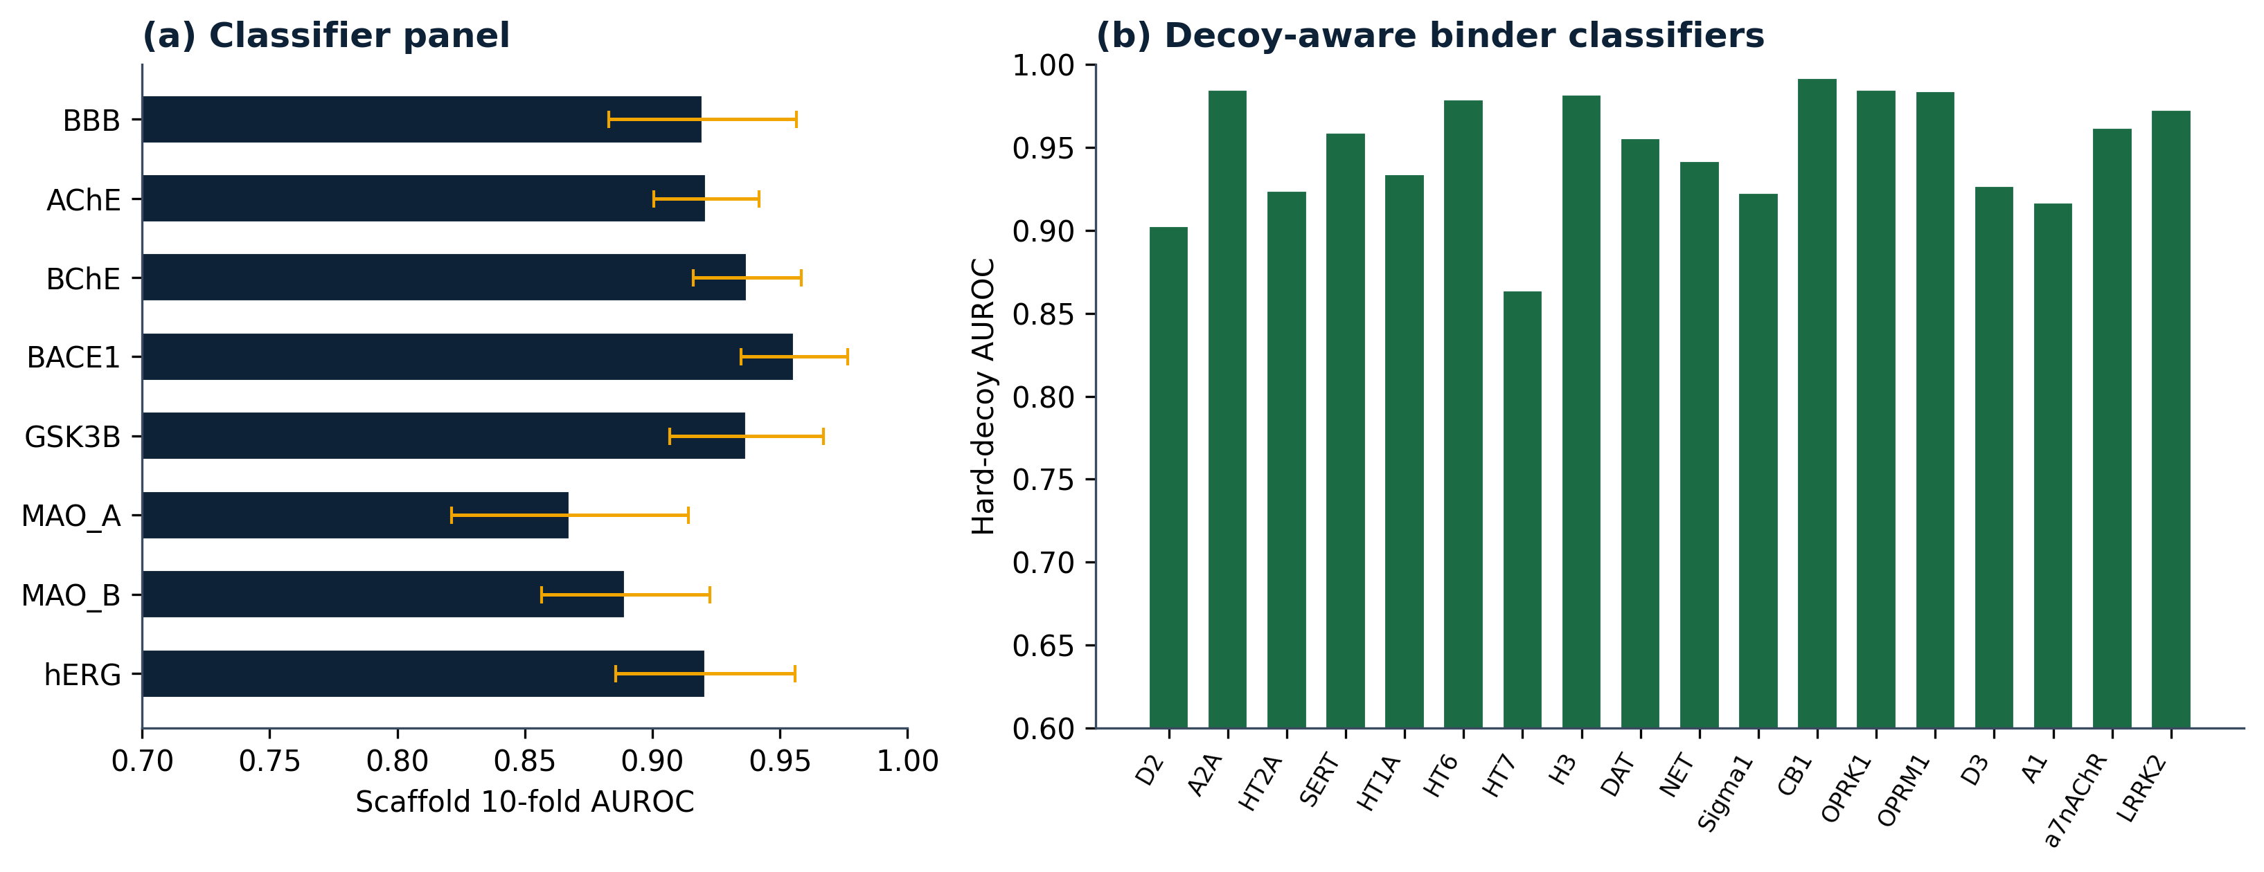
Figure 4
Figure 4. Validation. (a) Per-endpoint scaffold ten-fold AUROC for the eight classifier endpoints (bars, mean; whiskers, standard deviation across folds). (b) Hard-decoy AUROC for the eighteen decoy-aware receptor and transporter binder classifiers, evaluated against near-miss decoys.

References
[To be completed. Anchor citations: ChEMBL; BindingDB; B3DB; RDKit; Therapeutics Data Commons; KEGG; Reactome; IUPHAR/BPS Guide to Pharmacology; scikit-learn; Streamlit; Mondrian conformal prediction; isotonic calibration.]

