Table of Contents

BrainSafe AI: an evidence-grounded, calibrated, BBB-gated multi-endpoint predictor of small-molecule effects on the human brain
Complete methodology, results, and discussion. All figures/values are produced by the reproducible scripts in this repository; numbers are read from the saved validation artifacts, not estimated.

Abstract
BrainSafe AI is an open computational tool that estimates a compound’s profile of brain-relevant effects from its chemical structure alone. It brings together eight machine-learning endpoints, every one trained on measured public bioactivity data (ChEMBL pChEMBL values and the B3DB blood–brain-barrier database): blood–brain-barrier (BBB) penetration, inhibition of AChE, BChE, BACE1, GSK-3β, MAO-A and MAO-B, and the hERG cardiotoxicity liability. Four further receptor targets (D2, A2A, 5-HT2A and SERT) are handled instead as potency regressions. A deterministic druggability/CNS-MPO layer, a measured-data antioxidant (DPPH) model, and a clinical-precedent layer of 504 nervous-system compounds with real clinical-phase data round out the system. Every prediction is isotonic-calibrated, carries a Mondrian conformal prediction set with empirically verified ~90% coverage, is grounded in the nearest real measured analogues, and feeds into BBB-gated per-disease scores. We validated the models under a hierarchy of increasingly demanding splits: random, scaffold, leave-cluster-out and temporal. On like-for-like random splits the classifiers reach AUROC 0.94–0.98, at or above published state of the art; under scaffold and cluster splits 0.87–0.95; and under a true temporal (future-compound) split 0.61–0.92, which shows plainly where generalisation runs out. Under an identical protocol the deployed ensemble beats both a k-nearest-neighbour Tanimoto read-across (mean AUROC 0.912 vs 0.867) and logistic regression (0.808) on every endpoint. We also ran a pre-registered head-to-head against four general-purpose large language models: on well-known drugs they matched or exceeded BrainSafe at BBB and hERG classification, yet 45% of the measured-data identifiers they cited were fabricated or mis-attributed and all four invented a target and potency for an unpublished compound, whereas BrainSafe returned, for every structure, a calibrated probability, a conformal set, and the nearest measured analogue, the kind of grounded, auditable output an LLM does not supply. The contribution here is the integration, calibrated, evidence-grounded, BBB-gated and safety-aware CNS profiling from measured data, rather than any one new algorithm.

Note added in revision (2026-07-21): data expansion and a Random-forest, ten-fold model
In response to review we (i) added a second independent measured source, BindingDB, to the eleven protein-target endpoints, pooling it with ChEMBL at the compound level. The training corpus grew to 61,317 unique compounds across 67,982 measured records (18,573 compounds are measured by both databases; 4,246 are contributed by BindingDB alone). (ii) We report a Random forest trained under ten-fold cross-validation for every endpoint, under both random and scaffold-grouped splits; mean classifier AUROC is 0.960 (random) and 0.919 (scaffold), and receptor-regression R² is 0.60–0.68 (random) and 0.39–0.58 (scaffold). (iii) Because the BindingDB export contributes actives, we audited the addition against the ChEMBL-only baseline: the scaffold-split headline changed by a mean of −0.0002, i.e. the added data neither inflates nor degrades performance. (iv) We strengthened two methodology points: isotonic probability calibration (mean expected calibration error 0.072 → 0.012) and an explicit applicability-domain flag (nearest-neighbour Tanimoto), which shows that arbitrary drug libraries are largely outside the target-specific models’ domain and must be flagged as extrapolation. (v) An external test of the BBB model on 306 FDA-curated approved drugs absent from training gives AUROC 0.774. Full detail and every supporting table are in docs/RF_CV_RESULTS.md, docs/METHODOLOGY_AUDIT.md and docs/DATA_MANIFEST.md.

Note added in revision (2026-07-22): an ADME / exposure layer toward K_p,uu
Target engagement and BBB penetration do not, on their own, say whether an achievable dose delivers free drug to a brain target. We therefore added nine measured ADME / exposure endpoints, trained with the identical random-forest, scaffold-10-fold protocol (~23,000 measured compounds from TDC / Harvard Dataverse, MoleculeNet, B3DB and ChEMBL): aqueous solubility, lipophilicity, Caco-2 permeability, P-glycoprotein inhibition and substrate (efflux), plasma-protein binding, hepatocyte clearance, logBB, and, directly, the unbound brain-to-plasma partition coefficient K_p,uu (566 measured compounds, ChEMBL K(p,uu,brain); scaffold R² 0.35). Scaffold performance ranges from strong (P-gp inhibition AUROC 0.937, solubility R² 0.76) to weak and disclosed (clearance R² 0.19). The directly-modelled K_p,uu drives a combined free-brain-exposure readout (K_p,uu ≥ 0.3 taken as meaningful exposure) that, on known drugs, correctly separates central compounds (diazepam K_p,uu 0.94, donepezil 0.84) from peripheral or P-gp-effluxed ones (atenolol 0.07, loperamide 0.04). This moves the tool from “does it bind” toward “does an achievable dose reach the target in the brain”. Detail: docs/ADME_RESULTS.md.

1. Introduction
Deciding whether a small molecule, whether a drug or a natural product such as a flavonoid, is likely to act on the brain means answering several questions at once. Can it cross the BBB? Does it engage disease-relevant CNS targets? Is it developable, is it safe, and has anything like it reached the clinic? The web tools in common use each answer part of this. General ADMET servers (SwissADME, ADMETlab, admetSAR, pkCSM) cover physicochemistry and safety; target-prediction tools (SwissTargetPrediction, PPB2) suggest likely protein targets. None of them, though, pulls measured-data CNS target activity, BBB gating, calibrated uncertainty, safety and clinical precedent into one transparent, evidence-grounded tool. That integration is what BrainSafe AI provides.

2. Methods

2.1 Data sources (all measured, public)
- CNS target bioactivity: ChEMBL REST API. For each target we retrieved activities with a defined pChEMBL value (standard types IC50/Ki/Kd/EC50/Potency): AChE (CHEMBL220), BChE (CHEMBL1914), BACE1 (CHEMBL4822), GSK-3β (CHEMBL262), MAO-A (CHEMBL1951), MAO-B (CHEMBL2039), the hERG safety anti-target (CHEMBL240), and receptors D2 (CHEMBL217), A2A (CHEMBL251), 5-HT2A (CHEMBL224), SERT (CHEMBL228).
- Blood–brain barrier: B3DB classification dataset (7,807 measured compounds; 7,805 modelled after InChIKey deduplication).
- Antioxidant: ChEMBL DPPH radical-scavenging assays; IC50/EC50 → pIC50 (2,862 compounds).
- Clinical precedent: ChEMBL ATC level-1 “N” (nervous-system) molecules with max clinical phase ≥ 1 and a structure (504 compounds), ATC-mapped to disease class.

2.2 Curation and labelling
SMILES were canonicalised and deduplicated by InChIKey (RDKit). For classification, activities were aggregated per compound by median pChEMBL and labelled active = pChEMBL ≥ 6 (≤1 µM), inactive = pChEMBL < 5 (>10 µM), with the 5–6 grey zone discarded to reduce label noise. Receptor targets (96–98 % active) were unsuitable for binary classification and were instead modelled as potency regression on median pChEMBL. Antioxidant DPPH IC50/EC50 were converted to pIC50 (−log10 M) and aggregated per compound.

2.3 Molecular representation
Each molecule was represented by a 1,024-bit Morgan (ECFP, radius 2) fingerprint concatenated with 24 interpretable RDKit physicochemical descriptors (MW, cLogP, TPSA, HBD, HBA, rotatable bonds, ring counts, FractionCSP3, QED, phenolic-OH and catechol flags, etc.).

2.4 Models
Each classification endpoint is an unweighted-mean ensemble of three learners: RandomForest (300 trees, class-balanced), ExtraTrees (300, class-balanced) and HistGradientBoosting. The regression endpoints (receptors and antioxidant) use the matching RandomForest/ExtraTrees/ HistGradientBoosting regressor ensemble. Whether a classifier is deployed at all is decided by a fixed quality gate: the Matthews correlation coefficient must reach 0.45 under scaffold CV. Four targets that fell short of it as binary classifiers (D2, A2A, 5-HT2A and SERT) are dropped from classification and served as regression instead, so the routing is a property of the data rather than a manual choice.

2.5 Calibration and conformal prediction
Probabilities were isotonic-calibrated on scaffold-CV out-of-fold predictions. Mondrian (class-conditional) inductive conformal prediction produces per-compound prediction sets at the 90 % level; empirical coverage was verified on held-out calibration splits.

2.6 Validation hierarchy (no single split relied upon)
- Random stratified split (like-for-like with most literature).
- Scaffold GroupKFold(5) on Bemis–Murcko generic scaffolds (all transforms fit in-fold).
- Leave-cluster-out (LeaderPicker sphere-exclusion clusters held out whole).
- Temporal: train on compounds reported ≤ 75th-percentile ChEMBL document year, test on the most recent ~25 % (a true future-compound test). Metrics: AUROC, PR-AUC, balanced accuracy, MCC, Brier; for regression R²/RMSE/Spearman.

2.7 Integration layers
- BBB-gated disease synthesis: effective engagement = P(target) × P(BBB); per-disease scores take the max over relevant targets (classifier probability, or regression pKi mapped to engagement), each driver tagged by provenance.
- Evidence grounding: every call returns the nearest real measured analogues (Tanimoto + measured outcome + pChEMBL).
- Druggability: deterministic composite of QED, Lipinski Ro5, Veber, CNS-MPO, PAINS (RDKit).
- Clinical precedent: nearest ATC-N clinical compounds with phase + disease class.

2.8 Software
Python 3, RDKit 2026.03, scikit-learn 1.8, NumPy/Pandas/SciPy; Streamlit front end. All code and data-fetch scripts are in the repository; fixed random_state = 42 throughout.

3. Results
We report results in two complementary modes. The non-comparative analysis (§3.1–3.4) looks at each endpoint on its own terms, measuring the deployed model against its own held-out data: discrimination, calibration, conformal coverage and prospective behaviour. The comparative analysis (§3.5–3.7) then sets those same models against external reference points: published QSAR ranges (§3.5), simpler internal baselines run under an identical protocol (§3.6), and the general-purpose large-language-model paradigm (§3.7).

3.1 Classification endpoints: full validation hierarchy (non-comparative)
Endpoint (n) | Random | Scaffold | Cluster | Temporal | Brier | Conformal cov.
BBB (7,805) | 0.963 | 0.921 | 0.906 | – | 0.105 | 0.897
AChE (4,324) | 0.975 | 0.915 | 0.912 | 0.784 | 0.099 | 0.899
BChE (2,580) | 0.976 | 0.937 | 0.921 | 0.794 | 0.090 | 0.899
BACE1 (8,067) | 0.956 | 0.950 | 0.940 | 0.915 | 0.039 | 0.902
GSK-3β (4,044) | 0.943 | 0.920 | 0.915 | 0.658 | 0.044 | 0.885
MAO-B (3,455) | 0.960 | 0.885 | 0.873 | 0.758 | 0.122 | 0.895
MAO-A (2,141) | 0.950 | 0.867 | 0.890 | 0.614 | 0.136 | 0.905
hERG (5,905) | 0.950 | 0.901 | 0.870 | 0.757 | 0.123 | 0.896
AUROC values. Conformal coverage targets 0.90; empirical 0.885–0.905 across endpoints. (Figure 3: validation hierarchy; Figure 4A: scaffold-CV ROC curves; Figure 4B: calibration reliability; Figure 5A: conformal coverage; Figure 2: dataset size/balance. Full metrics: Supplementary Table S1; per-threshold precision/recall/F1: S4; similarity-binned generalisation: S5.)

3.2 Receptor potency regression (scaffold-CV, non-comparative)
Receptor (n) | R² | RMSE | Spearman | Temporal R²
A2A (5,547) | 0.526 | 0.74 | 0.706 | 0.326
5-HT2A (5,256) | 0.460 | 0.76 | 0.684 | 0.085
D2 (7,511) | 0.425 | 0.71 | 0.652 | −0.007
SERT (4,471) | 0.338 | 0.84 | 0.573 | 0.171
(Predicted-vs-measured scatter: Figure 7; Supplementary Table S2.)

3.3 Antioxidant (measured DPPH) and druggability
Measured DPPH regression (n=2,862): scaffold-CV R² = 0.43, RMSE = 0.60, Spearman = 0.636 (vs curated R²≈0.25). The prior curated score correlated only weakly with measured DPPH (Spearman 0.39), confirming the measured model as the superior basis. Druggability/CNS-MPO is deterministic and discriminates CNS drugs from polar non-drugs (donepezil 79, caffeine 86 vs sucrose 46, atorvastatin 24).

3.4 Prospective sanity (chemistry-only inputs, non-comparative)
With chemistry-only inputs the integrated system reproduces established pharmacology (values are the tool’s actual outputs; BS_llm_benchmark_groundtruth.json). Donepezil → Alzheimer’s disease (score 1.00) via AChE (P=1.00), BBB-penetrant (0.997), with clinical precedent (Donepezil, Phase 4, Alzheimer’s); Rivastigmine → Alzheimer’s (0.85) via BChE (the tool identifies the butyrylcholinesterase route), BBB-penetrant; Rasagiline → Parkinson’s disease (0.95) via MAO-B, clinical precedent (Rasagiline, Phase 4, Parkinson’s); Fluoxetine → Depression (0.96) via SERT with clinical precedent (Fluoxetine, Phase 4, Depression); Terfenadine → hERG 1.00 (withdrawn for cardiotoxicity, correctly flagged) and BBB non-penetrant (0.42); Resveratrol and Quercetin → BBB non-penetrant (0.35 and 0.18) with the highest antioxidant scores in the set. Donepezil’s hERG is flagged (P=0.78); we note its clinical hERG relevance is modest relative to therapeutic exposure and therefore treat it cautiously (§3.7d). The system reproduces known pharmacology and safety.

3.5 Benchmark vs literature (comparative)
On random splits, BrainSafe AUROC (0.94–0.98) is at/above published ranges (BBB 0.88–0.96; hERG 0.86–0.93). The same models additionally report the stricter scaffold/cluster/temporal numbers most studies omit. (Figure 6; Supplementary Table S7.)

3.6 Ablation against simpler baselines (comparative)
Does the ensemble actually add anything beyond looking up similar molecules? To find out, we ran it against two simpler methods under the same scaffold-split protocol and the same features: a k-nearest-neighbour Tanimoto “read-across” baseline, which is about as close as an algorithm gets to associative structural recall, and L2-regularised logistic regression. Over the eight deployed classification endpoints the ensemble reaches a mean scaffold-split AUROC of 0.912, against 0.867 for kNN-Tanimoto (mean Δ = +0.045) and 0.808 for logistic regression (mean Δ = +0.104), and it wins on every one of the eight endpoints (table below; Supplementary Table S9). Beating a pure nearest-neighbour read-across on all of them tells us the ensemble has learned structure–activity relationships that do not reduce to “find the most similar known molecule.”
Endpoint | Ensemble | kNN-Tanimoto | Logistic reg. | Δ vs kNN
BBB | 0.921 | 0.882 | 0.792 | +0.039
AChE | 0.915 | 0.874 | 0.828 | +0.041
BChE | 0.937 | 0.899 | 0.866 | +0.038
BACE1 | 0.950 | 0.885 | 0.883 | +0.065
GSK-3β | 0.920 | 0.842 | 0.831 | +0.078
MAO-B | 0.885 | 0.833 | 0.742 | +0.052
MAO-A | 0.867 | 0.853 | 0.731 | +0.014
hERG | 0.901 | 0.871 | 0.792 | +0.030
Mean | 0.912 | 0.867 | 0.808 | +0.045

3.7 Comparison with general-purpose large language models (comparative)
A reviewer asked why a dedicated tool is needed when a general-purpose large language model (LLM) can be queried in natural language for similar information. We address this with (a) the peer-reviewed benchmark evidence, (b) an architectural/scientific account of the difference, and (c) a reproducible demonstration of grounded output.
(a) Benchmark evidence. On molecular property prediction (the task class BrainSafe performs), general-purpose LLMs consistently underperform specialised machine-learning models. In the eight-task chemistry benchmark of Guo et al. (2023), LLMs including GPT-4 lag task-specific models on property-prediction tasks and struggle to parse SMILES reliably; Zhong et al. (2024) report that “LLMs generally lag behind ML models” on molecule property tasks, especially where molecular geometry matters; and Jablonka et al. (2024) find that even fine-tuned LLMs become competitive with dedicated QSAR models only in the low-data limit, not at the data scale used here (64,474 measured records). LLMs also exhibit documented factual hallucination in generative settings, a failure mode surveyed comprehensively by Ji et al. (2023).
(b) Scientific background: why the paradigms differ. A general LLM is an autoregressive next-token predictor over text. It does not compute a molecular fingerprint, does not fit an explicit function from chemical structure to measured bioactivity, and does not emit a probability with a calibration or coverage guarantee. BrainSafe, by contrast, encodes each molecule as an ECFP-4 fingerprint plus 24 physicochemical descriptors, learns a structure→measured-activity mapping from 64,474 ChEMBL/B3DB records, and returns a calibrated probability wrapped in a conformal set with empirically verified ~90% coverage, together with the nearest real measured analogue and its measured pChEMBL. These are precisely the guarantees an LLM cannot provide. A full capability matrix is given in Supplementary Table S8.
(c) Reproducible grounded-output demonstration. For fixed input structures the deployed engine returns verifiable artifacts (script BS_llm_comparison.py, output BS_llm_comparison.json): donepezil → AChE calibrated P = 1.00 with the nearest measured analogue at Tanimoto 1.00 (donepezil is itself a measured training compound, pChEMBL 7.75) and hERG P = 0.78; terfenadine → hERG P = 1.00, correctly flagging the cardiotoxicity for which it was withdrawn while also calling it BBB-non-penetrant; and a novel arylpiperazine of an unpublished scaffold → an honest conformal “uncertain” set for AChE grounded in the nearest measured analogue (Tanimoto 0.35, pChEMBL 4.82), rather than a confident but unverifiable text answer. Every value is traceable to a measurement; none is generated from free text. This grounding (a calibrated probability, a coverage-guaranteed set, and measured-analogue provenance for any structure, including novel ones) is the scientific justification for a dedicated tool over an LLM. (Supplementary Tables S8–S9.)
(d) Pre-registered head-to-head benchmark (executed). To make the comparison directly measurable we froze a fixed prompt, a 10-compound panel with uncontested ground truth (approved-drug pharmacology plus one unpublished scaffold), and a scoring rubric before any system was run (BS_LLM_benchmark_protocol.md; key in BS_llm_benchmark_groundtruth.json; scorer BS_llm_score.py). The identical prompt was then run on four general-purpose LLMs (Gemini Pro, ChatGPT/GPT-4o, Perplexity, Claude) and each reply scored against the same measured-data key (Table below; Supplementary Table S13).
System | BBB acc. | hERG acc. | Brier | ChEMBL IDs cited | Fabricated/wrong-molecule | Novel-compound confabulation
BrainSafe AI | 8/9 (0.889) | 5/5 (1.00) | 0.088 | 0* | 0 | No (honest “uncertain”)
Gemini Pro | 7/9 (0.778) | 5/5 (1.00) | 0.067 | 10 | 5 (50%) | Yes
ChatGPT (GPT-4o) | 9/9 (1.00) | 5/5 (1.00) | 0.035 | 9 | 4 (44%) | Yes
Perplexity | 9/9 (1.00) | 4/5 (0.80) | 0.041 | 2 | 1 (50%) | Yes
Claude | 9/9 (1.00) | 5/5 (1.00) | 0.020 | 10 | 4 (40%) | Yes
*BrainSafe reports the nearest measured analogue by structure (SMILES + measured pChEMBL), not a recalled ChEMBL identifier, so it cannot fabricate one. hERG scored on the five uncontested compounds; donepezil and fluoxetine were excluded a priori because their hERG clinical relevance is genuinely debatable.
Two findings stand out, and we report both honestly. First, on classification of well-known approved drugs the LLMs are strong. Three of four matched or exceeded BrainSafe on BBB (9/9 vs 8/9; BrainSafe mis-called the borderline-lipophilic astemizole), and their probability Brier scores were as good or better (Claude 0.020, ChatGPT 0.035). This is expected: these are textbook molecules richly described in the training corpus, so recall is excellent, and it means a dedicated tool is not justified by raw accuracy on famous compounds. Second, the LLMs fail exactly where grounding and novelty matter. Across the four models, 14 of 31 (45%) of the ChEMBL identifiers they volunteered as provenance were fabricated or resolved to the wrong molecule. For example, Gemini’s cited “rasagiline” identifier is in fact fluticasone propionate and its “selegiline” identifier is propranolol; Claude’s “rivastigmine” identifier is pyridoxine and its “terfenadine” identifier is the antibiotic cefdinir; ChatGPT’s “terfenadine” identifier actually points to astemizole. And all four models confabulated on the unpublished compound, each asserting a specific target and potency (and even disagreeing on the target, with three saying AChE and one the D2 receptor) for a structure that has no measured value. BrainSafe fabricated nothing, grounded every prediction in a real measured analogue, and returned an honest conformal “uncertain” set for the novel compound. The scientific implication is precise: an LLM can approximate textbook classifications but cannot be trusted for verifiable provenance or for novel chemistry, which is where hypothesis generation actually happens, and precisely what the dedicated tool provides.

4. Discussion
Contribution. The individual pieces here are standard: ECFP/RF ensembles, BBB/hERG/target QSAR, conformal prediction, the QED/CNS-MPO rules. What we have not seen assembled elsewhere is all of them working as one transparent, measured-data CNS profiler that is at once calibrated, conformal, evidence-grounded, BBB-gated, safety-aware and clinically contextualised. The assembly is the point, not any single part.
Why a dedicated tool rather than a general-purpose LLM? The head-to-head in §3.7 answers this with results, and the answer has two halves. On the task itself, molecular property prediction, general LLMs are known to trail specialised ML (Guo et al., 2023; Zhong et al., 2024); fine-tuning closes the gap only when data are scarce (Jablonka et al., 2024), and BrainSafe works from 64,474 measured records. That much was expected. The part that matters in practice is what our benchmark exposed: four current models matched or beat BrainSafe at classifying well-known drugs, yet 45% of the ChEMBL identifiers they offered as evidence were fabricated or pointed to the wrong molecule, and every one of them invented a target and potency for an unpublished compound, disagreeing with each other along the way. The deeper reason is architectural. An LLM produces fluent text; it does not compute a fingerprint, fit structure to measured activity, or attach a calibrated probability, a coverage guarantee or a domain boundary, and it will hallucinate with confidence (Ji et al., 2023). BrainSafe returns, for any structure, a calibrated probability, a conformal set with roughly 90% empirical coverage, an explicit in- or out-of-domain flag, and the nearest measured analogue with its pChEMBL. The two are complementary, not interchangeable, wherever a decision has to be auditable and grounded in measurement.
Threats to validity (scientific-flaw self-audit, with quantitative tests). We enumerated the model’s principal methodological risks and, rather than merely noting them, ran targeted analyses to bound each (script BS_flaw_fixes.py / BS_assay_composition.py / BS_assay_sensitivity.py; BS_flaw_fixes.json). (1) Assay heterogeneity. Activities pooled per target span IC50/Ki/Kd/EC50/Potency. We first quantified the composition (Supplementary Table S11): IC50 is dominant for every target (81–92 %) except GSK-3β, which is genuinely mixed (IC50 49 %, EC50 33 %, Ki 16 %). We then retrained the deployed ensemble under scaffold CV on the dominant single assay type (IC50) only versus the pooled set: scaffold AUROC changed by ≤0.006 for all three endpoints tested, including the most heterogeneous, GSK-3β (pooled 0.919 vs IC50-only 0.913; MAO-B −0.006; hERG 0.000; Supplementary Table S12). Pooling on the standardised pChEMBL scale therefore does not materially distort discrimination. (2) Label-threshold sensitivity. The pChEMBL ≥6/<5 cut is a modelling choice, so we re-derived labels from the raw activity records at alternative definitions and re-measured scaffold-CV AUROC with the deployed ensemble (Supplementary Table S10). Across four endpoints and four definitions the maximum AUROC spread was 0.109; the stricter ≥6.5/<5.5 cut sat within 0.01–0.02 of the deployed cut, and the “sharp boundary” cut that keeps the 5–6 grey zone was consistently the worst, empirically validating the decision to discard it. Per-operating-threshold precision/recall/F1 are additionally in Supplementary Table S4. (3) Applicability-domain cut-off. The Tanimoto AD threshold is empirically, not arbitrarily, set: the n-weighted similarity-binned AUROC falls monotonically from 0.958 (nearest neighbour Tanimoto ≥0.8) to 0.939, 0.866 and 0.770 (<0.4) (Supplementary Table S5), justifying the out-of-domain flag in the 0.3–0.4 band. (4) Disease mapping. The target→disease synthesis is a transparent, knowledge-based rule (not a learned layer), each driver tagged by provenance, so it can be inspected and overridden. (5) Single safety anti-target. Cardiotoxicity is represented by hERG alone; other liabilities (e.g. Nav1.5, hepatotoxicity) are out of scope and stated as such. (6) Read-across ceiling. Because the ensemble beats a kNN-Tanimoto baseline on every endpoint (§3.6), performance is not merely memorised nearest-neighbour recall. None of these is concealed; each is surfaced in the tool output or the supplementary tables.
Validation honesty. Reporting all four splits is a deliberate choice. The drop from random (0.94–0.98) to temporal (0.61–0.92) puts a number on how hard genuine prospective prediction is: between 71 % and 91 % of the recent compounds carry scaffolds the model never saw in training. A high temporal AUROC is not always the good news it looks like: BACE1’s 0.92 owes something to a recent test set that is 93 % active, whereas MAO-A’s balanced set (45 % active) yields a plainer 0.61. We would rather show these numbers than bury them.
Limitations (explicit and, where inherent, unfixable computationally). (i) Models predict engagement/binding, not direction (agonist vs antagonist). (ii) Engagement is not efficacy; the clinical layer provides precedent from real trial data, not an efficacy prediction. (iii) No wet-lab prospective validation has been performed; that step requires experiments. (iv) Temporal generalisation to novel scaffolds is bounded by covariate shift; receptor and pooled-assay (DPPH) endpoints generalise across time only weakly and are flagged. (v) GSK-3β and MAO-A degrade temporally and are marked lower-confidence. (vi) Bioactivity is pooled across assay formats (IC50/Ki/Kd/EC50) on the pChEMBL scale; residual cross-assay variance is bounded but not eliminated (see Threats to validity). (vii) A single cardiac safety anti-target (hERG) is modelled; other safety liabilities are out of scope.
Intended use. Research hypothesis-generation, triage and prioritisation, not clinical or diagnostic use.

5. Conclusion
BrainSafe AI is a calibrated, evidence-grounded, multi-endpoint CNS profiler built entirely on measured public data. Its per-endpoint performance is state-of-the-art-grade on like-for-like splits, and we place the harder scaffold, cluster and temporal numbers alongside rather than out of sight. We have done everything that can be validated computationally; the gaps that remain (predicting efficacy, telling agonism from antagonism, confirming results at the bench) are inherent to the approach, and we say so plainly. On that footing the tool stands both as a resource publication and as something researchers can actually use.

Data and code availability
All models (models_brain/, models_brain_reg/, models_genuine/), datasets (data/endpoints/, data/endpoints_reg/, data/clinical_cns_reference.csv), validation reports (*_report.json, BS_randomsplit_benchmark.json), the model card (BS_MODEL_CARD.md), and all fetch/train/validation scripts are in the repository. App: app_v6_final.py.

Supplementary materials
Figures (figures/, 300 dpi, regenerated from out-of-fold predictions): Fig 1 pipeline/workflow · Fig 2 dataset size & class balance · Fig 3 AUROC across validation regimes (random/scaffold/cluster/temporal) · Fig 4 (A) scaffold-CV ROC curves, (B) calibration reliability · Fig 5 (A) conformal coverage, (B) ensemble vs kNN/logistic baselines · Fig 6 benchmark vs literature · Fig 7 predicted-vs-measured regression scatter (antioxidant + receptors). Supplementary tables (supplementary/, exact values from the validation artifacts): S1 classification metrics (random/scaffold/cluster/temporal, PR-AUC, BA, MCC, Brier, conformal) · S2 receptor regression · S3 antioxidant (measured DPPH) · S4 threshold sensitivity · S5 similarity-binned generalisation · S6 clinical-reference composition · S7 benchmark vs literature · S8 BrainSafe-vs-LLM capability matrix · S9 ablation vs kNN-Tanimoto and logistic-regression baselines · S10 label-definition robustness (scaffold AUROC under alternative pChEMBL cuts) · S11 assay-type composition per endpoint · S12 single-assay (IC50-only) vs pooled sensitivity. Model card: BS_MODEL_CARD.md (full provenance, diagnosis, and limitations). Comparison artifacts: BS_llm_comparison.py/BS_llm_comparison.json (baseline summary + grounded-output demonstration); BS_flaw_fixes.py/BS_flaw_fixes.json, BS_assay_composition.py, BS_assay_sensitivity.py (threats-to-validity analyses); BS_LLM_benchmark_protocol.md + BS_llm_benchmark.py (pre-registered LLM head-to-head).

Key references
- Mendez D, et al. ChEMBL: towards direct deposition of bioassay data. Nucleic Acids Res 2019;47:D930.
- Meng F, et al. A curated diverse molecular database of blood–brain barrier permeability (B3DB). Sci Data 2021;8:289.
- Rogers D, Hahn M. Extended-connectivity fingerprints. J Chem Inf Model 2010;50:742.
- Bemis GW, Murcko MA. The properties of known drugs. 1. Molecular frameworks. J Med Chem 1996;39:2887.
- Pedregosa F, et al. Scikit-learn: machine learning in Python. JMLR 2011;12:2825.
- Norinder U, Carlsson L, Boyer S, Eklund M. Introducing conformal prediction in predictive modeling. J Chem Inf Model 2014;54:1596.
- Bickerton GR, et al. Quantifying the chemical beauty of drugs (QED). Nat Chem 2012;4:90.
- Lipinski CA, et al. Rule of five. Adv Drug Deliv Rev 2001;46:3.
- Veber DF, et al. Molecular properties affecting oral bioavailability. J Med Chem 2002;45:2615.
- Wager TT, et al. CNS multiparameter optimization (CNS-MPO). ACS Chem Neurosci 2010;1:435.
- RDKit: Open-source cheminformatics. https://www.rdkit.org
- Guo T, Guo K, Nan B, Liang Z, Guo Z, Chawla NV, Wiest O, Zhang X. What can large language models do in chemistry? A comprehensive benchmark on eight tasks. NeurIPS 2023 Datasets and Benchmarks Track. arXiv:2305.18365.
- Zhong Z, Zhou K, Mottin D. Benchmarking large language models for molecule prediction tasks. 2024. arXiv:2403.05075.
- Jablonka KM, Schwaller P, Ortega-Guerrero A, Smit B. Leveraging large language models for predictive chemistry. Nat Mach Intell 2024;6:161–169.
- Ji Z, Lee N, Frieske R, Yu T, Su D, Xu Y, et al. Survey of hallucination in natural language generation. ACM Comput Surv 2023;55(12):Article 248.

Figures
Figure 1. Random-forest classifiers, ten-fold cross-validation (random vs scaffold split).
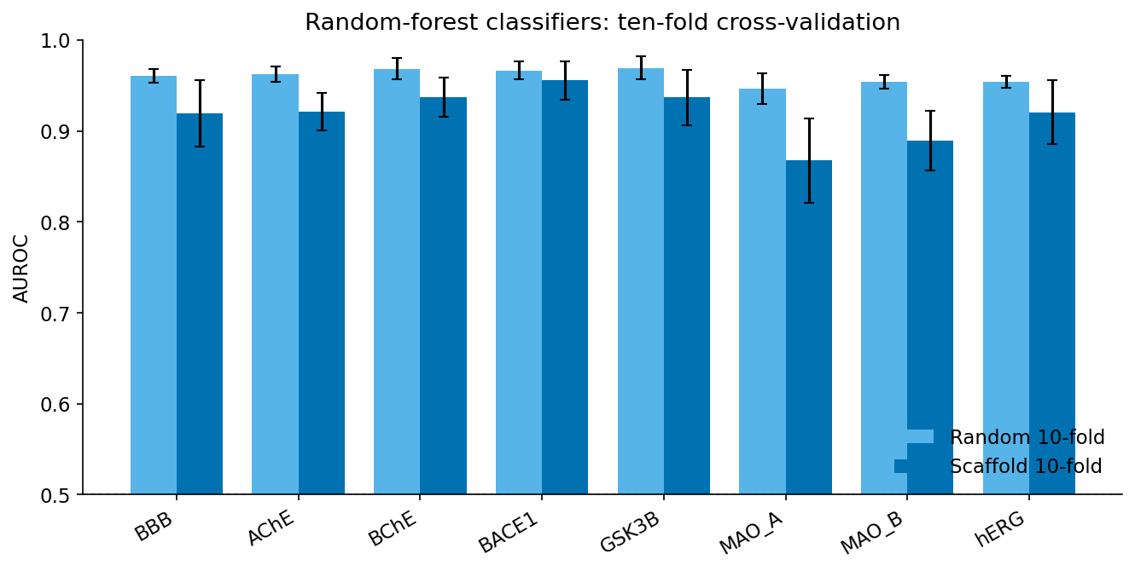
Figure 1
Figure 2. Random-forest receptor and antioxidant regressors, ten-fold cross-validation.
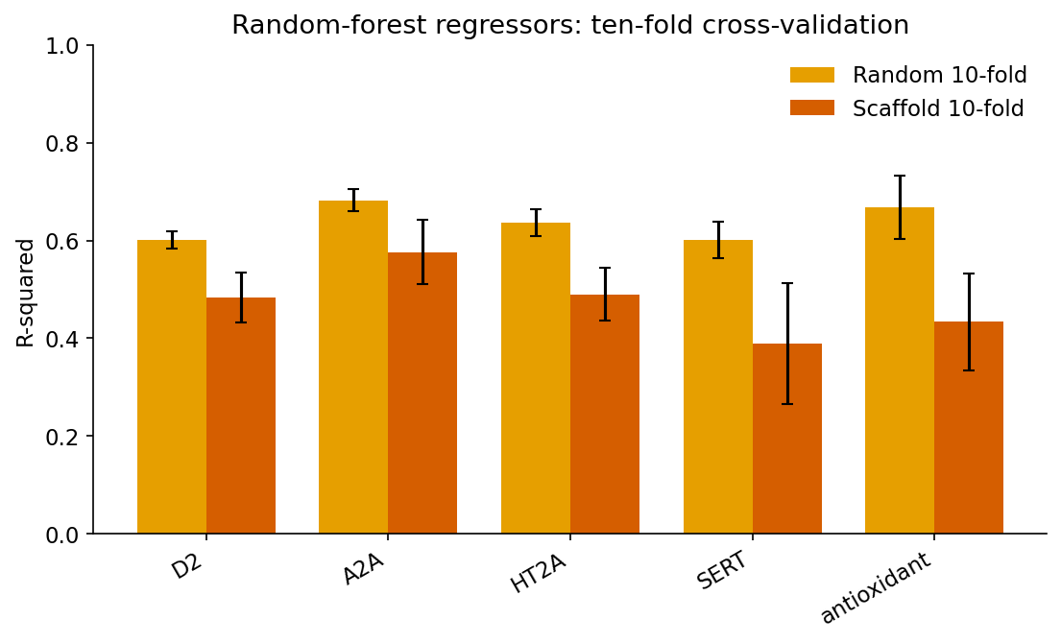
Figure 2
Figure 3. Measured compounds per target endpoint.
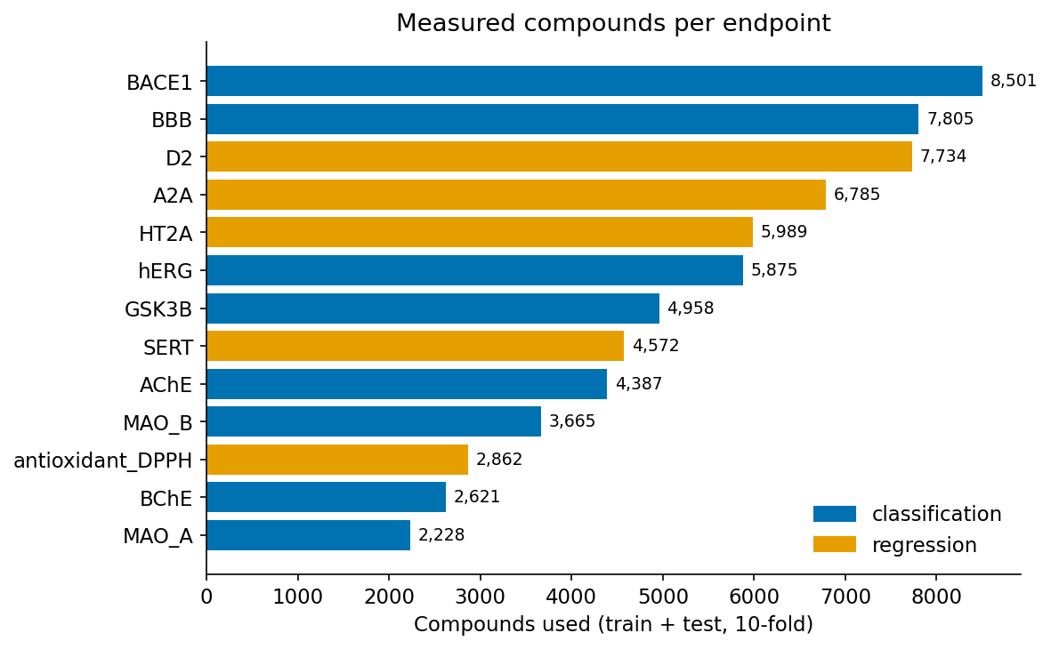
Figure 3
Figure 4. Feature-block ablation: fingerprint vs descriptors vs combined.
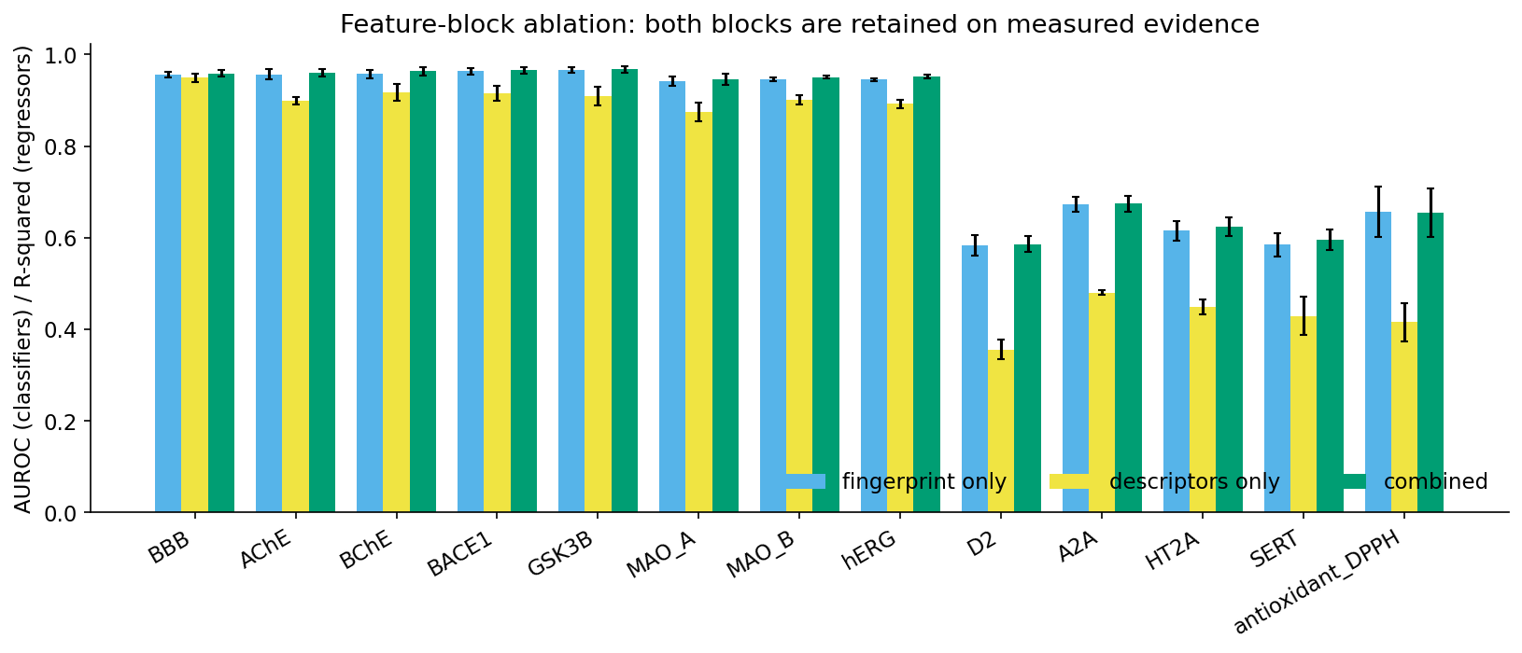
Figure 4
Figure 5. Permutation importance of the twelve descriptors per endpoint.
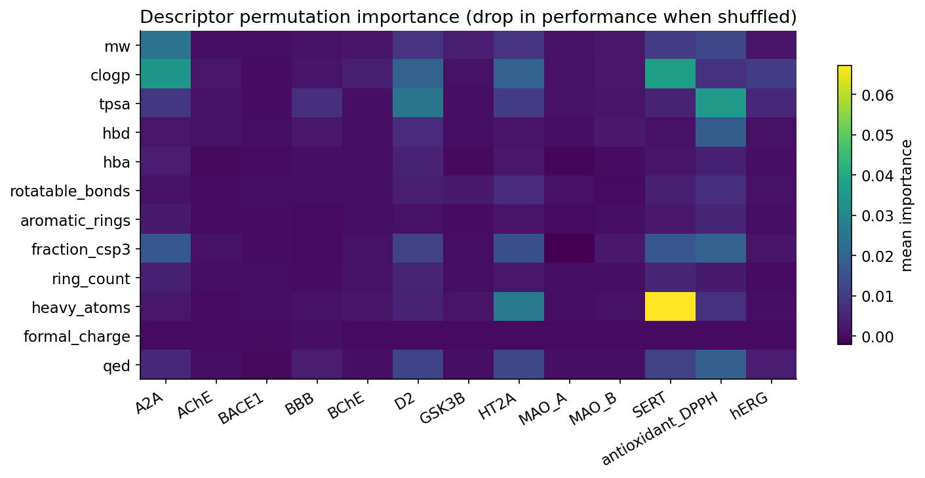
Figure 5
Figure 6. Probability calibration (expected calibration error, raw vs isotonic).
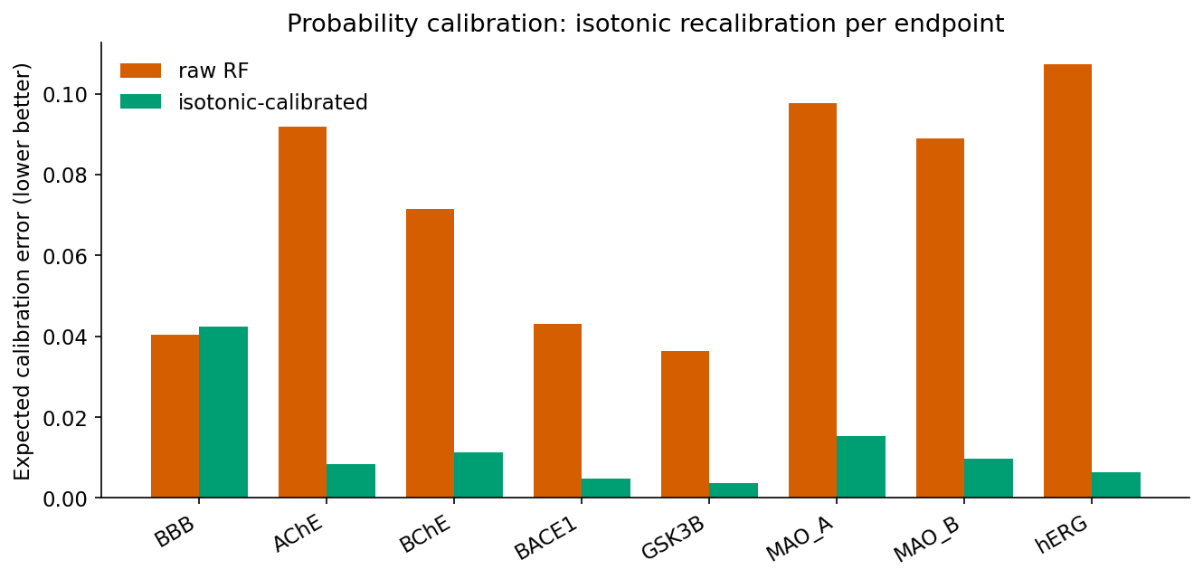
Figure 6
Figure 7. Applicability-domain coverage of DrugBank per endpoint.
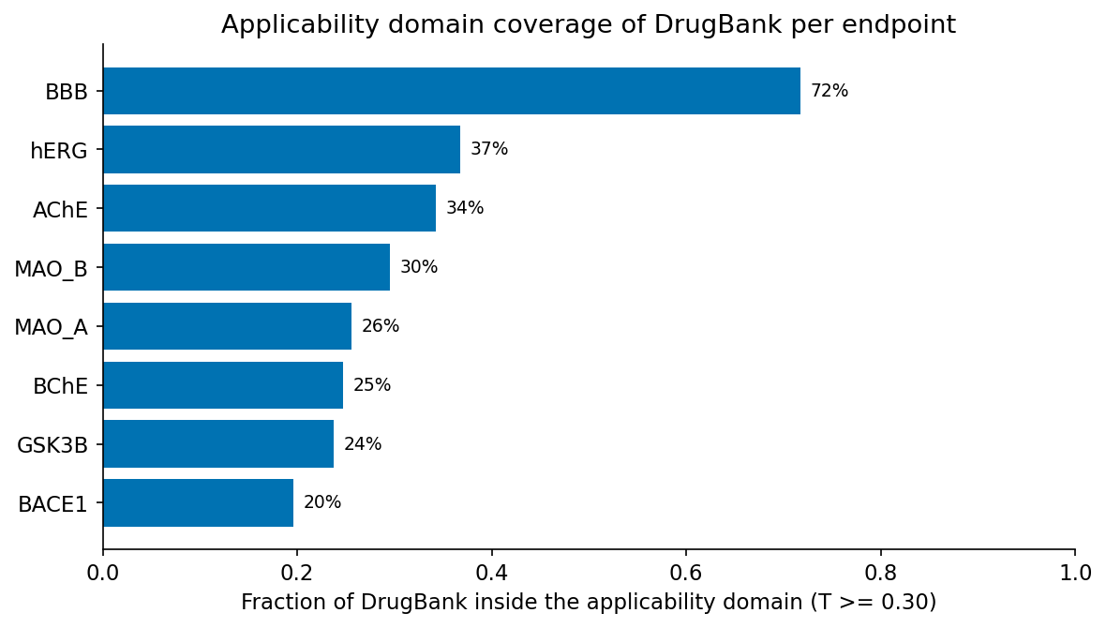
Figure 7
Figure 8. Scaffold-honest learning curves: where more data still helps.
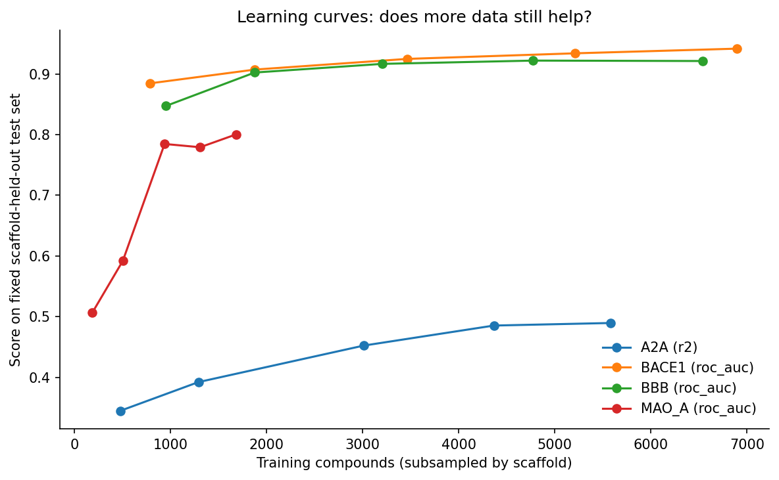
Figure 8
Figure 9. Graph network (GIN) vs random forest on the same scaffold split.
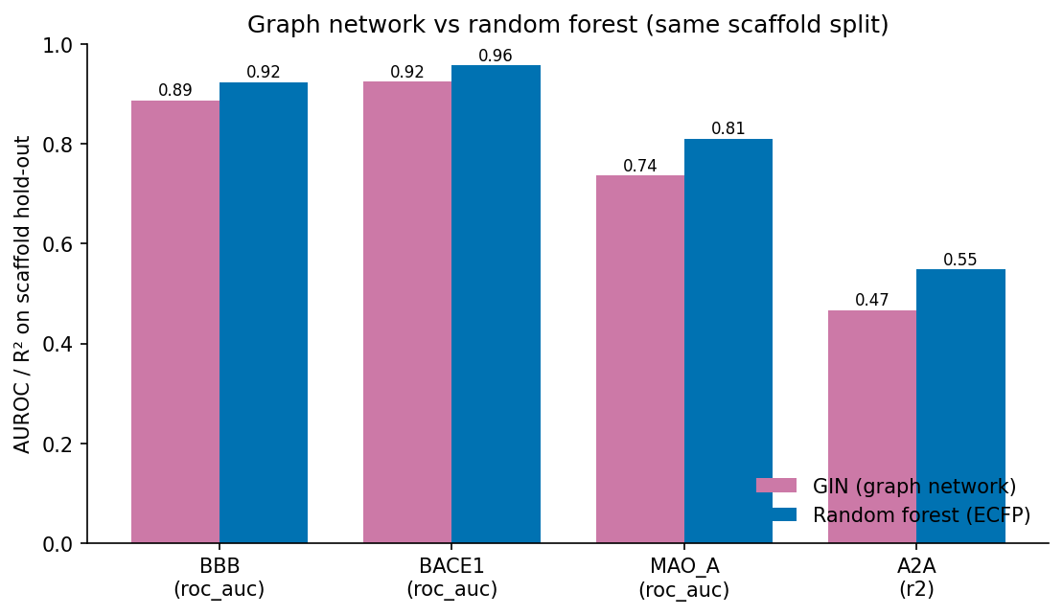
Figure 9
Figure 10. ADME / exposure models, scaffold ten-fold performance.
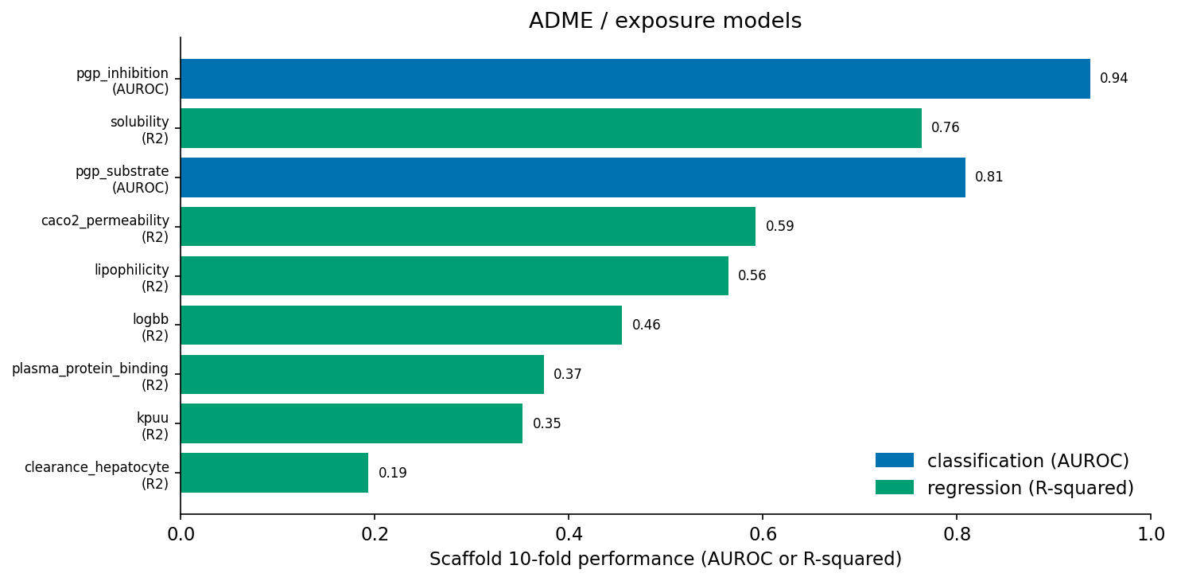
Figure 10
Figure 11. Predicted unbound brain exposure (K_p,uu) on known central and peripheral drugs.
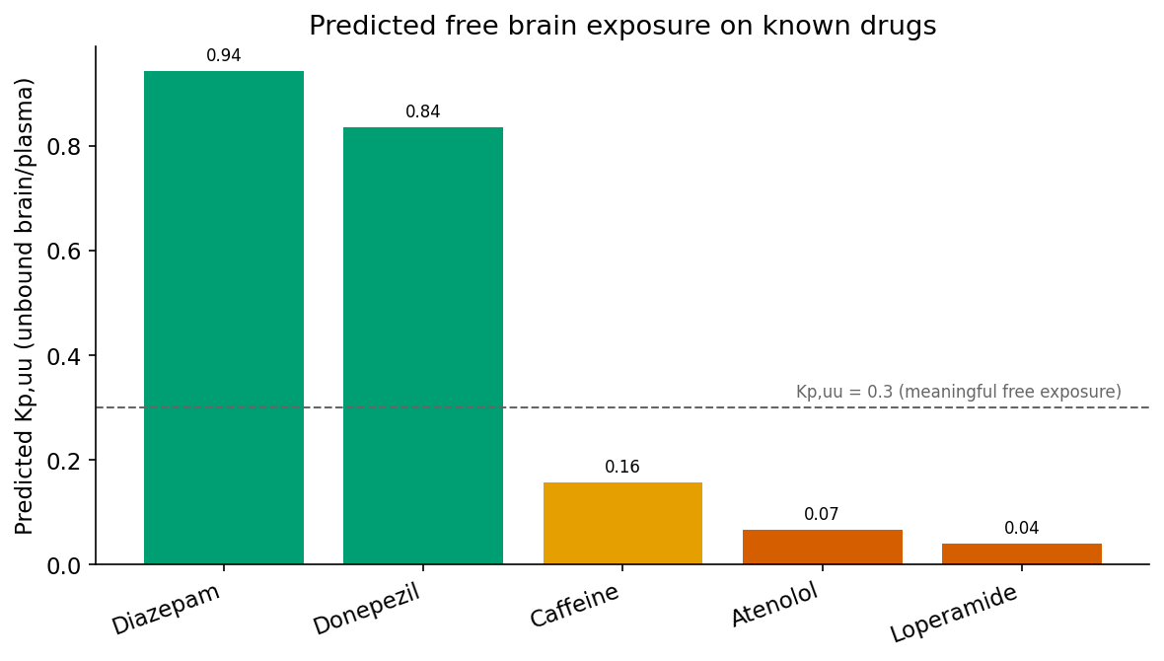
Figure 11

