BrainSafe AI: a calibrated, exposure-gated web server for multi-endpoint prediction of small-molecule action in the human brain
Authors: Krishnasalini Gunanathan¹, Raghunatha Sarma¹, Sai Shyam¹, Ramya E. M.¹, Venketesh Sivaramakrishnan¹
Affiliation: ¹Sri Sathya Sai Institute of Higher Learning (SSSIHL), Puttaparthi, Andhra Pradesh 515134, India.
Correspondence: Prof. Venketesh Sivaramakrishnan, svenketesh@sssihl.edu.in
Manuscript type: NAR Web Server Issue.
Graphical abstract: submitted as a separate file, manuscript/figures/GraphicalAbstract.png (and .pdf).
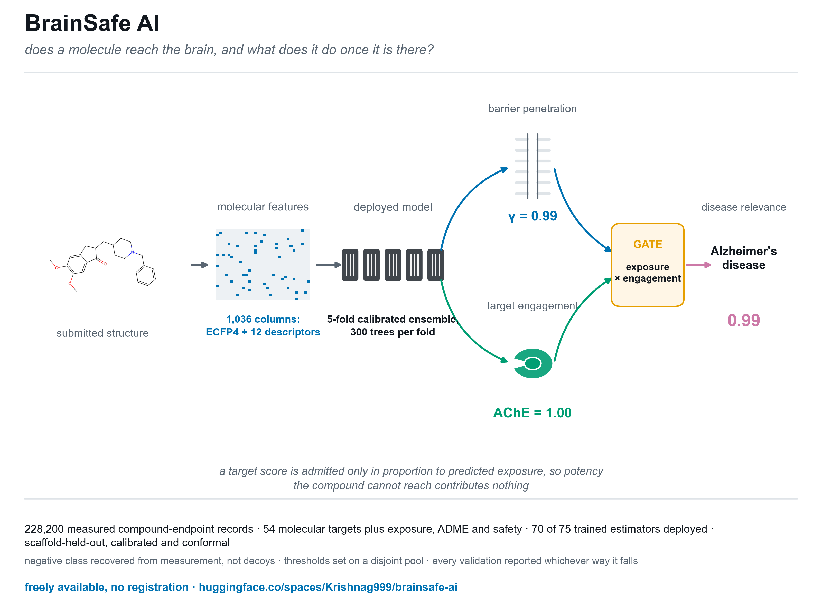
Graphical abstract
Reading copy only: the submission itself carries the graphical abstract as the separate file NAR requires, not inline. This copy embeds it here for circulation.
Key Points
- BrainSafe AI profiles small-molecule mechanism in the human brain from structure alone, gating every target score by predicted exposure so potency at a target a compound cannot reach contributes nothing to the output.
- Every one of its 74 cross-validated estimators is scaffold-grouped cross-validated and carries a calibrated probability; the 22 target-potency, exposure and safety estimators are additionally validated under a random split, the core classifiers reporting a conformal interval as well, and the server reports silence rather than a guess for chemistry outside its measured competence.
- Its negative class is recovered from compounds measured and found inactive rather than simulated with decoys, and every validation, including six adversarial checks written so that each could fail, is reported whichever way it falls, which led to withdrawing two endpoints that could not separate a real ligand from an unrelated metabolite.

Abstract
BrainSafe AI is a web server that profiles the mechanism by which a small molecule may act on the human brain, from structure alone. For a submitted SMILES string or compound name it returns, in a few seconds, engagement of 54 molecular targets spanning the principal neurodegenerative, psychiatric, neuroinflammatory, analgesic and sleep-related axes, predicted blood-brain barrier penetration, two cardiac safety liabilities, and a nine-endpoint ADME and exposure layer including a directly modelled unbound brain-to-plasma ratio. Every target score is admitted only in proportion to predicted brain exposure, so potency at a target a compound cannot reach contributes nothing, and engaged targets are traced through a curated pathway graph to the conditions they touch. The server is built on 75 estimators, 70 of them deployed, trained on 228,200 measured compound-endpoint records from ChEMBL (1), BindingDB (2) and B3DB (3). The measured-label classifiers are validated under both random and scaffold-grouped 10-fold cross-validation: mean AUROC 0.958 and 0.925 respectively, with expected calibration error falling from 0.0801 to 0.0147 after isotonic calibration. Every prediction carries a calibrated probability, a conformal interval and an applicability-domain distance to the nearest measured analogue, and the server reports silence rather than a guess for compounds outside its competence: on non-CNS chemistry its specificity is 0.925 (95% CI 0.907 to 0.940). The binder panel, validated against compounds measured and found inactive at the same target rather than against decoys, reaches a mean AUROC of 0.917 and recovers the pharmacologically correct driving target for reference drugs. Disease-level scores are presented as a route from a mechanism to the conditions it touches, not as an indication prediction, because 27 of the 51 targets in the pathway graph drive more than one condition and structure alone does not resolve which. BrainSafe AI is freely available without registration at https://huggingface.co/spaces/Krishnag999/brainsafe-ai, with source code, trained models and all validation artefacts at https://github.com/krishna-g-999/brainsafe-ai.

Introduction
Central nervous system drug discovery fails more often, and later, than discovery for most other therapeutic areas (4). A compound can be potent at its intended target and never reach the brain, or reach it and carry an unacceptable liability, or engage targets nobody tested and acquire a clinical profile nobody predicted. Pharmacokinetics and the barrier itself, rather than target affinity, account for a large share of central attrition (5), and the quantity that governs central action is not total brain concentration but the unbound brain-to-plasma ratio (6).
Answering “will this molecule act on the brain, through what, and is it safe” therefore requires exposure, target engagement and liability to be answered together. Existing public resources address these separately. Property-based schemes such as CNS MPO (7) score the exposure axis well but name no mechanism. Single-endpoint QSAR models name one mechanism but say nothing about whether the compound arrives. Large language models are fluent and will produce measured-looking identifiers that do not exist. None of these returns a calibrated probability with a statement of when it should not be trusted.
BrainSafe AI unifies these axes for any user-supplied structure, under three design commitments. First, every endpoint is trained only on measured experimental values, never on qualitative annotation, so a prediction is not a restatement of a curator’s opinion. Second, every prediction is accompanied by its uncertainty: a calibrated probability, a conformal interval, and the nearest measured analogue with its similarity, so a user can tell interpolation from extrapolation. Third, predictions are mechanistically traceable: individual target engagements are followed through a curated graph into disease-level scores, gated by predicted exposure, so the output is an explanation rather than a bare score.
The design also commits to reporting where the server does not work. Five endpoints were trained, tested and withdrawn; every adversarial check is written so that it could fail and is reported whichever way it falls, and one of the six passes only after a flawed control set was corrected rather than its criterion loosened; and the server stays silent rather than guessing on chemistry it cannot place.

Materials and Methods

Endpoint selection
The panel is organised around the four questions a CNS candidate must satisfy in sequence. Exposure is modelled first, because a molecule that reaches no free concentration in brain tissue cannot act centrally however potent it is. Target engagement covers the cholinergic axis, where acetylcholinesterase inhibition remains the mainstay symptomatic treatment in Alzheimer’s disease (8), and the amyloid and tau axes (9); monoamine oxidase B (10) and LRRK2 (11) for Parkinson’s disease; the monoaminergic, opioid, cannabinoid, histaminergic and adenosine systems underlying depression, psychosis, addiction, chronic pain and sleep regulation, the last including the orexin receptors (12); and three axes implicated across several neurodegenerative conditions rather than tied to one, NLRP3-driven neuroinflammation (13), KEAP1-NRF2 antioxidant signalling (14), and histone deacetylase activity, whose genetic removal modifies pathology in Huntington’s disease models (15). Glutamatergic targets are included on the same basis, riluzole being the long-standing approved agent acting on that axis (16). Safety is represented by hERG blockade, a leading cause of late-stage cardiovascular attrition through QT prolongation (17). Developability is covered by the ADME layer.

Training data and the recovery of the negative class
Protein-target activity is pooled at compound level from ChEMBL (1) pChEMBL values and BindingDB (2); blood-brain barrier labels come from B3DB (3) augmented with FDA-curated approved drugs; the nine ADME endpoints use measured sets from Therapeutics Data Commons (18), MoleculeNet (19), B3DB and ChEMBL. The panel holds 228,200 measured compound-endpoint records over 169,341 unique compounds keyed by the InChIKey of the desalted parent. No value is imputed and no annotation overrides a measurement. Each endpoint is trained on its own measured set alone; across the deployed panel those sets span from 387 compounds (KEAP1) to 10,276 (hERG), with a median of 3,789. That set is every deployed model owning a table in data/endpoints, the barrier model included; excluding it, since it is an exposure rather than a target endpoint, gives 54 tables and a median of 3,587.
A bioactivity record describes what was found to bind. A compound assayed and found inactive is frequently deposited only as a censored bound, standard_relation > with no pChEMBL value, and the conventional query, which filters on pChEMBL, discards exactly those rows. Training on what survives that filter yields a positive class drawn from measurement and a negative class drawn from property-matched decoys, and it left 35 of the 60 protein-target endpoints then in the panel above 90 per cent active, which is a property of the query rather than of the chemistry.
A censored bound settles a label whenever the entire interval it defines falls on one side of the activity cut. IC50 > 10 uM places the true potency strictly below pChEMBL 5.0 and is a measured non-binder; IC50 > 100 nM spans both classes and is discarded as undecidable rather than guessed at. Recovering these added 21,994 measured non-binders across 57 endpoints and reduced the endpoints above 90 per cent active from 35 to 13 (Supplementary Figure S1). A bound is never used as a value: it assigns a class and never enters a regression.

Representation and model selection
Each compound is reduced to its largest organic fragment, neutralised, sanitised, and represented by a fixed 1,036-column vector: a 1,024-bit folded ECFP-4 fingerprint (20) and twelve physicochemical descriptors (molecular weight, cLogP, TPSA, hydrogen-bond donors and acceptors, rotatable bonds, aromatic rings, fraction sp3, ring count, heavy atoms, formal charge, QED) (Figure S2). Folding means a set bit reports that some substructure environment hashing to that index is present, not which one, and chirality is excluded, so two enantiomers produce byte-identical rows. Rows identical in feature space are therefore collapsed before any split; leaving them in place would put copies of one compound on both sides of a fold.
For a CNS panel this exclusion needs a measured bound rather than a disclaimer. Of 228,198 training structures, 40.8 per cent carry an assigned stereocentre, so the data could in principle support a chirality-aware fingerprint. Where one flat skeleton appears as two or more stereoisomers measured at the same endpoint, however, which is the only situation in which chirality has anything to resolve, the measured labels agree in 94.6 per cent of the 8,013 such cases. Stereochemistry is therefore mostly not what separates an active from an inactive in this data, and the share of the whole panel where it could change a class call is 0.19 per cent. That bound is not an absolution: a quarter of the comparable pairs differ by more than one log unit in potency, and the disagreements concentrate where a pharmacologist would expect them, at the barrier model, BACE1, D2, OX2, the mu-opioid receptor and CB1. Predictions are made on the flat skeleton and should be read as applying to the racemate.
Neutralisation is part of the representation rather than a detail of it, because a drug and its salt are the same molecule and must give the same answer. Removing the counter-ion without it leaves the parent carrying the charge the salt gave it, so haloperidol hydrochloride written as public databases serve it is a different input from haloperidol: on the models this server previously deployed it returned a barrier probability of 0.613 against 0.993, and an hERG probability of 0.295 against 0.914, so a user who pasted the salt form lost a cardiac liability flag on a compound that has one. Only protonation states are undone. A permanent charge is kept, because a quaternary ammonium has no proton to lose and its charge is precisely what stops it crossing the barrier; formal_charge therefore reports permanent charge rather than how a depositor happened to write a row. Of the 170,617 unique structures in the panel, 198 change representation under this rule and 1,155 charged ones are correctly left alone, and the whole panel was refitted afterwards so that training and inference share one representation.
Five model families were compared under identical 5-fold cross-validation on both split regimes using scikit-learn (21), on the deduplicated matrix the deployed pipeline fits. Two are baselines a reader is entitled to demand: a five-nearest-neighbour read-across on Tanimoto similarity, which is what a medicinal chemist does by eye, and L2-regularised logistic regression. Three are ensembles: a random forest (22), XGBoost (23) and histogram gradient boosting, each class-weighted for the classification endpoints so that no family is compared unweighted against weighted competitors. On the scaffold split the random forest leads classification at 0.9212 mean AUROC, ahead of XGBoost (0.9156), histogram gradient boosting (0.9153), the read-across (0.8829) and logistic regression (0.8352), and it exceeds the read-across on all thirteen endpoints, by margins running from 0.0095 at D2 to 0.1099 on the antioxidant assay. It is best on seven of the eight classification endpoints, losing AChE to histogram gradient boosting at 0.9148 against 0.9247. It does not lead regression at all: histogram gradient boosting and XGBoost reach mean scaffold R² of 0.5424 and 0.5413 against 0.5190, and the forest is best on none of the five. A random forest is nonetheless deployed everywhere, because it leads where the principal claims are made, calibrates stably, supplies the vote distribution the conformal layer consumes, does not extrapolate beyond the training range, and is exactly rather than approximately explainable by TreeSHAP (24). The cost of that uniformity is 0.023 mean R² on the potency regressions and is stated rather than left for a reader to find.

Cross-validation, calibration and uncertainty
Every endpoint is cross-validated ten-fold, grouped on Bemis-Murcko scaffolds (25) so that entire structural classes are withheld together. The 22 target-potency, exposure and safety estimators are additionally cross-validated under a random split, and the distance between the two regimes is the honest statement of how far a model travels (Figure S3); the 52 binder classifiers, validated instead against compounds measured and found inactive at the same target (Section 3.3), are cross-validated under the scaffold-grouped regime alone. Across the 74 cross-validated estimators, spanning 70 distinct endpoints because four receptors carry both a potency regression and a binder classifier, this is 960 fitted models standing behind the deployed panel. A complete inventory of every estimator, with its prediction type, training-set size, validation scheme, calibration and fitting date, is given in Supplementary Table S1 and regenerates with one command.
Classifiers are isotonically calibrated (26) on out-of-fold predictions, so no compound contributes to the calibrator that scores it; mean expected calibration error falls from 0.0801 to 0.0147. The reported value is specific to how the calibrator is nested, and the nesting is therefore stated rather than left implicit: isotonic regression is fitted by five-fold cross_val_predict over the pooled out-of-fold prediction vector, and a different, equally defensible nesting is a different estimator with its own honest error, so the protocol is reported alongside the number rather than the number alone. Each prediction additionally carries a Mondrian conformal interval, computed on the same deduplicated matrix the classifiers are trained on, which converts the applicability domain from a caveat into a coverage statement (27): empirical coverage over the eight core classifiers is 0.876 to 0.933 against a 0.90 target, with mean set size from 0.956 to 1.215 on a two-class problem where 1.0 is a confident single label. The applicability domain itself is the maximum ECFP-4 Tanimoto similarity of the query to that endpoint’s own measured chemistry (28), reported with the nearest measured analogue and its structure.

Binder classifiers, and thresholds measured where they were not set
Receptor, transporter and kinase targets are reported in ChEMBL almost entirely as actives, so a naive potency regressor learns the training median. Each is therefore modelled as a binder classifier: positives are measured binders, negatives are measured non-binders where they exist plus property-matched decoys (29) with Tanimoto below 0.35 to any positive. Binder classifiers use sigmoid calibration (30), because the withheld set for one endpoint is often too small to fit a step function without overfitting it.
Decoys create a specific failure. If a decision threshold is chosen as a quantile of a sample and the false-positive rate is then computed on that same sample, the rate cannot exceed the quantile: it restates the target instead of measuring it. The 158,890-compound background library is therefore partitioned into three disjoint pools by a stable hash of the canonical structure, so a compound’s pool is a property of the molecule and never depends on run order: 95,515 compounds supply decoys, 31,694 set thresholds, and 31,681 measure the false-positive rate (Figure S4). Measured on the pool it was not set on, at the threshold the server currently deploys, the background false-positive rate has a median of 0.0262 across all 47 deployed endpoints and a maximum of 0.0512 at HT2A, exceeding the 0.05 target at two endpoints (HT2A and D2); under the previous procedure, where the same pool set the threshold and measured the rate, the two could not disagree by construction, so a genuinely disjoint measurement exceeding its target, if only slightly, is the expected behaviour of a real constraint rather than evidence against it.

Disease layer and implementation
Because several training sets are active-heavy, a raw calibrated probability is not evidence of engagement unless it exceeds the endpoint base rate; targets are therefore scored by enrichment over that base rate. A curated, versioned graph maps each target through a pathway to the diseases it informs, anchored to KEGG synapse and disease maps (31), the Reactome KEAP1-NFE2L2 oxidative stress response (32) and IUPHAR/BPS Guide to Pharmacology associations (33). A disease score is the strongest engaged target for that disease scaled by predicted barrier penetration; taking the strongest rather than an average prevents unrelated mechanisms from diluting a real signal.
The server is a single-page application built with Streamlit (34) and RDKit (35), accepting a SMILES string or a compound name resolved through PubChem. Models are loaded once and cached; a complete profile across all 70 deployed estimators, including both applicability-domain calculations against the 158,890-compound reference library, returns in a few seconds on one CPU core. No registration is required and sample compounds are provided.

Results
The server’s primary output is mechanism: which targets a compound engages, with what confidence, and whether it reaches them. That is where the evidence is strongest, and the results are presented in that order. The disease layer is a navigational aid built on top of the mechanism call, and its weaknesses are reported in their own section rather than folded into the headline.

Target engagement, the primary output
The 52 binder classifiers are validated not against the decoys used to train them but against compounds experimentally tested at the same target and found inactive. Across the 47 that are deployed they reach a mean AUROC of 0.917 and a mean sensitivity of 0.764, both measured on actives withheld by scaffold, at thresholds constrained simultaneously by held-out measured inactives and by the false-positive rate on a disjoint pool of unrelated chemistry. Both figures are means over 47 endpoints and the spread behind them is wide: AUROC ranges from 0.719 at GABA-A to 0.985 at CGRP, and sensitivity from 0.303 at GABA-A to 0.993 at CGRP with a median of 0.835, so the two means describe the panel and not any particular endpoint (Figure S5). Supplementary Table S1 gives every endpoint separately.
The sensitivity figure carries a correction we report rather than leave for a reader to find. Four scripts write this field in sequence, and the last of them scored every active in the endpoint table, roughly four fifths of which the model had been fitted on, while leaving the field’s own basis annotation reading that the measurement was held out. The panel mean was therefore published as 0.898 against a held-out 0.764, an inflation of 0.134, with nothing in the record disagreeing with anything else. The scoring script now reads the scaffold-held-out partition and declares its basis when it cannot, the registry has been recomputed from that partition and agrees with the threshold table on all 47 deployed endpoints, and a regression test fails if any deployed endpoint reports sensitivity on an undeclared basis. Six endpoints fall below the reliability gate on the corrected figure, against one before: COX-2, GABA-A, GluN2B, P2X7, SIRT1 and TAAR1. They remain deployed, because each holds its background false-positive rate at or below target and is therefore weak rather than misleading, and the interface marks a negative call from any of them as low-powered.
Five endpoints are withdrawn outright: Nav1.1 and GluA2 for firing on trivial metabolites at every usable threshold, and three added to test natural-product coverage, reported in the limitations. Withdrawal is re-derived whenever the panel is refitted rather than carried forward, because it is a claim about a particular fit: when the panel was retrained, Cav3.2 stopped failing and was reinstated while GluA2 began failing and was withdrawn.
The eight measured-label classifiers reach a mean AUROC of 0.958 under the random split and 0.925 under the scaffold split. BACE1 is most robust to chemotype change, losing 0.012 between splits, and MAO-A least, losing 0.056. The four receptor potency regressions reach R² 0.64 to 0.72 (random) and 0.46 to 0.62 (scaffold).
The mechanism call is correct where it can be checked against pharmacology that is not in dispute. For donepezil, haloperidol, morphine and fluoxetine the server names acetylcholinesterase, D2, the mu-opioid receptor and the serotonin transporter respectively as the driving target (Figure 4A). Attribution supports the same conclusion from a different direction: SHAP values computed with TreeExplainer (24) on the deployed forests, which is exact for a random forest rather than an approximation, recover known physicochemistry that was never supplied to the models. Over 800 sampled training compounds, larger TPSA, molecular weight and hydrogen-bond donor count all push the barrier model away from penetration (Spearman correlation between feature value and SHAP value of -0.93, -0.94 and -0.94) while drug-likeness pushes towards it (+0.93); for hERG, lipophilicity pushes towards blockade (+0.95).

The validations that a cross-validated score cannot replace
Leakage. Folds were rebuilt and the index sets interrogated directly. On the deduplicated matrix the pipeline fits, no InChIKey, no feature vector and no scaffold appears on both sides of any fold. On the raw endpoint tables, before deduplication, 15,104 feature-vector-identical rows exist across the panel, worst at BBB (3,773), which is precisely what deduplication removes; none of them reaches a fitted model.
Null models. With labels permuted, the same pipeline on the same folds returns a mean AUROC of 0.496 (random) and 0.503 (scaffold) over the eight core classifiers, every one of the sixteen values within 0.02 of chance and a smallest margin over its own null 19-fold larger than the largest such departure. Scaffold grouping alone confers nothing: paired by endpoint the scaffold null exceeds the random null by a mean of 0.007 (Wilcoxon p = 0.25) and is negative in three of eight. Whole scaffold classes do not carry enough class-frequency information for a label-free model to beat chance, so the scaffold figures are not inflated by that route.
Prospective sensitivity. Whole scaffold classes were withheld before training. Pooled recall on them is 0.803 (95% CI 0.797 to 0.809), with a per-target median of 0.815 across the 39 targets whose decision threshold did not collapse (Figure 3B). Targets are excluded only for a degenerate threshold, never for a poor recall.
External validation. The barrier model was tested on FDA-curated approved drugs absent from B3DB by InChIKey: AUROC 0.764 on all 306, and 0.767 on the 227 that are also distinguishable from the training set in feature space, which is the subset that supports an external claim (Figure 3C). The 79 excluded by that second criterion are feature-identical to a training compound and score 0.749. The two headline figures, 0.764 and 0.767, are close rather than one exceeding the other: excluding memorised compounds neither inflates nor depresses the external estimate, which is the outcome an honest exclusion criterion should produce.
For the target panel no external set of comparable size exists, because for most of these targets the public measured chemistry is the training set. Two kinds of independence were therefore constructed from the data that does exist, with every model refitted rather than scored, since the deployed models were fitted on all of it (Figure 5). By date: each endpoint was refitted on its pre-cutoff rows alone, with its decision threshold also frozen before the cutoff, and tested on compounds first published afterwards; 39 of the 47 deployed endpoints carry enough dated chemistry on both sides of the wall, giving 45,244 test compounds. Each was refitted a second time on a size-matched random split, because a time split trains on less data as well as none of the future. By curator: compounds deposited in BindingDB and absent from ChEMBL were withheld entirely and the panel refitted on the ChEMBL side, which is available for three endpoints at 1,303 actives.
Read in aggregate the time split looks like prospective decay: mean AUROC 0.823 against 0.951 for the size-matched random control, and mean sensitivity 0.489 against 0.872. It is not decay. The false-positive rate on background chemistry is unchanged (0.037 against 0.038), and the gap closes once test compounds are stratified by maximum Tanimoto similarity to the training actives. A random split of medicinal-chemistry data holds out 83 per cent close analogues of its own training set, because the published record is series; a time split holds out 28 per cent chemistry below Tanimoto 0.40. Within a novelty band the two splits differ by at most 0.081 in AUROC and 0.072 in recall against aggregate gaps of 0.128 and 0.383. Three test sets built by unrelated rules, withheld by date, at random, and by curator, trace one recall curve: 0.16, 0.55, 0.74 and 0.86 by date across the four bands, against 0.12, 0.52, 0.77 and 0.93 at random and 0.05, 0.46, 0.83 and 0.90 by curator (Figure 5D).
Recall is therefore a function of chemical distance rather than of publication date, which has three consequences. The reported scores do not expire. The deployed sensitivity describes a held-out population that is mostly close analogues, so it overstates what a novel scaffold should expect. And the expected recall for a submitted compound is knowable at query time from a quantity the server already computes and displays, which is how the interface now reports it. On genuinely distant chemistry that expectation is poor in absolute terms, near 0.16, and the finding is that the poor number is predictable rather than that it is better than it appeared.
Specificity. One thousand compounds carrying no recorded activity at any modelled target were scored through the deployed pipeline. 925 returned no actionable disease signal, a specificity of 0.925 (95% CI 0.907 to 0.940). Of the 75 false positives, 49 fired on a single condition rather than producing a diffuse profile; the median score across all 75 was 0.437, only modestly above the actionable threshold. These compounds are presumed inactive because nothing is recorded, not proven inactive, so this is a lower bound.
Adversarial checks. Six checks were written so that each could fail, and all six pass, including exact reproducibility of a retrained endpoint. The domain-flag check initially failed and passes only after its control set was corrected: 28 of the original controls are measured compounds inside the flag’s own reference library, where calling them in domain is the truthful answer rather than a failure. The passing criterion was not moved. Against chemistry genuinely absent from the reference the flag separates at median maximum similarity 0.47 against 0.57 for unseen drugs (n = 25, p = 1.8e-03), which is a weak signal and is described as one.
Attribution. SHAP attributions computed with TreeExplainer (24), which is exact for a random forest rather than an approximation, over the deployed classifiers recover known physicochemistry rather than artefacts. For the barrier model, larger TPSA, molecular weight and hydrogen-bond donor count all push away from penetration (Spearman correlation between feature value and SHAP value of -0.93, -0.94 and -0.94) while drug-likeness pushes towards it (+0.93); for hERG, lipophilicity pushes towards blockade (+0.95). These directions were not supplied to the models.

Comparison with existing approaches
Against the read-across baseline that represents what a chemist does by eye, the deployed random forest is better on all thirteen endpoints where the two were compared, on the scaffold split. The margin is quoted per metric rather than pooled, because eight of those endpoints are scored by AUROC and five by R-squared: the mean gain is 0.038 AUROC over the eight classifiers and 0.045 R-squared over the five potency regressions. Against property-based CNS scoring (7), which addresses exposure only, BrainSafe AI adds mechanism and liability but is not a replacement for expert medicinal-chemistry judgement on either axis. Against ADMET and permeability servers such as SwissADME (36), ADMETlab 2.0 (37), pkCSM (38) and admetSAR 2.0 (39), and against target-prediction servers such as SwissTargetPrediction (40), the difference is the gating: a target score here is admitted only in proportion to predicted exposure, so a potent binder that does not reach the brain is reported as such rather than as a hit, and no single one of these servers couples exposure, target engagement and disease relevance in one calibrated output. We are not aware of another freely available server that returns exposure-gated, calibrated, mechanism-resolved profiles across this many CNS endpoints with an explicit applicability-domain statement on every value.

Use case: a mechanism profile, and knowing when to stay silent
Submitting donepezil returns a barrier probability of 0.99 and acetylcholinesterase as the driving target, surfacing Alzheimer’s disease at 0.99 with cognition (cholinergic) alongside it. Haloperidol returns D2 and psychosis at 0.92; morphine returns the mu-opioid receptor and chronic pain at 0.97; fluoxetine returns the serotonin transporter and depression at 0.99 (Figure 4A). In each case the server names the mechanism, and the mechanism is the pharmacologically correct one.
The complementary behaviour is silence. Atorvastatin, metformin, losartan and hydrochlorothiazide return barrier probabilities between 0.18 and 0.46 and no disease score above the reporting threshold (Figure 4B). On the external reference set the server is correctly silent on 3 of the 5 non-CNS controls that are not already in its training chemistry. The two it calls are worth naming rather than pooling: insulin glargine, a peptide that a small-molecule descriptor set cannot represent and that the server should decline rather than score, and allopurinol at 0.395, just above the reporting threshold. The control set is smaller than it was because desalting and neutralisation made the in-training test stricter, moving two compounds that had been counted as external into the training set where they belong. Silence is not a side effect: a target score is admitted only in proportion to predicted barrier penetration, so a compound that does not arrive cannot generate a call.

The disease layer, and why it is a navigational aid rather than a prediction
The disease layer maps engaged targets onto conditions. It carries real information about its own map: asked to recover the disease its target graph implies, it reaches top-3 accuracy 0.790 against a permutation null of 0.163. It does not, however, predict clinical indication, and the evidence for that limit is worth stating precisely because it is easy to overstate the layer in either direction.
Validated against ChEMBL phase-4 indications on the 162 approved drugs whose structures appear nowhere in the training chemistry, and judging the ranking alone with no reporting threshold, top-3 accuracy is 0.451. The model beats a permutation null decisively at every depth, so its output does depend on the compound and is not memorisation. It does not beat a frequency null naming the commonest CNS indications, and, importantly, reporting more conditions does not close that gap but widens it:
Conditions reported | Model | Frequency null | Difference
top-1 | 0.296 | 0.395 | -0.099
top-3 | 0.451 | 0.654 | -0.204
top-5 | 0.549 | 0.821 | -0.272
top-8 | 0.605 | 0.969 | -0.364
A constant answer gains from each additional slot faster than the model does, because approved CNS indications are concentrated in a few classes. Deepening the list is therefore not a remedy.
Top-k accuracy is, however, the metric on which a constant answer is strongest, and it is worth recording what the layer does on two metrics a constant answer cannot pass. Per-indication AUROC asks whether the drugs that treat a condition score above the drugs that do not, and any constant predictor scores 0.500 by construction; over the nine indications carrying at least five of these drugs the layer averages 0.616 and beats chance on seven. Macro-averaged top-3 recall, which averages per indication rather than pooling and so cannot be carried by naming the common conditions, is 0.358 against 0.333. The spread is wide and is the substance of the result: depression and anxiety reach 0.798 and psychosis 0.765, while epilepsy at 0.490 and sleep at 0.499 sit at or just below chance. The layer therefore does respond to the compound, decisively for some conditions and not at all for others, which is why it is offered as a route from mechanism to condition and not as an indication prediction.
The reason is structural rather than a deficiency of fitting, and it is visible in the graph: 27 of the 51 targets in the pathway graph drive more than one condition. GABA-A alone contributes to depression and anxiety, sleep and wakefulness, and epilepsy. One molecular event genuinely underlies several indications, and what selects among them, dose, regimen, exposure duration, patient population and trial history, is not present in a structure. Consistent with this, the median rank of the true indication among the 162 never-seen drugs is 4.5: the server places the correct condition in the right mechanistic neighbourhood but cannot resolve which member of that neighbourhood a compound was developed for.
The disease scores are therefore presented as a route from a mechanism to the conditions that mechanism touches, useful for orientation and for deciding what to test next, and they are not offered as an indication prediction. The mechanism call, not the disease list, is the result this server stands on.

What the falsification analysis removed
Every result above was produced by first attempting to break it. The analysis returned findings in both directions. The disease layer carries real information: top-3 accuracy 0.790 against a permutation null of 0.163. Its curated edge weights do not: uniform and randomly permuted weights score 0.7897 and 0.7874 against 0.7901, so the predictive content lies in the graph topology, and the weights are reported as structure rather than as tuned parameters. The same analysis found a deployed endpoint, Nav1.1, calling glucose, urea, glycine, lactate and atenolol binders at its calibrated threshold, at a random-chemistry false-positive rate of 0.080 and a sensitivity of 0.120; no cut separates a metabolite from a sodium-channel ligand, and it is withdrawn. GluA2 fails the same test on the current fits and is withdrawn with it. Three overrides that had been applied to other endpoints were removed at the same time, because the observations that justified them do not reproduce on the refitted models and an override whose justification has expired costs sensitivity for a false positive that no longer occurs.

Discussion
BrainSafe AI answers the four questions a CNS candidate must satisfy in one pass, and reports the uncertainty on each. Its principal contribution is not any individual AUROC but the discipline imposed on how those numbers were obtained: a negative class recovered from censored measurements rather than simulated with decoys, thresholds measured on a pool disjoint from the one that set them, an applicability domain expressed as conformal coverage, and validations designed so that they could fail.
Five limitations bound its use. The applicability-domain flag is a weak signal rather than a decisive one: against chemistry genuinely absent from the reference library it scores a median maximum similarity, in the adversarial check, of 0.47 against 0.57 for unseen approved drugs (n = 25, one-sided Mann-Whitney p = 1.8e-03), but at a threshold that rejects a tenth of genuine drugs it catches only a fifth of distant chemistry. The conformal interval and the nearest-analogue distance remain the stronger statements of confidence and the interface presents them as such. What the flag does predict well is sensitivity: the distance it measures is the variable that recall tracks, so it is best read as a statement about how likely the panel is to miss a real activity rather than about whether an answer can be trusted.
A related limitation is the size of that effect. On chemistry more than a Tanimoto of 0.40 from anything the panel has measured, recall at the deployed operating point is near 0.16, and no analysis here improves it; what the prospective work establishes is that the figure is predictable, not that it is better than it looked. A negative result on a novel scaffold is close to uninformative, which is why the server now reports the expected recall beside it.
The specificity estimate also has a boundary worth stating plainly: it rests on compounds presumed inactive because nothing is recorded about them, drawn from within the reference library, so it does not bound behaviour on genuinely distant chemistry.
Natural-product chemistry is a fourth limit, and it is stated here because a reader will reasonably ask. The training library has a median fraction-sp3 of 0.34 and only 9.2 per cent of it is both sp3-rich and free of aromatic rings, so terpenoid and steroidal natural products are underrepresented in it: withanolide A, a steroidal natural product, submitted to the server returns a maximum Tanimoto of 0.43 to its nearest measured analogue and no engagement call. That distance is close enough to be called in domain rather than clearly outside it, and the expected recall the interface reports at that distance is 0.55 on 5,228 comparably distant test actives, so the silence here is moderate rather than uninformative evidence of inactivity: exactly the graded reading the applicability-domain distance is designed to support, rather than a binary in-or-out call. Measured activity for such compounds is scarce against these targets and is usually recorded against cell lines rather than proteins. Assembling an external test set from NPASS left only three endpoints with enough genuinely external data to score, after 1,385 nominally new compounds proved on inspection to be training compounds written as a different tautomer or salt, and on those three the panel returns AUROC 0.463 at AChE (n=41), 0.741 at GBA1 (n=89) and 0.461 at hERG (n=80). With two to five actives per endpoint those intervals are far too wide to establish failure, but they are equally far from supporting a claim of natural-product capability, and none is made. The server flags such compounds as outside its domain, which is the correct behaviour.
Extending the panel to the targets natural products are actually assayed against was attempted and did not work, and the attempt is reported because its outcome is informative. Surveying NPASS for human protein targets with at least 60 measured compounds and 15 in each class identified 58 targets absent from the panel. Three were selected on mechanism rather than on volume: NRF2 (651 compounds), the effector of the KEAP1-NRF2 axis whose sensor alone was modelled and which is the withanolide mechanism; NFKB1 (263), joining NLRP3 and RIPK1 on an existing neuroinflammation axis; and NR3C1 (140), the glucocorticoid receptor, the richest of the candidates in the sp3 chemistry the library lacks. All three were trained and cross-validated by the same procedure as every other endpoint, and all three were then withdrawn on the same criterion every endpoint faces. The distinction matters, because they are not simply noise. Under scaffold-grouped cross-validation they carry some signal, AUROC 0.725, 0.710 and 0.579 for NRF2, NFKB1 and NR3C1, but the fold-to-fold standard deviations are 0.134, 0.151 and 0.153, so that signal is not stable, and the three fail the deployment gate in three different ways rather than one. NRF2 discriminates its own held-out measured inactives well (AUROC 0.789, sensitivity 0.545) but its false-positive rate on random background chemistry is 0.057, just above the 5 per cent every deployed endpoint is held to, a near miss rather than a wide failure. NFKB1 fails outright, calling five trivial metabolites (glucose, urea, acetate, glycine, lactate) binders at its calibrated threshold while recovering no measured active at all (sensitivity 0.000). NR3C1 passes the specificity test, firing on no trivial molecule, and fails on discrimination instead: AUROC 0.410 against its own held-out measured inactives is below chance. An endpoint that cannot be given a threshold that finds actives without firing on unrelated chemistry is not usable, whatever its cross-validated AUROC. The cause is visible in what the labels are made of. A binder classifier is fitted to reproduce a direct binding constant, and for two of these three there is essentially none: of the labelled records, Ki or Kd accounts for 0.0 per cent at NRF2, 0.3 per cent at NFKB1 and 14.8 per cent at NR3C1, the remainder being almost entirely Potency, a pooled functional readout that mixes assay formats and does not define a binding class a ligand fingerprint can separate. NR3C1, the one with real binding data, is also the one with too few compounds to fit, 140 after deduplication. The gap is therefore not one that adding targets closes. It requires measured binding affinity on sp3-rich scaffolds, which is what does not exist.
The last limitation is the disease layer, and it is a limit of the question rather than of the fitting. Clinical indication is not a function of structure: 27 of the 51 targets in the pathway graph drive more than one condition, and what selects among them is dose, regimen, exposure and trial history. The layer does not beat a frequency baseline at any reporting depth, and reporting more conditions widens rather than closes that gap. It is offered as a route from a mechanism to the conditions that mechanism touches, and the mechanism call is the result the server stands on. Improving it would require the clinical covariates that determine indication, not a better model of the molecule.
The server is designed to be extended: adding an endpoint requires a measured table and one training command, and every artefact in this manuscript regenerates from the repository with a single command per number.

Data availability
BrainSafe AI is freely available without registration or login at https://huggingface.co/spaces/Krishnag999/brainsafe-ai, served over HTTPS. No account is created, no submitted structure is written to disk, logged or retained beyond the lifetime of its request, and none is used to train or update any model; the one exception is a compound entered by name, which is resolved to a structure through a single call to PubChem. Curated example compounds are provided so the server can be tried without preparing any input, and the interface’s About page documents every endpoint, every validation figure and the licence terms in place of a separate tutorial.
All code, the curated knowledge graph, per-fold validation artefacts, the falsification suite and the scripts that regenerate every table and figure are at https://github.com/krishna-g-999/brainsafe-ai under the MIT licence. Underlying data retain the licences of their own sources (ChEMBL, CC BY-SA 3.0; BindingDB; B3DB; Therapeutics Data Commons; MoleculeNet), and the KEGG, Reactome and IUPHAR/BPS pathway annotations are subject to their own terms, KEGG in particular restricting commercial redistribution; a user redistributing this server’s output is responsible for observing them. Trained estimators and the raw API responses are deposited separately, each with a committed manifest recording the SHA-256 of the archive and of every file inside it, so a download is verified rather than trusted.
[TO BE SUPPLIED BEFORE SUBMISSION] the archive deposit’s own DOI and the funding statement. Every other value in this manuscript, including the author list, the corresponding address and the server and repository URLs above, is stated as it currently stands in the repository and the deployed server rather than left as a placeholder.

Author contributions
[TO BE SUPPLIED BEFORE SUBMISSION] NAR requires a CRediT-style contribution statement naming what each author did (e.g. conceptualisation, methodology, software, validation, writing). This cannot be written from the repository the way the rest of this manuscript is, since it is a statement about people rather than about artefacts, and must be supplied by the author team.

Funding
[TO BE SUPPLIED]

Conflict of interest
None declared.

Figure legends
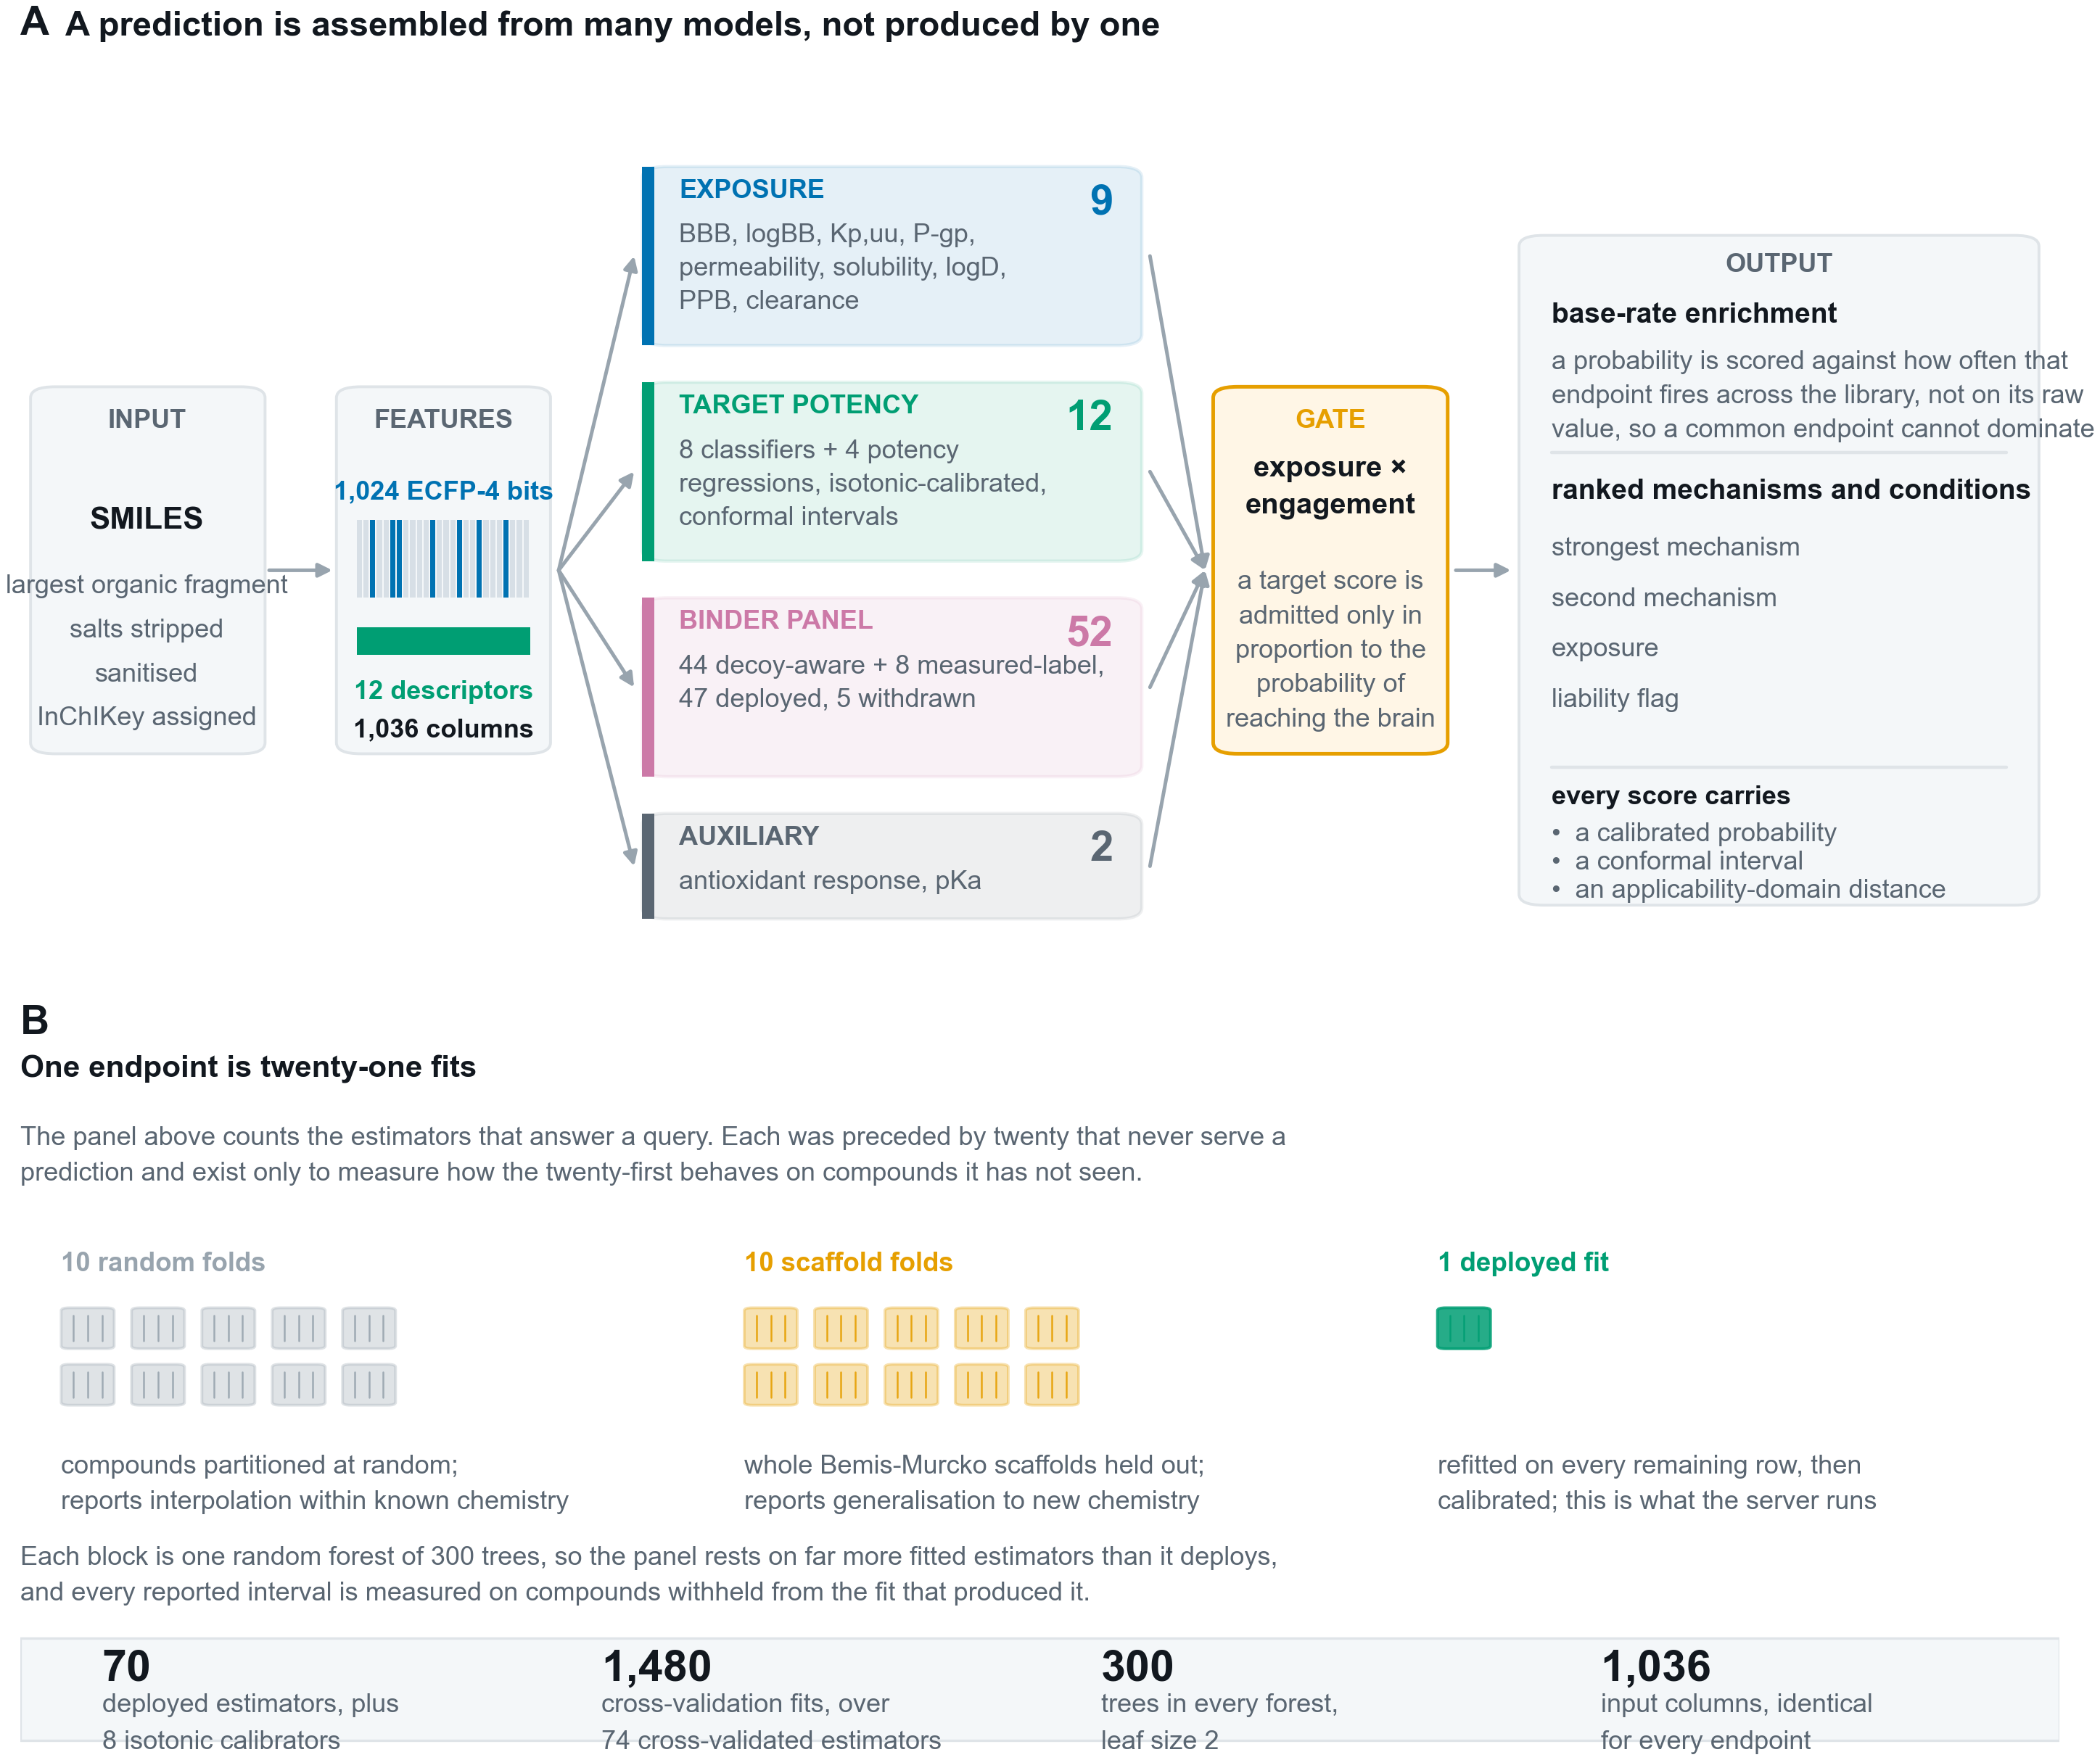
Figure 1
Figure 1. How a query is answered. (A) A submitted structure is standardised and represented as one fixed 1,036-column vector, scored by four model families, as MODEL_INVENTORY.csv defines them: the 52-endpoint binder panel of which 47 are deployed, twelve target potency and activity endpoints, the ten-endpoint exposure and ADME layer including the barrier model itself, and the single hERG safety classifier. Every target score is admitted only in proportion to the predicted probability that the compound reaches the brain, and surviving scores are ranked by enrichment over each endpoint’s base rate rather than by raw probability. Every reported value carries a calibrated probability and an applicability-domain distance, and the eight core classifiers additionally report a conformal interval. (B) The counts in (A) are trained estimators, 75 in total, of which 70 are deployed; each is the last of several fits that never serve a prediction and exist only to measure how it behaves on compounds it has not seen. A target-potency, exposure or safety endpoint, shown here, is validated under both regimes and is 21 fits, 10 random and 10 scaffold folds plus the deployed model; a binder classifier, validated under the scaffold regime alone, is 11. 960 fits stand behind the deployed panel in total.
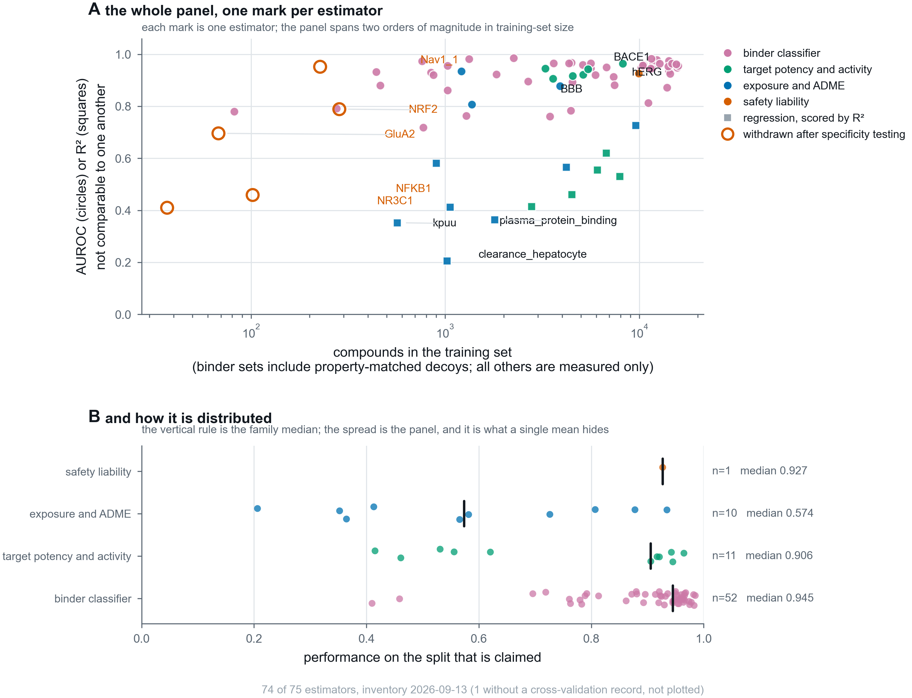
Figure 2
Figure 2. The panel, one mark per estimator, so that no claim rests on a mean a reader cannot check. (A) Every estimator, deployed or withdrawn, placed by the number of compounds it was trained on and by the performance claimed for it, coloured by model family. Marker shape carries the metric: AUROC and R² both run to 1.0 and are not the same quantity, since 0.5 is chance for one and a respectable fit for the other, so they are distinguished rather than averaged. The five estimators withdrawn after specificity testing are drawn in outline, because a panel showing only what survived is a selection rather than an inventory. Training sets span two orders of magnitude, from 37 to 15,831 rows; binder training sets include property-matched decoys while the others are measured compounds only, which the axis states. (B) The same population by family, with the family median marked. The spread is the point: the binder classifiers have a median of 0.945 while the exposure and ADME family, which mixes AUROC and R² endpoints, has a median of 0.574, and a single panel average would describe neither. The complete inventory, with training-set composition, validation scheme, calibration and fitting date for every estimator, is Supplementary Table S1.
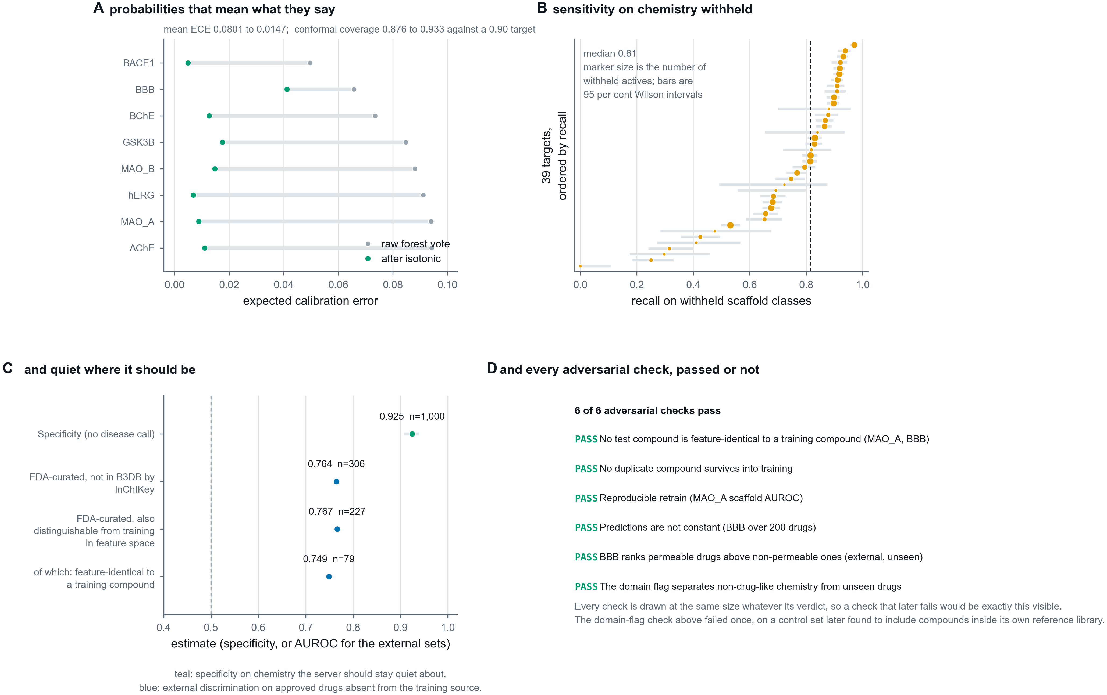
Figure 3
Figure 3. Four validations that a cross-validated score cannot replace. (A) Expected calibration error before and after isotonic regression fitted on out-of-fold predictions, so no compound contributes to the calibrator that scores it. (B) Recall on whole scaffold classes withheld before training, with 95 per cent Wilson intervals (41) and marker area proportional to the number of withheld actives, so an interval that is wide because the evidence is thin looks thin. (C) Specificity on chemistry the server should stay quiet about, and external discrimination on approved drugs absent from the training source. (D) The adversarial suite, in which each check was written so that it could fail. All six pass, one of them, the applicability-domain flag, only after its controls were corrected rather than its criterion retuned; every check is drawn at the same size whatever its verdict, so a future failure would be exactly this visible.
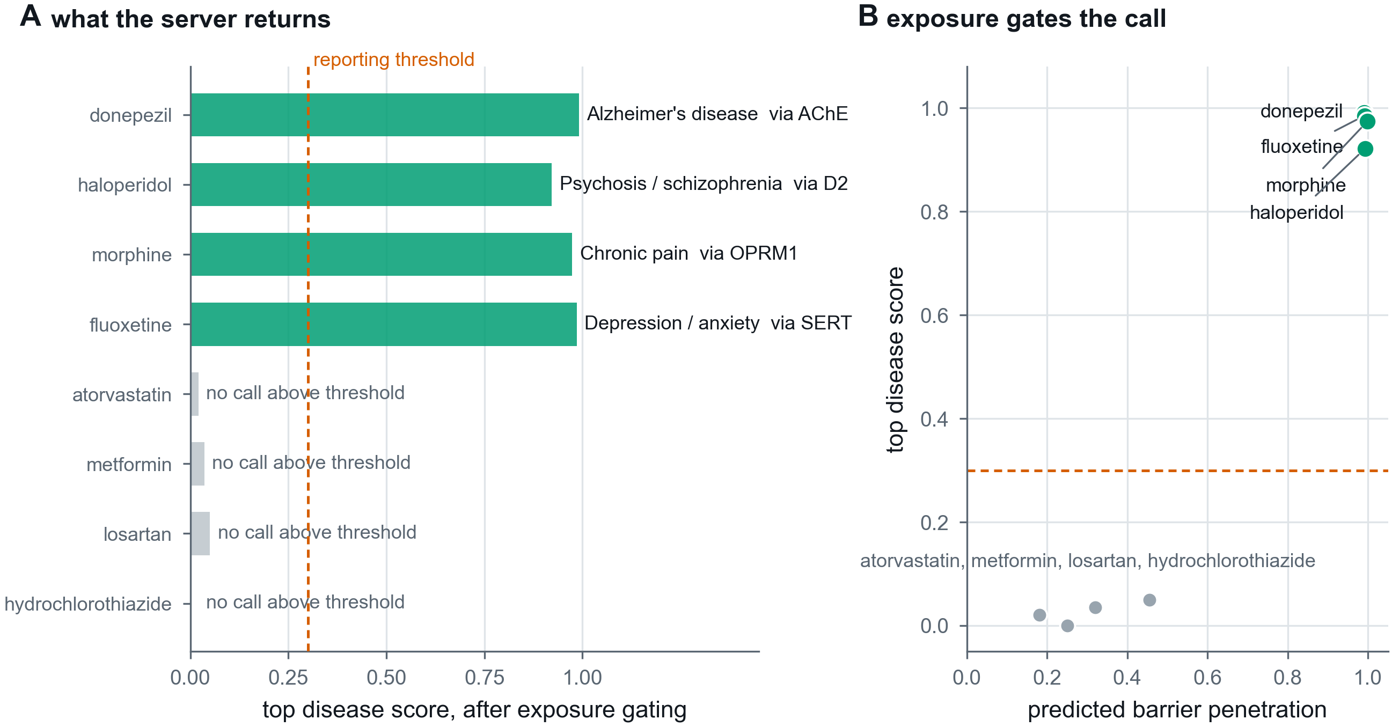
Figure 4
Figure 4. A worked profile and the silence behaviour. For four approved CNS drugs the server recovers the pharmacologically correct driving mechanism and the corresponding condition; for four peripherally acting compounds no disease score reaches the reporting threshold. Bars are disease scores after exposure gating, and the driving target is named beside each. The two behaviours are the same design decision seen from opposite sides: a target score is admitted only in proportion to predicted barrier penetration, so a compound that does not arrive cannot generate a disease call.
Supplementary figures, each named by the file it is generated into so that the number and the artefact cannot come apart:
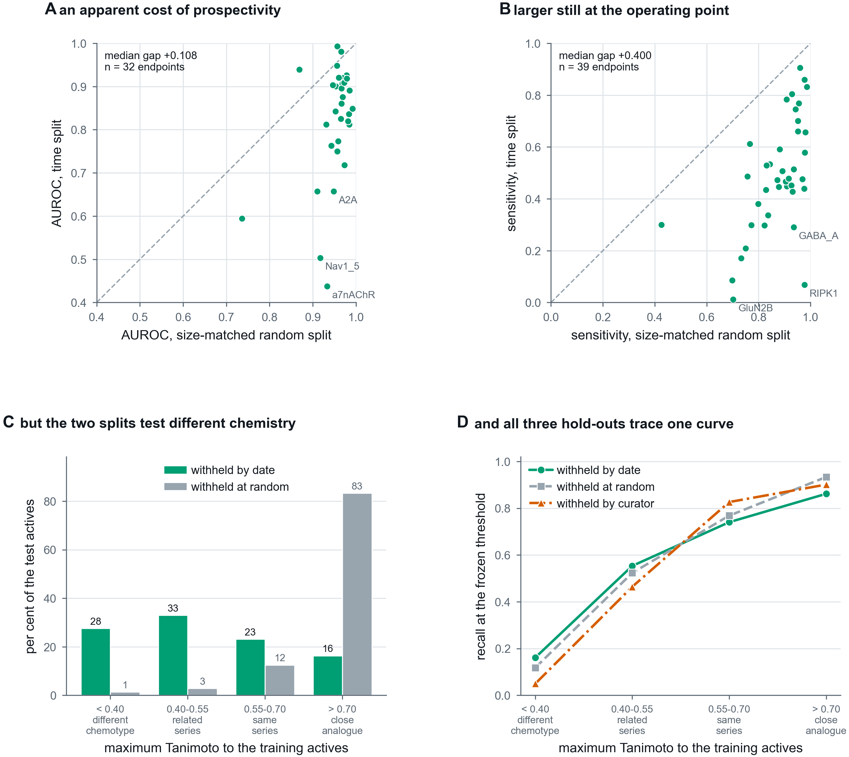
Figure 5
Figure 5. External validation, and an apparent temporal decay that is a composition effect. (A) Per endpoint, AUROC under a size-matched random split against AUROC under a time split that withholds the most recent quarter of the data and freezes the decision threshold before the cutoff. The size match matters: a time split trains on less data as well as none of the future, so without a control at the same n a drop cannot be attributed to either. (B) The same comparison for sensitivity at the frozen operating point, where the gap is larger. (C) Why the gap exists. A random split of medicinal-chemistry data holds out mostly close analogues of its own training set, because the published record is series; a time split does not. The two are not testing comparable populations. (D) The resolution. Recall against maximum Tanimoto similarity to the training actives, for three test sets built by unrelated rules: withheld by publication date, withheld at random, and withheld by curator, the last being compounds deposited in BindingDB and absent from ChEMBL. They trace one curve, so recall is a function of chemical distance rather than of how the set was held out, and the expected sensitivity for a submitted compound is knowable at query time.
Figure S1 (figures/Figure5_negative_class.png). Recovery of the measured negative class from censored bounds, and its effect on class balance per endpoint.
Figure S2 (figures/Figure2_feature_vector.png). The 1,036-column feature vector computed for a worked molecule, block by block.
Figure S3 (figures/Figure3_cv_design.png). The two cross-validation schemes, random and Bemis-Murcko scaffold-grouped, and what each withholds.
Figure S4 (figures/Figure4_pools_and_thresholds.png). The three disjoint background pools and the separation between the pool that sets a threshold and the pool that measures it.
Figure S5 (figures/Figure7_binder_panel.png). The complete binder panel, all 52 endpoints named, the 47 deployed and the 5 withdrawn distinguished by colour.

References
Every entry was resolved by a live query against CrossRef or Europe PMC and accepted only on a title match, or, where the identity is known and the registered title is a short form, by resolving the DOI and confirming the title and first author. The requested title, the matched title and the score are recorded in manuscript/references_verified.json, so the list can be re-checked mechanically. None is written from memory. A PubMed Central or PubMed abstract link is given where NCBI indexes the work (manuscript/references_links.json); neither exists for a work outside PubMed’s coverage, which is expected for some conference proceedings and for the software citations.
- Zdrazil B, Felix E, Hunter F et al. The ChEMBL Database in 2023: a drug discovery platform spanning multiple bioactivity data types and time periods. Nucleic Acids Research. 2024. doi:10.1093/nar/gkad1004. https://pmc.ncbi.nlm.nih.gov/articles/PMC10767899/ https://pubmed.ncbi.nlm.nih.gov/37933841/
- Gilson M, Liu T, Baitaluk M et al. BindingDB in 2015: A public database for medicinal chemistry, computational chemistry and systems pharmacology. Nucleic Acids Research. 2016. doi:10.1093/nar/gkv1072. https://pmc.ncbi.nlm.nih.gov/articles/PMC4702793/ https://pubmed.ncbi.nlm.nih.gov/26481362/
- Meng F, Xi Y, Huang J et al. A curated diverse molecular database of blood-brain barrier permeability with chemical descriptors. Scientific Data. 2021. doi:10.1038/s41597-021-01069-5. https://pmc.ncbi.nlm.nih.gov/articles/PMC8556334/ https://pubmed.ncbi.nlm.nih.gov/34716354/
- Pangalos M, Schechter L, Hurko O. Drug development for CNS disorders: strategies for balancing risk and reducing attrition. Nature Reviews Drug Discovery. 2007. doi:10.1038/nrd2094.
- Alavijeh M, Chishty M, Qaiser M et al. Drug metabolism and pharmacokinetics, the blood-brain barrier, and central nervous system drug discovery. NeuroRX. 2005. doi:10.1602/neurorx.2.4.554. https://pmc.ncbi.nlm.nih.gov/articles/PMC1201315/ https://pubmed.ncbi.nlm.nih.gov/16489365/
- Loryan I, Reichel A, Feng B et al. Unbound Brain-to-Plasma Partition Coefficient, Kp,uu,brain—a Game Changing Parameter for CNS Drug Discovery and Development. Pharmaceutical Research. 2022. doi:10.1007/s11095-022-03246-6. https://pmc.ncbi.nlm.nih.gov/articles/PMC9246790/ https://pubmed.ncbi.nlm.nih.gov/35411506/
- Wager T, Hou X, Verhoest P et al. Moving beyond Rules: The Development of a Central Nervous System Multiparameter Optimization (CNS MPO) Approach To Enable Alignment of Druglike Properties. ACS Chemical Neuroscience. 2010. doi:10.1021/cn100008c. https://pmc.ncbi.nlm.nih.gov/articles/PMC3368654/ https://pubmed.ncbi.nlm.nih.gov/22778837/
- Saify Z, Sultana N. Role of Acetylcholinesterase Inhibitors and Alzheimer Disease. Drug Design and Discovery in Alzheimer’s Disease. 2014. doi:10.1016/b978-0-12-803959-5.50007-6.
- Decourt B, Macias M, Sabbagh M et al. BACE1 Inhibitors: Attractive Therapeutics for Alzheimer’s Disease. Drug Design and Discovery in Alzheimer’s Disease. 2014. doi:10.1016/b978-0-12-803959-5.50010-6.
- Dezsi L, Vecsei L. Monoamine Oxidase B Inhibitors in Parkinson’s Disease. CNS & neurological disorders drug targets. 2017. doi:10.2174/1871527316666170124165222. https://pubmed.ncbi.nlm.nih.gov/28124620/
- West A. Achieving neuroprotection with LRRK2 kinase inhibitors in Parkinson disease. Experimental Neurology. 2017. doi:10.1016/j.expneurol.2017.07.019. https://pmc.ncbi.nlm.nih.gov/articles/PMC5693612/ https://pubmed.ncbi.nlm.nih.gov/28764903/
- Riemann D, Spiegelhalder K. Orexin receptor antagonists: a new treatment for insomnia?. The Lancet Neurology. 2014. doi:10.1016/s1474-4422(13)70311-9. https://pubmed.ncbi.nlm.nih.gov/24680373/
- Duan Y, Kelley N, He Y. Role of the NLRP3 inflammasome in neurodegenerative diseases and therapeutic implications. Neural Regeneration Research. 2020. doi:10.4103/1673-5374.272576. https://pmc.ncbi.nlm.nih.gov/articles/PMC7047811/ https://pubmed.ncbi.nlm.nih.gov/31960806/
- Yamazaki H, Tanji K, Wakabayashi K, Matsuura S, Itoh K. Role of the Keap1/Nrf2 pathway in neurodegenerative diseases. Pathology international. 2015. doi:10.1111/pin.12261. https://pubmed.ncbi.nlm.nih.gov/25707882/
- Kovalenko M, Erdin S, Andrew M et al. Histone deacetylase knockouts modify transcription, CAG instability and nuclear pathology in Huntington disease mice. eLife. 2020. doi:10.7554/elife.55911. https://pmc.ncbi.nlm.nih.gov/articles/PMC7581428/ https://pubmed.ncbi.nlm.nih.gov/32990597/
- RG M, JD M, M L et al. Riluzole for amyotrophic lateral sclerosis (ALS)/motor neuron disease (MND). Amyotrophic Lateral Sclerosis and Other Motor Neuron Disorders. 2003. doi:10.1080/14660820310002601.
- Ritter J. Cardiac safety, drug‐induced QT prolongation and torsade de pointes (TdP). British Journal of Clinical Pharmacology. 2012. doi:10.1111/j.1365-2125.2012.04193.x. https://pmc.ncbi.nlm.nih.gov/articles/PMC3370337/ https://pubmed.ncbi.nlm.nih.gov/22329611/
- Huang K, Fu T, Gao W, Zhao Y, Roohani Y, Leskovec J, Coley CW, Xiao C, Sun J, Zitnik M. Artificial intelligence foundation for therapeutic science. Nature chemical biology. 2022. doi:10.1038/s41589-022-01131-2. https://pmc.ncbi.nlm.nih.gov/articles/PMC9529840/ https://pubmed.ncbi.nlm.nih.gov/36131149/
- Wu Z, Ramsundar B, Feinberg E et al. MoleculeNet: a benchmark for molecular machine learning. Chemical Science. 2018. doi:10.1039/c7sc02664a. https://pmc.ncbi.nlm.nih.gov/articles/PMC5868307/ https://pubmed.ncbi.nlm.nih.gov/29629118/
- Rogers D, Hahn M. Extended-Connectivity Fingerprints. Journal of Chemical Information and Modeling. 2010. doi:10.1021/ci100050t. https://pubmed.ncbi.nlm.nih.gov/20426451/
- Pedregosa F, Varoquaux G, Gramfort A et al. Scikit-learn: Machine Learning in Python. Journal of Machine Learning Research. 2011;12:2825-2830. https://www.jmlr.org/papers/v12/pedregosa11a.html
- Breiman L. Random Forests. Machine Learning. 2001. doi:10.1023/a:1010933404324.
- Chen T, Guestrin C. XGBoost: A Scalable Tree Boosting System. Proceedings of the 22nd ACM SIGKDD International Conference on Knowledge Discovery and Data Mining. 2016. doi:10.1145/2939672.2939785.
- Lundberg S, Erion G, Chen H et al. From local explanations to global understanding with explainable AI for trees. Nature Machine Intelligence. 2020. doi:10.1038/s42256-019-0138-9. https://pmc.ncbi.nlm.nih.gov/articles/PMC7326367/ https://pubmed.ncbi.nlm.nih.gov/32607472/
- Bemis G, Murcko M. The Properties of Known Drugs. 1. Molecular Frameworks. Journal of Medicinal Chemistry. 1996. doi:10.1021/jm9602928. https://pubmed.ncbi.nlm.nih.gov/8709122/
- Niculescu-Mizil A, Caruana R. Predicting good probabilities with supervised learning. Proceedings of the 22nd international conference on Machine learning - ICML ’05. 2005. doi:10.1145/1102351.1102430.
- Norinder U, Carlsson L, Boyer S et al. Introducing Conformal Prediction in Predictive Modeling. A Transparent and Flexible Alternative to Applicability Domain Determination. Journal of Chemical Information and Modeling. 2014. doi:10.1021/ci5001168. https://pubmed.ncbi.nlm.nih.gov/24797111/
- Jaworska J, Nikolova-Jeliazkova N, Aldenberg T. QSAR Applicability Domain Estimation by Projection of the Training Set in Descriptor Space: A Review. Alternatives to Laboratory Animals. 2005. doi:10.1177/026119290503300508. https://pubmed.ncbi.nlm.nih.gov/16268757/
- Mysinger M, Carchia M, Irwin J et al. Directory of Useful Decoys, Enhanced (DUD-E): Better Ligands and Decoys for Better Benchmarking. Journal of Medicinal Chemistry. 2012. doi:10.1021/jm300687e. https://pmc.ncbi.nlm.nih.gov/articles/PMC3405771/ https://pubmed.ncbi.nlm.nih.gov/22716043/
- Lin H, Lin C, Weng R. A note on Platt’s probabilistic outputs for support vector machines. Machine Learning. 2007. doi:10.1007/s10994-007-5018-6.
- Kanehisa M, Goto S. KEGG: kyoto encyclopedia of genes and genomes. Nucleic acids research. 2000. doi:10.1093/nar/28.1.27. https://pmc.ncbi.nlm.nih.gov/articles/PMC102409/ https://pubmed.ncbi.nlm.nih.gov/10592173/
- Milacic M, Beavers D, Conley P, Gong C, Gillespie M, Griss J, Haw R, Jassal B, Matthews L, May B, Petryszak R, Ragueneau E, Rothfels K, Sevilla C, Shamovsky V, Stephan R, Tiwari K, Varusai T, Weiser J, Wright A, Wu G, Stein L, Hermjakob H, D’Eustachio P. The Reactome Pathway Knowledgebase 2024. Nucleic acids research. 2024. doi:10.1093/nar/gkad1025. https://pmc.ncbi.nlm.nih.gov/articles/PMC10767911/ https://pubmed.ncbi.nlm.nih.gov/37941124/
- Harding SD, Armstrong JF, Faccenda E, Southan C, Alexander SPH, Davenport AP, Spedding M, Davies JA. The IUPHAR/BPS Guide to PHARMACOLOGY in 2024. Nucleic acids research. 2024. doi:10.1093/nar/gkad944. https://pmc.ncbi.nlm.nih.gov/articles/PMC10767925/ https://pubmed.ncbi.nlm.nih.gov/37897341/
- Streamlit: an open-source app framework. https://streamlit.io
- RDKit: Open-source cheminformatics. https://www.rdkit.org
- Daina A, Michielin O, Zoete V. SwissADME: a free web tool to evaluate pharmacokinetics, drug-likeness and medicinal chemistry friendliness of small molecules. Scientific Reports. 2017. doi:10.1038/srep42717.
- Xiong G, Wu Z, Yi J et al. ADMETlab 2.0: an integrated online platform for accurate and comprehensive predictions of ADMET properties. Nucleic Acids Research. 2021. doi:10.1093/nar/gkab255.
- Pires DEV, Blundell TL, Ascher DB. pkCSM: Predicting Small-Molecule Pharmacokinetic and Toxicity Properties Using Graph-Based Signatures. Journal of Medicinal Chemistry. 2015. doi:10.1021/acs.jmedchem.5b00104.
- Yang H, Lou C, Sun L et al. admetSAR 2.0: web-service for prediction and optimization of chemical ADMET properties. Bioinformatics. 2019. doi:10.1093/bioinformatics/bty707.
- Daina A, Michielin O, Zoete V. SwissTargetPrediction: updated data and new features for efficient prediction of protein targets of small molecules. Nucleic Acids Research. 2019. doi:10.1093/nar/gkz382.
- Wilson E. Probable Inference, the Law of Succession, and Statistical Inference. Journal of the American Statistical Association. 1927. doi:10.1080/01621459.1927.10502953.

