jupyter change directory:==>

jupyter notebook --notebook-dir=/Users/yourname/folder1

usefull website:==>>>>

1)teachable machine

2)machine learning playground

machine learning==>>>>

1)supervised(label tag with data)

i)classification

ii)regression

2)unsupervised(no label tag with data):

i)clustering

ii)assiciation rule learning

3)reinforcement

i)skill acquisition real time learning

machine learning algorithm :=> ko model kah skte hai

1)data =>machine learning algorithm=> pattern

2)newData => same algorithm(model) =>more patterns

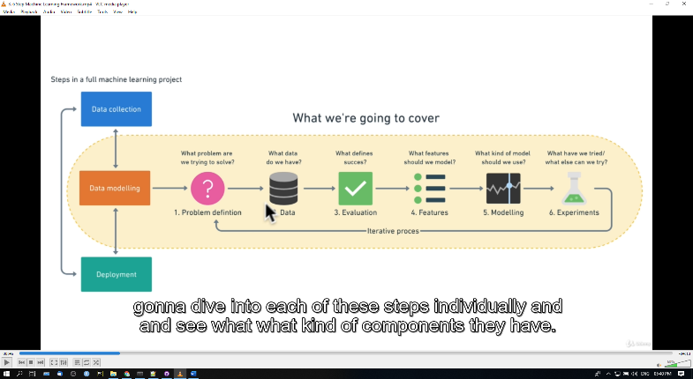

1.problem definaton:=>

Supervised ,unsupervised,classification,regression

2.data:=>

Hum kis tarah ka data chahte hai

3.evaluation(mulyakan):=>

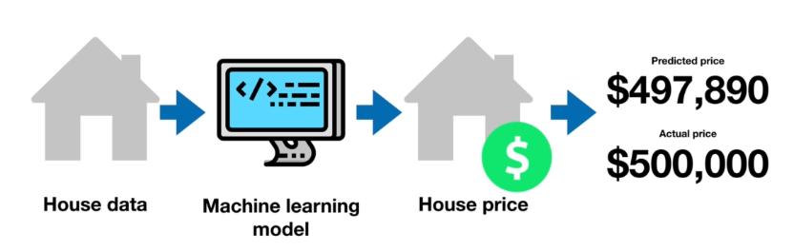

4.features:=>

Jo hum data ki bare me pahle se jante hai

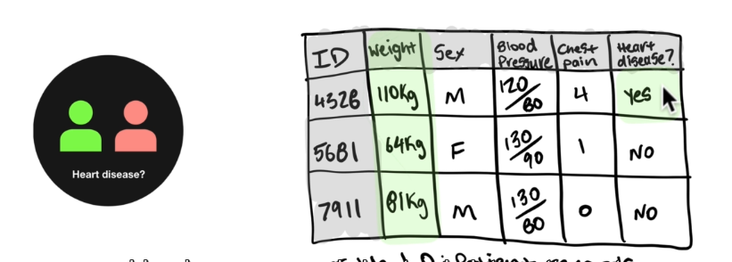

5.modelling:=>

Jaise data and jaise problem us ki according use kro

Mode

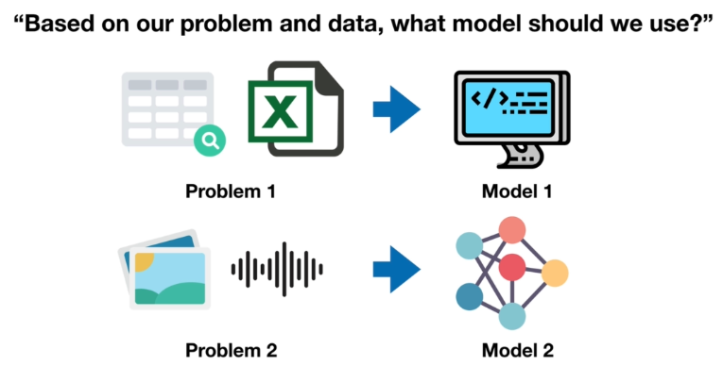

6.exprimentation:=>

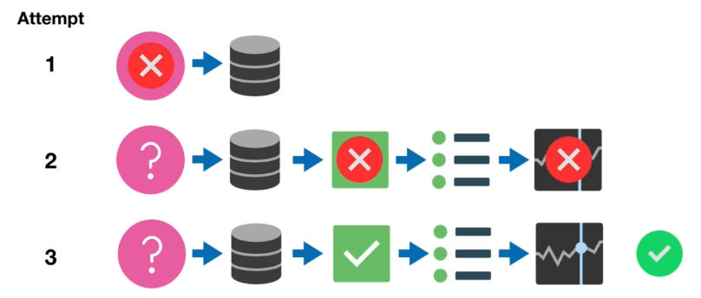

How to choose machine learning types:

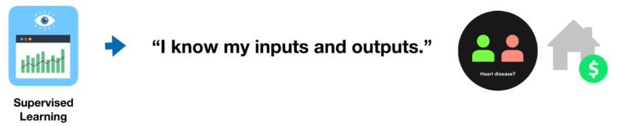

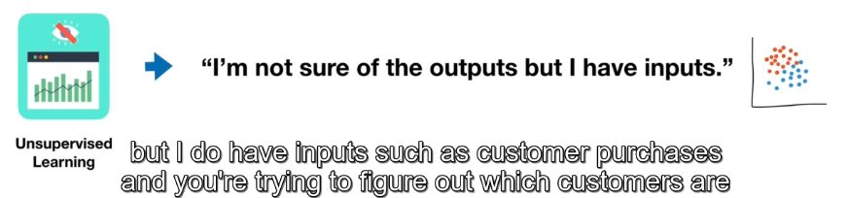

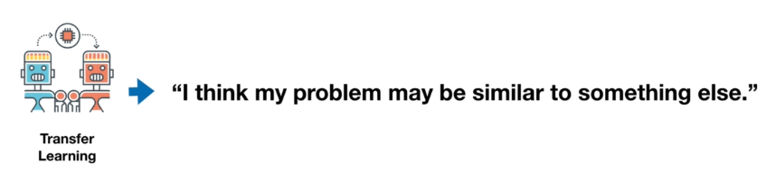

**Type of data:=>**

**1)structured**

**2)unstructured**

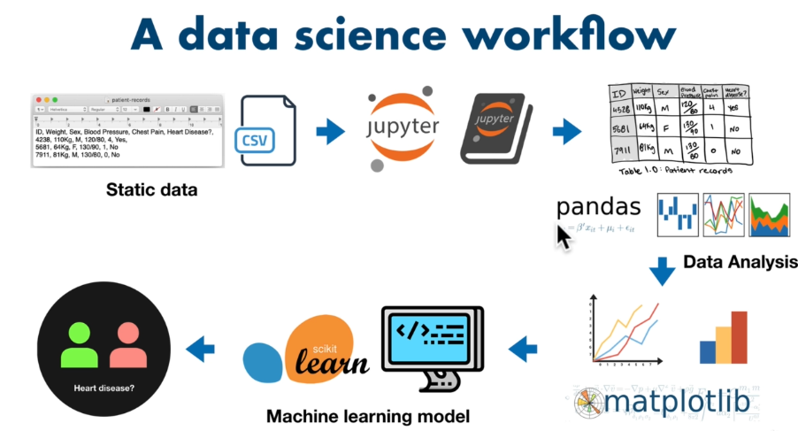

**Type of evaluation:=>**

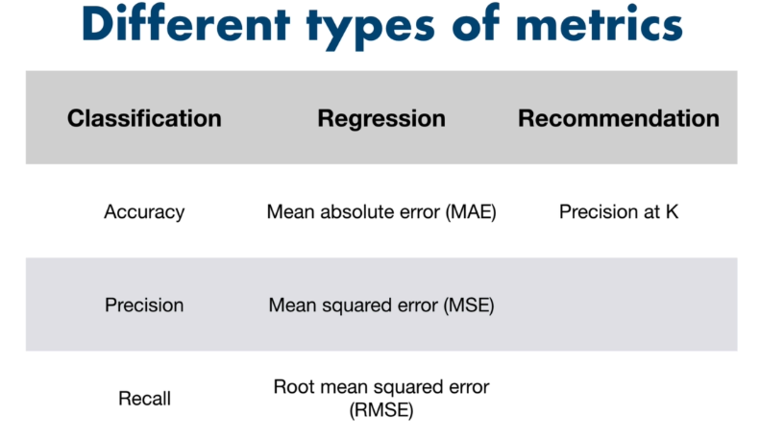

**Features:=>**

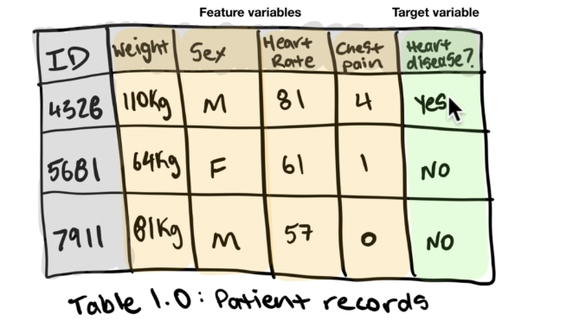

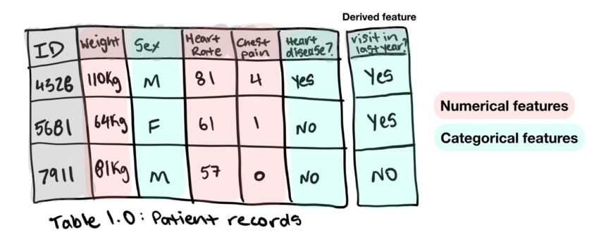

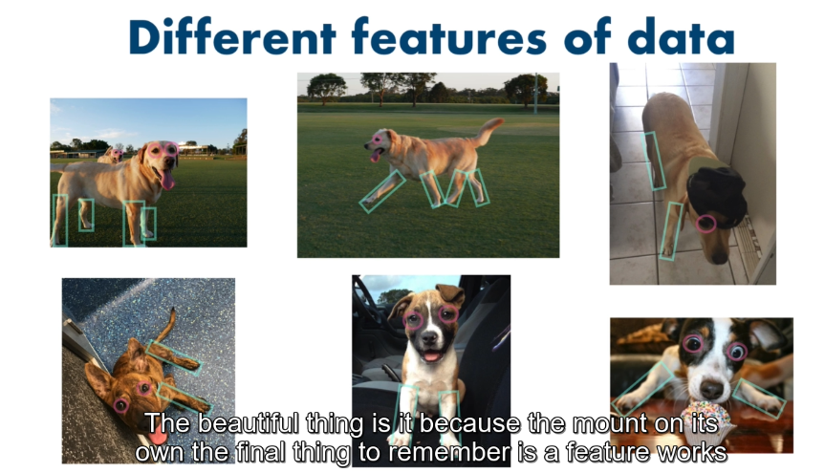

**Modelling:=>**

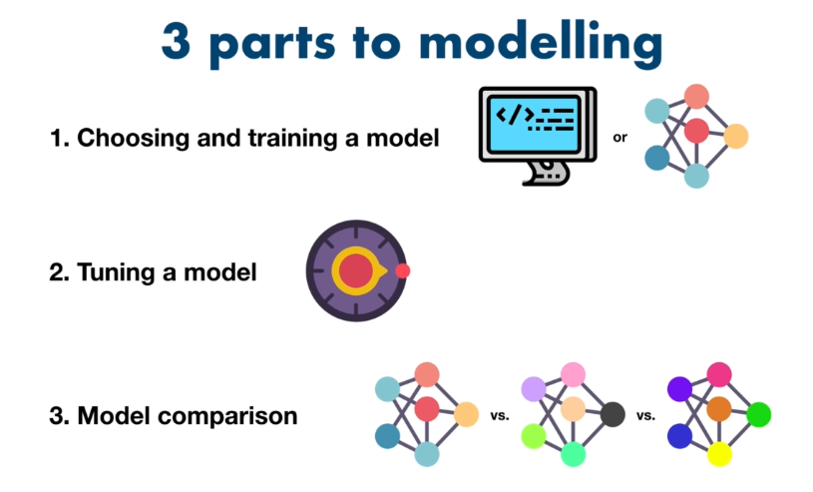

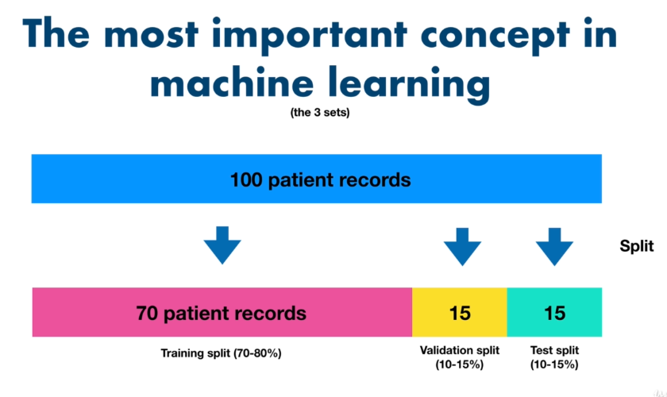

**Training data:=> jis data se model ko tran krenge**

**Test data:=> jis data se model ko check krenge**

**Validation date:=> jis data se model ke accurece**

**Check krenge**

**3.9**