ClimateSphere: An AI-Powered Platform for Predictive Climate Analytics

Problem Statement
The project addresses the following critical global challenges:
1) Rising Climate Instability – Global temperatures in 2024 reached 1.55 °C above pre-industrial levels, the warmest year on record, leading to unpredictable rainfall, glacier melt, and frequent floods, droughts, and heatwaves.
2) Fragmented Climate Data – Massive data from sources like NASA, NOAA, and local sensors remain scattered with no unified system for integrated analysis and decision-making.
3) Lack of Predictive Intelligence – Current systems focus only on monitoring, not forecasting future climate impacts using AI or Machine Learning models.
4) Unprepared Communities & Governments – Without real-time analytics or early predictions, authorities fail to implement timely disaster-prevention or adaptation strategies.
5) Absence of Actionable Insights – Over 90 % of natural disasters are weather- or water-related, yet most regions lack real-time analytics to prevent or mitigate their impact.
6) Need for a Unified Predictive Platform – There is an urgent demand for an AI-powered, data-driven platform that can analyze global climate trends, predict future risks, and provide actionable insights for sustainable planning.

Overview
ClimateSphere is an advanced AI-driven web application designed to transform raw climate data into actionable intelligence.
It serves as a unified analytical ecosystem for understanding climate dynamics, predicting future risks, and generating policy-ready insights — all through an interactive, data-rich interface.
By integrating Artificial Intelligence (AI), Machine Learning (ML), and Real-Time Data Visualization, ClimateSphere empowers decision-makers, researchers, and local communities to anticipate climate-related risks and plan proactive responses.
Key Features: What ClimateSphere Does
ClimateSphere offers a comprehensive suite of intelligent tools through an intuitive, responsive dashboard:
🔹 1. Real-Time Data Visualization
- Dynamic, interactive visualization of global and regional climate indicators (Temperature, CO₂, Rainfall, Humidity, AQI).
- Uses Chart.js, D3.js, and Leaflet.js for multi-layer visual rendering.
- Displays continuously updated data via APIs for the latest global climate metrics.
🔹 2. ML-Powered Climate Risk Prediction
- Predicts climate risks such as floods, droughts, heatwaves, and pollution surges.
- Employs ensemble ML models (XGBoost, Random Forest) for accurate classification and regression-based risk scoring.
- Includes Anomaly Detection (Isolation Forest) for identifying unusual or extreme weather events in advance.
🔹 3. Advanced Time-Series Forecasting
- Integrates LSTM (Long Short-Term Memory) and ARIMAmodels for long-term forecasting of parameters like temperature, rainfall, and CO₂ levels.
- Predictive horizon can extend up to 5, 10, or 15 years, providing policy-level planning capabilities.
🔹 4. Interactive Scenario Simulator
- Real-time “What-if” Simulation engine allows users to modify parameters (industrial emissions, reforestation rate, renewable energy adoption).
- Simulates alternative climate futures and updates projections dynamically using Hybrid LSTM + XGBoost models.
- Generates impact visualizations and comparative scenario reports.
🔹 5. AI-Driven Insights and Policy Recommendations
- Features a Natural Language AI Assistant (powered by NLP models) for field-level users — farmers, disaster officers, and researchers.
- Automatically generates data-driven recommendations such as adaptive agricultural practices or mitigation measures.
- Provides AI-generated policy briefs summarizing key findings, risk levels, and suggested interventions.
🔹 6. Multi-Modal & Multi-Region Analysis
- Combines multiple datasets — satellite data, weather APIs, and user-uploaded CSVs — to enable comprehensive climate understanding.
- Supports spatial clustering (K-Means, DBSCAN) to identify regional patterns and climate zones.
- Enables historical trend analysis (2010–2025) for temperature, CO₂, humidity, and rainfall patterns.

How It Works: System Architecture
The ClimateSphere platform is built on a modern, scalable, and modular three-tier architecture:
🖥️ Frontend (Visualization Layer)
- Built using HTML5, CSS3, and JavaScript for responsiveness and fluid interactivity.
- Incorporates Chart.js, D3.js, and Leaflet.js for real-time visual analytics and geospatial rendering.
- Provides user dashboards, model selection menus, and exportable visual reports (PNG, CSV, PDF).
⚙️ Backend (Application Layer)
Developed using Node.js and Express.js, the backend functions as the central logic hub:
- User Authentication – Managed via JWT (JSON Web Tokens) and bcrypt password hashing for secure access.
- Data Management – Handles dataset uploads, preprocessing, and model communication.
- API Endpoints – Provides structured routes for data processing, analytics, and insight generation.
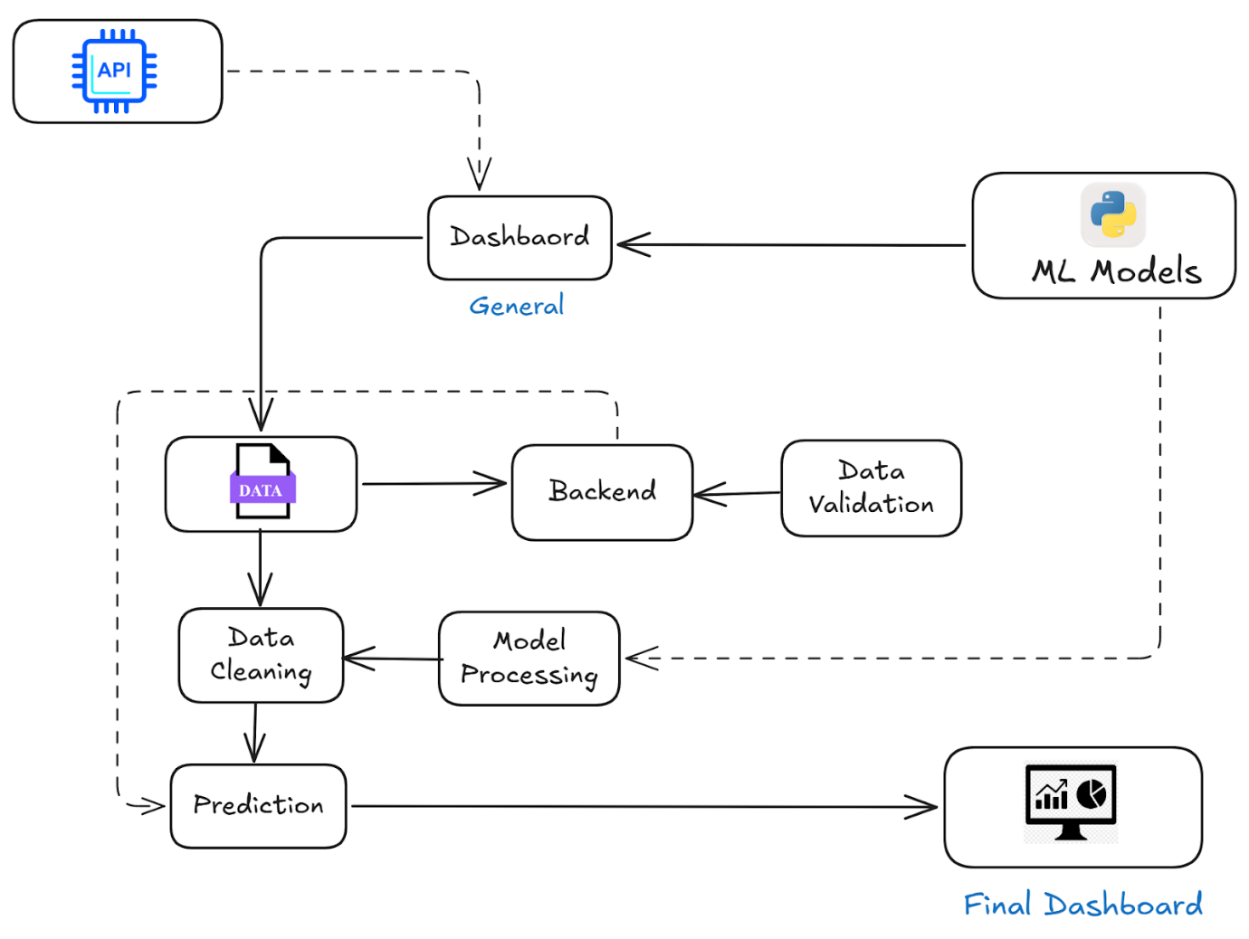

– AI Predictive Models Overview
Model | Feature | Type | Core Algorithm(s) | Purpose & Why
Model 1 | Predictions (1Month / 1–5Y) | Trend Forecasting | LSTM, Prophet, XGBoost | Forecast future Temperature, CO₂, Rainfall. XGBoost handles non-linearity; LSTM captures long-term climate trends.
Model 2 | Risk Probability (Flood, Drought, Heatwave) | Classification &Regression | Random Forest, SVM, DNN | Predicts disaster risk levels (High/Medium/Low) using rainfall, temperature, soil moisture, and event data.
Model 3 | Scenario Impact (Sliders) | Surrogate Model | Linear Regression, GPR, ANN | Provides real-time impact estimates (ΔCO₂ → ΔTemp) by emulating the main prediction model.
Model 4 | AI Insights & Policy Suggestions | Language Model (LLM) | Fine-tuned GPT , Climate LLM | Converts model outputs into clear insights and policy actions (e.g., flood prevention through mangroves).

Detailed Capabilities of the Platform
The backend is structured to support a wide range of advanced functions through dedicated API endpoints:
Authentication & Personalization:
- POST /api/auth/register: Create a new user account.
- POST /api/auth/login: Securely log in.
- GET /api/auth/profile: View and manage your user profile.
- PUT /api/auth/preferences: Update user preferences.
Data Upload & Management:
- POST /api/upload/dataset: Upload a new climate dataset.
- GET /api/upload/history: View a history of your past uploads.
- DELETE /api/upload/:uploadId: Delete a previously uploaded dataset.
In-Depth Analysis:
- GET /api/analysis/trends: Automatically identify and retrieve climate trends from data.
- POST /api/analysis/dataset: Run a deep analysis on a specific uploaded dataset.
- GET /api/analysis/correlation: Find hidden correlations between different climate variables.
- GET /api/analysis/regional/:region: Get analysis specific to a chosen geographical region.
Predictive Modeling:
- POST /api/prediction/risk: Get on-demand risk predictions for events like floods or droughts.
- POST /api/prediction/future: Generate future climate projections based on current data.
- POST /api/prediction/scenario: Run a custom "what-if" scenario simulation.
- GET /api/prediction/metrics: Check the performance and accuracy of the underlying ML models.
AI-Driven Insights:
- POST /api/insights/generate: Ask the AI to generate insights from a set of data.
- GET /api/insights/policy: Receive AI-driven policy recommendations.
- POST /api/insights/chat: Interact with an AI assistant to ask questions about your data.
- GET /api/insights/history: Review a history of previously generated insights.

Why It Matters
- ClimateSphere bridges the gap between complex climate science and practical decision-making.
- It empowers various users (researchers, policymakers, businesses, individuals).
- Users can not only see past climate events but also scientifically predict future ones.
- This enables better preparation, risk management, and more informed policy.

