**Flowchart**

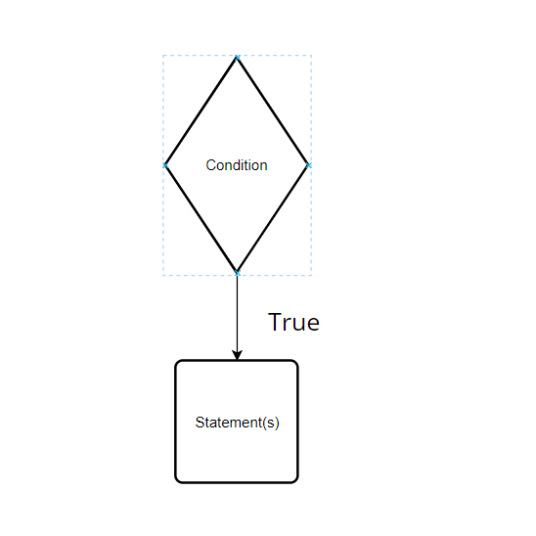

**Pseudocode**

if Condition then

Statement(s)

end if

**Note:**

* Relational Operators (==, !=, >, >=, <, <=) -> Compares two values and return Boolean result.
* Supported data types (primitive, reference type)
* ==, != (all supported types)
* >, >=, <, <= (all supported types)

**Example**