Ticket Booking Microservices System
Design and Technical Report
Assignment 1 - Scalable Services (SEZG583)
BITS Pilani WILP

Team Member | Service Owned | GitHub Branch
Krishna Sagar | Notification Service | krishnasagar/notification-service
Anwesa | Seat Service | anwesa/seat_service
Aishwarya | Booking Service | aishwarya/booking-service
Aarzoo | Payment Service | aarzoo/payment-service

Table of Contents
(Insert Word's auto-generated Table of Contents here: References > Table of Contents, after finalising section numbers.)

1. Problem and Scope

1.1 Overview
This project implements a ticket booking system as a set of independently deployable microservices, built to satisfy the engineering requirements of Assignment 1: correct behaviour under concurrent, repeated and partially-failing requests. The domain is event seat booking - a customer books one or more seats for an event, pays for the booking, and receives a confirmation. The system is deliberately built around the distributed-systems problems the assignment requires (a contended resource, an unsafe-to-repeat operation, a slow/failing dependency, and a transaction spanning multiple services), rather than being a simple CRUD wrapper around a database.

1.2 Assumptions
- Seats and events are pre-seeded (seed.sql); there is no admin UI to create events or seats.
- A single customer books 1 to 6 seats per booking (server-enforced maximum).
- Seat price is fixed and server-side (SEAT_PRICE env var); the client never sends a price.
- Payment is always processed through the mock gateway, never a real payment provider (explicitly out of scope per the assignment).
- User authentication is out of scope, per the assignment brief; customer_email is a free-text identifier only.
- All services and the database run on localhost for Assignment 1; containerisation is deferred to Assignment 2 per the brief.

1.3 Business Rules (BR1-BR4)
ID | Rule | Owning Service(s) | Error on Violation
BR1 | A seat belongs to one booking at a time. | Seat | 409 SEAT_UNAVAILABLE
BR2 | A hold expires after HOLD_SECONDS (30s); a paid (SOLD) seat is never released. | Seat | N/A (silent no-op on expiry sweep)
BR3 | A booking can be paid only while it is HELD and its hold has not expired. | Booking | 409 BOOKING_NOT_PAYABLE / 409 HOLD_EXPIRED
BR4 | A payment (Idempotency-Key) is applied once per booking; replays return the same result; reuse with a different payload is rejected. | Booking + Payment | 422 IDEMPOTENCY_KEY_REUSED / 409 REQUEST_IN_PROGRESS

1.4 Out of Scope
- User authentication / authorisation (per assignment instructions).
- A real UI (a script/Postman-style client is used instead, per assignment instructions).
- Real payment gateway integration (a self-built mock gateway simulates ok/down/slow behaviour).
- Containerisation and orchestration (Docker images per service, Kubernetes) - explicitly deferred to Assignment 2 per the brief, which states the same application is containerised and deployed on Docker/Minikube there.
- Automatic refund flow for the rare case where payment succeeds just as a hold expires (documented as a known limitation, Section 9).

2. Service Decomposition

2.1 Responsibility Table
Service | Port | Database | Responsibility | Business Rules Owned
booking-service | 8001 | booking_db | Orchestrates the booking lifecycle: create, pay, cancel, expire. The only service a client calls directly. | BR3, BR4 (booking side), state machine
seat-service | 8002 | seat_db | Owns seat inventory and the hold/sold state machine for every seat of an event. | BR1, BR2
payment-service | 8003 | payment_db | Charges a booking via the mock gateway and guarantees a charge happens at most once per Idempotency-Key. | BR4 (payment side)
notification-service | 8004 | notification_db | Records/“sends” a notification for a booking event (confirmed, cancelled, etc). A terminal, non-critical dependency. | none
mock-gateway | 8005 | none (stateless) | Simulates a third-party payment gateway with ok / down / slow modes, to let Payment's failure handling be tested on demand. | none

2.2 Why These Boundaries
Each service is split by business capability, not by technical layer: there is no generic 'controller service' or 'database service'. Every service can be described in one sentence (Section 2.1), and no two services change together on every request - Seat does not need to know about Payment, and Notification does not need to know about Seat. Booking is the only service that calls others, which keeps the call graph a star rather than a mesh and avoids a 'distributed monolith'.
The seat-booking-payment-notification split also directly maps to the assignment's five mandatory conditions: Seat is the contended resource (condition c), Payment is the unsafe-to-repeat operation (condition d), the mock gateway is the slow/unreliable dependency (condition e), and the pay flow (Booking -> Payment -> Seat -> Notification) is the cross-service transaction spanning 4 services (condition b, exceeding the required minimum of 3).

2.3 Alternatives Considered and Rejected
Alternative | Why Rejected
Merge Seat into Booking (one service owns both seats and bookings) | Would hide the contended-resource problem inside a single service and make Challenge 1 trivial (an in-process lock would appear to work, but would not survive multiple instances/processes - exactly the anti-pattern the assignment warns against).
A single shared 'core' database for all services | Violates the mandatory database-per-service requirement and would let a bug in one service corrupt another service's data directly.
Choreography (event-driven) instead of orchestration for the booking flow | The assignment's mandatory stack is REST over HTTP with no message broker required for the core flow (a broker is only one optional Challenge 3 path, 3D, which the team did not choose). Orchestration also gives one readable place (Booking) to reason about the whole transaction, easier to demo and to reason about failure/compensation.
Let Payment call Seat directly to confirm the seat after charging | Would make Payment aware of Seat's API and turn the call graph into a mesh. Booking (the orchestrator) calls Seat to confirm after Payment responds, keeping each service's knowledge of others to only what it strictly needs.

2.4 Data Ownership Table
Database | Owning Service | Tables | Referenced (not owned) IDs
booking_db | booking-service | bookings, booking_seats, idempotency_keys | event_id, seat_no (Seat); payment_id (Payment)
seat_db | seat-service | events, seats | booking_id (Booking)
payment_db | payment-service | payments, idempotency_keys | booking_id (Booking)
notification_db | notification-service | notifications | booking_id (Booking)

No service reads another service's database directly, and no cross-database foreign keys exist anywhere in the schema. Cross-service references are stored as plain scalar values (e.g. booking_id as a VARCHAR in seat_db), resolved only by calling the owning service's REST API when more detail is needed.

2.5 Shared Scaffold and Integration Workflow
To keep the four services consistent and interoperable from day one, the team started from one common scaffold applied identically to all four real services (booking, seat, payment, notification): the same FastAPI app structure (app/main.py, config.py, errors.py, logging_setup.py, db.py), the same correlation-ID middleware, the same uniform JSON error format, and the same environment-variable-based configuration convention. This meant every service owner could focus purely on their own routes, business rules and schema (app/api/, app/rules.py, schema.sql) without re-deriving cross-cutting concerns such as logging or error handling - and guaranteed that every service would be compatible with the others' correlation-ID propagation and error contract without needing a late integration pass to reconcile them.
Each member developed their service on an independent feature branch (<name>/<service>), with the mock payment gateway (mock-gateway) built first against the shared contract so that payment-service could be developed and tested against a realistic ok/down/slow dependency from the start. Once each service's unit tests passed independently, all four feature branches were merged into main and the full system was re-tested together: every service's unit test suite was re-run against the merged code (112 tests, Section 7.2), and the end-to-end script was run against all five real, running services together (Section 7.3). This integration step is what surfaced the retryable-vs-final idempotency issue described in Section 6.2 - a defect that was only visible once the real services were exercised together, not from any single service's unit tests in isolation - and it was corrected before the merge was finalised on main.

3. Architecture

3.1 Component Diagram
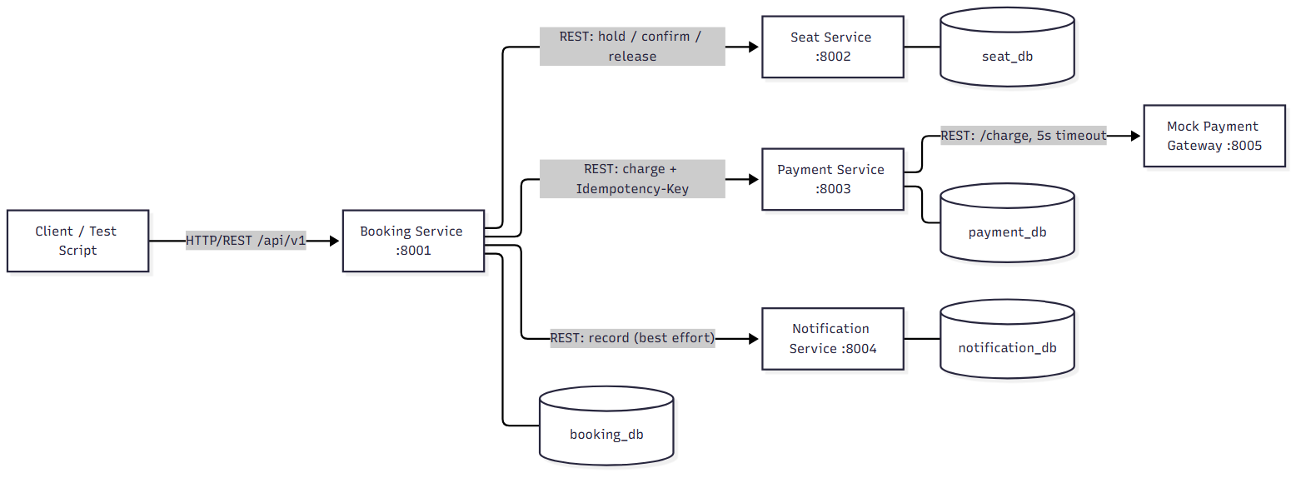
Figure 1: Component diagram. The client only talks to Booking; Booking orchestrates calls to Seat, Payment and Notification; Payment is the only service that calls the external (mocked) gateway. Every service owns exactly one database.
The longest synchronous chain in the system is Client -> Booking -> Payment -> Gateway (3 hops), which stays within the assignment's guidance to justify any chain longer than 3. There are no circular calls between services.

3.2 Main Transaction: Sequence Diagram (Happy Path and Failure Path)
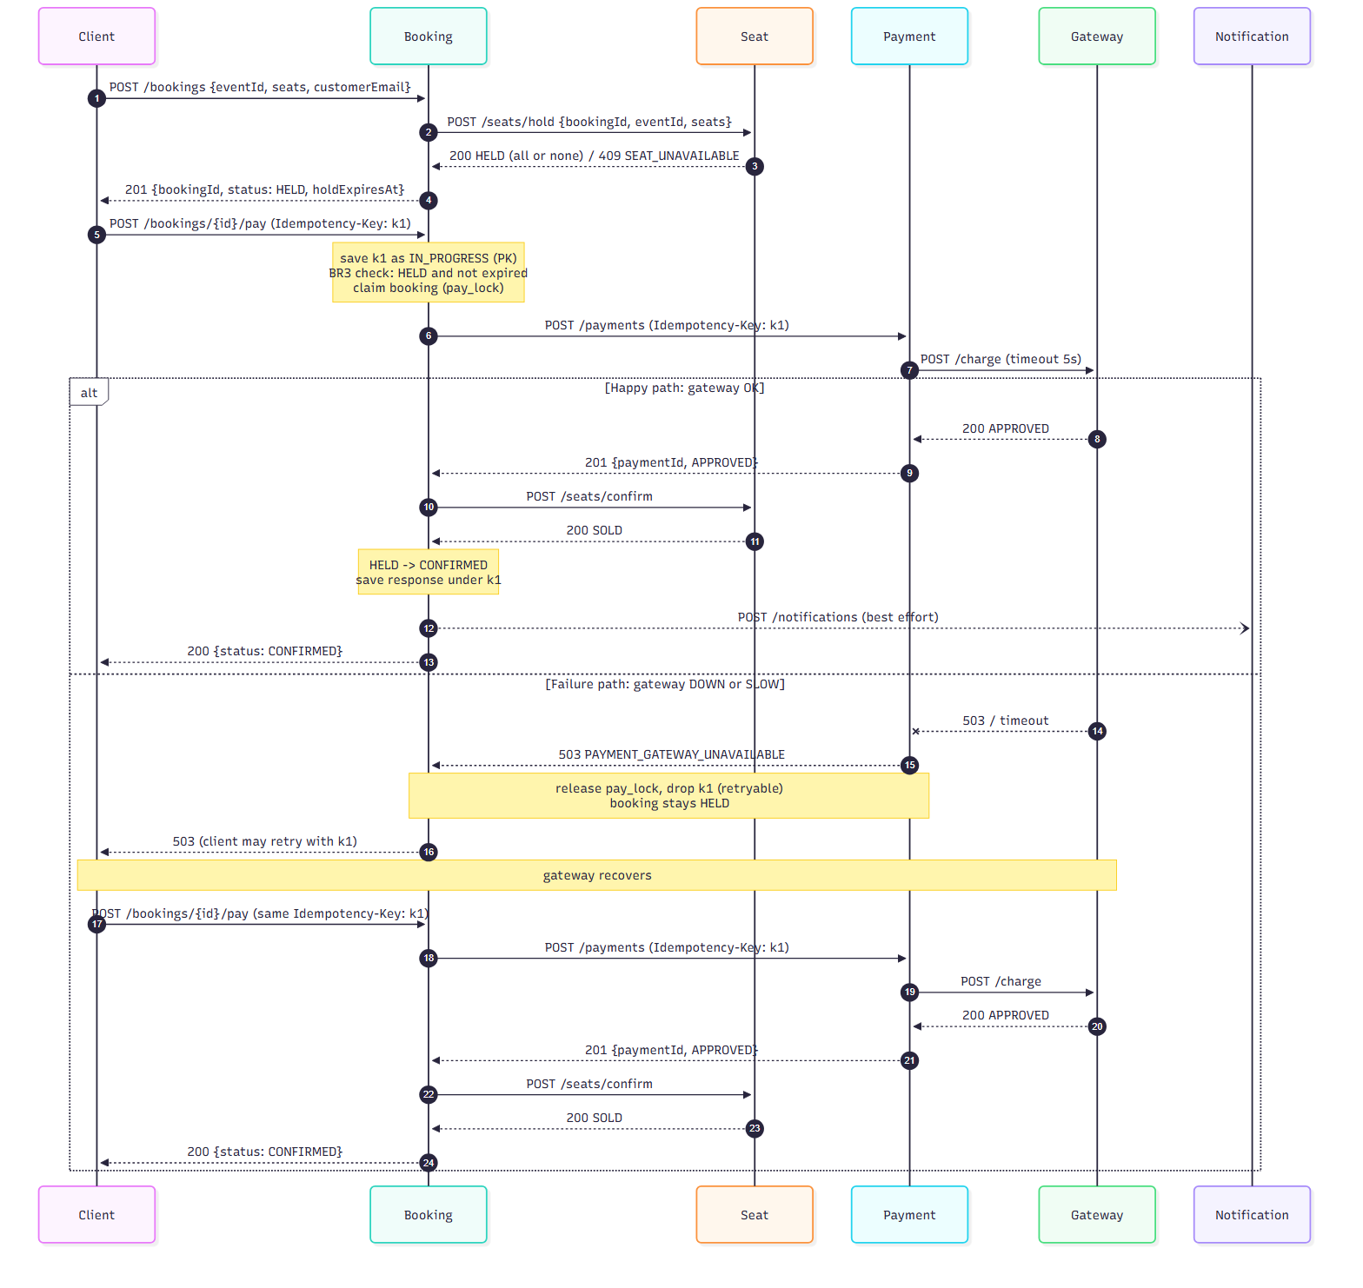
Figure 2: The main transaction (create booking, then pay). The alt block shows the happy path (gateway approves) versus the failure path (gateway down, then recovers and the same Idempotency-Key is retried to a successful confirmation).
On the happy path, a booking moves HELD -> CONFIRMED in a single pay call. On the failure path, a gateway outage returns a clean 503 to the client while the booking remains HELD and the Idempotency-Key is not permanently consumed; once the gateway recovers, retrying with the identical Idempotency-Key succeeds and confirms the booking, with the gateway charged exactly once overall.

3.3 Booking State Machine
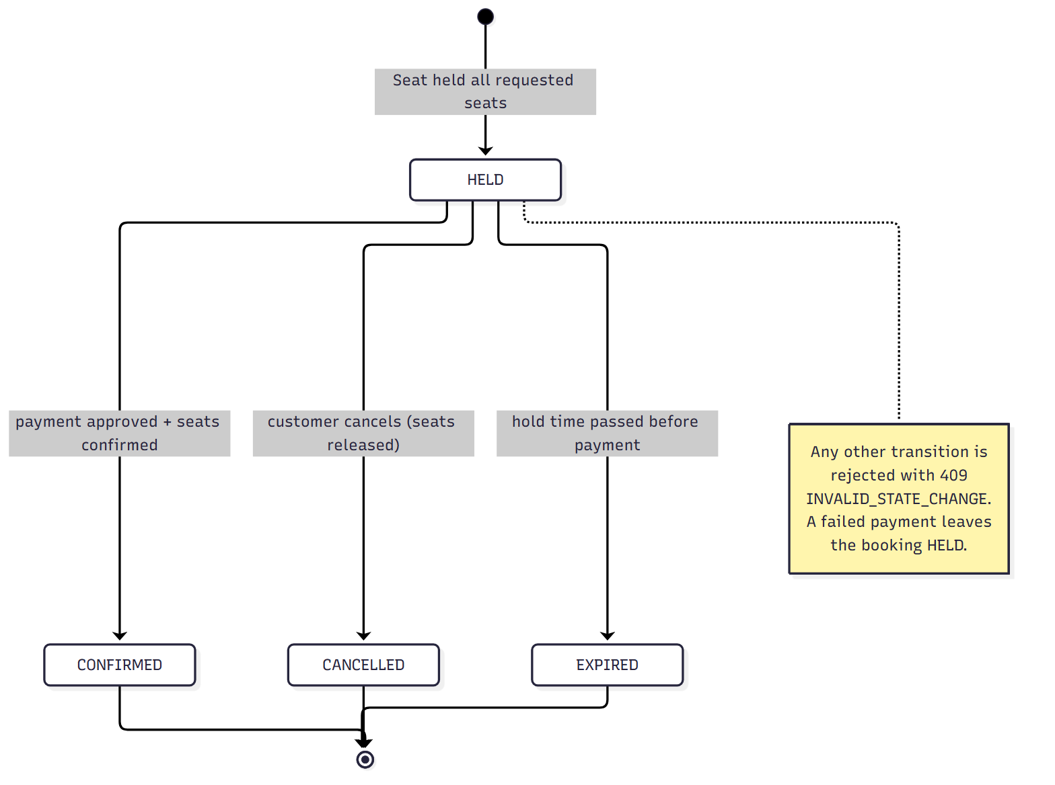
Figure 3: Booking states. Any transition not shown is rejected with 409 INVALID_STATE_CHANGE.

3.4 Seat State Machine
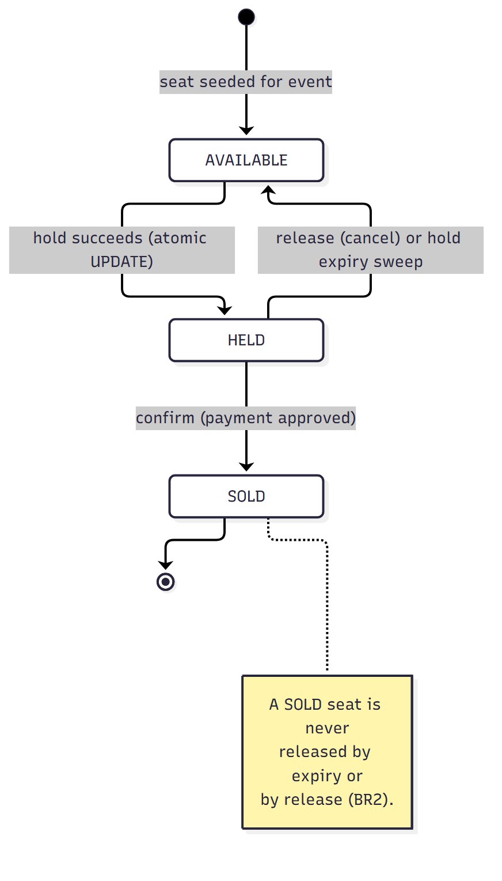
Figure 4: Seat states. A SOLD seat is never returned to AVAILABLE by either the release endpoint or the expiry sweep (BR2).

4. Data Design

4.1 ER Diagram: booking_db
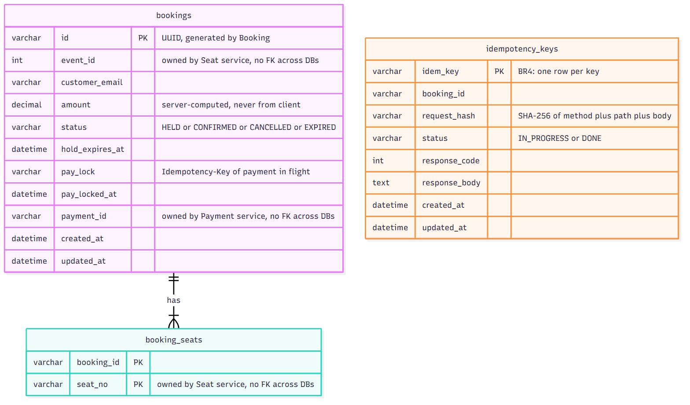

4.2 ER Diagram: seat_db
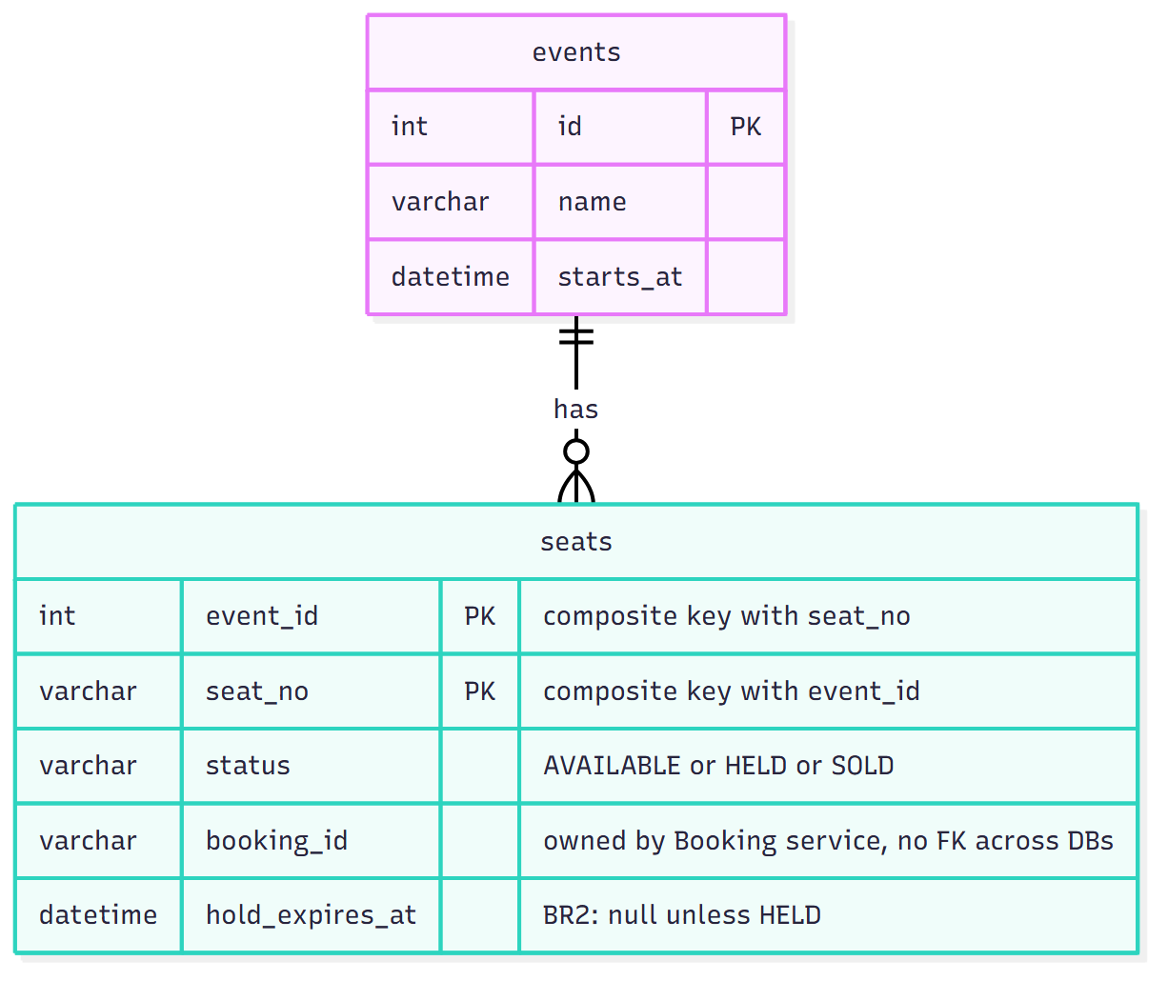

4.3 ER Diagram: payment_db
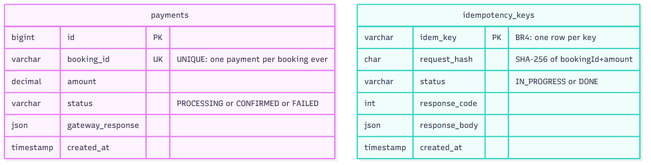

4.4 ER Diagram: notification_db
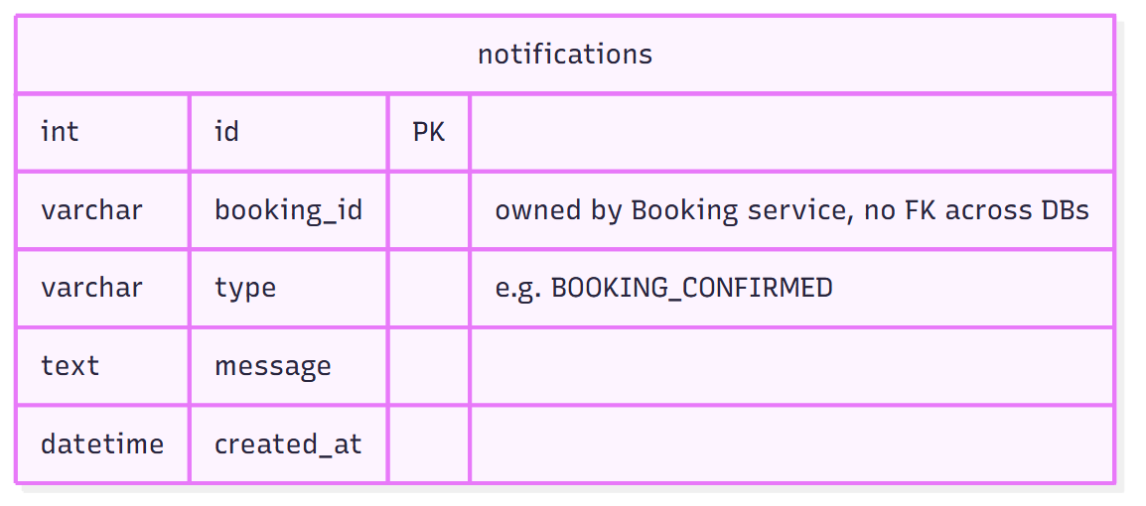

4.5 Cross-Service References
Every reference to an entity owned by another service is stored as a plain scalar column with no foreign-key constraint, and is never joined against in SQL. For example, seat_db.seats.booking_id is a VARCHAR that happens to hold a Booking UUID, but seat_db has no way to enforce or verify that the booking still exists - that check, if ever needed, must be done by calling booking-service's API. This is intentional: it keeps each database independently restorable and migratable, at the cost of needing application-level consistency (handled via the idempotent retry and compensation patterns described in Section 6).

5. API Design

5.1 Endpoint Table
Service | Method & Path | Purpose | Key Responses
booking | POST /api/v1/bookings | Create a booking; holds all requested seats (all-or-none) | 201 HELD / 400 / 404 / 409 SEAT_UNAVAILABLE / 503
booking | GET /api/v1/bookings/{id} | Read a booking | 200 / 404
booking | POST /api/v1/bookings/{id}/pay | Pay for a HELD booking (Idempotency-Key header required) | 200 CONFIRMED / 400 / 404 / 409 / 422 / 503
booking | POST /api/v1/bookings/{id}/cancel | Cancel a HELD booking and release its seats | 200 CANCELLED / 404 / 409
booking | POST /api/v1/bookings/expire | Mark overdue HELD bookings as EXPIRED (safe to run twice) | 200 {expiredCount}
seat | GET /api/v1/events/{eventId}/seats | List seats of an event and their status | 200 / 404 EVENT_NOT_FOUND
seat | POST /api/v1/seats/hold | Hold one or more seats for a booking (BR1, all-or-none) | 200 HELD / 404 / 409 SEAT_UNAVAILABLE
seat | POST /api/v1/seats/confirm | Turn held seats into SOLD after payment | 200 SOLD / 404 / 409 HOLD_EXPIRED
seat | POST /api/v1/seats/release | Free held seats (SOLD seats are never freed) | 200 AVAILABLE
seat | POST /api/v1/seats/expire-holds | Run the BR2 expiry sweep on demand | 200 {expiredCount}
payment | POST /api/v1/payments | Charge a booking (Idempotency-Key header required, BR4) | 201 APPROVED / 409 / 422 IDEMPOTENCY_KEY_REUSED / 503
notification | POST /api/v1/notifications | Record a notification for a booking | 201 {notificationId} / 400
notification | GET /api/v1/notifications/{bookingId} | List notifications for a booking | 200 []
mock-gateway | POST /charge | Simulate a charge (behaviour depends on current mode) | 200 APPROVED / 503 GATEWAY_DOWN
mock-gateway | POST /admin/mode | Switch gateway behaviour: ok / down / slow | 200 {mode}
all 5 | GET /health | Liveness check | 200 {status: UP, service}

5.2 Sample Request/Response - Create Booking
POST /api/v1/bookings
Content-Type: application/json
{
"eventId": 1,
"seats": ["A1", "A2"],
"customerEmail": "alice@example.com"
}
Response 201:
{
"bookingId": "372d6dcf-e437-43a9-a84f-5f52a7d197cb",
"eventId": 1,
"seats": ["A1", "A2"],
"customerEmail": "alice@example.com",
"amount": 500.0,
"status": "HELD",
"holdExpiresAt": "2026-10-24T12:23:33Z",
"paymentId": null,
"createdAt": "2026-10-24T12:23:03Z"
}

5.3 Sample Request/Response - Pay (Idempotent)
POST /api/v1/bookings/{id}/pay
Idempotency-Key: k-39a21c
(no body required - amount is taken from the booking)
Response 200 (first call and every identical replay return the same body):
{
"bookingId": "372d6dcf-e437-43a9-a84f-5f52a7d197cb",
"status": "CONFIRMED",
"amount": 500.0,
...
}
Response 422 if the same key is reused with a different request body:
{
"code": "IDEMPOTENCY_KEY_REUSED",
"message": "This Idempotency-Key was already used for a different request",
"correlationId": "e2e-..."
}

5.4 Uniform Error Model
Every service returns errors in exactly one JSON shape, implemented once in each service's shared errors.py and never duplicated in business logic:
{
"code": "SEAT_UNAVAILABLE",
"message": "Seat A1 is already held",
"correlationId": "e2e-6b3af0-happy"
}

5.5 Error Code Catalog
HTTP | Code | Meaning
400 | VALIDATION_ERROR | Request body/headers failed validation
404 | BOOKING_NOT_FOUND / EVENT_NOT_FOUND / SEAT_NOT_FOUND | Referenced entity does not exist
409 | SEAT_UNAVAILABLE | BR1: seat is not AVAILABLE
409 | HOLD_EXPIRED | BR2/BR3: the hold on the seat/booking has passed
409 | BOOKING_NOT_PAYABLE | BR3: booking is not in a payable state
409 | INVALID_STATE_CHANGE | Attempted transition not allowed by the state machine
409 | PAYMENT_IN_PROGRESS / REQUEST_IN_PROGRESS | BR4: a concurrent request with the same key is still running
409 | PAYMENT_DECLINED | Gateway responded but did not approve the charge
422 | IDEMPOTENCY_KEY_REUSED | BR4: same key, different request body
503 | SEAT_SERVICE_UNAVAILABLE / PAYMENT_SERVICE_UNAVAILABLE / PAYMENT_GATEWAY_UNAVAILABLE / DATABASE_UNAVAILABLE | A downstream dependency timed out, errored, or is unreachable

5.6 OpenAPI Specifications
Full machine-readable OpenAPI 3.1 specifications for every service are generated directly from the running FastAPI applications (so they can never drift from the implementation) and committed at:
- docs/openapi/seat-service.json
- docs/openapi/booking-service.json
- docs/openapi/payment-service.json
- docs/openapi/notification-service.json
Each service also serves its own interactive Swagger UI at GET /docs when running (e.g. http://localhost:8001/docs).

6. Engineering Challenges

6.1 Challenge 1: Concurrency Control (Mandatory) - Owned by Seat Service

The Problem
Multiple customers may try to hold the same seat at the same moment. Over-allocation (two bookings both believing they hold the same seat) is unacceptable and is exactly the class of bug the assignment targets.

Design Choice
Seat holds use a single atomic conditional UPDATE, never a SELECT followed by an UPDATE:
UPDATE seats SET status='HELD', booking_id=:bid, hold_expires_at=:t
WHERE event_id=:eid AND seat_no IN (...) AND status='AVAILABLE'
The number of rows the statement actually changed is the only source of truth: if it equals the number of seats requested, this request won every seat (all-or-none, re-using the same mechanism for multi-seat bookings). If it changed fewer rows, the whole hold is rolled back and the request is told exactly which seats were already held or sold (409 SEAT_UNAVAILABLE).

Why a Plain Check-Then-Update Fails
A naive implementation reads the current status in one step and writes a new status in a second step:
status = SELECT status FROM seats WHERE ... # 1. check
if status == 'AVAILABLE':
UPDATE seats SET status='HELD' ... # 2. act
Between steps 1 and 2, nothing stops a second request from also reading AVAILABLE before the first request's write is visible. Both requests then believe they are allowed to proceed, and both write - the seat ends up HELD by only one of them, but both clients were told 200. The team's own evidence script (naive_select_then_update.py, see Section 6.1 Evidence) reproduces this directly against the real database: with 20 concurrent requests, all 20 were told they held the seat.
The atomic UPDATE closes this gap because MySQL/InnoDB takes an exclusive row lock on the seat the moment the UPDATE's WHERE clause is evaluated. A second concurrent UPDATE on the same row must wait for the first to commit; once it does, the second UPDATE re-evaluates its WHERE clause against the now-committed row, sees status is no longer AVAILABLE, and matches zero rows. The check and the write happen as one indivisible database operation, so no interleaving can let two requests both succeed.

Evidence
Run | Parallel Requests | 200 (won) | 409 (rejected) | Final DB State
1 | 20, same seat | 1 | 19 | HELD, owned by the single winning bookingId
2 | 50, same seat | 1 | 49 | HELD, owned by the single winning bookingId

seat-service was run as 4 separate Uvicorn worker processes for this test specifically so that an in-process Python lock could not be the thing serialising the requests - only the database could. Full script, raw output (including the naive-pattern comparison showing 20/20 false positives), a database dump of the final state, and a log excerpt correlating each request's correlation ID to its outcome are in:
evidence/challenge-1-concurrency/
race_hold.py, race_output.txt, db_dump.txt
naive_select_then_update.py, naive_output.txt
service_log_excerpt.txt, README.md

Limitations
- The all-or-none guarantee is per-request only: it does not reserve seats across two separate hold calls for the same customer.
- A client that polls GET /seats before calling hold can still receive a 409 on the subsequent hold (expected, and treated as a normal business outcome, not a bug).

6.2 Challenge 2: Idempotency (Mandatory) - Owned by Payment Service (and Booking)

The Problem
A client may retry a pay request because of a network timeout, a dropped response, or a user double-clicking 'Pay'. If retried requests are treated as new charges, a customer could be charged twice for one booking - unacceptable for any payment-like operation.

Design Choice
Every pay request carries a client-supplied Idempotency-Key header. payment-service stores the key together with a SHA-256 fingerprint of the request body in a table whose primary key is the Idempotency-Key itself:
INSERT INTO idempotency_keys (idem_key, request_hash, status)
VALUES (:key, :hash, 'IN_PROGRESS')
Because idem_key is the primary key, the database itself guarantees that only one concurrent INSERT with the same key can ever succeed - this is what makes the mechanism safe for two truly simultaneous identical requests, not only sequential replays. The request that loses the INSERT race reads back the winner's state: if the stored fingerprint matches, it is a safe replay (either returns the winner's saved response once DONE, or 409 REQUEST_IN_PROGRESS if the winner is still running); if the fingerprint differs, the key was reused with a different payload and the request is rejected with 422 IDEMPOTENCY_KEY_REUSED.
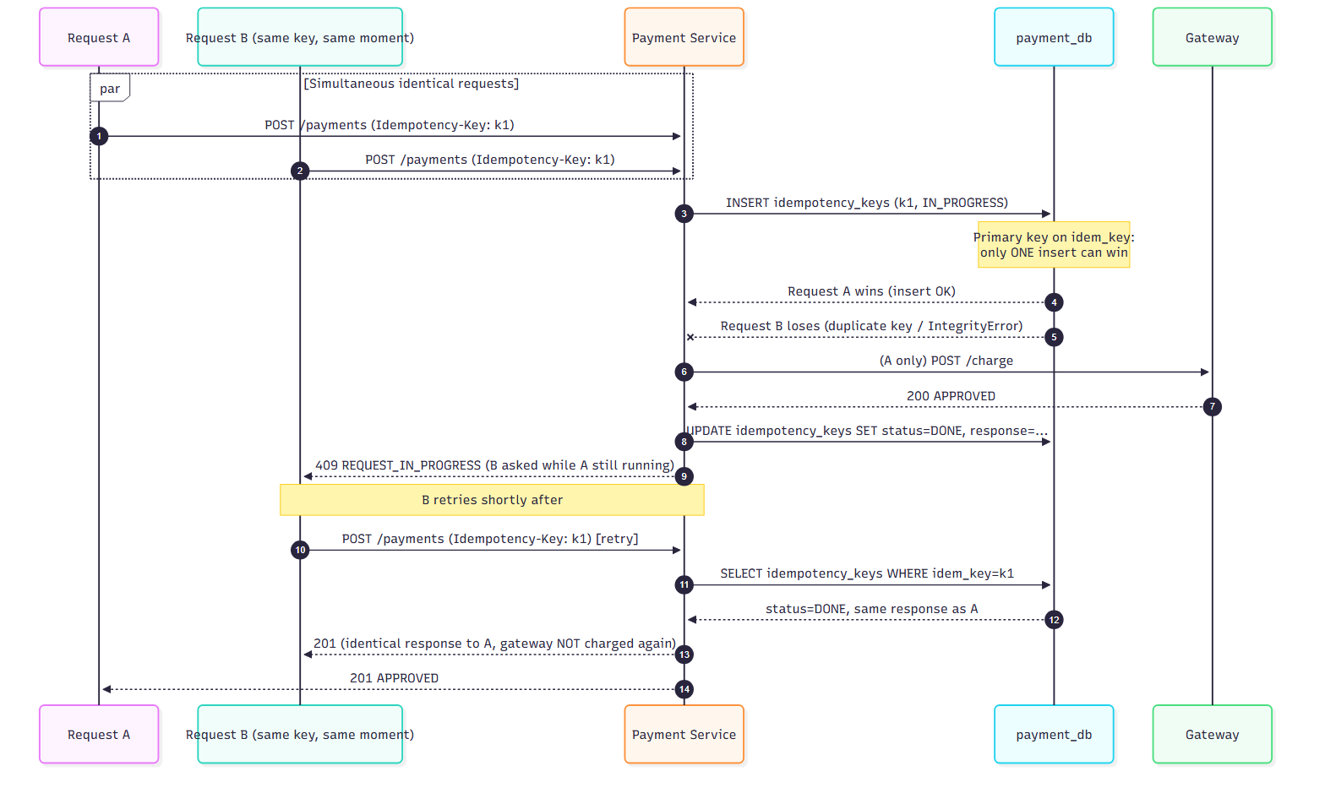
Figure 5: Two simultaneous requests with the same Idempotency-Key. The primary-key constraint ensures exactly one request reaches the gateway; the other safely replays the result once it is available.

A Crucial Refinement: Retryable vs Final Outcomes
An early version of payment-service cached a gateway-down response (503) against the Idempotency-Key as a permanent 'DONE' result, identically to a successful charge. This created a real bug, found during full end-to-end integration testing: once the gateway recovered, retrying with the same key kept replaying the stale 503 forever, because the key had already been marked DONE. The fix distinguishes retryable failures (the gateway being temporarily unreachable) from final outcomes (approved, or a genuine business rejection): on a retryable failure, the idempotency key and the payment reservation row are deleted rather than marked DONE, so a retry with the same key is treated as a fresh attempt. This is the same retryable-vs-final distinction booking-service already applies on its own idempotency layer (Section 3.4 of the Booking design notes), and the fix was verified to restore the expected behaviour via the full end-to-end script (Section 7).

Evidence
evidence/challenge-2-idempotency/challenge_2_idempotency.py drives payment-service's real API (with MySQL and the mock gateway running) through three scenarios, writing raw output and a database snapshot into the same folder:
# | Scenario | Result
1 | Identical request replayed twice (same key, same body) | Both calls returned 201 with equivalent response bodies ({"status":"APPROVED",...}); one payment row in the database
2 | Same key, different amount | Second call rejected with 422 IDEMPOTENCY_KEY_REUSED
3 | Two simultaneous requests, same key and body (fired concurrently) | One request returned 201 (approved), the other returned 409 REQUEST_IN_PROGRESS; exactly one payment row in the database

The database snapshot (database_dump.sql) confirms exactly one CONFIRMED payment row for each of the three test bookings, which is the key correctness property for BR4: no scenario produced more than one charge per booking, including the concurrent case. The evidence README also honestly notes a limitation of the measurement itself: the script's in-process counter cannot observe calls made to the separately running mock gateway process, so the number of payment rows (not a request counter) is used as the source of truth for 'charged once'.
evidence/challenge-2-idempotency/
challenge_2_idempotency.py, output.txt
database_dump.sql, README.md
Booking-service additionally implements the same key/fingerprint pattern on its own /pay endpoint (its own idempotency_keys table in booking_db), so a retried pay request never re-runs the Seat-confirm or Notification calls either. See scripts/booking_idempotency_demo.py.

Limitations
- An IN_PROGRESS key left behind by a process crash mid-request is not automatically cleaned up (acceptable for Assignment 1's scope; a TTL-based sweep is noted as future work).
- The fingerprint covers bookingId and amount only; it does not cover unrelated headers.
- The evidence script counts database rows, not gateway-side requests, as proof of a single charge (see README note above); a future iteration could additionally assert on gateway request logs for a fully independent check.

6.3 Challenge 3B: Time-Bound Holds (Team's Chosen Option)

The Problem
A seat held by a customer who never completes payment must not be unavailable forever - it must be released automatically after a configurable timeout (HOLD_SECONDS, 30s for the demo), while a seat that has already been paid for must never be released by the same mechanism, and the expiry sweep must be safe to run more than once (e.g. if triggered by both a background job and a manual call).

Design Choice - Seat Side
A background asyncio task (expiry_job.run_forever) periodically calls the same expire_holds logic exposed via POST /seats/expire-holds, which runs:
UPDATE seats SET status='AVAILABLE', booking_id=NULL, hold_expires_at=NULL
WHERE status='HELD' AND hold_expires_at < NOW()
Because the WHERE clause only ever matches status='HELD', a SOLD seat can never be touched by this statement (BR2), and because the statement is a pure conditional UPDATE with no side effects outside the matched rows, running it twice in a row simply matches zero rows the second time - it is naturally idempotent.

Design Choice - Booking Side
booking-service applies the identical pattern to its own bookings table via POST /bookings/expire:
UPDATE bookings SET status='EXPIRED'
WHERE status='HELD' AND hold_expires_at <= NOW()
This only ever matches HELD rows, so a CONFIRMED booking is never touched, and the statement is safe to run any number of times. Booking's hold_expires_at is also set independently of Seat's (computed from the same HOLD_SECONDS, but a moment earlier, before Seat is called) so that Booking's deadline is never later than Seat's - a payment attempt can never succeed at Booking after Seat has already released the seat.

Evidence - Seat Side
seat_hold_expiry.py drives seat-service through its public API with HOLD_SECONDS=30. Result: PASS, 8/8 checks.
Step | Expected | Observed
Hold seat 1 (unpaid); hold and confirm seat 2 (paid) | 200, 200, 200 BOOKED | as expected
expire-holds before 30s | expiredCount: 0, seat 1 still HELD | as expected
expire-holds after holdExpiresAt | expiredCount: 1, seat 1 AVAILABLE, seat 2 still BOOKED | as expected
expire-holds again | expiredCount: 0 (safe to run twice) | as expected
Expired booking tries to confirm seat 1 | 409 INVALID_STATE_CHANGE | as expected
New booking holds seat 1 | 200 | as expected

evidence/challenge-3b-holds/
seat_hold_expiry.py, seat_hold_expiry_output.txt, seat_db_dump.txt

Evidence - Booking Side
booking_hold_expiry.py drives the whole system through Booking's public API, with all five services running and HOLD_SECONDS=30 in both booking and seat. Result: PASS, 14/14 checks.
Step | Expected | Observed
Booking UNPAID holds a seat; booking PAID holds a seat and pays | 201 HELD, 201 HELD, 200 CONFIRMED | as expected
POST /bookings/expire before 30s | expiredCount: 0, UNPAID still HELD | as expected
POST /bookings/expire after UNPAID's holdExpiresAt | expiredCount: 1, UNPAID EXPIRED, PAID still CONFIRMED | as expected
POST /bookings/expire again | 200, expiredCount: 0 (safe to run twice) | as expected
Pay the EXPIRED booking | 409 HOLD_EXPIRED (BR3) | as expected
Pay the CONFIRMED booking again / cancel it | 409 BOOKING_NOT_PAYABLE / 409 INVALID_STATE_CHANGE | as expected
Seat-service view | UNPAID's seat AVAILABLE, PAID's seat SOLD | as expected
Book UNPAID's seat again | 201 | as expected

The bookings-table dump (booking_db_dump.txt) confirms the UNPAID row transitions HELD -> EXPIRED while the PAID row remains CONFIRMED with its updated_at timestamp unchanged by the expiry sweep - direct evidence that a paid booking is never touched. The underlying guarantee is the same single-statement pattern used throughout the system: UPDATE bookings SET status='EXPIRED' WHERE status='HELD' AND hold_expires_at<=now AND (pay_lock IS NULL OR pay_locked_at < stale) - a booking with a payment in flight (pay_lock set) is skipped, so expiry cannot race a payment that is actively being processed.
evidence/challenge-3b-holds/
booking_hold_expiry.py, booking_hold_expiry_output.txt, booking_db_dump.txt

Limitations
- The expiry sweep is pull-based (triggered by a background loop or a manual call), not a database-level TTL; an extremely long gap between sweeps would delay (but never incorrectly skip) an expiry.
- Seat-service and booking-service each compute 'now' independently; the design assumes both run on hosts with closely synchronised clocks (true locally; to be revisited if services are ever split across machines in Assignment 2).

7. Testing

7.1 Strategy
Each business rule has at least one dedicated unit test named test_BR<n>_..., run against SQLite in-memory databases (seat, booking) or against the real MySQL instance (payment, notification) with no network calls to other services (seat/booking tests use in-memory fake HTTP clients for cross-service calls, see tests/conftest.py in each service). In addition, one scripted end-to-end test (scripts/e2e_booking_flow.py) drives the main transaction through all five real, running services together, covering both success and failure scenarios in one run.

7.2 Unit Test Results (per service, independently)
Service | Test Count | Result | Notable Coverage
seat-service | 32 | 32 passed | BR1 (hold all-or-nothing, double-hold rejected), BR2 (expiry, background job, paid seats never released)
booking-service | 60 | 60 passed | BR3, BR4 (booking side), full state machine, concurrency and failure-path scenarios using fake Seat/Payment/Notification services
payment-service | 7 | 7 passed | BR4 (same key replay, same key different body rejected), plus the retryable-failure fix (Section 6.2)
notification-service | 11 | 11 passed | Create, list, ordering, empty-booking case, input validation
mock-gateway | 2 | 2 passed | Charge approved (ok mode), 503 (down mode)

Total: 112 automated unit/component tests passing across all five services.

7.3 End-to-End Test (All Five Real Services)
scripts/e2e_booking_flow.py was run against all five services live (MySQL, booking, seat, payment, notification, mock-gateway) with the fully merged codebase. All six scenarios passed:
# | Scenario | Result
1 | Happy path: create -> pay -> CONFIRMED (seat SOLD, notification recorded) | PASS
2 | Contended seat (Challenge 1): 20 parallel bookings of one seat | PASS - exactly 1x 201, 19x 409
3 | Failure path: gateway DOWN -> 503, booking stays HELD -> gateway OK -> retry same key -> CONFIRMED | PASS
4 | Slow dependency: gateway SLOW (10s) vs 5s timeout -> clean 503, booking stays HELD | PASS
5 | Cancel: cancel -> CANCELLED, cancel again -> 409, pay on cancelled -> 409 (BR3), seat rebookable | PASS

Final result printed by the script: ALL CHECKS PASSED.

7.4 Failures Deliberately Demonstrated
In line with the assignment's guidance that 'evidence that shows only the happy path earns little', the test suite and evidence scripts deliberately exercise failure modes: gateway outage (scenario 3), gateway timeout (scenario 4), invalid state transitions (cancel-twice, pay-after-cancel), and the naive-concurrency anti-pattern comparison in Challenge 1's evidence, which shows the failure mode the correct design avoids.

8. Design Decisions and Trade-offs

8.1 Orchestration vs Choreography
Decision: Orchestration, with booking-service as the single orchestrator.
Options considered: (a) orchestration - one service drives the whole flow and calls the others in sequence; (b) choreography - services react to events from a broker with no central coordinator.
Rationale: Orchestration gives one place to read and reason about the entire transaction, which is much easier to demo, debug and unit-test with fake downstream services (as booking-service's test suite does). Choreography would require a message broker, which is only needed for the optional Challenge 3D (not the team's chosen option) and would add infrastructure the assignment does not mandate. The cost of orchestration is that booking-service must know the request/response shape of every other service it calls (isolated entirely inside clients.py), which was judged an acceptable, contained coupling.

8.2 Synchronous REST vs Asynchronous Messaging
Decision: Synchronous REST over HTTP for all inter-service calls.
Options considered: (a) synchronous REST, as mandated by the assignment's communication requirement; (b) asynchronous messaging via a broker (RabbitMQ/Kafka/Redis Streams).
Rationale: The assignment's mandatory technical requirements specify REST over HTTP; messaging is only relevant to the optional Challenge 3D. The trade-off of synchronous REST is that a slow downstream service slows down the caller - mitigated by giving every outbound call an explicit timeout (SERVICE_TIMEOUT_SECONDS, PAYMENT_TIMEOUT_SECONDS, GATEWAY_TIMEOUT_SECONDS) and converting any timeout or connection failure into a defined 503 response rather than letting the caller hang indefinitely (demonstrated in e2e scenario 4).

8.3 Idempotency Enforced at Two Layers (Booking and Payment)
Decision: Both booking-service and payment-service implement independent idempotency-key handling on their own tables.
Options considered: (a) idempotency only at Payment, since that is where the actual charge happens; (b) idempotency at both Booking and Payment.
Rationale: The client-facing unsafe operation is POST /bookings/{id}/pay, not directly POST /payments - a defense-in-depth approach means a retried pay call at Booking never even re-issues the downstream Seat-confirm or Notification calls, in addition to Payment guaranteeing the charge itself happens once. The cost is two idempotency_keys tables (one per owning database) rather than one, which was judged acceptable since each table is small, simple, and owned entirely by its own service (no cross-database access needed).

8.4 Atomic Conditional Updates vs Explicit Locking
Decision: A single conditional UPDATE statement (UPDATE ... WHERE status=...) for every state transition, rather than SELECT ... FOR UPDATE or an application-level lock.
Options considered: (a) conditional UPDATE (one round trip, relies on the row lock InnoDB takes implicitly while evaluating the WHERE clause); (b) SELECT ... FOR UPDATE inside an explicit transaction (two statements, pessimistic lock held until commit); (c) a version column with optimistic-retry.
Rationale: The conditional UPDATE needs only one round trip and no explicit transaction management in application code, and its correctness does not depend on every caller remembering to start a transaction - it is correct by construction. SELECT ... FOR UPDATE was considered but rejected as unnecessary complexity for this access pattern; it holds a lock for a longer window (from the SELECT until commit) without adding safety the single UPDATE does not already provide here.

9. Limitations and Future Work

9.1 Known Limitations
- Payment succeeding exactly as a hold expires is logged as REFUND_REQUIRED but not automatically refunded (booking-service, Section 3.7 of the design notes) - a real system would trigger an automatic compensating refund.
- A crashed process mid-payment can leave a booking's pay_lock set; it is only treated as abandoned after PAY_LOCK_TTL_SECONDS (60s), not cleaned up proactively.
- An IN_PROGRESS idempotency key abandoned by a crash (in either booking_db or payment_db) is not automatically swept; a scheduled cleanup job is noted as future work.
- Clocks across services are assumed to be synchronised (true when all services run on one host, as in Assignment 1); this assumption should be revisited once services are split across containers/nodes in Assignment 2.
- The expiry sweep is interval-based (background loop / manual trigger), not a true database TTL; an unusually long gap between sweeps delays, but never skips, an expiry.

9.2 Future Work
- Containerise each service with its own Dockerfile and extend docker-compose.yml to cover all five services plus MySQL, as required for Assignment 2.
- Add an automatic compensating refund call to the mock gateway for the rare paid-but-seat-released race.
- Add a scheduled cleanup job for abandoned IN_PROGRESS idempotency keys and stale pay_lock values.
- Add a circuit breaker on the Booking -> Payment and Payment -> Gateway calls (noted as a bonus in the assignment's Challenge 3A, not the team's chosen option, but a natural extension of the existing timeout/retry handling).
- Replace the mock gateway's fixed 'slow' delay (10s) with configurable jitter to better exercise retry-with-backoff logic in a future iteration.

10. Links and Appendices

10.1 Repository
https://github.com/krishna-sagar2000/ticket-booking-microservices

10.2 Google Drive (video and supporting documents)
[PLACEHOLDER - Insert Google Drive link once the demo video and any additional documents are uploaded.]

10.3 Contribution Table
[PLACEHOLDER - Each member to confirm their commit history and fill in: tasks owned, approximate effort, and any pair-programming / review contributions on other members' services.]
Member | Primary Contribution | Branch
Krishna Sagar | Notification service; diagrams and report | krishnasagar/notification-service
Anwesa | Seat service (BR1, BR2); Challenge 1 evidence; Challenge 3B seat-side evidence; seat-service OpenAPI spec | anwesa/seat_service
Aishwarya | Booking service (BR3, BR4 booking-side, state machine, orchestration); e2e test script; Challenge 3B booking-side evidence; design notes | aishwarya/booking-service
Aarzoo | Payment service (BR4 payment-side); Challenge 2 evidence; payment-service OpenAPI spec | aarzoo/payment-service

10.4 Individual Reflections
[PLACEHOLDER - Each member to add a half-page reflection: what you built, the hardest problem you solved, and what you would change.]
Krishna Sagar – Notification Service, diagrams, and report: My main contribution was building the notification service, which records a confirmation every time a booking is paid successfully, and verifying the mock payment gateway's ok/down/slow modes that the rest of the team relies on for testing failure handling. Beyond my own service, I worked on merging all four branches into main, re-running the full test suite and the end-to-end script after each merge, and fixing a real defect in payment-service that only showed up once the system was tested end to end: a gateway-down failure was being cached as a permanent result against the Idempotency-Key, so a retry after the gateway recovered kept replaying the stale failure instead of succeeding. I also produced the architecture, sequence, state-machine and ER diagrams, and drafted the design and technical report, consolidating the evidence each teammate produced for their own engineering challenge.
The most challenging part was diagnosing that idempotency bug - it never showed up in any single service's unit tests, only once all five services were run together under a real failure-then-recovery scenario, which reinforced for me why integration testing across service boundaries matters as much as unit testing within one service. If I were to improve this further, I would add a scheduled job to clean up abandoned idempotency keys left by crashed requests, and I would push for every service to expose its own OpenAPI spec and Dockerfile earlier in the process, since reconciling those at the end took more coordination than it should have.

10.5 AI-Use Declaration
[PLACEHOLDER - Declare which AI tools were used and for what, per team member, e.g.: 'Used an AI coding assistant for exploring the codebase, drafting code, generating diagrams, and drafting report sections. All generated content was reviewed, tested, and run before being committed.' Each member who used AI tools should add their own specific declaration.]
Krishna Sagar - Used AI coding assistants (Claude and OpenCode) for exploring the existing codebase and scaffold, drafting the notification-service implementation and its tests, diagnosing the cross-service idempotency defect in payment-service described above, generating the architecture, sequence, state-machine and ER diagrams, and drafting sections of this design and technical report. All generated code, diagrams and report content were reviewed, tested, and verified against the running system before being committed or included.

