

Manual

Generate HTML from TPL WorkFLow

Opentext

138 Market Street

Level 33

Singapore 048946

[www.opentext.com](http://www.opentext.com)

OpenText Professional Services

March, 2017

Contents

1. Generate HTML from TPL workflow overview 3

2. WorkFlow Break-up 4

2.1. WorkFlow Components 4

2.2. Instantiation Window 4

2.3. Generate HTML external Task 6

3. Workflow configuration and Scripts 7

3.1. custom_instantiation.cfg 7

3.2. generate-html-from-tpl.ipm / generate-html-from-tpl.json 7

3.3. available_models.xml 7

3.4. get_tpl.ipl 7

3.5. TPL_to_HTML_external.ipl 7

# Generate HTML from TPL workflow overview

The “Generate HTML from TPL workflow” is a custom workflow with the purpose to provide a workaround to the out of the box “Generate output” function of TeamSite as it is not supported for non-OS users

The workflow consists mainly of two major tasks. An instantiation window task where the user will select and entered the necessary information to generate an HTML, and an external task where workflow will actually create the HTML out of the information provided by the user.  
The main flow is as follows

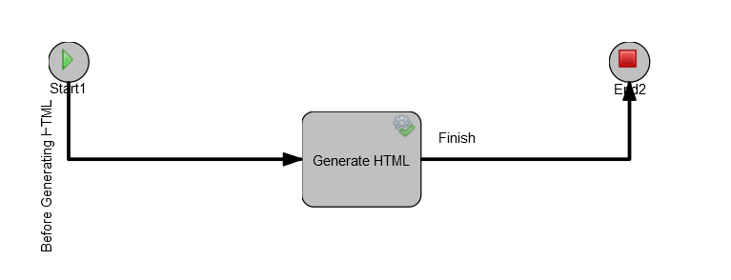

Before Generating HTML

1. User will initiate the workflow on file submit
2. A instantiation window will be prompted, and the user will input the necessary information
3. After the information is entered user will click on submit and the WF will start

Generate HTML

1. The information entered by the user plus some global information will be passed automatically to the Generate HTML task.
2. The Generate HTML task will call an external perl script that will create the HTML file

Finish

1. After generating HTML the external script will final status of the task and the Workflow will finish

The Generate HTML from TPL workflow is a totally automated workflow and no user interaction is necessary

# WorkFlow Break-up

## WorkFlow Components

The Generate HTML from TPL workflow consist of the following tasks

1. Instantiation window
2. Generate HTML external Task

## Instantiation Window

The Generate HTML from TPL workflow is by default available throughout all TeamSites’s branches (on how to change workflow availability please refer to WorkFlow configuration and script section). The workflow is started the following way

1. Select the desired DCR and click on Submit on the upper right corner of the screen  
     
   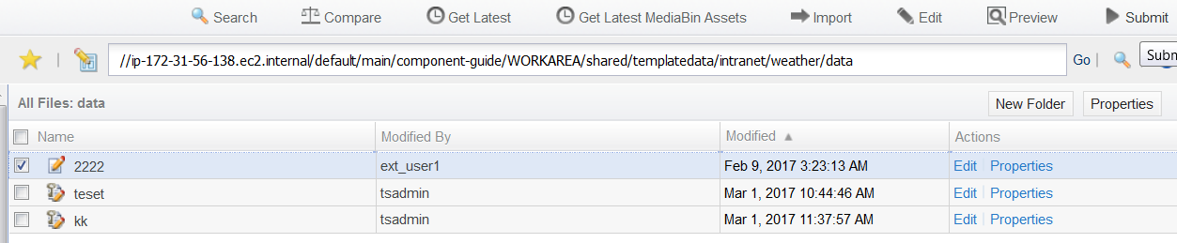
2. Select “Generate HTML from TPL” from the Select a Workflow screen and click on the Next button  
     
   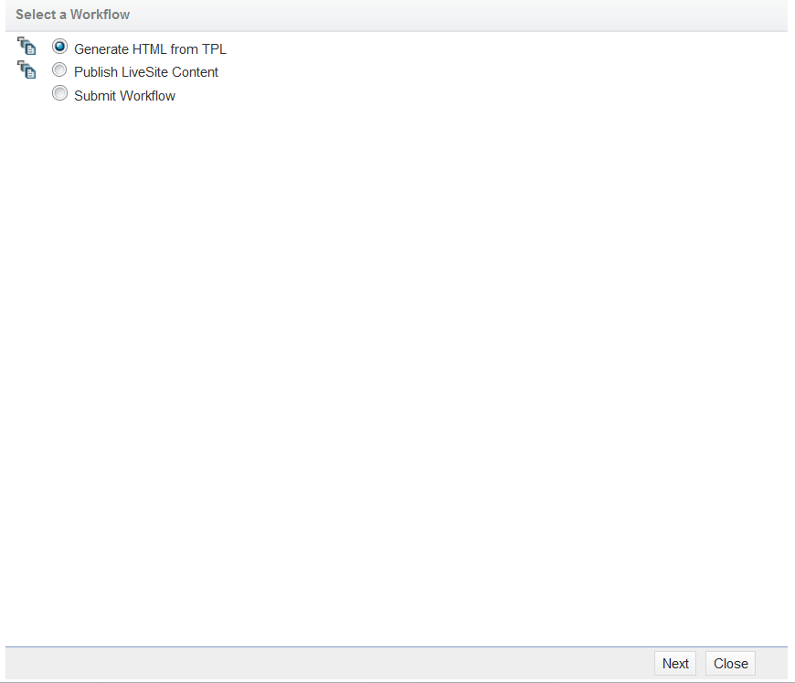
3. Fill the required fields of the Generate HTML from TPL custom scree  
   After selecting the Generate HTML from TPL work, a customized screen will appear. On this screen the user will input the necessary information for the Workflow to work.  
     
     
     
     
     
   The customized workflow screen has the following items  
     
   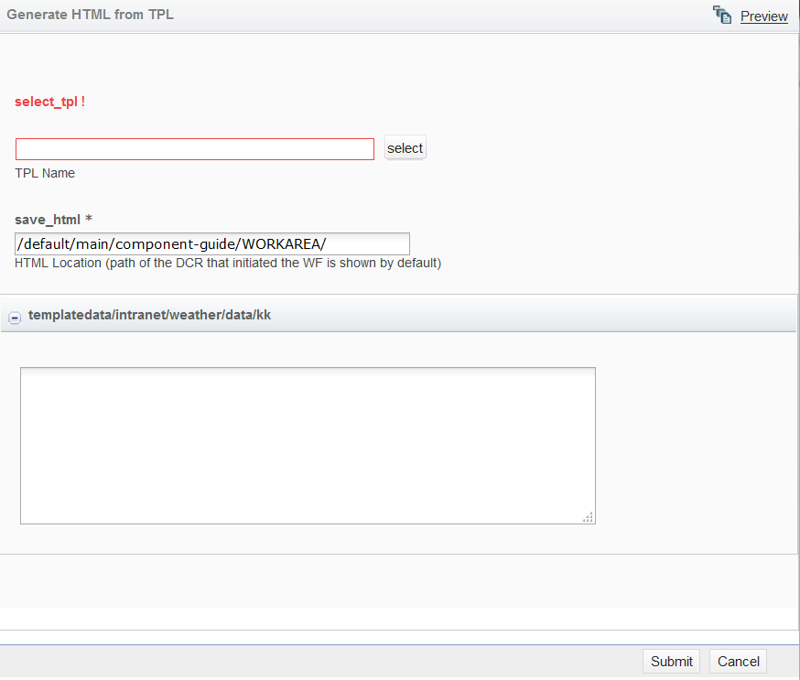  
   1. Select_tpl field  
      A mandatory text field where the user can click on the select button to let the system search for the available TPL’s within the workarea.  
      After clicking the select button, a Select TPL screen will be prompted with a list of all the available TPL’s for DCR that started the Workflow  
        
      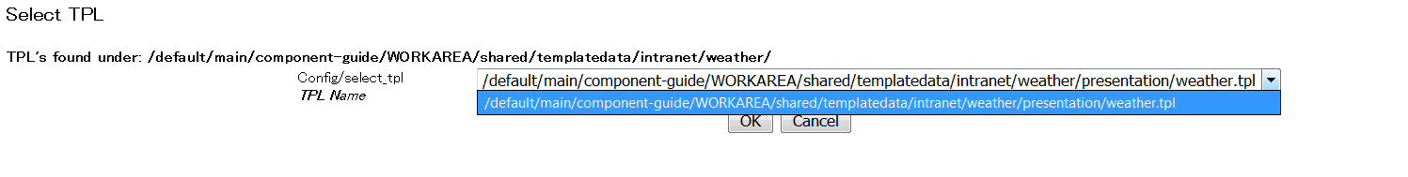   
      Select the desired tpl from the drop down menu and click on OK  
        
      About the TPL list shown by the Workflow
      1. The Workflow will only show the TPL’s that are properly defined on templating.cfg configuration file. On how to add a configuration to templating.cfg please refer to TeamSite’s official guides.
      2. If there are no TPL’s under the presentation directory that corresponds to the DCR. The screen will show an error stating that no files were found under that particular directory.
      3. If there are no configurations available on templating.cfg for the corresponding presentation directory, the screen will show an erro message stating that no tpl’s are defined on templating.cfg
      4. The workflow will dynamically parse and compare the information of templating.cfg with the available tpl’s under the corresponding presentation template every time the select button from the select_tpl field is pressed upon.
   2. Save_html field  
      A text field where the user will input the path and name of the HTML file to be generated by the workflow. By default the workarea vpath will be filled when the window is initialized. The vpath is a requirement for the workflow to work correctly. If user types the html file name only or a wrong path the HTML file won’t be generated.

## Generate HTML external Task

The generate HTML external task is an automated task that requires no user interaction. This task will take the parameters provided by the instantiation window plus some other parameters and use them to generate the HTML trough an external perl script.

The parameters that the external task handles are as follows:

1. DCR name and path
2. TPL name and path
3. HTML name and path

After the task is completed a log file will be generated on IW_HOME/local/config/tpl_wf/logs with a name as workflowtpl_{job id}.log. The log will be written to TeamSite file system on task completion and there will be one log per Job.

The information written to the log file is as follows:

**** START Log (Thu Mar 2 20:39:36 2017)*****

JOB ID: 7054

TASK ID: 7055

areapath: /default/main/component-guide/WORKAREA/shared

dcrpath: templatedata/intranet/weather/data/teset

tpl_name: /default/main/component-guide/WORKAREA/shared/templatedata/intranet/weather/presentation/weather.tpl

html_loc: /default/main/component-guide/WORKAREA/shared/log_sec.html

html_complete_loc: /iwmnt/default/main/component-guide/WORKAREA/shared/log_sec.html

Complete DCR Path: /iwmnt//default/main/component-guide/WORKAREA/shared/templatedata/intranet/weather/data/teset

Command to run: /usr/Interwoven/TeamSite/bin/iwgen -t /default/main/component-guide/WORKAREA/shared/templatedata/intranet/weather/presentation/weather.tpl -r /default/main/component-guide/WORKAREA/shared/templatedata/intranet/weather/data/teset /default/main/component-guide/WORKAREA/shared/test.html

Command Exit Status: 0

**** END LOG *****

An exit status different from 0 will mean that the HTML was either not created correctly or not created at all

# Workflow configuration and Scripts

The following are the configuration/script files necessary for the workflow to work properly

## custom_instantiation.cfg

The custom_instantiation.cfg is the main configuration file for the customized window that user use to enter the necessary information to create the HTML.

The custom_instantiation.cfg can be found on /IW_MOUNT/iwadmin/main/workflowModels/WORKAREA/iw-wa/Config/generate-html-from-tpl_config/ directory.

Any changes made to this file will not be applied to the customized window as long as the file is not submitted to STAGING area.

## generate-html-from-tpl.ipm / generate-html-from-tpl.json

Workflow modeller configuration files. This file contains all the instructions for the workflow to work properly and all the variables that are handed out by the custom_instantiation.cfg.

This files are also used by the TeamSite Modeler to create an interactive view of the workflow. These files are placed under /IW_MOUNT/iwadmin/main/workflowModels/WORKAREA/iw-wa/Models/ and need to be published to TeamSite in order to take effect on the workflow.

## available_models.xml

Global configuration file to make the workflow available to TeamSite branches. By default the Generate HTML from TPL workflow is available to all branches on the default store. Administrator can make workflow available on certain branches by editing this file. The file is under /IW_MOUNT/iwadmin/main/workflowModels/WORKAREA/iw-wa/Internal/.

## get_tpl.ipl

Main cgi script used to retrieve, validate, compare and display the available tpl’s the user can select to create an HTML. This script is ran every time the user clicks on the select button on the select_tpl field from the instantiation window. The script must be placed in /IW_HOME/httpd/iw-bin/ directory and given the properly permissions to run.

## TPL_to_HTML_external.ipl

Main external script used to actually generate the HTML file. This script must be placed under /IW_HOME/local/config/tpl_wf/. This script will output a log file for each time the workflow is executed under /IW_HOME/local/config/tpl_wf/logs/. The tpl_wf/ and tpl_wf/logs/ directories are not out of the box paths and must be created by the administrator also proper permission must be given to the script and directories for the scrip to run