

User Guide – ATM Branch and Locator

ATM Branch and Locator User guide

Opentext

138 Market Street

Level 33

Singapore 048946

[www.opentext.com](http://www.opentext.com)

OpenText Professional Services

January, 2017

Contents

1. Component Break-up 3

1.1. Component List 3

1.2. Page Structure 3

2. ATM-Locator common DCR Break-up 6

2.1. Header 6

2.2. Navigation 6

2.3. Footer 6

3. ATM-Locator Specific DCR Break-up 7

4. ATM-Locator Resources 8

4.1. CSS Resources 8

4.2. JavaScript Resources 8

# Component Break-up

## Component List

The ATM Branch and Locator is composed of the following components

1. Common Components
   1. Header
   2. Navigation
   3. Footer
2. ATM Branch and Locator specific components
   1. ATM Locator

## Page Structure

The page structure (component order) and brief explanation as follows. For component detailed explanation refer to Functional Specifications Document.

1. Header Component



Global Component composed from UOB logo, right by you logo, section menu details, login button and add country section data items

The header component’s default setting should have the following values in Content and Appearance:

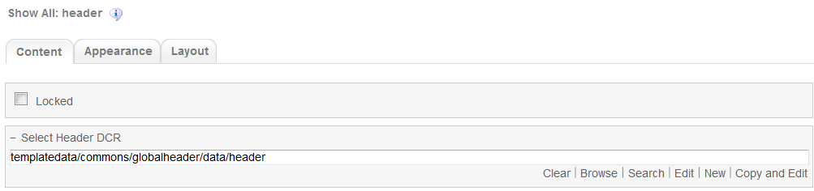

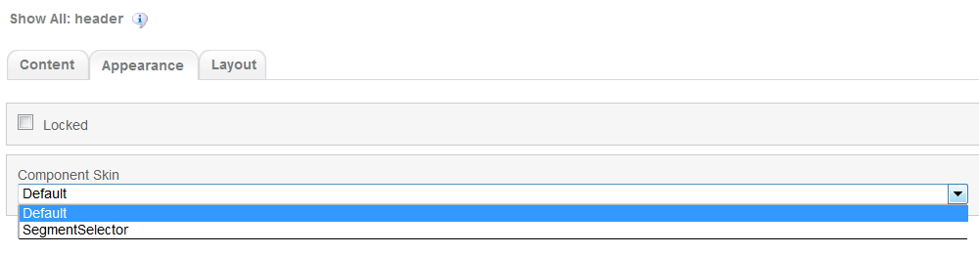

1. Navigation Component



Global component which uses TeamSite Site Map as the content source. Quick links information can be customized

Navigation Component’s default setting should have the following values in Content:

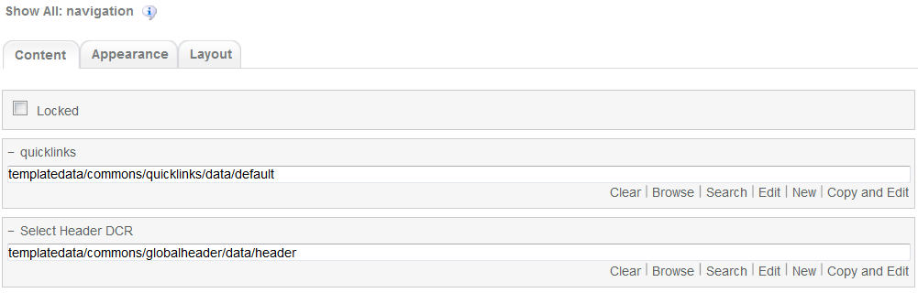

1. ATM Locator Component

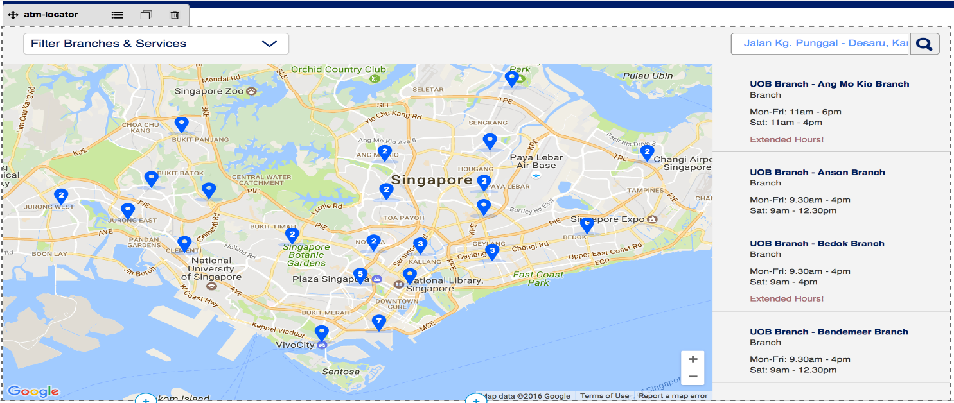

ATM-Locator is ATM Branch and Locator page specific component. This component integrates the JavaScript based ATM/Branch locator and is an XSL type component (No DCR available). ATM-Locator component is a free XSL type component. No DCR is available for customization; however, user can modify the appearance and behaviour of the component by updating the CSS and Javascript files attached to the component. Accessing the component properties from TeamSite Experience Studio (on how to access a component properties please refer to Home Page user guide) will lead in the following window.  
  
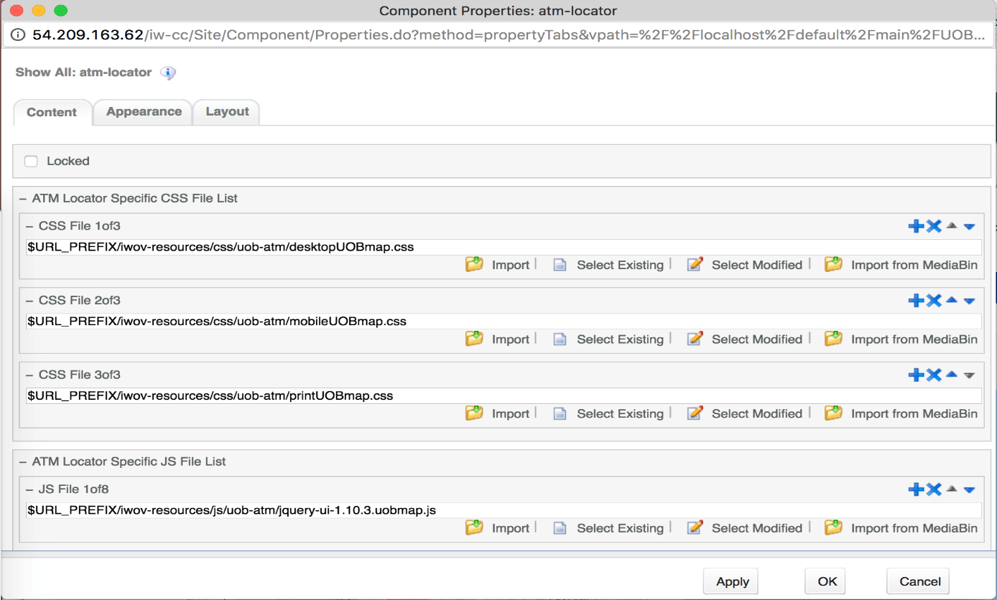

The component provides 2 lists of files, CSS and Javascript, for user to customize. User can add, remove or rearrange files in list via control buttons on the right corner of each file. Following is the default supporting CSS and Javascript files; changing any of them will lead to malfunction of the component so it is recommended to consult the TeamSite **Administrator** or a user with proficiency on front-end development.

List of default CSS files:

- <wa-path>/iwov-resources/css/uob-atm/desktopUOBmap.css

- <wa-path>/iwov-resources/css/uob-atm/mobileUOBmap.css

- <wa-path>/iwov-resources/css/uob-atm/printUOBmap.css

List of default Javascript files:

- <wa-path>/iwov-resources/js/uob-atm/jquery-ui-1.10.3.uobmap.js

- <wa-path>/iwov-resources/js/uob-atm/jquery.slimscroll.uobmap.js

- <wa-path>/iwov-resources/js/uob-atm/jScrollPane.uobmap.js

- <wa-path>/iwov-resources/js/uob-atm/markerclusterer.uobmap.js  
- <wa-path>/iwov-resources/js/uob-atm/data_sg.uobmap.js

- <wa-path>/iwov-resources/js/uob-atm/uobmap.uobmap.js

- <wa-path>/iwov-resources/js/uob-atm/main.uobmap.js

- <wa-path>/iwov-resources/js/uob-atm/map.uobmap.js

Because is an XSL type component. Changes to the component must be done directly to the xsl file that the component uses for reference on TeamSite CCpro. This xsl file can be found on <wa-path>/iw/xsl/atmlocator/atmlocator.xsl. Wrong changed to this file will lead to malfunction of the whole component so it is recommended that this file be edited only by the TeamSite **Administrator** or a user with proficiency on XSL (Extensible Stylesheet Language).

1. Footer component

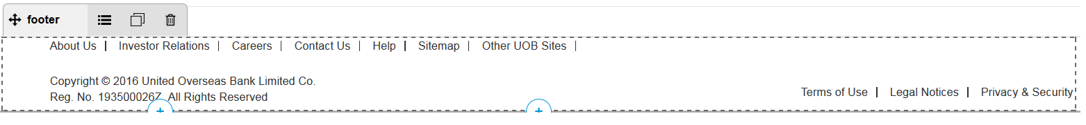

Global component controlled by DCR. Links and Copyright text can be customized

Footer component’s default setting should have the following values in Content:

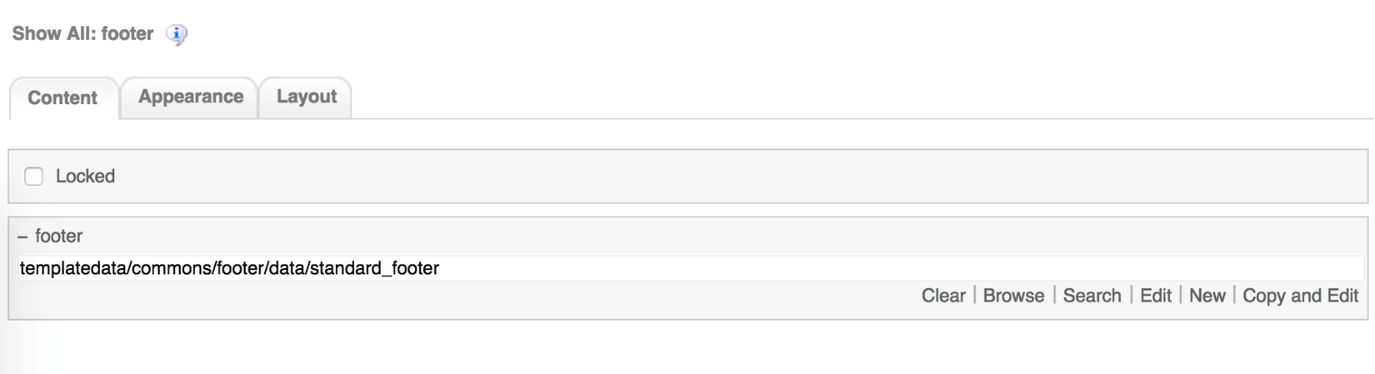

# ATM-Locator common DCR Break-up

In this section, a brief explanation of the ATM Branch and locator component common DCR will be made. Please refer to User_Guide-Home_page on how to navigate and select DCR’s.

## Header

Please refer to User_Guide-Home_page “Homepage Common DCR Break-up” for information on Header component

## Navigation

Please refer to User_Guide-Home_page “Homepage Common DCR Break-up” for information on Header component

## Footer

Please refer to User_Guide-Home_page “Homepage Common DCR Break-up” for information on Header component

# ATM-Locator Specific DCR Break-up

The ATM Branch and Locator page has only one specific (atm-locator) component. This component has no DCR related to and can be customized from its properties. Please refer to Page Structure section for information on this component parts

# ATM-Locator Resources

This section provides a list of the necessary resources (CSS & JavaScript) to create an ATM Branch and Locator template. On how to create a template please refer to the User_Guide-Home_Page.

## CSS Resources

The css resources for the ATM Branch and Locator template are as follows

|  |  |
| --- | --- |
| **Devices to use with** | **Path** |
| Desktop, Tablet, Mobile | <wa-path>/iwov-resources/css/bootstrap.min.css |
| <wa-path>/iwov-resources/css/style.css |
| Desktop | <wa-path>/iwov-resources/css/desktop-style.css |
| Tablet | <wa-path>/iwov-resources/css/tablet-style.css |
| Mobile | <wa-path>/iwov-resources/css/mobile-style.css |

These resources must be entered on the same order as the previous table or the page style will break

## JavaScript Resources

The JavaScript resources for the Product Detail template are as follows

|  |  |
| --- | --- |
| **Devices to use with** | **Path** |
| Desktop, Tablet, Mobile | <wa-path>/iwov-resources/js/cookie_handler.js |
| <wa-path>/iwov-resources/js/libs/bootstrap.min.js |
| <wa-path>/iwov-resources/js/libs/jquery.min.js |
| <wa-path>/iwov-resources/js/main.js |
| <wa-path>/iwov-resources/js/libs/modernizr.min.js |

These resources must be entered on the same order as the previous table or the page swill break