

User Guide – Card Comparison

Card Comparison User guide

Opentext

138 Market Street

Level 33

Singapore 048946

[www.opentext.com](http://www.opentext.com)

OpenText Professional Services

January, 2017

Contents

1. Component Break-up 3

1.1. Component List 3

1.2. Page Structure 3

2. Card Comparison Common DCR Break-up 8

2.1. Header 8

2.2. Navigation 8

2.3. Breadcrumb 8

2.4. Carousel 8

2.5. 3-column-image 8

2.6. 4-column-tiles 8

2.7. 3-column-menu 8

2.8. Footer 8

3. Card Comparison specific DCR Break-up 9

3.1. Card Compare 9

3.2. Card Information 9

4. Resources 12

4.1. CSS Resources 12

4.2. JavaScript Resources 12

# Component Break-up

## Component List

The Card Comparison is composed of the following components

1. Common Components
   1. Header
   2. Navigation
   3. Breadcrumb
   4. Carousel
   5. 3-column-image
   6. 4-column-tile
   7. 3-column-menu
   8. Footer
2. Card Comparison specific components
   1. Card Compare

## Page Structure

The page structure (component order) and brief explanation as follows. For component’s detailed explanation refer to Functional Specifications Document.

1. Header Component



Global Component composed from UOB logo, “right by you” logo, section menu details, login button and add country section data items

The header component’s default setting should have the following values in Content and Appearance:

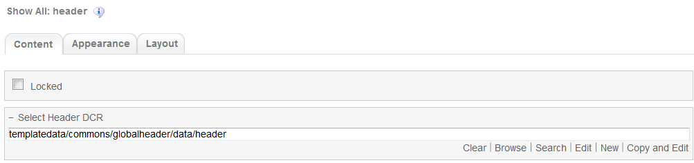

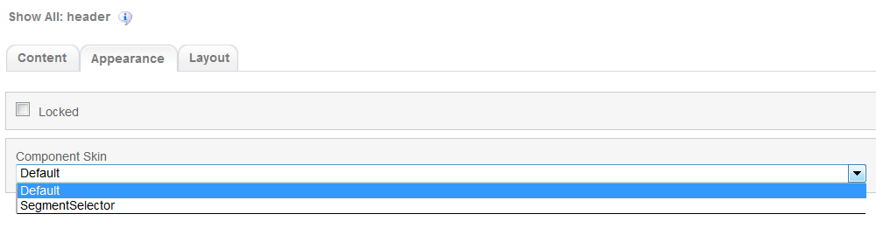

1. Navigation Component



Global component which uses TeamSite Site Map as the content source. Quick links information can be customized

Navigation Component’s default setting should have the following values in Content:

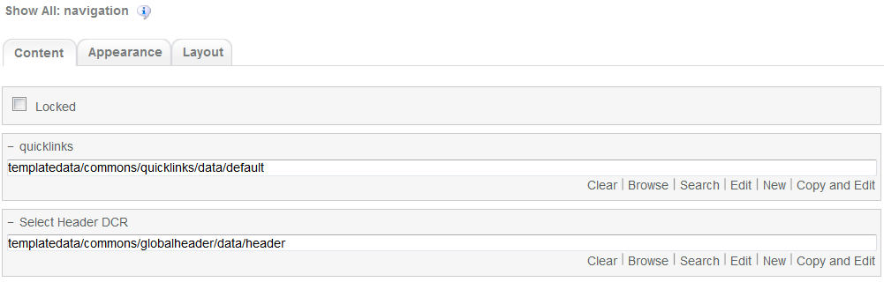

1. Breadcrumb Component



Global component to display the Home Link, Home Link Label and Home Link Target. Can be changed from component properties. If the pageName component properties is left blank then it will take the page name from the respective sitemap node.

Breadcrumb Component’s default setting should have the following values in Content

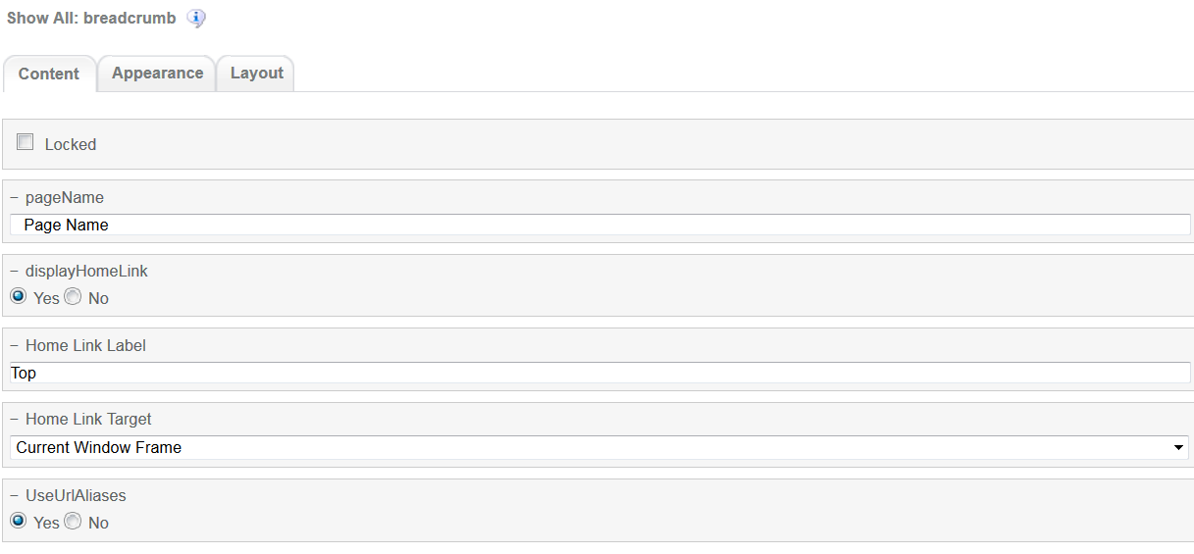

1. Carousel Component  
     
   

Global component to display banners. Banner DCR can be changed from component properties and DCR can be customized.

Carousel component’s default setting should have the following values in Content:

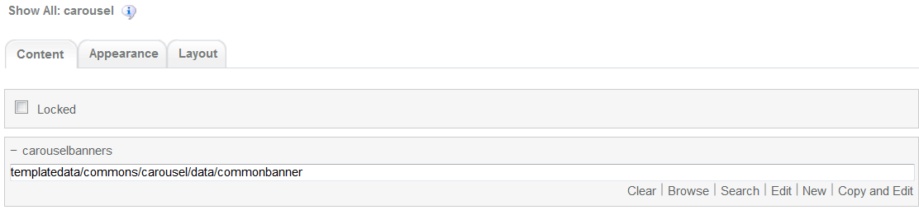

1. Card Compare Component

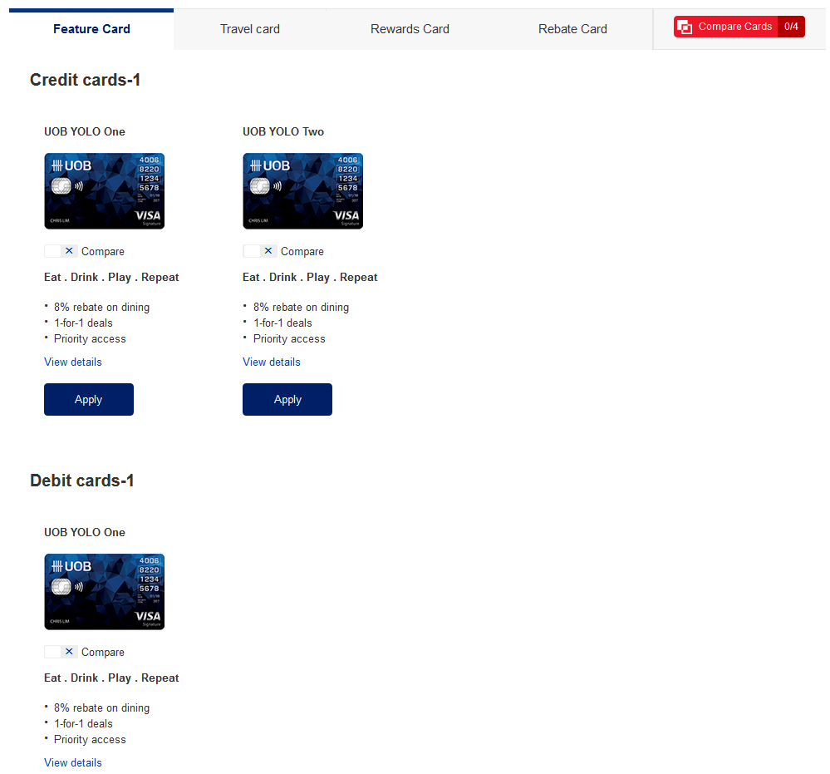

Card Comparison main component. This component can be customize through DCR

Card Comparison component’s default setting should have the following values in Content  
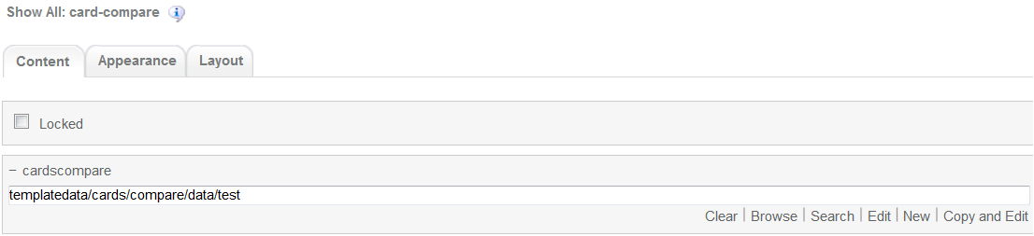

1. 3-column-image component

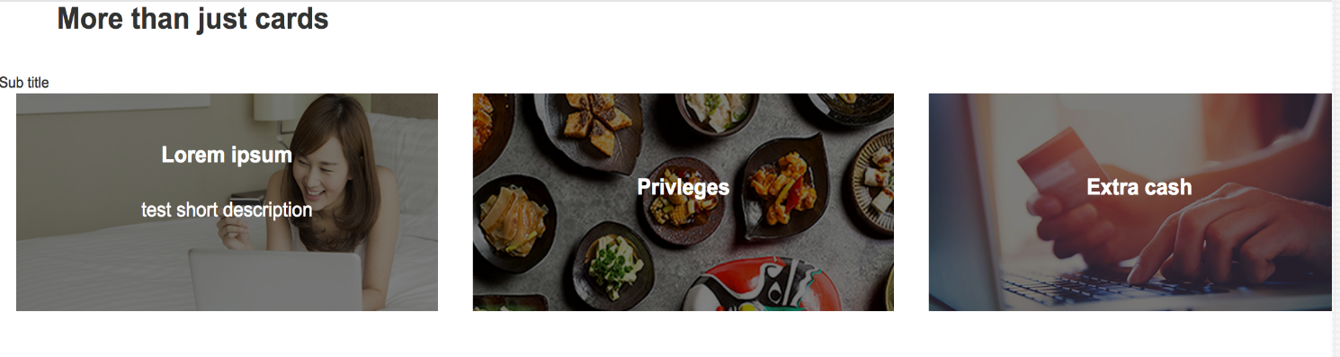  
Common component controlled by DCR. Image, title, links and other resources can be customized

3-coloumn-image-comonent default setting should have the following values in content

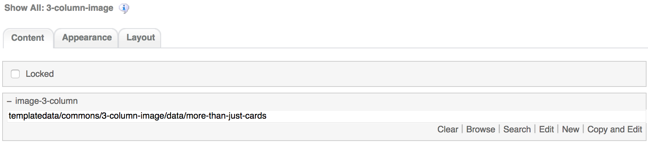

1. 4-column-tile

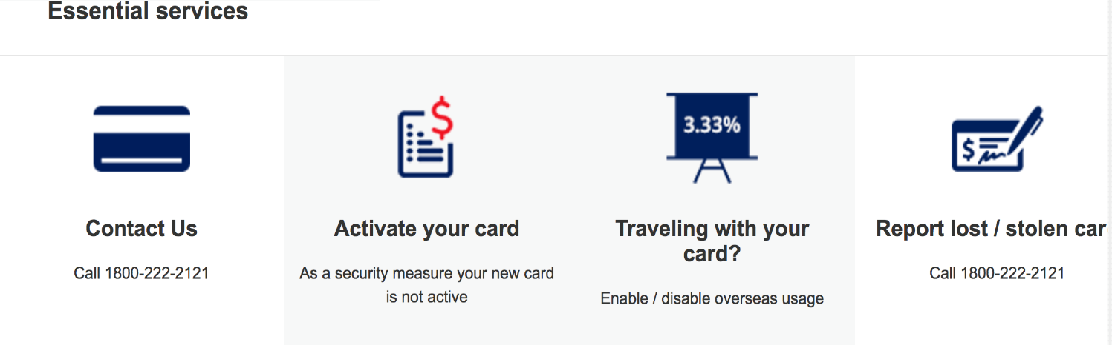

Common component controlled by DCR. Images, tile details, background, links and other resources can be customized

4-coloumn-tile component default setting should have the following values in content

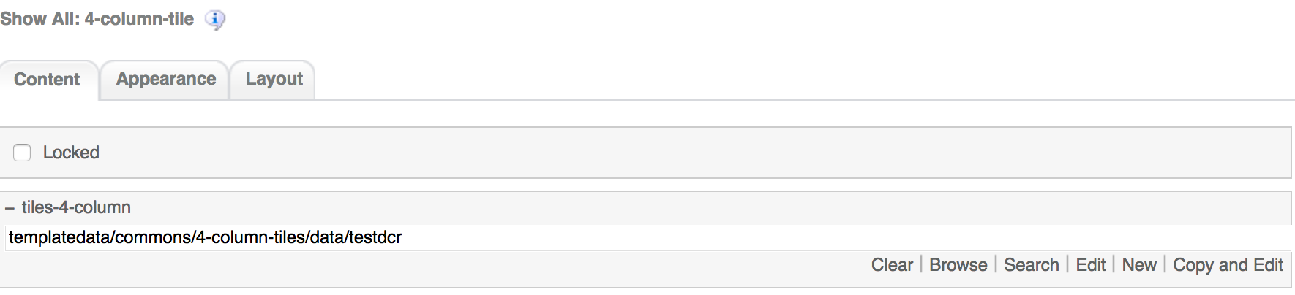

1. 3-column-menu component

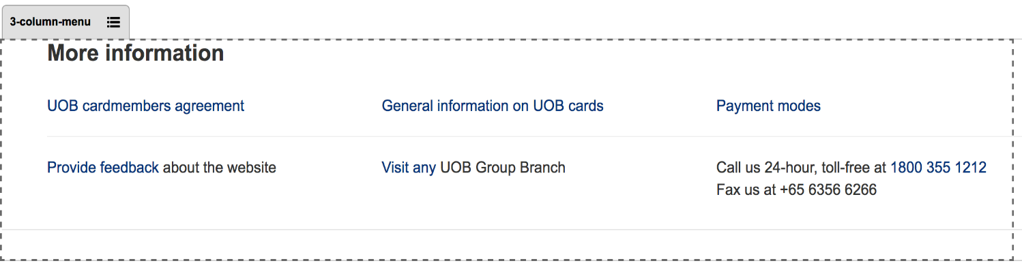

Common component controlled by DCR. Title, links, free formatting text can be customized

3-coloumn-menu component default setting should have the following values in content

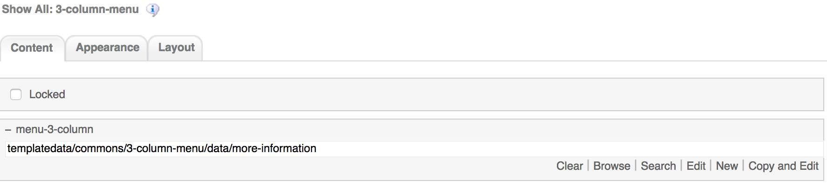

1. Footer component



Global component controlled by DCR. Links and Copyright text can be customized

Footer component’s default setting should have the following values in Content:

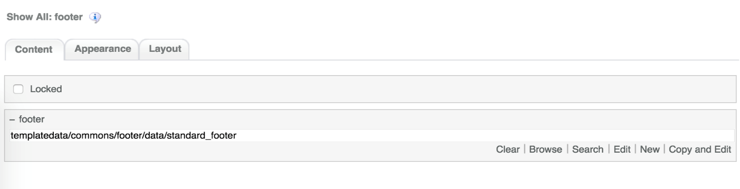

# Card Comparison Common DCR Break-up

In this section, a brief explanation of the Card Comparison common DCR will be made. Please refer to User_Guide-Home_page on how to navigate, select and edit DCR’s.

## Header

Please refer to User_Guide-Home_page “Homepage Common DCR Break-up” for information on Header

## Navigation

Please refer to User_Guide-Home_page “Homepage Common DCR Break-up” for information on Navigation component

## Breadcrumb

Please refer to User_Guide-Product_Landing “Product Landing Common DCR Break-up” for information on Breadcrumb component

## Carousel

Please refer to User_Guide-Product_Landing “Product Landing Common DCR Break-up” for information on Carousel component information

## 3-column-image

Please refer to User_Guide-Product_Landing “Product Landing Common DCR Break-up” for information on Carousel component information

## 4-column-tiles

Please refer to User_Guide-Product_Landing “Product Landing Common DCR Break-up” for information on 4-column-tiles component information

## 3-column-menu

Please refer to User_Guide-Product_Landing “Product Landing Common DCR Break-up” for information on 3-column-menu component information

## Footer

Please refer to User_Guide-Home_page “Homepage Common DCR Break-up” for information on Footer component

# Card Comparison specific DCR Break-up

In this section, a brief explanation of each Card Comparison specific component DCR will be made. Please refer to User_Guide-Home_page on how to navigate and select edit DCR’s.

## Card Compare

The DCT to create the Card Comparison card-compare DCT is located on *templatedata/cards/compare/* under the name datacapture.cfg and can be located using Team Site CCProfessional user interface.

The Card Comparison DCT has the following items

1. Cards Category Name Container  
   By default the DCT creates 4 Cards Category Name container. Each of these containers has a credit card and a debit card container and each of these ones can have until 8 replicas. The items on Cards Category Name are as follows
   1. Section Title  
      Text field. The name of the container “Cards Category Name” will be replaced by the value inside the section title for easy reference purposes  
      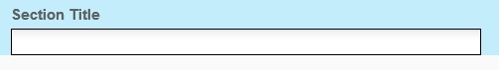
   2. The credit card container has the following fields
      1. Credit Card DCR Browse and Credit Card Page Browse  
         Browse filed where the user selects the corresponding card DCR or page by clicking on the Browse button  
         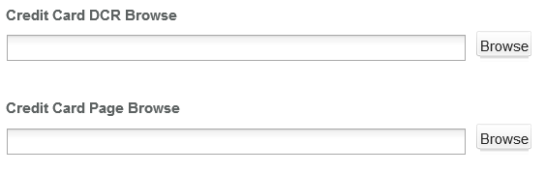
   3. The debit card container has the following fields
      1. Debit Card DCR Browse and Debit Card Page Brose  
         Browse filed where the user selects the corresponding card DCR or page by clicking on the Browse button  
         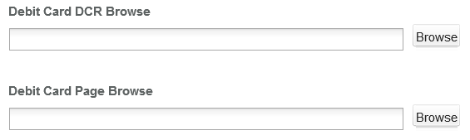

## Card Information

The information of every card comes from the DCR browse mentioned in part 3.1.

All the available DCRs for card can be found in directory <wa-path>/templatedata/cards/listing/data. By default, the DCR will have 4 containers:

1. First Container (No name)

This container is used for Card Comparison page. The following items in this container contains information to be displayed for that card in Card Comparison page:

* 1. Title

Text field. This is a required field.



* 1. Image

Browse field.

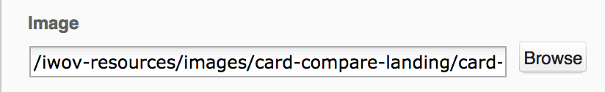

* 1. Image Alt Text

Text field.



* 1. Image Link

Text field.

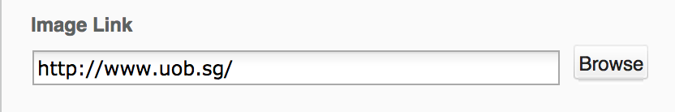

* 1. Sub Header

Text field.



* 1. Bulleted Highlight

Textarea field. This is a required field

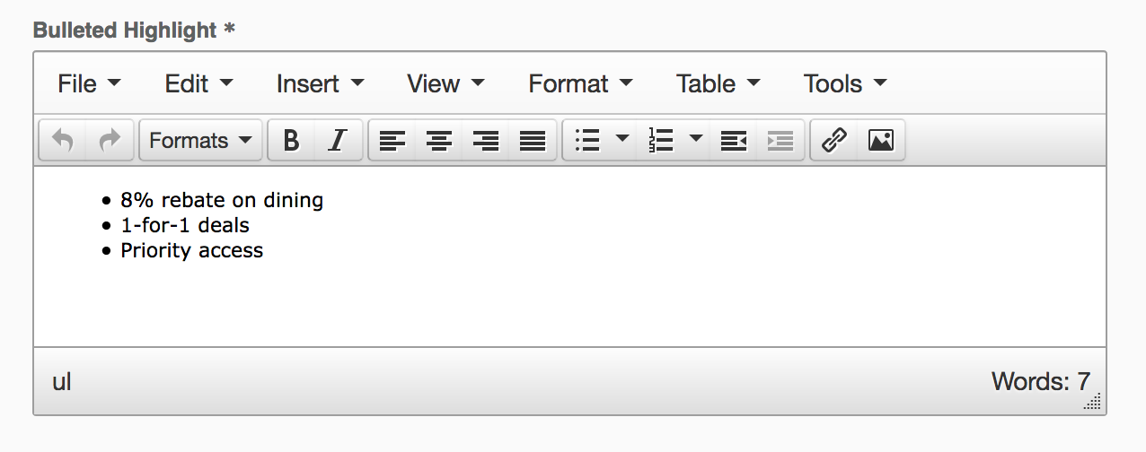

* 1. Apply Now Label

Text field. Leaving this field blank will hide the button “Apply Now” of the card.



* 1. Apply Now Link

Text field.



1. Tabbed Features Container

This container is used for Product and Card Details page only. No modification in this container is needed for updating card information in Card Comparison page.

1. Non Tabbed Features Container

This container is used for Product and Card Details page only. No modification in this container is needed for updating card information in Card Comparison page.

1. Apply Now Sticky Container

This container is used for Product and Card Details page only. No modification in this container is needed for updating card information in Card Comparison page.

# Resources

This section provides a list of the necessary resources (CSS & JavaScript) to create a Card Comparison template. On how to create a template please refer to the User_Guide-Home_Page.

## CSS Resources

The css resources for the Card Comparison template are as follows

|  |  |
| --- | --- |
| **Devices to use with** | **Path** |
| Desktop, Tablet, Mobile | <wa-path>/iwov-resources/css/bootstrap.min.css |
| <wa-path>/iwov-resources/css/style.css |
| Desktop | <wa-path>/iwov-resources/css/desktop-style.css |
| Tablet | <wa-path>/iwov-resources/css/tablet-style.css |
| Mobile | <wa-path>/iwov-resources/css/mobile-style.css |
| Desktop, Table, Mobile | <wa-path>/iwov-resources/css/card-compare-landing/cards-compare-landing-style.css |
| Desktop | <wa-path>/iwov-resources/css/card-compare-landing/cards-compare-landing-desktop-style.css |
| Tablet | <wa-path>/iwov-resources/css/card-compare-landing/cards-compare-landing-tablet-style.css |
| Mobile | <wa-path>/iwov-resources/css/card-compare-landing/cards-compare-landing-mobile-style.css |

These resources must be entered on the same order as the previous table or the page style will break

## JavaScript Resources

The JavaScript resources for the Card Comparison template are as follows

|  |  |
| --- | --- |
| **Devices to use with** | **Path** |
| Desktop, Tablet, Mobile | <wa-path>/iwov-resources/js/analytics.js |
| <wa-path>/iwov-resources/js/cookie_handler.js |
| <wa-path>/iwov-resources/js/initiator.js |
| <wa-path>/iwov-resources/js/libs/modernizr.min.js |
| <wa-path>/iwov-resources/js/libs/jquery.min.js |
| <wa-path>/iwov-resources/js/libs/bootstrap.min.js |
| <wa-path>/iwov-resources/js/libs/plugins.min.js |
| <wa-path>/iwov-resources/js/main.js |
| <wa-path>/iwov-resources/card-compare-landing/cards-compare-main.js |

These resources must be entered on the same order as the previous table or the page will break