

User Guide – Card Landing

Card Landing User guide

Opentext

138 Market Street

Level 33

Singapore 048946

[www.opentext.com](http://www.opentext.com)

OpenText Professional Services

January, 2017

Contents

1. Component Break-up 3

1.1. Component List 3

1.2. Page Structure 3

2. Card Landing Common DCR Break-up 7

2.1. Header 7

2.2. Navigation 7

2.3. Breadcrumb 7

2.4. Carousel 7

2.5. 4-column-tiles 7

2.6. 3-column-menu 7

2.7. Footer 7

3. Card Landing specific DCR Break-up 8

3.1. Card Landing 8

4. Resources 9

4.1. CSS Resources 9

4.2. JavaScript Resources 9

# Component Break-up

## Component List

The Card Landing is composed of the following components

1. Common Components
   1. Header
   2. Navigation
   3. Breadcrumb
   4. Carousel
   5. 4-column-tile
   6. 3-column-menu
   7. Footer
2. Card Landing specific components
   1. Card Landing

## Page Structure

The page structure (component order) and brief explanation as follows. For component’s detailed explanation refer to Functional Specifications Document.

1. Header Component



Global Component composed from UOB logo, “right by you” logo, section menu details, login button and add country section data items

The header component’s default setting should have the following values in Content and Appearance:

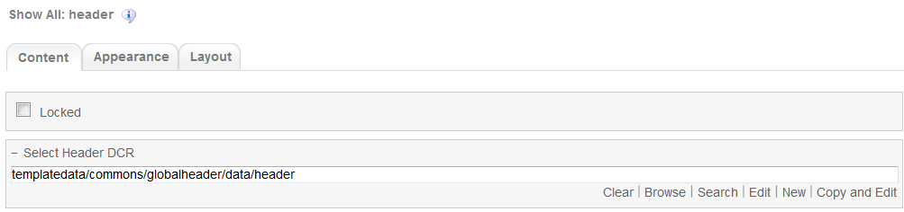

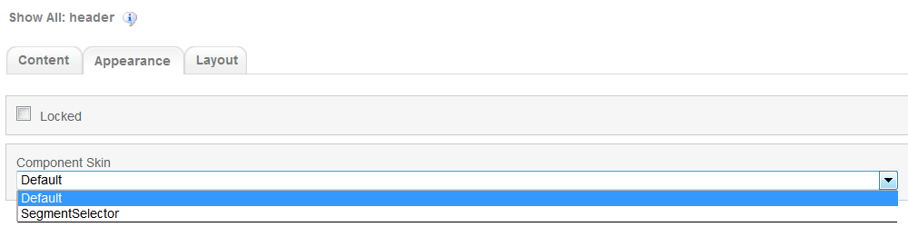

1. Navigation Component



Global component which uses TeamSite Site Map as the content source. Quick links information can be customized

Navigation Component’s default setting should have the following values in Content:

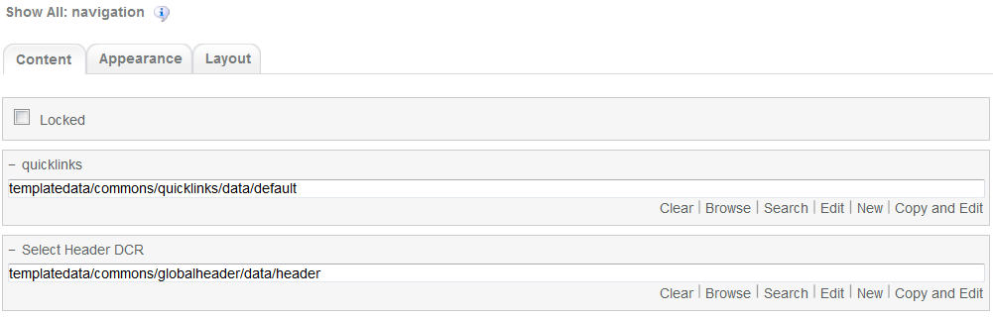

1. Breadcrumb Component



Global component to display the Home Link, Home Link Label and Home Link Target. Can be changed from component properties. If the pageName component properties is left blank then it will take the page name from the respective sitemap node

Breadcrumb Component’s default setting should have the following values in Content

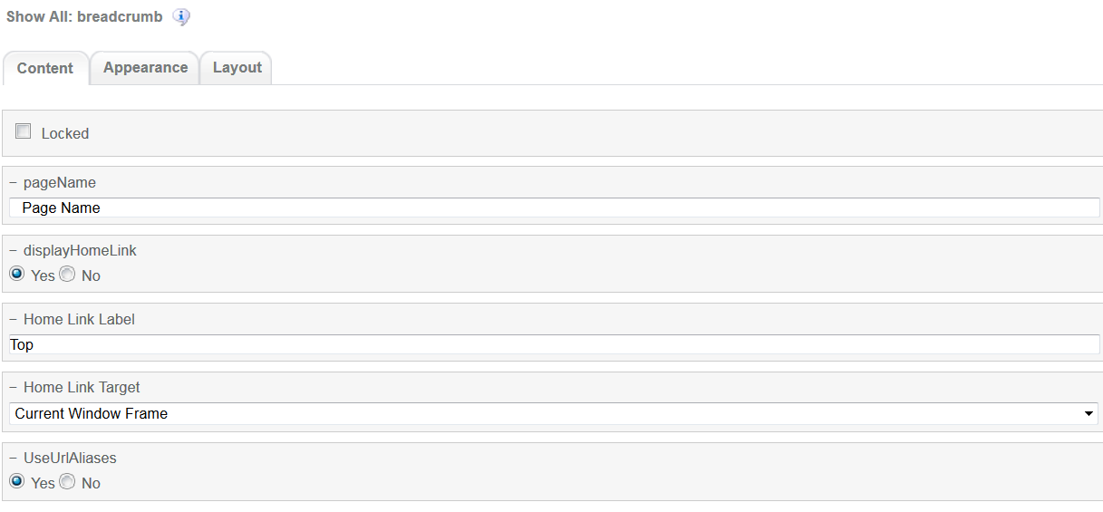

1. Carousel Component  
     
   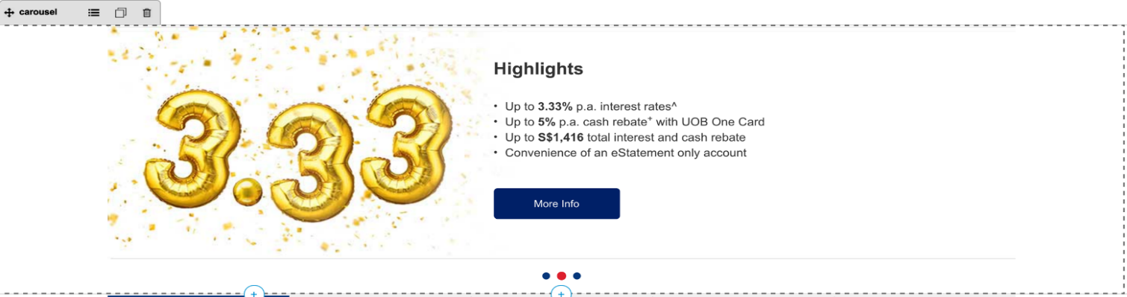

Global component to display banners. Banner DCR can be changed from component properties and DCR can be customized.

Carousel component’s default setting should have the following values in Content:

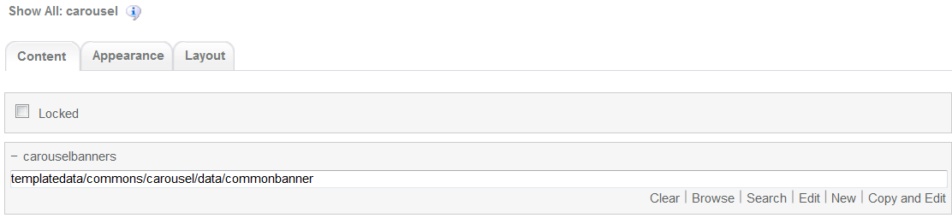

1. Card Landing

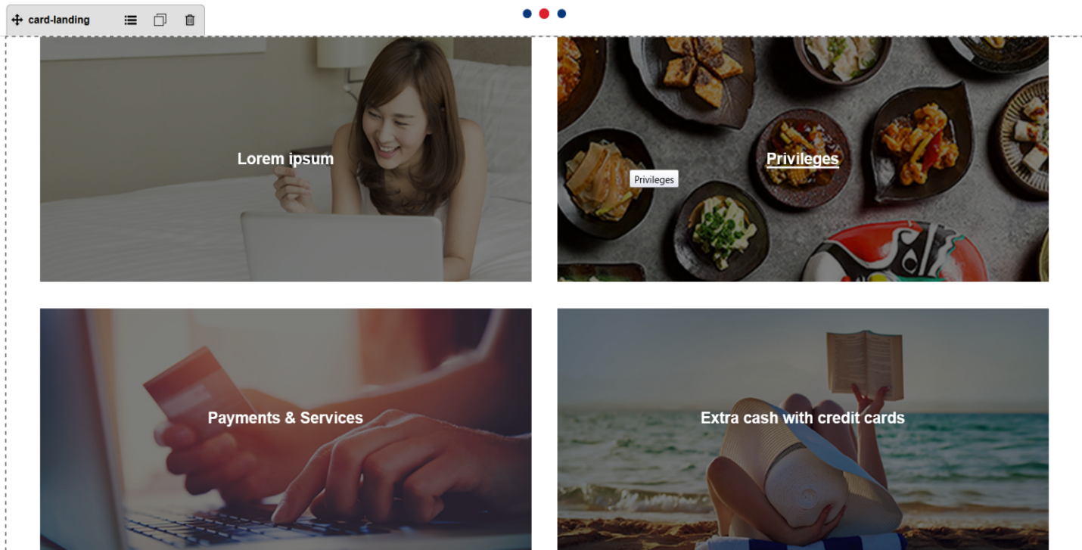

Card Landing main component. This component can be customize through DCR

Card Landing component’s default setting should have the following values in Content  
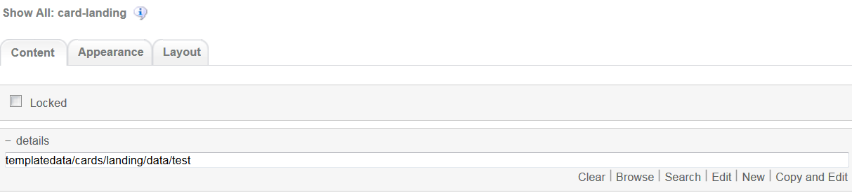

1. 4-column-tile

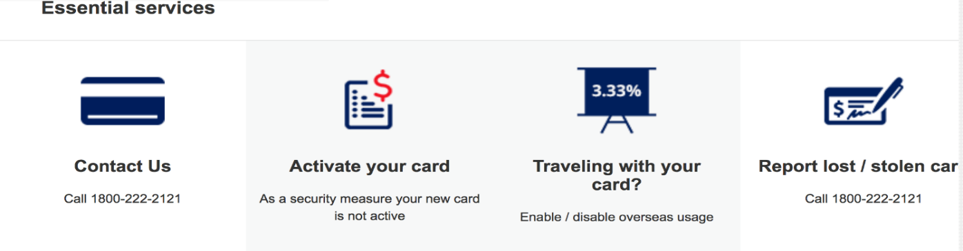

Common component controlled by DCR. Images, tile details, background, links and other resources can be customized

4-coloumn-tile component default setting should have the following values in content

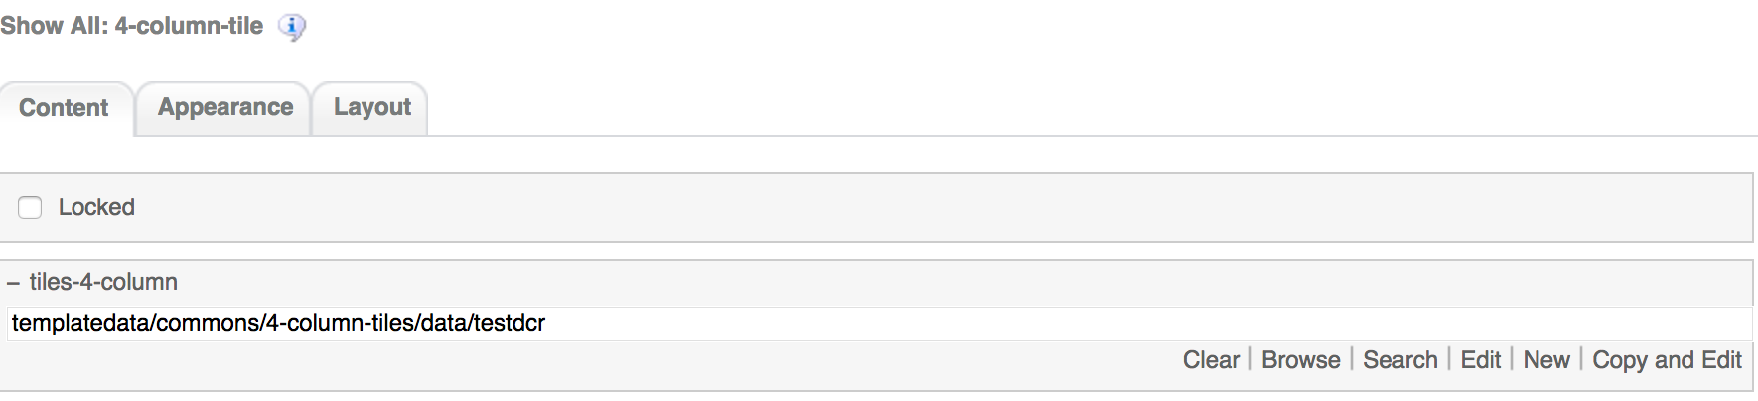

1. 3-column-menu component

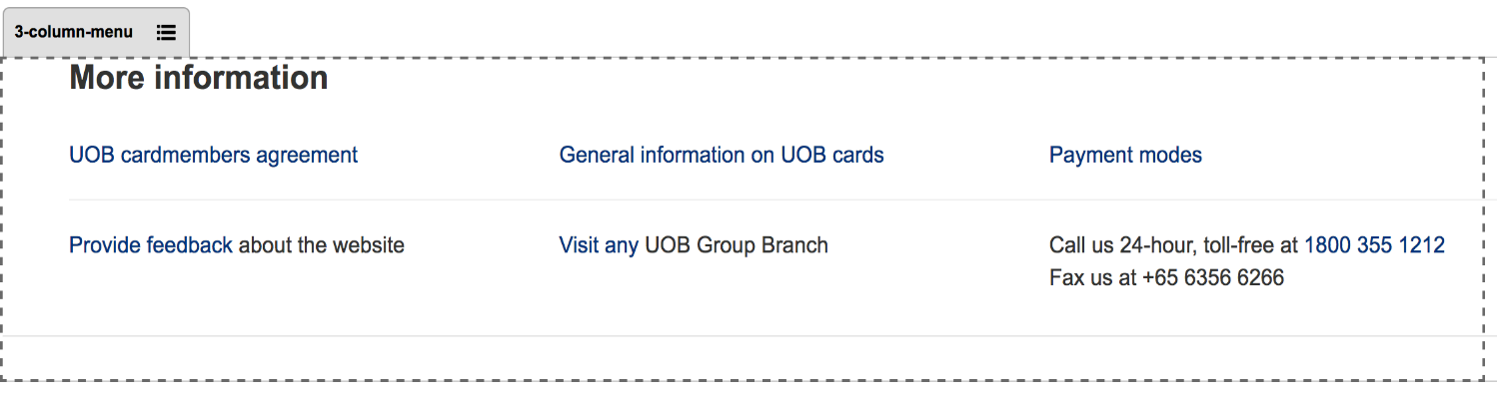

Common component controlled by DCR. Title, links, free formatting text can be customized

3-coloumn-menu component default setting should have the following values in content

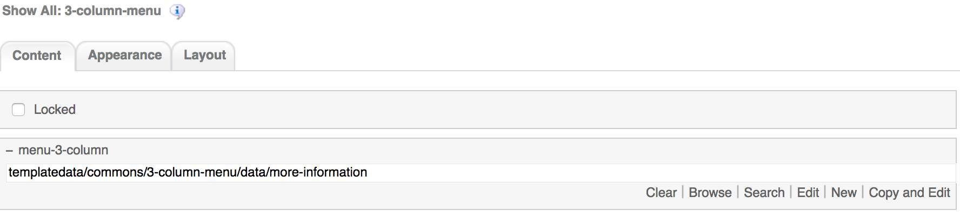

1. Footer component



Global component controlled by DCR. Links and Copyright text can be customized

Footer component’s default setting should have the following values in Content:

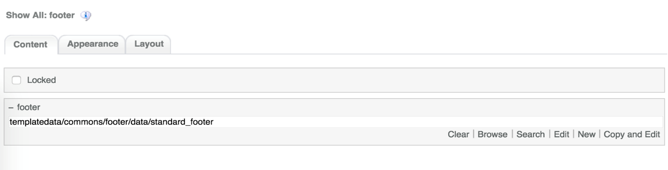

# Card Landing Common DCR Break-up

In this section, a brief explanation of the Card Landing common DCR will be made. Please refer to User_Guide-Home_page on how to navigate, select and edit DCR’s.

## Header

Please refer to User_Guide-Home_page “Homepage Common DCR Break-up” for information on Header

## Navigation

Please refer to User_Guide-Home_page “Homepage Common DCR Break-up” for information on Navigation component

## Breadcrumb

Please refer to User_Guide-Product_Landing “Product Landing Common DCR Break-up” for information on Breadcrumb component

## Carousel

Please refer to User_Guide-Product_Landing “Product Landing Common DCR Break-up” for information on Carousel component information

## 4-column-tiles

Please refer to User_Guide-Product_Landing “Product Landing Common DCR Break-up” for information on 4-column-tiles component information

## 3-column-menu

Please refer to User_Guide-Product_Landing “Product Landing Common DCR Break-up” for information on 3-column-menu component information

## Footer

Please refer to User_Guide-Home_page “Homepage Common DCR Break-up” for information on Footer component

# Card Landing specific DCR Break-up

In this section, a brief explanation of each Card Landing specific component DCR will be made. Please refer to User_Guide-Home_page on how to navigate and select edit DCR’s.

## Card Landing

The DCT to create the Card Landing cards-landing DCT is located on *templatedata/cards/landing/* under the name datacapture.cfg and can be located using Team Site CCProfessional user interface.

The Card Landing DCT has the following items

1. Card Landing Container  
   The main container has the following items
   1. Card Landing Title  
      Text field  
      
   2. 2 Column Image Container  
      The 2 column image container can have an unbound number of replicas each with another 2 containers with the following items
      1. Image  
         Browse field where user can select the desired image by clicking on the Browse button  
         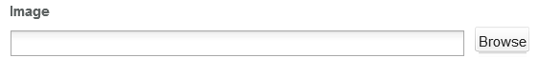
      2. Image Alt Text, Content Title, Short Description and Target Link  
         Text field  
         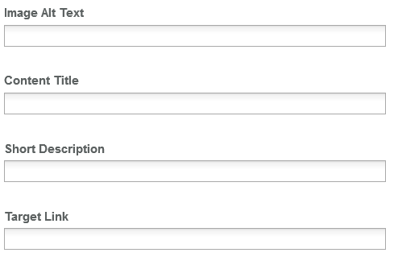
      3. Link Opening Option  
         Drop Down menu to select the link opening type  
         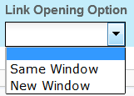

# Resources

This section provides a list of the necessary resources (CSS & JavaScript) to create a Card Landing template. On how to create a template please refer to the User_Guide-Home_Page.

## CSS Resources

The css resources for the Card Landing template are as follows

|  |  |
| --- | --- |
| **Devices to use with** | **Path** |
| Desktop, Tablet, Mobile | <wa-path>/iwov-resources/css/bootstrap.min.css |
| <wa-path>/iwov-resources/css/card-compare-landing/cards-compare-landing-style.css |
| Desktop | <wa-path>/iwov-resources/css/card-compare-landing/cards-compare-landing-desktop-style.css |
| Tablet | <wa-path>/iwov-resources/css/card-compare-landing/cards-compare-landing-tablet-style.css |
| Mobile | <wa-path>/iwov-resources/css/card-compare-landing/cards-compare-landing-mobile-style.css |
| Desktop, Tablet, Mobile | <wa-path>/iwov-resources/css/style.css |
| Desktop | <wa-path>/iwov-resources/css/desktop-style.css |
| Tablet | <wa-path>/iwov-resources/css/tablet-style.css |
| Mobile | <wa-path>/iwov-resources/css/mobile-style.css |

These resources must be entered on the same order as the previous table or the page style will break

## JavaScript Resources

The JavaScript resources for the Card Landing template are as follows

|  |  |
| --- | --- |
| **Devices to use with** | **Path** |
| Desktop, Tablet, Mobile | <wa-path>/iwov-resources/js/analytics.js |
| <wa-path>/iwov-resources/js/cookie_handler.js |
| <wa-path>/iwov-resources/js/initiator.js |
| <wa-path>/iwov-resources/js/libs/jquery.min.js |
| <wa-path>/iwov-resources/js/libs/modernizr.min.js |
| <wa-path>/iwov-resources/js/libs/plugins.min.js |
| <wa-path>/iwov-resources/js/main.js |
| <wa-path>/iwov-resources/card-compare-landing/cards-landing-main.js |
| <wa-path>/iwov-resources/js/libs/bootstrap.min.js |

These resources must be entered on the same order as the previous table or the page will break