

User Guide – Default Setting

Opentext

138 Market Street

Level 33

Singapore 048946

[www.opentext.com](http://www.opentext.com)

OpenText Professional Services

February, 2017

Contents

1. Component Break-up 3

1.1. Component List 3

1.2. Page Structure 3

2. Stay Informed Common DCR Break-up 10

2.1. Header 10

2.2. Navigation 10

2.3. Breadcrumb 10

2.4. 3-column-menu 10

2.5. Footer 10

3. Stay Informed specific DCR Break-up 11

3.1. Stay Informed 11

4. Resources 14

4.1. CSS Resources 14

4.2. JavaScript Resources 14

# Default Setting

The default setting for a site will apply to all the pages and templates created inside that site. Those settings are specified in the file default.site, located in site’s folder

In Experience Studio, user can see the default setting of a site by choosing “Details”:

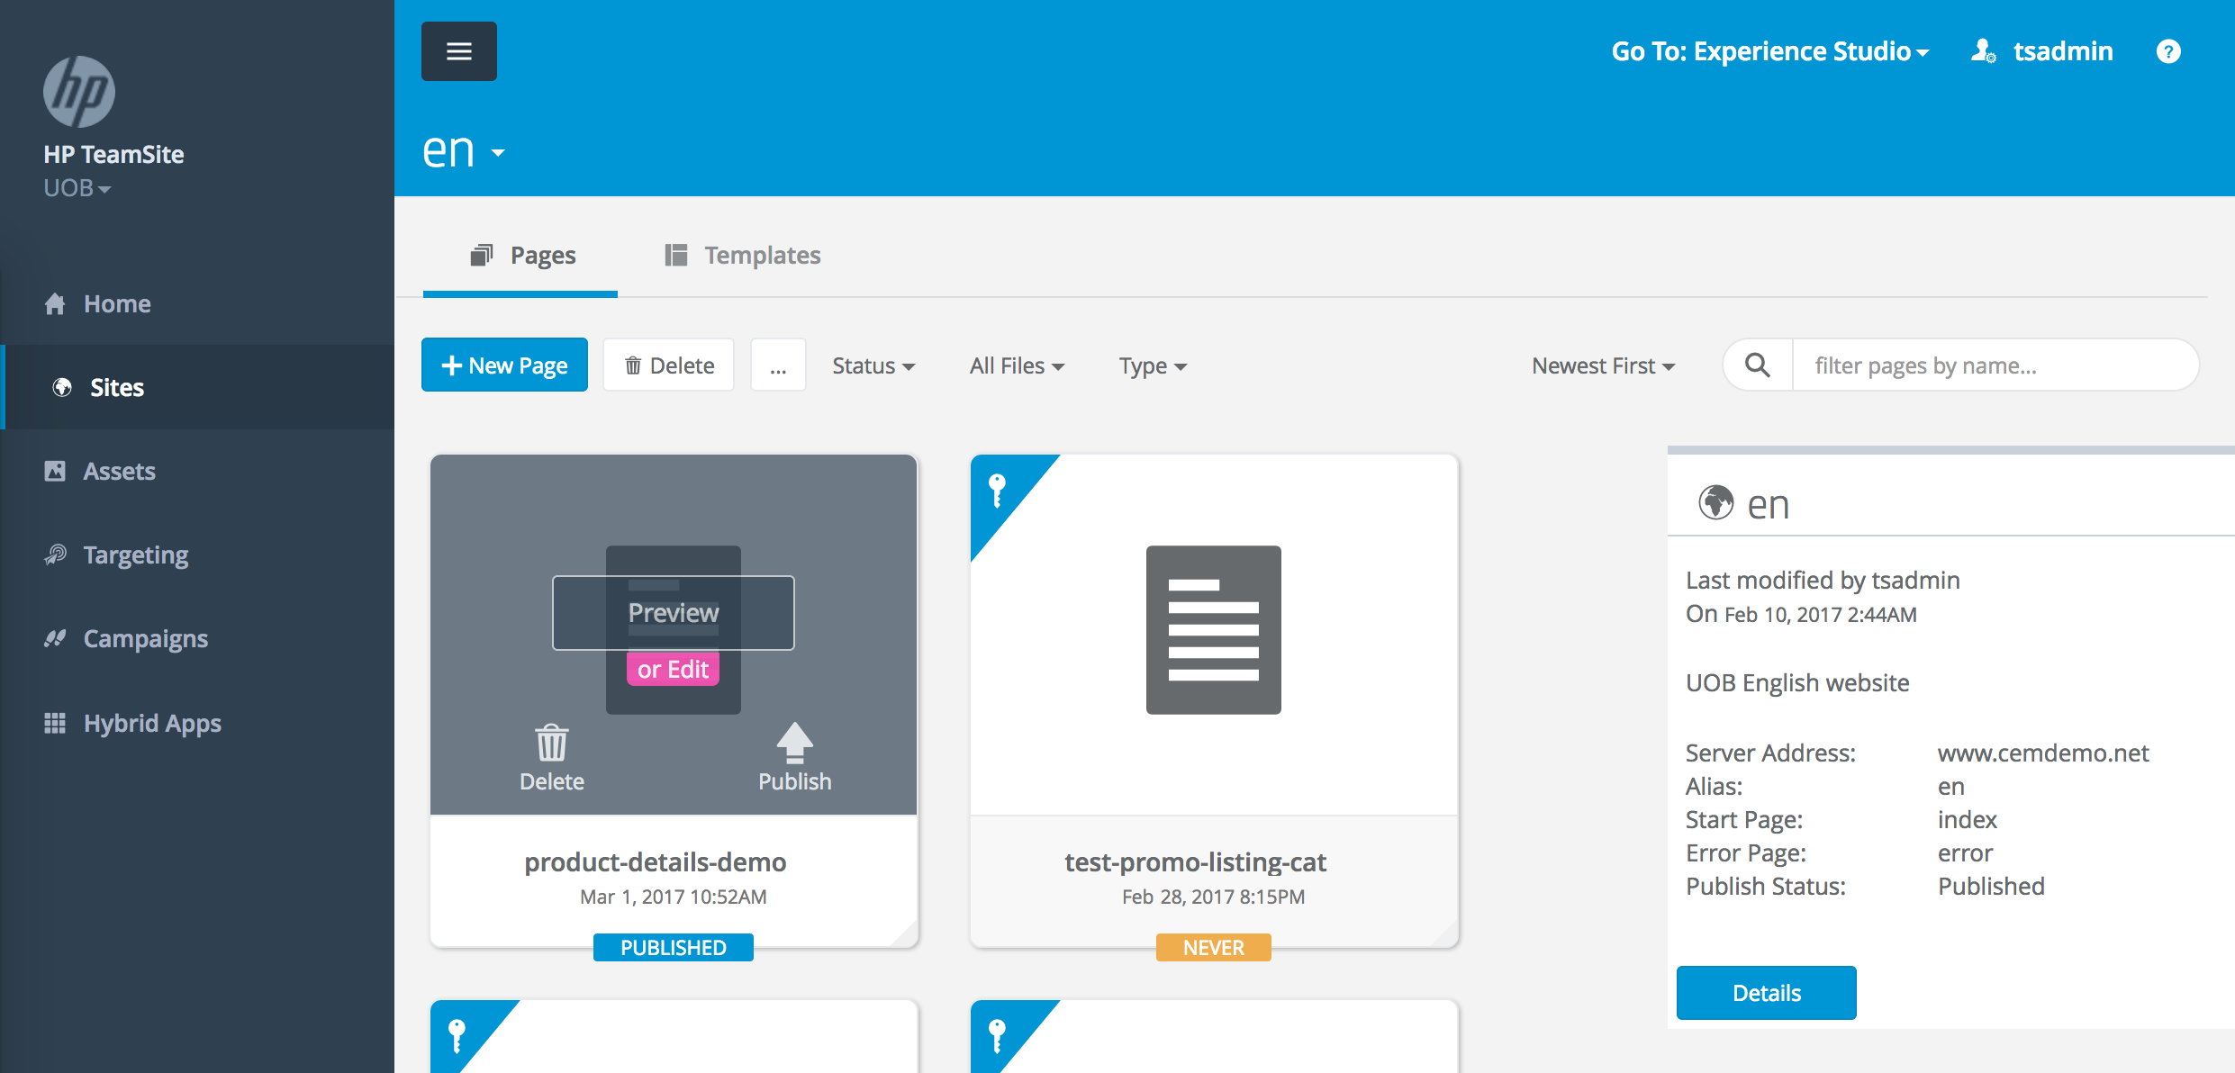

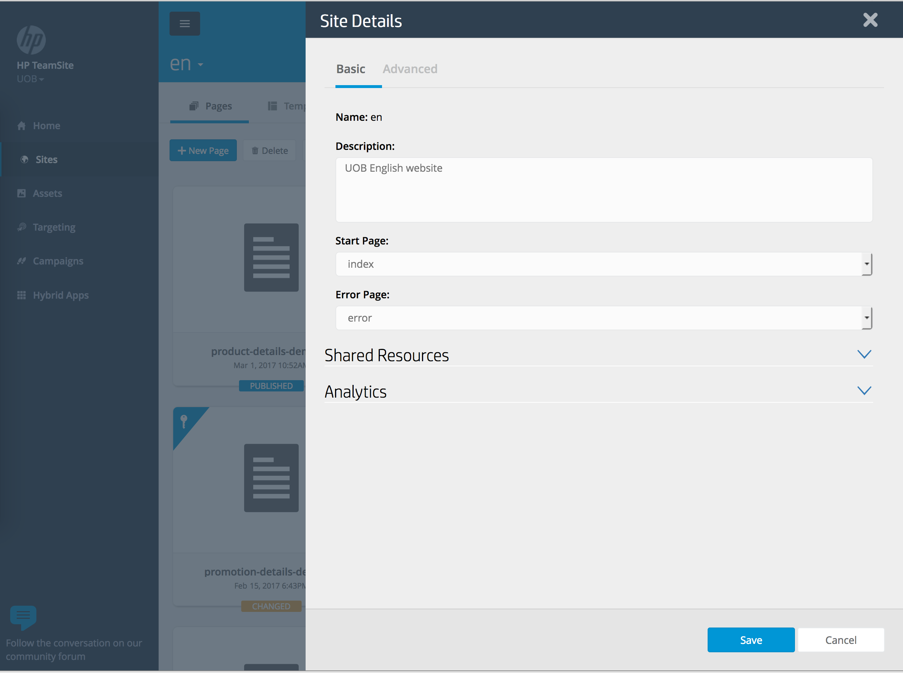

## Structures

The default setting contains 2 parts: Basic and Advanced

### Basic Setting

The basic setting of site consists of following fields:

1. Name:



The name of the site. This field is set after the site was created.

1. Description:  
   

The description of the site.

1. Start Page



The start page of the site.

1. Error page



The error page of the site.

1. Shared Resources

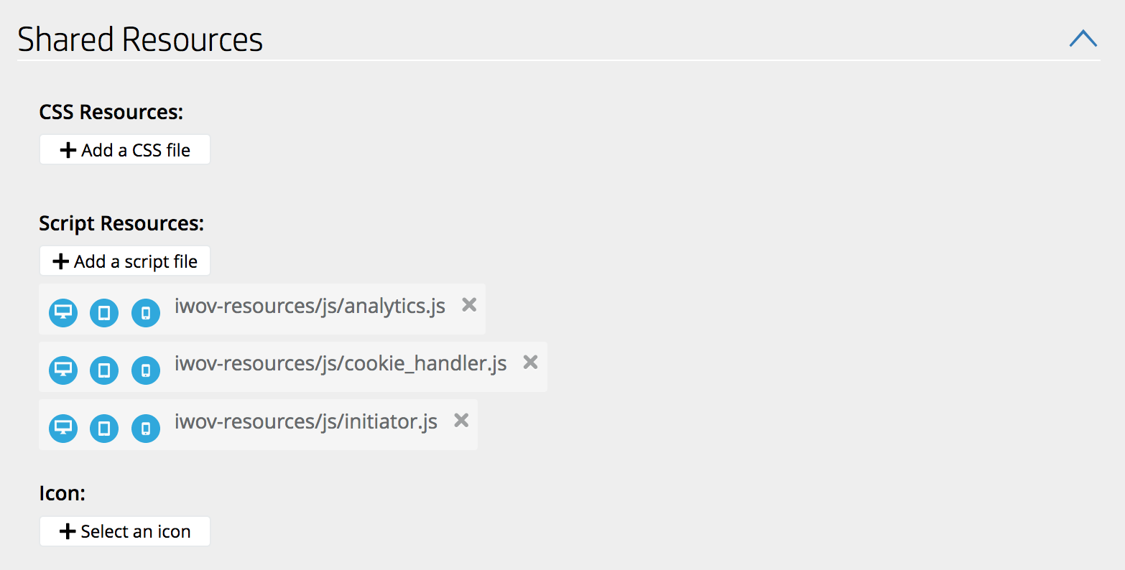

All resources listed in here will be used by every page and template of the site.

Default resources which must be in this field are:

* CSS Resources: None
* JavaScript Resources: 3 files:
  + Iwov-resources/js/analytics.js
  + Iwov-resources/js/cookie_handler.js
  + Iwov-resources/js/initiator.js
* Icon: None

1. Analytics

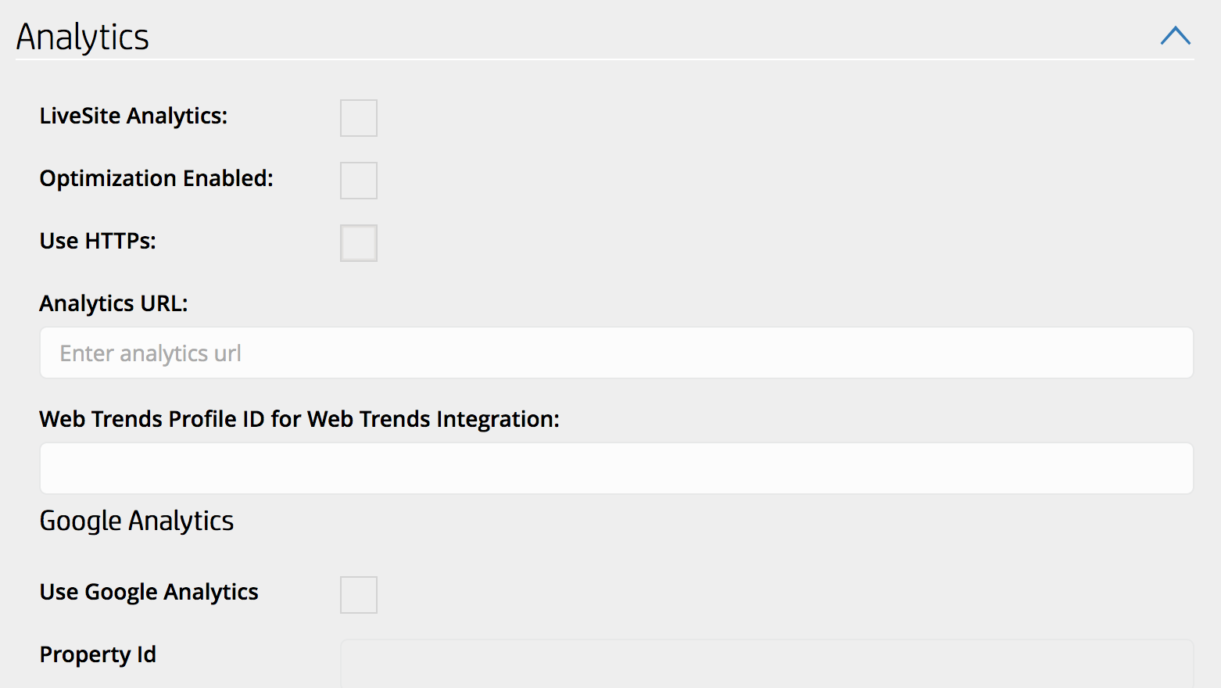

Currently, this field is unused.

### Advance Setting

1. Runtime

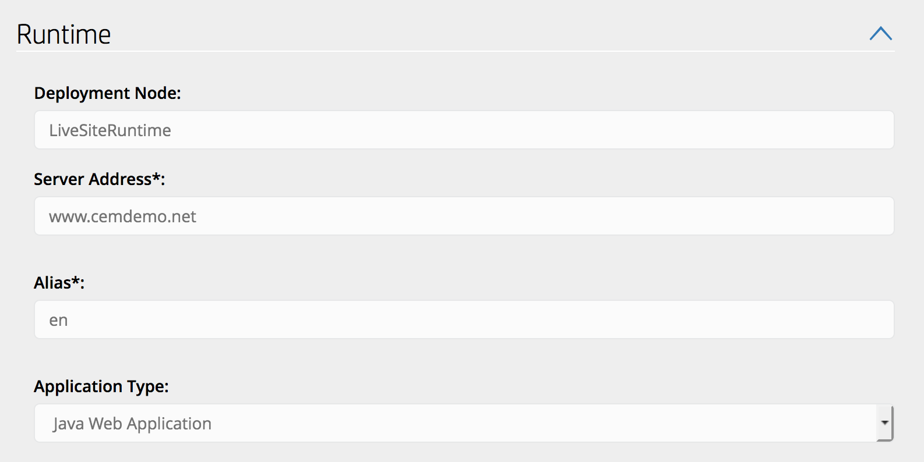

This field contains configuration information for runtime deployment. Modification in this field is not recommended, and any change should be consulted by technical team.

1. Metatags

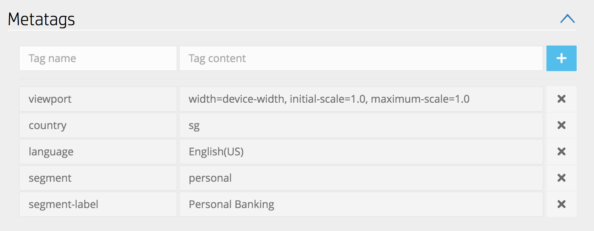

Metatags are used for display settings and site analytics. User can add their own metatags; however, there are default metatags for a site, and modification of those must be consulted by technical support, or referred to this documentation.

The default metatags for a site are:

* Metatag **“viewport”:** value is “width=device-width, initial-scale=1.0, maximum-scale=1.0”. Modification of this viewport is not recommended
* Metatag **“country”:** value is the 2-letter code of the country name, defined in ISO 3166-1 standard.
* Metatag **“language”:** value is a language option in the language option list in DCR of g**lobalheader.** The value is case-sensitive, and must be the same as in the DCR. Any difference might cause display issue.

Sample of language options in globalheader DCR:

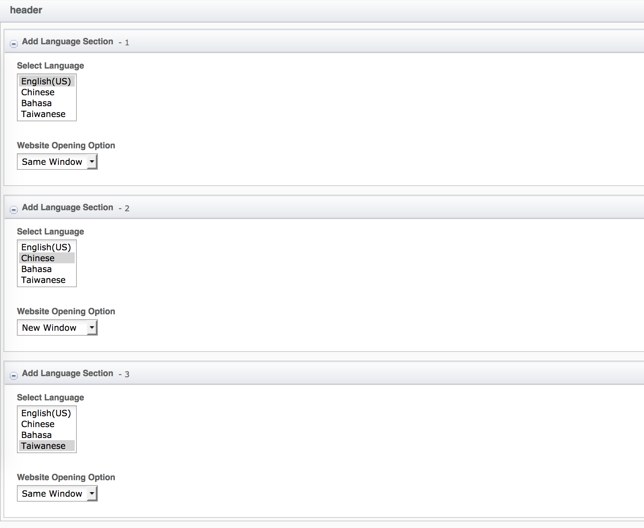

* Metatag **“segment”:** value is the name of segment of the site in runtime, e.g. “personal”, “business”
* Metatag **“segment-label”:** value is the label of the segment, displayed in dropdown for segment selection in header:



Value of segment-label is case-sensitive, and must be one available option in sector details in DCR of **globalheader.** A sample of sector details in globalheader DCR:

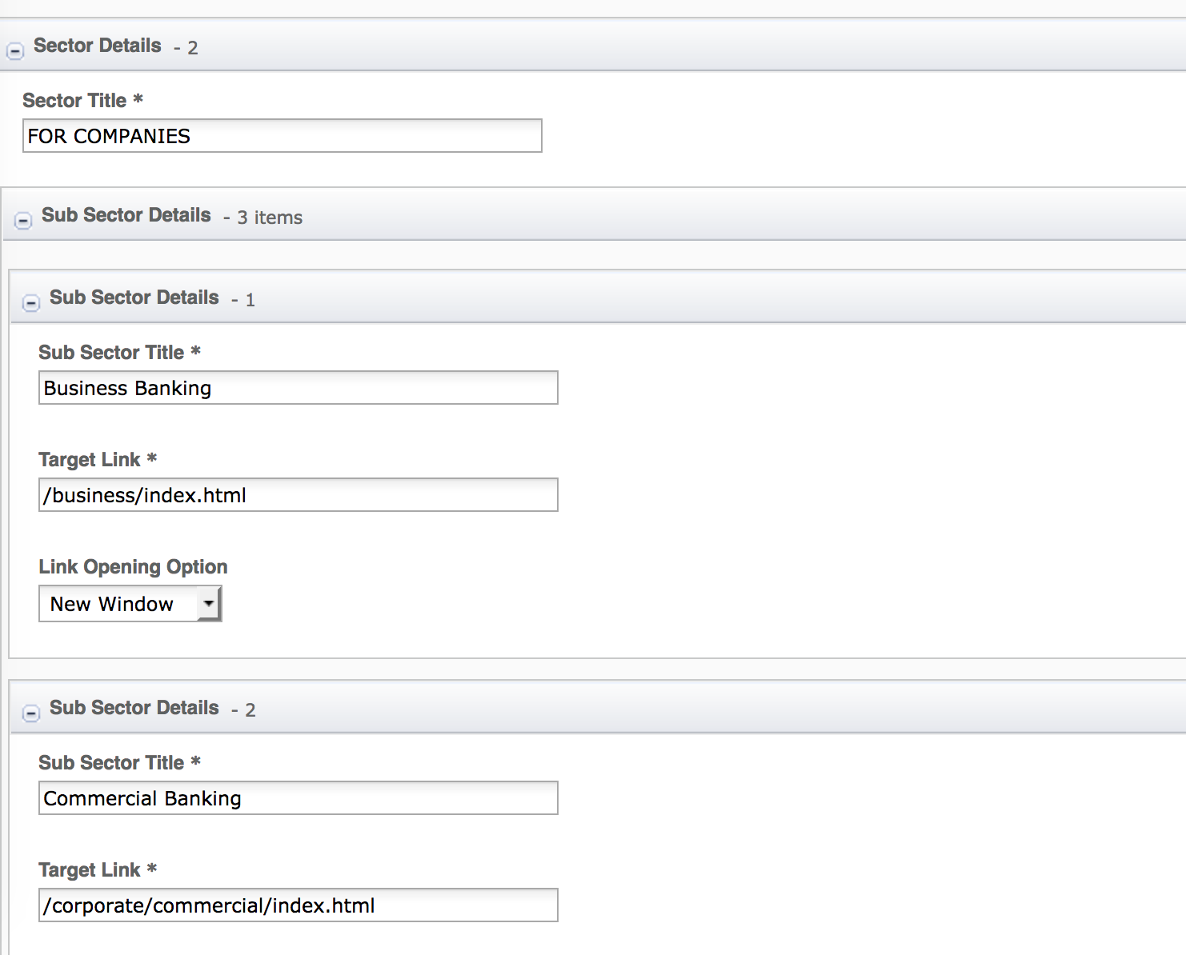

1. Pre-controllers:

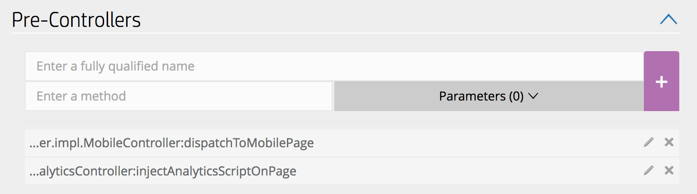

Define the list of controllers to run before each page in a site loads. Modification of this field must be consulted by technical support.

1. Post-controllers:

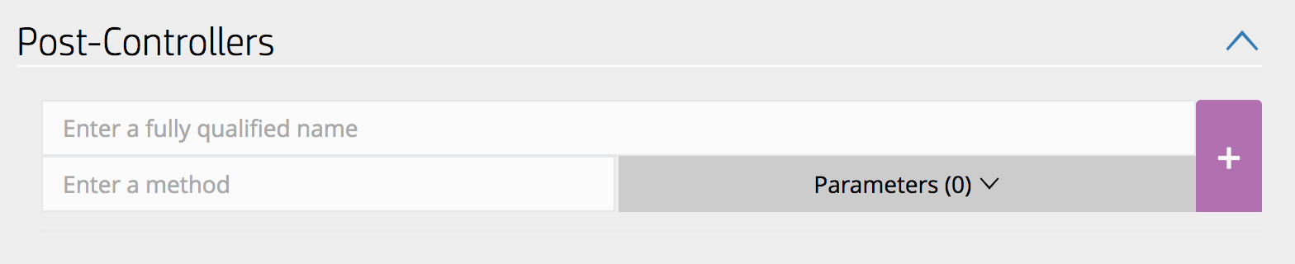

Define the list of controllers to run after each page in a site loads. Modification of this field must be consulted by technical support

1. Login:

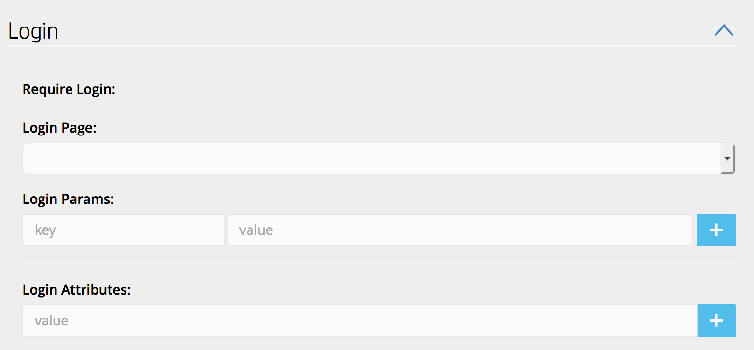

Define the login page for the site. Since current site structure does not have a login page, the field is left unused.

# Resources

This section provides a list of the necessary resources (CSS & JavaScript) to maintain default setting for a site.

## JavaScript Resources

The JavaScript resources for the Stay Informed template are as follows

|  |
| --- |
| **Path** |
| <wa-path>/iwov-resources/js/analytics.js |
| <wa-path>/iwov-resources/js/cookie_handler.js |
| <wa-path>/iwov-resources/js/initiator.js |

These resources must be entered on the same order as the previous table or the page will break