

User Guide – Fund Selector

Fund Selector User guide

Opentext

138 Market Street

Level 33

Singapore 048946

[www.opentext.com](http://www.opentext.com)

OpenText Professional Services

January, 2017

Contents

1. Component Break-up 3

1.1. Component List 3

1.2. Page Structure 3

2. Fund Selector Common DCR Break-up 6

2.1. Header 6

2.2. Navigation 6

2.3. Breadcrumb 6

2.4. Footer 6

3. Fund Selector specific DCR Break-up 7

3.1. Fund Selector 7

4. Resources 8

4.1. CSS Resources 8

4.2. JavaScript Resources 8

# Component Break-up

## Component List

The Fund Selector template is composed of the following components

1. Common Components
   1. Header
   2. Navigation
   3. Breadcrumb
   4. Footer
2. Fund Selector specific components
   1. Funds Selector

## Page Structure

The page structure (component order) and brief explanation as follows. For component’s detailed explanation refer to Functional Specifications Document.

1. Header Component



Global Component composed from UOB logo, “right by you” logo, section menu details, login button and add country section data items

The header component’s default setting should have the following values in Content and Appearance:

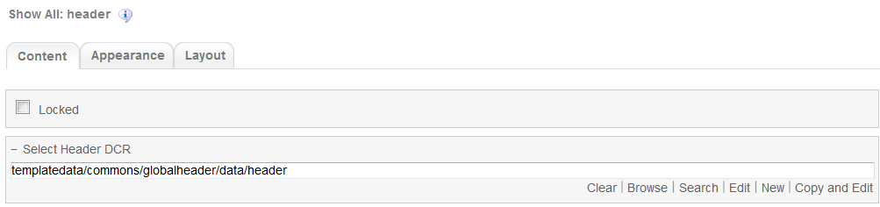

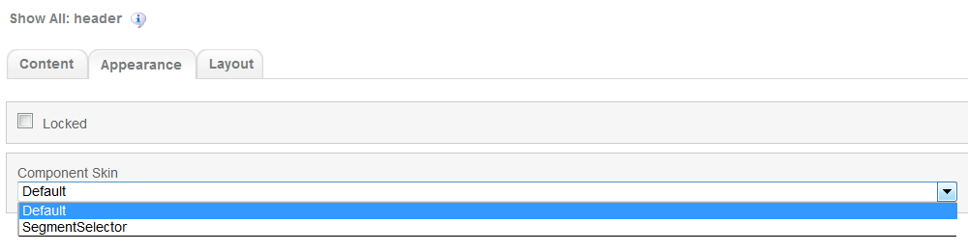

1. Navigation Component  
     
   

Global component which uses TeamSite Site Map as the content source. Quick links information can be customized

Navigation Component’s default setting should have the following values in Content:

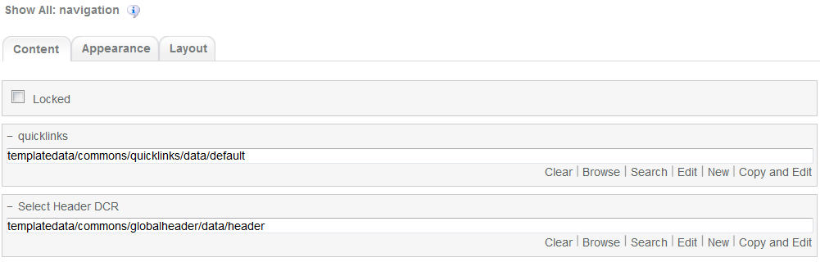

1. Breadcrumb Component  
   
2. Global component to display the Home Link, Home Link Label and Home Link Target. Can be changed from component properties. If the pageName component properties is left blank then it will take the page name from the respective sitemap node

Breadcrumb component’s default setting should have the following values in Content  
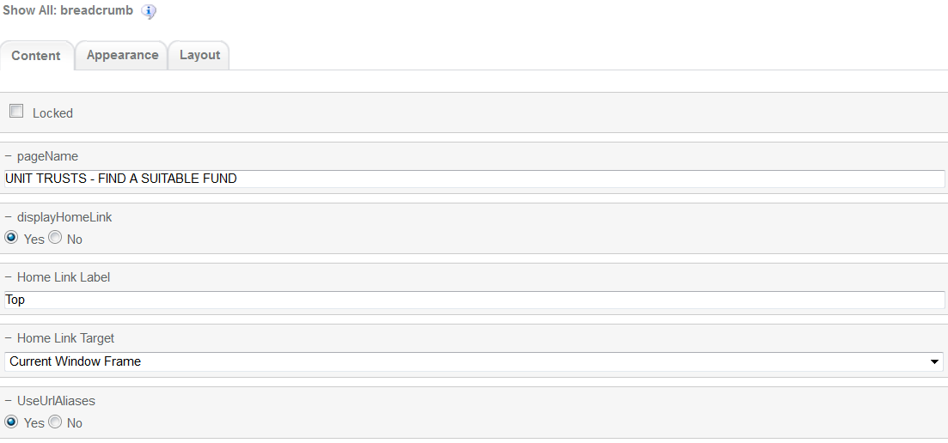

1. Funds Selector  
   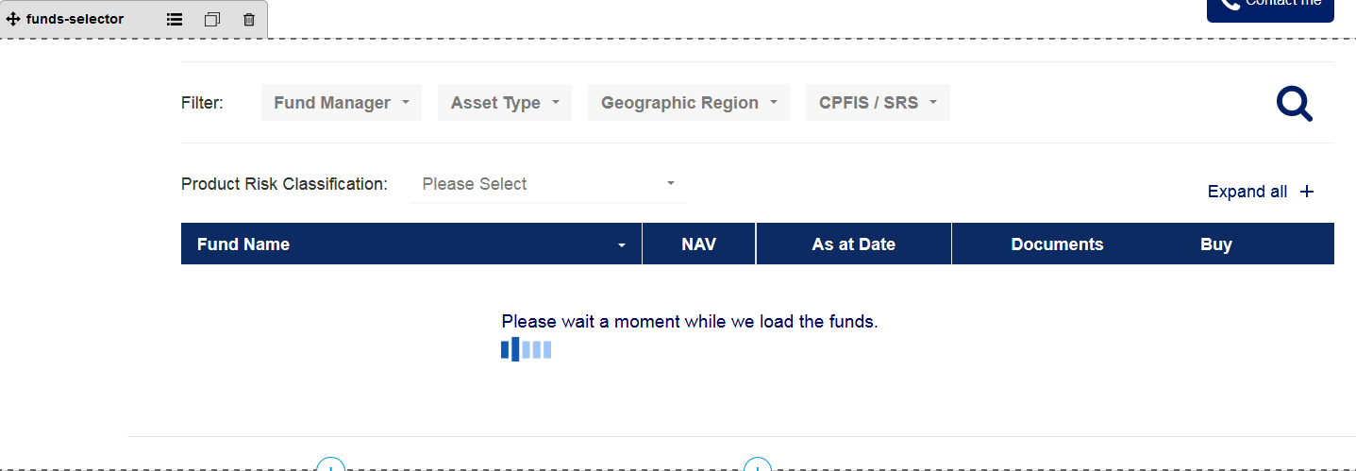

Fund Selector template specific component. This component does not have a DCR associated to it

Fund Selector component’s default setting should have the following values in Content  
  
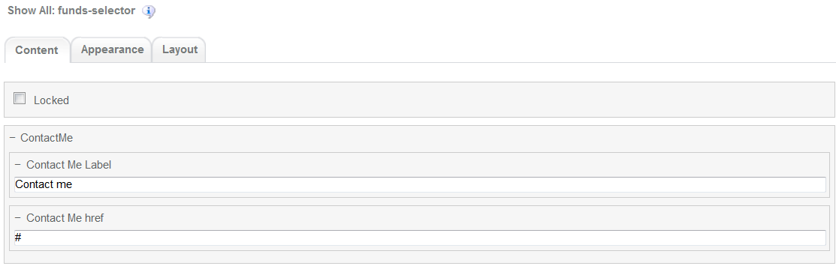

1. Footer component



Global component controlled by DCR. Links and Copyright text can be customized

Footer component’s default setting should have the following values in Content:

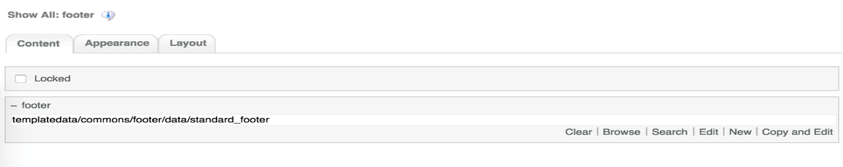

# Fund Selector Common DCR Break-up

In this section, a brief explanation of Fund Selector common DCR will be made. Please refer to User_Guide-Home_page on how to navigate and select edit DCR’s

## Header

Please refer to User_Guide-Home_page “Homepage Common DCR Break-up” for information on Header

## Navigation

Please refer to User_Guide-Home_page “Homepage Common DCR Break-up” for information on Navigation component

## Breadcrumb

Please refer to User_Guide-Product_Landing “Product Landing Common DCR Break-up” for information on Breadcrumb component

## Footer

Please refer to User_Guide-Home_page “Homepage Common DCR Break-up” for information on Footer component

# Fund Selector specific DCR Break-up

In this section, a brief explanation of each Fund Selector specific component DCR will be made. Please refer to User_Guide-Home_page on how to navigate and select edit DCR’s.

## Fund Selector

Fund Selector main component funds-selector does not have a DCR associated to it. Its customization must be done through the component itself and the xsl file it refers to for presentation.

Through the component properties the Contact Me button can be customized as follows

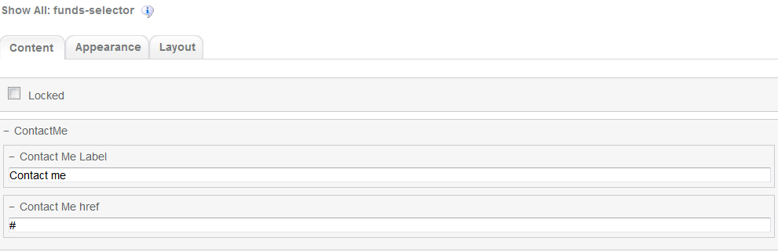

# Resources

This section provides a list of the necessary resources (CSS & JavaScript) to create a Fund Selector template. On how to create a template please refer to the User_Guide-Home_Page.

## CSS Resources

The css resources for the Fund Selector template are as follows

|  |  |
| --- | --- |
| **Devices to use with** | **Path** |
| Desktop, Tablet, Mobile | <wa-path>/iwov-resources/css/bootstrap.min.css |
| <wa-path>/iwov-resources/css/style.css |
| Desktop | <wa-path>/iwov-resources/css/desktop-style.css |
| Tablet | <wa-path>/iwov-resources/css/tablet-style.css |
| Mobile | <wa-path>/iwov-resources/css/mobile-style.css |
| Desktop | <wa-path>/iwov-resources/css/funds-selector/funds-selector-desktop-style.css |
| Tablet | <wa-path>/iwov-resources/css/funds-selector/funds-selector-tablet-style.css |
| Mobile | <wa-path>/iwov-resources/css/funds-selector/funds-selector-mobile-style.css |

These resources must be entered on the same order as the previous table or the page style will break

## JavaScript Resources

The JavaScript resources for the Fund Selector template are as follows

|  |  |
| --- | --- |
| **Devices to use with** | **Path** |
| Desktop, Tablet, Mobile | <wa-path>/iwov-resources/js/analytics.js |
| <wa-path>/iwov-resources/js/cookie_handler.js |
| <wa-path>/iwov-resources/js/initiator.js |
| <wa-path>/iwov-resources/js/libs/jquery.min.js |
| <wa-path>/iwov-resources/js/libs/bootstrap.min.js |
| <wa-path>/iwov-resources/js/libs/plugins.min.js |
| <wa-path>/iwov-resources/js/main.js |
| <wa-path>/iwov-resources/js/libs/modernizr.min.js |
| <wa-path>/iwov-resources/js/funds-selector/pnr_unit_trusts.js |
| <wa-path>/iwov-resources/js/funds-selector/funds-selector-main.js |

These resources must be entered on the same order as the previous table or the page will break