

User Guide – Product Landing

Product Landing User guide

Opentext

138 Market Street

Level 33

Singapore 048946

[www.opentext.com](http://www.opentext.com)

OpenText Professional Services

January, 2017

Contents

1. Component Break-up 3

1.1. Component List 3

1.2. Page Structure 3

2. Product Landing Common DCR Break-up 9

2.1. Header 9

2.2. Navigation 9

2.3. Breadcrumb 9

2.4. Carousel 10

2.5. 3-column-image 13

2.6. 4-column-tiles 14

2.7. 3-column-menu 15

2.8. Footer 17

3. Product Landing specific DCR Break-up 18

3.1. Product Landing 18

3.2. Apply Now Fixed Bottom 20

4. Resources 21

4.1. CSS Resources 21

4.2. JavaScript Resources 21

# Component Break-up

## Component List

The Product Landing is composed of the following components

1. Common Components
   1. Header
   2. Navigation
   3. Breadcrumb
   4. Carousel
   5. 3-column-image
   6. 4-column-tile
   7. 3-column-menu
   8. Footer
2. Product Landing specific components
   1. product-landing
   2. Apply Now Fixed Bottom

## Page Structure

The page structure (component order) and brief explanation as follows. For component’s detailed explanation refer to Functional Specifications Document.

1. Header Component



Global Component composed from UOB logo, “right by you” logo, section menu details, login button and add country section data items

The header component’s default setting should have the following values in Content and Appearance:

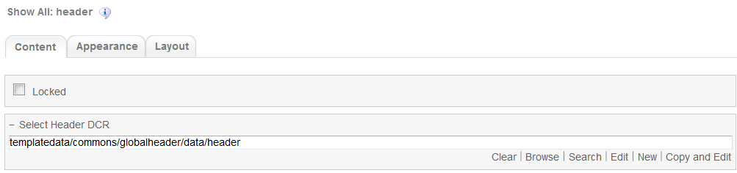

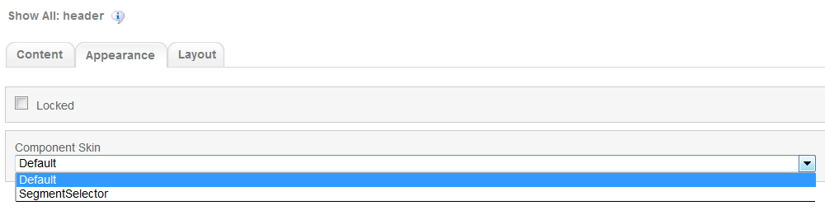

1. Navigation Component



Global component which uses TeamSite Site Map as the content source. Quick links information can be customized

Navigation Component’s default setting should have the following values in Content:

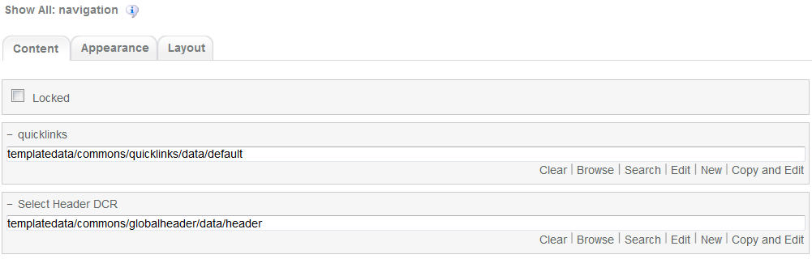

1. Breadcrumb Component



Global component to display the Home Link, Home Link Label and Home Link Target. Can be changed from component properties. If the pageName component properties is left blank then it will take the page name from the respective sitemap node

Breadcrumb component’s default setting should have the following values in Content  
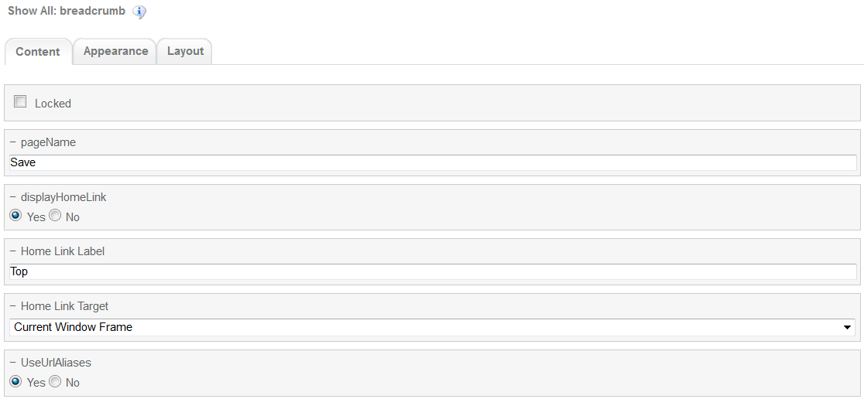

1. Carousel component

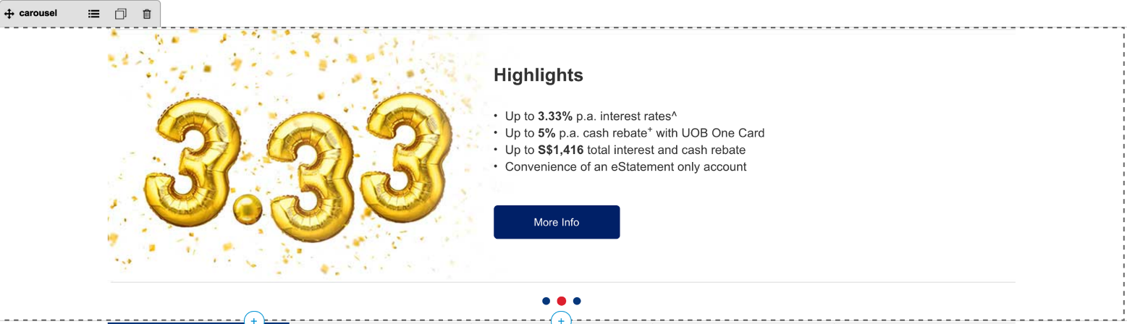

Global component to display banners. Banner DCR can be changed from component properties and DCR can be customized.

Carousel component’s default setting should have the following values in Content:

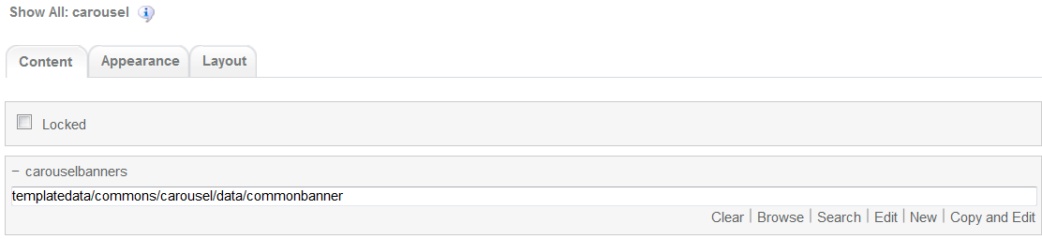

1. Product-landing  
     
   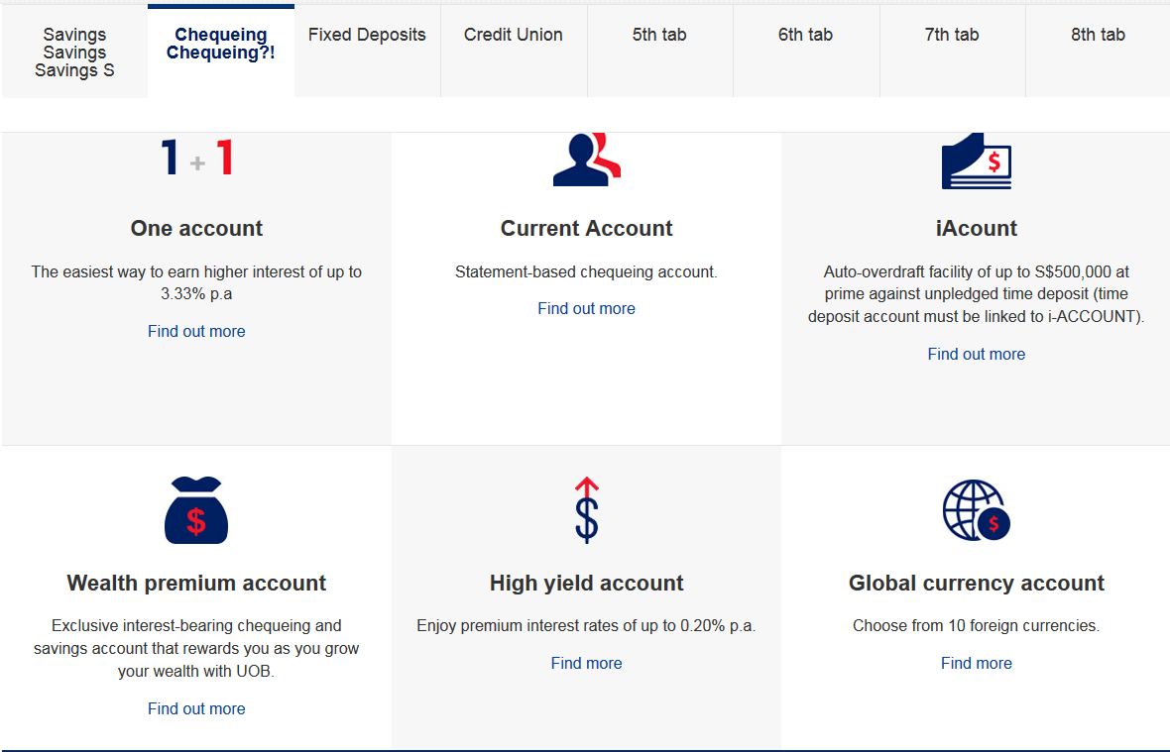

Product Landing main component. DCR is composed of Tabbed section container. Can be customized

Product Landing main component’s default setting should have the following values in Content:

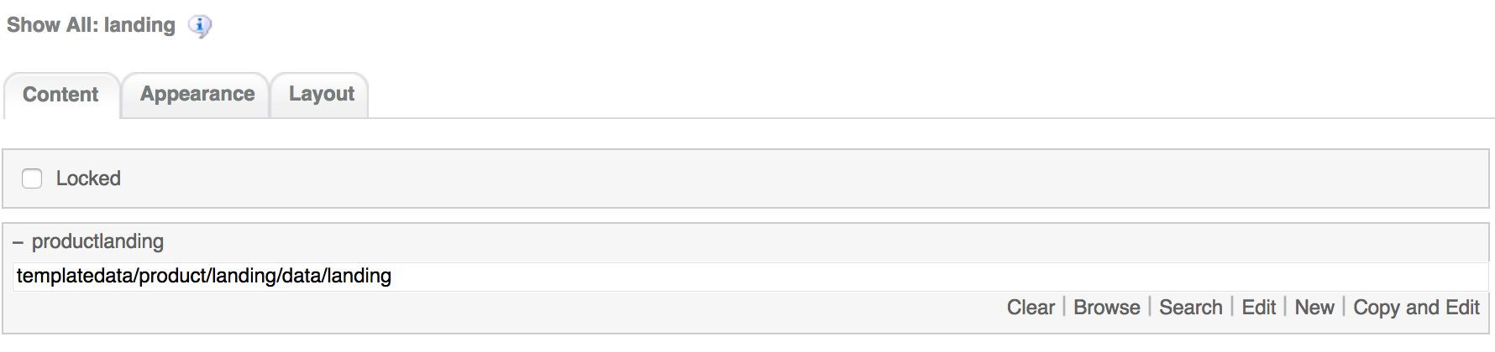

1. 3-column-image component

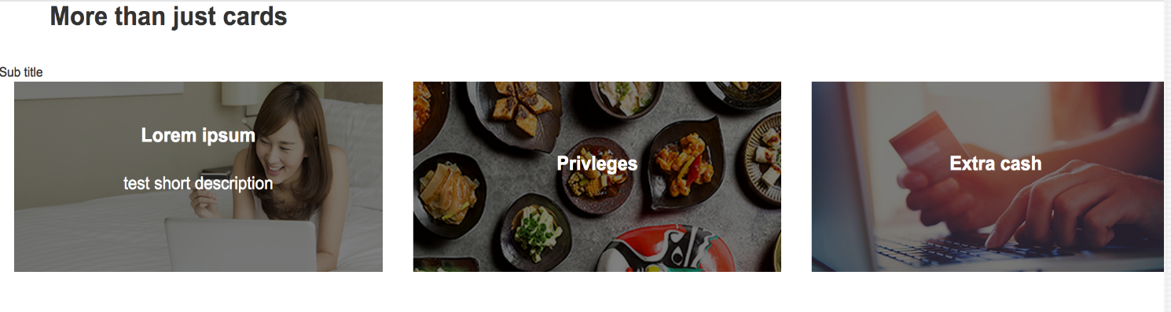  
Common component controlled by DCR. Image, title, links and other resources can be customized

3-coloumn-image-comonent default setting should have the following values in content

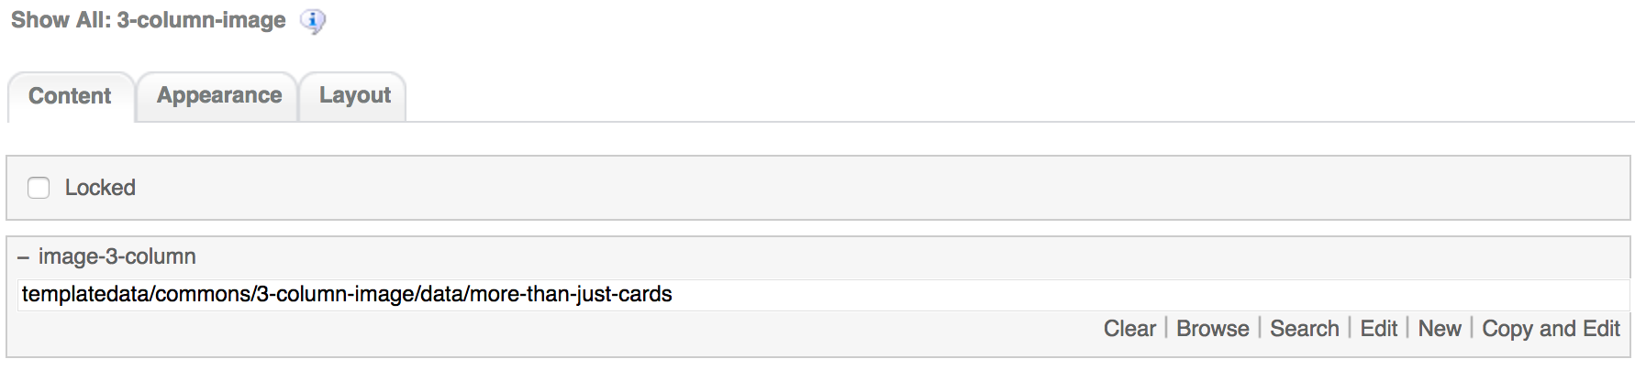

1. 4-column-tile

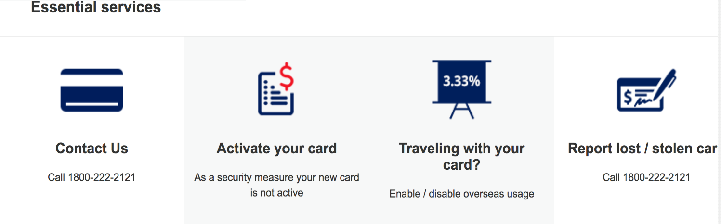

Common component controlled by DCR. Images, tile details, background, links and other resources can be customized

4-coloumn-tile component default setting should have the following values in content

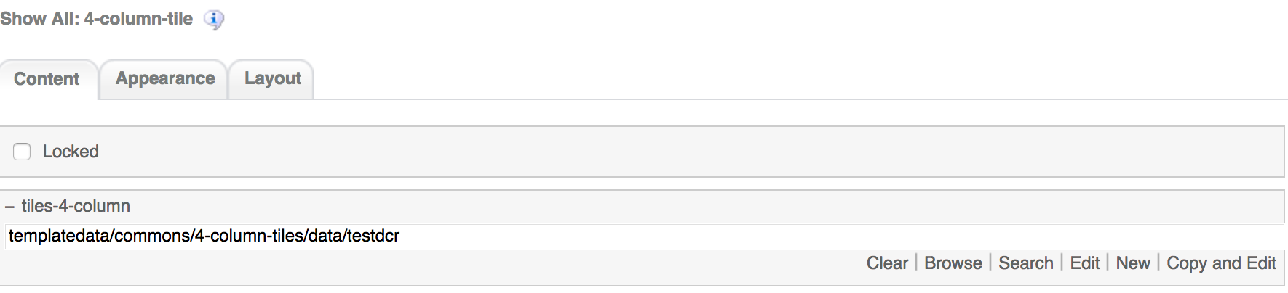

1. 3-column-menu component

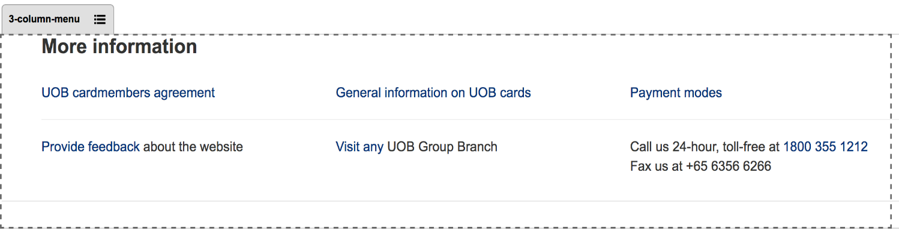

Common component controlled by DCR. Title, links, free formatting text can be customized

3-coloumn-menu component default setting should have the following values in content

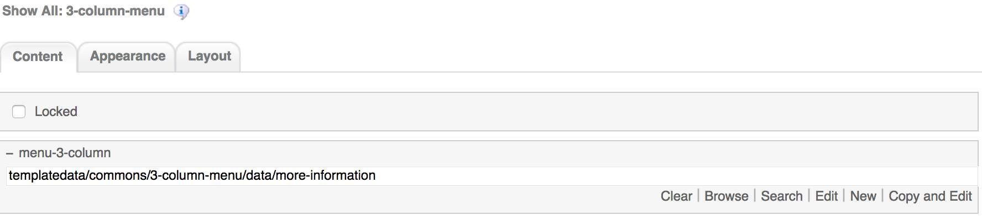

1. Apply Now Fixed Bottom

  
Product Landing specific component. This component has no DCR and its customization is done through the component properties

The Apply Now Fixed Bottom component default setting should have the following values in content  
  
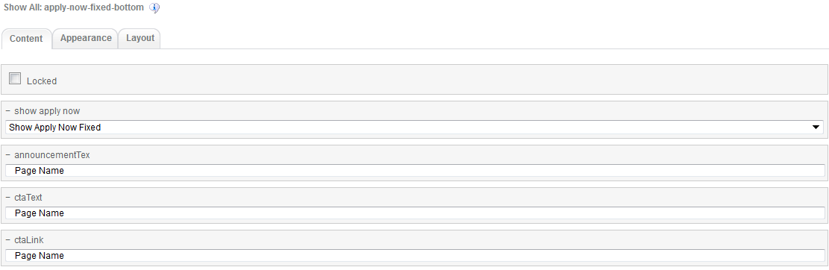

1. Footer component



Global component controlled by DCR. Links and Copyright text can be customized

Footer component’s default setting should have the following values in Content:

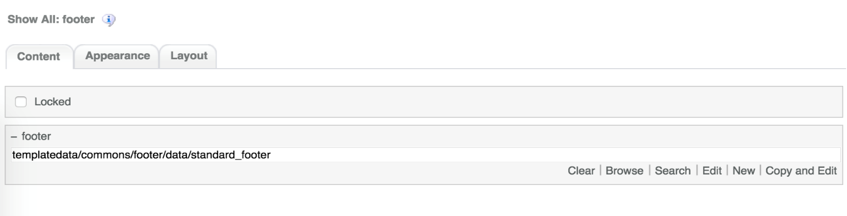

# Product Landing Common DCR Break-up

In this section, a brief explanation of Product Landing common DCR will be made. Please refer to User_Guide-Home_page on how to navigate and select edit DCR’s

## Header

Please refer to User_Guide-Home_page “Homepage Common DCR Break-up” for information on Header component

## Navigation

Please refer to User_Guide-Home_page “Homepage Common DCR Break-up” for information on Navigation component

## Breadcrumb

The breadcrumb component is no DCR component customizable through its component properties. On how to access a component properties please refer to Components, Templates and Pages section on User_Guide-Home_page.

The breadcrumb component has the following items

1. pageName  
   Text field where for page name input. If the pageName field is left blank then it will take the page name from the respective sitemap node  
   
2. displayHomeLink  
   Select Yes if the HomePage link has to be displayed at the beginning of the breadcrumb. Select No if HomePage not required to be displayed.  
   
3. Home Link Label  
   Text field where user can set a Label for the HomePage link, which will be the first link in the breadcrumb.  
   
4. Home Link Target  
   Drop Down menu for selecting the target frame when the home Link is clicked.  
   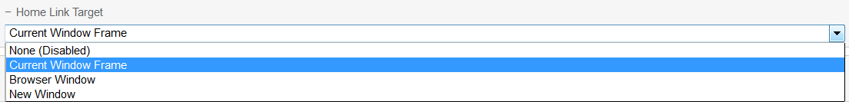
5. UserUrlAliases  
   If URL Aliases is present in SiteMap for this Node. User can select Yes to use the aliases or No for the default link.   
   

The Breadcrumb component has to be setup on the template but it will only show once the page is created and the node is added to Site Map. **Even in preview mode the breadcrumb component will not display anything on template, it will only display on page Edit or Preview mode.**

## Carousel

The DCT to create the Product Landing Carousel DCT is located on *templatedata/commonst/carousel/* under the name datacapture.cfg and can be located using Team Site CCProfessional user interface. This DCT can create DCR’s for both Product Details and Product Landing. For specific refer to Functional Specifications Document.

The Product Details carousel DCT has the following items

1. Banner Details Container

Under the Banner Details container, user can create up to 5 banners each one with the following fields

* 1. Banner Name  
     Text field  
       
     
  2. Banner Image  
     Browse field where user can select the desired image by clicking on the Browse button  
     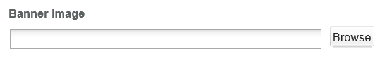
  3. Image Alt Text  
     Text field  
     
  4. Select Image Position  
     Drop Down menu to select the image position on the banner. This is a required field  
     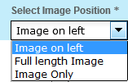
  5. Select Image Style  
     Drop Down menu to select the image style. Default is bright  
     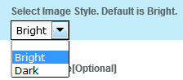
  6. Mobile Image  
     Browse field where user can select the desired image by clicking on the Browse button  
     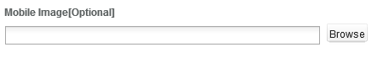
  7. Background Color  
     Text field. Color can be input by its name or by its Hexadecimal reference  
     
  8. Background Image  
     Browse field where user can select the desired image by clicking on the Browse button  
       
     
  9. Banner Text  
     Text field

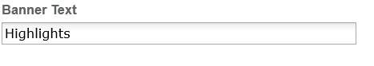

* 1. Banner Description  
     Text area field that uses TinyMCE for free formatting

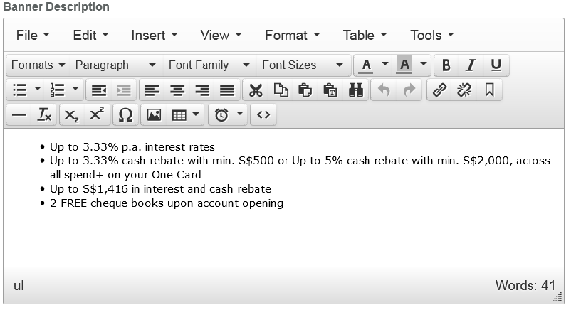

* 1. Activation Date  
     Text field with option to select activation date from custom JavaScript calendar by clicking on the Select Date button. This is a required field  
       
     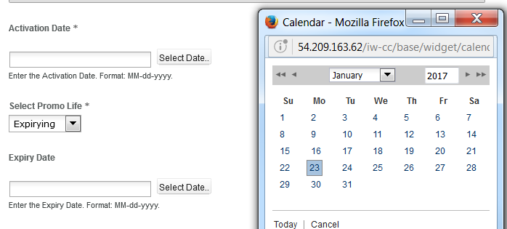
  2. Select Promo Life  
     Drop Down menu to select the promotion life type. This is a required field  
     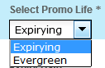
  3. Expiry Date  
     Text field with option to select expiry date from custom JavaScript calendar by clicking on the Select Date button. This is a required field  
       
     
  4. CTA Button Text  
     Text field

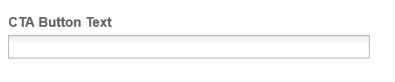

* 1. CTA Link  
     Browse field to select CTA link  
     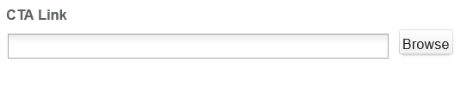
  2. Link Opening Option  
     Drop Down field to select the opening of the CTA Link  
     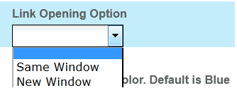
  3. Select CTA button color  
     Drop Down field to select the color of the CTA button. Default is blue  
       
     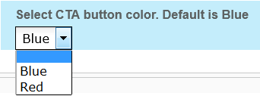

## 3-column-image

The DCT to create the Product Landing 3-column-image DCR is located on *templatedata/commons/3-column-image/* under the name datacapture.cfg and can be located using Team Site CCProfessional user interface.

The Product Landing 3-column-image DCT has the following items

1. Main container

Under the main container, user can create the title and sub title. Inside the main container another 3 column container is created by default and this container has 3 column image tiles container. There can be any number of 3 column image containers

Main container fields are as follows

* 1. Section Title and Section Sub Title  
     Text field  
     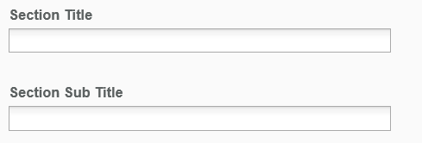

3 column image container has by default a 3 column image container with three 3 column image tile container inside it.  
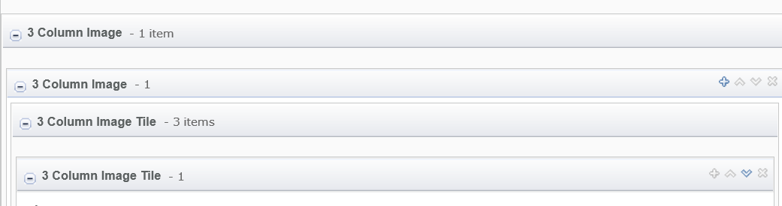

The 3 column image tile container has the following fields

1. Image   
   Browse field to select the desired image from the Browse button.  
   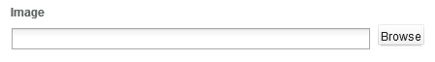
2. Image Alt Text, Content Title, Short Description, Target Link  
   Text field  
     
   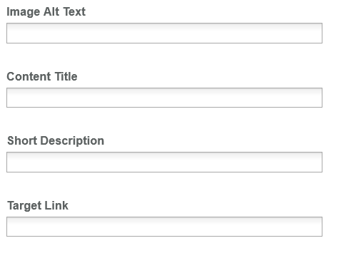
3. Link Opening Option  
   Drop Down field to select the opening of the Target Link  
   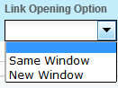

## 4-column-tiles

The DCT to create the Product Landing 4-column-tile DCR is located on *templatedata/commons/4-column-tiles/* under the name datacapture.cfg and can be located using Team Site CCProfessional user interface.

The Product Landing 4-column-tile DCT has the following items

1. Main container

Under the main container, user can create the title and sub title. Inside the main container another Tiled Display-4 column container is created by default and this container has Tiled details container. There can be any number of 4 Tiled Display-4 column container

Main container fields are as follows

* 1. Section Title and Section Sub Title  
     Text field  
     

Tiled Display-4 column container has by default a 4 tile details container inside it.  
  
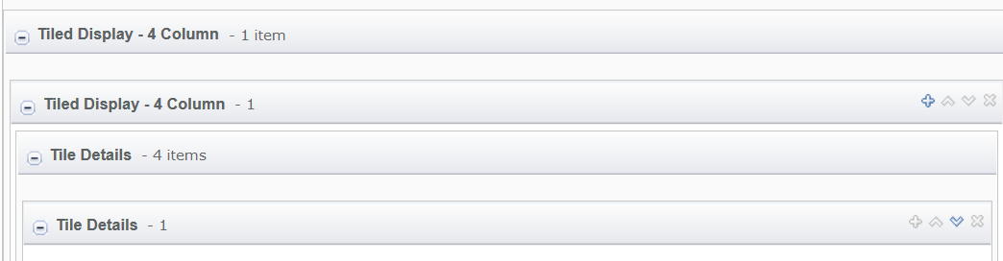

The Tile Details container has the following fields

1. Background  
   Drop Down field to select the background color  
   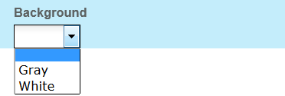
2. Title  
   Text field  
   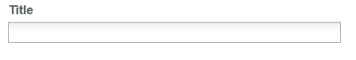
3. Image  
   Browse field where user can select the image by clicking on the Browse button  
   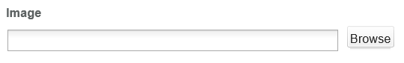
4. Image Alt Text  
   Text field  
   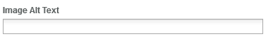
5. Summary  
   Text Area field  
   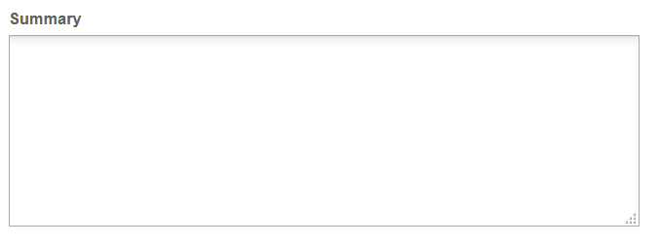
6. Tile Target Link  
   Text field  
   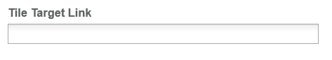
7. Link Opening Option  
   Drop Down field to select the opening of the CTA Link  
   

## 3-column-menu

The DCT to create the Product Landing 3-column-menu DCR is located on *templatedata/commonst/3-column-menu/* under the name datacapture.cfg and can be located using Team Site CCProfessional user interface.

The Product Landing 3-column-menu DCT has the following items

1. Main container

Under the main container, user can create the title and sub title. Inside the main container another 3 column container is created by default and this container has 3 column menu container. There can be any number of 3 column menu containers

Main container fields are as follows

* 1. Section Title and Section Sub Title  
     Text field  
     

3 column menu container has by default 3 Menu Details containers inside it.  
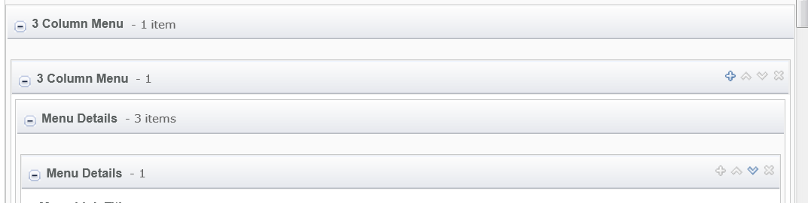

The Menu Details container has the following fields

* 1. Menu Link Title and Menu Link  
     Text field  
     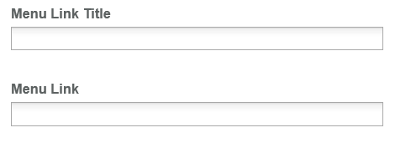
  2. Link Opening Option  
     Drop Down field to select the opening of the CTA Link  
     
  3. Menu Text  
     A text area field that uses TinyMCE for free formatting  
       
     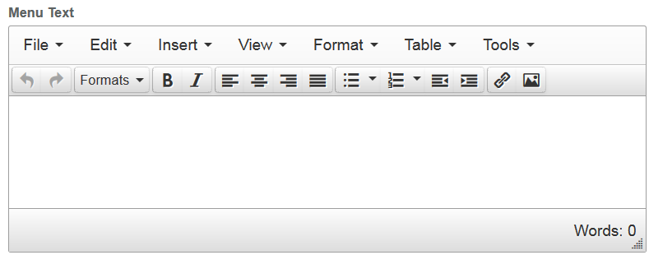

## Footer

Please refer to User_Guide-Home_page “Homepage Common DCR Break-up” for information on Footer component

# Product Landing specific DCR Break-up

In this section, a brief explanation of each Product Landing specific component DCR will be made. Please refer to User_Guide-Home_page on how to navigate and select edit DCR’s.

## Product Landing

The DCT to create the Product Landing product-landing DCT is located on *templatedata/product/landing/* under the name datacapture.cfg and can be located using Team Site CCProfessional user interface.

The Product Landing landing DCT has the following items

1. Tabbed Sections Container

Under the Tabbed Sections container, user can create up to 8 containers each one with the following fields

* 1. Section Titile  
     Text Field  
     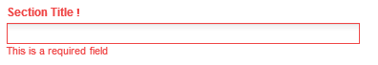
  2. Tab Link  
     Browse field to select the desired link to apply to tab  
     
  3. Tab Link Label  
     Text field that will appear on the tab  
     
  4. Tab Link Opening Option  
     Drop Down menu to select the opening of the Tab Link  
     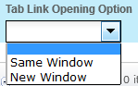

A Section elements container can also be created inside the Tabbed Sections Container. There can be up to 3 replicas of this container and inside this container a Tiled Display-3column container with another 3 default Tile Details Container is created  
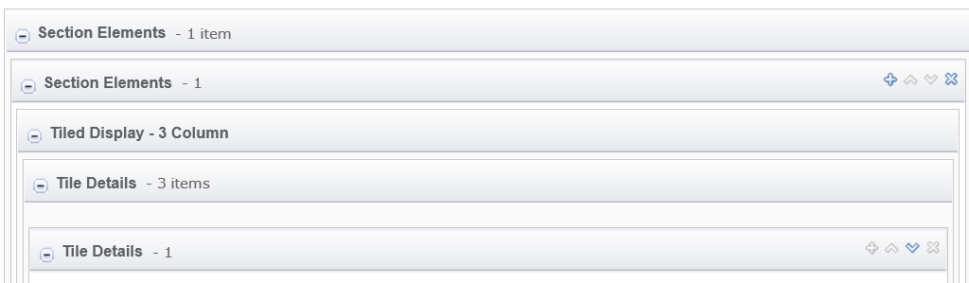

The Tile Details Container has the following fields

* 1. Background  
     Drop Down field to select the background color  
     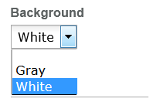

1. Title  
   Text field  
   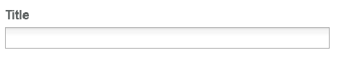
2. Image  
   Browse field where user can select the desired image by clicking on the Browse button  
   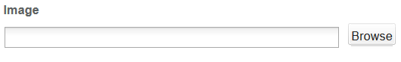
3. Summary  
   Text area field  
   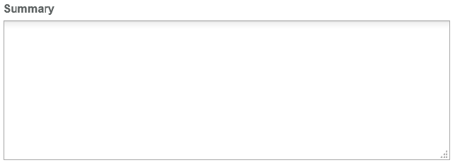
4. CTA Text and CTA Link  
   Text field  
   
5. CTA Link  
   Browse field to select the desired link  
   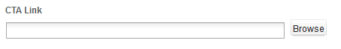
6. Link Opening Option  
   Drop Down field to select the opening CTA link option  
   

If the user wants for example show only 2 columns instead of the default 3, the user can leave the Title, Image, Summary, CTA Text, CTA Link fields blank for a given Tile Details container. By doing this that column will not be reflected on the component.

## Apply Now Fixed Bottom

The Apply Now Fixed Bottom component has no DCT associated to it. The component customization is done from the component properties (on how to access the component properties, refer the homepage user guide)

Under the component properties the following fields can be customized for this component

1. Show Apply now  
   Select whether to show the component or not  
     
   
2. annoucementText, ctaText and ctaLink  
   Text fields  
     
   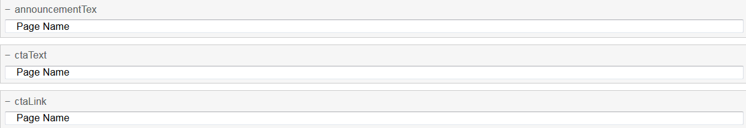

# Resources

This section provides a list of the necessary resources (CSS & JavaScript) to create a Product Landing template. On how to create a template please refer to the User_Guide-Home_Page.

## CSS Resources

The css resources for the Product Landing template are as follows

|  |  |
| --- | --- |
| **Devices to use with** | **Path** |
| Desktop, Tablet, Mobile | <wa-path>/iwov-resources/css/bootstrap.min.css |
| <wa-path>/iwov-resources/css/style.css |
| Desktop | <wa-path>/iwov-resources/css/desktop-style.css |
| Tablet | <wa-path>/iwov-resources/css/tablet-style.css |
| Mobile | <wa-path>/iwov-resources/css/mobile-style.css |
| Tablet | <wa-path>/iwov-resources/css/product-landing/product-landing-tablet-style.css |
| Desktop | <wa-path>/iwov-resources/css/product-landing/product-landing-desktop-style.css |
| Tablet | <wa-path>/iwov-resources/css/product-landing/product-landing-tablet-style.css |
| Mobile | <wa-path>/iwov-resources/css/product-landing/product-landing-mobile-style.css |
| Desktop, Tablet, Mobile | <wa-path>/ iwov-resources/css/product-landing/product-landing-style.css |

These resources must be entered on the same order as the previous table or the page style will break

## JavaScript Resources

The JavaScript resources for the Product Landing template are as follows

|  |  |
| --- | --- |
| **Devices to use with** | **Path** |
| Desktop, Tablet, Mobile | <wa-path>/iwov-resources/js/analytics.js |
| <wa-path>/iwov-resources/js/cookie_handler.js |
| <wa-path>/iwov-resources/js/initiator.js |
| <wa-path>/iwov-resources/js/libs/modernizr.min.js |
| <wa-path>/iwov-resources/js/libs/jquery.min.js |
| <wa-path>/iwov-resources/js/libs/bootstrap.min.js |
| <wa-path>/iwov-resources/js/libs/plugins.min.js |
| <wa-path>/iwov-resources/js/main.js |
| <wa-path>/wiov-resources/product-landing/product-landing-main.js |

These resources must be entered on the same order as the previous table or the page will break