

User Guide – Product Details

Product Details User guide

Opentext

138 Market Street

Level 33

Singapore 048946

[www.opentext.com](http://www.opentext.com)

OpenText Professional Services

January, 2017

Contents

1. Component Break-up 3

1.1. Component List 3

1.2. Page Structure 3

2. Product Details Common DCR Break-up 8

2.1. Header 8

2.2. Navigation 8

2.3. Breadcrumb 8

2.4. Carousel 8

2.5. 4-column-tiles 8

2.6. 3-column-menu 8

2.7. Footer 8

3. Product Details specific DCR Break-up 9

3.1. Product Details Main 9

3.2. Product Categories DCT 20

4. Resources 21

4.1. CSS Resources 21

4.2. JavaScript Resources 21

# Component Break-up

## Component List

The Product details is composed of the following components

1. Common Components
   1. Header
   2. Navigation
   3. Breadcrumb
   4. Carousel
   5. 4-column-tile
   6. 3-column-menu
   7. Footer
2. Product Details specific components
   1. Product Details Main

## Page Structure

The page structure (component order) and brief explanation as follows. For component’s detailed explanation refer to Functional Specifications Document.

1. Header Component



Global Component composed from UOB logo, “right by you” logo, section menu details, login button and add country section data items

The header component’s default setting should have the following values in Content and Appearance:

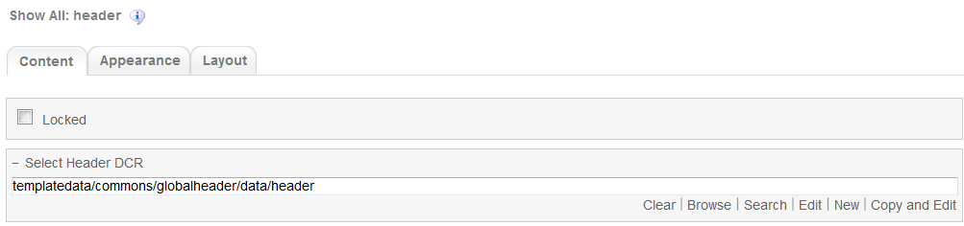

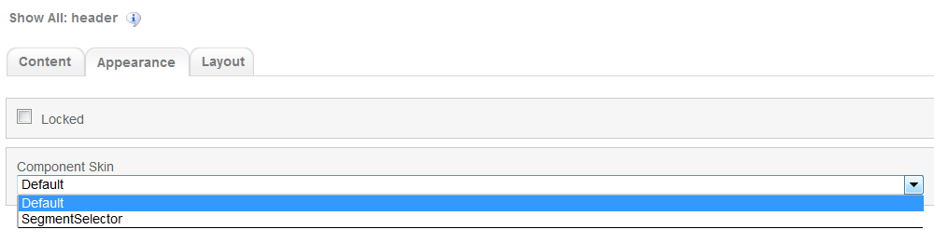

1. Navigation Component



Global component which uses TeamSite Site Map as the content source. Quick links information can be customized

Navigation Component’s default setting should have the following values in Content:

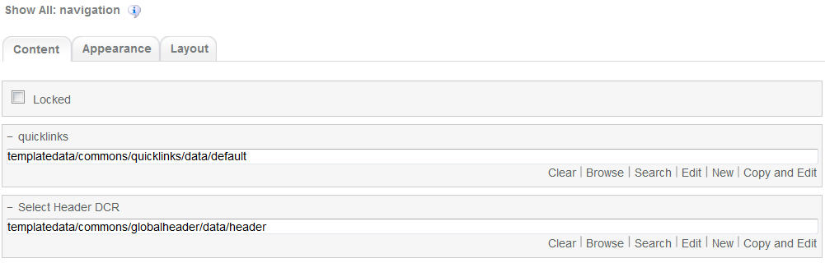

1. Breadcrumb Component



Global component to display the Home Link, Home Link Label and Home Link Target. Can be changed from component properties. If the pageName component properties is left blank then it will take the page name from the respective sitemap node

Breadcrumb component’s default setting should have the following values in Content  
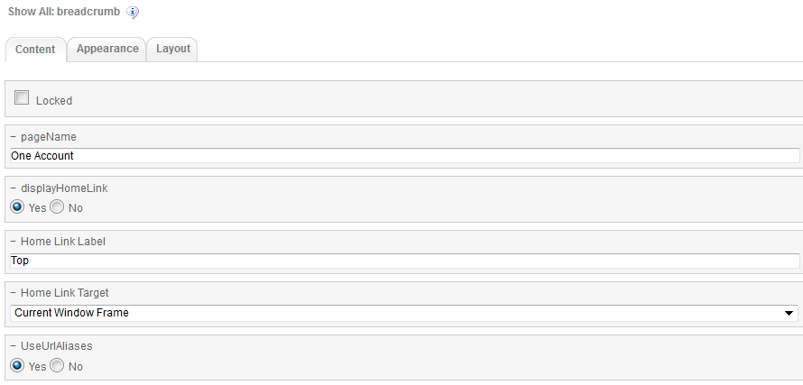

1. Carousel component

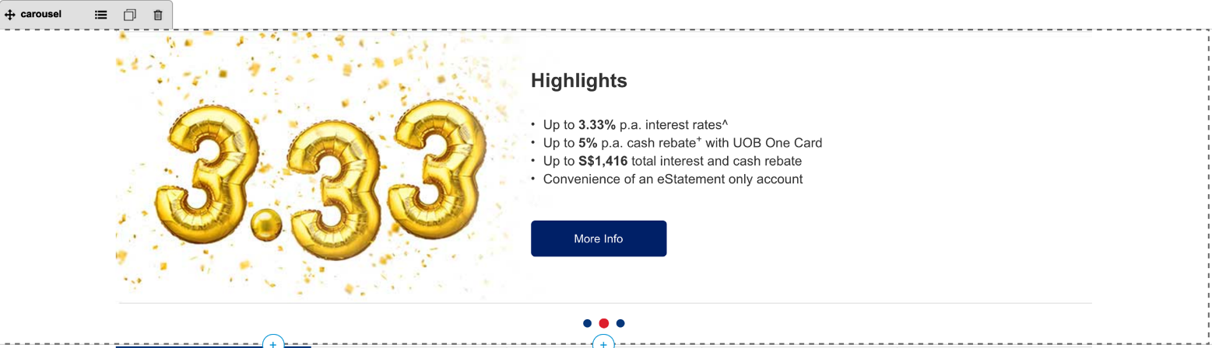

Global component to display banners. Carousel DCR can be changed from component properties and DCR can be customized.

Carousel component’s default setting should have the following values in Content:  
  
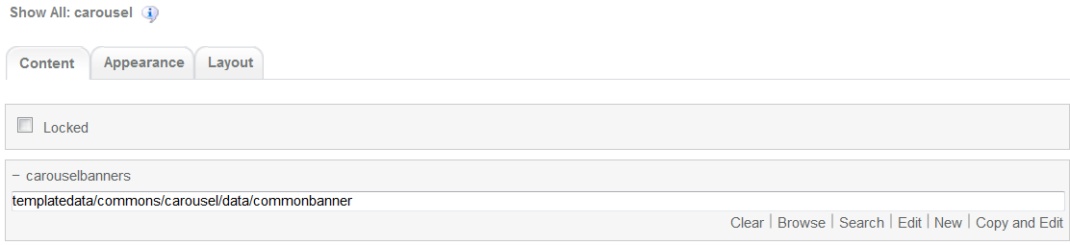

1. Product Details Main Component  
   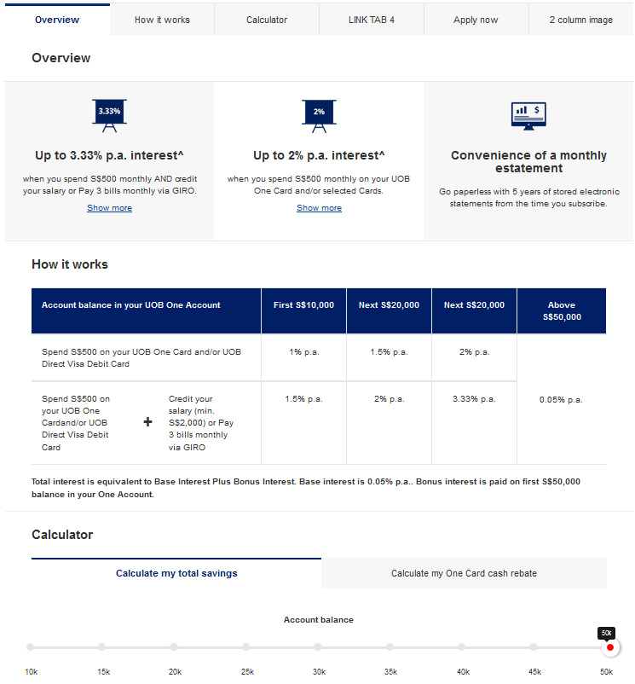

Product Details main component. DCR is composed of Tabbed feature and Non-Tabbed features. Can be customized

Product Details main component’s default setting should have the following values in Content:

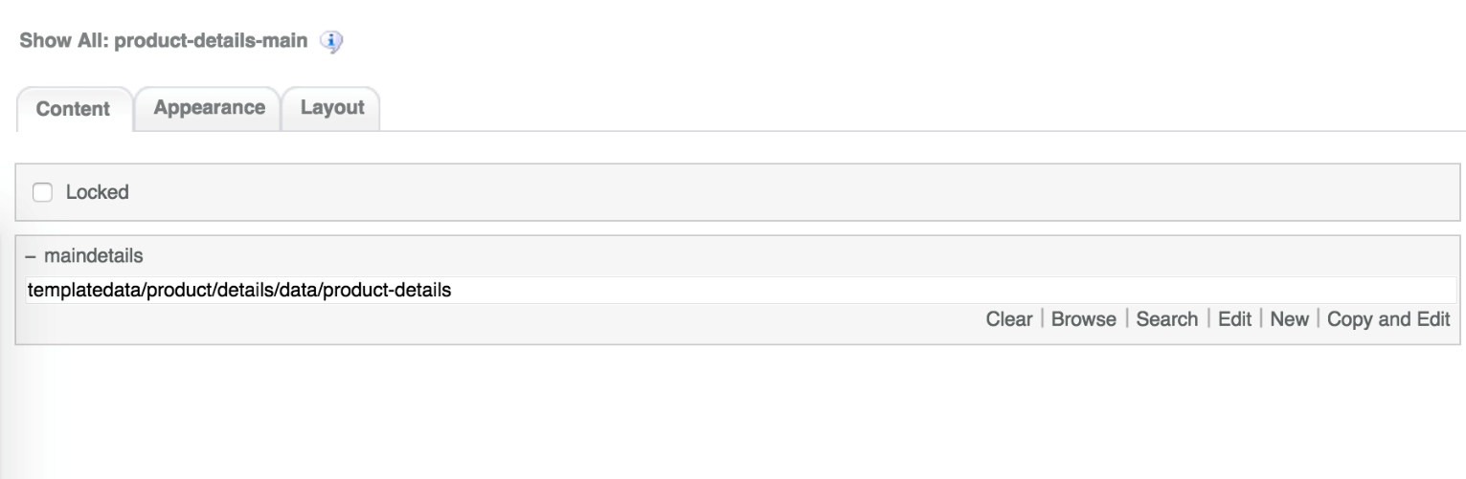

1. 4-column-tile component  
   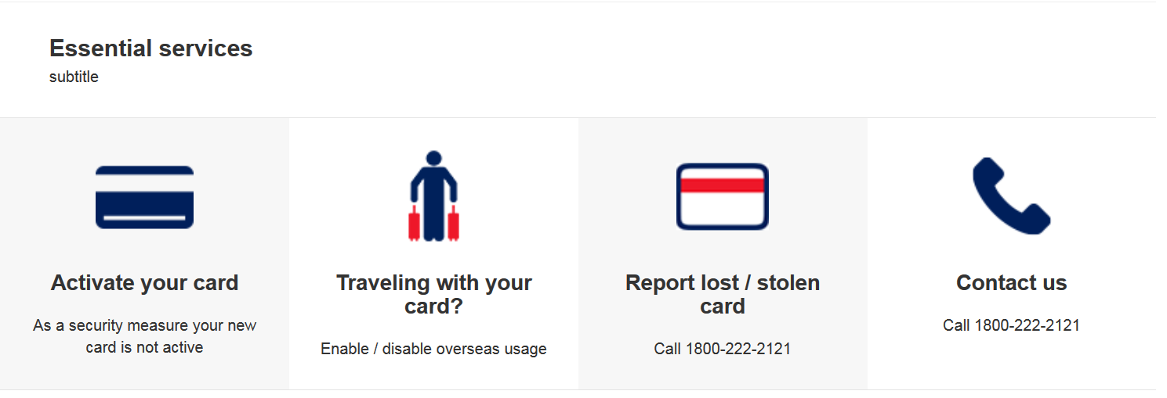

Common component controlled by DCR. Images, tile details, background, links and other resources can be customized

4-coloumn-tile component default setting should have the following values in content

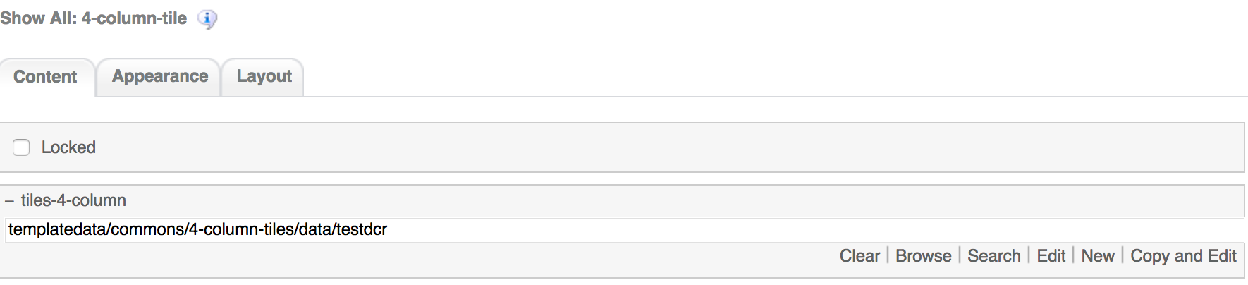

1. 3-column-menu component

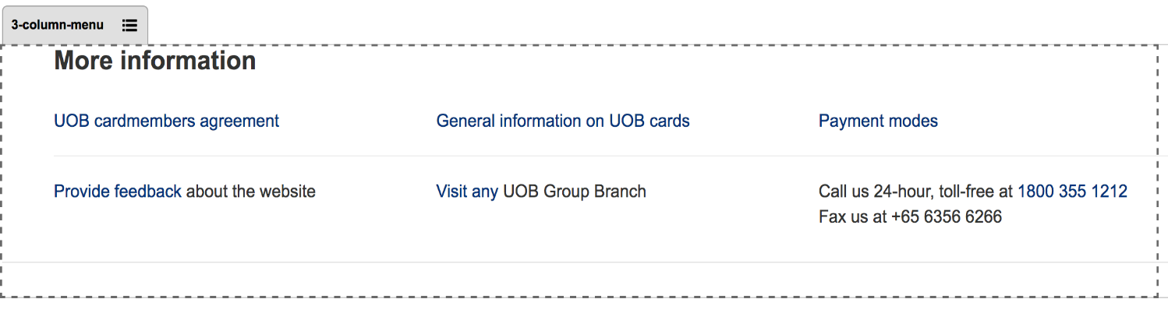

Common component controlled by DCR. Title, links, free formatting text can be customized

3-coloumn-menu component default setting should have the following values in content

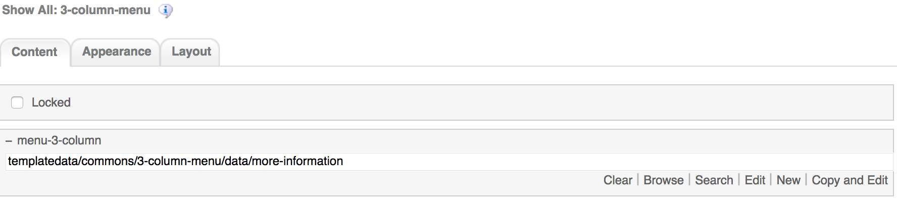

1. Footer component



Global component controlled by DCR. Links and Copyright text can be customized

Footer component’s default setting should have the following values in Content:

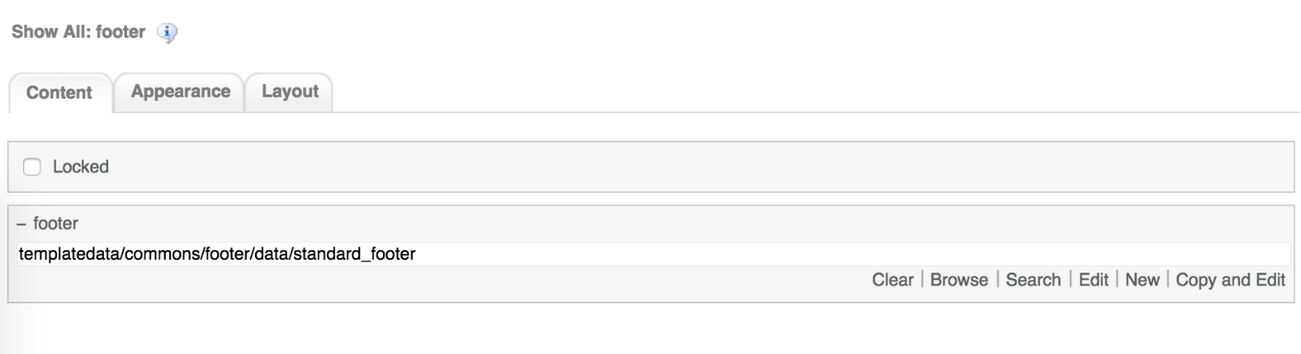

# Product Details Common DCR Break-up

In this section, a brief explanation of the Product Details common DCR will be made. Please refer to User_Guide-Home_page on how to navigate, select and edit DCR’s.

## Header

Please refer to User_Guide-Home_page “Homepage Common DCR Break-up” for information on Header

## Navigation

Please refer to User_Guide-Home_page “Homepage Common DCR Break-up” for information on Navigation component

## Breadcrumb

Please refer to User_Guide-Product_Landing “Product Landing Common DCR Break-up” for information on Breadcrumb component

## Carousel

Please refer to User_Guide-Product_Landing “Product Landing Common DCR Break-up” for information on Carousel component information

## 4-column-tiles

Please refer to User_Guide-Product_Landing “Product Landing Common DCR Break-up” for information on 4-column-tiles component information

## 3-column-menu

Please refer to User_Guide-Product_Landing “Product Landing Common DCR Break-up” for information on 3-column-menu component information

## Footer

Please refer to User_Guide-Home_page “Homepage Common DCR Break-up” for information on Footer component

# Product Details specific DCR Break-up

In this section, a brief explanation of each Product Details specific component DCR will be made. Please refer to User_Guide-Home_page on how to navigate and select edit DCR’s.

## Product Details Main

The DCT to create the Main Details

DCR is located on *templatedata/product/details/* under the name datacapture.cfg and can be located using Team Site CCProfessional user interface. For specific refer to Functional Specifications Document.

The Main Details DCR has the following items

1. Service Type Name

Select dropdown item for available Sites in the Workarea. This is a required field.



1. Product Category  
   Drop Down menu to select the product category  
   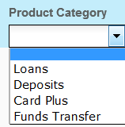
2. Product Name  
   Drop Down menu to select the product name related to the category selected  
   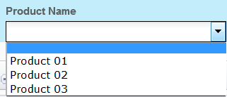

The fields that appear on the Product Category and Product Name are read from another DCR under /templatedata/product/categories/data. For explanation on this DCT, please refer to Product Categories DCT section

The Product Category and Product Name selected fields are used for analytics tagging when user is in a product details page. These get injected into the page header as metadata.

1. Tabbed Features Container

Under the Tabbed Features container, user can create up to 8 containers each one with the following fields

* 1. Feature Title  
     Required text field

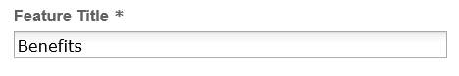

**The name of the corresponding Tabbed Features container will change to the string on the Feature Title for easy referencing purposes.**

* 1. Tab Link  
     Browse field to select the desired link by clicking on the Browse button. This will make the corresponding tab clickable and the content of this tab will not be shown on the page  
     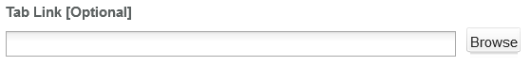
  2. Tab Link Label  
     Text field. This field will overwrite the Feature title value on the page if link selected  
       
     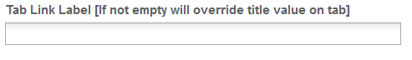
  3. Link Opening Option  
     Drop Down menu to select the Link opening  
     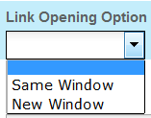
  4. Section Subtitle  
     Text field  
       
     

A Tabbed Feature Element container can also be created inside the Tabbed Features container with the option to choose between Free Text 1 column, Tiled Display -2 column, Tiled Display – 3 column, Tiled Display – 4 column, 1 Column Image + Text, 2 Column Image, 3 Column Image, Apply Now, Accordion, 3 Column Menu, Static Banner, Promotion 2 Column, Promotion 3 Column, Text -2 Column, FreeForm, Table or FreeText 2 Column. The Tabbed Feature Elements can have up to 3 replicas

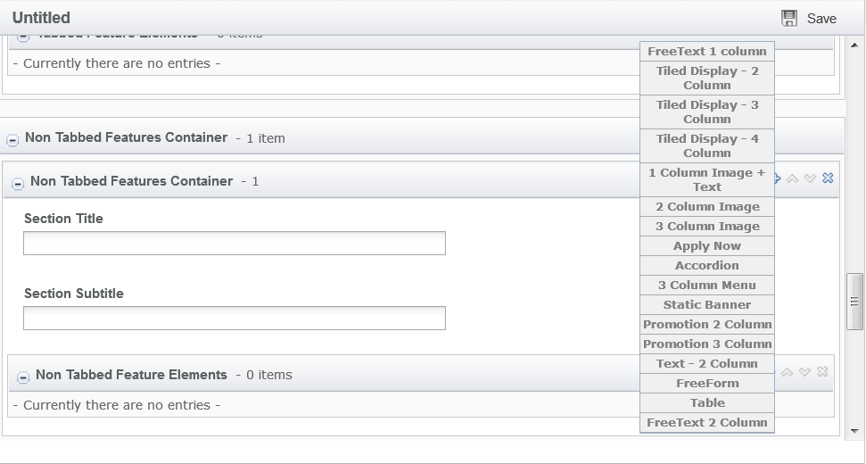

The items for each element are as follows

1. Free Text 1 Column
   1. Description  
      A text area field that uses TinyMCE for free formatting. This is a required field

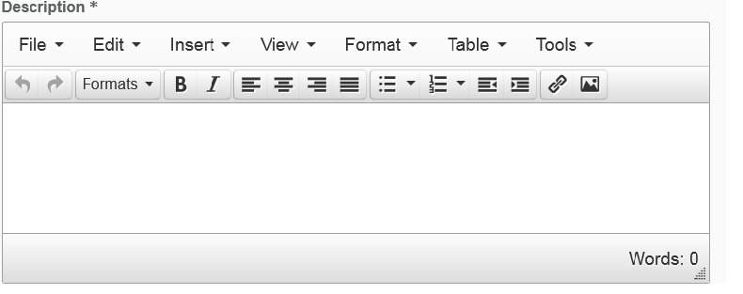

1. Tiled Display – 2 Column
   1. Background  
      Drop down menu to choose the background color  
      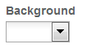
   2. Title  
      Text field

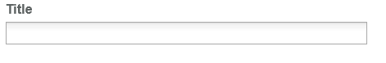

* 1. Image

Browse field where use can select the desired image by clicking on the Browse button

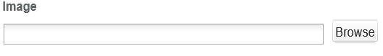

* 1. Image Alt Text  
     Text field  
     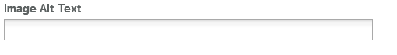
  2. Summary

Text area field

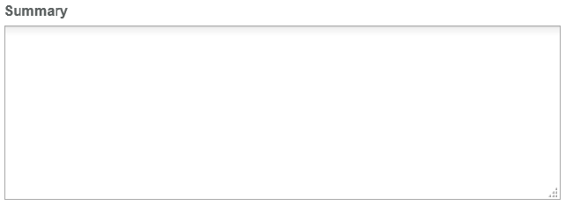

* 1. Description  
     A text area field that uses TinyMCE for free formatting

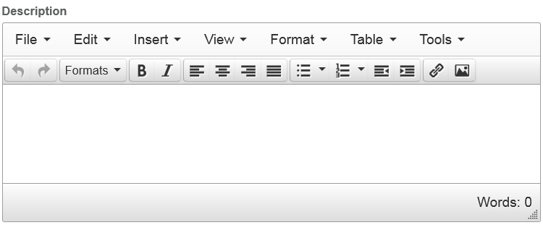

* 1. CTA Label and CTA Link  
     Text field  
     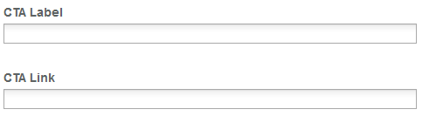
  2. Link Opening Option  
     Drop down menu to select link opening option (Same window or New window)  
     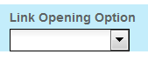

1. Tiled Display – 3 Column

Same fields as Tiled Display – 2 Column

1. Tiled Display – 4 Column
   1. Background  
      Drop down menu to choose the background color  
      
   2. Title  
      Text field



* 1. Image

Browse field where use can select the desired image by clicking on the Browse button



* 1. Summary

Text area field



* 1. CTA Label and CTA Link  
     Text field  
     
  2. Link Opening Option  
     Drop down menu to select link opening option (Same window or New window)  
     

1. 1 Column Image + Text
   1. Image  
      Browse field. This is a required field  
      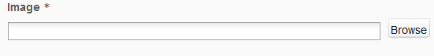
   2. Image Alt Text  
      Text field. This is a required field  
      
   3. Image for Mobile  
      Browse field to select mobile images  
      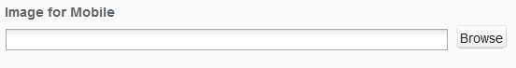
   4. Content Headline  
      Text field  
      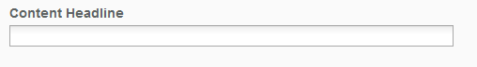
   5. Content Body  
      A text area field that uses TinyMCE for free formatting  
      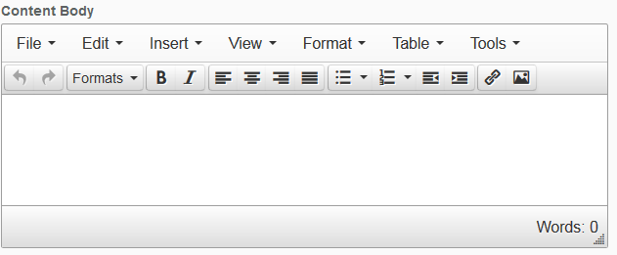
   6. Border Option  
      Drop Down menu to select the border type  
      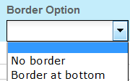
2. 2 Column Image Tile
   1. Image  
      Browse field to select the corresponding image  
      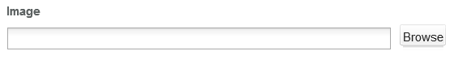
   2. Image Alt Text, Content Title, Short Description, Target Link  
      Text area fields  
      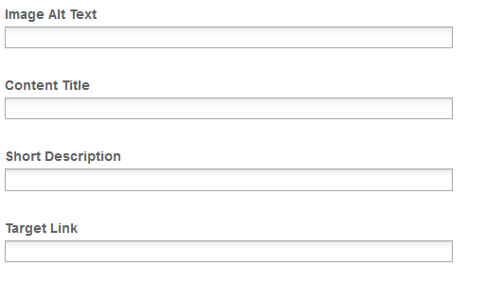
   3. Link Opening Option  
      Drop down menu to select link opening option (Same window or New window)  
      
3. 3 Column Image Tile  
   Same fields as 2 Column Image tile
4. Apply Now
   1. Title (Content Column container up to 2 replicas)  
      Text field  
      
   2. Title (Content Item container up to 2 replicas)  
      Text field  
      
   3. Image  
      Browse field to select the corresponding Image  
      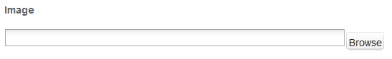
   4. Image Alt Text  
      Text field  
      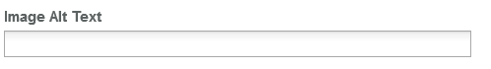
   5. Description  
      A text area field that uses TinyMCE for free formatting



* 1. Button Title  
     Text field  
     
  2. Button Type  
     Drop Down menu to select button based on customer type  
     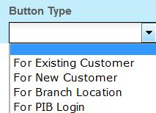
  3. Button Link  
     Text field  
     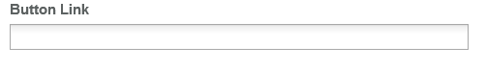
  4. Link Opening Option  
     Drop Down menu  
     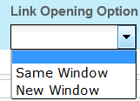

1. Accordion
   1. Title  
      Text field  
      
   2. Description  
      A text area field that uses TinyMCE for free formatting



1. 3 Column Menu

Creates 3 Menu Details containers with the following fields

* 1. Menu Link Title

A text field



* 1. Menu Link

A text field

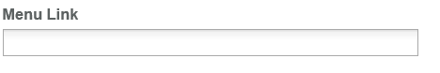

* 1. Link Opening Option  
     Drop down menu to select link opening option (Same window or New window)  
     
  2. Menu text

A text area field that uses TinyMCE for free formatting

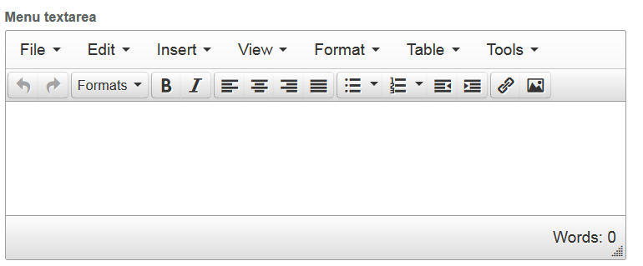

1. Static Banner
   1. Banner Image  
      A browse field to select the desired image. This is a required field  
      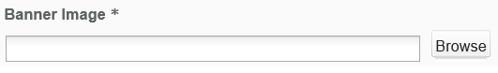
   2. Banner Image Alt Text

A text field

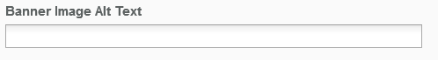

* 1. Banner Headline Text  
     A text area field

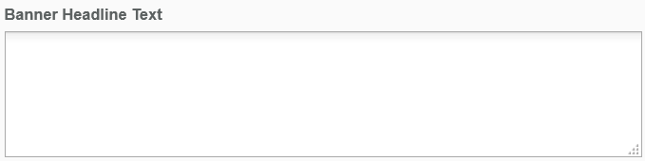

* 1. Banner Sub heading Text  
     A text area field

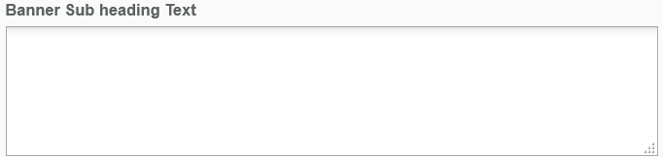

* 1. CTA Label & CTA Link

A text field

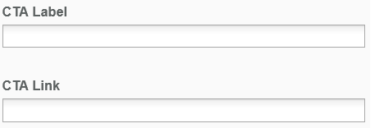

* 1. Link Opening Option  
     Drop down menu to select link opening option (Same window or New window)  
     

1. Promotion 2 Column and Promotion 3 Column
   1. Image  
      Browse field to select the corresponding image. This is a required field  
      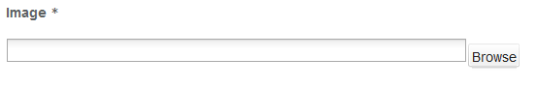
   2. Image Alt Text  
      Text field  
      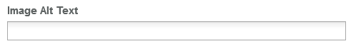
   3. Image for Mobile  
      Browse field to select the corresponding image. This is a required field  
      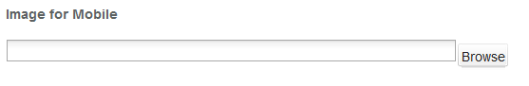
   4. Promotion Headline and Promotion Content  
      Text area that uses TinyMCE for free formatting  
      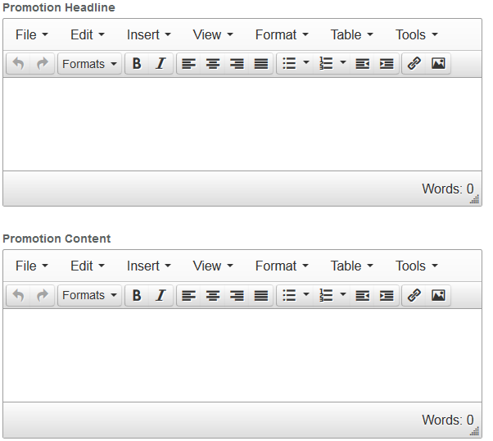
2. Text 2 Column
   1. Text Left and Text Right  
      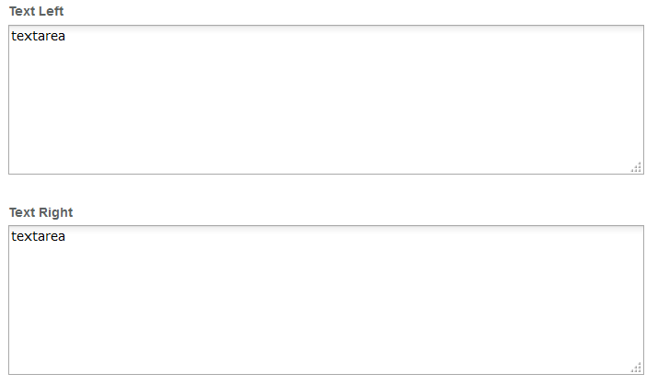
3. FreeForm  
   A text area that uses TinyMCE for free formatting. This is a required field  
   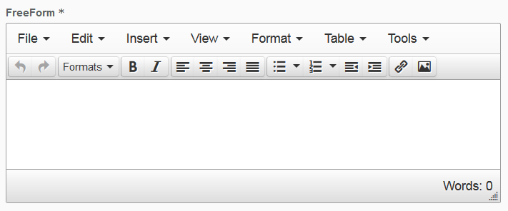
4. Table  
   A text area that uses TinyMCE for free formatting. This is a required field  
     
   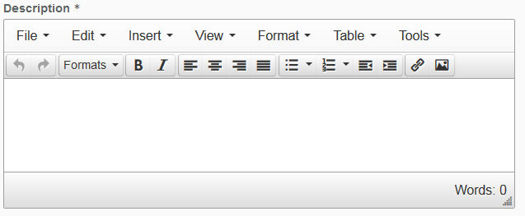
5. Free Text 2 Columns
   1. Heading  
      Text field  
      
   2. FreeForm  
      A text area that uses TinyMCE for free formatting. This is a required field  
      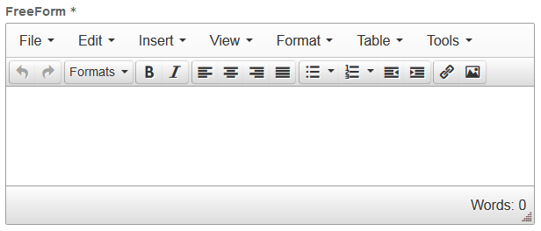
6. Non Tabbed Features Container

Under the Non Tabbed Features container, user can create up to 20 containers each one with the following fields

* 1. Section Title  
     A text field

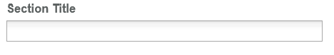

* 1. Section Subtitle  
     A text field

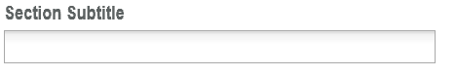

A Non Tabbed Feature Element container can also be created inside the Non Tabbed Features container with the option to choose the same containers as Tabbed Features. The Non Tabbed Features Container can have up to 3 replicas

1. Apply Now Sticky  
   The apply now container contains the following items
   1. Content Message  
      A text area field  
      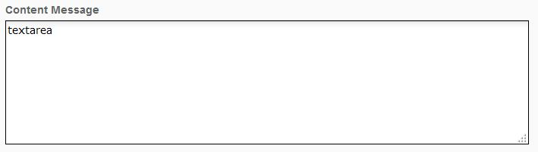
   2. CTA Label and CTA Link  
      Text fields  
      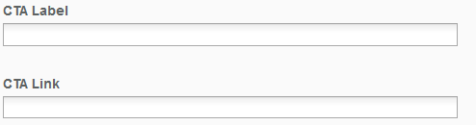
   3. Link Opening Option  
      Drop down menu to select link opening option (Same window or New window)  
      

## Product Categories DCT

The product categories DCT can be found in */templatedata/product/categories/* under the name of datacapture.cfg. The DCR resulting from editing the DCT is referenced by the product details DCR “Products Category” and “Products Name” explained on the section before.

The Product categories DCT has the following items

1. Service Type Name

Select dropdown item for available Sites in the Workarea. This is a required field.



1. Product Categories Container  
   The product categories container can have up to 50 replicas with the following fields
   1. Product Category Name  
      Text field. This is a required field  
      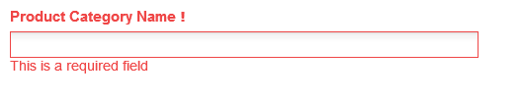
   2. Within the Product Category Name there is another container named Product Details. The product details container can have up to 100 replicas with the following fields
      1. Product Name  
         Text field  
         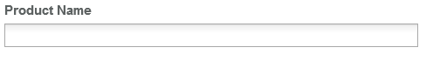

The entered value on the Product category name will be reflected on the Product Category Drop Down menu from the Product Details Main DCT. Product Name values will be reflected on the Product Name Drop Down menu of Product Details Main DCT as well.

# Resources

This section provides a list of the necessary resources (CSS & JavaScript) to create a Product Detail template. On how to create a template please refer to the User_Guide-Home_Page.

## CSS Resources

The css resources for the Product Detail template are as follows

|  |  |
| --- | --- |
| **Devices to use with** | **Path** |
| Desktop, Tablet, Mobile | <wa-path>/iwov-resources/css/bootstrap.min.css |
| <wa-path>/iwov-resources/css/style.css |
| Desktop | <wa-path>/iwov-resources/css/desktop-style.css |
| Tablet | <wa-path>/iwov-resources/css/tablet-style.css |
| Mobile | <wa-path>/iwov-resources/css/mobile-style.css |
| Desktop, Tablet, Mobile | <wa-path>/iwov-resources/css/product-card-detail/product-card-detail-style.css |
| Desktop | <wa-path>/iwov-resources/css/product-detail/product-card-detail/product-card-detail-desktop-style.css |
| Tablet | <wa-path>/iwov-resources/css/product-detail/product-card-detail/product-card-detail-tablet-style.css |
| Mobile | <wa-path>/iwov-resources/css/product-detail/product-card-detail/product-card-detail-mobile-style.css |

These resources must be entered on the same order as the previous table or the page style will break

## JavaScript Resources

The JavaScript resources for the Product Detail template are as follows

|  |  |
| --- | --- |
| **Devices to use with** | **Path** |
| Desktop, Tablet, Mobile | <wa-path>/iwov-resources/js/analytics.js |
| <wa-path>/iwov-resources/js/cookie_handler.js |
| <wa-path>/iwov-resources/js/initiator.js |
| <wa-path>/iwov-resources/js/libs/jquery.min.js |
| <wa-path>/iwov-resources/js/libs/bootstrap.min.js |
| <wa-path>/iwov-resources/js/libs/plugins.min.js |
| <wa-path>/iwov-resources/js/main.js |
| <wa-path>/iwov-resources/js/product-card-detail/product-card-detail-main.js |
| <wa-path>/iwov-resources/js/libs/modernizr.min.js |

These resources must be entered on the same order as the previous table or the page swill break