

User Guide – Promotion Categories

Promotion Categories User guide

Opentext

138 Market Street

Level 33

Singapore 048946

[www.opentext.com](http://www.opentext.com)

OpenText Professional Services

December, 2016

Contents

1. Component Break-up 3

1.1. Component List 3

1.2. Page Structure 3

2. Promotion Categories Common DCR Break-up 8

3. Promotion Categories specific DCR Break-up 9

3.1. Promotion Categories 9

4. Resources 10

4.1. CSS Resources 10

4.2. JavaScript Resources 10

# Component Break-up

## Component List

The Promotion Categories is composed of the following components

1. Common Components
   1. Header
   2. Navigation
   3. Breadcrumb
   4. Carousel
   5. 4-column-tile
   6. 3-column-menu
   7. Footer
2. Promotion Categories specific components
   1. Promotion Categories

## Page Structure

The page structure (component order) and brief explanation as follows. For component’s detailed explanation refer to Functional Specifications Document.

1. Header Component



Global Component composed from UOB logo, “right by you” logo, section menu details, login button and add country section data items

The header component’s default setting should have the following values in Content and Appearance:

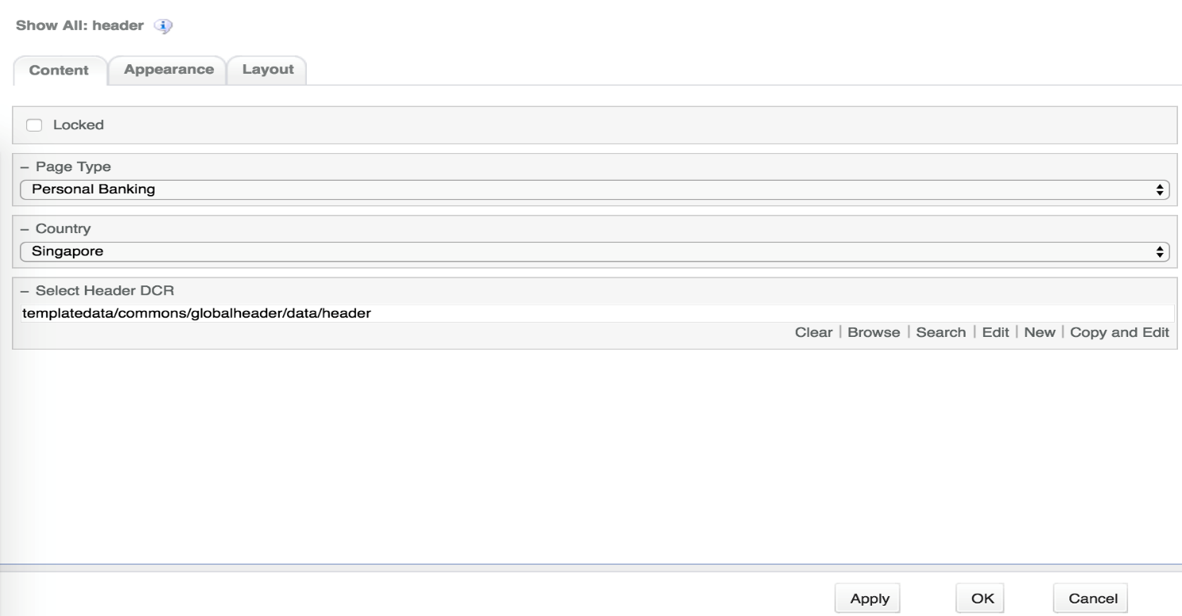

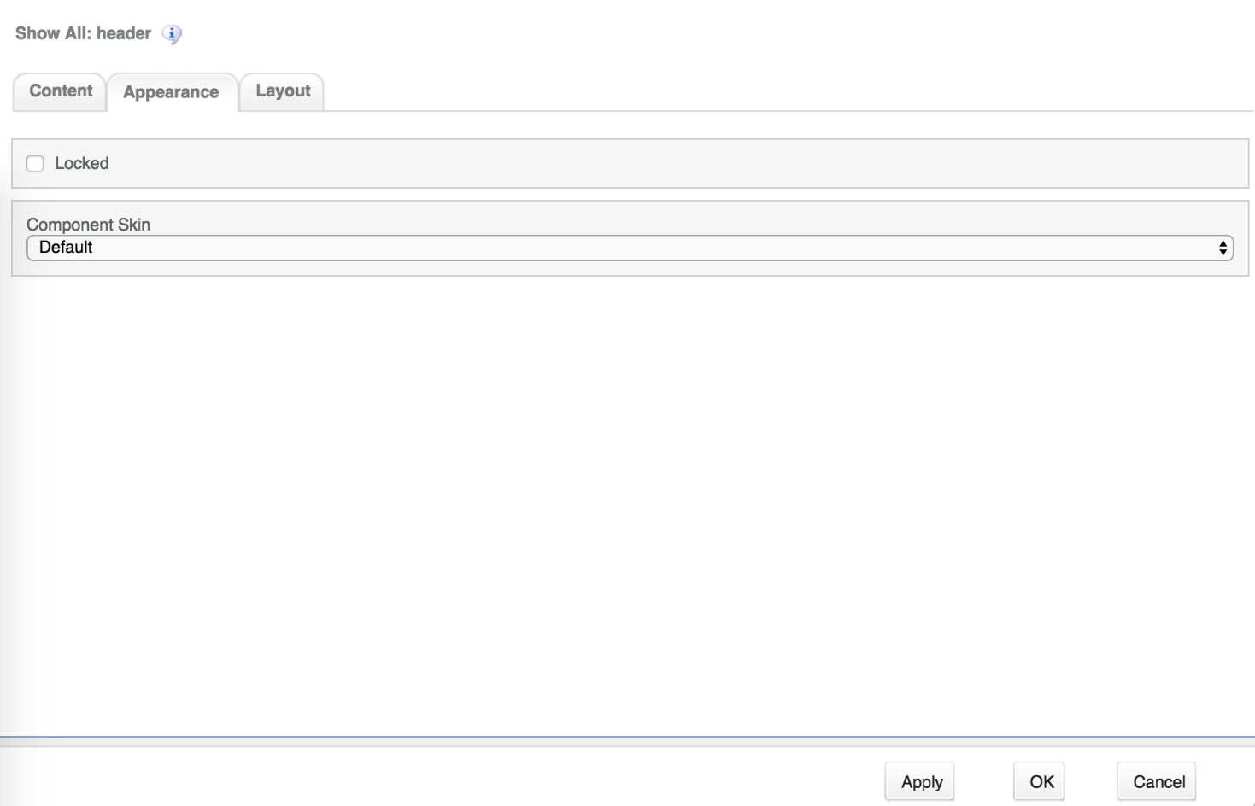

1. Navigation Component



Global component which uses TeamSite Site Map as the content source. Quick links information can be customized

Navigation Component’s default setting should have the following values in Content:

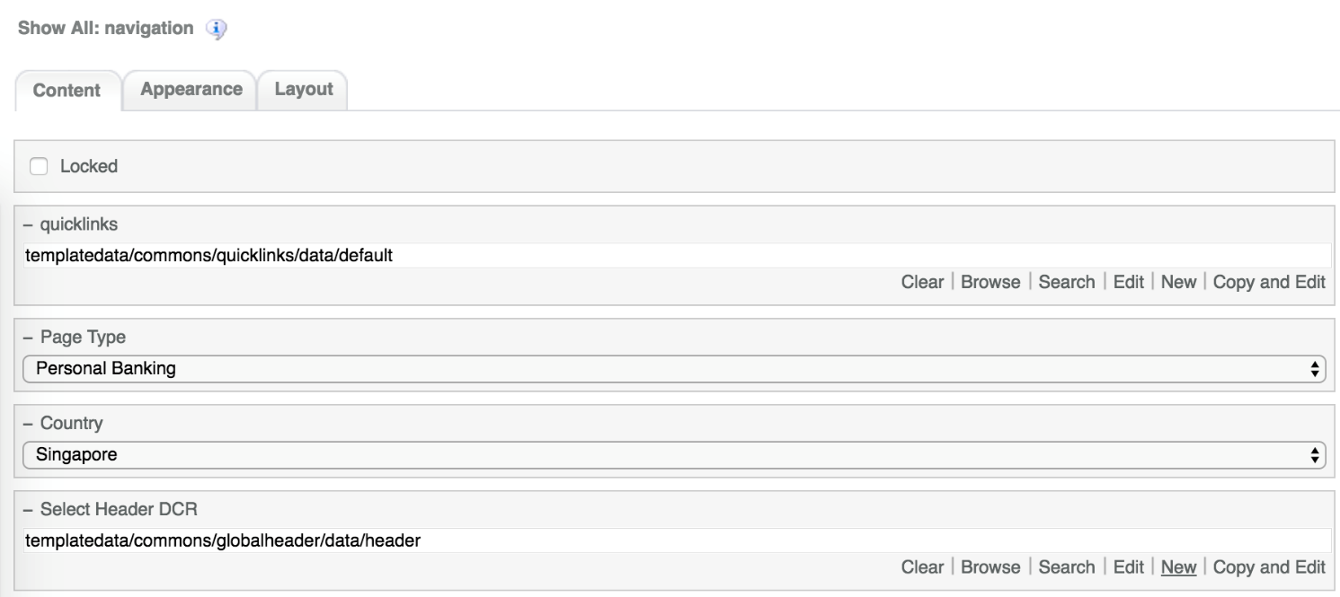

1. Breadcrumb Component



Global component to display the Home Link, Home Link Label and Home Link Target. Can be changed from component properties. If the pageName component properties is left blank then it will take the page name from the respective sitemap node

Breadcrumb Component’s default setting should have the following values in Content

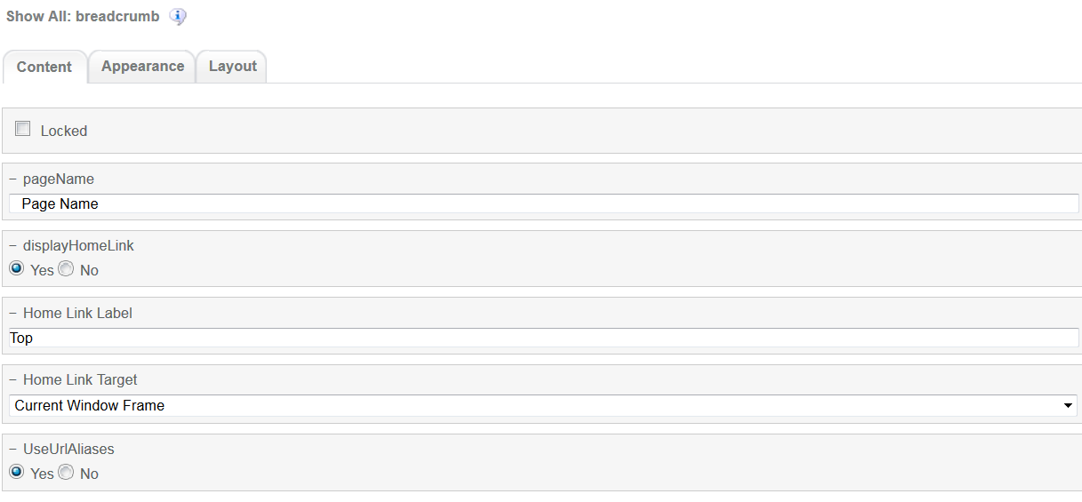

1. Carousel Component  
     
   

Global component to display banners. Banner DCR can be changed from component properties and DCR can be customized.

Carousel component’s default setting should have the following values in Content:

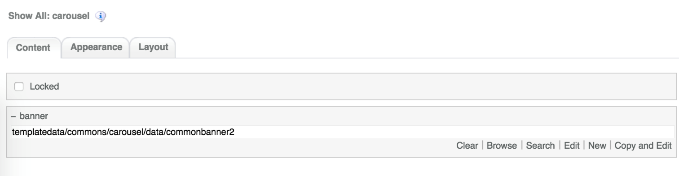

1. Promotion Categories

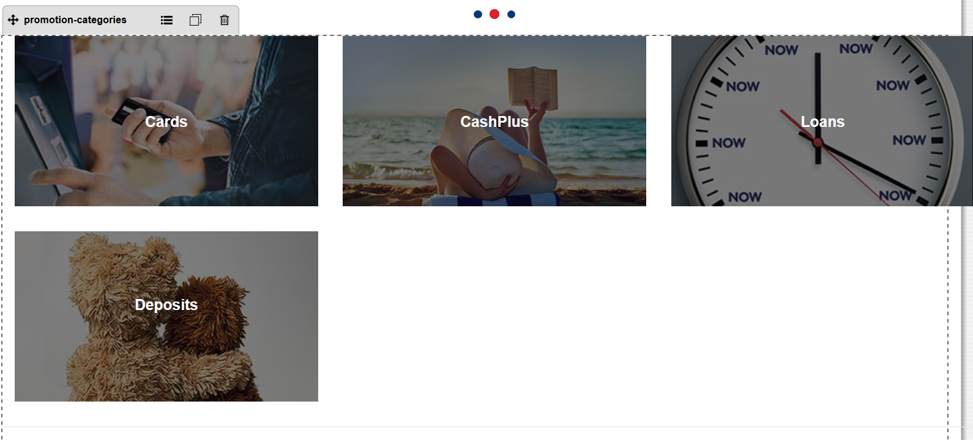

Promotion Categories main component. This component can be customize through DCR

Promotion Categories component’s default setting should have the following values in Content  
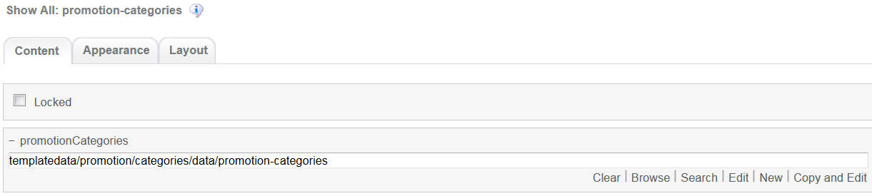

1. 4-column-tile

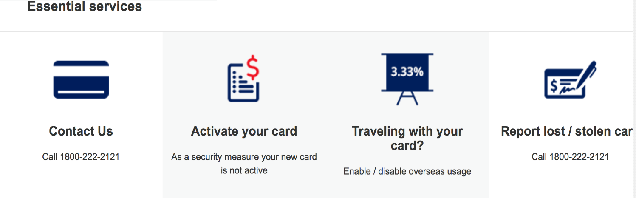

Common component controlled by DCR. Images, tile details, background, links and other resources can be customized

4-coloumn-tile component default setting should have the following values in content

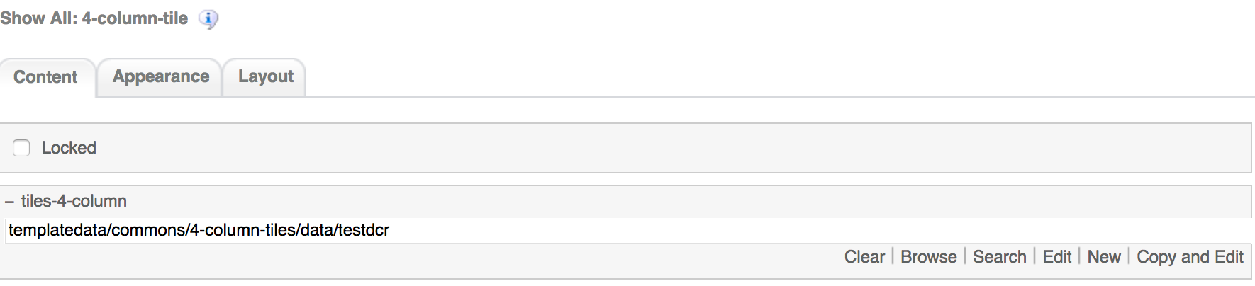

1. 3-column-menu component

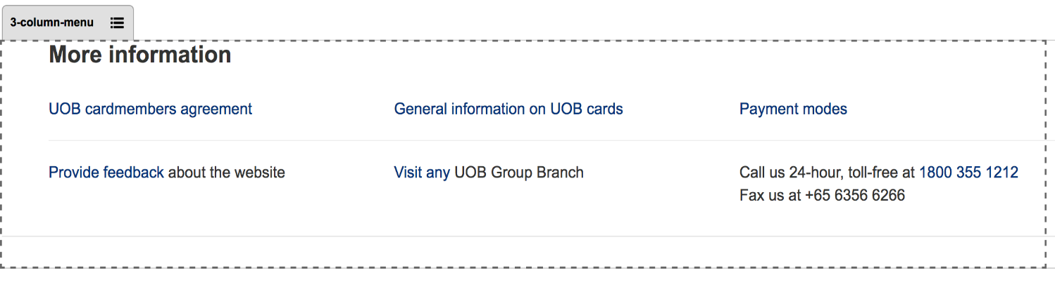

Common component controlled by DCR. Title, links, free formatting text can be customized

3-coloumn-menu component default setting should have the following values in content

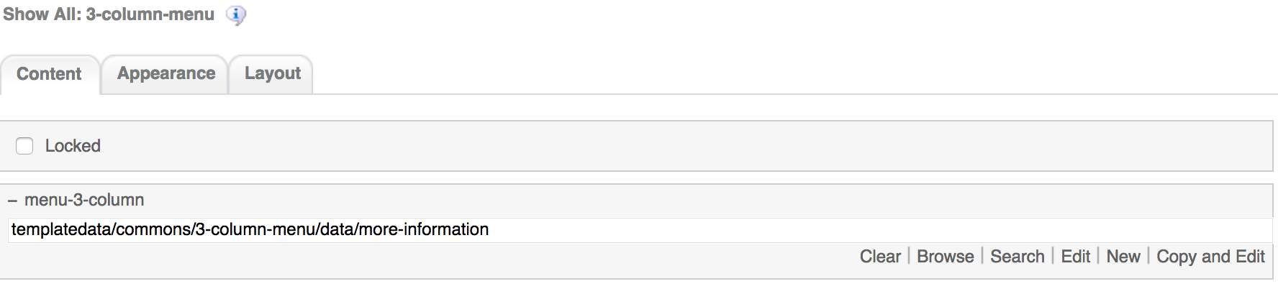

1. Footer component

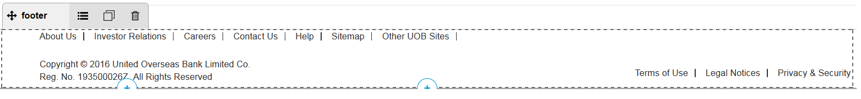

Global component controlled by DCR. Links and Copyright text can be customized

Footer component’s default setting should have the following values in Content:

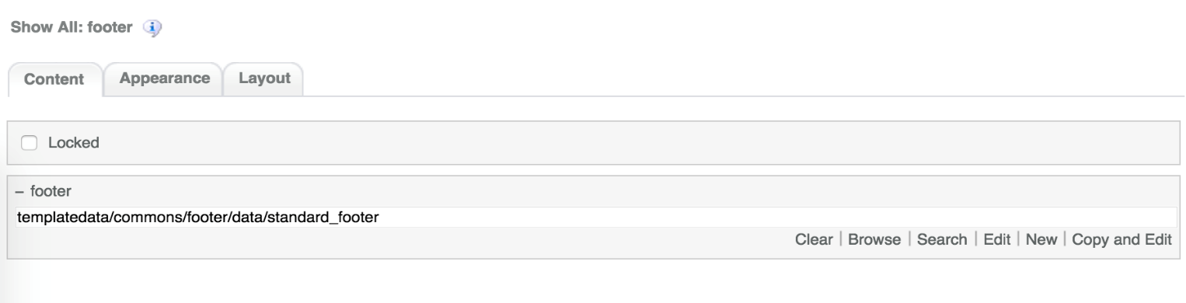

# Promotion Categories Common DCR Break-up

The common components used in Promotion Categories are the same as the ones used in Product Landing. For information on each common component please refer to User_Guide-Product_Landing user guide.

# Promotion Categories specific DCR Break-up

In this section, a brief explanation of each Promotion Categories specific component DCR will be made. Please refer to User_Guide-Home_page on how to navigate and select edit DCR’s.

## Promotion Categories

The DCT to create the Promotion Categories promotion-categories DCT is located on *templatedata/promotion/categories/* under the name datacapture.cfg and can be located using Team Site CCProfessional user interface.

The Promotion Categories DCT has the following items

1. Promotion Category Details container  
   The Promotion Category Details container can have until 15 replicas and has the following fields
   1. Product Category Name  
      Text field. This is a required field  
      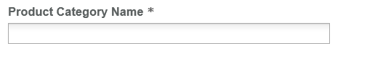
   2. Image  
      Browse field where the user can select the corresponding Image by clicking on the Browse button  
      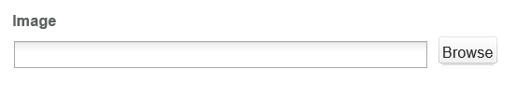
   3. Alt Text  
      Text field  
      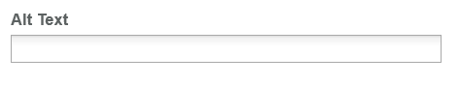
   4. Target Promotion Listing Page  
      Browse field where the user can select the corresponding page by clicking on the Browse button  
      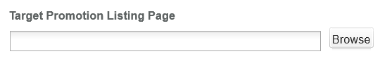
   5. Link Title  
      Text field  
      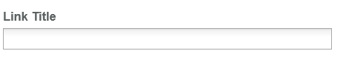

# Resources

This section provides a list of the necessary resources (CSS & JavaScript) to create a Promotion Categories template. On how to create a template please refer to the User_Guide-Home_Page.

## CSS Resources

The css resources for the Promotion Categories template are as follows

|  |  |
| --- | --- |
| **Devices to use with** | **Path** |
| Desktop, Tablet, Mobile | <wa-path>/iwov-resources/css/productlanding/bootstrap.min.css |
| <wa-path>/iwov-resources/css/promotion-landing/style.css |
| Desktop | <wa-path>/iwov-resources/css/promotion-landing/desktop-style.css |
| Tablet | <wa-path>/iwov-resources/css/promotion-landing/tablet-style.css |
| Mobile | <wa-path>/iwov-resources/css/promotion-landing/mobile-style.css |
| Desktop, Tablet, Mobile | <wa-path>/iwov-resources/css/style.css |
| Desktop | <wa-path>/iwov-resources/css/desktop-style.css |
| Tablet | <wa-path>/iwov-resources/css/tablet-style.css |
| Mobile | <wa-path>/iwov-resources/css/mobile-style.css |

These resources must be entered on the same order as the previous table or the page style will break

## JavaScript Resources

The JavaScript resources for the Promotion Categories template are as follows

|  |  |
| --- | --- |
| **Devices to use with** | **Path** |
| Desktop, Tablet, Mobile | <wa-path>/iwov-resources/js/cookie_handler.js |
| <wa-path>/iwov-resources/js/productdetails/libs/modernizr.min.js |
| <wa-path>/iwov-resources/js/productdetails/jquery.min.js |
| <wa-path>/iwov-resources/js/productdetails/bootstrap.min.js |
| <wa-path>/iwov-resources/js/productdetails/plugins.min.js |
| <wa-path>/iwov-resources/js/promotionlanding/main.js |

These resources must be entered on the same order as the previous table or the page will break