

User Guide – Promotion List

Promotion List User guide

Opentext

138 Market Street

Level 33

Singapore 048946

[www.opentext.com](http://www.opentext.com)

OpenText Professional Services

January, 2017

Contents

1. Component Break-up 3

1.1. Component List 3

1.2. Page Structure 3

2. Promotion List Common DCR Break-up 8

2.1. Header 8

2.2. Navigation 8

2.3. Breadcrumb 8

2.4. Carousel 8

2.5. 3-column-image 8

2.6. 4-column-tiles 8

2.7. 3-column-menu 8

2.8. Footer 8

3. Promotion List specific DCR Break-up 9

3.1. Promotion Listing 9

4. Resources 10

4.1. CSS Resources 10

4.2. JavaScript Resources 10

# Component Break-up

## Component List

The Promotion List is composed of the following components

1. Common Components
   1. Header
   2. Navigation
   3. Breadcrumb
   4. Carousel
   5. 3-column-image
   6. 4-column-tile
   7. 3-column-menu
   8. Footer
2. Promotion List specific components
   1. Promotion Listing

## Page Structure

The page structure (component order) and brief explanation as follows. For component’s detailed explanation refer to Functional Specifications Document.

1. Header Component



Global Component composed from UOB logo, “right by you” logo, section menu details, login button and add country section data items

The header component’s default setting should have the following values in Content and Appearance:

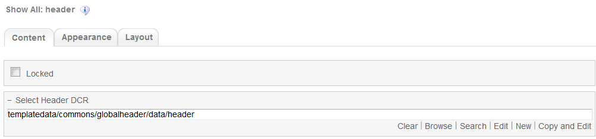  
  
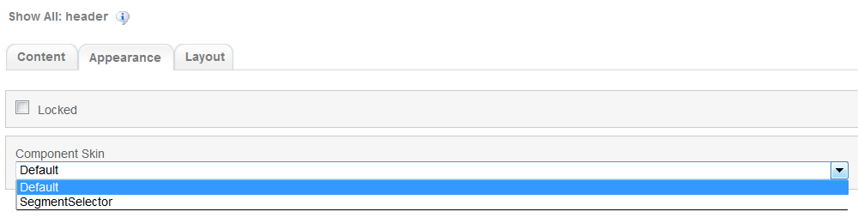

1. Navigation Component



Global component which uses TeamSite Site Map as the content source. Quick links information can be customized

Navigation Component’s default setting should have the following values in Content:

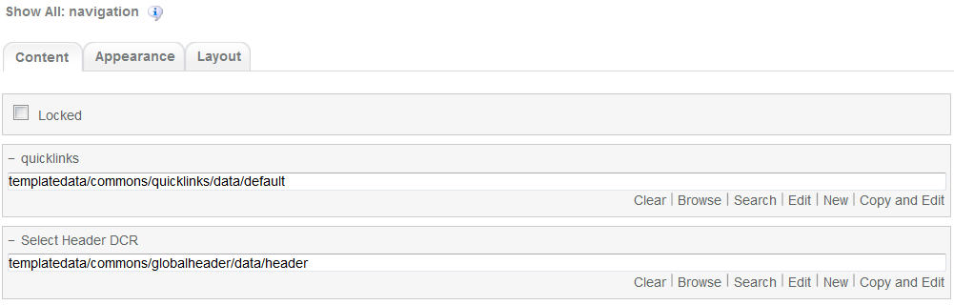

1. Breadcrumb Component



Global component to display the Home Link, Home Link Label and Home Link Target. Can be changed from component properties. If the pageName component properties is left blank then it will take the page name from the respective sitemap node.

Breadcrumb Component’s default setting should have the following values in Content

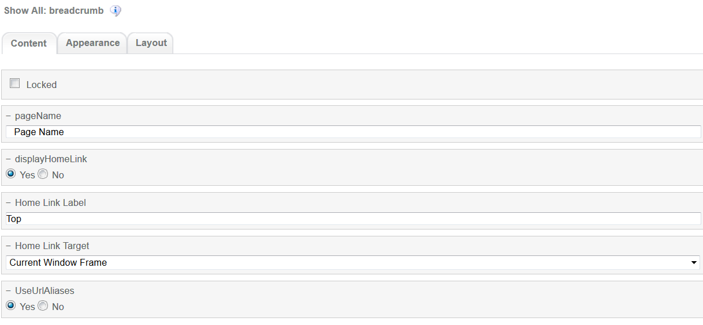

1. Carousel Component  
     
   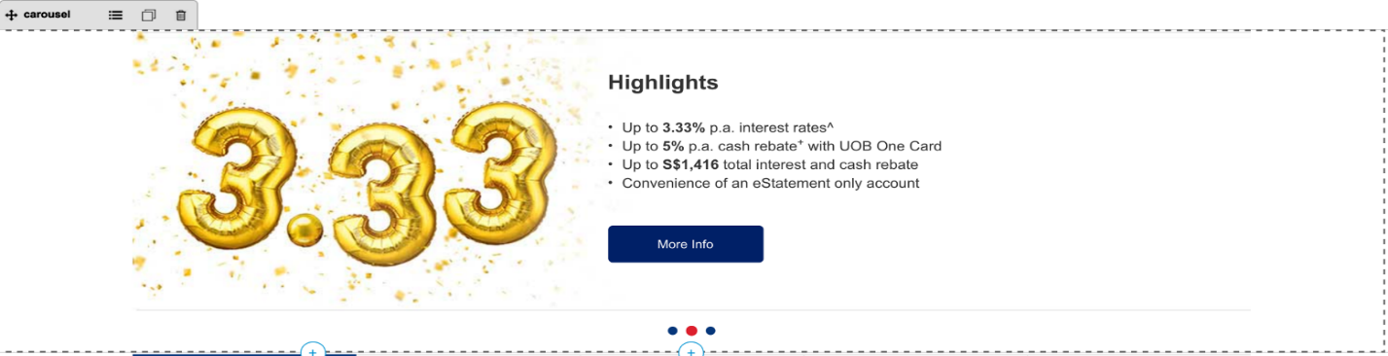

Global component to display banners. Banner DCR can be changed from component properties and DCR can be customized.

Carousel component’s default setting should have the following values in Content:

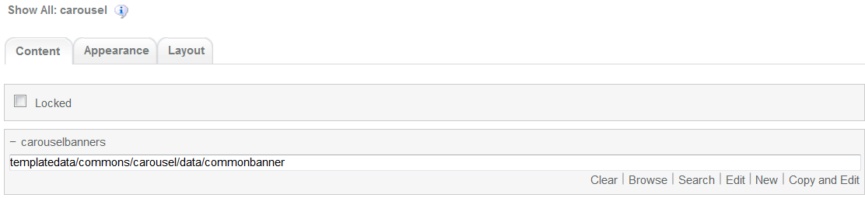

1. Promotion Listing

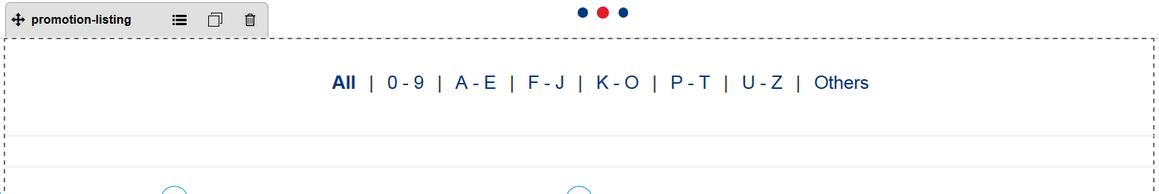

Promotion List main component. This component does not have a DCT

Promotion List component’s default setting should have the following values in Content  
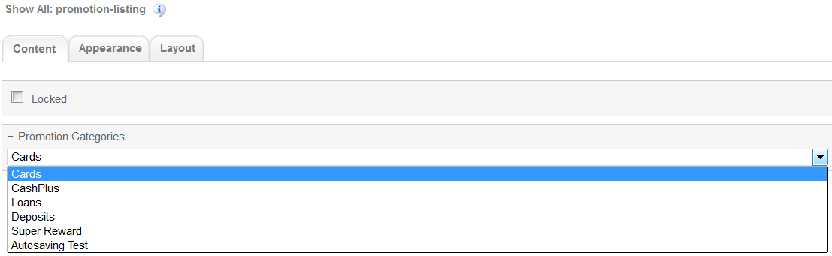

The fields that appear on the Promotion Categories are read from promotion categories DCR under /templatedata/promotion/categories/data/promotion-categories. For information on DCR please refer to User_Guide-Promotion_details.

1. 3-column-image component

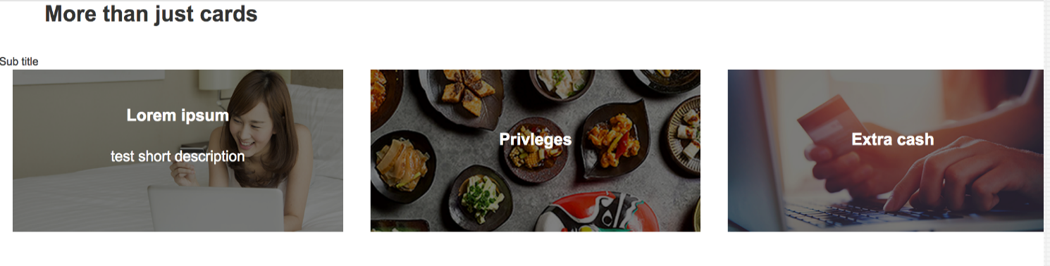  
Common component controlled by DCR. Image, title, links and other resources can be customized

3-coloumn-image-comonent default setting should have the following values in content

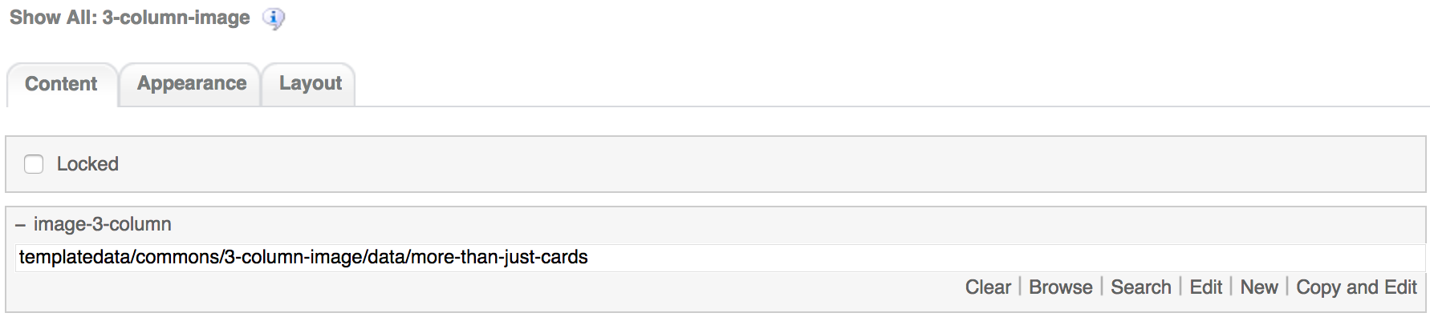

1. 4-column-tile

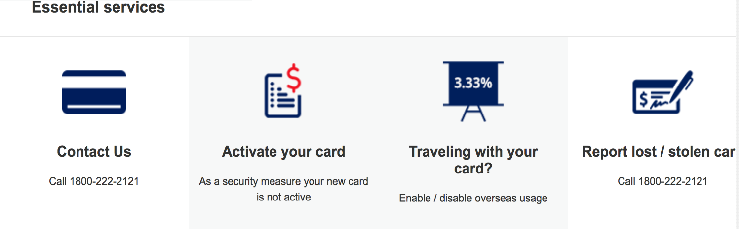

Common component controlled by DCR. Images, tile details, background, links and other resources can be customized

4-coloumn-tile component default setting should have the following values in content

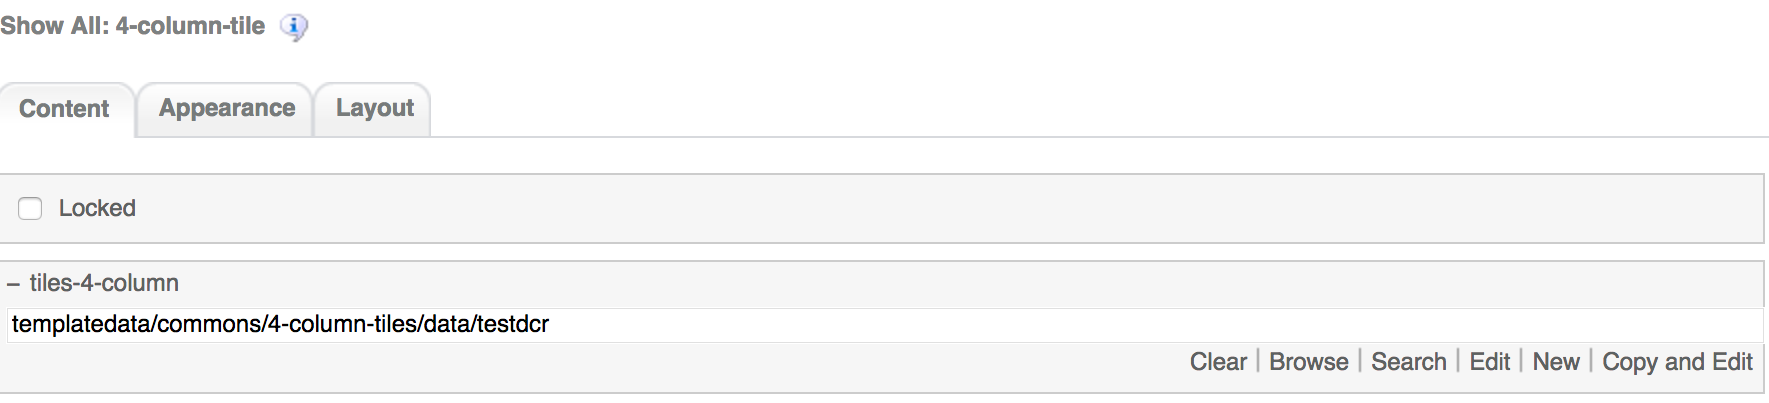

1. 3-column-menu component

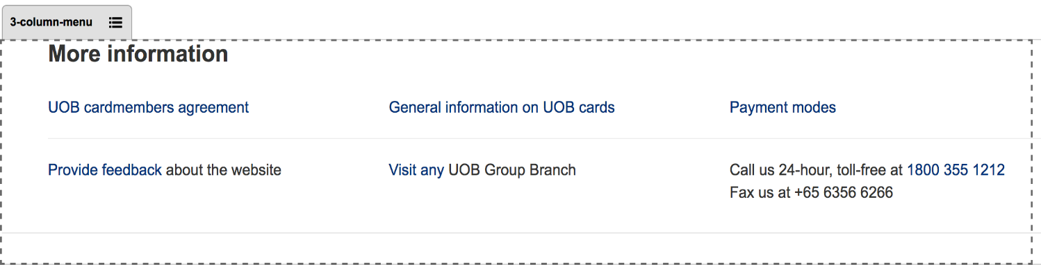

Common component controlled by DCR. Title, links, free formatting text can be customized

3-coloumn-menu component default setting should have the following values in content

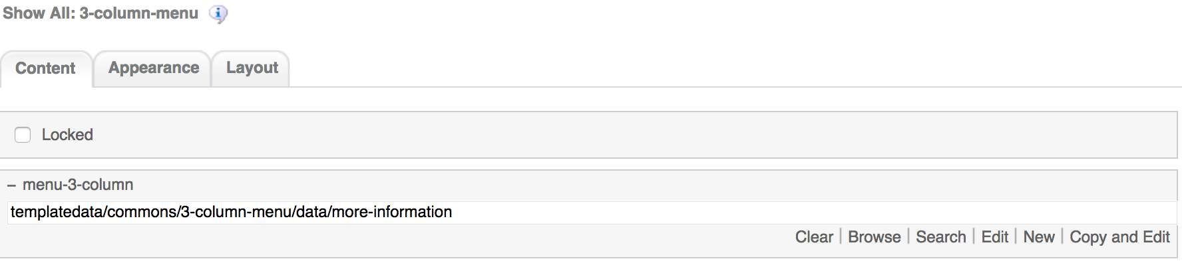

1. Footer component



Global component controlled by DCR. Links and Copyright text can be customized

Footer component’s default setting should have the following values in Content:

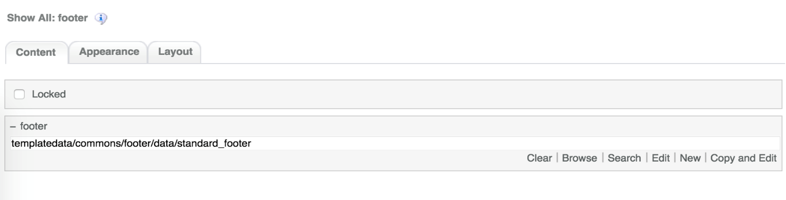

# Promotion List Common DCR Break-up

In this section, a brief explanation of the Promotion List common DCR will be made. Please refer to User_Guide-Home_page on how to navigate, select and edit DCR’s.

## Header

Please refer to User_Guide-Home_page “Homepage Common DCR Break-up” for information on Header

## Navigation

Please refer to User_Guide-Home_page “Homepage Common DCR Break-up” for information on Navigation component

## Breadcrumb

Please refer to User_Guide-Product_Landing “Product Landing Common DCR Break-up” for information on Breadcrumb component

## Carousel

Please refer to User_Guide-Product_Landing “Product Landing Common DCR Break-up” for information on Carousel component information

## 3-column-image

Please refer to User_Guide-Product_Landing “Product Landing Common DCR Break-up” for information on Carousel component information

## 4-column-tiles

Please refer to User_Guide-Product_Landing “Product Landing Common DCR Break-up” for information on 4-column-tiles component information

## 3-column-menu

Please refer to User_Guide-Product_Landing “Product Landing Common DCR Break-up” for information on 3-column-menu component information

## Footer

Please refer to User_Guide-Home_page “Homepage Common DCR Break-up” for information on Footer component

# Promotion List specific DCR Break-up

In this section, a brief explanation of each Promotion List specific component DCR will be made. Please refer to User_Guide-Home_page on how to navigate and select edit DCR’s.

## Promotion Listing

The promotion-listing component is an XSL type. The component is mainly customized by its corresponding xsl file uder <wa-path>/iw/xsl/promotionlanding/promotion_listiing.xsl and the component itself under <iwadmin-path>/<wa-path>/promotionlanding/promotion-listing.component.

# Resources

This section provides a list of the necessary resources (CSS & JavaScript) to create a Promotion List template. On how to create a template please refer to the User_Guide-Home_Page.

## CSS Resources

The css resources for the Promotion List template are as follows

|  |  |
| --- | --- |
| **Devices to use with** | **Path** |
| Desktop, Tablet, Mobile | <wa-path>/iwov-resources/css/productlanding/bootstrap.min.css |
| <wa-path>/iwov-resources/css/style.css |
| Desktop | <wa-path>/iwov-resources/css/desktop-style.css |
| Tablet | <wa-path>/iwov-resources/css/tablet-style.css |
| Mobile | <wa-path>/iwov-resources/css/mobile-style.css |
| Desktop | <wa-path>/iwov-resources/css/promotion-landing/promotion-landing-desktop-style.css |
| Tablet | <wa-path>/iwov-resources/css/promotion-landing/promotion-landing-tablet-style.css |
| Mobile | <wa-path>/iwov-resources/css/promotion-landing/promotion-landing-mobile-style.css |

These resources must be entered on the same order as the previous table or the page style will break

## JavaScript Resources

The JavaScript resources for the Promotion List template are as follows

|  |  |
| --- | --- |
| **Devices to use with** | **Path** |
| Desktop, Tablet, Mobile | <wa-path>/iowv-resources/js/analytics.js |
| <wa-path>/iwov-resources/js/cookie_handler.js |
| <wa-path>/iwov-resources/js/initiator.js |
| <wa-path>/iwov-resources/js/promotionlanding/modernizr.min.js |
| <wa-path>/iwov-resources/js/promotionlanding/jquery.min.js |
| <wa-path>/iwov-resources/js/promotionlanding/bootstrap.min.js |
| <wa-path>/iwov-resources/js/promotionlanding/plugins.min.js |
| <wa-path>/iwov-resources/js/promotionlanding/main.js |
| <wa-path>/iwov-resources/js/promotionlanding/promotionlanding.js |

These resources must be entered on the same order as the previous table or the page will break